Forecasting Time Series Data: A Comparative Analysis of RNN and LSTM Models for Weather and Financial Predictions

Authors: Brian Hodgson, Ahmad Bakir
Deep Learning Course by Bernd Ebenhoch - Alfa Training - November 8th, 2024 - Germany

Abstruct:
This report presents an analysis of two distinct datasets: one for weather forecasting and the other for predicting the Standard and Poor's stock prices. We employ Recurrent Neural Networks (RNN) and Long Short-Term Memory (LSTM) networks to forecast outcomes based on these datasets. The report discusses various parameters that influence the performance of these models, providing insights into their impact on prediction accuracy. By comparing the effectiveness of RNN and LSTM architectures, we aim to highlight the strengths and limitations of each approach in handling time series data for forecasting applications.

Introduction
In this report, we explore the modeling of weather forecasting data using a parametric approach that incorporates four key parameters to shape the temperature signal over a three-month period. A notable characteristic of temperature data is its periodic nature, exhibiting seasonal variations throughout the year. Additionally, daily temperature fluctuations contribute to this periodicity, with an observable upward trend during the spring season, which serves as a case study for our prediction process.
Whereas the financial dataset utilized in this analysis is sourced from the Yahoo Finance API, specifically focusing on the S&P 500 index (^GSPC) over a four-year period, from October 1, 2020, to November 6, 2024 [1][2].
Both datasets undergo preprocessing and transformation into arrays of time sequences, with distinct configurations for the length of the sequences and the forecasting period. These differences will be elaborated upon in the following section, setting the stage for our comparative analysis of forecasting methodologies.

Data set description

Dataset Description: S&P 500
The S&P 500 dataset Figure 1 comprises several key components that are essential for time-series analysis and predictive modeling:
- Date: Serves as the index for the time-series data, allowing for chronological analysis of stock performance.
- Close and Adjusted Close Prices: These values are frequently utilized in predictive modeling and analysis, providing insights into the stock's performance at the end of each trading day.
- High, Low, and Open Prices: These metrics are often employed to calculate various indicators, such as daily price ranges, volatility, and candlestick patterns, which can enhance the understanding of market movements.
- Volume: This feature represents the total number of shares traded during a specific period and is used to gauge trading activity, offering insights into market sentiment and potential price movements.
Together, these components provide a comprehensive framework for analyzing the S&P 500 index and developing forecasting models.
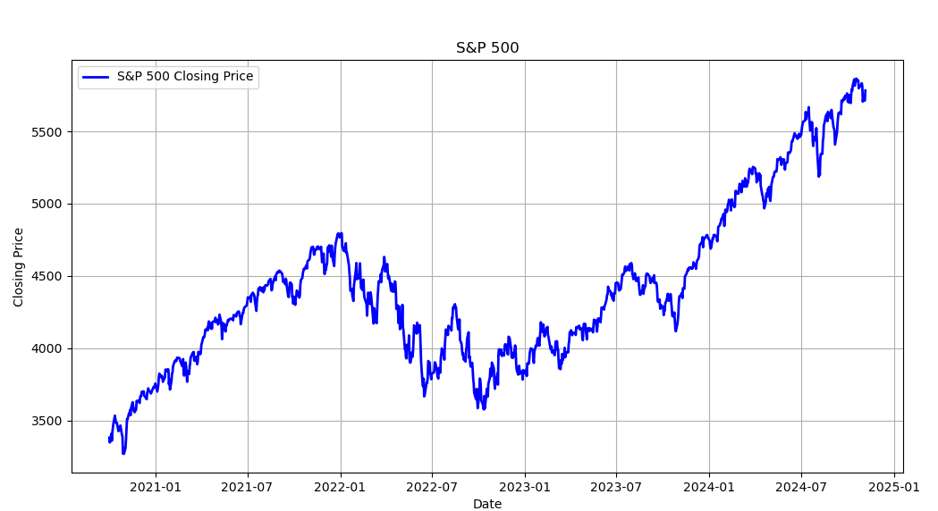

Figure 1. Closing Prices of the S&P 500 as a Dataset for Financial Modeling

Weather Forcasting Model (WFM)
A simple Weather Forecasting Model will be presented. We have selected a signal generation method as described in the slides on 'Page Nr 04' from the sixth lecture. The signal represents temperature variations, characterized by:
- A rising trend throughout the spring period. Additionally, the model incorporates
- an oscillating component to account for periodic fluctuations, as well as
- a noise term to reflect daily variations in temperature.

This temperature forecasting model will function as a dataset generator see Figure 2 to train both recurrent neural networks RNN and LSTM for future predictions.

The graph in Figure 2 illustrates a plot of temperature data over a 90-day period during the spring season. In this temperature model, we have adjusted the following parameters:
- a=0.0025 (Coefficient for the rising trend, RT)
- b=5 (Coefficient for the oscillating term, OS)
- c=0.5 (Frequency for the oscillating term, OS)
- d=5 (Amplitude for the noise component)
These parameter settings enable the temperature to fluctuate between an average range of 0 to 30 degrees, which is suitable for modeling springtime temperatures in regions such as the Middle East.

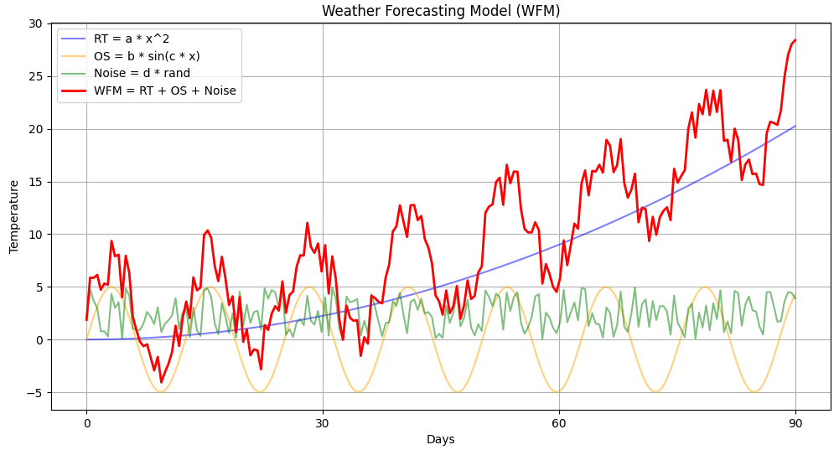
Figure 2. Weather Forecasting Model for Temperature: Comprising a Rising Trend (RT), an Oscillating Term (OS), and a Noise Component Over a 90-Day Period.

Preparing data for the Analysis
The follwing steps are followed for the preprocessing of the WFM data:

- Data Splitting: Divide time series into training and test datasets.
- Sequence Segmentation: Break the time series into smaller sequences for RNN model input.
- Dimensions of X: The variable X represents the input data and has the shape
[Batch size=30, Sequence length=60, Number of features=1]
  - Batch size: The number of sequences processed together in one iteration.
  - Sequence length: The number of time steps in each sequence.
  - Number of features: The number of different variables or measurements at each time step.
- Predicting the Last Point of the Sequence: The goal is to predict the last point in each sequence, which is represented by y. This is the target output for the model.
- Dimensions of y: The variable y has the shape
[Batch size=30, Number of features=1]
This means that for each sequence in the batch, there is a corresponding output that the model needs to predict.
- Output Neurons for Each Feature: For each feature in y, an output neuron must be created in the model. This allows the model to predict multiple outputs simultaneously.
- Flexible Parameters: The history length and step size are freely chosen for sequence generation.
- Pre-Processing Code Explanation: First we initialize empty lists for X and y, then iterates over the time series data to fill these lists with sequences and their corresponding targets. The loop uses parameters like
  - sequence_length
  - total_size
  - forecast_length
  - sequence_step
to determine how to slice the data. Finally, X and y are converted into NumPy arrays for further processing. (Source Slide 11 Lecture 6)

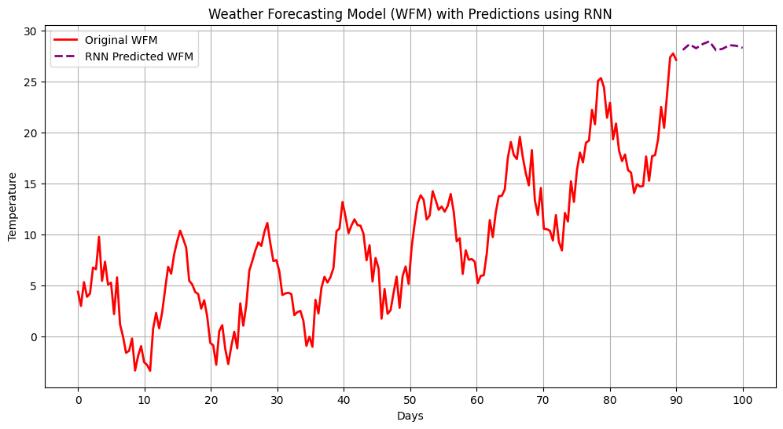

Figure 3. Temperature Prediction for the Next 10 Days Using an RNN Layer Followed by a Dense Layer.

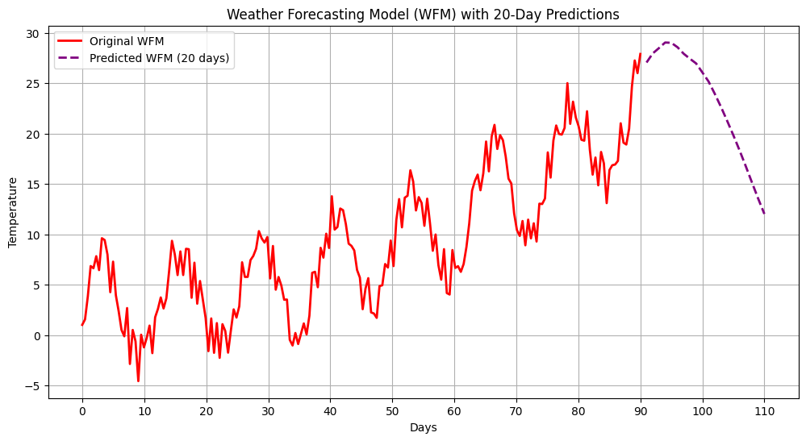

Figure 4. Temperature Prediction for the Next 20 Days Using an LSTM Layer Followed by a Dense Layer.

The Standard and Poor's 500
Using LSTM (Long Short-Term Memory) networks for S&P 500 stock prediction offers a compelling advantage due to LSTM's ability to handle time-series data, capturing both short-term patterns and long-term dependencies, which are essential for financial forecasting

Stock prices are sequential, influenced by past movements, trends, and events. Unlike traditional neural networks, LSTM networks are designed to retain information across time steps, effectively learning from both recent and historical data. This ability to remember previous information over long sequences is crucial for predicting stock prices, where short- and long-term patterns both matter.

Basic RNNs are simpler but may not capture long-term dependencies as well as LSTMs. They can be a good starting point but may struggle with highly volatile or long-term dependencies in financial data.

Time sequence prediction using RNN and LSTM

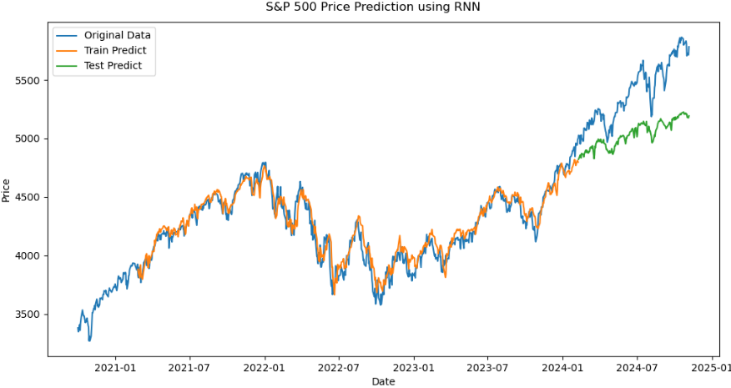
Figure 5. S&P 500 Price Prediction Model using RNN

Figure 5. This plot shows the S&P 500 Price Prediction using an RNN model with three sets of data plotted over time:
- Original Data (Blue Line):
  - This line represents the actual S&P 500 closing prices from 2020-10-01 to 2024-11-06. It is the ground truth data used to train and test the model.

- Train Predict (Orange Line):
  - This line shows the model's predictions on the training dataset. The RNN model was trained on this portion of the data, and the orange line indicates how well the model fit the training data.
  - The close alignment between the blue and orange lines indicates that the model captured the general trends in the training data, though some variations are present.
- Test Predict (Green Line):
  - This line represents the model's predictions on the test dataset (unseen data during training).
  - The test predictions generally follow the original data trend but show some deviation, which is normal since this part is used to evaluate model performance.
  - The alignment between the green and blue lines suggests that the model can somewhat generalize to unseen data, though differences in certain areas indicate potential areas for improvement.

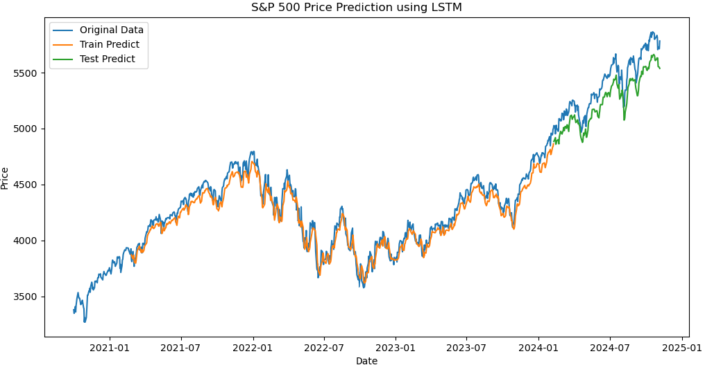
Figure 6. S&P 500 Price Prediction Model using LSTM

This plot shows the S&P 500 Price Prediction using an LSTM model over the period from 2020-10-01 to 2024-11-06. The plot includes three sets of data lines:
- Original Data (Blue Line):
  - This line represents the actual S&P 500 closing prices. It serves as the ground truth against which the model’s performance on both training and testing sets is compared.
- Train Predict (Orange Line):
  - This line shows the model's predictions on the training data. The close alignment between the orange line and the blue line during the training period indicates that the LSTM model has learned the patterns and trends in the training data well.
  - The close fit between the orange and blue lines suggests that the model is capturing the general pattern of the training data without excessive overfitting.
- Test Predict (Green Line):
  - This line represents the model's predictions on the test (unseen) data.
  - The green line follows the blue line closely, indicating that the model has generalized well to the test data. The LSTM captures the overall trends and fluctuations in the unseen data, even though minor deviations occur in some sections, which is expected in financial forecasting.

Interpretation:
- Improved Generalization: Compared to the previous RNN plot, this LSTM model appears to generalize better on the test data, with the predictions following the original data quite closely. This reflects the ability of LSTM networks to capture and retain long-term dependencies in sequential data, which is beneficial for time series like stock prices.
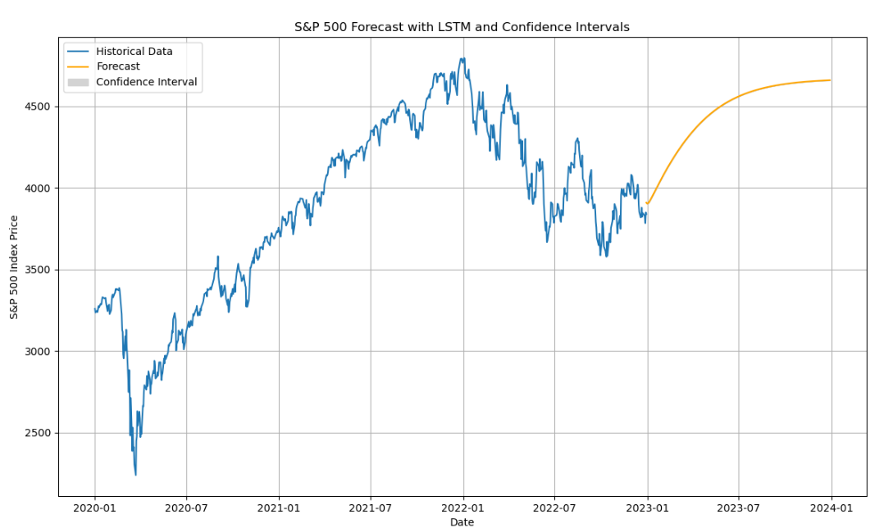
Figure 7. S&P 500 Price Prediction Model using LSTM and Confidence Intervals

This plot shows an S&P 500 Forecast with an LSTM model and Confidence Intervals.
- Historical Data (Blue Line):
  - This blue line represents the historical S&P 500 closing prices from early 2020 to the end of the available data, likely near the start of 2023.
  - It shows past trends in the S&P 500 index, which the model uses to make future predictions.
- Forecast (Orange Line):
  - The orange line is the model's forecast of the S&P 500 index for future dates beyond the historical data range.
  - The forecast shows an upward trend starting from the last available date in the historical data (around early 2023) and extending into the year 2024.
  - This line indicates the LSTM model's predicted values for the S&P 500 index based on learned patterns in the historical data.
- Confidence Interval (Shaded Area):
  - The shaded area around the orange forecast line represents the confidence interval of the forecast.
  - This interval provides a range of uncertainty around the predicted values, illustrating the model's confidence in its predictions.
  - A wider confidence interval means more uncertainty, while a narrower interval suggests greater confidence in the forecast accuracy.
  - As time moves further into the future, the confidence interval typically widens, reflecting increased uncertainty in long-term predictions.

Interpretation
- Upward Forecast Trend: The model predicts an upward trend in the S&P 500 index in the forecast period, implying that the model has learned positive patterns from historical data.
- Increasing Uncertainty Over Time: The widening of the confidence interval as the forecast extends further into 2024 is expected, as uncertainty generally increases with time in financial forecasting.
- Good Model Confidence in the Short Term: In the early part of the forecast period (near the transition from historical to forecast data), the confidence interval is relatively narrow, suggesting the model is reasonably confident in its short-term predictions. This interval widens as the forecast period progresses.

Discussion

1. RNN (Recurrent Neural Network)
Technical Perspective:
- RNNs are foundational models for sequential data and can capture some temporal dependencies, making them a better choice than feed-forward networks for time series tasks.
- However, RNNs are challenged by the vanishing gradient problem, which limits their ability to remember long-term dependencies. This issue arises because gradients used in backpropagation tend to diminish as they propagate backward through time, leading to weaker influence from earlier data points.
- Due to this limitation, RNNs often struggle with complex or long-sequence time series data where events from far in the past significantly affect future outcomes.
Practical Considerations:
- RNNs tend to overfit easily, especially if the model is complex and the dataset is small. Regularization techniques like dropout can help but may not be enough.
- In many real-world applications, like finance or weather forecasting, long-term dependencies are common and critical. The inability of RNNs to capture these dependencies makes them less suitable for many complex forecasting tasks.
- For simpler tasks or applications with shorter sequences, RNNs can be computationally efficient, offering a lightweight alternative to LSTM or GRU models.
Summary:
- RNNs are often a good starting point for sequential data modeling but are rarely used alone in complex time series forecasting tasks. The rise of LSTMs and GRUs has largely addressed RNNs' limitations, making them preferable for most applications.

2. LSTM (Long Short-Term Memory Network)
Technical Perspective:
- LSTMs were designed to address the shortcomings of RNNs by introducing gated mechanisms (input, forget, and output gates) that allow them to retain or forget information over long sequences effectively. This design solves the vanishing gradient problem, enabling LSTMs to learn from long-term dependencies and capture complex temporal relationships.
- The ability to control memory allows LSTMs to handle both long-term and short-term patterns, making them highly versatile for time series data.
- In tasks with intricate patterns (e.g., stock market predictions, demand forecasting), LSTMs generally outperform RNNs due to their enhanced memory capabilities.

Practical Considerations:
- While LSTMs are powerful, they are computationally intensive, especially on large datasets or when used with multiple layers and a high number of units.
- Training LSTMs can take longer and may require more fine-tuning to optimize performance. Hyperparameters like the number of units, learning rate, and regularization need careful adjustment to prevent overfitting or underfitting.
- Despite their increased complexity, LSTMs have become the default choice for most time series applications due to their balance of flexibility and performance.
Summary:
- LSTMs are widely used in industry for time series forecasting tasks where both long- and short-term dependencies are important. They provide a strong balance between capturing complex dependencies and maintaining a feasible computational cost.

3. LSTM with Confidence Intervals
Technical Perspective:
- Adding confidence intervals to LSTM predictions introduces a new dimension: uncertainty quantification. Rather than providing just point forecasts, models with confidence intervals indicate a range in which future values are likely to fall. This approach is particularly useful in high-risk domains where understanding uncertainty is as important as the prediction itself.
- Confidence intervals can be generated using techniques such as bootstrapping, quantile regression, or Monte Carlo dropout. These techniques add layers of computational complexity and may increase training time, but they significantly enhance interpretability.
- Models with confidence intervals provide a probabilistic forecast, which is invaluable for assessing risk, making informed decisions, and planning for contingencies in scenarios where the consequences of predictions are high.

Conclusion

- RNNs can be used for simple time series data but are generally outperformed by LSTMs, especially for complex, long-sequence data.
- LSTMs are powerful for capturing both short- and long-term dependencies in time series, making them suitable for most forecasting tasks.
- LSTMs with Confidence Intervals are ideal when uncertainty quantification is crucial, adding a layer of interpretability and robustness to the predictions, especially in high-stakes applications.

References

[1] Chen, Zemeng. "S&P 500 Stock Price Prediction using LSTM." Highlights in Science, Engineering and Technology 88 (2024): 57-63.

[2] https://github.com/arogan178/lstm-stock-prediction-sp500

Using Long Short-Term Memory to predict stock price movement for S&P500 Andrea Bugeja University of Malta

