**Fire Fighter Robot**

Functional Specifications

ENEL 387 Design Project

Jiwoun Kim (200329205)

Noa Rowbotham (200364559)

March 6th, 2020

**1 System Information  
 1.1 Description** The goal of this design project is to build an autonomous robot that explores and detects designated targets within a predefined course. The robot maneuvers down hallways and into rooms. In each of four rooms, the robot attempts to detect various objects, such as an incandescent light bulb or target blocks which have lines to be recognized by infrared sensors. Walls can be detected by different types of sensors on the robot to aid with traversing the course. The robot generates beeping sounds as a system output to notify the user which room the robot is in and what object it found. After all tasks are complete, the robot returns to home base.   
 To build our robot we will use the STM32F100RB microcontroller, STM32VLdiscovery board, and ENEL 384 board. In addition, we will use other peripherals such as; infrared sensors, ultrasonic sensors, a servo motor, DC motors, DC motor drivers, a buzzer and battery arrays according to the requirements the robot must meet.

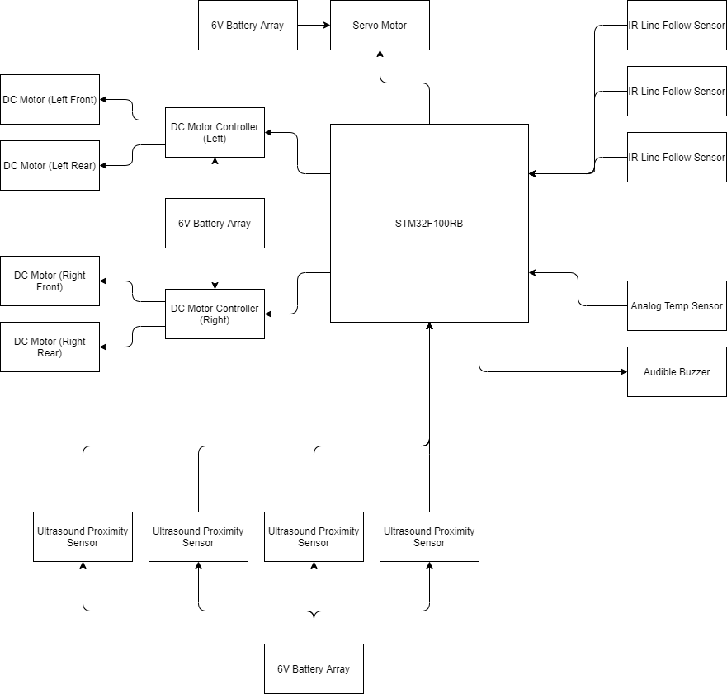**1.2 Block Diagram**

Figure 1. Robot Block Diagram

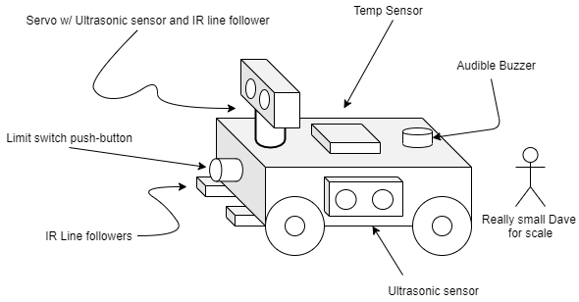 **1.3 Physical Sketch**

Figure 2. Physical Sketch of the Robot

**1.4 Input and Output Specification**

|  |  |  |
| --- | --- | --- |
| **Inputs** | | |
| **Component** | **Quantity - Location** | **Purpose** |
| Ultrasonic proximity sensor | 4 - Mounted to the left, right, and front. Fourth mounted to a servo motor for room scanning. | Detecting the presence of walls and maintaining distance from them. |
| IR line follower | 3 - Two mounted to the front-bottom. Third mounted on the front face of the chassis. | Allows autonomous traversal of the course’s hallways. Scans the identification code of doorways upon entering. Scans the identification code on obstacles in the rooms. |
| Analog temperature sensor | 1 - Mounted on the roof of the chassis. | Detects the presence of an incandescent light bulb. |
| Push-buttons | 3 - Mounted to the front, rear, and roof of the chassis. | Front and rear buttons act as limit switches incase other sensors fail to detect wall or obstacle. Third switch is used as user input. |

|  |  |  |
| --- | --- | --- |
| **Outputs** | | |
| **Component** | **Quantity - Location** | **Purpose** |
| DC motor | 4 - Powering each wheel | Propulsion |
| Servo motor | 1 - Roof of the chassis | Used to turn the ultrasonic sensor that scans rooms for obstacles. |
| Audible buzzer | 1 | Tells the user which mode it is in as well as which obstacle in which room it found. |
| DC motor controller | 2 | Each controller operates a side of the chassis. Allows us to rotate the vehicle and at different speeds. |

**2 Operation  
 2.1 Start-up** Once the vehicle has been powered holding the user input button for 5 seconds will transition the vehicle from idle mode to traversal mode. After transitioning, the user has 8 seconds before the vehicle will begin traversing the course. The vehicle has chimes to notify the user of the transition as well as it’s countdown to operation.

**2.2 Robot Translation Chart** In the following table keywords will be used to differentiate a long audible buzz versus a short audible buzz. The two variations are used to create meaning for transmitting information to the user. A long audible buzz is denoted by a *boop,* while a short audible buzz is denoted by a *beep.* These patterns may use different tones to produce more distinct sounds.

|  |  |
| --- | --- |
| **Buzz Pattern** | **Meaning** |
| *beep beep beep* | “I’ve transitioned to traversal mode!” |
| *beep* (once every second, for 8s) | “I’m counting down before I start!” |
| *beep [pause]* (room code) *beep [pause]* (obstacle code or light code) | “I’m trying to tell you some important stuff!” |
| *boop* (# of times equal to room #) | “This is what room I am in!” |
| *boop* (# of times equal to obstacle #) | “This is the obstacle I found!” |
| *boop boop boop boop* | “I couldn’t find anything in this room, how sad.” |
| *beep beep beep beep beep beep boop* | “Ah! I found fire! Nvm, it’s a lightbulb.” |
| *beep beep boop beep beep boop boop* | “I’ve returned home!” |

**2.3 Autonomous Behavior**

The robot traverses the hallways using the navigation line until it detects a doorway has appeared. If it detects a doorway it will check the room for an obstacle or light. Once complete it returns to the hallway and proceeds looking for the next doorway. Once it has found all doorways it follows the navigation lines until it reaches home base.

To search a room the robot first enters slowly and allows the IR sensors to read the doorway code. Once this is complete the robot circles the room. It uses its mounted servo to search for obstacle identifiers on the wall. The servo is always rotated to face the wall that the robot is driving along. Once the robot has completed it’s search it will notify the user of what it found.

**2.4 Unexpected Error Behavior**

The following features are how we expect the robot to handle these issues, but without further testing these are simply theories. They are subject to change as we understand how to best resolve the issues.

If the robot unexpectedly encounters a wall during hallway traversal the robot will reverse slowly, rotate 180 degrees, and attempt to proceed to follow the line.

If the robot unexpectedly encounters a wall in a room it will attempt to reverse slowly, use the servo mounted ultrasonic sensor to find a wall, and readjust to that wall. The robot will then continue to circle the room.

If the robot cannot find an obstacle or light, it gives up, like most people who can’t find what they are looking for. It will signify this with a beep pattern. If the robot could not detect a valid room identification the robot will attempt to pass over the id code again to get another reading.

**2.4 End Cycle**

Once the robot has completed the course and returned home it plays its returned home indication. After this, the robot transitions to an idle state that cannot be exited. Once powered off the robot is reset and can be operated again once powered.