CAPSTONE PROJECT 3

SECURITY INFORMATION AND EVENT MANAGEMENT (SIEM) DEPLOYMENT, DETECTION ENGINEERING AND INCIDENT INVESTIGATION
Project Title:
Design and Implementation of a Virtualized SOC/SIEM Monitoring Environment Using Splunk Enterprise
Student Name: Brian Ibiyekebo Jackreece
Platform: Oracle VirtualBox
SIEM Platform: Splunk Enterprise
Endpoint Monitoring: Splunk Universal Forwarder
Operating Systems: Windows and Ubuntu Linux
Lab Network: 192.168.56.0/24

EXECUTIVE SUMMARY
This project involved the design and implementation of a small, isolated Security Operations Center (SOC) and Security Information and Event Management (SIEM) environment using Splunk Enterprise, Windows, Ubuntu Linux, Oracle VirtualBox, and Splunk Universal Forwarders.
The objective was to demonstrate the complete security monitoring lifecycle: infrastructure deployment, endpoint log collection, centralized
event ingestion, controlled security-event generation, detection engineering, investigation, and remediation.
The laboratory environment consisted of a physical Windows computer running Splunk Enterprise, a Windows virtual machine representing a monitored Windows endpoint, and an Ubuntu virtual machine representing a monitored Linux endpoint. The endpoints communicated with the Splunk host through an isolated VirtualBox Host-Only network. The documented architecture uses the physical Windows host at 192.168.56.1, the Windows endpoint at 192.168.56.20, and the Ubuntu endpoint at 192.168.56.30.
Splunk Enterprise was configured as the central SIEM and receiver on TCP port 9997. Windows event logs were collected through the Windows Universal Forwarder, while Ubuntu authentication and system logs were collected through the Linux Universal Forwarder.
Three principal security scenarios were investigated:
- SSH failed-authentication/brute-force simulation.
2.Unauthorized local account creation and privileged-group modification.
3.Suspicious PowerShell/process activity.
An optional fourth scenario involved Windows Security Event Log clearing, represented by Event ID 1102.
The project demonstrates how endpoint telemetry can be centralized into a SIEM, queried using Splunk Search Processing Language (SPL), correlated into detection logic, and presented through a SOC dashboard.

TABLE OF CONTENTS

1. INTRODUCTION 1
2. PROJECT OBJECTIVES 1
3. LAB ARCHITECTURE 2
3.1 Architecture Overview 2
3.2 Windows Endpoint 4
3.3 Ubuntu Linux Endpoint 5
4. SIEM DEPLOYMENT 6
4.1 Splunk Enterprise 6
5. SPLUNK DATA INGESTION CONFIGURATION 7
5.1 Splunk Receiving Port 7
5.2 Network Connectivity Verification 8
6. SPLUNK INDEX DESIGN 9
7. WINDOWS UNIVERSAL FORWARDER 10
7.1 Windows Event Log Collection 11
8. WINDOWS LOG INGESTION VALIDATION 12
8.1 Windows Security Logs 13
9. UBUNTU UNIVERSAL FORWARDER 14
10. LINUX LOG INGESTION VALIDATION 15
11. SECURITY EVENT SIMULATIONS 16
12. ATTACK SCENARIO 1: SSH FAILED-AUTHENTICATION / BRUTE-FORCE SIMULATION 17
12.1 Scenario Description 17
12.2 Raw Linux Evidence 17
12.3 Splunk Detection 18
Security significance 19
13. ATTACK SCENARIO 2: UNAUTHORIZED LOCAL ACCOUNT AND PRIVILEGE MODIFICATION 20
13.1 Scenario Description 20
13.2 Event ID 4720: Account Creation 20
13.3 Event ID 4732: Privileged Group Modification 22
14. CORRELATED ACCOUNT DETECTION 23
15. ATTACK SCENARIO 3: SUSPICIOUS POWERSHELL / PROCESS ACTIVITY 24
15.1 Scenario Description 24
15.2 PowerShell Operational Log Validation 25
15.3 PowerShell Forwarding Configuration 26
15.4 Process Creation Investigation 26
15.5 Detection Status 27
16. OPTIONAL ATTACK SCENARIO 4: SECURITY LOG CLEARING 28
17. DETECTION ENGINEERING 29
SSH failed authentication 29
Windows account creation 29
Privileged group modification 30
PowerShell Script Block Logging 30
Windows process creation 30
Security log clearing 30
18. DETECTION LOGIC 30
19. SOC DASHBOARD 31
Panel 1: Windows Events 31
Panel 2: Linux Events 32
Panel 3: Failed SSH Authentication 32
Panel 4: New Windows Accounts 32
Panel 5: Privileged Group Changes 32
Panel 6: Process Creation 32
20. PRIMARY INCIDENT INVESTIGATION 34
20.1 Incident Title 34
20.2 Affected Host 34
20.3 Incident Description 34
21. INCIDENT TIMELINE 34
22. INCIDENT ANALYSIS 36
23. INVESTIGATION SEARCH 37
24. REMEDIATION 38
26. SECURITY OPERATIONS ANALYSIS 38
26.1 Log Collection 38
26.2 Log Normalization and Indexing 38
26.3 Detection Engineering 38
26.4 Event Correlation 39
26.5 Incident Investigation 39
26.6 Remediation 39
26.7 Visualization 39
27. LIMITATIONS AND OBSERVATIONS 39
27.1 PowerShell telemetry 39
27.2 Event ID 4688 40
27.3 SSH source address 40
28. RECOMMENDED SOC IMPROVEMENTS 41
29. CONCLUSION 41

1. INTRODUCTION
Modern security operations depend heavily on centralized visibility into endpoint and system activity. Individual computers generate large volumes of security-relevant information, including authentication events, process creation, account-management events, system activity, and application errors.
A SIEM platform provides a centralized location where these events can be collected, indexed, searched, correlated, and investigated.
This project implements a controlled SOC/SIEM laboratory using Splunk Enterprise. Rather than interacting with real production systems, all security activities were performed against intentionally isolated virtual machines. The project therefore demonstrates security monitoring and detection concepts without exposing external systems to testing activity.
The laboratory was designed around a three-system architecture:
- Physical Windows host: Splunk Enterprise/SIEM.
2.Windows virtual machine: monitored Windows endpoint.
3.Ubuntu virtual machine: monitored Linux endpoint.
This architecture provides both Windows and Linux telemetry and allows the SOC analyst to investigate different categories of security events.

2. PROJECT OBJECTIVES
The major objectives of the project were to:
- Design an isolated virtualized security laboratory.
2.Deploy Splunk Enterprise as the central SIEM.
3. Configure Splunk to receive endpoint telemetry.
4. Deploy Splunk Universal Forwarder on Windows.
5. Deploy Splunk Universal Forwarder on Ubuntu Linux.
6. Create separate Splunk indexes for Windows and Linux telemetry.
7. Verify successful log ingestion.
8. Generate controlled and benign security events.
9. Develop SPL-based detection searches.
10. Investigate security events using Splunk.
11. Develop a SOC monitoring dashboard.
12. Document evidence, timelines, findings, and remediation actions.
The project procedure specifically identifies SSH brute-force simulation, unauthorized local administrator-account activity, suspicious PowerShell/command execution, and optional Security Event Log clearing as the principal attack scenarios.

3. LAB ARCHITECTURE

3.1 Architecture Overview
The final laboratory architecture consisted of the following components:

Component | Role | IP Address
Physical Windows Host | Splunk Enterprise / SIEM | 192.168.56.1
Windows VM | Windows monitored endpoint | 192.168.56.20
Ubuntu VM | Linux monitored endpoint | 192.168.56.30
Splunk Receiver | Universal Forwarder ingestion | TCP 9997
Splunk Web | SIEM management/search interface | TCP 8000
The architecture uses a VirtualBox Host-Only network so that the physical host and virtual machines can communicate within the isolated laboratory environment. The documented design identifies 192.168.56.0/24 as the laboratory network.

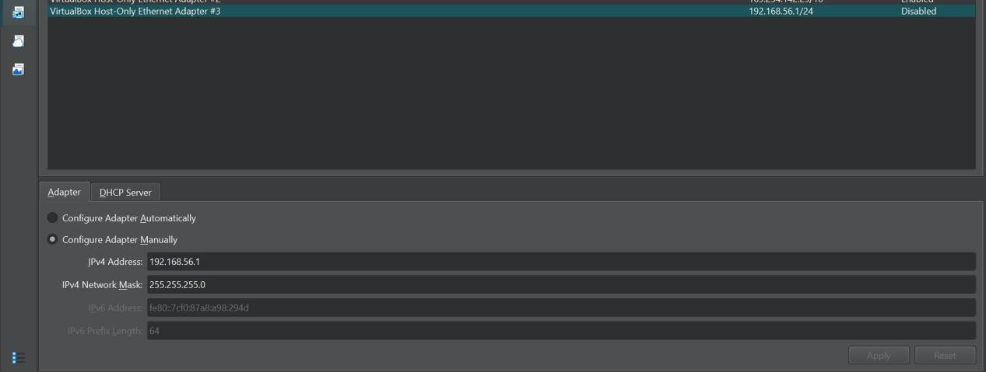
Figure 1: VirtualBox Host-Only network configuration used to provide isolated communication between the Splunk SIEM host and monitored endpoints.

3.2 Windows Endpoint
The Windows virtual machine served as the primary Windows endpoint. It generated Application, Security, and System Windows Event Log telemetry.
The endpoint was configured with the static address:
192.168.56.20
The Windows Universal Forwarder transmitted collected telemetry to the Splunk host at:
192.168.56.1:9997
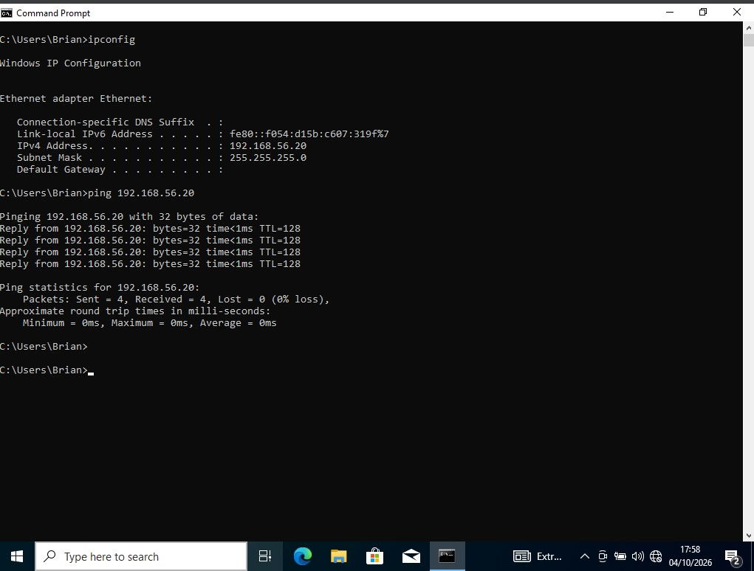

Figure 2: Windows endpoint network configuration showing the laboratory IP address and connectivity to the Splunk host.

3.3 Ubuntu Linux Endpoint
The Ubuntu virtual machine served as the Linux monitoring endpoint.
Its configured laboratory address was:
192.168.56.30
The Linux Universal Forwarder collected authentication and system logs, principally:
- /var/log/auth.log
2./var/log/syslog
These logs were forwarded to Splunk and stored in the linux index.
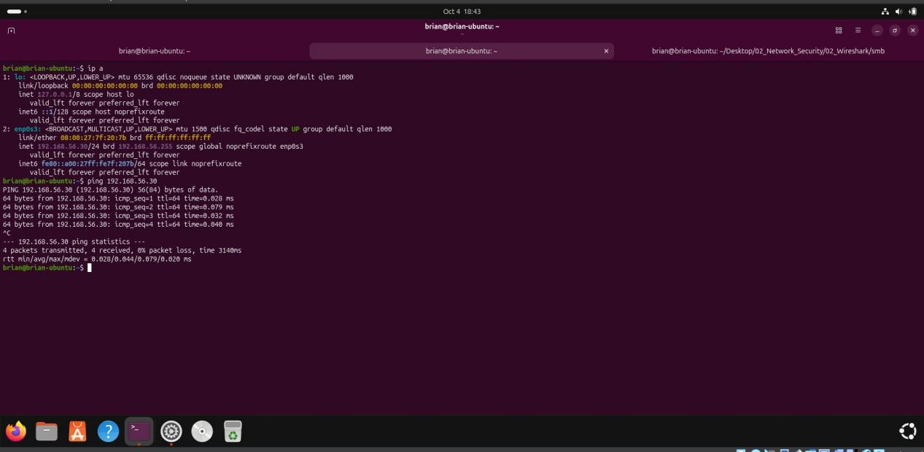

Figure 3: Ubuntu Linux endpoint configured on the isolated SOC network and communicating with the Splunk host.

4. SIEM DEPLOYMENT

4.1 Splunk Enterprise
Splunk Enterprise was installed on the physical Windows host and used as the central SIEM platform.
The Splunk Web interface provided the primary interface for:
- Searching logs.
2.Investigating events.
3. Developing SPL detection searches.
4. Creating dashboards.
5. Reviewing endpoint telemetry.
The project documentation identifies Splunk Enterprise as the SIEM component running on the physical Windows host.

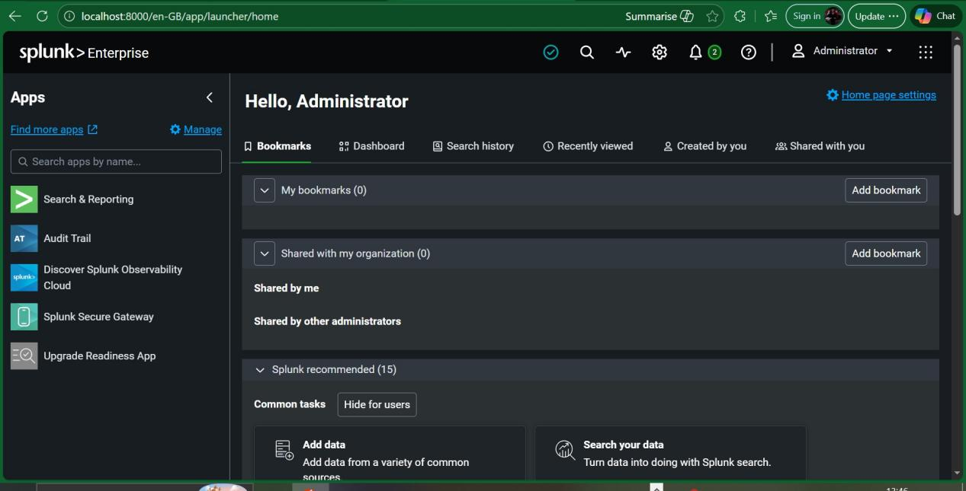
Figure 4: Splunk Enterprise Web interface operating as the centralized SIEM platform for the laboratory environment.

5. SPLUNK DATA INGESTION CONFIGURATION

5.1 Splunk Receiving Port
The Splunk host was configured to receive Universal Forwarder data over TCP port 9997.
This receiver provides the ingestion path from the Windows and Ubuntu endpoints into Splunk.
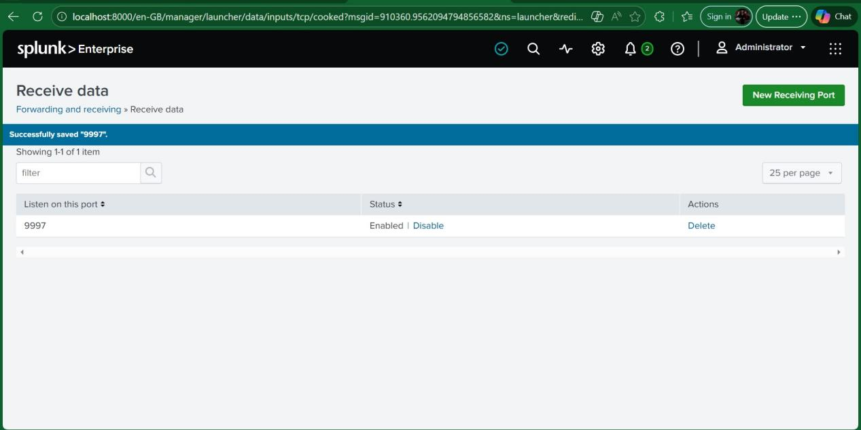
Figure 5: Splunk Enterprise configured to receive Universal Forwarder telemetry on TCP port 9997.
The project documentation identifies TCP 9997 as the receiver port used by the laboratory.

5.2 Network Connectivity Verification
Connectivity to TCP port 9997 was tested from the Ubuntu endpoint using:
nc -zv 192.168.56.1 9997

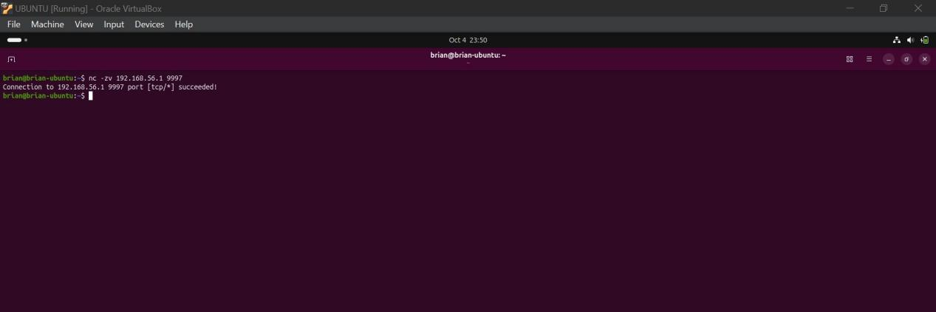
Figure 6: Successful TCP connectivity test from the Ubuntu endpoint to the Splunk Universal Forwarder receiving port.
This is important evidence because it demonstrates that network connectivity existed between the endpoint and the SIEM ingestion service.

6. SPLUNK INDEX DESIGN
Two primary indexes were created:
1.windows
2.linux
The windows index was used for Windows endpoint telemetry, while the linux index was used for Ubuntu Linux telemetry.
Separating the data into indexes simplifies searching, access control, investigation, and detection development.
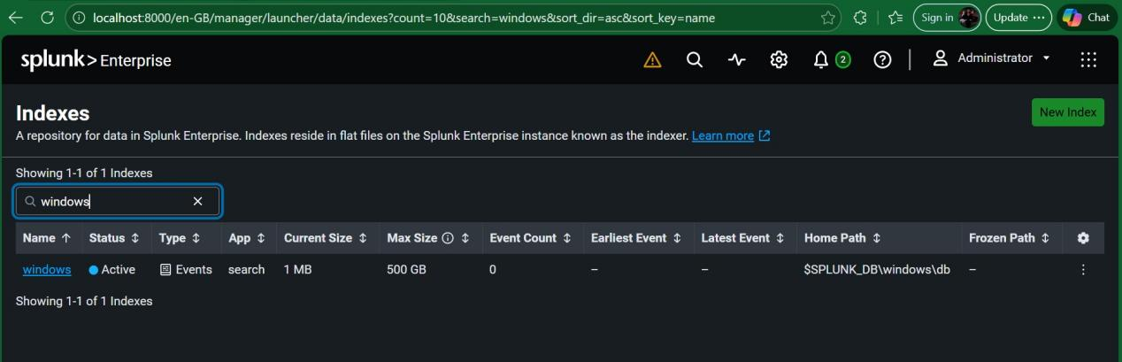
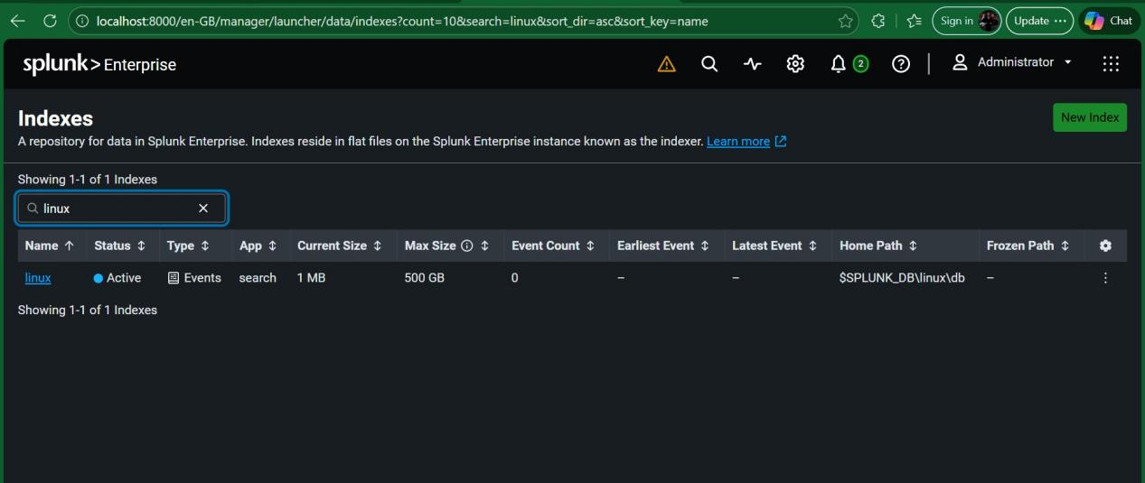
Figure 7: Splunk index configuration showing separate Windows and Linux indexes for centralized endpoint telemetry.

7. WINDOWS UNIVERSAL FORWARDER
The Splunk Universal Forwarder was installed on the Windows virtual machine.
The Windows Forwarder was configured to send endpoint telemetry to:
192.168.56.1:9997
The Windows Forwarder service was verified as running.
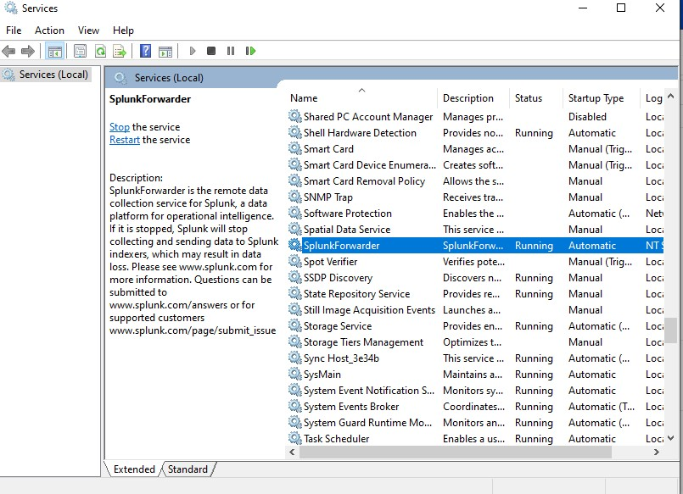
Figure 8: Windows Splunk Universal Forwarder service running on the monitored endpoint.

7.1 Windows Event Log Collection
The Windows Forwarder was configured to collect the following logs:
[WinEventLog://Application]
disabled = 0
index = windows

[WinEventLog://Security]
disabled = 0
index = windows

[WinEventLog://System]
disabled = 0
index = windows
This configuration allowed the SIEM to receive Windows Application, Security, and System events.

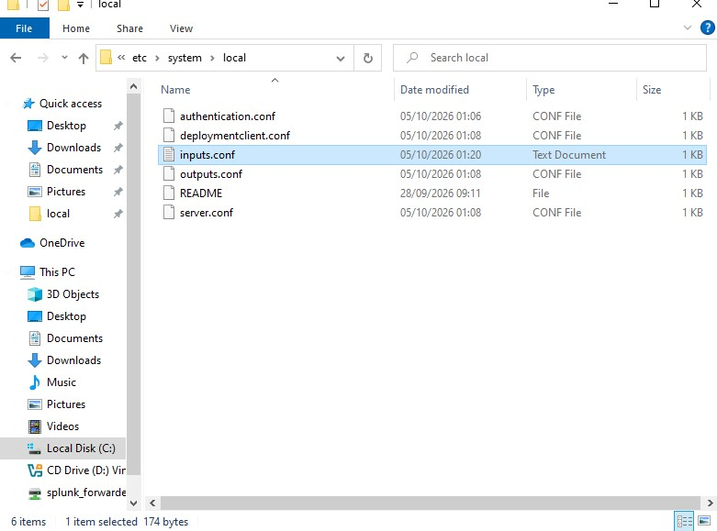
Figure 9: Windows Universal Forwarder input configuration for Application, Security, and System Event Logs.
The documented project procedure specifies these three Windows Event Log inputs.

8. WINDOWS LOG INGESTION VALIDATION
Successful ingestion was validated in Splunk using:
index=windows
The search returned Windows events from the monitored endpoint.
The Windows telemetry included Security, System, and Application events.
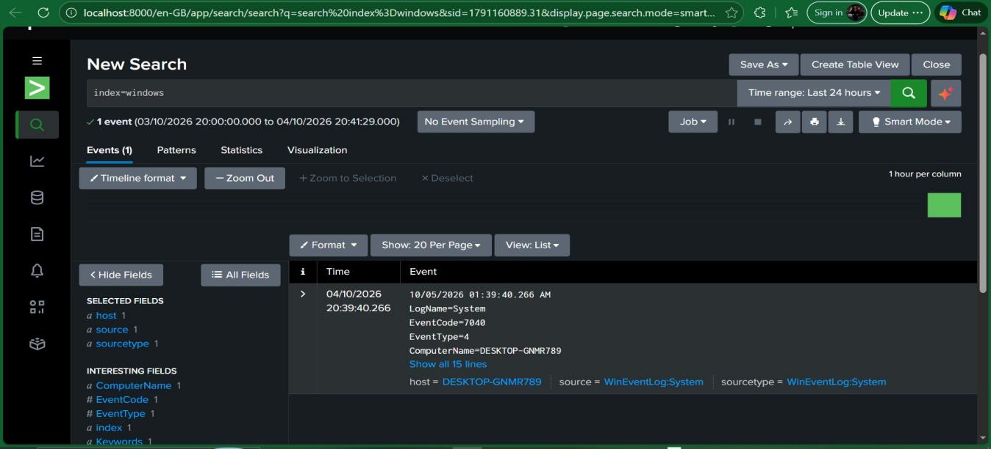
Figure 10: Successful ingestion of Windows endpoint telemetry into the Splunk SIEM.
This is a key validation point because it establishes that the endpoint-to-SIEM data pipeline was operational.

8.1 Windows Security Logs
The Security log was queried using:
- index=windows source="WinEventLog:Security"
Security events subsequently provided the telemetry used for account-management and process-creation investigations.
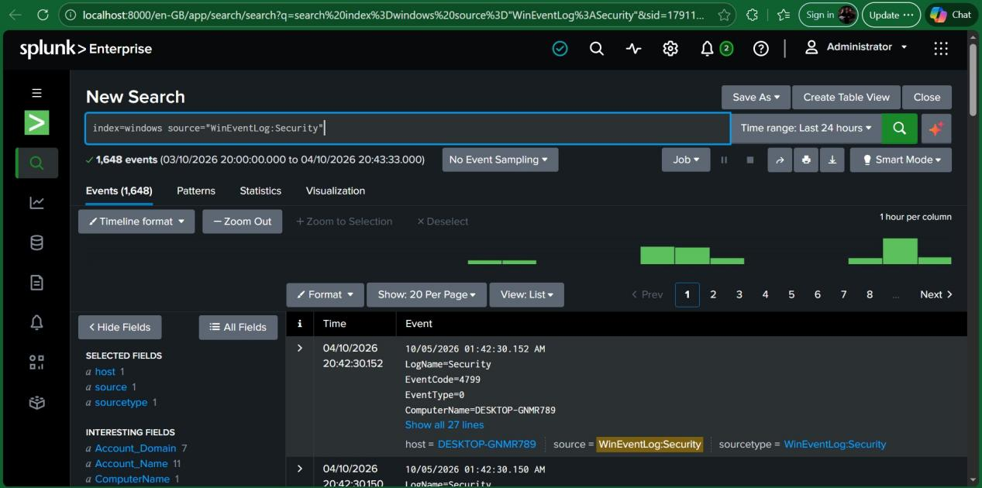
Figure 11: Windows Security Event Log data successfully indexed in Splunk.

9. UBUNTU UNIVERSAL FORWARDER
The Linux Universal Forwarder was installed on Ubuntu and configured to transmit telemetry to:
192.168.56.1:9997
The following Linux logs were monitored:
/var/log/auth.log
/var/log/syslog
The configured input structure was:
[monitor:///var/log/auth.log]
disabled = 0
index = linux
sourcetype = linux_secure

[monitor:///var/log/syslog]
disabled = 0
index = linux
sourcetype = syslog
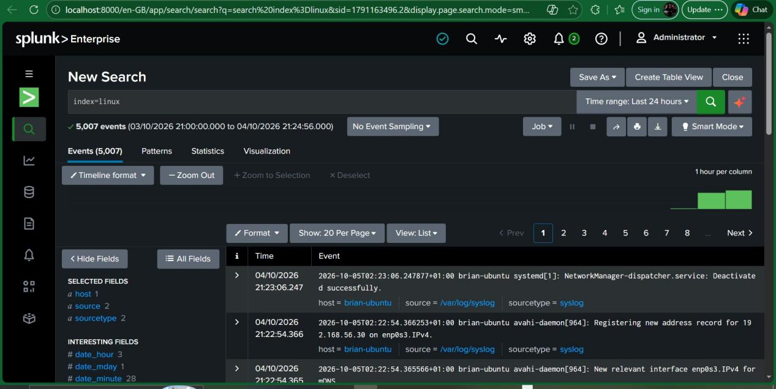
Figure 12: Ubuntu Universal Forwarder configuration monitoring authentication and system logs.
The project documentation specifies auth.log and syslog as the principal Linux data sources.

10. LINUX LOG INGESTION VALIDATION
Linux telemetry was validated using:
index=linux
Authentication-specific telemetry could also be queried using:
index=linux source="/var/log/auth.log"
System telemetry could be queried using:
index=linux source="/var/log/syslog"
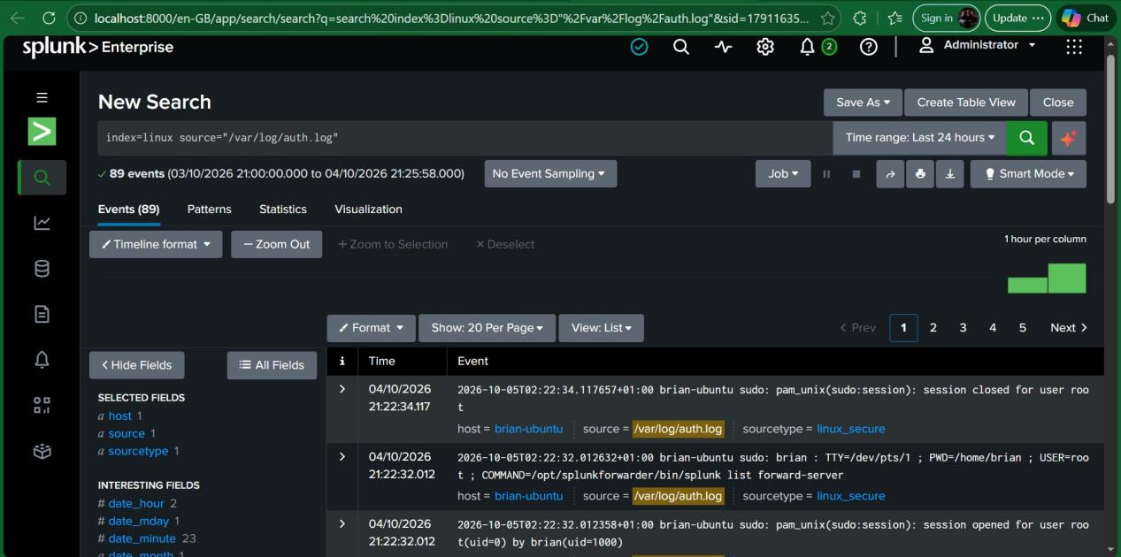
Figure 13: Ubuntu Linux authentication and system telemetry successfully ingested into Splunk.
The successful ingestion of both Windows and Linux telemetry established the foundation for the subsequent detection-engineering phase.

11. SECURITY EVENT SIMULATIONS
Following successful telemetry validation, controlled security-event simulations were performed inside the isolated laboratory.
The purpose was not to deploy malware or attack external infrastructure. Instead, benign activities were deliberately performed to generate recognizable security telemetry for SOC detection and investigation.
The project specifically identifies three required scenarios and one optional scenario.

12. ATTACK SCENARIO 1: SSH FAILED-AUTHENTICATION / BRUTE-FORCE SIMULATION

12.1 Scenario Description
The first scenario simulated repeated failed SSH authentication attempts against the Ubuntu endpoint.
The Windows endpoint was used to initiate SSH connection attempts to the Ubuntu system. Incorrect authentication credentials were intentionally entered.
The objective was to generate authentication failures that could be detected by the SIEM.

12.2 Raw Linux Evidence
The Ubuntu /var/log/auth.log generated multiple failed authentication messages.
The observed events included:
Invalid user testuser
Failed password for invalid user testuser
Connection closed by invalid user testuser
Importantly, the observed source address in the captured Ubuntu authentication events was:
192.168.56.1
This should be reported as the observed source IP, rather than assuming that the Windows VM's configured address was the source.
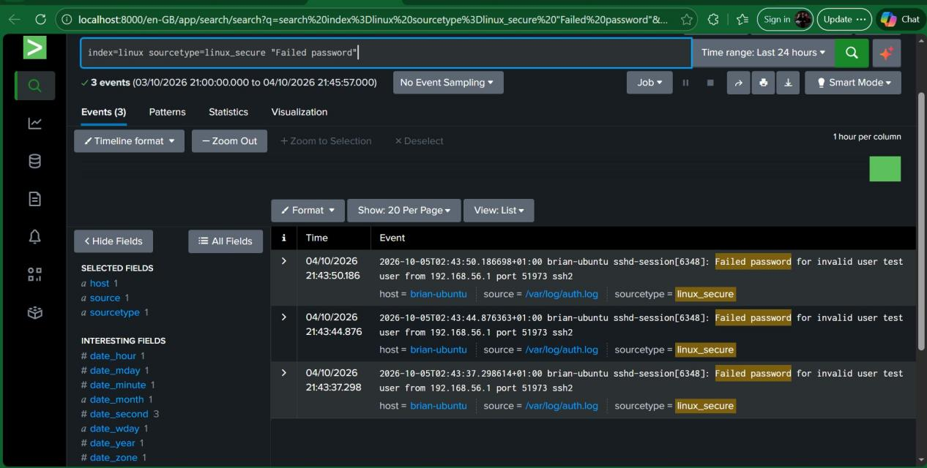
Caption:
Figure 14: Ubuntu authentication log showing repeated failed SSH authentication attempts associated with the controlled brute-force simulation.

12.3 Splunk Detection
The corresponding Splunk search was:
index=linux sourcetype=linux_secure "Failed password"
A more analytical detection can group repeated attempts:
index=linux sourcetype=linux_secure "Failed password"
| rex "Failed password for (?:invalid user )?(?<user>\S+) from (?<src_ip>\S+)"
| stats count by src_ip user
| where count >= 3
| sort - count
The second query is more representative of detection engineering because it identifies repeated authentication failures by source and targeted username.

Security significance
Repeated failed authentication attempts may indicate:
- Brute-force activity.
2.Password guessing.
3. Unauthorized access attempts.
4. Account enumeration.
The activity was performed only against the isolated laboratory Ubuntu endpoint.

13. ATTACK SCENARIO 2: UNAUTHORIZED LOCAL ACCOUNT AND PRIVILEGE MODIFICATION

13.1 Scenario Description
The second scenario simulated unauthorized account creation followed by privilege escalation through membership in the local Administrators group.
A lab-only Windows account named:
- LabTestUser
was created and added to the local Administrators group.
The purpose was to generate Windows Security events associated with account creation and privileged-group modification.

13.2 Event ID 4720: Account Creation
The account creation event was investigated using:
index=windows EventCode=4720
Event ID 4720 provides evidence that a user account was created.
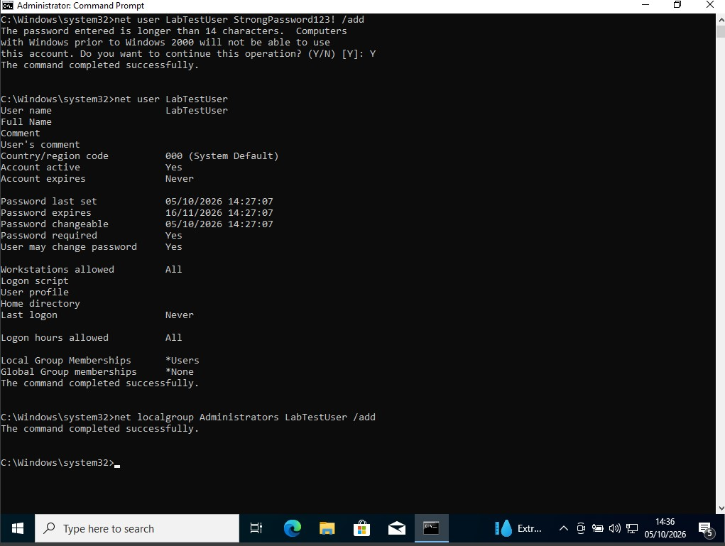
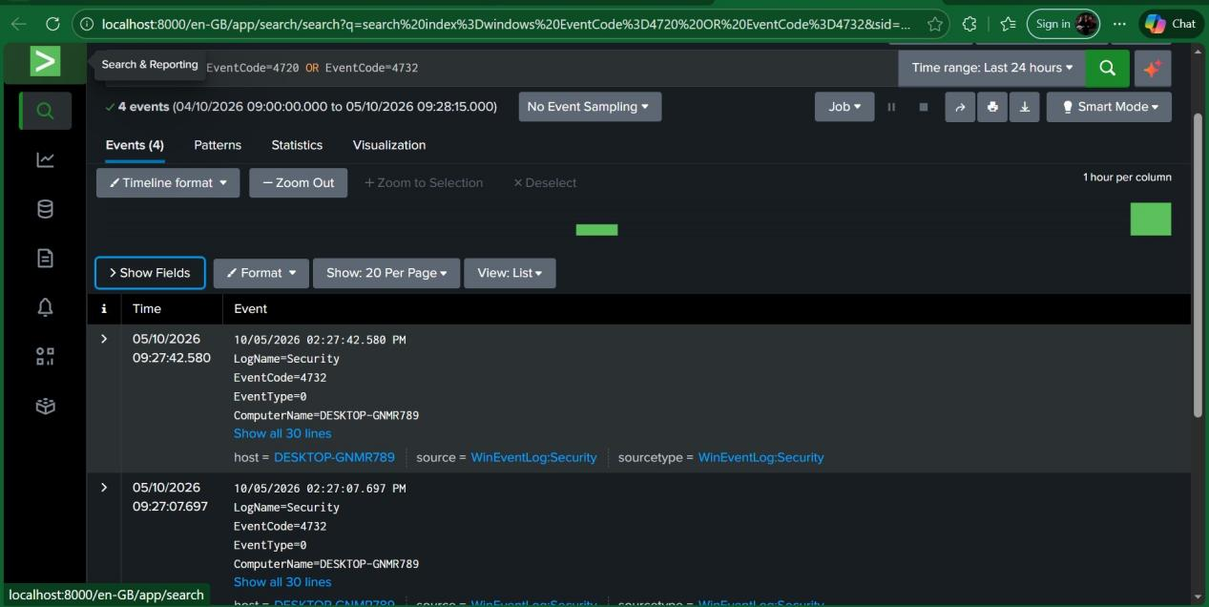
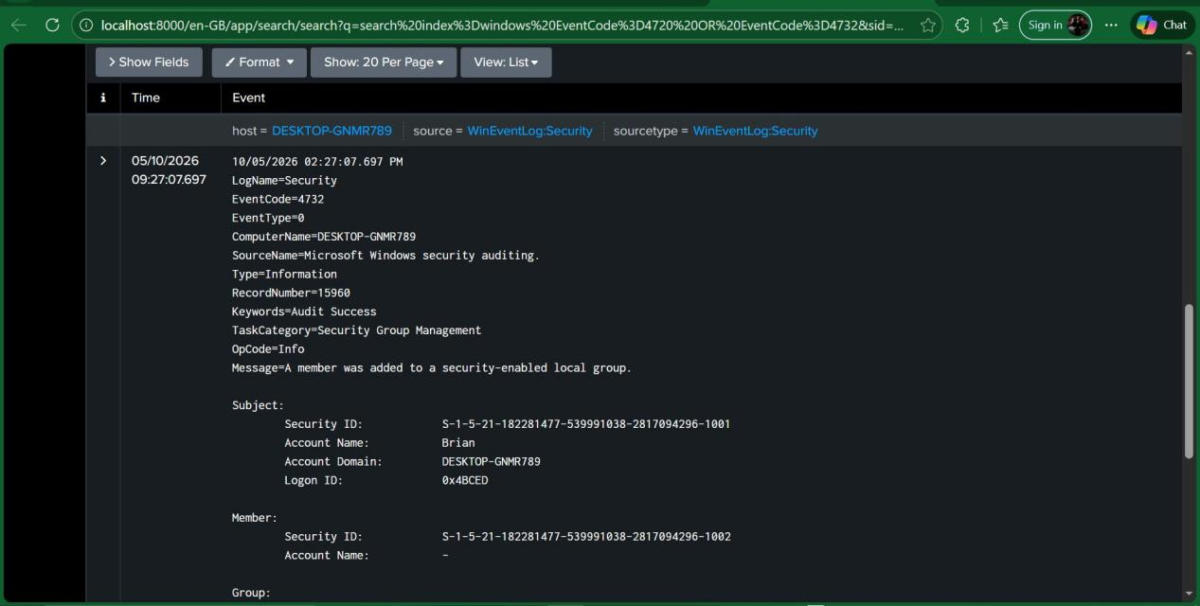
Figure 16: Windows Security Event ID 4720 showing creation of the controlled laboratory test account.

13.3 Event ID 4732: Privileged Group Modification
The next investigation searched for:
index=windows EventCode=4732
A captured Event ID 4732 showed:
- LogName=Security
- EventCode=4732
- ComputerName=DESKTOP-GNMR789
4.SourceName=Microsoft Windows security auditing
5.Keywords=Audit Success
6.Group Name: Administrators
The event message indicated that a member was added to a security-enabled local group.
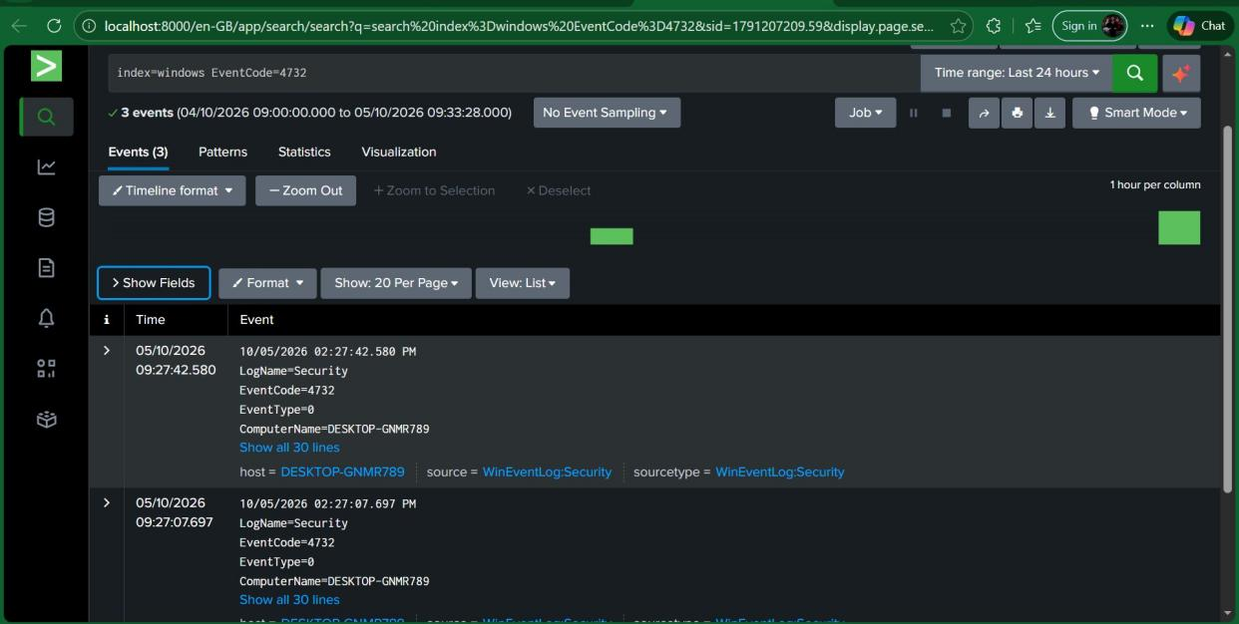

Figure 17: Windows Security Event ID 4732 showing modification of the local Administrators group during the controlled account privilege simulation.
This is one of the strongest pieces of evidence in the project because it demonstrates the transition from simple account creation to privileged-group membership.

14. CORRELATED ACCOUNT DETECTION
The two account-management events were correlated using:
index=windows (EventCode=4720 OR EventCode=4732)
| sort _time
This query allows the analyst to reconstruct the sequence of activity.
The expected investigative relationship is:
Account creation => Privileged group modification => Potential unauthorized administrative access
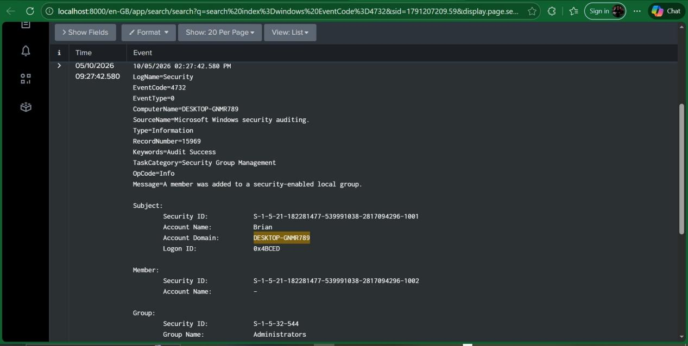
Figure 18: Correlated Splunk investigation showing Windows account creation and subsequent privileged-group modification in chronological order.

15. ATTACK SCENARIO 3: SUSPICIOUS POWERSHELL / PROCESS ACTIVITY

15.1 Scenario Description
The third scenario used harmless PowerShell commands rather than malware.
The primary command used was:
Get-Process
This was intended to generate PowerShell and process-related telemetry suitable for SOC investigation.

15.2 PowerShell Operational Log Validation
The Windows endpoint was queried locally using:
Get-WinEvent -LogName "Microsoft-Windows-PowerShell/Operational" -MaxEvents 5
The local results demonstrated that the PowerShell Operational log was active and included Event ID 4104.
This is important because Event ID 4104 can provide PowerShell Script Block Logging information.
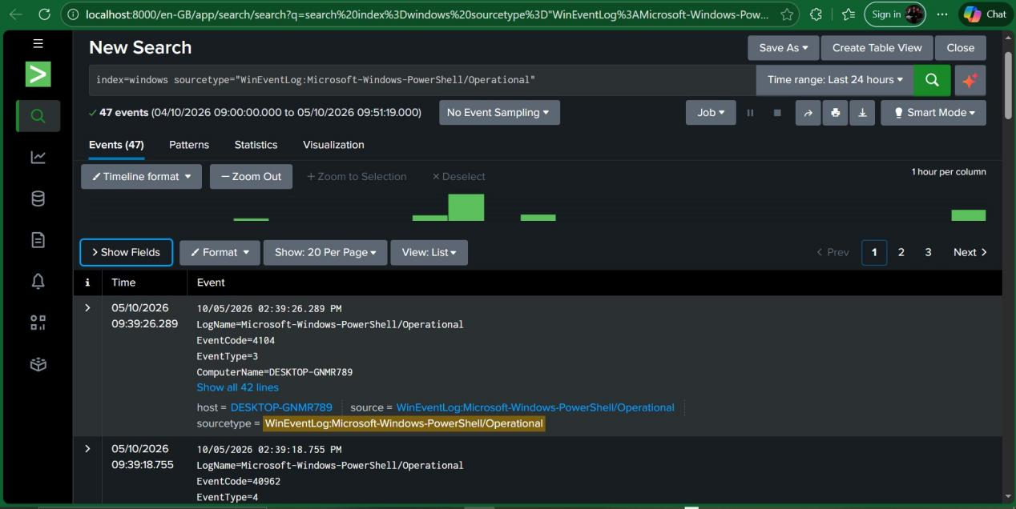
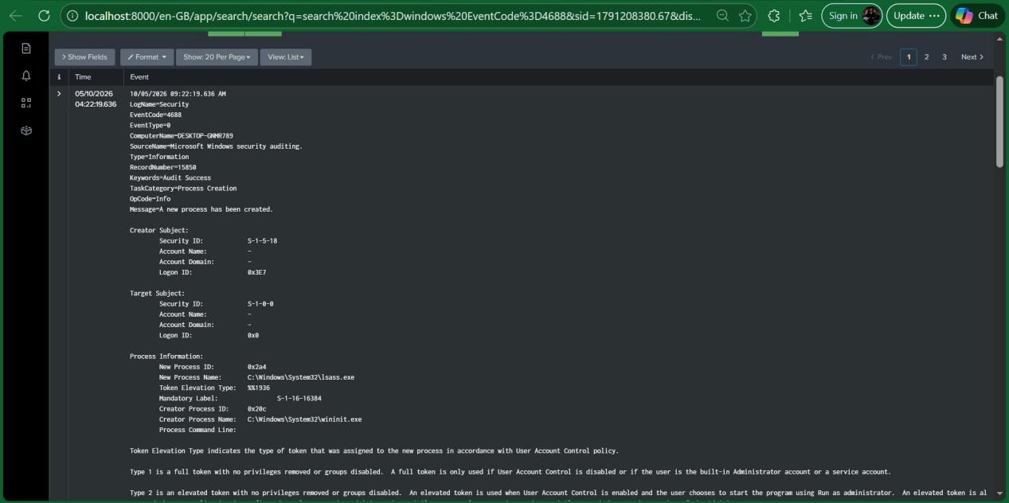

Figure 19: Windows PowerShell Operational log showing locally generated PowerShell telemetry, including Event ID 4104.

15.3 PowerShell Forwarding Configuration
The Windows Universal Forwarder was subsequently configured with:
[WinEventLog://Microsoft-Windows-PowerShell/Operational]
disabled = 0
index = windows
This configuration was intended to forward PowerShell Operational events into Splunk.

15.4 Process Creation Investigation
Windows process creation telemetry was searched using:
index=windows EventCode=4688
A captured Event ID 4688 demonstrated successful Windows process-creation telemetry.
However, the specific event captured during the investigation represented:
C:\Windows\System32\lsass.exe
Therefore, it should not be described in the final report as proof that Get-Process was captured.
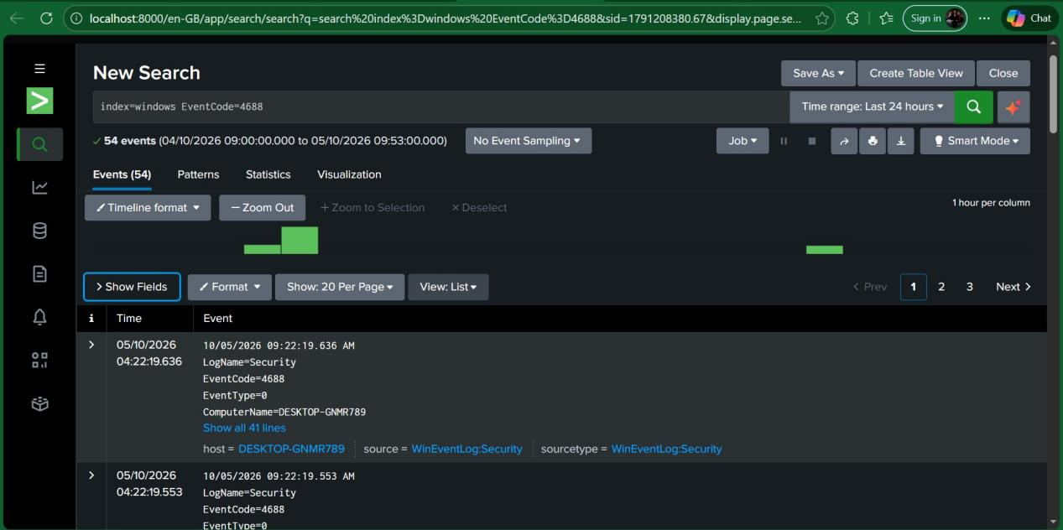
Figure 20: Windows Security Event ID 4688 demonstrating successful process-creation telemetry available to the Splunk SIEM.

15.5 Detection Status
The local Windows endpoint successfully generated PowerShell Operational events, including Event ID 4104.
However, the Splunk search:
index=windows sourcetype="WinEventLog:Microsoft-Windows-PowerShell/Operational"
did not initially return results.
Consequently, the evidence supports the conclusion that PowerShell telemetry existed locally, but additional validation is required before claiming successful ingestion of Event ID 4104 into Splunk.
This distinction is important from a SOC analyst perspective because detection engineering must be based on verified telemetry rather than assumed telemetry.

16. OPTIONAL ATTACK SCENARIO 4: SECURITY LOG CLEARING
If included in the final assessment, Windows Security Event Log clearing can be represented by Event ID:
1102
The corresponding Splunk search is:
index=windows EventCode=1102

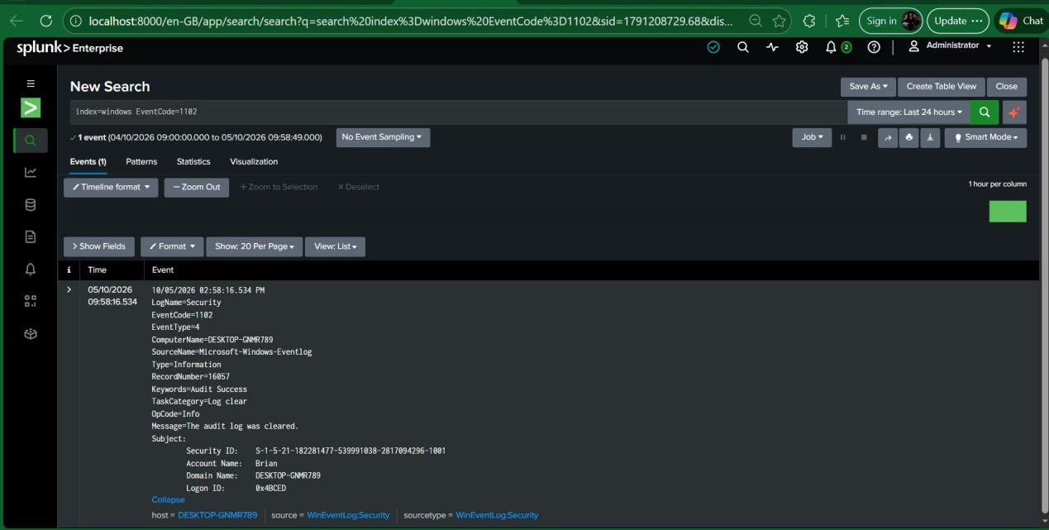
Figure 21: Windows Security Event ID 1102 indicating that the Security audit log was cleared in the isolated laboratory environment.
This activity should be performed only on the disposable lab endpoint because clearing the Security log removes existing security evidence from that system.

17. DETECTION ENGINEERING
The project transitioned from basic log collection to detection engineering by developing targeted SPL queries.
The principal detection searches were:

SSH failed authentication
index=linux sourcetype=linux_secure "Failed password"

Windows account creation
index=windows EventCode=4720

Privileged group modification
index=windows EventCode=4732

PowerShell Script Block Logging
index=windows EventCode=4104

Windows process creation
index=windows EventCode=4688

Security log clearing
index=windows EventCode=1102
These searches transform raw endpoint telemetry into focused investigation and detection queries.

18. DETECTION LOGIC
The detection strategy can be summarized as follows:
Scenario | Data Source | Detection
SSH brute force | Ubuntu auth.log | Repeated Failed password
Account creation | Windows Security | Event ID 4720
Privileged group modification | Windows Security | Event ID 4732
PowerShell activity | PowerShell Operational | Event ID 4104
Process creation | Windows Security | Event ID 4688
Security log clearing | Windows Security | Event ID 1102

The most significant correlation in the project is the relationship between Event IDs 4720 and 4732.
A newly created account followed by membership in the local Administrators group represents a higher-risk sequence than either event viewed independently.

19. SOC DASHBOARD
A centralized Splunk dashboard was designed to provide high-level SOC visibility.
The dashboard is named:
CAPSTONE SOC Dashboard
The recommended panels are:

Panel 1: Windows Events
index=windows

Panel 2: Linux Events
index=linux

Panel 3: Failed SSH Authentication
index=linux sourcetype=linux_secure "Failed password"

Panel 4: New Windows Accounts
index=windows EventCode=4720

Panel 5: Privileged Group Changes
index=windows EventCode=4732

Panel 6: Process Creation
index=windows EventCode=4688
An additional panel can be included for Event ID 1102:
index=windows EventCode=1102
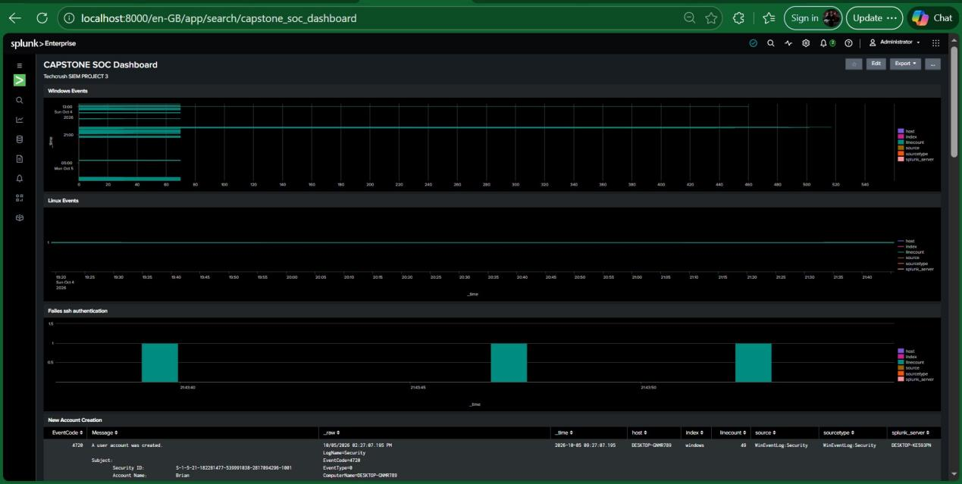
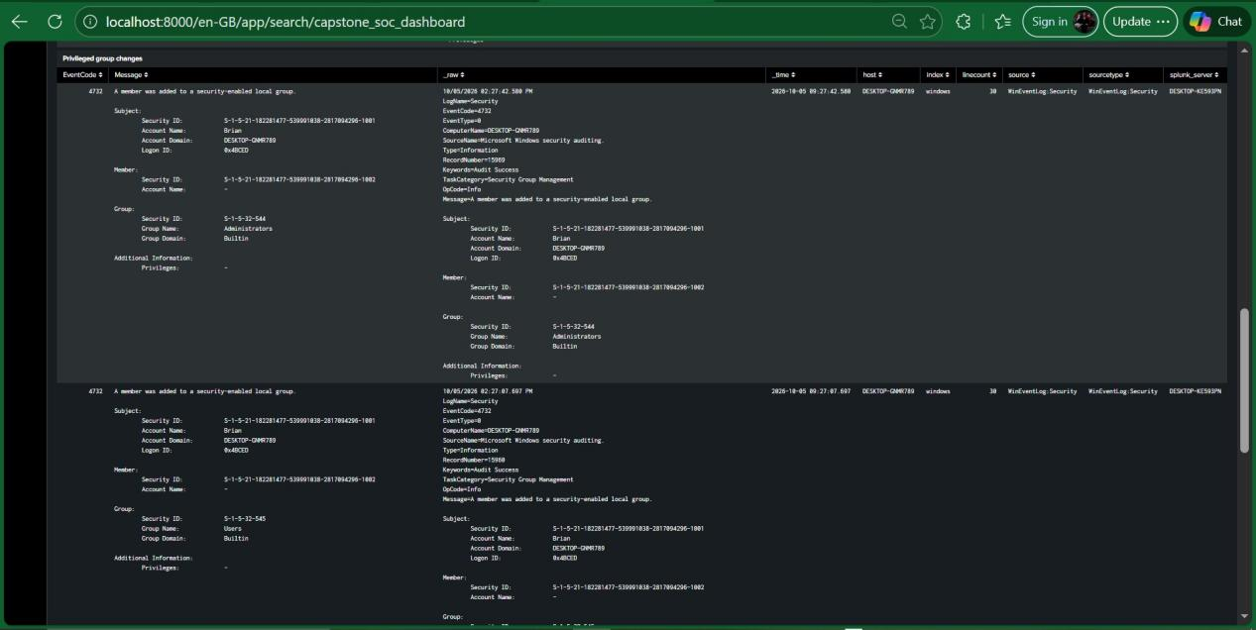
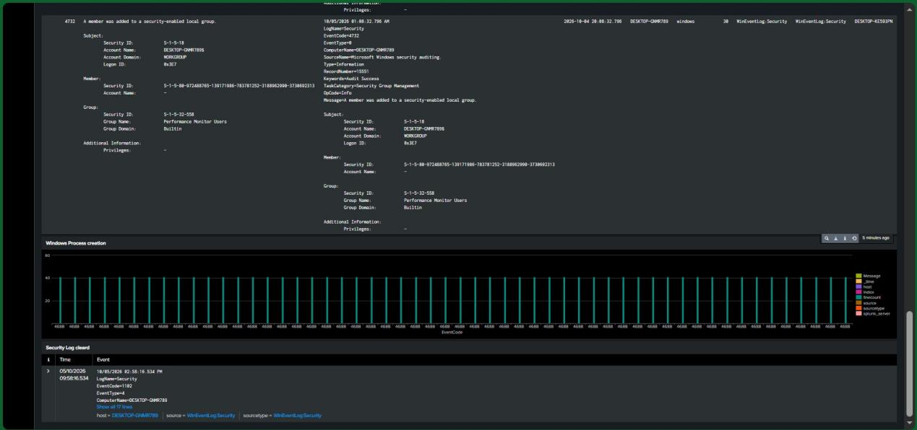
Figure 22: CAPSTONE SOC Dashboard providing centralized visibility into Windows and Linux telemetry and security-relevant detection events.
The dashboard demonstrates the transition from raw log collection to an operational SOC monitoring interface.

20. PRIMARY INCIDENT INVESTIGATION

20.1 Incident Title
Unauthorized Local Administrator Account Detected

20.2 Affected Host
Windows endpoint
DESKTOP-GNMR789

20.3 Incident Description
A controlled security simulation was conducted in which a new local Windows account was created and subsequently added to the local Administrators group.
The objective was to demonstrate how a SOC analyst could detect potentially unauthorized account creation followed by privilege assignment.

21. INCIDENT TIMELINE
The incident timeline should be constructed from the actual timestamps contained in the Splunk events rather than estimated or example timestamps.
Recommended timeline format:
Time | Event | Evidence
Actual timestamp | Local account created | Event ID 4720
Actual timestamp | Account added to Administrators | Event ID 4732
Actual timestamp | Detection query executed | Splunk search
Actual timestamp | Investigation performed | Analyst activity
Actual timestamp | Lab account removed | Remediation
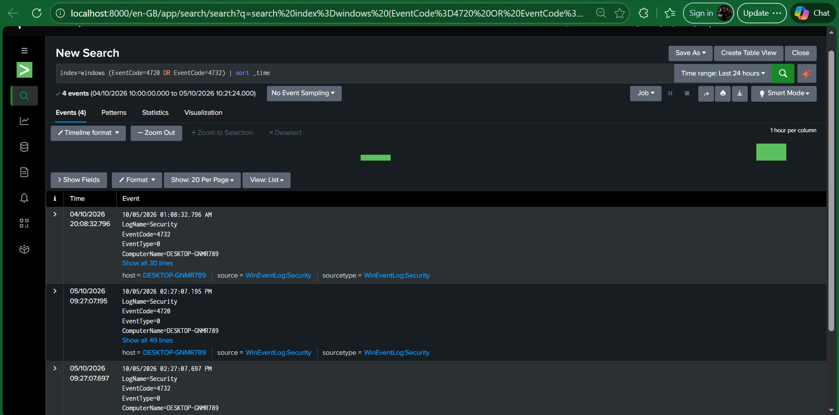
Figure 23: Chronological Splunk investigation timeline showing account creation followed by privileged-group modification.
The original project guidance explicitly recommends using actual Splunk timestamps rather than example times.

22. INCIDENT ANALYSIS
From a SOC analyst perspective, the combination of Event ID 4720 and Event ID 4732 is more significant than either event in isolation.
Event ID 4720 establishes that a new user account was created.
Event ID 4732 establishes that an account was subsequently added to a security-enabled local group. In the observed event, the relevant group was:
Administrators
The combination therefore represents a potential privilege-escalation or persistence scenario.
In a production environment, an analyst would investigate:
- Who created the account?
2.Was the account creation authorized?
3. Which host generated the event?
4. Who added the account to the privileged group?
5. Was the activity associated with a change request?
6. Was the account subsequently used for interactive login?
7. Were additional processes executed after privilege assignment?
8. Did the account access sensitive resources?
In this laboratory, the activity was intentional and authorized as part of the security exercise.

23. INVESTIGATION SEARCH
The following SPL was used to correlate account-management events:
index=windows (EventCode=4720 OR EventCode=4732)
| sort _time
Caption:Figure 25: Splunk correlation search displaying account creation and privileged-group modification events in chronological order.
This search represents a basic correlation rule that could be developed further in a production SOC.

24. REMEDIATION
After evidence collection, the laboratory test account was removed.
The remediation command was:
- net user LabTestUser /delete
The account was then verified as removed.
This demonstrates the final stage of the incident-response lifecycle: remediation and restoration of the affected system to its intended state.

26. SECURITY OPERATIONS ANALYSIS
The project demonstrates several fundamental SOC analyst capabilities.

26.1 Log Collection
Endpoint telemetry was centralized from both Windows and Linux systems.

26.2 Log Normalization and Indexing
Data was separated into windows and linux indexes, allowing analysts to focus investigations on specific endpoint populations.

26.3 Detection Engineering
SPL searches were developed for authentication failures, account creation, privileged-group modification, process creation, PowerShell activity, and Security Log clearing.

26.4 Event Correlation
The account-management investigation demonstrated the value of correlating multiple events rather than examining individual records in isolation.

26.5 Incident Investigation
The analyst was able to identify the relevant host, event IDs, timestamps, account activity, and privileged-group modification.

26.6 Remediation
The controlled account was removed following evidence collection.

26.7 Visualization
A SOC dashboard was designed to provide centralized visibility into Windows and Linux activity.

27. LIMITATIONS AND OBSERVATIONS
Several technical observations are important when interpreting the results.

27.1 PowerShell telemetry
PowerShell Operational logging was confirmed locally on the Windows endpoint. Event ID 4104 was present locally.
However, the corresponding Splunk search did not initially return PowerShell Operational events. Therefore, additional forwarding validation is required before stating that Event ID 4104 was successfully ingested into Splunk.

27.2 Event ID 4688
Event ID 4688 was successfully observed in Splunk, confirming process-creation telemetry.
However, the specific event captured showed:
C:\Windows\System32\lsass.exe
It should therefore be described as process-creation telemetry, not as definitive evidence of the Get-Process command.

27.3 SSH source address
The Ubuntu authentication records observed during the SSH simulation identified:
192.168.56.1
as the source address in the captured events.
The report should use the observed event value rather than assuming that the source was 192.168.56.20.
These distinctions improve the technical accuracy and credibility of the SOC investigation.

28. RECOMMENDED SOC IMPROVEMENTS
If this laboratory were expanded into a more mature SOC environment, the following improvements would be recommended:
1.Configure PowerShell Operational forwarding and validate Event ID 4104 ingestion.
2.Enable appropriate Windows process-command-line auditing.
3. Create threshold-based detections for repeated SSH failures.
4. Create correlation rules combining account creation with privileged-group modification.
5. Add alert severity levels.
6. Add dashboards for authentication, privilege changes, process activity, and endpoint health.
7. Implement automated alerting for high-risk events.
8. Add additional Windows endpoints.
9. Add additional Linux endpoints.
10. Develop formal incident-response playbooks.
11. Capture analyst actions and timestamps during investigations.
12. Establish baseline behavior to reduce false positives.

29. CONCLUSION
This project successfully demonstrated the construction of a small virtualized SOC/SIEM environment using Splunk Enterprise, Windows, Ubuntu Linux, VirtualBox, and Splunk Universal Forwarders.
The laboratory established an isolated network connecting the Splunk SIEM with Windows and Linux endpoints. Endpoint logs were collected and forwarded to the centralized Splunk instance, where they were indexed and made available for investigation.
The project progressed beyond basic SIEM installation by generating controlled security events and developing detection searches for those activities.
The SSH simulation demonstrated detection of failed authentication activity through Ubuntu authentication logs. The Windows account-management simulation demonstrated the ability to identify account creation through Event ID 4720 and privileged-group modification through Event ID 4732. Process-creation telemetry was demonstrated through Event ID 4688, while PowerShell Operational logging was verified locally and identified as an area requiring additional forwarding validation.
The account-creation and privileged-group investigation provided the strongest demonstrated incident scenario. Correlating Event IDs 4720 and 4732 allowed the analyst to reconstruct the sequence of account creation followed by privileged-group modification.
The project therefore demonstrates the fundamental SOC workflow:
Endpoint Activity -> Log Collection -> Centralized SIEM -> SPL Detection -> Event Correlation -> Investigation -> Incident Timeline
-> Remediation -> SOC Dashboard
The exercise demonstrates that effective SOC operations depend not simply on collecting logs, but on transforming endpoint telemetry into actionable security detections and investigations.

