**Background/Motivation**  
Flooding is an environmental hazard that poses risk to many areas throughout Hawaii. Disastrous flood events can cause serious damage to infrastructure and causalities, but smaller flood events also contribute to road blockages and other issues. Warning systems for predicting floods exist, but their practical usage is limited in Hawaii compared to the Continental U.S. Residents stay prepared during extreme events through online community groups and stream/tide data.

**Goals**  
We are looking to provide user friendly flood awareness tools to communities that are at risk. The Waikane area in Windward Oahu is a hot spot for flooding, causing road closures nearly every year. To help this community be better prepared for road closures and other flooding issues, we are looking to create a Web App that connects real time gage and buoy data to flooding information that is easily understandable and relatable. An example of such an app already exists for Hanalei, Kauai (Hanalei App in the Apple Appstore, Fig. 1). We want to provide a framework for the Web App development in Waikane with a focus on scalability so that other flood-prone watersheds can be included in the future.

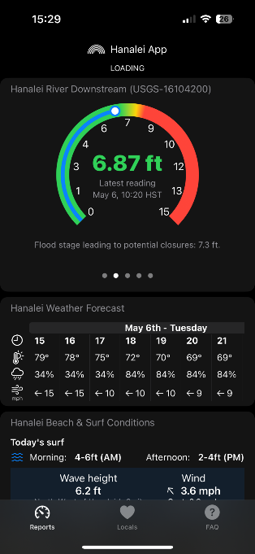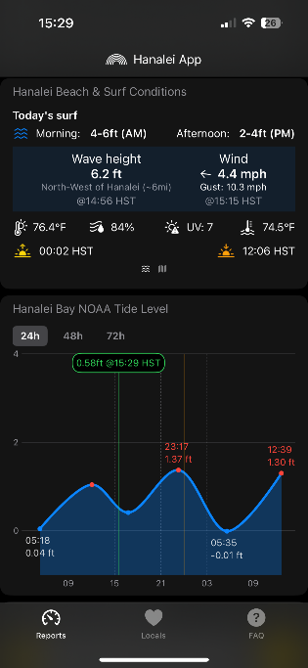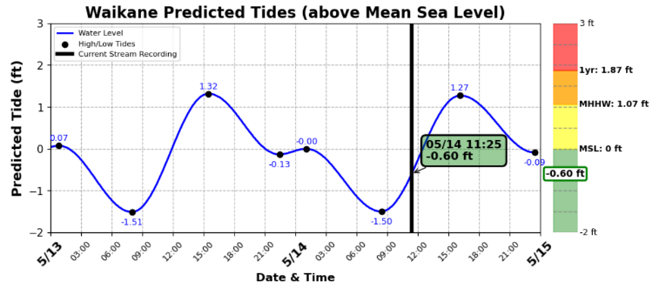**Methods**   
To complete this task, we are looking for a student who has experience with Web App development and deployment or is driven to learn to complete this project. We will pull stream and tide data through APIs, create user friendly visualizations, develop the Web App on React, and then deploy it on UH JetStream servers. The student will be working closely with Brian Gorberg (PhD student in the Earth Sciences Department) and his advisor, Chris Shuler (hydrologists in the Water Resources Research Center) and. Brian has written python code to pull the data and create sample visualizations to give the perspective student a bit more information on the data and visuals we are looking in this Web App(Fig. 2). The code can be accessed through this github link: <https://github.com/brianjgorberg/Waikane_Flood_Dashboard>

**Figure 1**: Screenshots of the Hanalei App. This app shows the current tides, waves, and stream height. These are the main factors influencing flooding in Hanalei and many coastal regions around Hawaii.

**Figure 2**: These figures show an example of tide/stream data visualizations we could produce for the Web App.

