FSLvbm document:

template list: the number of images in each group are same so that the template is not biased.
Script: b_fslvbm01_MakeTemplateList.R

design matrix columns:
ptsd, nonptsd, trauma, male, female, age

contrasts:
1 -1 0 0 0 0
-1 1 0 0 0 0
1 0 -1 0 0 0
-1 0 1 0 0 0
0 1 -1 0 0 0
0 -1 1 0 0 0

BET:

fslvbm_1_bet -b -f 0.35 -R
-f fractional intensity threshold (0->1); default=0.5; smaller values give larger brain outline estimates

fslvbm_2_template -n (non-linear)

fslvbm_3_proc (no parameters in this step)

smoothing: sigma = 2,3,4mm corresponding: FWHM = 4.6mm~9mm

inferential test:
randomise -i GM_mod_merg_s3 -m GM_mask -o fslvbm -d design.mat -t design.con -T -n 5000

SPM VBM:

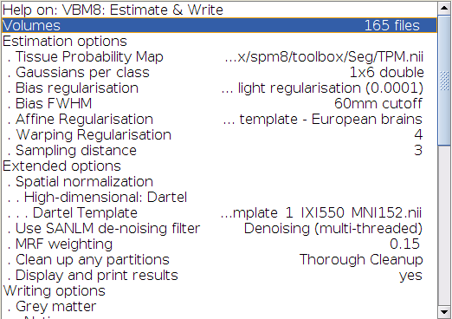

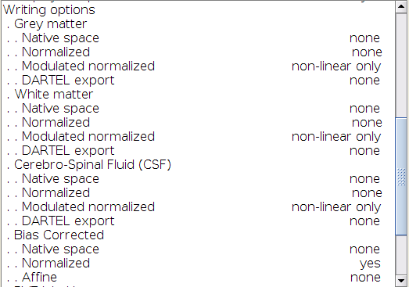

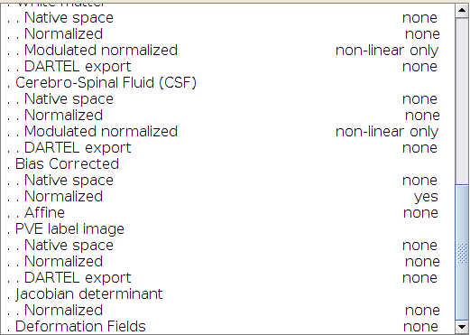

DTI:
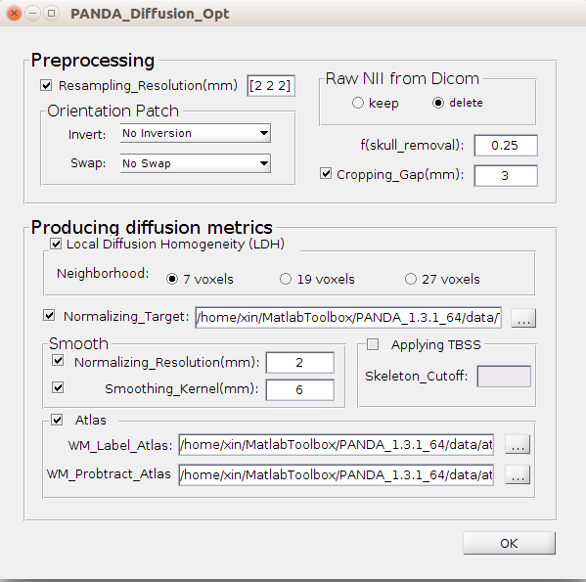

Resting state:

Abbreviations:
A - Slice Timing
R - Realign
W - Normalize
S – Smooth
D - Detrend
F - Filter
C - Covariates Removed
B – ScruBBing

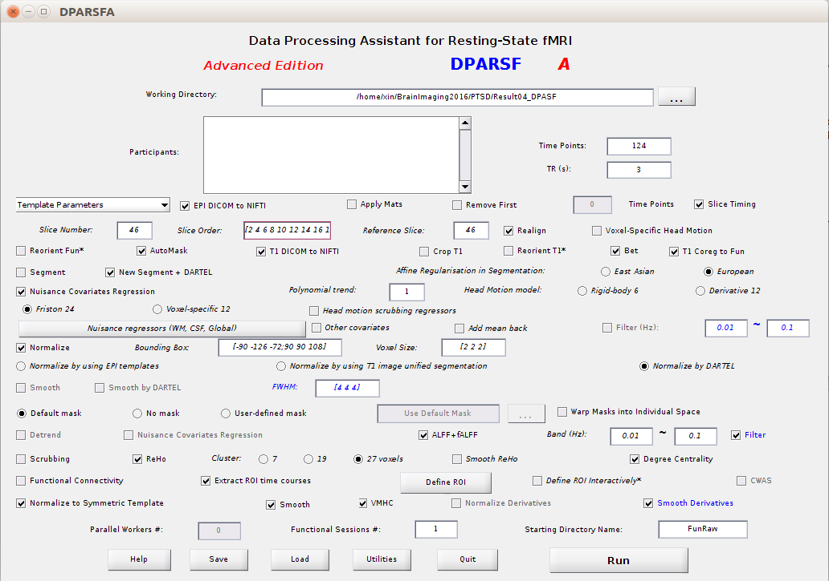
You can select Functional Connectivity if you wish the software directly compute it. And you also need to define ROI by clicking the button and select an atlas.

We did not remove frist 10 time points for the reason below:

In order to reach steady-state signal levels, the sequence performed two additional dummy scans at the start of the sequence. These scans were not saved to the image database.

(Theodore D. Satterthwaite 2014 NeuroImage)

Slicer order:

Interleaved - In this mode, the order of acquisition depends on the number of slices acquired:
If there is an odd number of slices, say 27, the slices will be collected as:
1 3 5 7 9 11 13 15 17 19 21 23 25 27 2 4 6 8 10 12 14 16 18 20 22 24 26.

If there is an even number of slices (say 28) the slices will be collected as:
2 4 6 8 10 12 14 16 18 20 22 24 26 28 1 3 5 7 9 11 13 15 17 19 21 23 25 27.

https://practicalfmri.blogspot.com/2012/07/siemens-slice-ordering.html

Brain imaging processing notes:

Resting state fMRI:

slice order:

it seems the slice order is [2 : 2 : 46, 1 : 2 : 45]

as noted in the website:
https://practicalfmri.blogspot.com/2012/07/siemens-slice-ordering.html

PNC data used VB17 software so it should follow the slice ordering below:

Siemens slice ordering
I've heard on the wind that there is still confusion or even a total lack of awareness of the change in slice ordering for interleaved slices when going from an odd number to an even number of slices, or vice versa. It makes a big difference for slice timing correction. So I though I'd post below a section from my user training guide/FAQ as a ready reference. Note that as far as I know this change in slice ordering is only an issue for Siemens scanners running VB15 or VB17 software, I can't comment on VD11 or other versions, and I haven't actually tested any scanner platform except a TIM Trio. Furthermore, it's only an issue if you're using interleaved slices. If anyone has additional information, especially if it conflicts with the situation posted here, then the field would probably appreciate a comment!

__________________

In what order does the scanner acquire EPI slices?

There are three options for slice ordering for EPI. To understand the ordering you first need to know the Siemens reference frame for the slice axis: the negative direction is [Right, Anterior, Foot] and the positive direction is [Left, Posterior, Head]. The modes are then:
- Ascending - In this mode, slices are acquired from the negative direction to the positive direction.
- Descending - In this mode, slices are acquired from the positive direction to the negative direction.
- Interleaved - In this mode, the order of acquisition depends on the number of slices acquired:
  - If there is an odd number of slices, say 27, the slices will be collected as:
1 3 5 7 9 11 13 15 17 19 21 23 25 27 2 4 6 8 10 12 14 16 18 20 22 24 26.
  - If there is an even number of slices (say 28) the slices will be collected as:
2 4 6 8 10 12 14 16 18 20 22 24 26 28 1 3 5 7 9 11 13 15 17 19 21 23 25 27.
Interleaved always goes in the negative to positive direction, e.g. foot-to-head for transverse slices.

So, if you are doing 28 interleaved axial slices the order will be evens then odds in the foot-to-head direction. 27 interleaved axial slices would also be acquired in the foot-to-head direction but would be in the order odds then evens. If you switch to 28 descending axial slices the acquisition order will become 1,2,3,4,5…28 and the direction will swap to being head-to-foot.

Note 2018-08-28:

we have some error in slice timing when the slice order is [2 : 2 : 46, 1 : 2 : 45]
reference slice: 46.

'Error in Slice Timing, time point number doesn't match:

try to run without slice timing.

Still got error.

It seems the voxel size should be set as [2 2 2]. We have error if is it [3 3 3].

