Elliott Drake

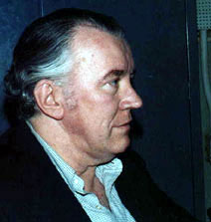

Elliott “Bud” Drake was a pioneering radio producer whose career spanned more than three decades (1940s-70s). He is associated with *High Adventure, John Steele, Adventurer*, and the prestigious NBC radio program, *Monitor*. He also went on to produce television programming.

Drake graduated from Princeton in 1940 and went on to serve his country during World War II as a 1st Lieutenant. After the war, he began working with Mutual Broadcasting and produced such shows as *High Adventure* (1947-50) and *John Steele, Adventurer* (1949-56). He moved on to NBC where his “breakthrough show was the Sunday Night Monitor, a live news presentation, for which he was given the George Peabody Broadcasting Award” (*Princeton Memorial*). He worked on such programs as the riots following the night that James Meredith tried to become the first African-American student at the University of Mississippi. He and his entire crew received the Peabody Award for that coverage.

In 1976, he produces a show honoring NBC’s 50th Anniversary in Oct 10 – Nov 7, 1976.

After a long and successful career, he died in 2002.

*Princeton Alumni Weekly, Vol. 77*, 1976.

<https://paw.princeton.edu/memorials/30/89/>

Image taken from: <http://www.monitorbeacon.net/photo-album/photo-album-page-7.html>

Hart, Dennis. *Monitor, Take 2*. iUniverse, 2003.