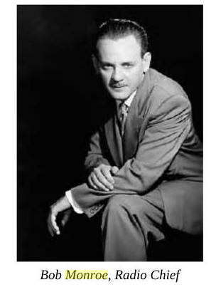Robert A. (Bob) Monroe was born in 1915 in Indiana and grew up in Kentucky and Ohio. Although he started college conventionally enough, Monroe took take a year off to tramp around the country. He returned and earned his BA from Ohio State University in 1937 where he also got his first experience with radio broadcasting. He wrote for a radio station in Cleveland, but he wanted more. He took a bus to New York where, after two years of slow starvation, he was contacted by NBC about a script. By his twenty-fifth birthday, he was earning $1,000 a week as a writer. Soon, he was able to afford a small personal plane, but he also developed ulcers. As a result, he was classified 4F (unfit for military service) during World War II. During the early 1940s, he wrote an aviation column for *Argosy* and produced a weekly radio show for the National Aeronautic Association: *Scramble!* designed to attract young men to aviation.

By 1943, he was an up-and-coming personality in radio programming. In the course of his daily life, he met with such influential people as Walter Winchell, Sam Goldwin, and Louis B. Mayer. From 1944-46, he produced his own daily, thirty-minute show called *Screen Test*.

To break through to a more powerful and lucrative position, Monroe offered the Vice President of Mutual a show complete with “script, actors, and director, free of charge for a month” (Russell). Mutual provided the space, the equipment, and the orchestra. That show was the highly successful *High Adventure* broadcast weekly for seven years: George Sanders introduced ordinary people embroiled in life-threatening situations. Monroe also developed several quiz shows including *Take a Number, Meet Your Match,* and *Name That Tune*.

By 1954, he became the Vice President of Programming for Mutual. At one point, he was writing, directing, and composing music for up to 19 different shows at once. After several years at this hectic pace, he resigned and he purchased his first two radio stations. Having the leisure to explore other options, he began studying biorhythm and sleep-learning.

Between 1958 and 1963, Monroe had several seizures, which he saw as out-of-body experiences. He became fascinated with the topic and researched, studied, and eventually wrote several books about his experiences.

At the same time, he continued to work in the entertainment industry. By 1962, Monroe Industries was known for its radio stations, its development of cable television, and later, it produced a series of audio cassettes on sleep learning, biorhythm, astral projection, etc.

He died in 1995 at the age of 79.

Russell, Ronald. *The Journey of Robert Monroe: from Out-of-Body Explorer to Consciousness Pioneer.* 2007.

<http://en.wikipedia.org/wiki/Robert_Monroe>

<https://www.monroeinstitute.org/robert-monroe> (image and some text)