Walter Hampden is the stage name of Walter Hampden Dougherty, who arrived in the world on June 30, 1879 in Brooklyn, New York.

His rich voice and commanding presence carried thim through fifty years in the entertainment field. His accomplishments embraced Broadway, award-winning films and television appearances, working as a manager and excellent coach for other actors, and truly memorable radio broadcasts.

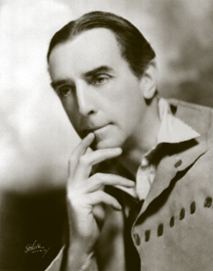

Figure : a young Walter Hampden (ca. 1913) from digitaldeliftp.com

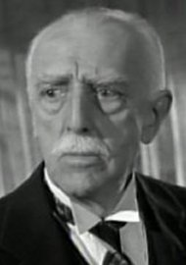

Figure : from the movie "Sabrina" (1954). www.movie-dude.co.uk

His father was a lawyer, who regularly took his children to the theater in New York. Although Walter initially planned to study law, he was drawn to the theater where he was spellbound by actors like Henry Irving, Ellen Terry, and Helene Modjeska. (Smith 35). Walter would have seen most of them. Walter graduated from “Poly Prep” (high school) at sixteen. He starred in the senior play as Shylock in *The Merchant of Venice*. His family knew that he wanted to pursue the theater as a career, but his father insisted that Walter earn a four-year college degree first. He went to Harvard for a year but didn’t like the atmosphere. He came home and earned an BA in Classics from Polytechnic Institute of Brooklyn.

Although he did not study further, he was a highly intelligent man, pursuing interests in economics (See clipping from *Ottawa Citizen*, below) and religion throughout his life.

He apprenticed in the English theater for six years, then went on to play in *Hamlet, Henry V, Cyrano de Bergerac, The Crucible*, and many other plays on Broadway. He owned his own company for many years.

His first major film role was as the “good” brother to the archbishop in Charles Laughton’s *The Hunchback of Notre Dame* (1929). He was sixty (Wikipedia).

He flirted with retirement in the 1940s (see clipping, *The Evening Independent*, below), but he always came back to some form of entertainment. He starred in the radio mystery series *The Adventures of Leonidas Witherall* for Mutual beginning June 4, 1944, but it wasn’t until someone influential heard his role in *Libel* on *The Theatre Guild on the Air* that he was offered *Great Scenes from Great Plays*, which he hosted in 1948 and 1949 (Smith 335. See also clipping, *The Pittsburgh Press*).

He died June 11, 1955 in Los Angeles after suffering a stroke. (See clippings from *Lodi News Sentinel* and *Reading Eagle*.)

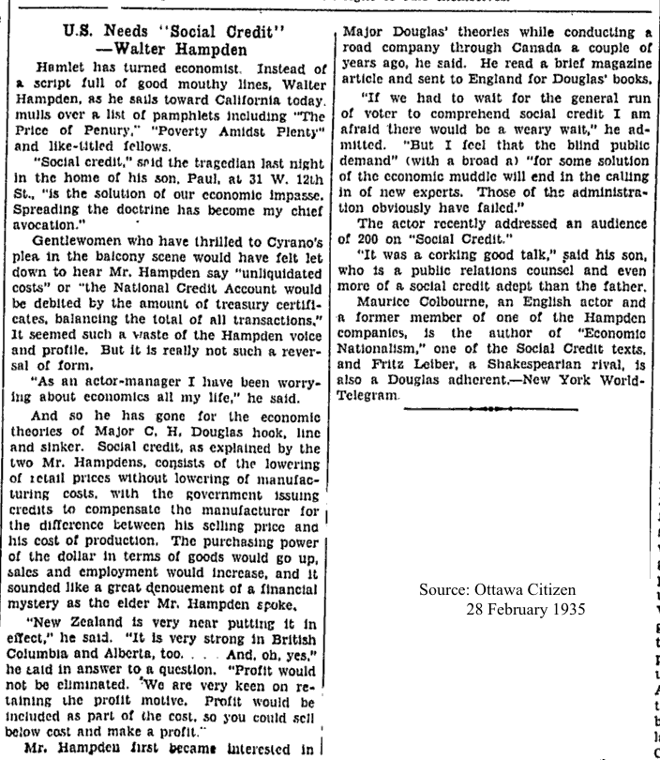

(All clippings courtesy of Kathy Hamel)

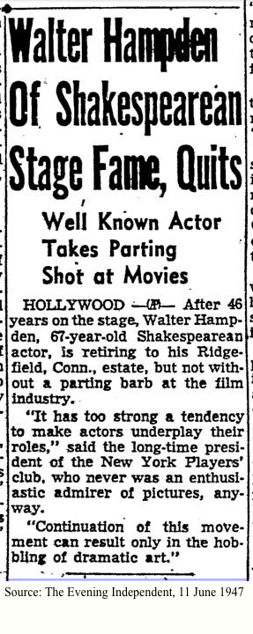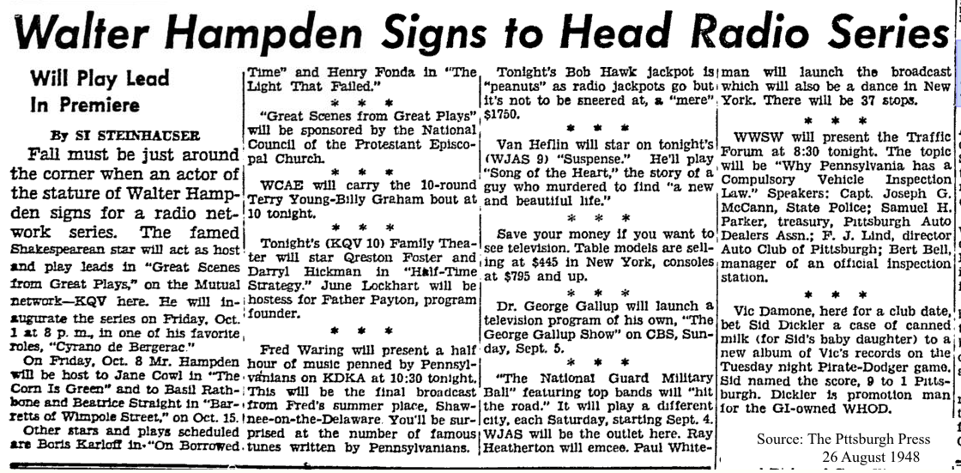

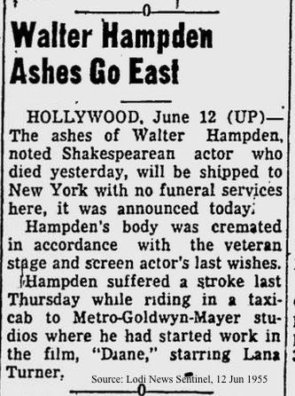

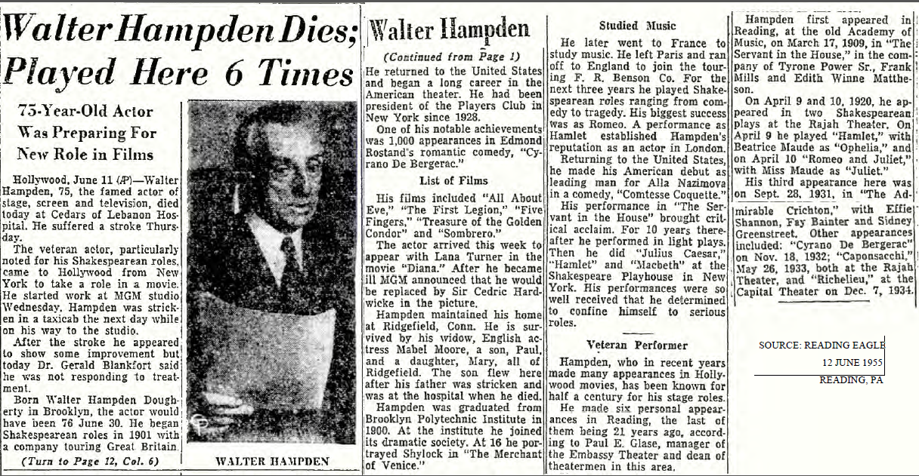

Sources:

Hamel, Kathy. Newspaper research

Internet Movie Database. http://www.imdb.com/name/nm0358899/bio

Smith, Geddeth. *Walter Hampden: Dean of the American Theatre.*

Wikipedia <https://en.wikipedia.org/wiki/Walter_Hampden>