BusTasker:

User Manual

Brian Kim

Jiqi Wang

Xiong Jin

Yi Dai

**Home Screen**

*** Screenshots 1-6 (Left -> Right)

1. <- indicates first screenshot

Extra details on screen not mentioned in instructions that Users could find helpful

**Functionalities:**

User wants to check the nearby bus stops

1. Open the app and the home screen will be displayed (1)
2. Press the Plus FAB Button on the right
3. Home screen will update and show all the bus stops within 500 meter(2)

User wants to check the arrival times of one of the bus stops nearby

1. Follow the steps above
2. Press on the bus stop of interest (2)
3. Dialog box will show fastest arrival times (3)

User wants to set a reminder notification (x) minutes before the bus arrival

1. Follow the steps above
2. Choose a specific arrival time of the bus stop of interest (3)
3. Dialog will disappear the bus time will be displayed at the top of the screen (4)
4. Press on the dashboard icon labeled below
5. Choose how many minutes the you want to be reminded by before the buss arrival time (5)
6. Press the FAB button on the right to start the reminder!

*The timer will run whether the app is in the background or closed*

1. The user will be notified when the timer hits 0 (6)

**Map Mode**

1. Press on the Map FAB button to enter MAP Mode (pic 1)

*User will see nearby bus stops from your current (red markers) (pic 2)*

**Functionalities:**

User wants see nearby bus stops anywhere on the map

1. Press on any location on the map
2. Nearby bus stops (red markers) surrounding pressed location (blue markers) (pic 3)

User wants to see all incoming buses that visit a specific bus stop

1. Simply press on one of the bus stops
2. All incoming bus name and time will be displayed in numerical order (pic 4)

User wants to see all the bus stops that the incoming bus passes through

1. Press on one of the bus options
2. Amazing (pic 5)

**FAB Instructions:**

“+” Fab: Maximizes FAB options (pic 1)

“-” Fab: Minimizes FAB options (pic 6)

Navigation/Arrow Fab: Switches to Direction Mode

“X” Fab: Clears all bus stops from the map

*Does not include nearby bus stops to current location*

Note/Schedule Fab (very top FAB): User will be able to see saved the saved bus route schedule from the Direction mode

**Notes:**

*Maximum of two user points (blue markers) to find nearby bus stops. Third user point will reset the first two user points.*

*Bus times (pic 4):*

* *All incoming/future times the bus will visit that stop*
* *Limited to that day*
* *Limited to 15 times before showing the next bus schedule*

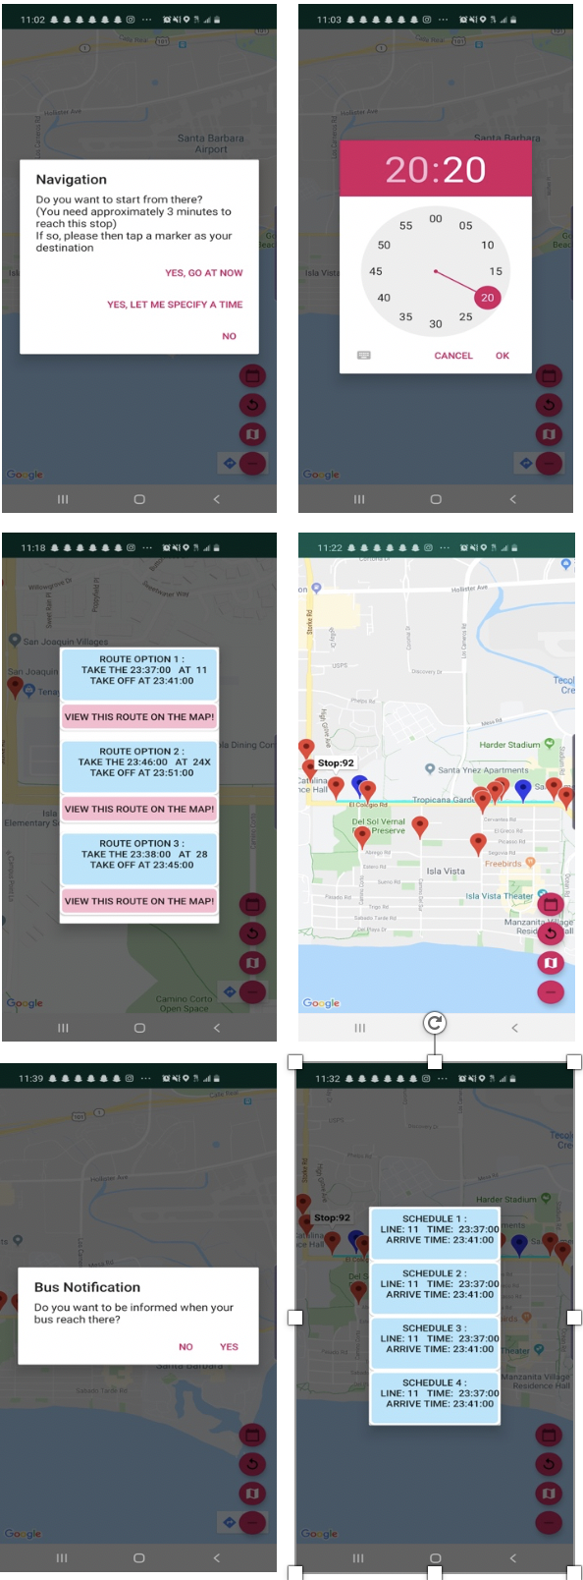

**Direction Mode**

Enter Direction Mode by pressing on the Direction Fab from Map Mode

*\*\*\*Pay attention to the screenshots because not every action will be explained due to the many functionalities and limited time ☹*

**Navigation**

Choose a starting point (bus stop)

*User can access bus stops by clicking around the map and getting nearby bus stops*

1. Click on the bus stop on the map the User wants to depart from

*Bus Tasker will estimate and display the amount of time it needs to reach the starting bus stop****(pic 1).*** *Also warns the User if they can’t reach the stop if it takes longer than 15 minutes*

1. Configure departure time
   1. Go now
   2. Specify a time **(pic 2)**
   3. Cancel

Choosing a destination point (bus stop)

1. Click on the bus stop on the map the User wants to arrive at
2. Bus route options will be displayed in a dialog box **(pic 3).** Users will also have the option to see the routes on the map **(pic 4)**

**\*\*\*** *Notifies users if there are no routes available*

**\*\*\****Bus Tasker will also include transition stops (green markers) where navigators transitions to a different bus (ex. 24x to 11) in order to reach their final bus stop*

*\*\*\*Bus Tasker will automatically saves these options , which can be viewed by clicking on the Note/Schedule FAB*

1. *User can set reminder when User is approaching destination stop (1-3 minutes away)* ***(pic 5)***

**Fab Buttons:**

“+” Fab: Maximizes FAB options

“-” Fab: Minimizes FAB options

Map Fab: Switches to Direction Mode

“X” Fab: Clears all bus stops and routes from the map. If things get messy just press it ☺

Note/Schedule Fab (very top FAB): User will be able to see saved the saved bus route schedule. You can delete each individual route in this dialog by clicking on it **(pic 6)**