ggplot

Brian

11/3/2020

# ggplot으로 그래프 그리기

## 데이터

library(ggplot2)  
midwest

## # A tibble: 437 x 28  
## PID county state area poptotal popdensity popwhite popblack popamerindian  
## <int> <chr> <chr> <dbl> <int> <dbl> <int> <int> <int>  
## 1 561 ADAMS IL 0.052 66090 1271. 63917 1702 98  
## 2 562 ALEXA~ IL 0.014 10626 759 7054 3496 19  
## 3 563 BOND IL 0.022 14991 681. 14477 429 35  
## 4 564 BOONE IL 0.017 30806 1812. 29344 127 46  
## 5 565 BROWN IL 0.018 5836 324. 5264 547 14  
## 6 566 BUREAU IL 0.05 35688 714. 35157 50 65  
## 7 567 CALHO~ IL 0.017 5322 313. 5298 1 8  
## 8 568 CARRO~ IL 0.027 16805 622. 16519 111 30  
## 9 569 CASS IL 0.024 13437 560. 13384 16 8  
## 10 570 CHAMP~ IL 0.058 173025 2983. 146506 16559 331  
## # ... with 427 more rows, and 19 more variables: popasian <int>,  
## # popother <int>, percwhite <dbl>, percblack <dbl>, percamerindan <dbl>,  
## # percasian <dbl>, percother <dbl>, popadults <int>, perchsd <dbl>,  
## # percollege <dbl>, percprof <dbl>, poppovertyknown <int>,  
## # percpovertyknown <dbl>, percbelowpoverty <dbl>, percchildbelowpovert <dbl>,  
## # percadultpoverty <dbl>, percelderlypoverty <dbl>, inmetro <int>,  
## # category <chr>

## 점 그래프

library(ggplot2)  
ggplot(midwest, aes(x=area, y=poptotal)) + geom_point()

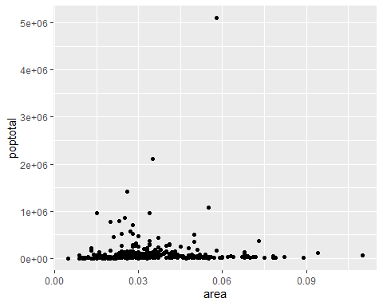

### 점 그래프, 색상 수정

### Dot graph, color change

library(ggplot2)  
ggplot(midwest, aes(x=area, y=poptotal, color=area)) + geom_point()

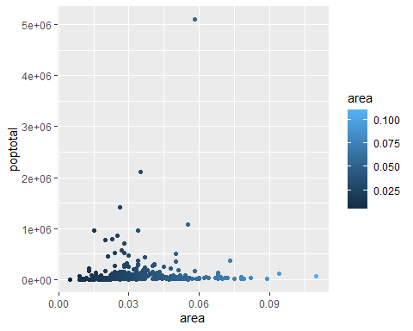

점 그래프 y축 최소,최대 설정

library(ggplot2)  
ggplot(midwest, aes(x=area, y=poptotal)) + geom_point() +  
 xlim(c(0, 0.1)) + ylim(c(0, 1000000))

## Warning: Removed 5 rows containing missing values (geom_point).

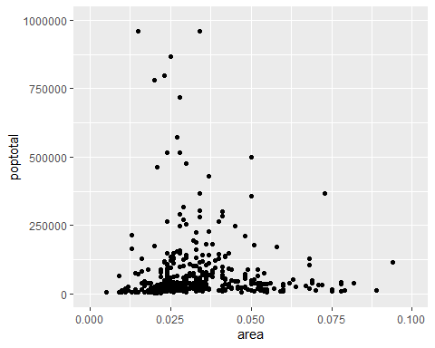

선 그래프

library(ggplot2)  
ggplot(midwest, aes(x=area, y=poptotal)) + geom_line()

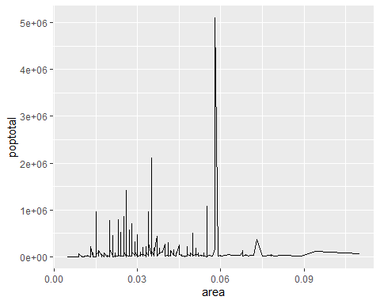

막대 그래프

library(ggplot2)  
ggplot(midwest[1:10,], aes(x=county, y=poptotal)) + geom_bar(stat="identity")

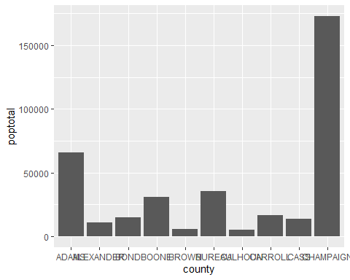

막대 그래프, 색상 추가

library(ggplot2)  
ggplot(midwest[1:10,], aes(x=county, y=poptotal, fill=county)) +  
 geom_bar(stat="identity")

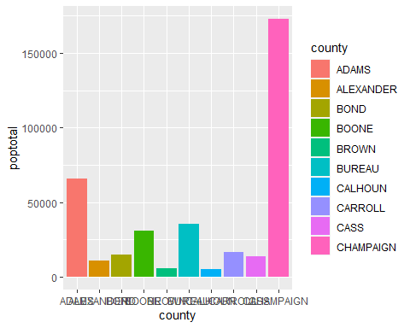

막대 그래프, 회전

library(ggplot2)  
ggplot(midwest[1:10,], aes(x=county, y=poptotal)) + geom_bar(stat="identity") +  
 coord_flip()

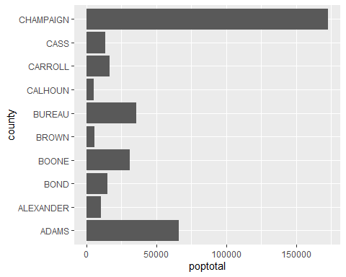

x, y축 이름 변경

library(ggplot2)  
ggplot(midwest[1:10,], aes(x=county, y=poptotal)) + geom_bar(stat="identity") +  
 labs(title="Population", x="County", y="Population")

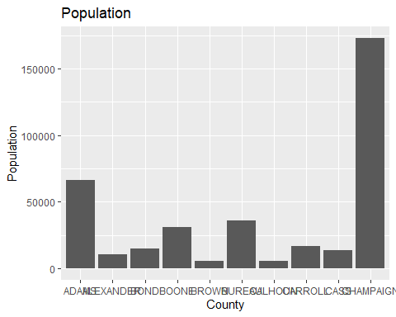

막대 폭 변경

library(ggplot2)  
ggplot(midwest[1:10,], aes(x=county, y=poptotal)) +   
 labs(title="Population", x="County", y="Population") +  
 geom_bar(stat="identity", width=0.2)

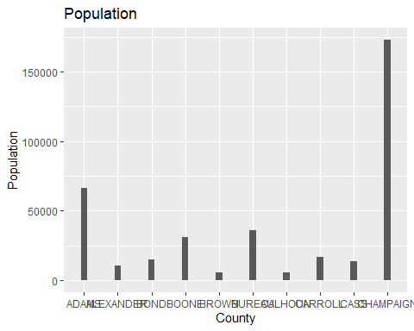

state별로 poptotal 합

library(tidyverse)  
midwest %>% group_by(state) %>% summarise(all = sum(poptotal)) %>%  
 ggplot(aes(x=state,y=all, fill=state)) + geom_bar(stat="identity")

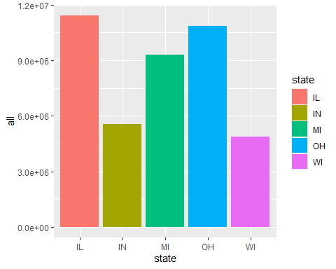

범례

다중 선 그래프

히스토그램

그룹별 별도 그래프

점 그래프, state 별로 분리, 세로

library(ggplot2)  
ggplot(midwest, aes(x=area, y=poptotal, color=area)) + geom_point() +  
 facet_grid(state ~ .)

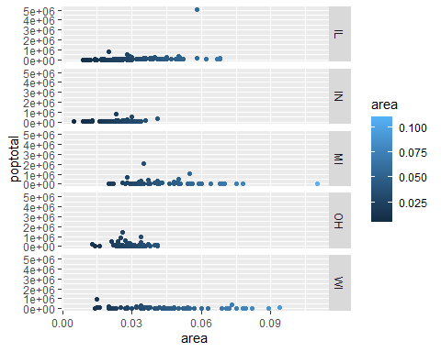

점 그래프, state 별로 분리, 가로

library(ggplot2)  
ggplot(midwest, aes(x=area, y=poptotal, color=area)) + geom_point() +  
 facet_grid(. ~ state)

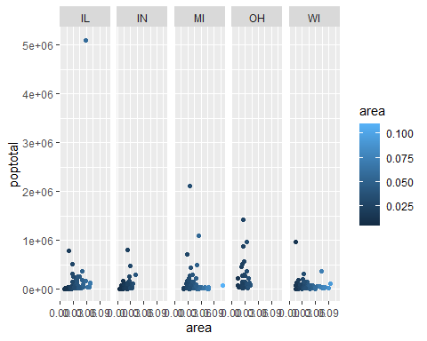

Heat map

산포도

추세도

## 참고자료

* <http://r-statistics.co/Complete-Ggplot2-Tutorial-Part1-With-R-Code.html>
* <http://www.sthda.com/english/wiki/ggplot2-essentials>