

**Newport News Waterworks Toolbars**

**User Guide**

**NNWW GIS**

Python Add-In

Release: 2

Release Date: May 13, 2016

Contents

Installation 1

NNWW (Search GIS Features) Toolbar 2

NNWW (Find Street Intersection) Toolbar 3

NNWW (Drawings) Toolbar 3

NNWW (New Project Data Extractor) Toolbar 5

NNWW (User Guide) Toolbar 5

# Installation

*-------- Must run* ***Update Local GIS Features*** *to maximize toolbar performance. --------*

The toolbar is located at:

\\amazon\waterworks\Divisions\InfoTech\Shared\GIS\Python_Addins\NNWW_Toolbars.esriaddin

If using the electronic version of the User Guide, click HERE and then select “Install Add-In”. Close all sessions that are open of ArcMap and the next time a session is started, the toolbars will be ready to use. This will only have to be done once unless a new version is released.To get full functionality of the toolbars, an extension must be enabled. When ArcMap is restarted, click Customize 🡪 Extensions… and check the box next to NNWW Toolbar Extension.

The collection of toolbars in Version 0.1 currently consist of 5 separate toolbars. To enable all toolbars, click Customize 🡪 Toolbars and check each toolbar that you wish to work with.

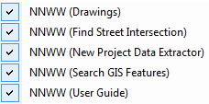

In ArcMap, all of toolbars can be docked together like so or if you only use specific ones the others can be disabled as you like. This is up to personal preference.

*Docked and Grouped*



*Undocked*

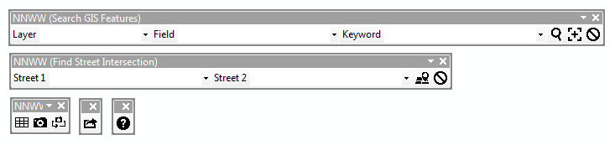

Python Window

Pop ups will appear periodically as the collection of toolbars are used, but for immediate and more detailed results, use the built in Python window in ArcMap.



# NNWW (Search GIS Features) Toolbar

Select Layer to search

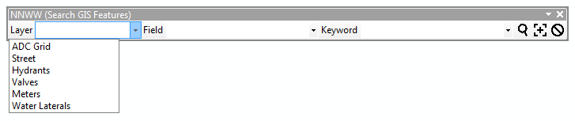

Currently, there are six layers that are searchable. This list of layers will most likely become more detailed as user feedback is received.

Select Field

The items that appear in this list are based on the Layer that is chosen. The fields listed are not all of the fields for the layer. This field list will also change depending on user feedback.

There is a custom field option that can be selected when the Street Layer is selected. The NAME field automatically fills the Keyword search with the street Prefix, Name, Type, and Suffix.

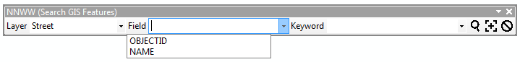

Enter Keyword

This is not case sensitive and does not need to be put in quotes. AutoFill feature has been enabled for this dropdown box based on the Layer and Field selected.

Search



When this button is selected, a search will start. If there is a match, the Layer will be returned zoomed to the selected items matching your search. If there is not a match, a pop up will display alerting the user that no matches have been found. Along with the pop up, the Layer that the user wished to search will be added to the map.

Make Layer from Search Results



This button is independent of the Search button. When this button is selected, a search will start. If there is a match, only the selected feature of the Layer will be returned and the display will zoom to the feature. If there is not a match, a pop up will display alerting the user that no matches have been found.

Remove all Python Add-In Layers



When this button is selected, all entries will be cleared from the combo boxes and all layers will be removed from your map document that have been added by this tool.

# NNWW (Find Street Intersection) Toolbar

Street 1 and Street 2



AutoFill feature has been enabled for both dropdown fields. The fields are automatically filled with the street Prefix, Name, Type, and Suffix.

Find Intersection



This button starts a search and returns three layers, a point layer of where the intersection occurs between the two roads and a layer for each of the streets. These layers will be depicted by a red X marking the intersection(s) of the roads shown in green and orange.

The toolbar will provide feedback if one or both of the street names do not return a match or if the two roads do not intersect.

Remove Intersection Point



When this button is selected, all entries will be cleared from the combo boxes and the three layers will be removed from your map document that have been added by this tool.

# NNWW (Drawings) Toolbar



Add CAD Index



This button adds the cadindex.shp to the map document as the ‘CAD Index’ layer. This layer can be used for reference if needed, but is not necessary for the tool to work properly.

Add Drawings



When this button is selected, the cursor will change to a crosshair. Click once and hold to start drawing the rectangular search box and release to complete the box. The size of the search box dictates how long it takes for this tool to complete.

Once the tool has finished processing, a new Group Layer will be added to the top of your map document’s Table of Contents named, ‘Drawings & Historical Orthophotographs’. This group layer will contain all of the files that were intersected by the search box listed in chronological order. Each drawing has been added unchecked to preserve drawing speed in ArcMap. The files that will be added are TIF, DXF and DWG. The DXF and DWG files will be added will all associated files.

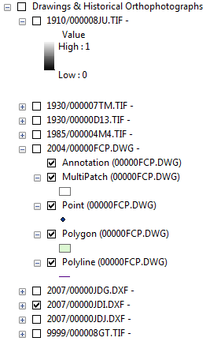

To quickly organize the Table of Contents, Hold Ctrl and click the minus sign of any layer listed in the group layer. This will collapse all layers in the group layer allowing you to quickly choose the layer that you are interested in.

A pop up will display alerting the user the results of the search. Check the Python window for more detail of results.

Remove Drawings



When this button is selected, the group layer, ‘Drawings & Historical Orthophotographs’ will be removed containing the drawings as well as the CAD Index layer if that was added as well.

# NNWW (New Project Data Extractor) Toolbar



Data Extractor



When this button is selected, the cursor will change to a crosshair. Click once and hold to start drawing the rectangular search box and release to complete the box. The size of the search box dictates how long it takes for this tool to complete.

Once the tool has finished processing, all layers that where intersected by the search box will be added to the map document. A pop up will display telling you the name of the project folder that was created by your search. The project folder will be located HERE:

\\amazon\waterworks\Divisions\InfoTech\Shared\GIS\NewProjectApplication\ExtractionFolder

The project folder will contain an Excel spreadsheet and a file geodatabase containing all data within the search box. You are now free to do with the new project folder whatever you like such as Cut and Paste and/or rename the folder. Check the Python window for more detail of results.

# NNWW (User Guide) Toolbar



User Guide



When selected, a pop up will display showing the user where this document is located. Check the Python window for more detail of results where the link can be copy and pasted into Windows or Internet Explorer.