Software Requirements Specification

for
Multimodal Biometrics
Version 2.0
Brian Tan
Davina Doran
Fulya Kocaman
Konnor Gutierrez
California State Fullerton
CPSC 362 SOFTWARE ENGINEERING
09/28/2020
Table of Contents
Table of Contents 2
Revision History 2
1. Introduction 3
1.1 Purpose 3
1.2 Scope 3
1.3 Definitions, Acronyms, and Abbreviations 4
1.4 References 4
1.5 Overview 4
2. Overall Description 4
3. Specific Requirements 5
3.1 Product Perspective 5
3.2 Functionality 5
3.3 User Case Models 6
3.4 Operating Environment 2
3.5 Design and Implementation Constraints 2
3.6 User Documentation 2
3.7 Derived Requirements 3
4. External Interface Requirements 3
4.1 User Interfaces 3
4.2 Hardware Interfaces 3
4.3 Software Interfaces 3
4.4 Communications Interfaces 3
5. Other Nonfunctional Requirements 4
5.1 Performance Requirements 4
5.2 Safety Requirements 5
5.3 Security Requirements 5
5.4 Software Quality Attributes 5
5.5 Cost Requirements 5
5.6 Time Requirements 5
5.7 Schedule Requirements 5
6. Other Requirements 5
Appendix A: Glossary 5
Appendix B: Analysis Models 5
Appendix C: To Be Determined List 5

Revision History
Name | Date | Reason For Changes | Version
Fulya Kocaman | 9/28/20 | Created | 1
Fulya Kocaman | 9/30/20 | Changed iris and hand to retinal and palm scans | 2
 |  |  | 3
 |  |  | 4

Introduction

The aim of this document is to gather and analyze and give an in-depth insight of the complete Multimodal Biometrics Recognition System by defining the problem statement in detail. Nevertheless, it also concentrates on the capabilities required by customer and their needs while defining high-level product features. The detailed requirements of the Multimodal Biometrics Recognition System are provided in this document.

Purpose

The purpose of this Software Requirements Specification (SRS) document is to provide a detailed overview of our software product which is a system that uses multimodal biometrics recognition system that can be customized based on the usage requirements, its parameters and goals. This document describes the project's target audience and its user interface, hardware and software requirements. It defines how our client, team and audience see the product and its functionality. Nonetheless, it helps any designer and developer to assist in software delivery lifecycle (SDLC) processes.

Scope

Since biometrics has become a key technology for identity management and security, the U.S. Army has growing need to improve access control of its many systems, both in wartime and in peacetime. [1]

- This project’s goal is to use multimodal biometrics recognition system that can be customized based on the usage requirements to provide access to secure locations/rooms/systems for authorized personnel in military facilities.
  - The advantage of multimodal over single modal biometrics is that if fingerprint or voice recognition fails, a retinal scan, face recognition or palm scanning could still produce a match to validate that individual.
  - The multiple biometric modalities improve the accuracy of identification and to cope with people in the army that are missing a finger, or have disability problems that prevent use of retina or face recognition.[3]
  - In military security is curial, so multimodal biometric systems are very difficult to spoof as compared to unimodal systems. Even if one biometric modality could be spoofed for example fingers made of gelatin, contact lenses, etc., the individual can still be authenticated using the other biometric identifiers.

- Another aspect of this project is to make biometrics completely contactless for hygienic reasons due to the COVID-19 pandemic.
  - Instead of touching a pad for fingerprint and palm scanning of personnel, cameras and microphones will capture their retinal, face scans and/or voice in a matter of seconds without an operator present in the screening area.
  - This project also aims to make facial recognition technology more advanced by including masked face detection and recognition technology.
- However, the mobile application of this multimodal biometrics system will be outside the scope of this project.

Definitions, Acronyms, and Abbreviations

Spoofing | The act of fooling biometric systems to either impersonate someone else, or falsely go undetected. Sometimes achieved with false biometrics
COVID-19 | Coronavirus disease 2019
CISO | Chief Information Security Officer
CAC | A smart card about the size of a credit card used as the standard identification for Active Duty United States Defense personnel

References
The references used in this document are:

[1] https://www.rand.org/pubs/monograph_reports/MR1237.html
[2] https://neurotechnology.com/megamatcher-large-scale-AFIS-and-biometric-identification-systems.html
[3] https://en.wikipedia.org/wiki/BioAPI
[4] https://www.dsp.dla.mil/Specs-Standards/List-of-DISR-documents/

Overview

The remaining sections of this document provide a general description, including characteristics of the users of this project, the product's hardware, and the functional and data requirements of the product.
- Section 2 contains General description of the project.
- Section 3 gives the functional requirements, design and implementation constraints and assumptions made while designing the multimodal biometrics. It also gives the user viewpoint and the specific requirements of product.
- Section 4 is for external interface requirements.
- Section 5 is for detailed description of non-functional requirements such as performance, security, cost, time and much more.
- Section 6 is for other requirements.

Overall Description

The customers and stakeholders of this project are U.S. Military, defense contractors, the CISO and their IT staff who are responsible for monitoring, running and supporting the Biometric system technologies. Here is the overall list that illustrates their needs and wants:

The objectives of the system are to:
- Have a system that uses multimodal biometrics recognition system that can be customized based on the usage requirements.
- Provide access to secure locations/rooms/systems for personnel who are authorized to be there.
- Reduce instances of intrusion
- Avoid redundancy in authorization

The things that need to be accomplished are to:
- Increase security through the use of unique identifiers (retina, fingerprint, voice, face, palm)
- Add additional security authorization in the event another fails
- Log of events of who accesses
- Mitigate intrusion of unauthorized personnel.
- Make biometrics completely contactless for hygienic reasons due to the COVID-19 pandemic
- Recognize a person wearing a mask

The ways that this project fits into the needs of the military are to:
- Secure valuable data/high clearance buildings and rooms
- Allow for biometric tracking of who has accessed these secure locations/devices
- Mitigate intrusion via stolen credentials.

The product is going to be used to:
- Access secure locations (weapons, administrative, “war rooms”)
- Access secure data (secret/top secret information, confidential information and medical records)

Specific Requirements

Product Perspective
Controlling access to facilities, computer systems, and classified information depends on fast and accurate information. The Army also operates a vast set of human resources services involving heath care, retiree and dependent benefits, troop support services and many others. These services create the need for accurate identification to prevent fraud and abuse. [1]

The U.S. Army currently uses a combination of a CAC card and a personal identification numbers (PINs) for traditional means of access control. This project’s perspective is to use the multimodal biometrics in conjunction with the CAC cards to
- improve accurate identification and security,
- reduce operational and administrative costs and
- increase user convenience.

The figure 1 below shows our model in a nutshell.
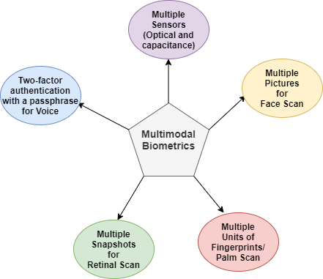

Figure 1: Basic scenario in a multimodal biometrics system

Functionality

- The server shall provide system data processing and storage capabilities.
- The system shall able to extract and match the user biometrics data which already been stored on the database side.
- Only the authorized user shall be able to use the system.
- The system shall allow administrator employee to enroll the new employee.
- The system shall not allow general employee to access to the administrator employee options.
- The administrator employee shall able to manage employees.
- The system shall able to capture the biometrics of the new employee on employee registration phase.
- The system shall be attached to multiple sensors and cameras to capture the biometrics.
- The administrator employee shall able to delete the employee record form the system.
- The system shall not allow employee to clock in, who is already clock in to the system.
- The system shall not allow employee to clock out who is already clock out to the system.
- The administrator employee shall be able to generate log reports.
- The system shall recognize a person wearing a mask with more advanced facial recognition by identifying face features as forehead, face contour, eyes, cheekbones, etc.

The figure 2 below shows a flow diagram of our multimodal biometrics system.
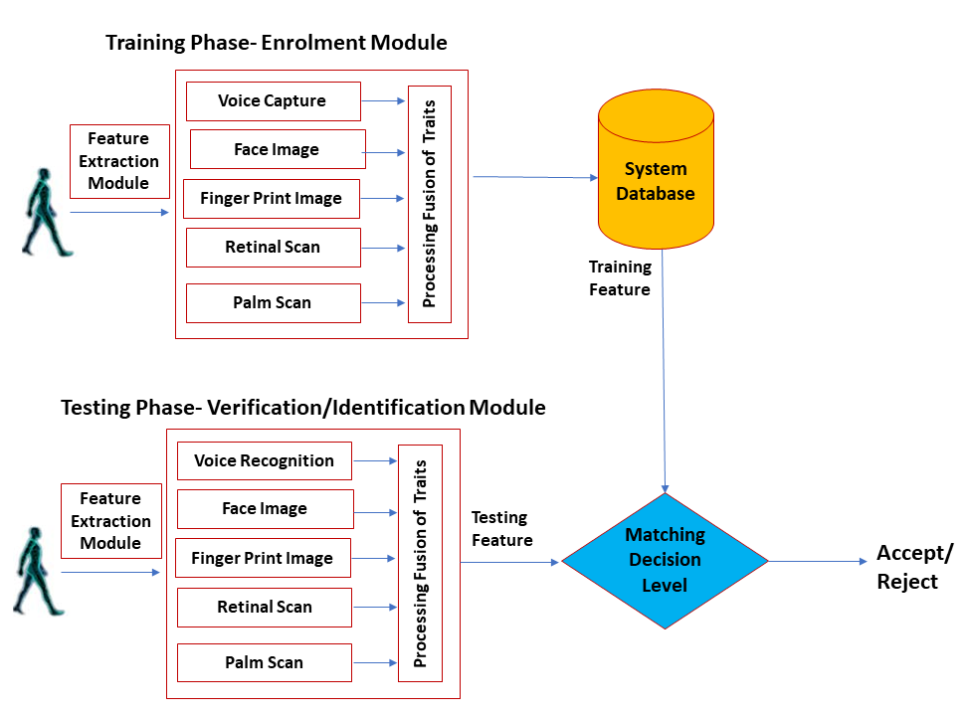
Figure 2: Flow diagram of the multimodal biometrics system

User Case Models

The customer shall choose one or more of the following models they would like to purchase and each of them focuses on different scenarios:

User Case 1: This model in the figure 3 is designed based on the most commonly used physical biometrics characteristics which are fingerprint, face and retinal traits.

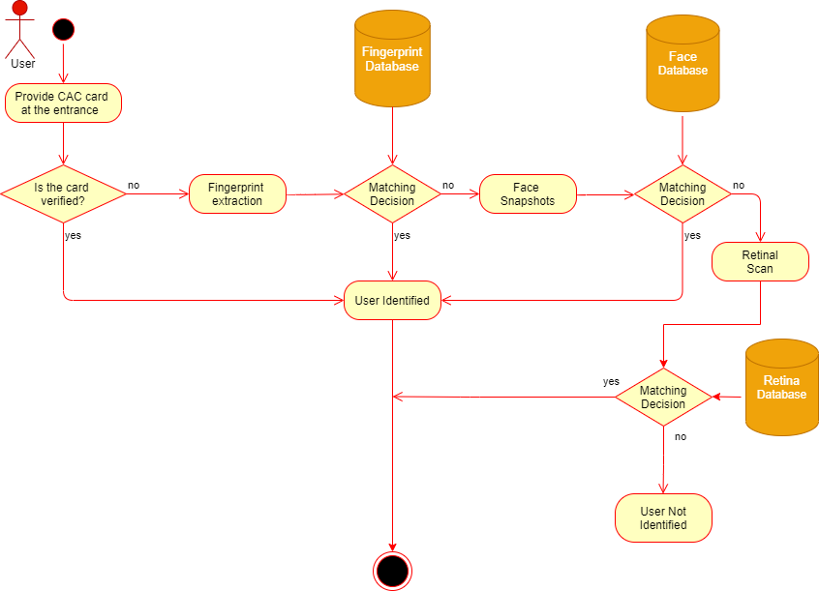

Figure 3: Activity diagram user case 1

User Case 2: This model in the figure 4 is designed based on the recent Covid-19 pandemic in mind where a user gets scanned using voice, face and retinal identification without an operator present in the screening area. Not only does this model cover cases where a user does not need to touch any screens for hygiene reasons, but also ease concerns with the users who wear gloves and would not want to take them off.

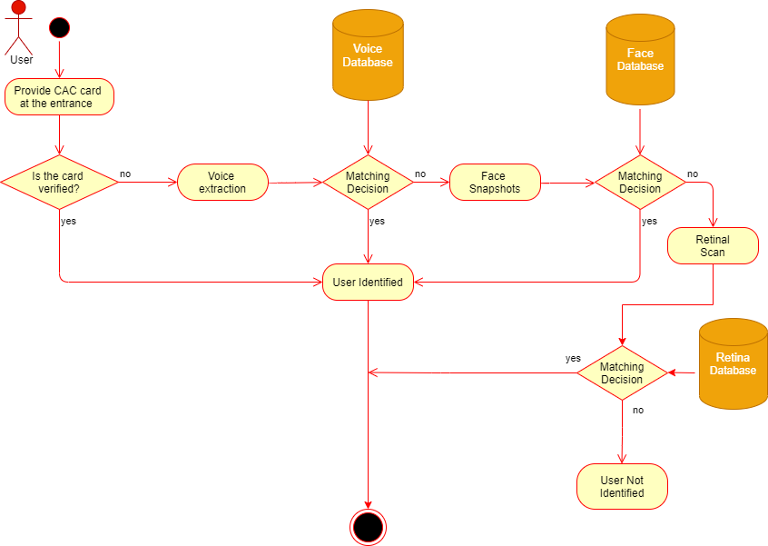

Figure 4: Activity diagram user case 2- contactless option due to Covid-19

User Case 3: This model in the figure 5 is designed to have a top-notch security incorporating all biometrics characteristics we provide. It consists of two parts. The first part of the model consists of the scenario we proposed in the user case 1. The second part of the model provides the additional security needed in certain rooms/areas in a Military facility.

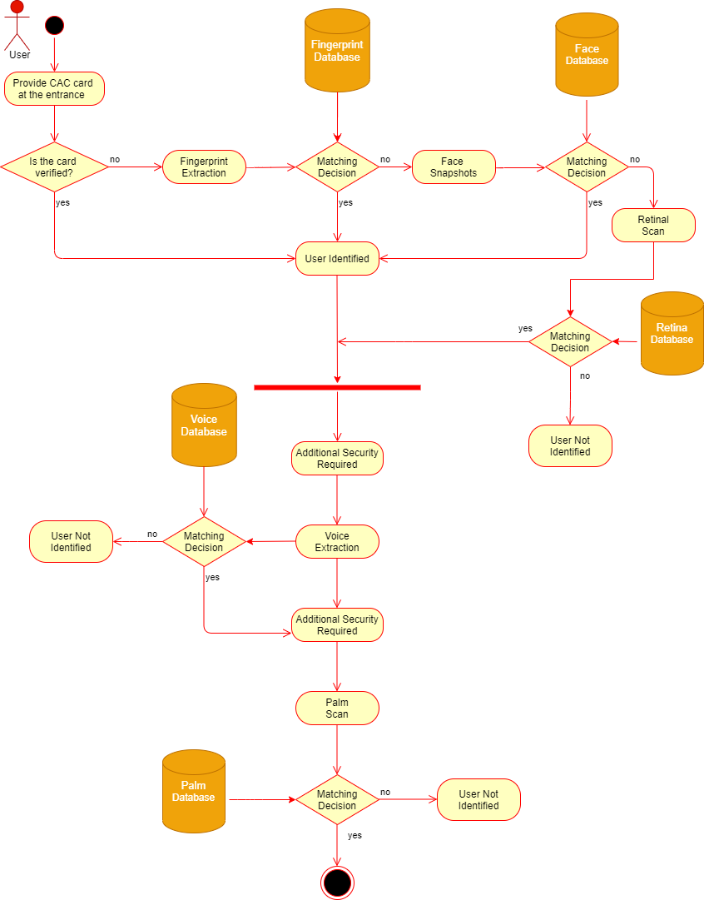

Figure 5: Activity diagram user case 3- top secure areas

<Identify the various user classes that you anticipate will use this product. User classes may be differentiated based on frequency of use, subset of product functions used, technical expertise, security or privilege levels, educational level, or experience. Describe the pertinent characteristics of each user class. Certain requirements may pertain only to certain user classes. Distinguish the most important user classes for this product from those who are less important to satisfy.>

Operating Environment (not sure whether to keep this section?)

Environmental Requirements

The system’s environment shall be very controlled both indoors and outdoors by
- Keeping it at certain temperature
- Providing proper lighting for the cameras
- Reducing glare by using anti-glare screen for the user
- Providing a quite space for voice recognition
- For highest tier
  - Should be reinforced structurally to mitigate physical intrusion to device’s internal components.
  - Modules need to be built to survive a 15 foot drop 10 times in a row.
  - Modules requiring transparent material should be using a minimum of 3mm thick acrylic.
    - Will need to be UV resistant in the event of outdoor deployment.
    - Scratch resistance will be needed due to heavy use.
  - Be able to operate in extreme temperature environments.
    - Should operate in -70F to 165F range
      - Environments like this might limit module choice to iris and voice due to attire worn in these climates, but face/hand will be supported.
- Base tier
  - Use of materials should not change from highest tier, but reinforcements removed as they are likely unnecessary in these deployments.
    - Minimal structural reinforcement.
    - Survive a 5 foot drop 10 times.
    - Transparent material can be made of 2mm thick glass.
    - Intended to operate in normal climates
      - Should operate in 0F to 125F range.

<Describe the environment in which the software will operate, including the hardware platform, operating system and versions, and any other software components or applications with which it must peacefully coexist.>

Design and Implementation Constraints
<Describe any items or issues that will limit the options available to the developers. These might include: corporate or regulatory policies; hardware limitations (timing requirements, memory requirements); interfaces to other applications; specific technologies, tools, and databases to be used; parallel operations; language requirements; communications protocols; security considerations; design conventions or programming standards (for example, if the customer’s organization will be responsible for maintaining the delivered software).>
<I’m not sure if this is where I should put this, also verify sizes w/ scale. - DD>
- The recognition decision needs to be made in real-time, therefore computing efficiency is critical.
  - 2GHz processor minimum required.
  - 2 GB RAM minimum required.
- Database system will be used to track and log movement across the system. Minimal data stored.
- C/C# will be the designated programming language, and the BioAPI (Biometric Application Programming Interface) will be used for development.
- Protocol states that once the smart ID is scanned, then the biometric scan/test will be initiated.
- System Response Time Per Usage
  - Highest tier
    - Iris: Under 3 seconds
    - Palm: Under 2 Seconds
    - Voice: Under 3 Seconds
    - Facial: Under 1 Second
  - Base Tier:
    - Iris: Under 5 Seconds
    - Palm: Under 10 seconds
    - Voice: Under 5 Seconds
    - Facial: Under 3 Seconds
- Frequency of system being used
  - Highest tier
    - Will need to be accessed by simultaneous users across a network.
      - Network infrastructure will need to support data streams for multiple end nodes.
      - System will need to support 100-1000 users simultaneously utilizing the network.
  - Base tier
    - Not intended to be a high-volume usage. System should be able to handle usage every 60 seconds.
      - Note: Burst usage should be supported but sustaining burst usage for over 5 minutes should impact performance.
        - Example: Start of business day and users are clocking in.

User Documentation
<List the user documentation components (such as user manuals, on-line help, and tutorials) that will be delivered along with the software. Identify any known user documentation delivery formats or standards.>
- Documentation will be given to end users that have a support plan that would require spares to be left on site and to be installed by end user.
  - Documentation should be done in two methods, “quick setup” and user manual.
    - Quick setup should be primarily pictorial, with worded instructions that last one to two sentences per step
    - User manual will be an in-depth multi-chapter instructional book that covers everything

Derived Requirements
- A high-resolution camera shall be required to capture the face and iris images of a person accurately when training data.
- Additional hardware (multiple sensors) and/or software (multiple algorithms) could be needed to capture the data using multiple modalities. For example, a facial recognition system might employ multiple cameras to capture different angles on a face.
- A high-quality microphone for voice recognition shall be required.

External Interface Requirements
- The interface that shall be used in this project is BioAPI (Biometric Application Programming Interface) which is a standard application program interface (API) that allows biometric technology modules and applications to communicate with each other by performing enrollment and verification (or identification).
- Enrollment is the process of collecting biometric samples from a person and the device produces an enrollment template.
- Matching is the process of comparing a submitted biometric sample against one (verification) or many (identification) templates in the system’s database.

- The purpose of the BioAPI specification is to define an architecture and all necessary interfaces (using C programming language specifications) to allow biometric applications (perhaps distributed across a network) to be integrated from modules provided by different vendors.[3]

- BioAPI supports all the use cases from multiple biometric modalities (for example, retina, fingerprint, voice, face, palm), both to improve the accuracy of identification and to cope with people that are missing a finger, or have disability problems that prevent use of iris or face recognition. [3]

User Interfaces

Hardware Interfaces
- Quantity
  - How many?
    - Highest Tier:
      - 50 to 500 modules per server.
    - Base Tier:
      - Up to 50 modules per server
        - Additional modules can be purchased for a fee.
- Device should be mounted to existing physical infrastructure
  - Wall with studs
  - Secured table
- Dimensions of scanning unit: Varies depending on multimodal configuration
  - 13x10x7 inches max
  - 10x7x7 inches minimum
- Dimensions of server
  - Highest Tier
    - Should fit in server rack. 1U to 2U spec.
      - May require SAN environment depending on scale of customer
  - Base Tier
    - ATX to EATX form factor. Blade configuration also an option.

Software Interfaces

Communications Interfaces
- Communicates over existing network infrastructure.
  - Must be wired infrastructure.
    - Wireless infrastructure reduces stability, and is easily compromised in security.

Other Nonfunctional Requirements

Performance Requirements
- In order for the system to perform reliable identification in terms of accuracy, multi-biometric sample shall be collected using several fingerprint images, several face samples with different angles and retinal samples etc. from a given person because biometric identification systems tend to accumulate False Acceptance Rate (FAR) and false reject rate (FRR) with database size increase.

- A fused algorithm shall be used to create a single identification decision based on the results of those multiple measurements to increase matching reliability. [2]

- Identification requests shall be processed as quickly and efficiently as possible (ideally in real-time), requiring considerable computational power.

- The system shall show high productivity and efficiency, regardless of its scale: [2]
- System scalability is important, as a system may continue to expand and a high level of productivity should be available through the addition of units to the existing system.
- The daily number of identification requests could be very high for certain applications.
- Support for large databases shall be required.

- The system shall support the major biometric standards, thereby allowing the use of system-generated templates or databases across a variety of platforms, independent of the vendor source.

- The biometric software engines shall be based on deep neural networks and contain many proprietary algorithmic solutions such as fingerprint, face, palm, voice and retina that are especially useful for large-scale identification problems.[2]

Safety Requirements
- With a hand scanner, the interface will be touched a lot. Cleaning of the surface must be implemented regularly. An unclean surface poses a health risk.
- <Specify those requirements that are concerned with possible loss, damage, or harm that could result from the use of the product. Define any safeguards or actions that must be taken, as well as actions that must be prevented. Refer to any external policies or regulations that state safety issues that affect the product’s design or use. Define any safety certifications that must be satisfied.>

Security Requirements
- System shall have IP rating of 65 or higher; protection from entry by tools, wires, or brute force. It shall be dust tight with moisture protection. Outdoor systems shall withstand elements of the region; high temperatures, snow, rain, wind, hail.
- In the event of system failure or glitch, system must be intuitive to shut down.
- In the event of unauthorized tampering of the hardware, system must be intuitive to alert the administrators, and shut down, maintain door lockdown to protect from unauthorized access.

- <Specify any requirements regarding security or privacy issues surrounding use of the product or protection of the data used or created by the product. Define any user identity authentication requirements. Refer to any external policies or regulations containing security issues that affect the product. Define any security or privacy certifications that must be satisfied.>

Software Quality Attributes

- The build of the system must be in compliance of aforementioned standards. Therefore, the precision engineering must be employed in order to ensure IP compliance, and in accordance with the military aesthetic.
- <Specify any additional quality characteristics for the product that will be important to either the customers or the developers. Some to consider are: adaptability, availability, correctness, flexibility, interoperability, maintainability, portability, reliability, reusability, robustness, testability, and usability. Write these to be specific, quantitative, and verifiable when possible. At the least, clarify the relative preferences for various attributes, such as ease of use over ease of learning.>

Cost Requirements:
- The quality and accuracy must be very curial in the military, so it shall cost time and money to achieve the level of software quality requested.
- The cost of an advanced retinal scanner will be about $50,000.00, an advanced facial scanner will be about $25,800.00, a voice recognition software will be about $500.00, an advanced fingerprint scanner will be about $1,298.00, and a palm scanner will be about $1,000.00.
- How much is the customer planning to pay?
- How many units of the product is the customer planning to buy?
- How much initial investment will the customer give as an upfront payment?
- Based on the initial investment and the time frame given by the customer how much should it cost to make the project profitable at the end.
- Do I have the right to expand my customer base e.g. U.S. Airforce, U.S. Navy?
- The cost will change depending on the customer going with how many biometrics traits they would like to combine.
    - Price will be dependent on the amount of scanning modules deployed, not multimodal scanners.
      - Example: an iris/palm/voice scanner consists of three modules.

Time Requirement:
- What is the time frame required for the customer?
- The faster we develop; it may take less time to complete the project. It might also affect the cost meaning that we might be paying less to the software engineers, but we might need pay more to get a faster response on data collection and analysis.
- How much will the initial investment be given by the customer? Initial investment is recouped in a short amount of time to achieve fast return on investment.
- Downtime Turnaround
  - Varies based upon customer
    - Highest Tier:
      - Spare parts are located on site, ready to be deployed by end user. Guide to be included with all spares.
        - Additional spare will be sent to customer after issue has been logged.
          - Should be delivered within 24 hours.
        - Failed equipment will be sent back to be refurbished.
    - Base Tier:
      - 72-hour response time for repair.
        - Troubleshooting consists of:
          - Swapping modules
          - Validating module slots
          - Validating integrity of entire scanner
          - Replacing module
          - Replacing scanner

Schedule Requirement:
- The schedule for this product to deploy shall be more flexible approximately 8-10 months since the security in military applications must be very accurate.
- Availability?
  - Highest tier
    - 24x7x365 for high security deployments.
  - Base Tier
    - 8x5 for daytime operation environments
      - After hours option should be considered for select

Other Requirements
- System must meet standards outlined in the Department of Defense Information Technology Standards Registry (DISR).
- System must be in compliance of cyber-security mandates detailed in the National Institute of Standards and Technology 800-171 (NIST 800-171) Special Publication.
- <Define any other requirements not covered elsewhere in the SRS. This might include database requirements, internationalization requirements, legal requirements, reuse objectives for the project, and so on. Add any new sections that are pertinent to the project.>
Appendix A: Glossary
- CAC – Common Access Card
- DOD – Department of Defense
- DISR - Department of Defense Information Technology Standards Registry
- NIST - National Institute of Standards and Technology
- <Define all the terms necessary to properly interpret the SRS, including acronyms and abbreviations. You may wish to build a separate glossary that spans multiple projects or the entire organization, and just include terms specific to a single project in each SRS.>
Appendix B: Analysis Models
<Optionally, include any pertinent analysis models, such as data flow diagrams, class diagrams, state-transition diagrams, or entity-relationship diagrams.>
Appendix C: To Be Determined List
<Collect a numbered list of the TBD (to be determined) references that remain in the SRS so they can be tracked to closure.>

Not sure where to put this yet. –Brian

*Risk Management:
- Determining which technology to use at each access point, or a combination of technologies. If possible, develop system to be a one-size-fits-all solution where the system will be capable of all technologies, but stakeholder may disable whichever they choose. This may run the risk of having unused components such as the hand scanner.

- With a hand scanner, the interface will be touched a lot. Cleaning of the surface must be implemented regularly. An unclean surface poses a health risk.

- In the event of system failure or glitch, system must be intuitive to shut down.

