Mirror Adder – Lab Number 3

Author : Brian Landy

Lab Instructor : Abhishek Vashist

TA : Andrew Fountain

TA : Sabrina Ly

Lab Section : Lab #2

Submission Date : 9/27/2019

Table of Contents

ABSTRACT 3

DESIGN METHODOLOGY 3

RESULTS & ANALYSIS 3

CONCLUSIONS 4

QUESTIONS 4

APPENDICES 5

# ABSTRACT

The exercise performed included building a Mirror Adder circuit which uses

**This is where you will write your abstract. An abstract should tell the reader what you did and what your results are. Think of it as a very short (one paragraph only) synopsis of your work**. The idea is that the reader should be able to pick up the paper, read the abstract, and immediately know whether this paper is of value to that person or not.

# DESIGN METHODOLOGY

If this section exists (your lab handout will tell you if it is required or not), its purpose is to describe your reasoning behind doing what you did. In other words, you should be answering the question of – “Why did you design it that way?”. It should be very obvious after reading this section why you did what you did and why it was a valid approach. Make sure to include any supporting figures, tables, and / or equations.

# RESULTS & ANALYSIS

This section should be the meat of your report. Here you need to describe in vivid detail exactly what was done. If you simulated something, explain what you simulated and how you simulated it. All of the supporting waveforms, schematics, tables, derivations, etc… should be included in this section (unless directed otherwise by the lab handout). This section should flow very well.

As an example, take a look at the content at the end of this section. The following is shown:

* How to properly include and reference an image
* How the image should look like (properly labeled!!) – Ideally everything including the axes should be readable. For this course, some of the images get to be difficult to render, so that will be excused; however, **if it is not obvious what is happening in your figure then you will lose points**. The TAs should be able to look at the figure and have it immediately support what you are stating.
  + Center figures. If caption exceeds one line, justify the text.
  + Size your figures appropriately (make them readable and no larger)
  + All figures should be properly colored, i.e. white background with black lines. For printing purposes use grayscale.
* How tables should be inserted and formatted
  + Center tables. If caption exceeds one line, justify the text.
* What captions for figures and tables should be like (include lots of details!)

Before continuing, you should note the academic policy. Cheating or plagiarizing of any sort will not be tolerated. You may use this document as a template; however, that is all it may be used for. If you try to pass this example content off as your own, serious consequences will ensue – You have been warned.

The inverter was also tested via transient analysis. A load capacitor, *CL*, was added to the netlist. The rise and fall times (*Tr* and *Tf*), as well as the propagation delay from a high to low signal, *TP,HL*, and a low to high signal, *TP,LH*, were measured for various cases. Fig. 1 shows the worst-case simulation (***make sure you include all of your simulations, not just one – remember that this is just an example***) and Table 1 shows the tabulated results. From Table 1 it is apparent that the worst timings occur when (***make sure to explain your results in good detail, i.e. the worst timings occurred at __ because of __***)….

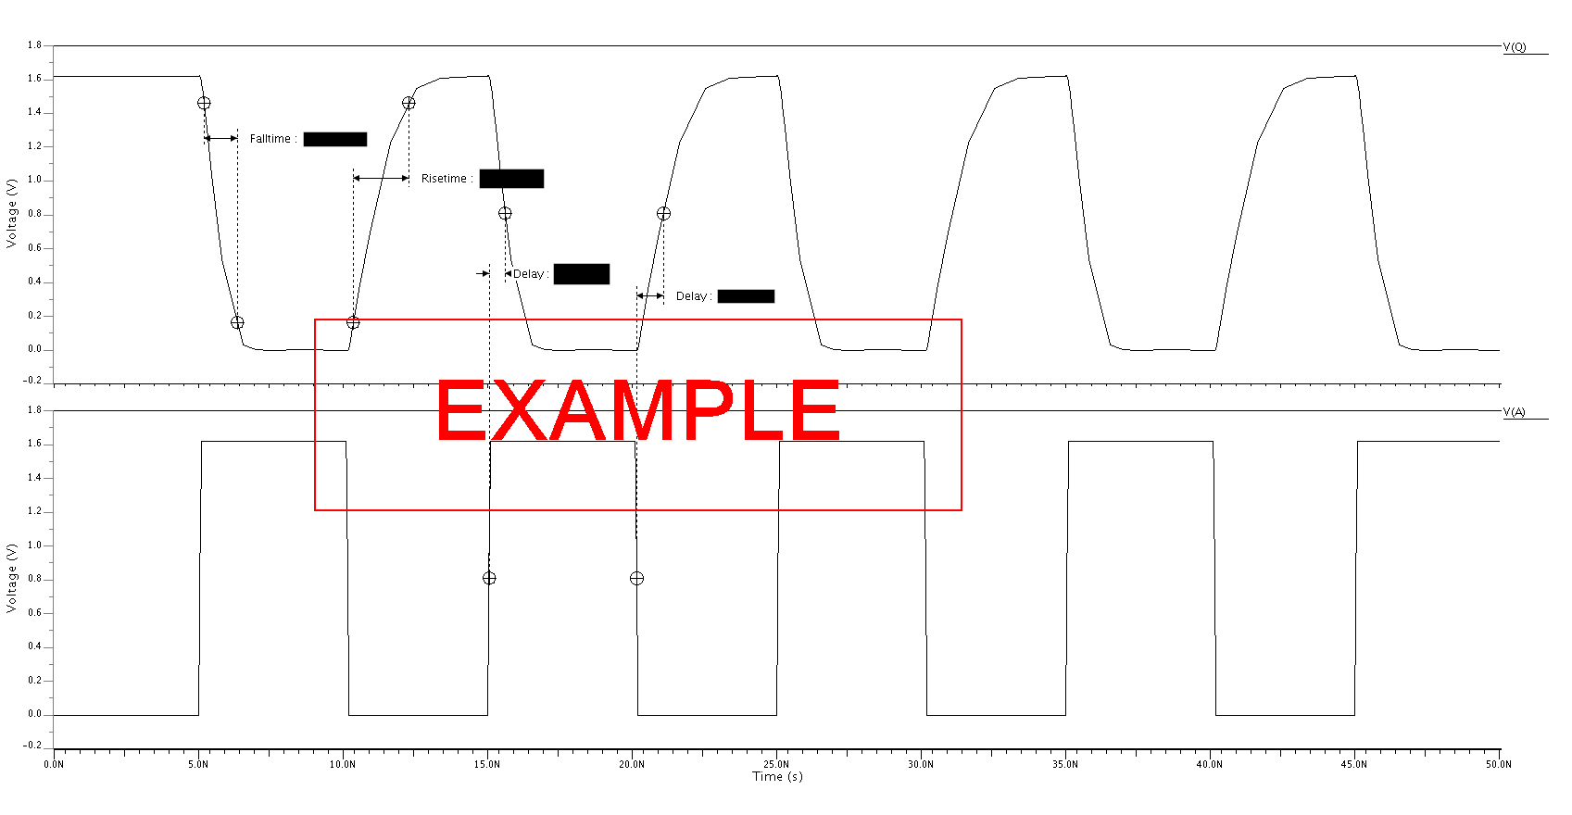

Fig. 1: Transient analysis of the inverter for the “worst” case (*T* = 125°C, *VDD* = 1.62 V) with *CL* = 120 fF. The measured values are *Tr* = X ns, *Tf* = X ns, *TP,HL* = X ps, and *TP,LH* = X ps.

Table 1: Timing results for the inverter

|  |  |  |  |  |  |  |
| --- | --- | --- | --- | --- | --- | --- |
| **VDD [V]** | **T [°C]** | **CL [fF]** | **Tr [ps]** | **Tf [ps]** | **TP,HL [ps]** | **TP,LH [ps]** |
| 1.8 | 70 | 0 | X | X | X | X |
| 1.8 | 70 | 120 | X | X | X | X |
| 1.62 | 125 | 0 | X | X | X | X |
| 1.62 | 125 | 120 | X | X | X | X |

# CONCLUSIONS

The conclusion should repeat what you did and what your results were. You should additionally add in any statements about why things happened and possible future work. The conclusion should be between one and two paragraphs.

# QUESTIONS

1. Each question should be numbered and the text repeated, i.e. what you are reading right now should be the question that was in the lab.

And this text should be your answer.

# APPENDICES

In this section, include any items that were requested. Make sure that each item is properly labeled with a useful caption. Additionally, make sure that each item is referenced by your report’s body. Simply having something in the appendix without referencing it is useless. Also, the appendix should always start on a new page.

Some additional note – Make sure to update the references in the table of contents (right click on it, update field, update entire table, ok). If you do that while the entire document is highlighted (ctrl+a) you will update all of the references in your entire document.