Layout of CMOS Logic Gates – Lab Number 4

Author : Brian Landy

Lab Instructor : Sayed Ashraf Mamun

TA : Andrew Fountain

TA : Sabrina Ly

Lab Section : Lab #4

Submission Date : 10/11/2019

Table of Contents

ABSTRACT 3

DESIGN METHODOLOGY 3

RESULTS & ANALYSIS 5

CONCLUSIONS 9

QUESTIONS 9

APPENDIX 10

SOURCES 12

# ABSTRACT

Complementary metal-oxide semiconductor (CMOS) devices are extremely valuable circuit components as they allow for small digital logic circuits to be placed in an extremely small amount of area on a chip. These circuits are fast and complex tools can synthesize designs, but the way to get the fastest and most highly customized circuits are to design these circuits with layout tools. In this lab exercise, layout tools were used to design a CMOS inverter circuit. The results of timing and simulation were compared to the generated version of the circuit. This lab successfully showed the importance of custom layouts and that a speed benefit can come from custom layouts. Pyxis layout was used. Various design rule checks were adhered to in this procedure as the layout needs to be able to be fabricated. That is what design rules are for. The timing results were also recorded so important metrics could be calculated like through put maximum and input maximum frequencies. When looking at the worst-case results of the schematic method and the layout method, the maximum throughput and input frequencies were 16.4GHz and 8.3GHz for the layout. For the schematic the results were 27.7GHz and 10.3GHz for throughput and input frequencies respectively. The schematic method was faster, and this is probably due to intense optimizations for the tool and the fact that this is a trivial circuit. Nontrivial circuits will likely show a better performance increase with a custom design.

# DESIGN METHODOLOGY

A CMOS layout consists of a few materials organized in a specific way to get the proper results. The design for the circuit in this exercise was generated using the cross section of an inverter provided in the exercise handout. Figure 1 shows the cross section of the inverter (RIT CMPE Lab4 1).

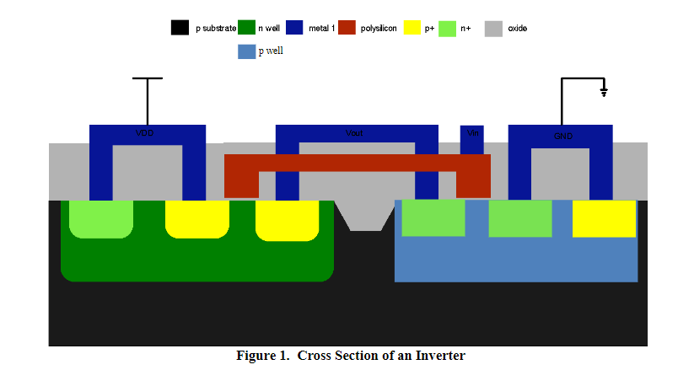

**Fig. 1:** CMOS Inverter Cross Section (RIT CMPE Lab 4)

This cross section contains all the important parts of the design that needed to be considered. The purpose of the design using the layout tool is to maximize speed. The layout tool has many different material types. The NMOS portion had a p well to on it, and the NMOS portion had an n well in it. These 2 bodies were connected through metal links and a polysilicon gate. And at the connector points between the metal and the well, there was either a P+ region or an n+ region. And lastly, there was a diffusion region over all the areas with connections. The nwell creates negative charge and the pwell creates positive charge. The current then flows through the regions with specific voltages applied to the terminals. There is a design rule set to follow. A design rule is one which needs to be followed for the actual circuit to function properly and to be able to be created in the fabrication process. This includes material sizing, placement and widths and lengths as well as other things. By following these rules, the layout in figure 2 was created for the exercise. It is a CMOS inverter.

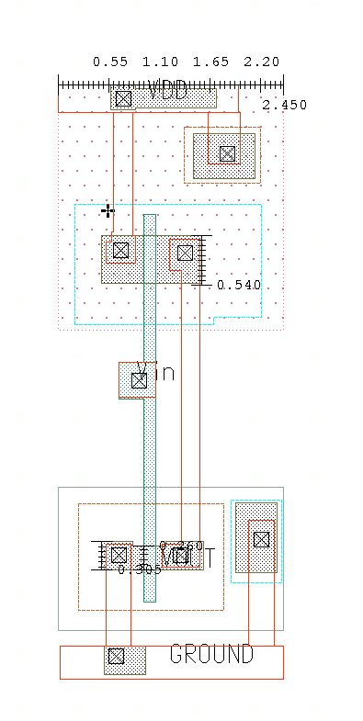

**Fig. 2:** CMOS Inverter Layout

The figure contains all materials. The orange rectangles are metal lines. The red polka dots are the nwell region. The light blue dotted lines are p+ regions. The half shaded grey areas are diffusion regions. The little black squares are contact points where the layers can connect. The orange dotted section is an n+ area and the greyish area surrounding it is the pwell. Lastly, the greenish long portion in the middle of the layout is the polysilicon gate. The input voltage passes through the gate and the output is connected to a piece of metal that touches the PMOS and NMOS. The ground is connected to the NMOS side and the PMOS side is connected to VDD. The body connections are also set up and if they were not, the circuit would not properly function at all. The portion where the polysilicon touches diffusion is the transistor width metric. The length of the gate strip is the transistor length. The PMOS width is double the NMOS width as per a unit inverter. Metal is used because it is good at carrying charge. The polysilicon is used because it is good at carrying charge when under the correct operating conditions. The n and p wells are good for providing electrons or charge and receiving charge or providing holes. The doped regions, n+ and p+ are used to make the substance act more like a conductor than it would normally be. Lastly, the diffusion region is good for providing a path for the flow.

It is necessary to follow design rules when setting up a CMOS inverter. The design rules are there to force a circuit to be built properly. Some of the things the DRC check take care of are transistor layering and boundary area, connections, minimum width and lengths and layer area. If the rules do not get satisfied, the circuit can not be considered valid. These rules are determined by the fabrication process. There are another set of rules and comparisons for the circuit but they exist to verify the transistor matches a provided schematic. This will help determine the connections are setup right, ports match, transistor sizing matches a schematic and other thing specific to the circuit. Both checks were used in the exercise.

# RESULTS & ANALYSIS

The purpose of the results section in this exercise was to compare the layout CMOS inverter with the schematic CMOS inverter. The schematic of the CMOS inverter that was used in the exercise is shown in figure 3.

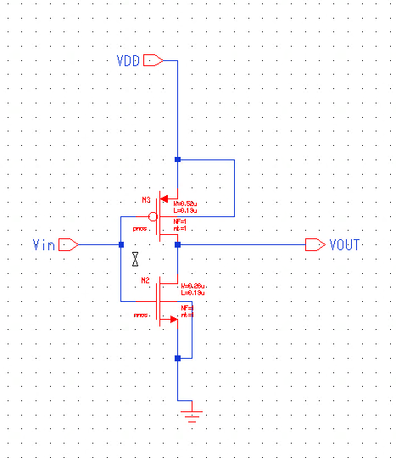

**Fig. 3:** CMOS Inverter Schematic

This is the circuit that was used for the circuit verification step which is LVS. LVS stands for layout vs schematic and it does exactly what the name implies. This is the final check before waveform simulation takes place. The behavior of a CMOS inverter is simple. A capacitive load is applied from the output terminal to ground. This will further delay the output and increase the time it takes for the circuit to operate. It is to understand the effect of a load on the timing results. The transistor widths and lengths are also important. The NMOS width and length are .13uM and .26uM. These numbers are determined by the process being used. The PMOS needs double the width to be as powerful as the NMOS. The width is .52uM and the length is .13uM.

To simulate, first all rule checks were run and passed. Then PEX timing was done. After this had finished, a spice netlist was generated. This spice netlist was used by the Eldo simulator in conjunction with a circuit file. The circuit simulation profile file is shown in the appendix. The circuit file was just a text-based way of setting up the circuit simulation profiles. The circuit simulations were run with and without a 120fF capacitor and under nominal and worst-case conditions. The fist simulations run were the voltage characteristics of the schematic. Figure 4 shows the plot of input and output voltage for the inverter schematic. This is used as a baseline for the expectations of the simulated CMOS layout inverter.

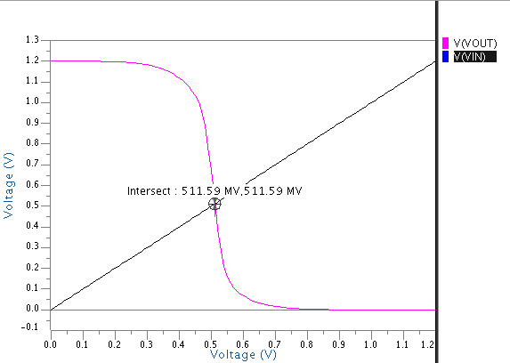

**Fig. 4:** Plotted CMOS Inverter characteristics using schematic with profile (T = 25 degrees C, DC signal on Vin swept from 0V to 1.2V and Vdd held constant at 1.2V)

The intersection point on the graph of Vout and Vin in figure 4 is the midpoint voltage. This is where Vout is the same as vin. Ideally, it should be right in the middle of 0 and 1 for best operation. In this case, the midpoint voltage is 511.59. The next plot is shown in figure 5 and it is a transient plot of input pulses and the inverter response. This is also from the schematic of the inverter.

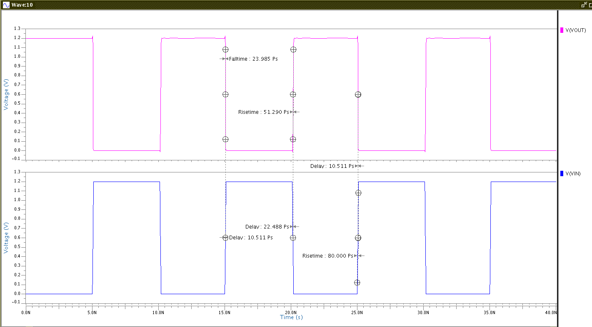

**Fig. 5:** Plotted CMOS Inverter Vin and Vout with 40ns transient analysis with profile (T = 25 degrees C, 1.2V Pulse on Vin swept)

The delay, rise and fall times were measured and they are shown on the plot in figure 5. These metrics will operate as a baseline for the expectations of the layout developed during this exercise. Figure 6 is the DC voltage characteristic plot of the layout.

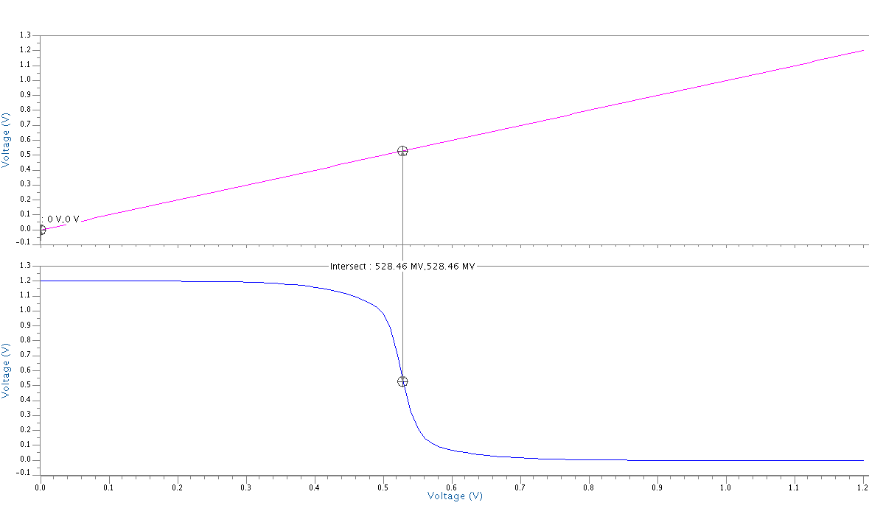

**Fig. 6:** Plotted CMOS Inverter characteristics using layout with profile (T = 25 degrees C, DC signal on Vin swept from 0V to 1.2V and Vdd held constant at 1.2V)

This plot is almost the same as the inverter from the schematic but there is a slight variance in the behavior. The midpoint voltage is now at 528.46mv. This increase means the circuit is technically less receptive to noise because the midpoint voltage is closer to the theoretical midpoint of 1.2V which is .6V. The plot of the layout pulse simulation is shown in figure 7.

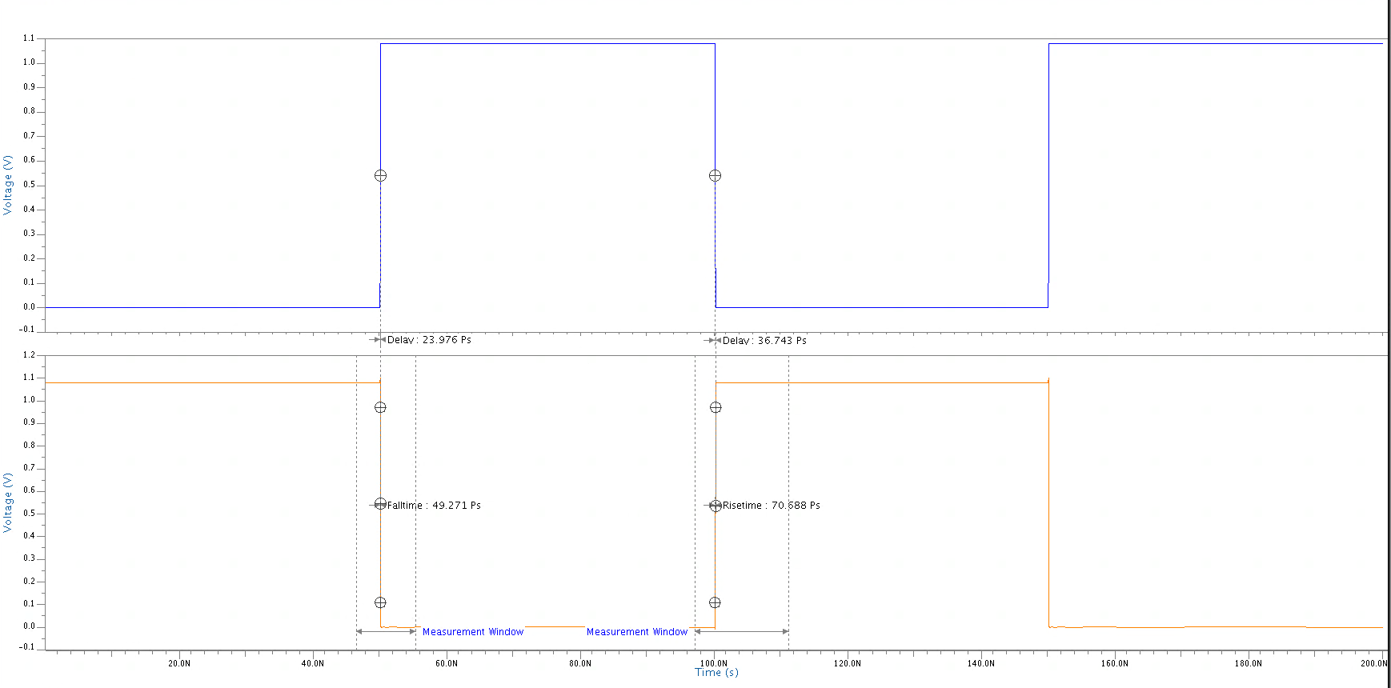

**Fig. 7:** Plotted CMOS Inverter from Layout Vin and Vout with 40ns transient analysis with profile (T = 25 degrees C, 1.2V Pulse on Vin swept)

These measurements were used to gather timing information about the inverter circuit made by the layout. The timing information from the inverter circuit with the schematic is shown in figure 1.

Table 1: Schematic Inverter Results

|  |  |  |  |  |  |  |  |
| --- | --- | --- | --- | --- | --- | --- | --- |
|  | **VDD [V]** | **Temp [°C]** | **Load**  **Capacitance [fF]** | **Rise Time[S]** | **Fall Time[S]** | **TP,HL [S]** | **TP,LH [S]** |
| Nominal | 1.2 | 25 | 0 | 5.13E-11 | 2.40E-11 | 2.25E-11 | 1.05E-11 |
| Nominal | 1.2 | 25 | 120 | 1.74E-09 | 9.08E-10 | 4.65E-10 | 8.15E-10 |
| Worst Case | 1.08 | 125 | 0 | 5.39E-11 | 4.26E-11 | 2.33E-11 | 1.28E-11 |
| Worst Case | 1.08 | 125 | 120 | 2.04E-09 | 1.32E-09 | 9.58E-10 | 6.03E-10 |

The timing information extracted from these plots are shown in table 2.

Table 2: Layout Inverter Results

|  |  |  |  |  |  |  |  |
| --- | --- | --- | --- | --- | --- | --- | --- |
|  | **VDD [V]** | **Temp [°C]** | **Load**  **Capacitance [fF]** | **Rise Time[S]** | **Fall Time[S]** | **TP,HL [S]** | **TP,LH [S]** |
| Nominal | 1.2 | 25 | 4.42E-11 | 5.63E-11 | 1.86E-11 | 3.37E-11 | 4.42E-11 |
| Nominal | 1.2 | 25 | 1.80E-09 | 9.22E-10 | 4.88E-10 | 8.23E-10 | 1.80E-09 |
| Worst Case | 1.08 | 125 | 7.07E-11 | 4.93E-11 | 2.40E-11 | 3.67E-11 | 7.07E-11 |
| Worst Case | 1.08 | 125 | 2.05E-09 | 1.29E-09 | 6.08E-10 | 9.67E-10 | 2.05E-09 |

The values of these tables are very similar and the best way to compare is to compare the input and throughput frequencies of the circuits. Equations 1 and 2 are the method of solving for these critical frequencies.

$$F In Max= \frac{1}{rise time+fall time}$$

**Equation 1.** F Input Max calculation

$$F througput MAx= \frac{1}{Tp,HL+Tp,LH}$$

**Equation 2.** F throughput max calculation

These equations were used to generate the worst case frequency information in table 3.

Table 3: Inverter Frequencies

|  |  |  |  |  |  |
| --- | --- | --- | --- | --- | --- |
| **Type** | **VDD [V]** | **Temp [°C]** | **Load**  **Capacitance [fF]** | **Finput, max [Hz]** | **FThroughput, Max [Hz]** |
| Schematic | 1.08 | 125 | 0 | 1.037E+10 | 2.771E+10 |
| Schematic | 1.08 | 125 | 120 | 2.976E+08 | 6.404E+08 |
| Layout | 1.08 | 125 | 0 | 8.331E+09 | 1.647E+10 |
| Layout | 1.08 | 125 | 120 | 2.994E+08 | 6.349E+08 |

From the table, it is easy to see that the custom layout performed worse in almost all cases except for worst case input frequency. This is most likely since the synthesized layout is already tuned because this is a trivial circuit. More complex circuits could possibly be made to be faster through design improvements that are specific to that circuit in the layout editor. It should be noted that the effect temperature and capacitance slow circuit operation. Temperature changes the rate of transistor current flow and the added capacitance further slow delay by requiring that they be fully saturated before anything hits the output line.

The area of the layout is 15.516 uM2 as the length is 6.465uM and the width is 2.4uM. There is one PMOS and one NMOS in the design.

# CONCLUSIONS

The way to get the fastest and most highly customized circuits are to design these circuits with layout tools. In this lab exercise, layout tools were used to design a CMOS inverter circuit. The results of timing and simulation were compared to the generated version of the circuit. This lab successfully showed the importance of custom layouts and that a potential speed benefit can come from custom layouts. When looking at the worst-case results of the schematic method and the layout method, the maximum throughput and input frequencies were 16.4GHz and 8.3GHz for the layout. For the schematic the results were 27.7GHz and 10.3GHz for throughput and input frequencies respectively. Since the design is trivial, the synthesis tool is probably tuned for this sort of layout generation and so the non-custom layout was better. This is probably not always the case though.

# QUESTIONS

1. From your extracted SPICE netlist, draw a picture of your inverter with the extracted parasitic capacitances and resistances. You will need the files that are included in your .sp file (.include ). Briefly discuss what each RC network represents.
   1. The model is shown at the end of this explanation. Each RC network shown is a sub circuit that represents the parasitic resistances and capacitances that are associated with each node of the circuit. These passive components include all parts of the circuit, which means the transistors are shown in the RC delay model form in here. They are in this list somewhere in some combination of resistors and capacitors.
   2. Here is the drawn circuit:

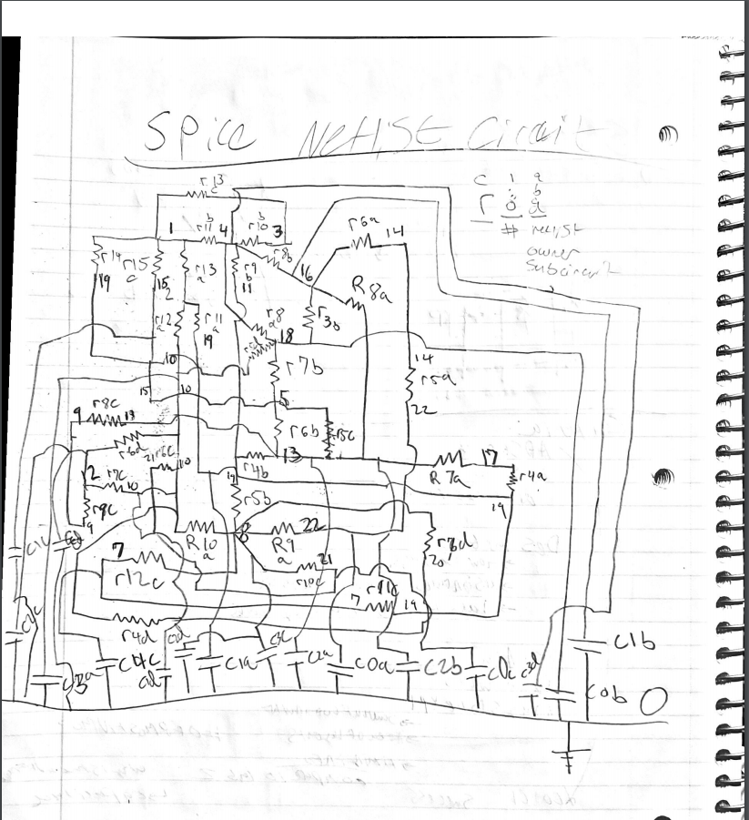

# APPENDIX

Simulation Profile Circuit File:

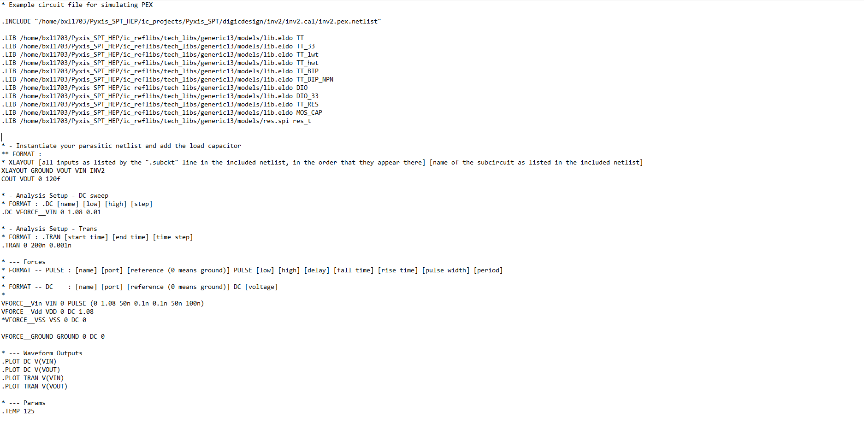

Extracted HSPICE netlist:

* File: inv2.pex.netlist.pex

* Created: Fri Oct 4 15:57:17 2019

* Program "Calibre xRC"

* Version "v2013.4_26.18"

* Nominal Temperature: 27C

* Circuit Temperature: 27C

*

.subckt PM_INV2_GROUND 1 2 16

c0 22 0 0.15714f

c1 19 0 0.281799f

c2 13 0 0.329739f

c3 10 0 0.228983f

r4 17 19 0.327298

r5 14 22 0.026824

r6 14 16 0.100282

r7 13 17 0.0453973

r8 13 16 0.188169

r9 8 22 0.0153724

r10 8 10 0.29363

r11 2 19 15.53

r12 2 10 15.61

r13 1 2 6.27522

.ends

.subckt PM_INV2_VOUT 1 3 8

c0 18 0 0.537529f

c1 16 0 0.10202f

c2 13 0 0.09945f

r3 16 18 0.0577135

r4 11 13 0.03584

r5 8 11 0.0624

r6 5 13 0.0126293

r7 5 18 1.16293

r8 4 16 15.53

r9 4 11 15.61

r10 3 4 3.51923

r11 1 4 6.01622

.ends

.subckt PM_INV2_VDD 1 3 12

c0 21 0 0.16146f

c1 15 0 0.103081f

c2 9 0 0.251373f

c3 8 0 0.23468f

c4 7 0 0.0985f

r5 13 15 0.0615211

r6 10 21 0.0254635

r7 10 12 0.044

r8 9 13 0.0351279

r9 9 12 0.173333

r10 8 21 0.0168226

r11 7 19 0.0611843

r12 7 8 0.48186

r13 1 3 3.44885

r14 1 19 15.53

r15 1 15 15.61

.ends

.subckt PM_INV2_VIN 4 8 12

c0 12 0 0.1256f

c1 10 0 0.166f

c2 8 0 0.376634f

c3 4 0 0.513364f

r4 10 20 10.0225

r5 10 18 9.82252

r6 10 12 11.07

r7 8 20 86.1538

r8 4 18 133.077

.ends

# SOURCES

Rit CMPE Digital IC design lab 4 manual, RIT

