Mini Project 3

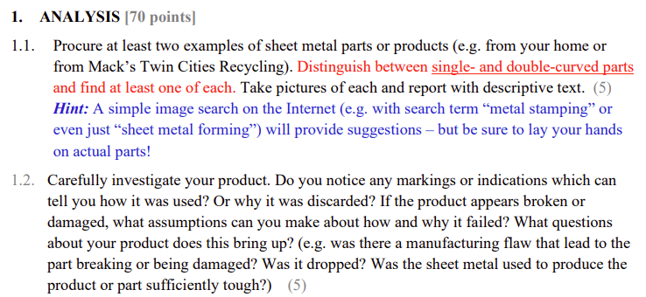



**Figure 1. Dish Tray**

The above photo is a dish tray rack that is commonly used in households. On the bottom of the tray there is a metal plate that collects the excess water from the dishes. According to its curvature and shape it seems to be manufactured through stamping. There are any signs of usage because mainly the part is stationary collecting water droplets and does not have external forces acting on them constantly.



**Figure 2. Lollipop Can**

The photo above is a can that used to contain lollipops. The can has a vertical connecting section where we can speculate the manufacturing method, roll forming. Once the sheet metal goes through the roll the two ends of the metal need to be connected to form a cylindrical shape. The product was used to contain lollipops so it is quite difficult to notice indications of usage. However, there are some dents on the side from forces



**Figure 3. Bookend**

The bookend above holds the book from falling towards the side. The bookend is manufactured by simply bending sheet metal in a single curvature. There are signs of wear due to dropping the bookend to the ground. Also, there may be some bent on other bookends from external forces.

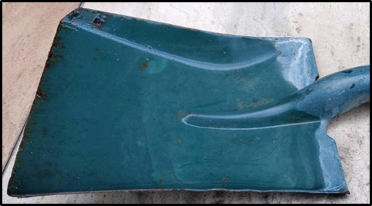

**Figure 4. Steel shovel head.**

Shown above is a steel shovel head commonly used in outdoor environments for displacing soil or sand. The shovel head is manufactured from sheet metal, via heating and shaping by a machine press. It is curved in two directions, from the base to the tip, as well as from one side to the other. Thus, it is considered a double-curved sheet metal component. The shovel head exhibits signs of heavy usage and significant wear due to the external environment it is exposed to as well as the intended usage of the part. However, while there is significant rust damage and loss of external paint due to constant exposure to moisture and external forces, the overall geometry of the shovel head is relatively unchanged from its original shape. This implies that the sheet metal used to produce the shovel head was sufficiently tough and resistant to plastic deformation.

1.3. Which of the alloys shown in the table below has the “best” formability, and which has the “worst”? Explain briefly. (10)

*Hints: Consider which property is inextricably tied to tensile plastic deformation as a principle and which property can, at best, only be a limitation for the method or means of manufacturing. Further, consider that in theory, you can always find (or build) a bigger machine. So, yield stress can at best only be a practical limit to formability (in combination with sheet metal size and thickness, it can be a problem for a given piece of machinery), not a principal constraint.*

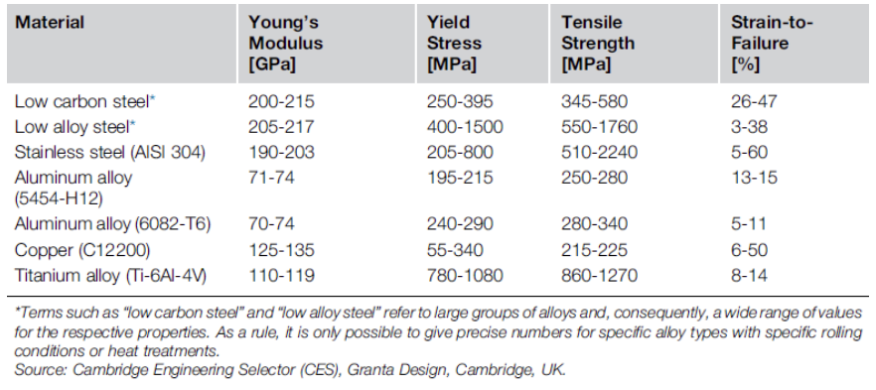**Figure 5. Various metal alloys and corresponding material properties.**

* Formability is the ability of a certain metal part to undergo plastic deformation without being damaged. This property is closely related to ductility, another material property that determines how much plastic deformation due to tensile stress a part can experience before failing. Compared to ductility, which is intrinsically tied to the amount of tensile plastic deformation, formability is generally limited by the method or means of manufacturing. Formability is best suited to be described by the values of the strain-to-failure percentages in the table above. As can be seen above, stainless steel would most likely possess the “best” formability as the higher bound of the strain-to-failure of 60% is the highest among all the materials. Contrastingly, low alloy steel, with a minimum strain-to-failure of only 3%, has the “worst” formability. Yield stress is not used to determine formability as the value of yield stress must be exceeded in sheet metal forming in order to generate sufficient plastic strain to permanently deform the material.

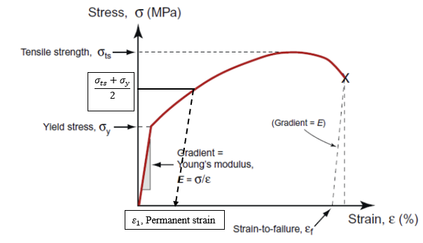**Figure 6. Stress-strain diagram of a given metal component.**

1.4. Consider the stress-strain diagram. Suppose we deform the metal component to a stress halfway between its yield stress and its tensile strength and then unload it. On a sketch of the stress-strain curve, show how you would find the permanent strain up to this point. The metal component is then re-loaded to find its new, strain-hardened yield stress. Explain why the value will be higher than the nominal value at the point when unloading was started in the previous test. (10) *Hints: Think carefully about how the component’s dimensions change during a tensile test, and how yield stress is defined.*

* Yield stress is defined as the stress at which a material begins to deform plastically. When the metal component is loaded past its yield stress , it yields and begins to undergo plastic deformation. Strain hardening also begins as the stress exceeds the yield stress which increases the strength of the metal. When the metal is unloaded, it follows a linear path whose slope is equal to the Young’s modulus of the material until the stress reaches zero, at which all elastic strain is recovered. However, there will be some permanent strain or plastic strain retained by the metal, denoted in the figure above by . As the metal is loaded again, the stress-strain behavior would follow the same path as when it unloaded, represented by the dashed line in the figure until it intersects with the original stress-strain curve. This point represents the new strain-hardened yield stress and its value is higher than the original yield stress value as a result of the strain hardening experienced by the metal component by loading it beyond the elastic limit.

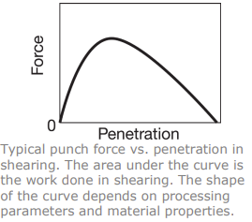

**Figure 7. Graph of typical punch force vs. penetration in shearing.**

1.5. (a) Discuss the material and process variables that influence the shape of the curve of punch force vs. stroke for shearing, such as that shown in the figure alongside, including its height and width. (5)

i. The geometry of the shearing region, such as the total surface area that is being sheared and the thickness of the sheet. These variables increase both the punch force and stroke for shearing.

ii. Material properties such as the shear strength of the material and the corresponding strain-hardening exponent increase the total amount of force required to successfully shear the material.

iii. The area of material that is experiencing burnishing due to contact between the punch and die walls that can result in increased force required for shearing.

iv. Process variables such as punch and die diameter, clearance, punch speed, and lubrication can also affect the required punch force and penetration.

(b) As a practicing engineer specializing in manufacturing, why would you be interested in the shape of the curve? Explain. (5)

- The shape of the punch force vs. penetration curve illustrated above is important as it provides critical information regarding process variables. For example, as the y-axis represents the typical punch force required, the height of the curve depicts the maximum punch force while the horizontal axis illustrates the punch travel distance required in order to successfully shear the material. Additionally, as the area under the curve is equivalent to the product of force and distance, this region shows the total energy expended during the shearing operation.

1.6. (a) Explain why and how various factors influence springback in bending of sheet metals.

- When sheet metal parts are bent into the desired shape, they undergo plastic deformation. However, when the bending pressure is removed, the bent part partially recovers its original shape as there is residual elastic energy remaining in the part as a result of their finite modulus of elasticity. Given a certain value for the modulus of elasticity, a greater yield stress value corresponds to greater springback as a result of the increased elastic recovery strain. Springback can also be approximated as a ratio of the initial bend radius to final bend radius as shown in the equation below:



As can be seen, springback increases as the initial bend radius increases while increasing the sheet thickness results in reduced springback.

(b) Does the hardness of a sheet metal influence the metal’s springback in bending? Explain. (5)

- Hardness is a material property that is dependent on strength, which itself is a measure of the ability of a material to sustain an applied load without experiencing plastic deformation. As yield stress is an indicator of the onset of plastic deformation, this implies that the strength of a material is derived from its yield stress. Thus, following from Equation (1) above, springback is proportional to yield stress and hence the hardness of a sheet metal influences the amount of springback experienced by it in bending.

1.7. Estimate the maximum bending force required for a 2-mm thick and 250-mm wide Ti-6Al-4V titanium alloy, annealed and quenched at 25ºC, in a V-die with a width of 150 mm.(5)

- Given parameters: 

The maximum bending force required can be calculated as below:



For a V-die, the value of *k* ranges from 1.2 to 1.33. An average of this range is used for the following calculations:

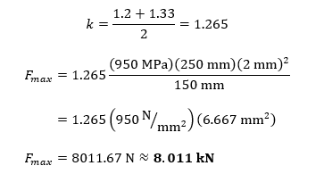

1.8. Calculate the press force needed in punching 0.25-mm-thick 5052-H34 aluminum sheet in the shape of a square hole 30 mm on each side. (5)

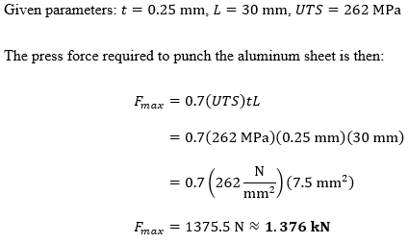

1.9. A straight bead is being formed on a 1-mm-thick aluminum sheet in a 20-mm-diameter die, as shown in the accompanying figure. (See also Fig. 7.25a. in Kalpakjian’s book.) Let Sy = 90 MPa. Considering springback, calculate the outside diameter of the bead after it is formed and unloaded from the die. (10) *Hint: Use equation (7.10) in Kalpakjian’s book.*

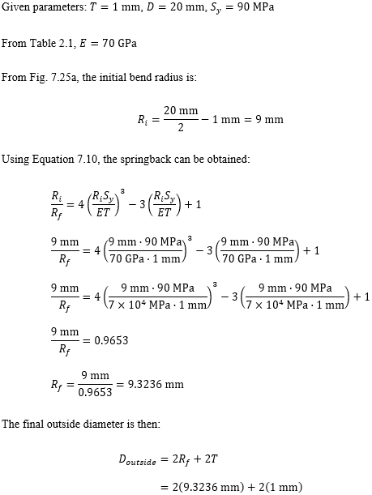

**

**2. DESIGN CHALLENGE [30 points]**

2.1. (a) Design a box that will contain a 100-mm × 150-mm × 75-mm volume. The box should be produced from a single piece of sheet metal and require no tools or fasteners for assembly. In your answer, you should consider the blank shape, whether the box will be deep-drawn or produced by bending operations, the method of attaching the parts, and the dimensions of the two halves. (10)

The box should be created first using deep drawing, with the dimensions of the purple rectangle indicated in figure 3 below: 150 mm × 100 mm. Then, we will use a wiping die to stamp along the blue line indicated below to close off the box. Using deep drawing and wiping dies allow us to make 90 degree angles very easily, and the dimensions are necessary because after one side of the box is bent, we need to make sure it can fit over the die so that we can bend the other side.



**Figure 8. Blank model of box constructed in Creo.**

(b) You must make a low-fidelity prototype of your design by using cardboard and tape, for instance. Take high-resolution pictures of this prototype and show these in your answer, together with explanatory text. (10)

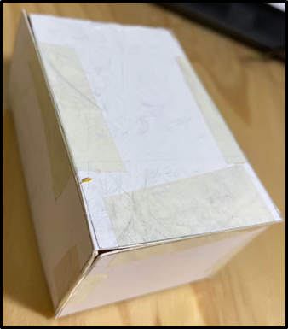

**Figure 9. Scaled-down prototype of box design previously illustrated.**

Shown in Figure 9 above is the prototype of the cardboard box designed in part (a). The prototype is scaled down by a ratio of 1:2.083 (12:25), as we were unable to procure a piece of cardboard box that allowed us to cut out the exact dimensions as provided in the previous section. The new, scaled-down dimensions are 48-mm × 72-mm × 36-mm. The shape of the cardboard is cut into the beginning shape shown above and folded by the lines between the squares.

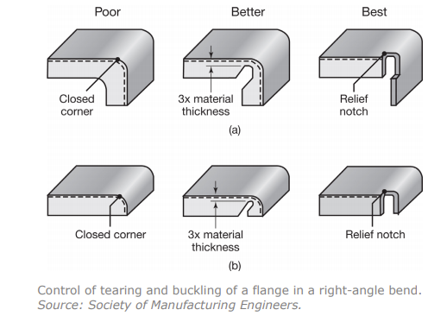

**Figure 10. Design suitability for the control of tearing and buckling of flanges in a right-angle bend (Society of Manufacturing Engineers).**

2.2. Obtain a few pieces of cardboard and carefully cut the profiles to produce bends as shown alongside. Demonstrate (with the use of photos of the parts) that the designs labeled as “best” are actually the best designs. Comment on the difference in strain states between the designs. (10)

i. ‘Poor’ designs:

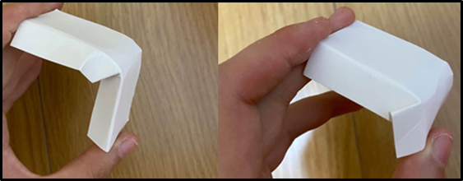

**Figure 11 & 12. Cardboard profiles cut according to the ‘Poor’ design category and subjected to a right-angle bend. Significant crinkling and folding is observed at corners.**

Figure 11 depicts the top left ‘Poor’ model that we have created. As shown in the photo there is a significant amount of buckling experienced by the cardboard at the point of curvature, with the most extreme curve at the center of the curvature, where the cardboard begins to fold over itself. Thus, we can deduce from the behavior of the cardboard piece that it would be extremely hard to bend a piece of sheet metal in a similar manner, since there would be so much stress placed on the metal, cracks and fractures will appear where the curve begins to form. Figure 12 is a model of the bottom design under the ‘Poor’ category and exhibits similar phenomena to the former model. One notable difference between the two models is that the vertical wall folds into the model for the first model while in the latter, the vertical wall folds onto and out of the model. Thus, it would be extremely hard to bend a piece of sheet metal in a similar manner, since there would be so much stress placed on the metal it will crack and break where the curve begins to form.

ii. ‘Better’ designs:

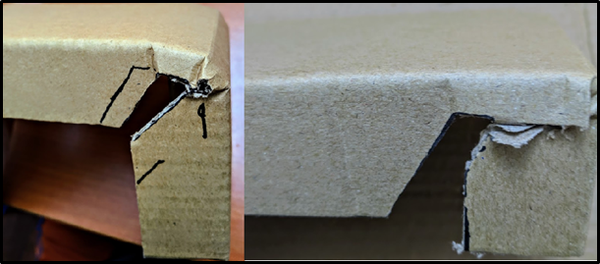

**Figures 13 & 14. Cardboard profiles cut according to the ‘Better’ design category and subjected to a right-angle bend. Some crinkling is observed at corners.**

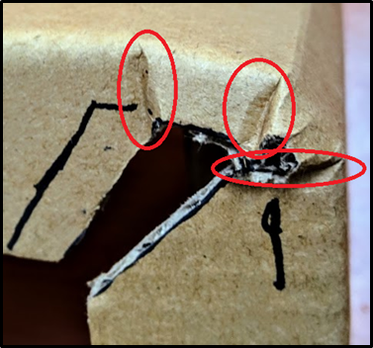

**Figure 15. Regions of significant strain due to stress concentration.**

Figure 13 shows a recreation of the upper design in the ‘Better’ category, where a notch is cut into the sides of the cardboard at the curved section. The distance between the top edge of the notch and the upper surface of the cardboard is approximately three times the thickness of the cardboard (3 mm×3=9 mm). When bent at a right angle, the cardboard shows some degree of crinkling but is significantly less than exhibited by the ‘Poor’ models. There are three notable points where the crinkling is most obvious, which are at the edges and the midpoint of the curvature, each of which coincides with the corners of the notch, and are shown in more detail in Figure 15. The cardboard model in Figure 14 is constructed based on the bottom design in the ‘Better’ design category and is similar to the previous design with the exception of a narrower notch. When subjected to a right-angle bend, the cardboard produces a relatively sharp bend instead of a gradual curve as the stress concentration is higher at the tip of the notch as compared to the previous model due to the narrowed notch.

iii. ‘Best’ designs:

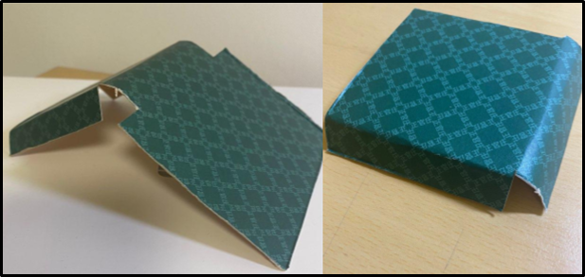**Figure 16 & 17. Cardboard profiles cut according to the ‘Best’ design category and subjected to a right-angle bend.**

Figure 16 and 17 shows the upper and lower designs in the ‘Best’ category respectively, and are constructed with relief notches incorporated into both designs. These notches are essential for controlling the behavior of the sheet material and prevents unwanted deformation. They help to reduce the amount of distortion or tearing of the material at the bend as these are usually seen at the transition layer between a bend and flat surface. When subjected to a right-angle bend, the cardboard profiles exhibit a smooth curve without any crumpling or buckling, as compared to the models based on those in the ‘Poor’ and ‘Better’ categories.

Works Cited

1. “Titanium Ti-6Al-4V (Grade 5), Annealed.” *ASM Material Data Sheet*, ASM Aerospace Specification Metals Inc., asm.matweb.com/search/SpecificMaterial.asp?bassnum=MTP641.
2. “Aluminum 5052-H34.” ASM Material Data Sheet, ASM Aerospace Specification Metals Inc., asm.matweb.com/search/SpecificMaterial.asp?bassnum=MA5052H34.
3. Bedford A., Liechti K.M. (2020) States of Strain and Stress-Strain Relations. In: Mechanics of Materials. Springer, Cham. <https://doi.org/10.1007/978-3-030-22082-2_8>
4. “Reliefs.” *Sheet Metal Workbook*, [www.sheetmetalworkbook.com/reliefs.htm](http://www.sheetmetalworkbook.com/reliefs.htm).
5. Davis, Gerald. “Design Tips for Sheet Metal.” The Fabricators, 25 Oct. 2001, www.thefabricator.com/thefabricator/article/bending/design-tips-for-sheet-metal-bend-relief-small-holes-hole-distortion-near-bends-and-minimum-flange-widths.