ME 270

**Mini Project 4**

Personalized Assistive Device to be Manufactured by 3-D Printing

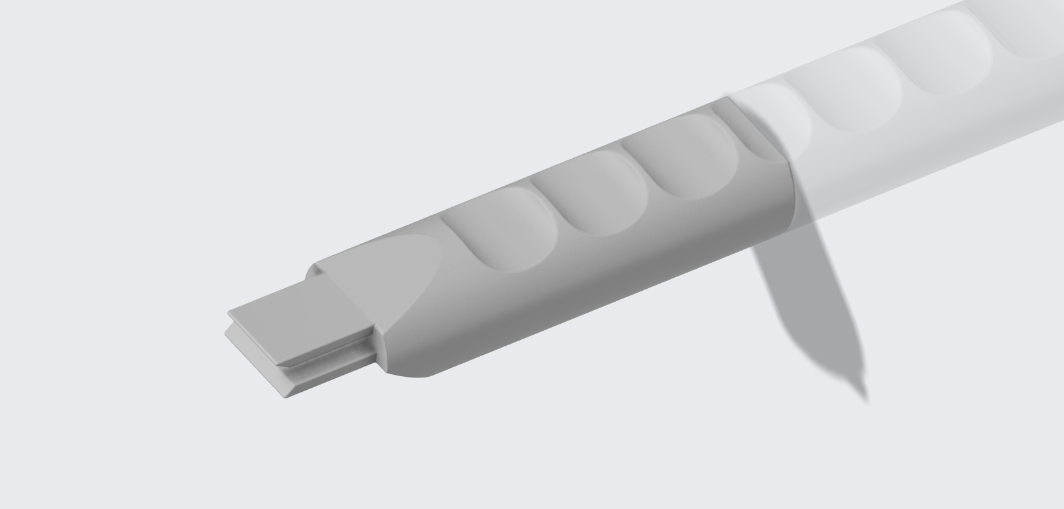

Group: ABG_2

Group Members: Alice Lin, Brian Lee, Ryan Phoon

Due Date: 10/15/2020

1. **DESIGN**
   1. **Identify Need**

Aluminum cans and tins are one of the most commonly used products for the storage of foods and beverages. Almost all modern aluminum cans and tins have built-in ring tabs that serve as their opening mechanism. Food tins usually use full-top pull-tabs that allow for the removal of the entire top cover while beverage cans mostly utilize stay-on-tabs. Opening the lids of said containers require the individual to lift the tab and pull on it, which even for most individuals, requires some amount of strength and grip to achieve due to its small size which requires more force to open the lid. Musculoskeletal disorders can lead to degradation of muscles in the hand and affect hand dexterity, strength, and coordination. Motor disorders such as ulnar nerve palsy and carpal tunnel syndrome are common conditions that can result in a weak grip. Both musculoskeletal and motor disorders can affect an individual’s fine motor skills and their ability to perform most routine tasks. Individuals affected by the aforementioned conditions will thus find it extremely difficult and inconvenient to manually open food and drink cans without assistance from others.

To assist individuals with musculoskeletal or motor disorders, a product would be designed that would be able to allow users to more easily lift the tab as well as generate enough force to open the lids of food or beverage cans. The product, while most optimized for standard-sized beverage cans, would also be designed in such a way that it would also function for larger cans without sacrificing much effectiveness. Furthermore, while the target audience for the product are individuals with physical disabilities, the product can also be utilized by the general public with ease.

* 1. **Background Research**
     1. **Journal Papers and Articles**

Atroshi I, Gummesson C, Johnsson R, Ornstein E, Ranstam J, Rosén I. Prevalence of Carpal Tunnel Syndrome in a General Population. JAMA. 1999;282(2):153–158. doi:10.1001/jama.282.2.153

Individuals with carpal tunnel syndrome suffer from symptoms such as pain, numbness, as well as tingling sensation in the hands and is also a factor that contributes to work disability. The article also shows that carpal tunnel syndrome is a relatively common motor disorder, with the prevalence of clinically certain carpal tunnel syndrome at 3.8%, while 2.7% of the 3000 subjects had been clinically diagnosed with the disorder. Hence, this implies that the proposed assistive device would be able to positively influence the daily lives of a significant number of people as well as have a large target audience.

Eli Carmeli, Hagar Patish, Raymond Coleman, The Aging Hand, *The Journals of Gerontology: Series A*, Volume 58, Issue 2, February 2003, Pages M146–M152, <https://doi.org/10.1093/gerona/58.2.M146>

The journal by Eli Carmeli mainly focuses on the effects of aging in people’s hands. The journal starts off with discussing the importance of our hand in our daily lives. Mainly, the journal stresses that the hand is the only prehensile, ability to wrap around, organ in a human body. Then, Eli elaborates on the functionality loss due to aging in terms of hand muscles, hand tendons, joints, fingernails, nerve changes and skin changes. In general, in every aspect, deterioration of our hand is inevitable. To summarize some data, hand muscles reduction range from 25% to 45% resulting in decreased grip strength by 20-25%; hand tendons, the tissues that deliver the force to the bones, decreased by 30-50%; bones reduces their density by 0.72% per year; fingernails grow slower after 60 causing difficulty in fine grip and manipulation of small objects; nerve become dull; the surface of the skin change causing difficulties in griping. The journal suggests that elders, especially anyone after the age of 60, have difficulty functionally moving their hand. Thus, many elderly people would have difficulty in using both hands, one to grip an aluminum can, and the other to make a rotational movement.

Neuprez, A., Bruyère, O., Maheu, E. et al. Aesthetic discomfort in hand osteoarthritis: results from the LIège Hand Osteoarthritis Cohort (LIHOC). Arthritis Res Ther 17, 346 (2015). <https://doi.org/10.1186/s13075-015-0807-y>

This article mainly discusses the causes of hand distortion for patients with hand osteoarthritis. It also mentions that hand osteoarthritis is a very common condition among us. Patients with this condition tend to have difficulty conducting daily activities that require fingers’ agility or joint movements. This most certainly makes it very difficult for patients to open pop cans, which requires a certain amount of strength and agility even for people without disabilities. The article also mentions that further distortion of the hands is caused by erosion of joints, which is in turn caused by the application of strain on these joints (such as lifting heavy objects and making large joint movements). The proposal of this device would limit the patients joint movements and allow them to use minimal strength to open the can.

Sande, Luciane Pascucci, et al. “Effect of Musculoskeletal Disorders on Prehension Strength.” *Applied Ergonomics*, vol. 32, no. 6, Dec. 2001, pp. 609–616. *EBSCOhost*, doi:10.1016/S0003-6870(01)00035-7.

As mentioned in the article, individuals suffering from musculoskeletal disorders possessed a reduced maximum grip strength and ability to generate larger grip forces on tools as compared to healthy individuals. Additionally, the article suggests that sustained occupational exposure may also be associated with a reduction in hand grip strength. The article also proposes that the affected individual should preferably use minimal strength for actions as a possible remedy for musculoskeletal disorders as well as to prevent the injury from worsening.

Hence, the assistive device to be designed can also aid affected individuals with the recovery process, in addition to alleviating the difficulties and discomfort that would be experienced in the process of using the product in question.

Ye, L., Kalichman, L., Spittle, A. et al. Effects of rehabilitative interventions on pain, function and physical impairments in people with hand osteoarthritis: a systematic review. Arthritis Res Ther 13, R28 (2011). <https://doi.org/10.1186/ar3254>

Hand osteoarthritis causes joint pain and stiffness, as well as weakness in grip strength. This article mainly discusses effective methods to recover from hand osteoarthritis. Some methods suggested include minimal range of motion of joints to prevent further erosion of musculoskeletal structures and the reduction of strength in daily works. From this article it is evident that our proposal matches with the suggested actions found in this article.

* + 1. **Professional Organizations and Websites**

Access 3D Services (A3D) [https://www.access3dservices.com/] is a nonprofit organization under Access Independence that utilizes 3D printing technology to aid individuals affected with disabilities on the path to independence and societal integration. The organization is a rapid prototyping and engineering firm that designs and manufactures custom-made assistive devices using additive manufacturing. An example of their work is a 3D printed attachable handle designed to fit onto drink cartons for an individual who was suffering from a spinal cord injury.

CATI [<https://www.cati.com/blog/2018/04/assistive-devices-impact-3d-printing-technology/>] is a professional organization in engineering that compiles information and news on innovations in the field of engineering. This website shows that 3D printing technology is quite commonly used in the medical community nowadays. According to CATI, assistive devices using 3D printing can be made as simple as a holder for utensils or as complicated as internal organs or prosthetics. The advantage of 3D printing these assistive devices is that medical institutions or companies can produce personalized devices according to preferences and conditions of the customer, which in turn enhances the user experience of these devices. It has also made medical prosthetics more accessible to more people, since 3D printing technology has effectively reduced the cost of manufacture and hence becomes more inexpensive to the general public. Such assistive devices are also used as means of treatment for patients who might not afford surgical recovery.

* 1. **Product Design Specifications / Point-of-View Statement**

PDS:

1. MATERIALS
   1. The material must have a high enough strength to resist elastic deformation in order to effectively open the clip of the can with minimal applied force.
   2. The material must also possess some elasticity to ensure that it would not experience brittle fracture when placed under stress as a result of opening the clip of the can.
   3. For FDM processes, commonly used materials are ABS plastic, polycarbonate, and resin, all of which are very strong and durable (Stratasys: Fused Deposition Modelling), and are thus suitable candidates for the material of the assistive device.
   4. The material used to manufacture the assistive device must also be waterproof and heat resistant.
2. SIZE
   1. The assistive device has a length of 13 cm
   2. The assistive device has a width of 3 cm
3. WEIGHT
   1. The assistive device weighs a maximum of 30 g
   2. The assistive device should be lightweight to ensure that it can be easily utilized by individuals with musculoskeletal or motor disorders.
4. PRODUCT LIFE SPAN
   1. The assistive device is expected to have a minimal lifespan of 1 year at a usage frequency of 5 times a day.
   2. A unibody design would increase the lifespan of the product by eliminating any defects that may arise from assembly of multiple parts.
5. CUSTOMER
   1. Individuals who have pre-existing conditions with musculoskeletal or motor disorders, where it would be extremely difficult to pull the ring tab back and open the can.
   2. A small number of customers may not have conditions that affect their daily functions but still have trouble with opening aluminum cans due to their nails: those who keep long, manicured nails, in which case the nails would break and cause injuries when opening a can; and those who keep their nails very short due to their careers or personal preferences.
   3. In other words, this assistive device is not only useful for people with physical disorders but also benefits individuals who desire for an easier method to open cans.
6. MAINTENANCE AND REPAIR
   1. The assistive device would be designed such that it would require no maintenance.
   2. The assistive device would have no moving parts, which would eliminate any premature or accelerated deterioration of the product due to friction which would result in more frequent maintenance.

Point-of-View Statement:

Individuals with musculoskeletal disorders or motor impairments require an assistive device that allows them to open up aluminum tins or cans without external assistance by providing them with more grip and leverage than personally possible because aluminum tins and cans are very common products that will likely be encountered on a daily basis by the user and thus the product would allow the user to open the cans while spending less time and effort in doing so.

* 1. **Generate Design Ideas (“Ideate”)**

Our team started with basic analysis on the mechanics behind opening a pop can. We found that under any circumstances, a person with no disabilities would first lift the ring tab up, and then pull the tab in the direction of the seal, which is a scored portion of the lid. This allows the tab attached to the lid to function as a lever in which the part of the tab in direct contact with the seal will push down on it and consequently depress it until it is folded underneath the top surface. Different designs of the can indicate that sometimes the moment created by the forces acting on the ring tab may be in opposite directions, so users would have to pull in the opposite directions in order to remove the seal.

This finding shows us that we need to design an assistive device that can allow users to create moments in both the positive and negative z-direction (in or out of the page) in order to remove the ring tab. And we revolved our designs around this idea.



**Figure 1. Miro collaborative page illustrating ideation phase with creative brainstorming process.**

* 1. Analyze and Select Design

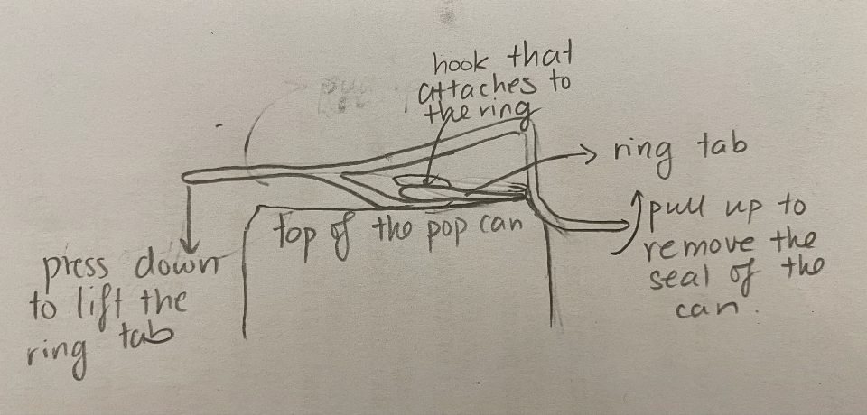

**Figure 2. Initial concept sketch for the assistive device, Design 1. Used as control for the Pugh matrix.**

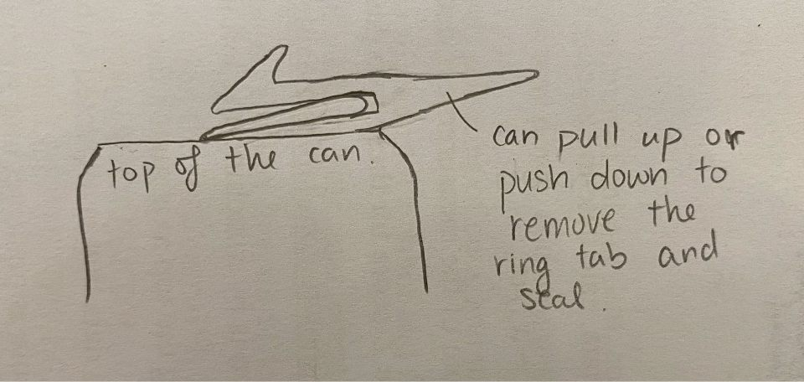

**Figure 3. Sketch of Design 2, created by simplifying and increasing wall thickness of initial design**

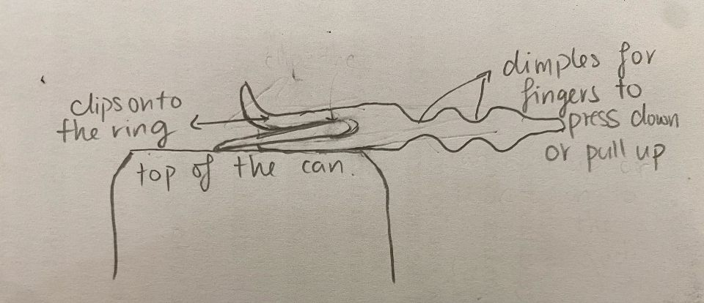

**Figure 4. Illustration of Design 3. Depressions or ‘dimples’ spanning the width of the assistive device are added to provide locations to hold the fingers of the user in place during usage.**

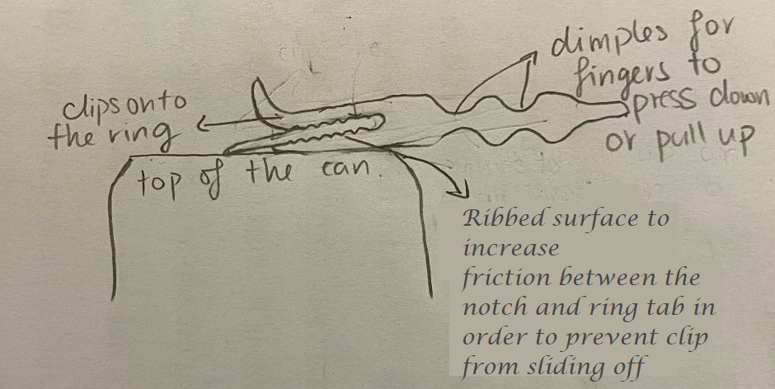

**Figure 5. Sketch of Design 4. Similar to Design 3 but with inner surfaces of the notch textured to prevent the device from sliding off the ring tab during usage.**

* + = better than
* ++ = much better than
* - = worse than
* -- = much worse than
* S = about the same as the datum, some doubt, etc.

**Table 1. Pugh Matrix for determining the best product design iteration.**

|  |  |  |  |  |  |
| --- | --- | --- | --- | --- | --- |
| CONCEPT  CRITERIA | WEIGHT of Criteria  1 = Low  3 = High | 1 | 2 | 3 | 4 |
| Weight | 2 |  | S | S | S |
| Size | 2 |  | ++ | + | + |
| Performance | 3 |  | S | + | ++ |
| Ergonomics | 2 | D | + | ++ | ++ |
| Ease of Use | 3 | A | S | + | + |
| Product Lifespan | 1 | T | + | + | + |
| Manufacturing Cost | 1 | U | ++ | + | + |
| Resistance to Water | 2 | M | S | S | S |
| Resistance to Temperature | 2 |  | S | S | S |
| Resistance to Shock | 2 |  | ++ | + | + |
| Maintenance Requirements | 1 |  | S | S | S |
| Total of + | | n/a | 13 | 18 | 19 |
| Total of - | | n/a | 0 | 0 | 0 |
| TOTAL | | n/a | 13 | 18 | 19 |

A Pugh selection matrix was used to evaluate each concept design iteration to select the best design to be used as the final design for 3-D printing using FDM. The initial design was designated as the control for the Pugh matrix where subsequent designs were evaluated relative to it. In the Pugh matrix, the performance and ease of use criteria were given the highest weights of 3 as these two criteria are the most important in ensuring that the target audience can utilize the product to its fullest potential. Performance was judged based on how much force will the user be required to use in order to successfully operate the device. This means that the less force and strength used by the user to open the can or tin, the higher the performance rating of the device. The ease of use criteria is evaluated based on how convenient it is for the user to correctly set up and operate the product. The size, weight, and ergonomics of the device were all given an equal weight of 2 as the three criteria were closely related to each other and would be evaluated based on the comfort level of the user during operation of the assistive device. Resistances of the device to water, temperature, and shock were also given a weight of 2 each as the device is expected to be placed in locations with possible exposure to the aforementioned elements. For example, if the device is to be kept in the kitchen, it would be subjected to high temperatures from the stove, water from the sink, as well as shock from users accidentally dropping the device on hard surfaces. Criteria such as product life span, maintenance, and manufacturing cost were given the least weightage as the product was intended to be a specially designed device primarily targeted towards individuals with musculoskeletal or motor disorders while being easily replaceable.

The initial design had issues regarding its ease of use and strength, due to its complex design and thin, branching structures. The second iteration of the design included a complete redesign of the original sketch by simplifying and consolidating the design to take on a more compact but robust form. This design version would have greatly reduced the manufacturing cost as well as increased the shock resistance of the assistive device due to the thicker walls. Performance would remain relatively unchanged due to the initial improvement from incorporating the tab notch being offset from the decreased lever length of the design, which would require the user to impart more force to lift the tab. However, this design proved to be a large improvement as compared to the original design.

Design 3 further builds on the pros of the previous iteration while addressing the known drawbacks such as the performance criteria. In this iteration, the ring hook was modified to a more streamlined shape to provide additional clearance at the frontal end of the device. This prevents the top surface of the notch from interfering with the operation of the device by coming into contact with the ring tab. Additionally, depressions or ‘dimples’ were incorporated along the width of the handle in order to provide the user with locations to place their fingers on while applying force on the handle. While the modifications made to the design resulted in increases in the size and manufacturing cost, various improvements were also made in other areas. For example, the performance, ergonomics, and ease of use of this design was improved due to the depressions along the handle which allowed the user to maintain a better grip on the handle to exert more force while providing some degree of comfort. Design 4 further improves upon Design 3 by including ribbed surfaces for the interior of the notch. This would help to prevent the notch from slipping off from the ring tab during usage by increasing the friction between the notch and the ring tab. This would further improve the performance of the assistive device by minimizing the force required for counteracting the slipping of the device.

Based on the results of the Pugh selection matrix, it is apparent that Design 4 would be the most suitable design for 3-D printing using FDM in the Innovation Studio. The smaller size and would result in more rapid printing times with less usage of material which consequently leads to a lower manufacturing cost.

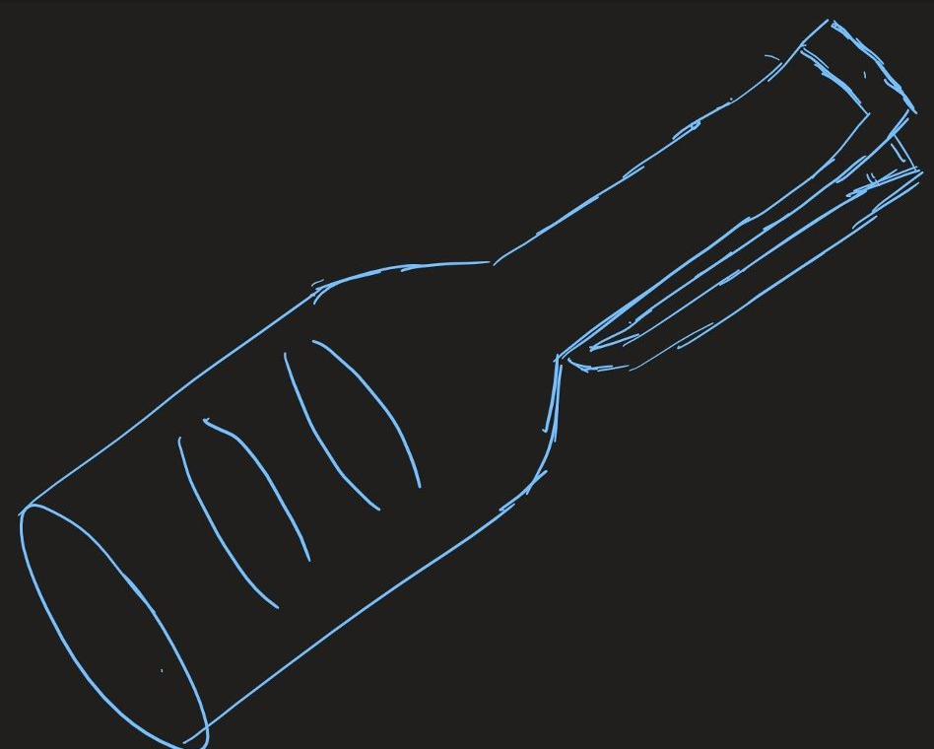

**Figure 6. Rough sketch illustrating the final design choice.**

* 1. **Detail Design**

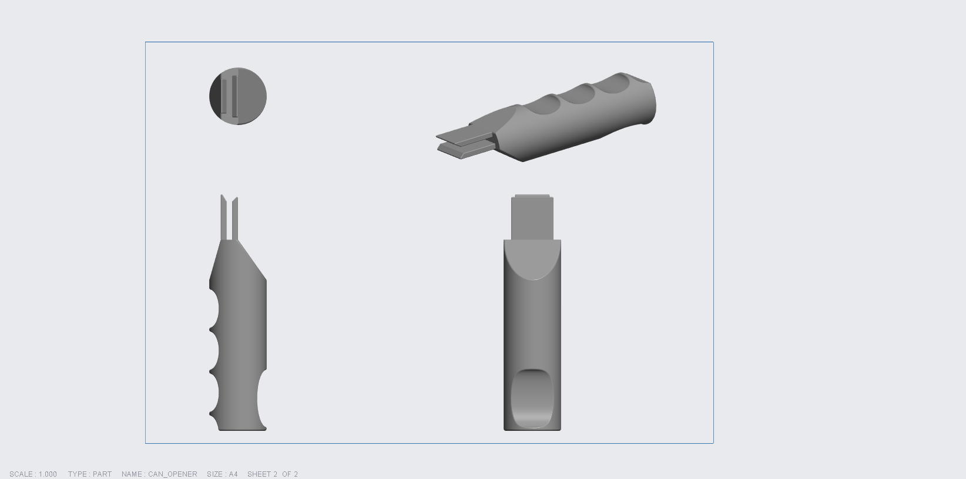

**Figure 7. 3-D model of designed assistive device constructed in Creo Parametric. Isometric, top, front, and side view included.**

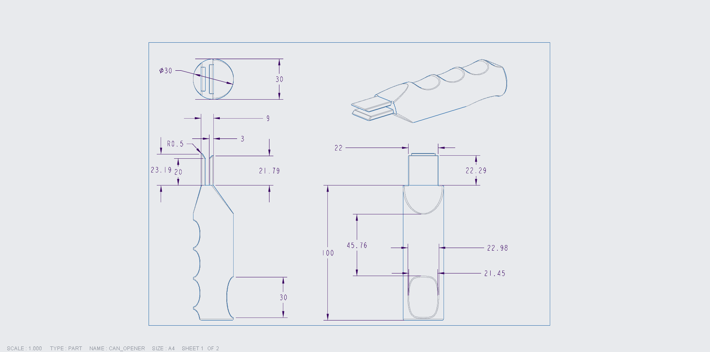

**Figure 8. Assembly drawing of designed assistive device with dimensions included. Isometric, top, front, and side views included.**

The most suitable 3D printing material for this particular part would be PLA. The available 3D printing materials in the MechSE Innovation Studio are PLA, ABS, and CPE. Most 3D printing plastics have similar durabilities. However, PLA stood out as its operating temperature range was deemed the most suitable with regards to the situation and environment that the designed part would be subjected to during routine usage. While the product is unsuitable to be utilized on a hot aluminum can, however, as beverages in aluminum cans are in environments with heat sources, PLA would be better to manufacture this product due to their higher operating temperature range of 60°C - 120°C . The ultimate tensile strength of PLA ranges between 14 MPa - 117 MPa, while its density ranges from 1 - 2.47 g/cc. Lastly, PLA has a Young’s modulus in the range of 0.0850 GPa - 13.8 GPa. From the Pugh selection matrix as shown in Table 1 and considering the availability as well as properties of various 3D printing materials, Design 4 would be the most appropriate part that would be possible to be fabricated via FDM in the MechSE Innovation Studio.

**Table 2. Cost analysis of the designed part for various quantities.**

|  |  |  |
| --- | --- | --- |
| Quantity | Unit Cost | Total Cost |
| 1 | $86.71 | $86.71 |
| 10 | $82.37 | $823.70 |
| 100 | $21.41 | $2141.00 |

A cost analysis was performed on the designed part by using an online tool. The stereolithography (.stl) file of the 3D model for the part was uploaded to the cost calculator provided at Sculpteo. Polypropylene was selected as the manufacturing material along with Multi Jet Fusion as the 3D printing process to be used. The cost analysis process was then initiated to provide cost estimates for the manufacturing of 1, 10, and 100 individual parts. The results of the cost analysis are included in Table 2 above. For a single part, the total cost is equal to the unit cost and is estimated to be $86.71, which is relatively expensive but is expected due to the high fixed costs. By increasing the print quantity to 10 parts, the total cost is predicted to increase to $823.70, with the unit cost obtained by dividing the total cost by 10, at $82.37. While there is a slight decrease in unit cost, it is still too expensive to be commercially sold. However, a large decrease in unit cost can be seen when the total print quantity is further increased to 100 parts, at which the total cost is estimated to be $2141.00, resulting in a unit cost of only $21.41. This means that the unit cost per 100 parts is only approximately one quarter of that when only 10 parts were produced. Further increasing production quantity would lead to consequent reductions in unit costs. While a unit cost of $21.41 is still considered to be relatively expensive, this is expected due to the manufacturing method chosen for the assistive device, as additive manufacturing is more suited towards prototypes and custom-made parts, which justifies the price of the designed assistive device.

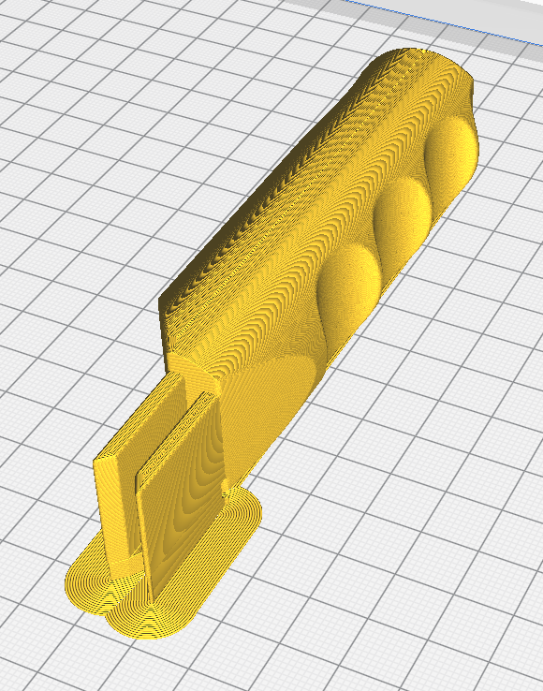

**Figure 9. Preview of designed part in Ultimaker CURA.**

1. **Conclusion**

For this project, our team made very deliberate and thorough consideration with the design of the assistive device, in order to ensure that the design of the device would meet the needs of those with hand grip and strength problems and that our device would be able to assist them in an efficient and effective manner. Further analysis and comparisons were made between different design iterations as to obtain the most suitable design to be used as the final prototype. Considerations were also made with regards to designing the handle of the part to be fairly large to ensure that users would not have to grip down on it to operate the assistive device. The part was also designed to minimize the amount of force the user would have to apply to open the can or lid.

**Works Cited**

Atroshi I, Gummesson C, Johnsson R, Ornstein E, Ranstam J, Rosén I. Prevalence of Carpal Tunnel Syndrome in a General Population. JAMA. 1999;282(2):153–158. doi:10.1001/jama.282.2.153

“Aluminum Bottle/Can Opener - 24 Hr.” *4imprint*, www.4imprint.com/product/7868-24HR/Aluminum-BottleCan-Opener-24-hr.

Eli Carmeli, Hagar Patish, Raymond Coleman, The Aging Hand, *The Journals of Gerontology: Series A*, Volume 58, Issue 2, February 2003, Pages M146–M152, <https://doi.org/10.1093/gerona/58.2.M146>

Erickson, A. (2018, April 04). The Impact of 3D Printing Technology on Assistive Devices. Retrieved October 15, 2020, from <https://www.cati.com/blog/2018/04/assistive-devices-impact-3d-printing-technology/>

“Fused Deposition Modeling [FDM] Parts On Demand.” *Stratasys*, [www.stratasysdirect.com/technologies/fused-deposition-modeling](http://www.stratasysdirect.com/technologies/fused-deposition-modeling).

Neuprez, A., Bruyère, O., Maheu, E. et al. Aesthetic discomfort in hand osteoarthritis: results from the LIège Hand Osteoarthritis Cohort (LIHOC). Arthritis Res Ther 17, 346 (2015). <https://doi.org/10.1186/s13075-015-0807-y>

Sande, Luciane Pascucci, et al. “Effect of Musculoskeletal Disorders on Prehension Strength.” *Applied Ergonomics*, vol. 32, no. 6, Dec. 2001, pp. 609–616. *EBSCOhost*, doi:10.1016/S0003-6870(01)00035-7.

Ye, L., Kalichman, L., Spittle, A. et al. Effects of rehabilitative interventions on pain, function and physical impairments in people with hand osteoarthritis: a systematic review. Arthritis Res Ther 13, R28 (2011). <https://doi.org/10.1186/ar3254>

1. **ePORTFOLIO**

https://illinois.digication.com/ME-270-mini-projects-yantong4-yphoon2-kjl3/identifying-needs