**CTD41**

**EMULATOR**

Table of Contents

Table of Contents

1 Description

2 Block Diagrams

3 Functional Description

4 Supported Features

# 1 Description

This document describes the hardware and software functionality of the simulator. The purpose of this document is to provide a detailed description of the hardware, demonstrate how the simulator will be used for testing, and list the expectations and goals of the project. The document will also show how these goals and expectations were met.

1.1

# 2 Block Diagram

Below is the block diagram of the simulator

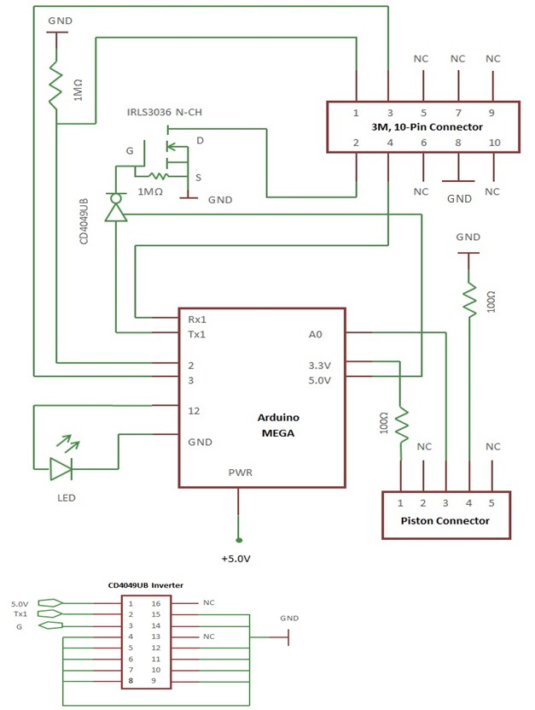

# 3 Functional Description

The simulator will be the means of performing mission tests for the Teledyne Webb Research Float product that runs on the APF-9 controller board. The simulator will replace the CTD for testing purposes.

The major functional blocks of the simulator are as follows:

* Microprocessor
  + Flash = 256KB
  + SRAM = 8KB
  + EEPROM = 4KB
* Power Management
  + 5V
* Communications
  + Serial (x4)
    - Serial0 for USB-to-TTL Serial chip
    - Serial1 TTL serial data with APF-9

# 4 Supported Features

|  |  |  |
| --- | --- | --- |
| **APF9-CTD Simulation** | | |
| Command | CTD Expected Output | Simulator Output |
|  |  |  |
|  |  |  |
|  |  |  |
|  |  |  |
|  |  |  |
|  |  |  |
|  |  |  |

|  |  |  |
| --- | --- | --- |
| **APF11-CTD Simulation** | | |
| Command | CTD Expected Output | Simulator Output |
| seabird_get_p |  | Seabird error: 0, Pressure: pppp,pppp |
| seabird_get_t |  | Seabird error: 0, Temperature: tt.tttt |
| seabird_get_pt |  | Seabird error: 0, Pressure: pppp,pppp, Temperature: tt.tttt |
| seabird_get_pts |  | Seabird error: 0, Pressure: pppp,pppp, Temperature: tt.tttt, Salinity: ss,ssss |
| seabird_cmode |  | eng> |
| sys_chat COM2 B9600 |  | S> |
| ds |  | ds <data1*> |
| dc |  | dc <data2**> |
| da |  | <data3***> |
| qsr |  | qsr  powering down  S>ppp.pppp, tt.tttt |
| seabird_cmode off |  | eng> |
| seabird_start_profile |  | Profile started |
| seabird_stop_profile |  | Profile stopped |
| seabird_binaverage |  | Bin average complete |
|  |  |  |