Vivado Design Flow
Introduction
This lab guides you through the process of using Vivado IDE to create a simple HDL design targeting the EGo1. You will simulate, synthesize, and implement the design with default settings. Finally, you will generate the bitstream and download it in to the hardware to verify the design functionality
Objectives
After completing this lab, you will be able to:
- Create a Vivado project sourcing HDL model(s) and targeting a specific FPGA device located on the EGo1
- Use the provided Xilinx Design Constraint (XDC) file to constrain the pin locations
- Simulate the design using the Vivado simulator
- Synthesize and implement the design
- Generate the bitstream
- Configure the FPGA using the generated bitstream and verify the functionality
Procedure
This lab is broken into steps that consist of general overview statements providing information on the detailed instructions that follow. Follow these detailed instructions to progress through the lab.
Design Description
The design consists of some inputs directly connected to the corresponding output LEDs. Other inputs are logically operated on before the results are output on the remaining LEDs as shown in Figure 1.
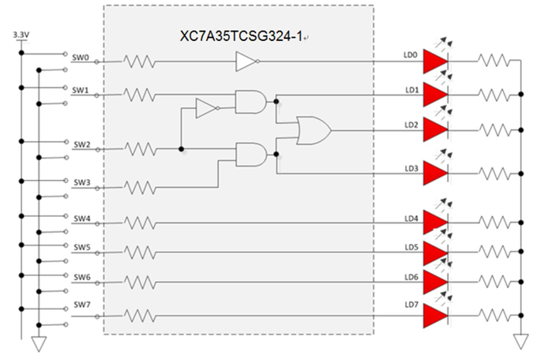
Figure 1. The Completed Design

General Flow
Step 4:
Implement the Design
Step 3:
Synthesize the Design
Step 2: Simulate the Design using Vivado Simulator

Step 1: Create a Vivado Project using IDE

Step 6:
Verify Functionality in Hardware

Step 5: Perform the Timing Simulation

- Create a Vivado Project using IDE Step 1
  - Launch Vivado and create a project targeting the XC7A35TCSG324-1 (EGo1), and using the Verilog HDL. Use the provided lab1.v and lab1_<EGo1>.xdc files from the 2017_1_artix7_sources\lab1 directory.
    - Open Vivado by selecting Start > All Programs > Xilinx Design Tools > Vivado 2017.1 > Vivado 2017.1
    - Click Create New Project to start the wizard. You will see Create A New Vivado Project dialog box. Click Next.
    - Click the Browse button of the Project location field of the New Project form, browse to c:\xup\fpga_flow\2017_1_artix7_labs, and click Select.
    - Enter lab1 in the Project name field. Make sure that the Create Project Subdirectory box is checked. Click Next.
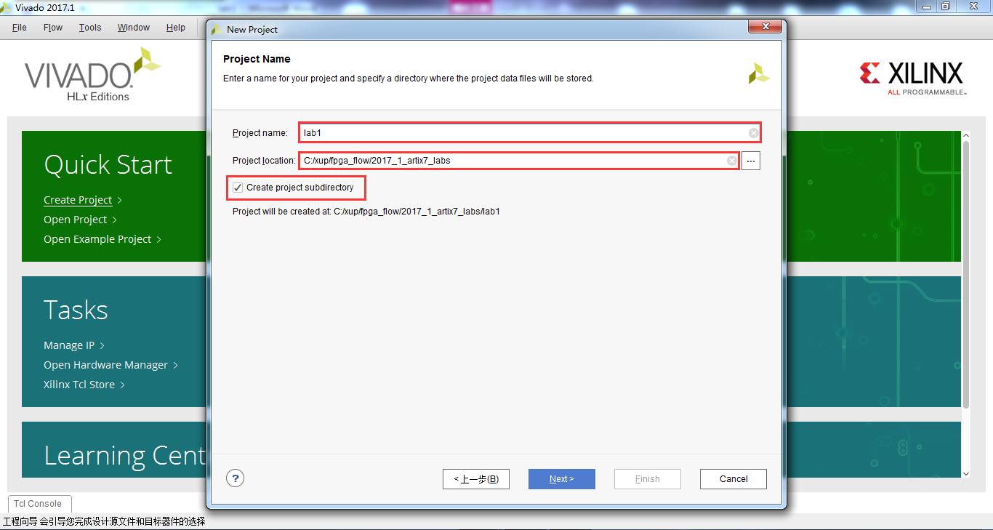
Figure 2. Project Name and Location entry
    - Select RTL Project option in the Project Type form, and click Next.
    - Using the drop-down buttons, select Verilog as the Target Language and Simulator Language in the Add Sources form.
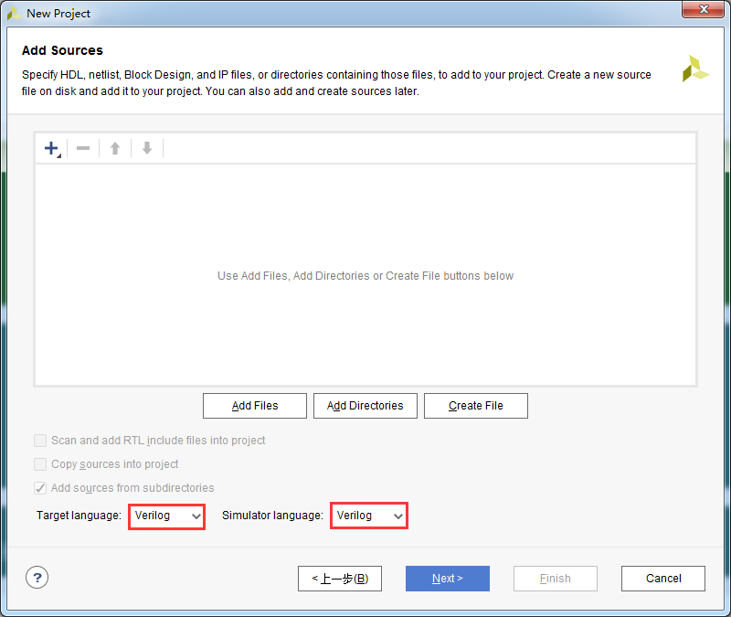
Figure 3. Selecting Target and Simulator language
    - Click on the Green Plus button, then Add Files… and browse to the c:\xup\fpga_flow\2017_1_artix7_sources\lab1 directory, select lab1.v, click OK.
If it isn’t already checked, check Copy sources into project and then click Next to get to the Add Existing IP form.
    - Since we do not have any IP to add, click Next to get to the Add Constraints form.
    - Click on the Green Plus button, then Add Files… and browse to the c:\xup\fpga_flow\2017_1_artix7_sources\lab1 directory (if necessary), select lab1_EGo1.xdc and click OK (if necessary), and then click Next.
This Xilinx Design Constraints file assigns the physical IO locations on FPGA to the switches and LEDs located on the board. This information can be obtained either through the board’s schematic or the board’s user guide.
    - In the Default Part form, use the Parts option and various drop-down fields of the Filter section. Please select the XC7A35TCSG324-1 part.
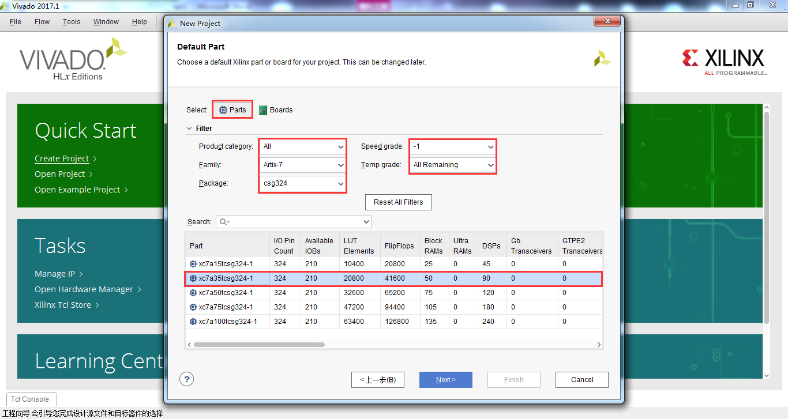
Figure 4. Part Selection for the EGo1
    - Click Next.
    - Click Finish to create the Vivado project.
Use the Windows Explorer and look at the c:\xup\fpga_flow\2017_1_artix7_labs\lab1 directory. You will find that the lab1.cache and lab1.srcs directories and the lab1.xpr (Vivado) project file have been created. The lab1.cache directory is a place holder for the Vivado program database. Two directories, constrs_1 and sources_1, are created under the lab1.srcs directory; deep down under them, the copied lab1_EGo1.xdc (constraint) and lab1.v (source) files respectively are placed.
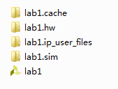
Figure 5. Generated directory structure
  - Open the lab1.v source and analyze the content.
    - In the Sources pane, double-click the lab1.v entry to open the file in text mode.
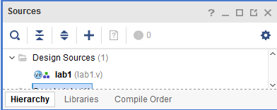
Figure 6. Opening the source file
    - Notice in the Verilog code that the first line defines the timescale directive for the simulator. Lines 2-4 are comment lines describing the module name and the purpose of the module.
    - Line 7 defines the beginning (marked with keyword module) and Line 19 defines the end of the module (marked with keyword endmodule).
    - Lines 8-9 defines the input and output ports whereas lines 12-17 defines the actual functionality.
  - Open the lab1_EGo1.xdc source and analyze the content.
    - In the Sources pane, expand the Constraints folder and double-click the lab1_<EGo1>.xdc entry to open the file in text mode.
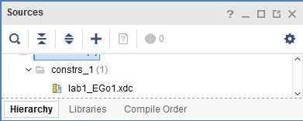
Figure 7. Opening the constraint file
    - For the lines 5-12 defines the pin locations of the input switches [7:0] and lines 17-24 defines the pin locations of the output LEDs [7:0].
  - Perform RTL analysis on the source file.
    - Expand the Open Elaborated Design entry under the RTL Analysis tasks of the Flow Navigator pane and click on Schematic.
The model (design) will be elaborated and a logic view of the design is displayed.
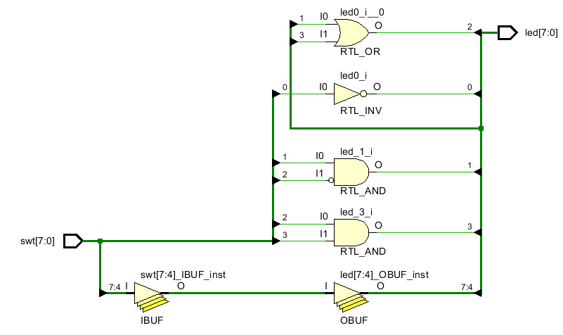
Figure 8. A logic view of the design
Notice that some of the switch inputs go through gates before being output to LEDs through output buffers and the rest go through input buffers and output buffers to LEDs as modeled in the file.
- Simulate the Design using the Vivado Simulator Step 2
  - Add the lab1_tb.v testbench file.
    - Click Add Sources under the Project Manager tasks of the Flow Navigator pane.
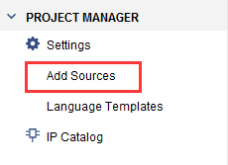
Figure 9. Add Sources
    - Select the Add or Create Simulation Sources option and click Next.
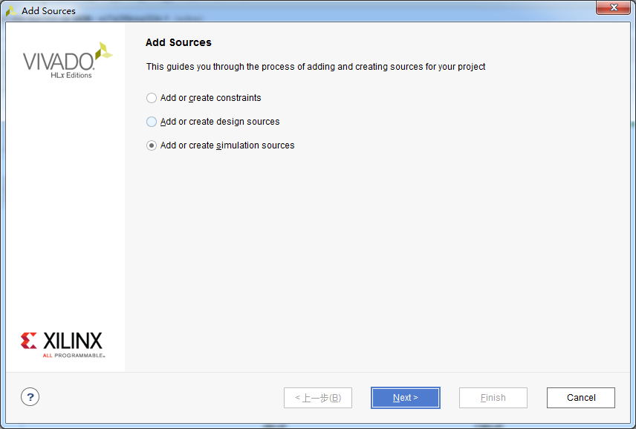
Figure 10. Selecting Simulation Sources option
    - In the Add Sources Files form, click the Green Plus button and then Add Files….
    - Browse to the c:\xup\fpga_flow\2017_1_artix7_sources\lab1 folder and select lab1_tb.v and click OK.
    - Click Finish.
    - Select the Sources tab and expand the Simulation Sources group.
The lab1_tb.v file is added under the Simulation Sources group, and lab1.v is automatically placed in its hierarchy as a dut (device under test) instance.
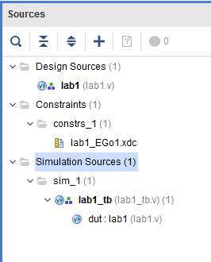
Figure 11. Simulation Sources hierarchy
    - Using the Windows Explorer, verify that the sim_1 directory is created at the same level as constrs_1 and sources_1 directories under the lab1.srcs directory, and that a copy of lab1_tb.v is placed under lab1.srcs > sim_1 > imports > lab1.
    - Double-click on the lab1_tb in the Sources pane to view its contents.
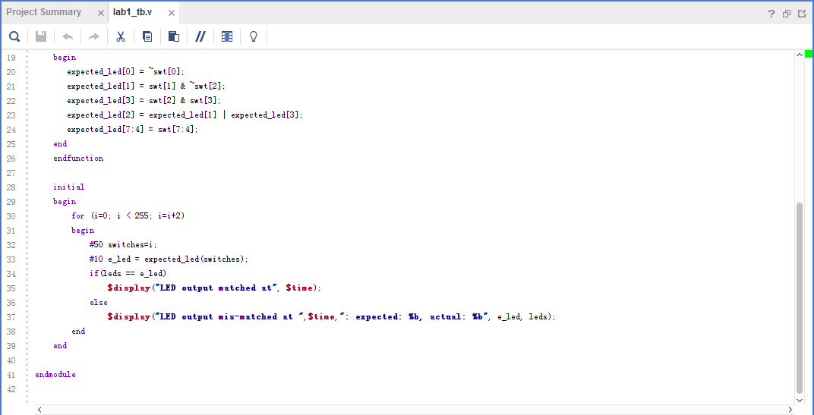
Figure 12. The self-checking testbench
The testbench defines the simulation step size and the resolution in line 1. The testbench module definition begins on line 5. Line 15 instantiates the DUT (device/module under test). Lines 17 through 26 define the same module functionality for the expected value computation. Lines 28 through 39 define the stimuli generation, and compare the expected output with what the DUT provides. Line 41 ends the testbench. The $display task will print the message in the simulator console window when the simulation is run.
  - Simulate the design for 200 ns using the Vivado simulator.
    - Select Simulation Settings under the Project Manager tasks of the Flow Navigator pane.
A Project Settings form will appear showing the Simulation properties form.
    - Select the Simulation tab, and set the Simulation Run Time value to 200 ns and click OK.
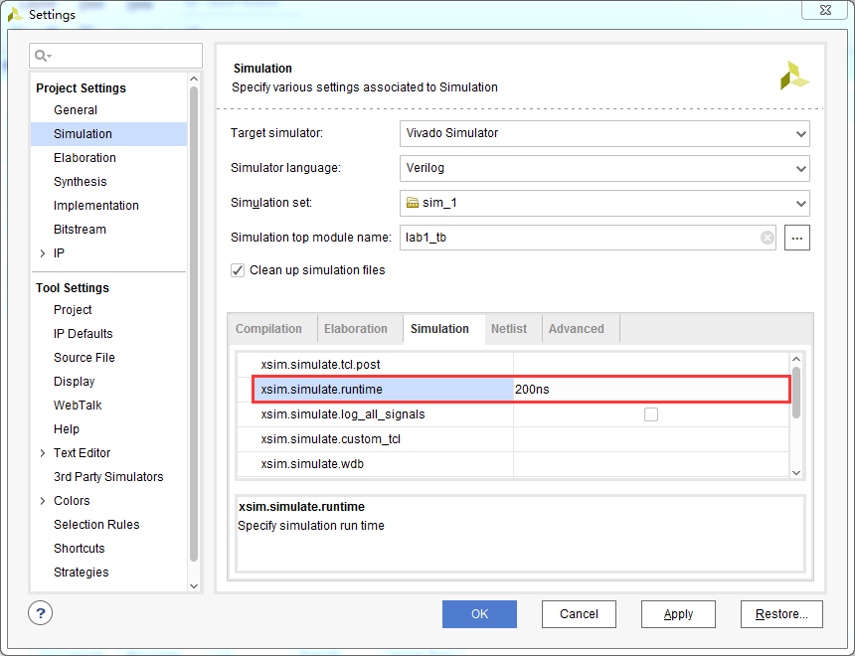
Figure 13. Setting simulation run time
    - Click on Run Simulation > Run Behavioral Simulation under the Project Manager tasks of the Flow Navigator pane.
The testbench and source files will be compiled and the Vivado simulator will be run (assuming no errors). You will see a simulator output similar to the one shown below.
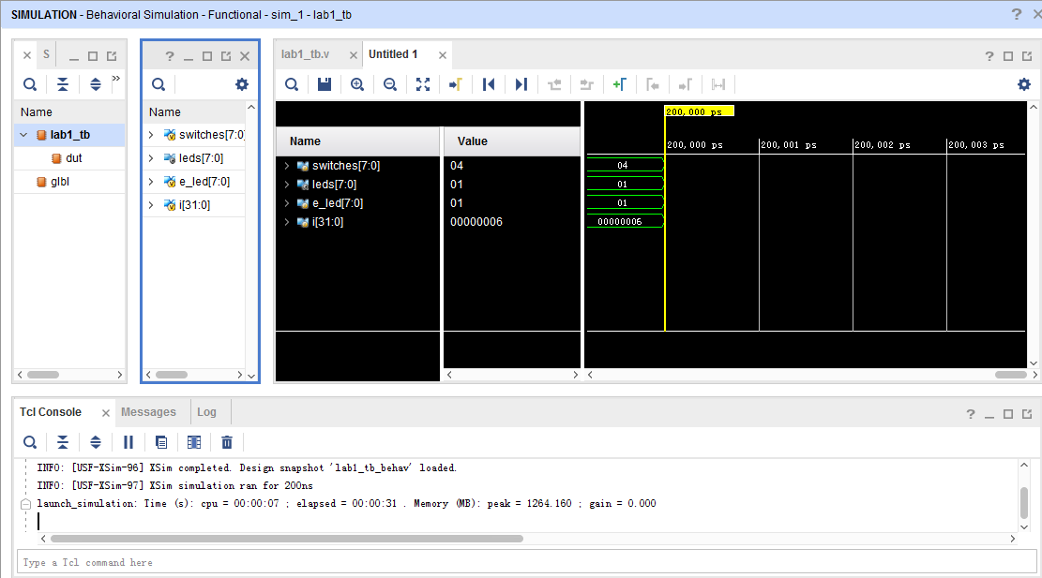
Figure 14. Simulator output
You will see four main views: (i) Scopes, where the testbench hierarchy as well as glbl instances are displayed, (ii) Objects, where top-level signals are displayed, (iii) the waveform window, and (iv) Tcl Console where the simulation activities are displayed. Notice that since the testbench used is self-checking, the results are displayed as the simulation is run.
Notice that the lab1.sim directory is created under the lab1 directory, along with several lower-level directories.
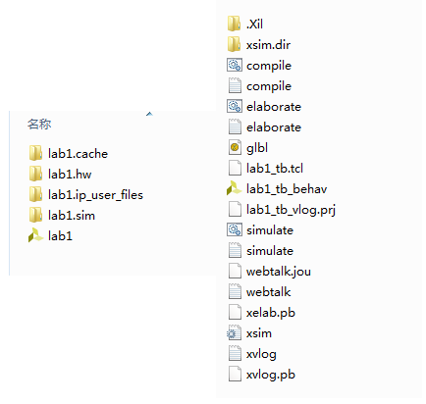
Figure 15. Directory structure after running behavioral simulation
You will see several buttons next to the waveform window which can be used for the specific purpose as listed in the table below.
Table 1: Various buttons available to view the waveform
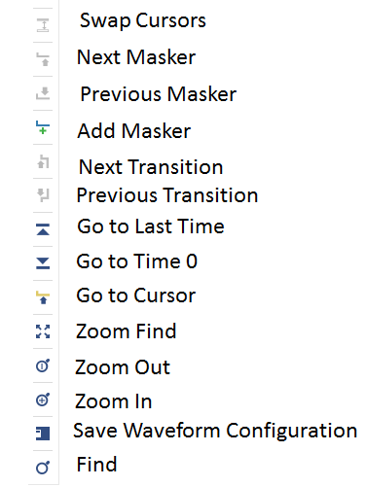
    - Click on the Zoom Fit button () to see the entire waveform.
Notice that the output changes when the input changes.
You can also float the simulation waveform window by clicking on the Float button on the upper right hand side of the view. This will allow you to have a wider window to view the simulation waveforms. To reintegrate the floating window back into the GUI, simply click on the Dock Window button.

Figure 16. Float Button

Figure 17. Dock Window Button
  - Change display format if desired.
    - Select i[31:0] in the waveform window, right-click, select Radix, and then select Unsigned Decimal to view the for-loop index in integer form. Similarly, change the radix of switches[7:0] to Hexadecimal. Leave the leds[7:0] and e_led[7:0] radix to binary as we want to see each output bit.

  - Add more signals to monitor the lower-level signals and continue to run the simulation for 500 ns.
    - Expand the lab1_tb instance, if necessary, in the Scopes window and select the dut instance.
The swt[7:0] and led[7:0] signals will be displayed in the Objects window.
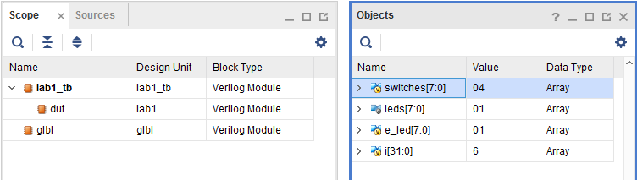
Figure 18. Selecting lower-level signals
    - Select swt[7:0] and led[7:0] and drag them into the waveform window to monitor those lower-level signals.
    - On the simulator tool buttons ribbon bar, type 500 over in the simulation run time field, click on the drop-down button of the units field and select ns () since we want to run for 500 ns (total of 700 ns), and click on the () button.
The simulation will run for an additional 500 ns.
    - Click on the Zoom Fit button and observe the output.
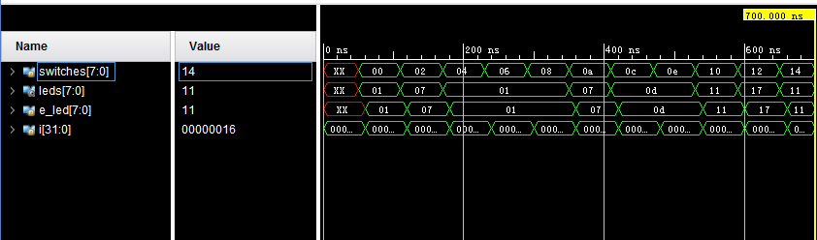
Figure 19. Running simulation for additional 500 ns
Observe the Tcl Console window and see the output is being displayed as the testbench uses the $display task.
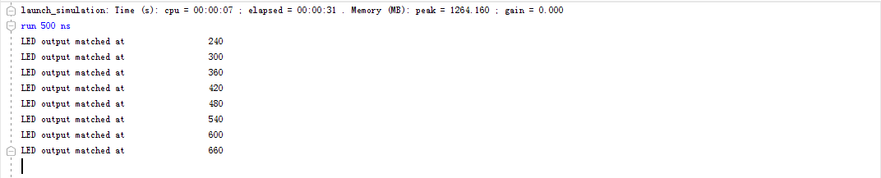
Figure 20. Tcl Console output after running the simulation for additional 500 ns
    - Close the simulator by selecting File > Close Simulation.
    - Click OK and then click Discard to close it without saving the waveform.
- Synthesize the Design Step 3
  - Synthesize the design with the Vivado synthesis tool and analyze the Project Summary output.
    - Click on Run Synthesis under the Synthesis tasks of the Flow Navigator pane.
The synthesis process will be run on the lab1.v file (and all its hierarchical files if they exist). When the process is completed a Synthesis Completed dialog box with three options will be displayed.
    - Select the Open Synthesized Design option and click OK as we want to look at the synthesis output before progressing to the implementation stage.
Click Yes to close the elaborated design if the dialog box is displayed.
    - Select the Project Summary tab and understand the various windows.
If you don’t see the Project Summary tab then select Layout > Default Layout, or click the Project Summary icon.
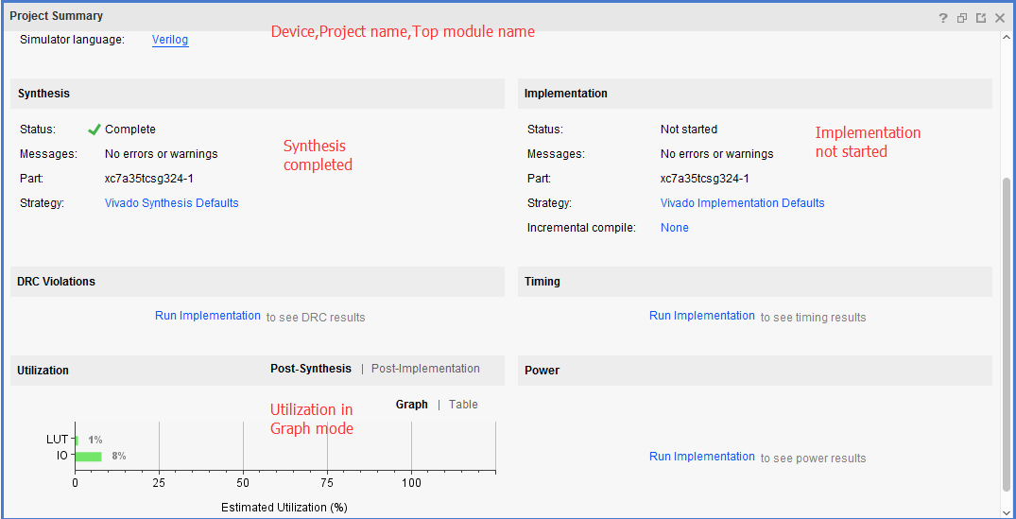
Figure 21. Project Summary view
Click on the various links to see what information they provide and which allows you to change the synthesis settings.
    - Click on the Table tab in the Project Summary tab.
Notice that there are an estimated three LUTs and 16 IOs (8 input and 8 output) that are used.
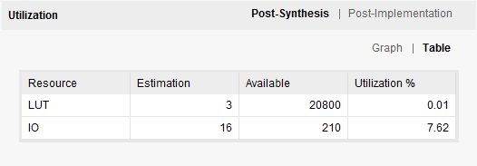
Figure 22. Resource utilization estimation summary for the EGo1
    - In The Flow Navigator, under Synthesis (expand Synthesized Design if necessary), click on Schematic to view the synthesized design in a schematic view.
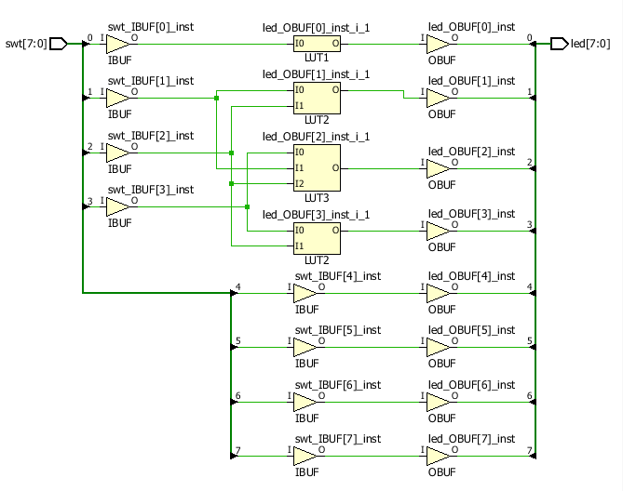
Figure 23. Synthesized design’s schematic view
Notice that IBUFs and OBUFs are automatically instantiated (added) to the design as the input and output are buffered. The logical gates are implemented in LUTs (1 input is listed as LUT1, 2 input is listed as LUT2, and 3 input is listed as LUT3). Four gates in RTL analysis output are mapped onto four LUTs in the synthesized output.
Using Windows Explorer, verify that lab1.runs directory is created under lab1. Under the runs directory, synth_1 directory is created which holds several files related to synthesis.
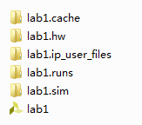
Figure 24. Directory structure after synthesizing the design

- Implement the Design Step 4
  - Implement the design with the Vivado Implementation Defaults (Vivado Implementation 2017) settings and analyze the Project Summary output.
    - Click on Run Implementation under the Implementation tasks of the Flow Navigator pane.
The implementation process will be run on the synthesized design. When the process is completed an Implementation Completed dialog box with three options will be displayed.
    - Select Open implemented design and click OK as we want to look at the implemented design in a Device view tab.
    - Click Yes, if prompted, to close the synthesized design.
The implemented design will be opened.
    - In the Netlist pane, select one of the nets (e.g. led_OBUF[1]) and notice that the net displayed in the X1Y1 (Nexys4 DDR), X0Y0 (Basys3), or X0Y0 (Nexys Video) clock region in the Device view tab (you may have to zoom in to see it).
    - If it is not selected, click the Routing Resources icon to show routing resources.
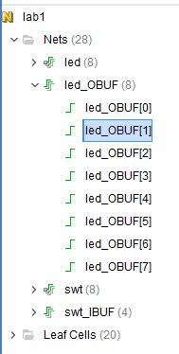
Figure 25. Selecting a net

Figure 26. Viewing implemented design for the EGo1
    - Close the implemented design view by selecting File > Close Implemented Design, and select the Project Summary tab (you may have to change to the Default Layout view) and observe the results.
Select the Post-Implementation tab.
Notice that the actual resource utilization is three LUTs and 16 IOs. Also, it indicates that no timing constraints were defined for this design (since the design is combinatorial).
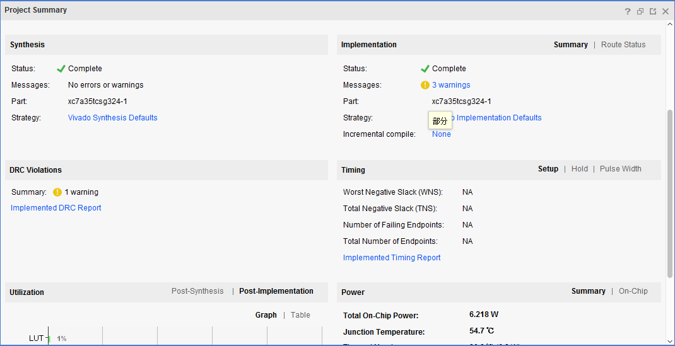
Figure 27. Implementation results for the EGo1
Using the Windows Explorer, verify that impl_1 directory is created at the same level as synth_1 under the lab1.runs directory. The impl_1 directory contains several files including the implementation report files.
    - In Vivado, select the Reports tab in the bottom panel (if not visible, click Window in the menu bar and select Reports), and double-click on the Utilization Report entry under the Place Design section. The report will be displayed in the auxiliary view pane showing resource utilization. Note that since the design is combinatorial no registers are used.
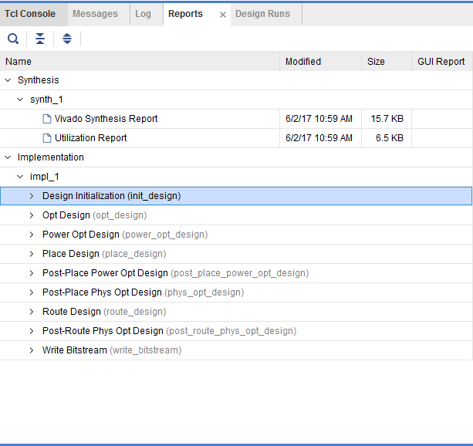
Figure 28. Available reports to view
- Perform Timing Simulation Step 5
  - Run a timing simulation.
    - Select Run Simulation > Run Post-Implementation Timing Simulation process under the Simulation tasks of the Flow Navigator pane.
The Vivado simulator will be launched using the implemented design and lab1_tb as the top-level module.
Using the Windows Explorer, verify that timing directory is created under the lab1.sim > sim_1 > impl directory. The timing directory contains generated files to run the timing simulation.
    - Click on the Zoom Fit button to see the waveform window from 0 to 200 ns.
    - Right-click at 50 ns (where the switch input is set to 0000000b) and select Markers > Add Marker.
    - Similarly, right-click and add a marker at around 55.000 ns where the leds changes.
    - You can also add a marker by clicking on the Add Marker button (). Click on the Add Marker button and left-click at around 60 ns where e_led changes.
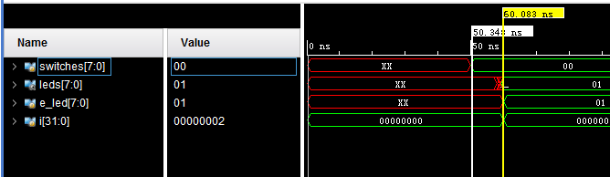
Figure 29. iming simulation output
Notice that we monitored the expected led output at 10 ns after the input is changed (see the testbench) whereas the actual delay is about 5 to 5.9 ns (depending on the board).
    - Close the simulator by selecting File > Close Simulation without saving any changes.
- Generate the Bitstream and Verify Functionality Step 6
  - Connect the board and power it ON. Generate the bitstream, open a hardware session, and program the FPGA.
    - Make sure that the Micro-USB cable is connected to the JTAG PROG connector (next to the power supply connector for the EGo1 JTAG PROG connector is located next to the UART connector).
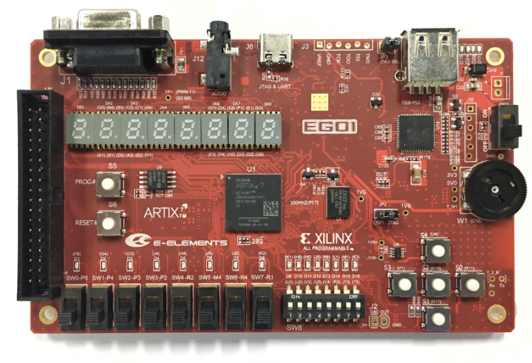
Figure 30. Board connection for the EGo1
    - Click on the Generate Bitstream entry under the Program and Debug tasks of the Flow Navigator pane.
The bitstream generation process will be run on the implemented design. When the process is completed a Bitstream Generation Completed dialog box with three options will be displayed.
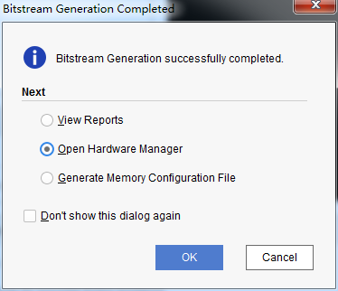
Figure 31. Bitstream generation
*****This process will have generated a lab1.bit file under impl_1 directory in the lab1.runs directory.
    - Select the Open Hardware Manager option and click OK.
The Hardware Manager window will open indicating “unconnected” status.
    - Click on the Open target link.
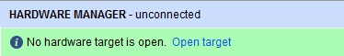
Figure 32. Opening new hardware target
    - From the dropdown menu, click Auto Connect.
The Hardware Session status changes from Unconnected to the server name and the device is highlighted. Also notice that the Status indicates that it is not programmed.
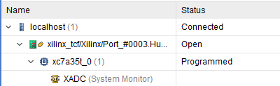
Figure 33. Opened hardware session for the EGo1
    - Select the device and verify that the lab1.bit is selected as the programming file in the General tab.
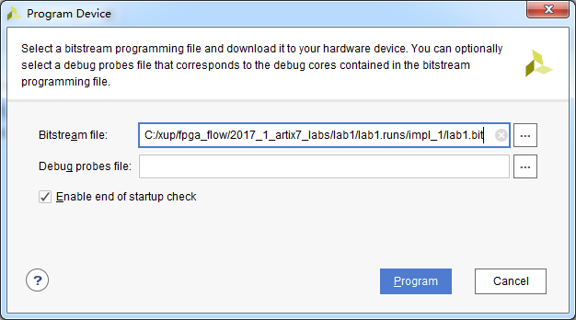
Figure 34. Programming file
    - Click on the Program device > XC7A100T_0 or the XC7A35T_0 link in the green information bar to program the target FPGA device.
Another way is to right click on the device and select Program Device…
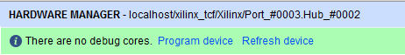
Figure 35. Selecting to program the FPGA
    - Click Program to program the FPGA.
The DONE light will light when the device is programmed. You may see some other LEDs lit depending on switch positions.
    - Verify the functionality by flipping switches and observing the output on the LEDs (Refer to the earlier logic diagram).
    - When satisfied, power OFF the board.
    - Close the hardware session by selecting File > Close Hardware Manager.
    - Click OK to close the session.
    - Close the Vivado program by selecting File > Exit and click OK.
Conclusion
The Vivado software tool can be used to perform a complete HDL based design flow. The project was created using the supplied source files (HDL model and user constraint file). A behavioral simulation using the provided testbench was done to verify the model functionality. The model was then synthesized, implemented, and a bitstream was generated. The timing simulation was run on the implemented design using the same testbench. The functionality was verified in hardware using the generated bitstream.

