Synthesizing a RTL Design
Introduction
This lab shows you the synthesis process and effect of changing of synthesis settings. You will analyze the design and the generated reports.
Objectives
After completing this lab, you will be able to:
- Use the provided Xilinx Design Constraint (XDC) file to constrain the timing of the circuit
- Elaborate the design and understand the output
- Synthesize the design with the provided basic timing constraints
- Analyze the output of the synthesized design
- Change the synthesis settings and see their effects on the generated output
- Write a checkpoint after the synthesis so the results can be analyzed after re-loading it
Procedure
This lab is broken into steps that consist of general overview statements providing information on the detailed instructions that follow. Follow these detailed instructions to progress through the lab.
Design Description
The design consists of a uart receiver receiving the input typed on a keyboard and displaying the binary equivalent of the typed character on the 8 LEDs. When a push button is pressed, the lower and upper nibbles are swapped. The block diagram is as shown in Figure 1.
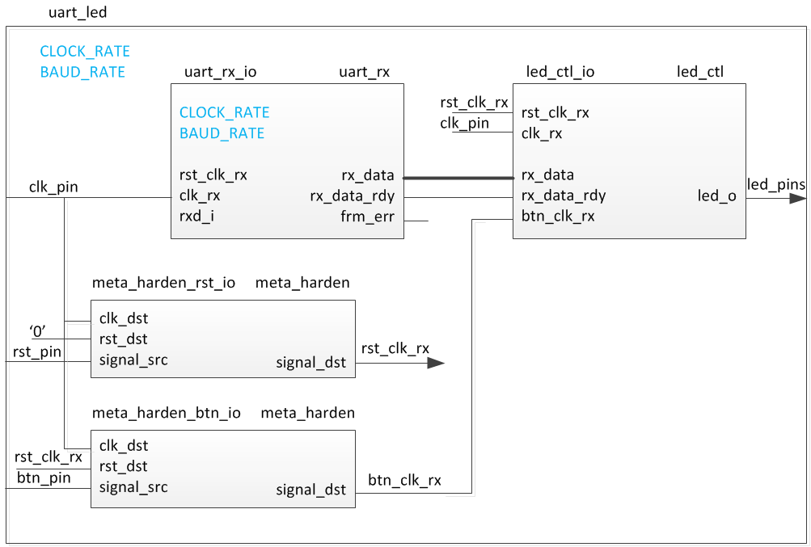
Figure 1. The Completed Design

General Flow
Step 4:
Read the Checkpoints
Step 3:
Synthesize the Design
Step 2: Elaborate the Design

Step 1: Create a Vivado Project using IDE

- Create a Vivado Project using IDE Step 1
  - Launch Vivado and create a project targeting the XC7A35TCSG324-1 (EGo1) and using the Verilog HDL. Use the provided Verilog source files, uart_led_pins_<EGo1>.xdc and uart_led_timing.xdc files from the <2017_1_artix7_sources>\lab2 directory.

References to <2017_1_artix7_labs> is a placeholder for the c:\xup\fpga_flow\2017_1_artix7_labs directory and <2017_1_artix7_sources> is a place holder for the c:\xup\fpga_flow\2017_1_artix7_sources directory.
    - Open Vivado by selecting Start > All Programs > Xilinx Design Tools > Vivado 2017.1 > Vivado 2017.1
    - Click Create New Project to start the wizard. You will see Create A New Vivado Project dialog box. Click Next.
    - Click the Browse button of the Project location field of the New Project form, browse to <2017_1_artix7_labs>, and click Select.
    - Enter lab2 in the Project name field. Make sure that the Create Project Subdirectory box is checked. Click Next.
    - Select RTL Project option in the Project Type form, and click Next.
    - Using the drop-down buttons, select Verilog as the Target Language and Simulator Language in the Add Sources form.
    - Click on the Green Plus button, then the Add Files… button and browse to the <2017_1_artix7_sources>\lab2 directory, select all the Verilog files (led_ctl.v, meta_harden.v, uart_baud_gen.v, uart_led.v, uart_rx.v, and uart_rx_ctl.v), click OK, and then click Next to get to the Add Existing IP form.
    - Since we do not have any IP to add, click Next to get to the Add Constraints form.
    - Click on the Green Plus button, then Add Files… and browse to the c:\xup\fpga_flow\2017_1_artix7_sources\lab2 directory (if necessary), select uart_led_timing.xdc and click Open.
    - Click Next.
This Xilinx Design Constraints file assigns the basic timing constraints (period, input delay, and output delay) to the design.
    - In the Default Part form, using the Parts option and various drop-down fields of the Filter section, select the XC7A100TCSG324-1 (for the Nexys4 DDR), the XC7A35TCPG236-1 (for the Basys3) part, or the XC7A200tsbg484-1 (for the Nexys Video).
Using the Boards option, you may select the Nexys4 DDR, the Basys3, or the Nexys Video depending on your board.
    - Click Next.
    - Click Finish to create the Vivado project.
  - Analyze the design source files hierarchy.
    - In the Sources pane, expand the uart_led entry and notice hierarchy of the lower-level modules.
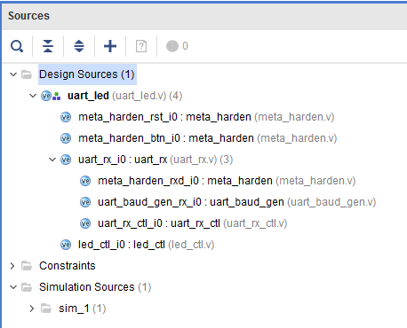
Figure 2. Opening the source file
    - Double-click on the uart_led entry to view its content.
Notice in the Verilog code, the BAUD_RATE and CLOCK_RATE parameters are defined to be 115200 and 100 MHz respectively as shown in the design diagram (Figure 1). Also notice that the lower level modules are instantiated. The meta_harden modules are used to synchronize the asynchronous reset and push-button inputs.
    - Expand uart_rx_i0 instance to see its hierarchy.
This module uses the baud rate generator and a finite state machine. The rxd_pin is sampled at a x16 the baud rate.
  - Open the uart_led_timing.xdc source and analyze the content.
    - In the Sources pane, expand the Constraints folder and double-click the uart_led_timing.xdc entry to open the file in text mode.
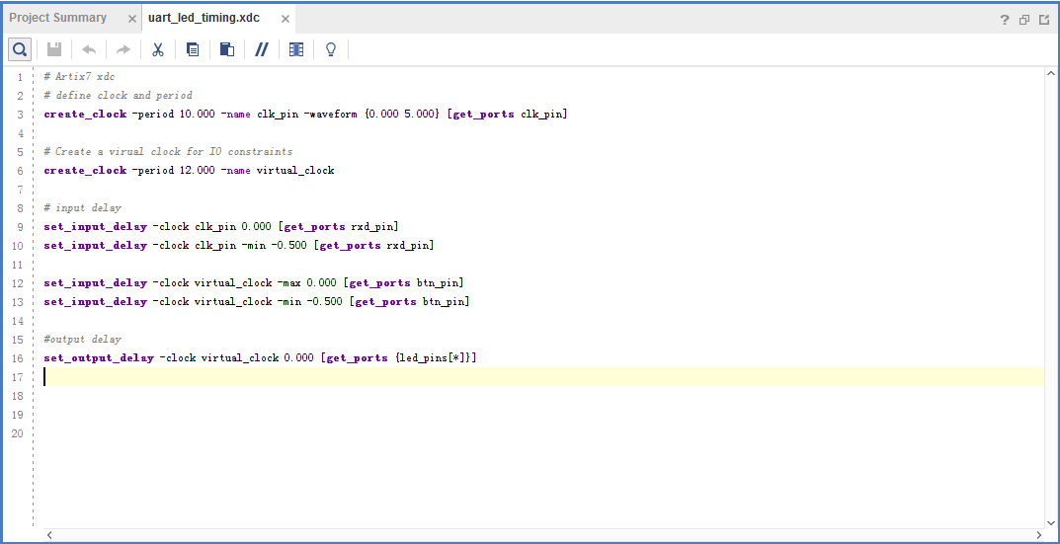
Figure 3. Timing constraints
Line 3 creates the period constraint of 10 ns with a duty cycle of 50%. Line 6 creates a virtual clock of 12 ns. This clock can be viewed as the upstream device is generating its output with respect to its clock and outputs data with respect to it. The rxd_pin is constrained with respect to the design clock (lines 9, and 10) whereas the btn_pin is constrained with respect to the upstream clock (lines 12, 13). The led_pins are constrained with respect to the upstream clock as the downstream device may be using it.
- Elaborate the Design Step 2
  - Elaborate and perform the RTL analysis on the source file.
    - Expand the Open Elaborated Design entry under the RTL Analysis tasks of the Flow Navigator pane and click on Schematic.
The model (design) will be elaborated and a logical view of the design is displayed.
Figure 4. A logic view of the design
You will see four components at the top-level, 2 instances of meta_harden, one instance of uart_rx, and one instance of led_ctl.
    - To see where the uart_rx_i0 gets generated, right-click on the uart_rx_i0 instance and select Go To Source and see that line 84 in the source code is generating it.
    - Double-click on the uart_rx_i0 instance in the schematic diagram to see the underlying components.
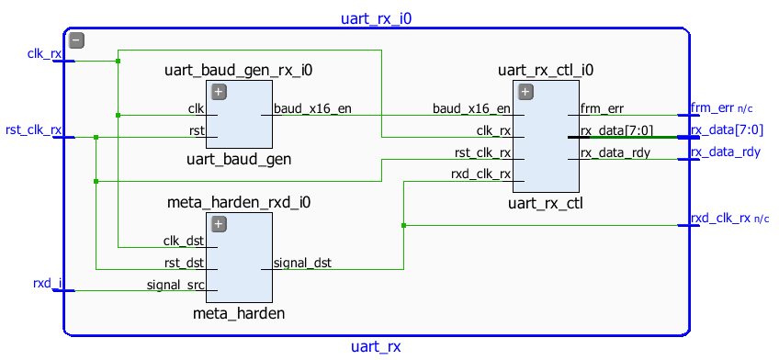
Figure 5. Lower level components of the uart_rx_i0 module
    - Click on Report Noise under the Open Elaborated Design entry of the RTL Analysis tasks of the Flow Navigator pane.
    - Click OK to generate the report named ssn_1.
    - View the ssn_1 report and observe the unplaced ports, Summary, and I/O Bank Details are highlighted in red because the pin assignments were not done. Note that only output pins are reported as the noise analysis is done on the output pins.
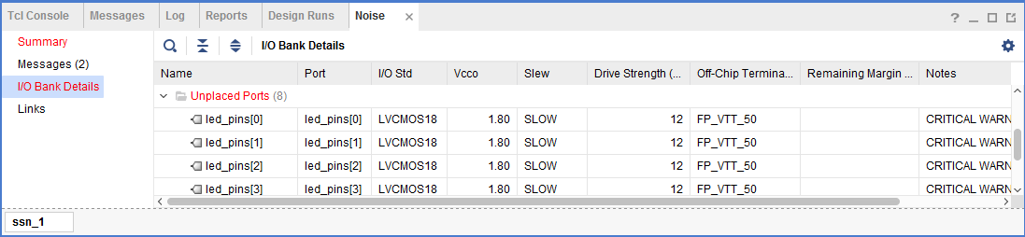
Figure 6. Noise report
    - Click on Add Sources under the Project Navigator, select Add or Create Constraints option and click Next.
    - Click on the Green Plus button, then the Add Files… button and browse to the <2017_1_artix7_sources>\lab2 directory, select the uart_led_pins_<EGo1>.xdc file (depending on the target board), click OK, and then click Finish to add the pins location constraints.
Notice that the sources are modified and the tools detect it, showing a warning status bar to re-load the design.
    - Click on the Reload link. The constraints will be processed.
    - Click on Report Noise and click OK to generate the report named ssn_1. Observe that this time it does not show any errors (no red).
- Synthesize the Design Step 3
  - Synthesize the design with the Vivado synthesis tool and analyze the Project Summary output.
    - Click on Run Synthesis under the Synthesis tasks of the Flow Navigator pane.
The synthesis process will be run on the uart_led.v and all its hierarchical files. When the process is completed a Synthesis Completed dialog box with three options will be displayed.
    - Select the Open Synthesized Design option and click OK as we want to look at the synthesis output.
Click Yes to close the elaborated design if the dialog box is displayed.
    - Select the Project Summary tab
If you don’t see the Project Summary tab then select Layout > Default Layout, or click the Project Summary icon .
    - Click on the Table tab in the Project Summary tab and fill out the following information.
Question 1
Look through the table and find the number used of each of the following:
FF:
LUT:
I/O:
BUFG:
    - Click on Schematic under the Open Synthesized Design tasks of Synthesis tasks of the Flow Navigator pane to view the synthesized design in a schematic view.
Figure 7. Synthesized design’s schematic view
Notice that IBUF and OBUF are automatically instantiated (added) to the design as the input and output are buffered. There are still four lower level modules instantiated.
    - Double-click on the uart_rx_i0 instance in the schematic view to see the underlying instances.
    - Select the uart_baud_gen_rx_i0 instance, right-click, and select Go To Source.
Notice that line 84 is highlighted. Also notice that the CLOCK_RATE and BAUD_RATE parameters are passed to the module being called.
    - Double-click on the meta_harden_rxd_io instance to see how the synchronization circuit is being implemented using two FFs. This synchronization is necessary to reduce the likelihood of meta-stability.
    - Click on the () in the schematic view to go back to its parent block.

  - Analyze the timing report.
    - Click on Report Timing Summary under the Synthesized Design tasks of the Flow Navigator pane.
    - Click OK to generate the Timing_1 report.
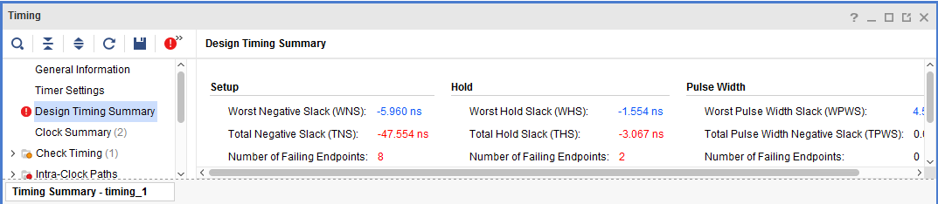
Figure 8. Timing report for the EGo1
Notice that the Design Timing Summary and Inter-Clock Paths entry in the left pane is highlighted in red indicating timing violations. In the right pane, the information is grouped in Setup, Hold, and Width columns.
Under the Setup column Worst Negative Slack (WNS) is linked indicating that clicking on it can give us insight on how the failing path has formed. The Total Negative Slack (TNS) is highlighted in red indicating the total amount of violations in the design and the Number of Failing Endpoints indicate total number of failing paths.
    - Click on the WNS link and see the 8 failing paths.
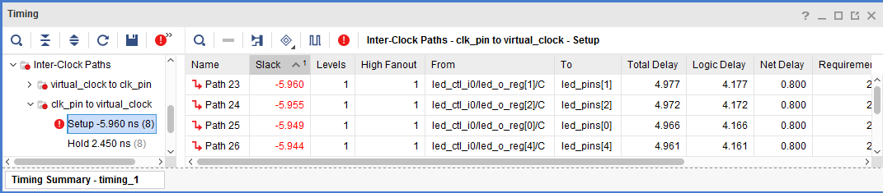
Figure 9. The 8 failing paths for the EGo1
    - Double-click on the Path 23 to see how the path is made.
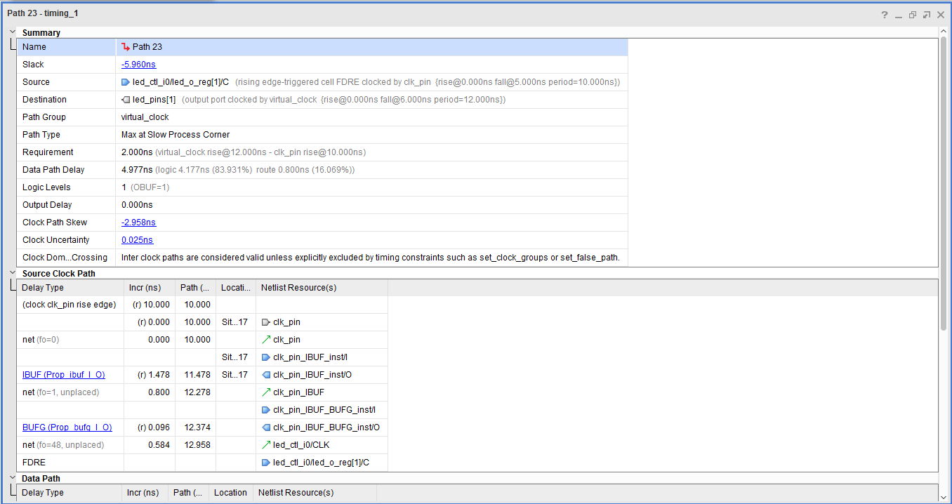
Figure 10. Worst failing path for the EGo1
Note that this is an estimate only. The nets are specified as unplaced and have all been allocated default values (0.800 ns). No actual routing delays are considered.
  - Generate the utilization and power reports.
    - Click Report Utilization under the Synthesized Design, and click OK to generate the utilization report.
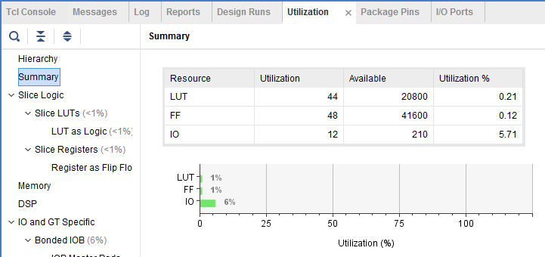
Figure 11. Utilization report for the EGo1
Question 2
Look through the report and find the number used of each of the following:
FF:
LUT:
I/O:
BUFG:
    - Select Slice LUTs entry in the left pane and see the utilization by lower-level instances. You can expand the instances in the right pane to see the complete hierarchy utilization.
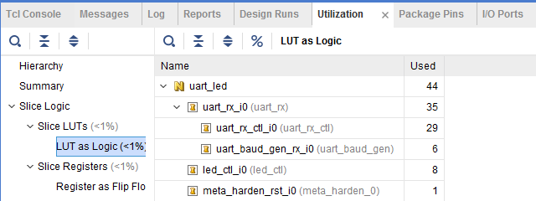
Figure 12. Utilization of lower-level modules for the EGo1
    - Click Report Power under the Synthesized Design, and click OK to generate the estimated power consumption report using default values.
Note that this is just an estimate as no simulation run data was provided and no accurate activity rate, or environment information was entered.
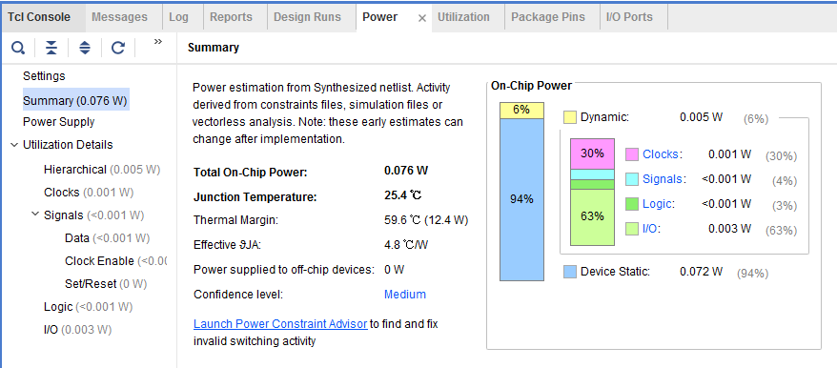
Figure 13. Power consumption estimation for the EGo1
Question 3
From the power report, find the % power consumption used by each of the following:
Clocks: %
Signals: %
Logic: %
I/O: %
You can move the mouse on the boxes which do not show the percentage to see the consumption.
  - Write the checkpoint in order to analyze the results without going through the actual synthesis process.
    - Select File > Write Checkpoint… to save the processed design so it can be opened later for further analysis.
    - A dialog box will appear showing the default name of the file in the current project directory.
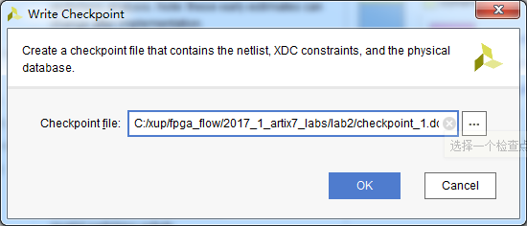
Figure 14. Writing checkpoint
    - Click OK.
  - Change the synthesis settings to flatten the design. Re-synthesize the design and analyze the results.
    - Click on the Project Settings under the Project Manager, and select Synthesis.
    - Click on the flatten_hierarchy drop-down button and .
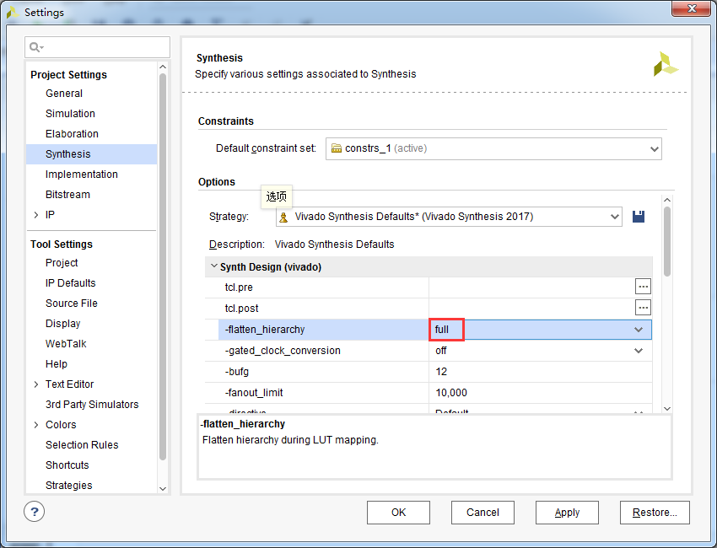
Figure 15. Selecting flatten hierarchy option
    - Click OK.
    - A Create New Run dialog box will appear asking you whether you want to create a new run since the settings have been changed.
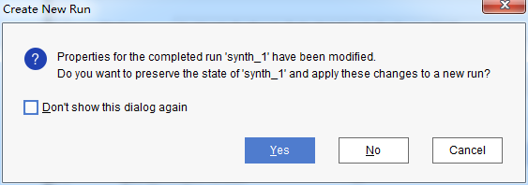
Figure 16. Create New Run dialog box
    - Click Yes.
    - Change the name from synth_2 to synth_flatten and click OK.
    - Click Run Synthesis to synthesize the design.
    - Click Save, OK, and again OK to save the synthesized design and save the constraints.
The Reload Design dialog box may re-appear. Click Cancel.
    - Click OK to open the synthesized design when synthesis process is completed.
    - Click on Schematic under the Open Synthesized Design tasks of Synthesis tasks of the Flow Navigator pane to view the synthesized design in a schematic view.
Notice that the design is completely flattened.
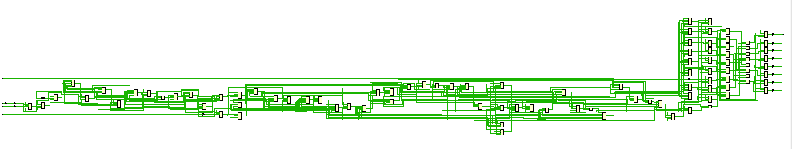
Figure 17. Flattened design
    - Click on Report Utilization and observe that the hierarchical utilization is no longer available. Also note that the number of Slice Registers is 48.
  - Write the checkpoint in order to analyze the results without going through the actual synthesis process.
    - Select File > Write Checkpoint… to save the processed design so it can be opened later for further analysis.
    - A dialog box will appear showing the default name of the file (checkpoint_2.dcp) in the current project directory.
    - Click OK.
    - Close the project by selecting File > Close Project.
- Read the Checkpoints Step 4
  - Read the previously saved checkpoint (checkpoint_1) in order to analyze the results without going through the actual synthesis process.
    - Select File > Open Checkpoint… at the Getting Started screen.
    - Browse to <2017_1_artix7_labs>\lab2 and select checkpoint_1.
    - Click OK.
    - If the schematic isn’t open by default, in the netlist tab, select the top-level instance, uart_led, right-click and select Schematic.
You will see the hierarchical blocks（分层块）. You can double-click on any of the first-level block and see the underlying blocks. You can also select any lower-level block in the netlist tab, right-click and select Schematic to see the corresponding level design.
    - In the netlist tab, select the top-level instance, uart_led, right-click and select Show Hierarchy.
You will see how the blocks are hierarchically connected.
    - Select Reports > Timing > Report Timing Summary and click OK to see the report you saw previously.
    - Select Tools > Report > Report Utilization… and click OK to see the utilization report you saw previously
    - Select File > Open Checkpoint, browse to <2017_1_artix7_labs>\lab2 and select checkpoint_2.
    - Click No to keep the Checkpoint_1 open.
This will invoke second Vivado GUI.
    - If the schematic isn’t open by default, in the netlist tab, select the top-level instance, uart_led, right-click and select Schematic.
You will see the flattened design.
    - You can generate the desired reports on this checkpoint as you wish.
    - Close the Vivado program by selecting File > Exit and click OK.

Conclusion
In this lab you applied the timing constraints and synthesized the design. You viewed various post-synthesis reports. You wrote checkpoints and read it back to perform the analysis you were doing during the design flow. You saw the effect of changing synthesis settings.

Answers
- Look through the table and find the number used of each of the following:
FF: 48
LUT: 41
I/O: 12
BUFG: 1
- Look through the report and find the number used of each of the following:
FF: 48
LUT: 41
I/O: 12
BUFG: 1
- From the power report, find the % power consumption used by each of the following (Nexys4 DDR):
Clocks: 31%
Signals: 6%
Logic: 5%
I/O: 58%

For the Basys3:
Clocks: 31%
Signals: 7%
Logic: 5%
I/O: 57%

For the Nexys Video:
Clocks: 52%
Signals: 9%
Logic: 7%
I/O: 32%

