GIT 337: Intermediate Web Coding Fall 2026
Deliverable: Application, Registration, or Request Flow
Brian Love

Test Records

Select accessible name: Passed. The workshop session select had the accessible name “Workshop session/date (required),” confirming that its label is correctly associated with the control.
Textarea accessible name: Passed. The accommodation textarea had the accessible name “Accessibility/accommodation request (optional).”
Radio group accessibility: Passed. The individual radio buttons had the accessible names “In person” and “Virtual,” and both were grouped under the accessible group name “Attendance method (required)” provided by the fieldset legend.
Checkbox accessible name: Passed. The agreement checkbox had the accessible name “I agree to follow the workshop participation guidelines. (required),” confirming that the visible label is correctly associated with the checkbox.
Empty submission: Passed. When the form was submitted with all required fields empty, the browser prevented submission and displayed the native message “Please fill out this field” on the first required control.
Malformed email: Passed. When test.example was entered in the required email field, the browser prevented submission and displayed a native validation message instructing the user to include an “@” in the email address.
Boundary minimum: Passed. With 1 entered for the number of attendees, the form accepted the value because it matches the minimum allowed value.
Boundary maximum: Passed. With 4 entered for the number of attendees, the form accepted the value because it matches the maximum allowed value.
Valid submission: Passed. The form accepted valid fictional data without displaying native validation errors. After submission, the page reloaded and the form fields returned to their blank state.
Keyboard-only test: Passed. I navigated through the registration form using the Tab key, operated radio buttons with the arrow keys, selected the checkbox with the keyboard, and submitted the form without using a mouse. The focus indicator remained visible while navigating the controls.
Text input accessible name: Passed. Chrome’s accessibility information showed the Full name input with the accessible name “Full name (required),” confirming that the <label for="full-name"> is correctly associated with the input.
HTML validation

Pass

Final HTML produced no validator errors or warnings after the empty action attribute was removed.
CSS validation

Pass

Final CSS passed validation with no errors.

320px
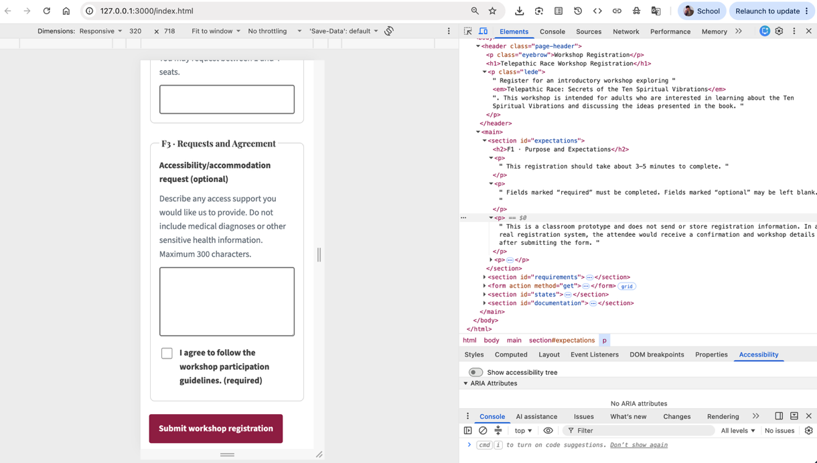
768px
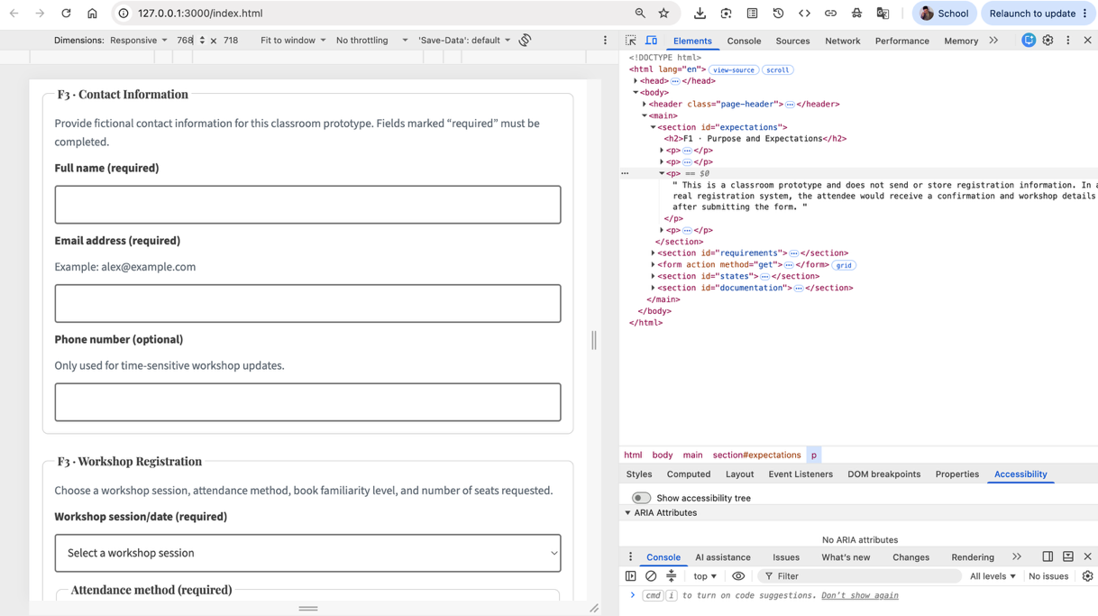
1280px
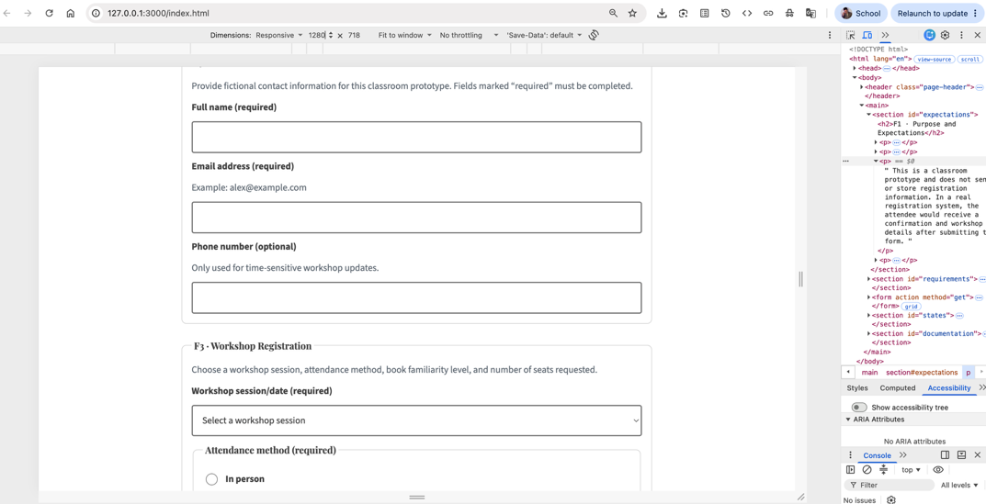
200%
