OFFICIAL OWNER HANDBOOK • WHATSAPP EDITION
🛍️ MIDEVA'S COLLECTION
Store Owner Guide for Mona Lisa Mideva

🌐 Public Storefront Link: | https://midevas-collection.vercel.app
🔒 Private Admin Dashboard: | https://midevas-collection.vercel.app/#admin
📱 WhatsApp Order Hotline: | +254 748 094795 | EcoCash: 0774809479
🔑 Secret Admin Passcode: | mideva2026 (Email: monalisamideva@gmail.com)

🌟 Welcome, Mona Lisa!
Welcome to your brand-new campus digital store! If you have never run a website before, do not worry at all. This system was custom-built to be as simple to use as WhatsApp and Instagram. You do not need any coding or computer science knowledge.
This guide walks you through every single step with high-resolution visual screenshots: how to unlock your admin desk, how to receive and fulfill student orders, how to add new clothes or perfumes right from your phone camera, how to change prices, and how to do hostel delivery runs.
💡 Pro Tip — Put Your Store on Your Phone Home Screen:
1. Open https://midevas-collection.vercel.app on your phone in Chrome or Safari.
2. Tap the browser Menu (three dots or Share button) and select 'Add to Home Screen'.
3. An app icon named Mideva's will appear on your phone screen just like WhatsApp or TikTok!

🔑 CHAPTER 1: How to Log Into Your Admin Workspace
You can manage your entire store from your smartphone or laptop at any time:
• Step 1: Open https://midevas-collection.vercel.app on your phone.
• Step 2: Tap the Sign In / Profile icon in the top header bar.
• Step 3: Select 'Store Staff & Admin Sign In'.
• Step 4: Enter Email: monalisamideva@gmail.com and Passcode: mideva2026
• Step 5: Tap 'Unlock Workspace'. You are immediately in your master command dashboard!

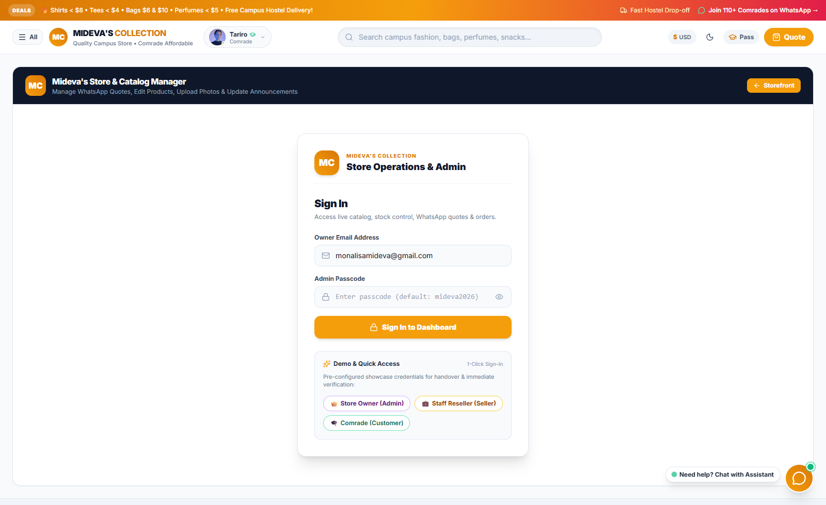
Figure 1: The Secure Admin Passcode Screen on Phone & Laptop

🧭 CHAPTER 2: Tour of Your Storefront & Admin Dashboard
What students see when they visit your shop:

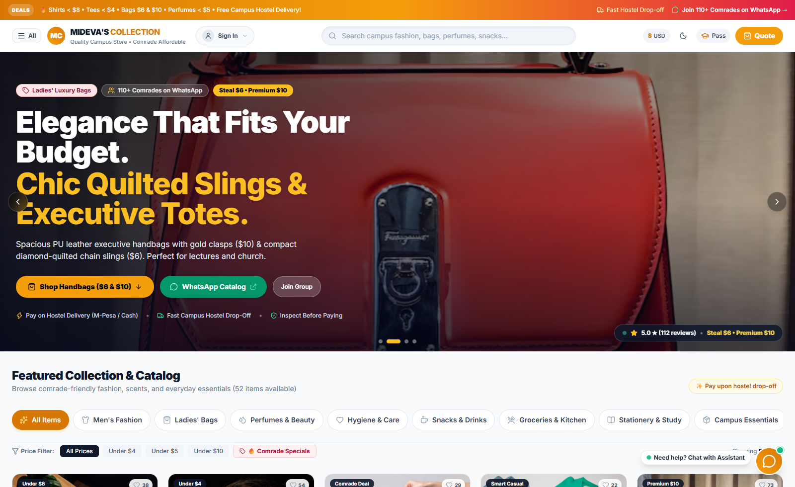
Figure 2: The Modern Campus Storefront with Live Deals & Currency Switcher
Your Master Admin workspace gives you complete control over orders, stock, and prices:

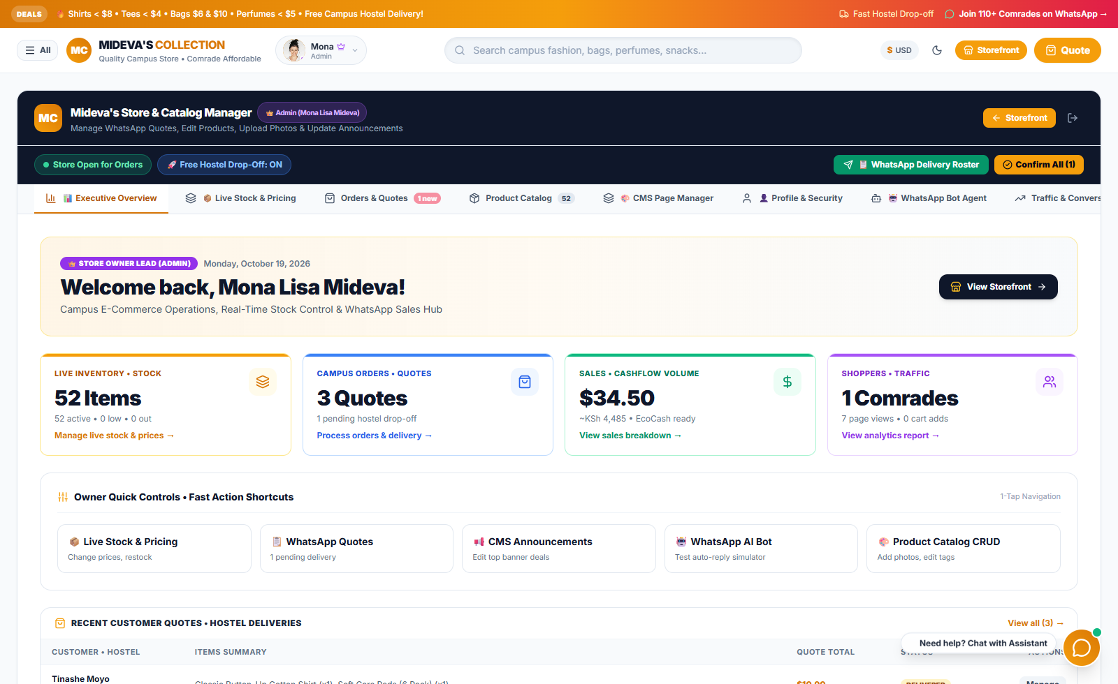
Figure 3: Admin Command Strip and Performance Metrics

☀️ CHAPTER 3: A Day in the Life — Your Daily Routine
Here is the simple, stress-free routine you can follow every day to run your business like a pro:
🌅 08:00 AM — Morning Routine: Open the Store & Post Flyer
1. Open https://midevas-collection.vercel.app/#admin on your phone.
2. Check that the top status button is green: '🟢 Store Open for Orders'.
3. Tap '🎨 Flyers', pick 2 hot items, and tap 'Download PNG Poster'.
4. Share the poster to your WhatsApp Status with the link: https://midevas-collection.vercel.app
5. Students start browsing and adding items to their bag!
💬 12:00 PM — Daytime Routine: Receive Student Orders
1. Students view products, pick sizes/colors, and tap 'Send Order via WhatsApp'.
2. Your WhatsApp will buzz with an itemized message showing their name, hostel room number, items, and total price.
3. Reply: 'Hi! Order received! I have both in stock. I will drop them off to your hostel at 4:30 PM.'
4. All orders are automatically logged in your '📦 Orders & Quotes' tab!
🚶‍♀️ 04:00 PM — Afternoon Routine: Hostel Delivery Run
1. In your Admin dashboard, tap the status button to '🟡 Out on Delivery Run'.
2. Tap '📋 WhatsApp Delivery Roster' — your complete packing and delivery checklist is instantly copied to your clipboard!
3. Paste it in your personal WhatsApp chat, pack your tote bag, and walk to the hostels.
4. Hand over the items, collect the cash or EcoCash/M-Pesa payment!
🌙 08:00 PM — Evening Routine: Updating Stock & Resting
1. In '📦 Orders & Quotes', mark delivered orders as 'Delivered' (or tap ⚡ Confirm All).
2. In '📊 Live Stock & Pricing', reduce stock or set 0 for any item you sold out of.
3. Switch the status button to '🔴 Store Closed' when you want to study or sleep peacefully.
How student orders look when they add to cart:

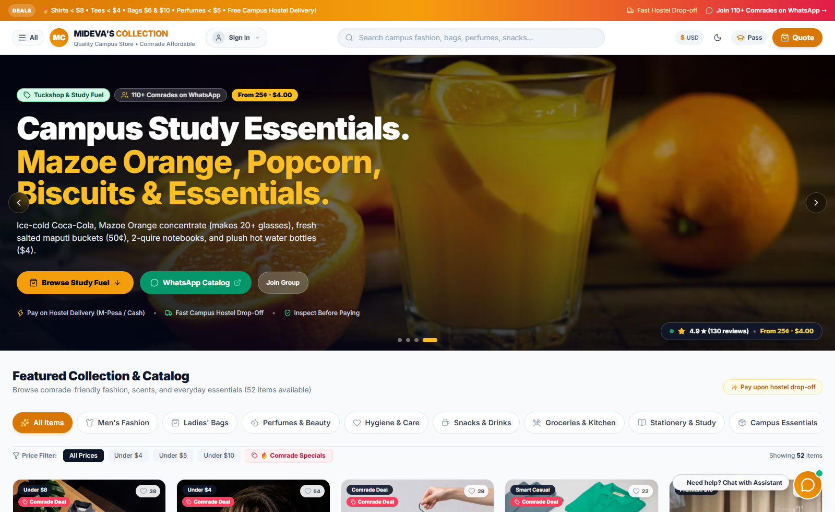
Figure 4: The WhatsApp Slide-Out Checkout Cart

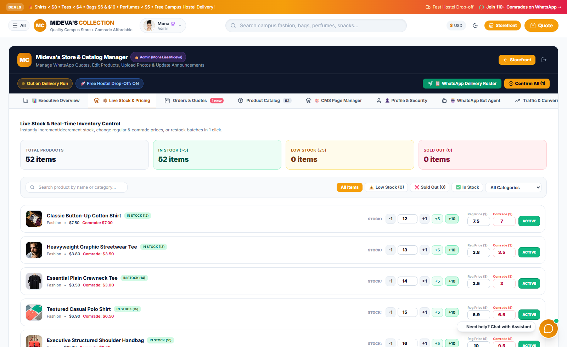
Figure 5: The Orders & Hostel Delivery Manager

🛠️ CHAPTER 4: Step-by-Step 'How-To' Guides
Guide 1: How to Add a New Item with Your Phone Camera
1. In your Admin, tap the '🛍️ Product Catalog' tab.
2. Tap the blue '+ Add New Product' button.
3. Type the product name, select category, and enter regular price + student price.
4. Tap 'Upload Photo' -> your phone lets you snap a photo with your camera!
5. Tap 'Save Product' — it goes live on your store instantly!
Guide 2: How to Change Prices or Mark an Item 'Sold Out'
1. Tap '📊 Live Stock & Pricing'.
2. To change a price: Tap into the Reg ($) or Comrade ($) box, type the new price, and tap away — it saves automatically!
3. To adjust stock: Tap [+1], [+5], or [-1] buttons.
4. To mark Sold Out: Type 0 in the stock box. The website will immediately show a red 'Sold Out' badge so students cannot order it.
Guide 3: How to Edit the Moving Announcement at the Top
1. Tap '🎨 CMS Content'.
2. Under 'Top Announcement Ticker', edit the text (e.g. '🔥 WEEKEND SALE: FREE HOSTEL DROP-OFF TODAY!').
3. Tap 'Save Announcement'. Refresh your store to see it scrolling across the top!
Guide 4: How to Change Your Secret Admin Passcode
1. Tap '👤 Profile & Security'.
2. Enter your current passcode (default: mideva2026), type your new secret code, and confirm.
3. Tap 'Update Passcode'. Only you will know the new passcode!

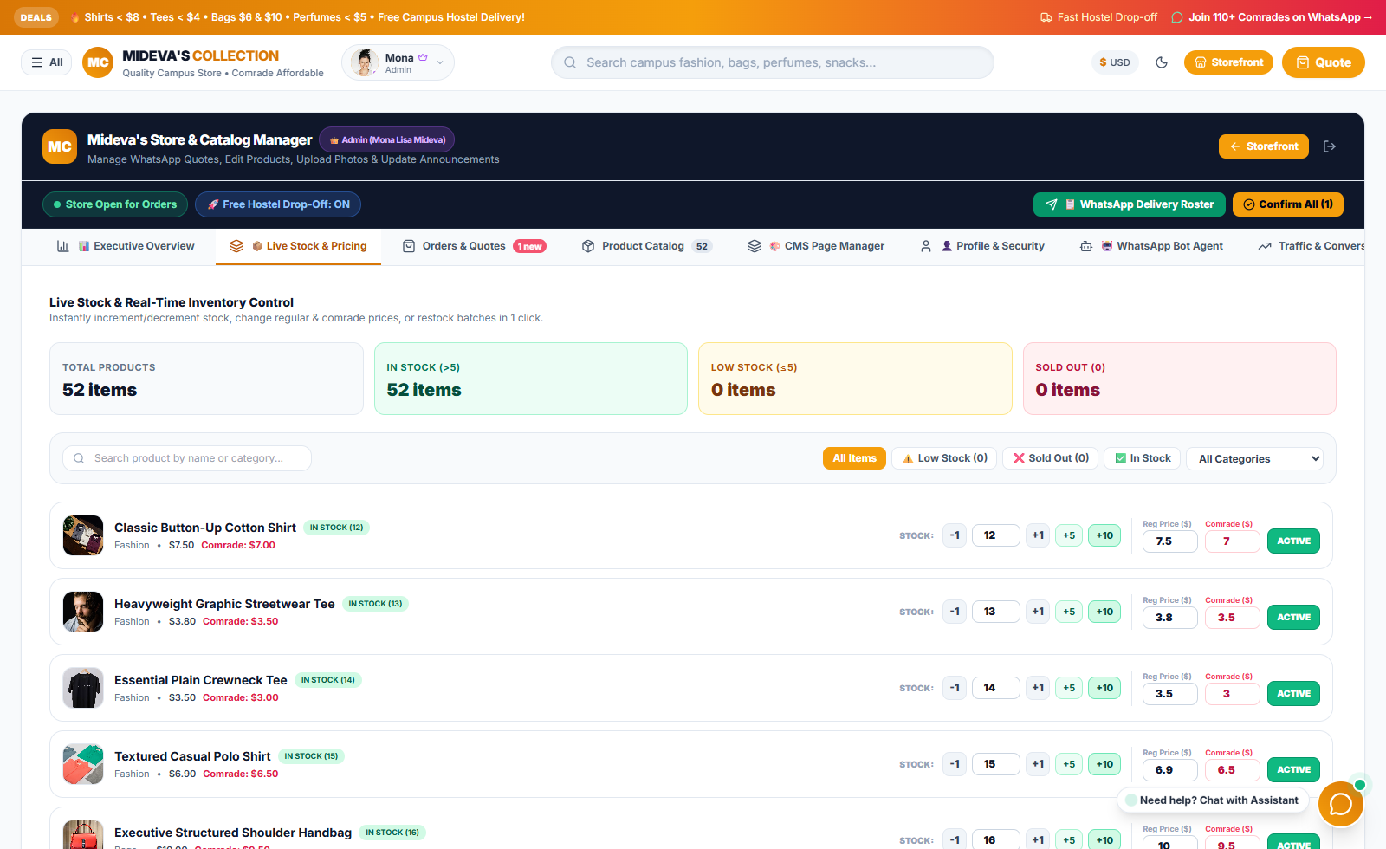
Figure 6: Live Stock and Fast Price Steppers

📲 CHAPTER 5: WhatsApp Business Catalog & Auto-Reply Bot
To make your business look truly professional and allow students to browse your catalog and chat with an automated assistant inside WhatsApp, follow these simple steps:
Part A: Install WhatsApp Business (FREE from Meta)
1. Download 'WhatsApp Business' from Google Play Store or Apple App Store.
2. Register with your store number: +254 748 094795.
3. Set Business Name: Mideva's Collection | Category: Shopping & Retail.
4. Add your website: https://midevas-collection.vercel.app and description.
Part B: Add Items to Your WhatsApp Catalog
1. In WhatsApp Business, tap Menu (three dots) -> Business Tools -> Catalog -> Add New Item.
2. Upload a photo, type the item name, price, and paste your website link.
3. Students can now tap your profile picture in WhatsApp and see your products immediately without leaving the app!
Part C: Set Up Auto-Reply Greeting & Away Messages
1. Greeting Message: Go to Business Tools -> Greeting Message -> Turn ON. Paste a welcome message with numbered menu options (1: Deals, 2: Bags, 3: Men's wear, 4: Perfumes, 5: Snacks, 6: Hygiene, 7: Payment, 8: Chat with Mideva).
2. Away Message: Go to Business Tools -> Away Message -> Turn ON for outside business hours.
3. Quick Replies: Add shortcuts like /thanks, /payment, /delivered, and /link for 1-tap replies.
Part D: Built-In WhatsApp Bot Simulator on Website
1. In your Admin Dashboard (#admin), tap the '🤖 WhatsApp Bot' tab.
2. Test how customer queries get answered automatically.
3. Customize your greeting text, agent name, and M-Pesa / EcoCash payment details anytime!

❓ CHAPTER 6: Frequently Asked Questions (FAQ)
Q: How do students pay me?
A: Students pay via Cash on Hostel Delivery when you hand them their bag, or via EcoCash / M-Pesa to your phone number (+254 748 094795 / 0774809479). You collect the money directly!
Q: Can a student see how much money I make or change my prices?
A: Never! Student accounts are locked to customer mode only. Only you have the secret passcode to open the admin workspace.
Q: What if I make a mistake in a product price or name?
A: Go to 'Product Catalog', tap the yellow 'Edit' button on that product, correct it, and tap 'Update'. It updates immediately.
Q: What if I accidentally mess up my catalog?
A: There is a red button in 'Product Catalog' called 'Reset to Factory Catalog'. Tapping it safely restores all 52 original items with clean photos and prices.

📋 CHAPTER 7: Quick Reference Pocket Cheat Sheet
Public Store Website | https://midevas-collection.vercel.app
Admin Direct Link | https://midevas-collection.vercel.app/#admin
Admin Login Email | monalisamideva@gmail.com
Secret Admin Passcode | mideva2026
WhatsApp Order Hotline | +254 748 094795
EcoCash Merchant Line | 0774809479
Default KSh Currency Rate | 130 KSh per 1 USD
Default EcoCash ZiG Rate | 28 ZiG per 1 USD

