**Analyzing and Visualizing WeRateDogs Twitter page**

**Introduction:**

In this project, I worked on the twitter account WeRateDogs. WeRateDogs is a Twitter account that rates people's dogs with a humorous comment about the dog. These ratings almost always have a denominator of 10. The numerators, though? Almost always greater than 10. 11/10, 12/10, 13/10, etc. Why? Because "[they're good dogs Brent](http://knowyourmeme.com/memes/theyre-good-dogs-brent)." WeRateDogs has over 4 million followers and has received international media coverage.

The basis of this project was to get some insights by analyzing and visualizing the wrangled data gathered a variety of sources. Insights like:

1. correlation variable heatmap for various insights?
2. Correlation between retweet count and favorite count
3. Popular dog stage distribution
4. Distribution source for the medium used to access WeRateDogs twitter account.

**Insight one: Correlation heatmap**

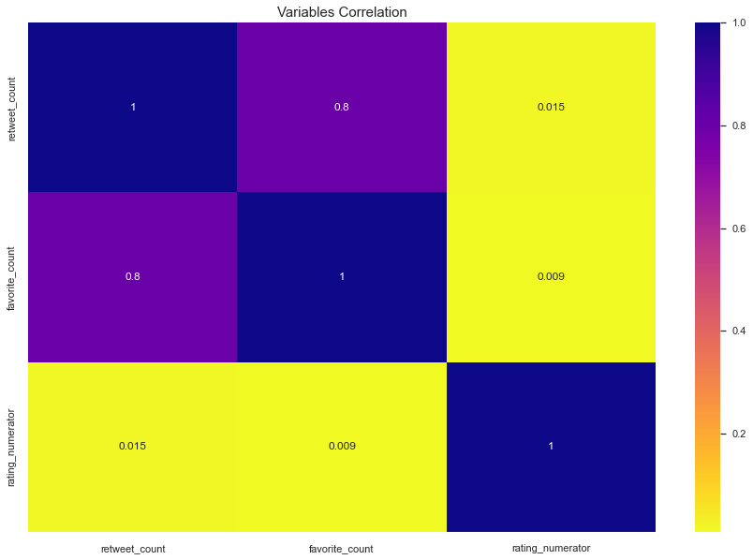

Correlation heatmaps are a type of plot that visualize the strength of relationships between numerical variables. Correlation plots are used to understand which variables are related to each other and the strength of this relationship.

From this correlation heatmap the Strongest correlation is between retweet_count and and favorite count having a correlation coefficient of 0.8.

**Insight Two: Correlation between retweet count and favorite count**

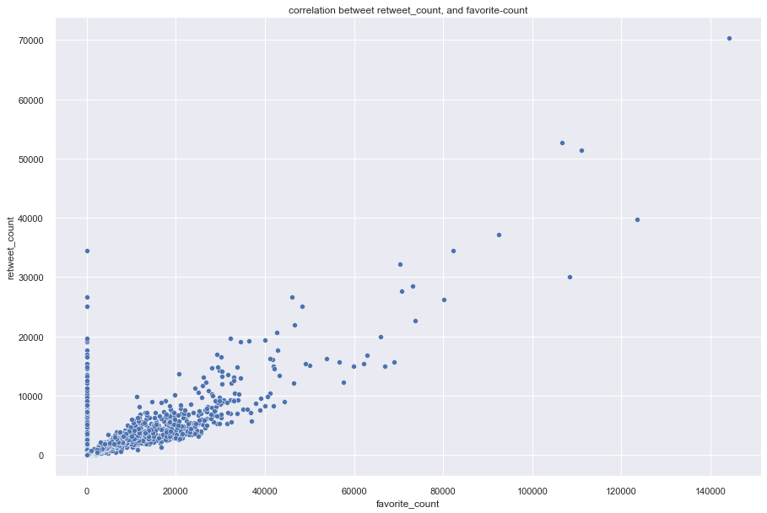

We often see patterns or relationships in scatterplots. When the y variable tends to increase as the x variable increases, we say there is a positive correlation between the variables. The above scatter plot shows that there is a positive correlation between retweet_counts and favorite_counts.

**Insight Three: Popular Stage distribution**

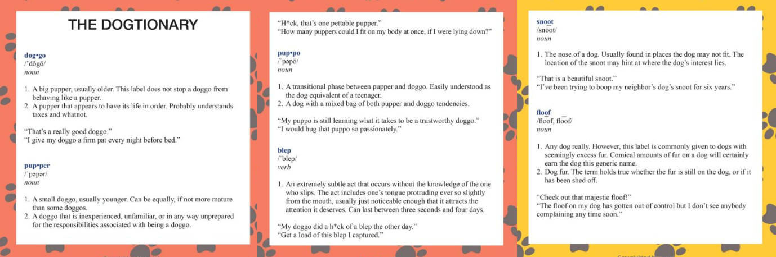

The bar chart above shows pupper is the most popular dog stage, followed by doggo.

**Insight Four: Distribution source for the medium used to access WeRateDogs twitter account.**

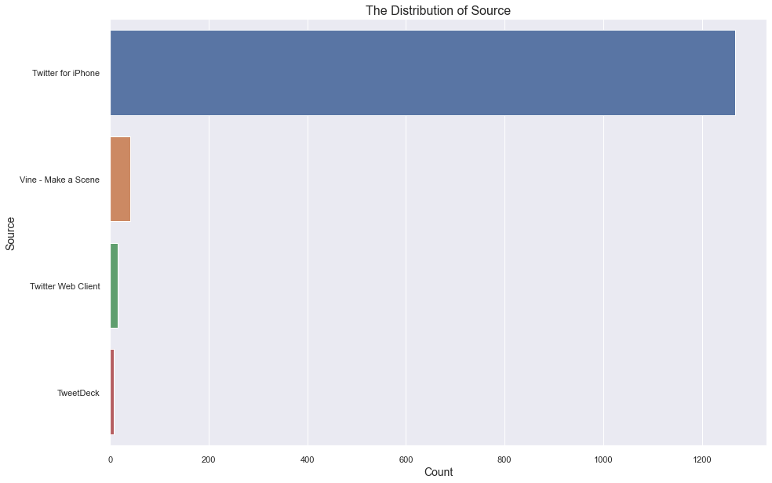

Its clearly observed that twitter for iphone was widely used medium that individuals used to access and rate the dogs. Subsequently followed by Vine, Twitter Web Client, TweetDeck.  
  
 **- (TweetDeck is a social media dashboard application for management of Twitter accounts. Originally an independent app, TweetDeck was subsequently acquired by Twitter Inc. and integrated into Twitter's interface. It has long ranked as one of the most popular Twitter clients by percentage of tweets posted, alongside the official Twitter web client and the official apps for iPhone and Android.) [https://en.wikipedia.org/wiki/TweetDeck]**