# DICOM Template Maker: A Simple Solution for Transitioning to TG263

**Brian M. Anderson PhD1, Laura Padilla1, Jeff Ryckman, Elizabeth Covington, Kevin L. Moore1, Casey Bojechko1**

*University of California San Diego Health*

***1****Department of Radiation Medicine & Applied Sciences*

# Abstract

Consistency of nomenclature within radiation oncology is becoming increasingly important as data becomes more accessible and sharing becomes more prevalent. Further standardization and automation of radiation oncology workflows depend on standardized contour nomenclature. The American Association of Physicists in Medicine (AAPM) have created a report, Number 263 titled ‘Standardizing Nomenclatures in Radiation Oncology’ to assist in this nomenclature. Unfortunately, the burden of converting to the new nomenclature requires retraining of staff or creation of templates, depending on the treatment planning system implemented. Our work aims to provide a simple method of creating DICOM RT Structure files and XML files, along with providing several templates already conforming to Report 263. The program enables for continuous updates from an online airtable maintained by TG263, and also facilitates clinics more easily updating their own templates. The C# program has been written as an installable executable on any Windows system and has been evaluated for ease of use and functionality. The program will be publicly available via our GitHub page, allowing feedback and improvement as needed from community use.

# Introduction

In the creation of a treatment plan within radiation oncology, regions of interest (ROIs) must be defined. These ROIs can be the target of radiation therapy, organs at risk (OARs), contrast agents, etc. While the Digital Imaging and Communications in Medicine (DICOM) provides a standard for communicating these generated structures (RT-Structures) in the treatment planning system, the creation of the RT-Structures is often left to the treatment planning system.

The most important ROIs will vary based on the treatment site. For example, when treating disease in the skull, the Liver will likely not be of interest. Depending on the treatment planning system, the user will then be required to manually create each ROI, individually labeling the structures involved (‘Liver’, ‘Brain’, ‘Brainstem’, etc.). This can be not only tedious, but also error prone (‘Brian’ instead of ‘Brain’). Furthermore, the naming of an ROI can vary from person to person (‘Lung_R’ vs ‘Right Lung’).

While several treatment planning systems provide a method of creating templates to automatically create the desired ROIs based on the treatment site, these templates are often manually created, a relatively time intensive process which will need to be repeated if templates need to be updated.

The American Association of Physics in Medicine (AAPM) has created Report 263 titled ‘Standardizing Nomenclatures in Radiation Oncology’, whose purpose is to provide guidance on a standard nomenclature for ROIs. Unfortunately, adoption of this can be time consuming based on the tools available in the clinic. In a recent survey provided by TG-263, 689 responses from members of AAPM, the American Society for Radiation Oncology (ASTRO), and the American Association of Medical Dosimetrists (AAMD) were asked about their likelihood for adopting TG-2631. For respondents who had not yet adopted the nomenclature, the majority stated that the largest hurdle was difficulty with retraining staff and/or a lack of time/resources to create new templates.

With this work, we aim to provide a simple system that can easily create desired RT-Structure files, XML files, and provide several standard templates for commonly treated sites directly from TG263. The system is designed to work on any Windows system, and operate with all treatment planning systems by utilizing the DICOM standard.

# Methods and Results

The program was written using the C# coding language [ref]. The program workflow is broken down into three major steps. Step 1) the creation of a template. The template (typically named after a particular site being treated, like ‘Breast’), defines what ROIs will be written. Step 2) Manipulation of ROIs. This step allows the user to select what type of ROIs are present (PTVs, Organs, etc.). Step 3) Setting DICOM paths and requirements. This step is where the user establishes where the program should *look* for new DICOM that need an RT Structure file, and differentiate if all DICOM present will receive an RT Structure file. For example, the user could require that the images have a Series Description containing ‘Breast’. Color coding of the buttons help guide the user to logical next steps. DICOM files are manipulated via the publicly available FellowOakDicom package2, and a C# wrapper for the ITK coding package, SimpleITK3.

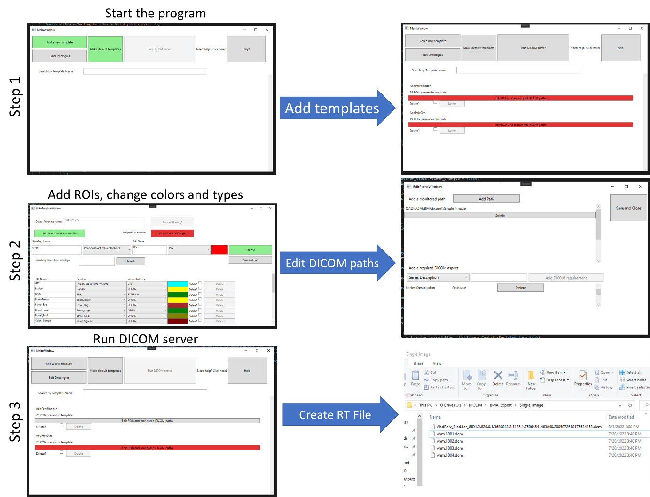

Figure :General workflow of the program

## Installation

This program was written to be run on the Windows operating system, operating system 8 or later. The program is available for download at <https://drive.google.com/drive/folders/113BQatCuYgOLmrDJEeARqACwGf6PwU9x>, and is presented as a zipped file. After extraction, the user should install with the setup.exe function, Figure 2.

Figure : Demonstration of files present after download and unzip from the website

## Running program

After installation, the program can be found via searching ‘DicomTemplateMakerGUI’, Figure 3.

Figure : Searching for program post-installation

The starting splash screen will highlight two buttons in green, prompting the user to either add a new template manually, or to create a template based on shipped default templates, Figure 4.

Figure : First run splash screen. Green buttons indicate the user should create a new template manually or via creation of the default shipped templates.

## Creation of Template - Default

The program comes with over 50 premade template options based on anatomical site and surgical status. Any number of these templates can be created via check box and selection of ‘Build Default Templates’ button, Figure 5. These default structures are based on ROIs defined at [anonymized for submission purposes], and [anonymized for submission purposes].

Figure : Example of selecting ‘AbdPelvBladder’ and ‘AbdPelvLiver’ templates from default templates.

These templates are then added to the main splash screen. Added templates button will automatically be red. The reason for this is that the program does not yet know where DICOM files will be located. This will need to be set within each individual template, and will remain red otherwise, Figure 6.

Figure : Example of front screen after the creation of the default templates ‘AbdPelvBladder’ and ‘AbdPelvGyn’. Note that both buttons are highlighted in red. This means that the templates have no information regarding folder locations to monitor.

## Manual Creation/Edit of Template

After a template has been created, either manually or via default structures, each ROI present will be listed. The ROIs are listed alphabetically within their Interpreter type. This means any ROI with a type of PTV will be listed above CTV, and then GTV, and then all other types, Figure 7. The list of ROI interpreter types can be found in the DICOM Standard Brower: <https://dicom.innolitics.com/ciods/rt-structure-set/rt-roi-observations/30060080/300600a4>

Figure : Edit within the template window for ‘AbdPelv_Gyn’. The user can add targets, and see the presented ROIs listed below. Here, the ‘PTV’ is about to be added.

### Adding ROI

ROIs can be added via the program interface or via selection of an existing RT Structure file, with the ‘Add ROIs from RT Structure File’ button. Users might find it easier to import a series of ROIs from a previously exported RT Structure than to add them manually.

### Defining monitored DICOM paths

Without a defined path, the program does not know where to monitor for new DICOM files to create an RT structure. User specified paths must be provided for each template. Paths can be added within each template with the ‘Edit monitored DICOM paths’ button, highlighted in red in Figure 7. Selecting this button will open the path window, Figure 8.

Figure : Example of setting monitored paths for the program. DICOM files placed within the list of paths will have RT Structure files created. Furthermore, users can add a required Series Description and Study Description. Here, the Series Description must contain the word ‘Prostate’.

### Defining necessary DICOM Tags

Furthermore, if the DICOM images are consistently placed within the same folder, the users can also define values that need to be present within the Series Description or Study Description before an RT Structure file will be created, bottom of Figure 8.

## Clicking ‘Run DICOM server’

After a template has been made, and an associated path set, the template will no longer be highlighted in red. Selecting the ‘Run DICOM server’ will depress button.

Figure : Example of program after providing a path for the AbdPelvBladder template. Note that the ‘Run DICOM server’ button has been depressed.

In the background, the program is now iterating through all folders presented in the path, and creating an RT Structure file for each unique DICOM image set present. In this example, a dummy patient with four CT slices was placed within the folder monitored in Figure 8. The program will then create an RT Structure file of the name ‘AbdPelv_Bladder_UID*’ where UID is preceded by the UID for that image set, Figure 10.

Figure : Example of the creation of an RT Structure file from the AbdPelv_Bladder template.

## Behind the scenes

This section is written to help the reader understand how the program writes and maintains the information present. It is not recommended for the user to manually alter the files created without a high level of confidence. However, should issues arise, the program can be re-downloaded from the site presented above.

### Creation of ROIs

Each ROI is saved as an individual text file, consisting of three lines. The first line is the RGB color which will be presented for the ROI in the treatment planning system. The second line is the associated ontology. The third line is the ROI interpreted type, as listed in the DICOM Standard Brower: <https://dicom.innolitics.com/ciods/rt-structure-set/rt-roi-observations/30060080/300600a4>. The interpreted type can be changed at any time within the template software, as shown in Figure 1.

Figure : Example of a template named ‘TG263_Breast’. The user has the ability to change the interpreted type of a region of interest after creation. Likewise, the color, name, and ontology can be changed.

ROIs can be added manually, or uploaded from an existing RT-Structure file, via the ‘Add ROIs from RT Structure File’ button. This will populate the template with ROIs, and populate the available Ontologies based on the ontologies present in the RT Structure.

### Creation of Paths

Each template contains a file called ‘Paths.txt’, which contains a list of lines specifying what paths the program should monitor.

### Creation of Ontologies

DICOM RT Structures have an Identification Code Sequence which is a code, typically an unambiguous sequence of numbers, that relates the ROI with a name defined by the coding scheme. The sequence is defined by several items, including a code value, coding scheme designator, and code meaning. The coding scheme designator is a short string which relates the code value to a human interpretable value. A list of available code schemes can be found online: <https://dicom.nema.org/medical/dicom/current/output/chtml/part16/chapter_8.html>. The code value is an unambiguous code that is typically not natural language, e.g., ‘50801’ which relates to a natural language value via the coding scheme. The code meaning is text that is human interpretable. Detailed descriptions of each of these can be found in the DICOM Standard Brower, <https://dicom.innolitics.com/ciods/rt-structure-set/rt-roi-observations/30060080/30060086>.

Any newly created ROI is required to have an associated ontology. These can be uploaded manually, by including a Common Name, associated Code, and Code Scheme. For example, the ‘Brain’ in the Foundation Model of Anatomy (FMA)2 is defined as having a code value of 50801 (<http://purl.org/sig/ont/fma/fma50801>). An example of the ontology for ‘Brain’ is shown in Figure 2.

Figure : Demonstration of ontology ‘Brain’. Based on the FMA model, the ‘Brain’ has a code value of 50801. <http://purl.org/sig/ont/fma/fma50801>

When ontologies are not present, a newly created ROI will default to ‘Undefined Normal Tissue’, this is not an FMA ontology, but instead a Varian Medical Systems code.

## Creating RT Structures

While running, the program will loop through each of the monitored paths defined within each template. A file system watcher monitors for file changes at each path, waiting 3 seconds between each change to ensure all files are uploaded before the process begins.

An image series reader then identifies all present DICOM files, separating them based on the series instance UID. This ensures that a unique RT structure file will be made for each image series, even if all the files are placed within the same folder.

For each unique series instance UID, a new RT-Structure file is created, updating the necessary frame of reference UID, and SOP Instance UID for the associated images. Several other DICOM tags are associated with the Structure to match the associated image, including: study time, study date, accession number, referring physician name, study description, patient name, patient ID, patient birthdate, patient sex, study instance UID, and study description.

Generated RT Structure files have been evaluated within the treatment planning system of Eclipse. Colors are accurately represented, as well as names, interpreter types, and associated ontologies, Figure 5.

Figure : Evaluation of generated RT Structure ‘TG263_Breast’ after importation into anonymized patient

# Discussion and Conclusion

RT Structure files are generated within 5 seconds of the images of being uploaded to the monitored paths, making it efficient with regard to clinical workflow. Templates can be easily edited in case of future changes, and default TG263 templates can be easily downloaded from our publicly available google drive.

We believe this simple tool can be of significant benefit to clinics which do not have access to templates within their treatment planning systems, or do not have sufficient resources to create new templates. If the user would like to create a template within the TPS, it is easily facilitated by the use of the program as well.

# References

1. Larouche, R., Mayo, C., Tantot, L., Ying, X., Covington E. Update from AAPM TG263U1: Standardizing Nomenclatures in RO. In: ; 2022.

2. fo-dicom/fo-dicom: Fellow Oak DICOM for .NET, .NET Core, Universal Windows, Android, iOS, Mono and Unity. Accessed July 22, 2022. https://github.com/fo-dicom/fo-dicom

3. Beare R, Lowekamp B, Yaniv Z. Image segmentation, registration and characterization in R with simpleITK. *J Stat Softw*. 2018;86(1):1-35. doi:10.18637/jss.v086.i08

4. Foundational Model of Anatomy - Summary | NCBO BioPortal. Accessed July 22, 2022. https://bioportal.bioontology.org/ontologies/FMA?p=summary