# DICOM Template Maker: A Simple Solution for Transitioning to TG263

**Brian M. Anderson PhD1, Laura Padilla1, Jeff Ryckman, Elizabeth Covington, Kevin L. Moore1, Casey Bojechko1**

*University of California San Diego Health*

***1****Department of Radiation Medicine & Applied Sciences*

# Abstract

Consistency of nomenclature within radiation oncology is becoming increasingly important as big data efforts and data sharing become more prevalent. Automation of radiation oncology workflows depends on standardized contour nomenclature which enables retrospective data analysis and outcomes research. The American Association of Physicists in Medicine (AAPM) published a report, Task Group 263 titled ‘Standardizing Nomenclatures in Radiation Oncology’ to create standardized nomenclature for structures and dosimetric data. Converting to the new nomenclature requires retraining of staff and the creation of structure templates which can be a considerable burden on staff. Our work aims to provide a simple method of creating DICOM RT Structure files and XML files, along with providing several templates already conforming to TG-263 in English, Spanish, and French. The program enables continuous updates from an online spreadsheet maintained by TG-263 members, and also facilitates clinics to easily update their own templates. The C# program has been written as an installable executable on any Windows system and has been evaluated for ease of use and functionality. The program will be publicly available via our GitHub page, allowing feedback and improvement as needed from community use.

# Introduction

In the creation of a treatment plan within radiation oncology, regions of interest (ROIs) must be defined. These ROIs can be the target of radiation therapy, organs at risk (OARs), contrast agents, etc. While the Digital Imaging and Communications in Medicine (DICOM) provides a standard for communicating these generated structures (RT-Structures) in the treatment planning system (TPS), the creation of the RT-Structures is often left to the treatment planning system.

The ROIs that are created in each treatment plan will vary based on the treatment site. For example, when treating disease in the skull, the liver will likely not be of interest. Depending on the TPS, the user will then be required to manually create each ROI, individually labeling the structures involved (‘Liver’, ‘Brain’, ‘Brainstem’, etc.). This can be not only tedious but also error-prone (‘Brian’ instead of ‘Brain’). Furthermore, the naming of an ROI can vary from person to person (‘Lung_R’ vs ‘Right Lung’) with greater than 10 variants reported for the same OAR1.

While several TPSs provide a method of creating templates to automatically create the desired ROIs based on the treatment site, these templates are often manually created, a relatively time-intensive process that will need to be repeated if templates need to be updated.

The American Association of Physics in Medicine (AAPM) has created Report of Task Group 263 titled ‘Standardizing Nomenclatures in Radiation Oncology’1, whose charge was to create a standard nomenclature for ROIs and dosimetric data. While adoption of the standard nomenclature is widely supported, clinical implementation can be time-consuming based and resource intensive. In a recent survey conducted by TG-263 members of AAPM, the American Society for Radiation Oncology (ASTRO), and the American Association of Medical Dosimetrists (AAMD) were asked about their likelihood of adopting TG-2632. For respondents who had not yet adopted the nomenclature, the majority stated that the largest hurdle was difficulty with retraining staff and/or a lack of time/resources to create new templates.

With this work, we aim to provide a simple system that can easily create desired RT-Structure files, XML files, and provide several standard templates for commonly treated sites directly from TG-263. The system is designed to work on any Windows system, and operate with all TPSs by utilizing the DICOM standard.

# Methods and Results

The program was written using the C# coding language3. The program workflow is broken down into three major steps. Step 1) the creation of a template. The template (typically named after a particular site being treated, like ‘Breast’), defines what ROIs will be written. Step 2) Manipulation of ROIs. This step allows the user to select what type of ROIs are present (PTVs, OARs, etc.), the color specification, and ontology. Step 3) Setting DICOM paths and requirements, or creating loadable DICOM/XML files. The user establishes where the program should *look* for new DICOM that need an RT Structure file, and differentiate if all DICOM present will receive an RT Structure file. For example, the user could require that the images have a Series Description containing ‘Breast’. Color coding of the buttons helps guide the user to logical next steps. DICOM files are manipulated via the publicly available FellowOakDicom package4, and a C# wrapper for the ITK coding package, SimpleITK5. The framework for creating RT Structure files in Python has been previously reported6.

## Instructional Videos

Videos for the installation and running of the program can be found linked at the bottom of the publicly available GitHub page: <https://github.com/brianmanderson/DicomTemplateMakerCSharp>, these are continually updated to show the performance of the program, and demonstrate all features.

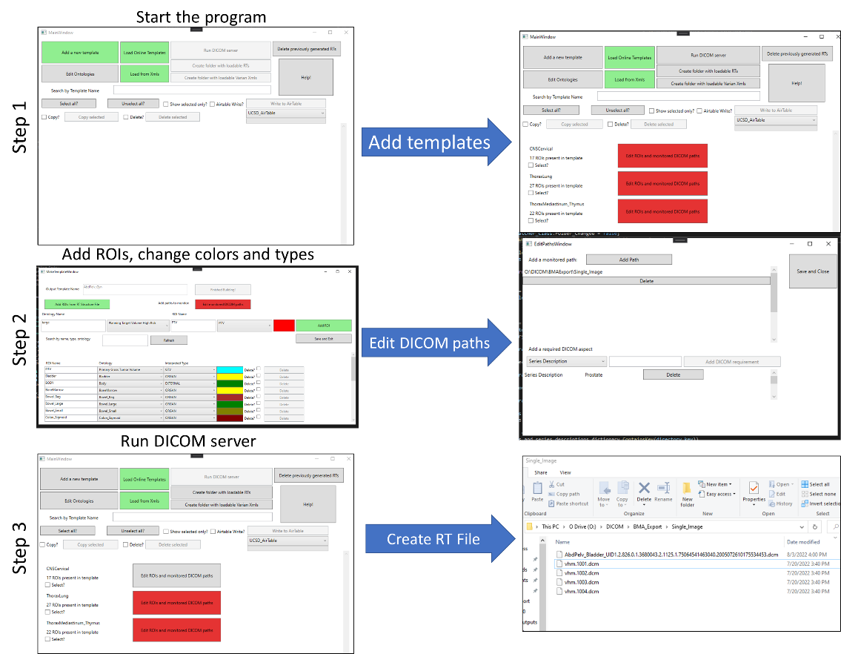

Figure : General workflow of the program

## Installation

This program was written to be run on the Windows operating system, operating system 8 or later. The link to download is available at the bottom of our GitHub page (cited above), and is presented as a zipped file. After extraction, the user should install the setup.exe function

## Running program

After installation, the program can be found via searching ‘DicomTemplateMakerGUI’.

The starting splash screen will highlight three buttons in green, prompting the user to add a new template manually, load a template from the online Airtables, or load from XML files specific to Varian as shown in Figure 3.

Figure : First run splash screen. Green buttons indicate the user should create a new template manually, load from an online template, or load from XML files (Varian)

## Creation of Template

### Load Online Templates

The program comes with over 50 premade structure set templates based on anatomical site and surgical status. The online spreadsheet containing the raw data for all templates may be found at the following link: [bit.ly/StructureNaming](https://airtable.com/shrojSoXyfnHHKzJV). Any changes to the online spreadsheet are viewed and updated by the program in real time, therefore this is an evergreen program. These default structure sets are arranged by treated organ and include all sites based on an American Society for Radiation Oncology (ASTRO) consensus paper7. There were two types of structures: Recommend and Consider. Recommended should be contoured in all adult definitive cases and may assist for palliative cases. Consider are to be considered on a case-by-case basis. These templates were further customized with common target structures for each site, relevant OARs, combining Abdomen and Pelvis roots into “AbdPelv” as there is not a natural barrier between these sites and pelvic malignancies commonly include paraortic coverage, and building out additional sub-site specific templates (e.g., intact and post-operative prostate, partial breast, whole breast, etc.). Brachytherapy templates were created by polling the AAPM brachytherapy working group for consensus, including breast, endobronchial, gynecological, ocular, prostate, and skin templates., Template roots were designed by Miscellaneous, Targets, and by anatomic Sites and Subsites. Sample Miscellaneous structures include BODY, Fid (fiducials), Hi HU (high Hounsfield units), Pacemaker, Scalp, Scar, Skin05, and Spacer. Sample Target include: “_Targets” as the root with suffixes such as “Basic”, “1DoseLevel”, “2DoseLevel”, “3DoseLevel”, “4DoseLevel”, “Breast”, “Chest wall” and “Regional Nodal Irradiation” (RNI). The current list of structures can be seen in xxx sup figure.

An informal consensus on OAR coloration and target coloration was achieved, though color selections are fully customizable within the program. For example, target coloration was based on institutional preference at MDACC (personal communication: Sue Yom), UCSF (personal communication: Anne Lee), and Michigan (personal communication: Chuck Mayo), reflecting the Clifford Chao’s original IMRT book8 color preferences (e.g., all GTV’s green, and if only one dose level, CTV Red and PTV Red; if three dose levels, CTV_Low and PTV_Low Yellow; CTV_Mid and PTV_Mid Blue, and CTV_High and PTV_High Red). As noted previously, coloration of targets and OARs are fully customizable within the program. Template language can be selected as English, Spanish, or French. A default ordering including a combination of primary and reverse orders are default selected within the program, as reverse order may reflect natural language more clearly (e.g., Anal_Canal vs Canal_Anal, Bowel_Bag, etc). Additionally, laterality first (L_Breast, not Breast_L) can be selected, Figure 4.

Figure : Example of online templates loaded from TG-263, with English and laterality first selected.

i

### Load from XMLs

If the user has access to Varian .xml files, the folder to these files can be selected and templates will be created for each unique file. Template names come from the ID attribute, replacing spaces with ‘_’.

### Manual Creation

Selecting the ‘Add a new template’ button will prompt the user to create a new template name, prepping the addition of ROIs.

## Edit of Template

After a template has been created, each ROI present will be listed. The ROIs are listed alphabetically within their Interpreter type. This means any ROI with a type of PTV will be listed above CTV, then GTV, and then all other types, as shown in Figure 5. The list of ROI interpreter types can be found in the DICOM Standard Brower.9

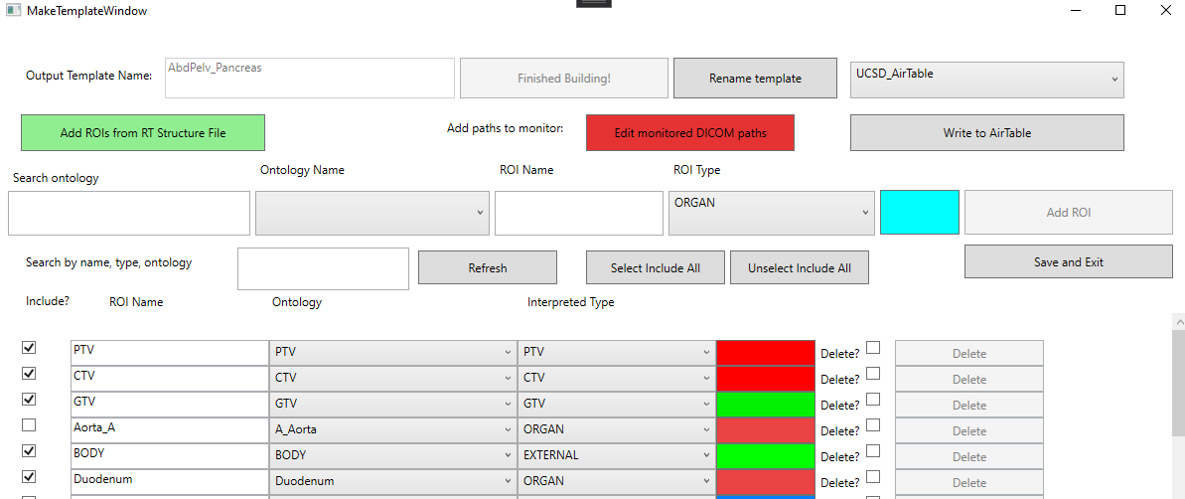

Figure : Edit within the template window for ‘AbdPelv_Gyn’. The user can add targets, and see the presented ROIs listed below. Here, the ‘PTV’ is about to be added.

### Adding ROIs

ROIs can be added via the program interface or selection of an existing RT Structure file, with the ‘Add ROIs from RT Structure File’ button. Users might find it easier to import a series of ROIs from a previously exported RT Structure than to add them manually as ontologies (FMA codes) will automatically be created after reading the RT Structure file.

## Outputs of the program

### Running the program as a DICOM Server

Should the user decide to run the program as a server, automatically creating RT Structure files for each new DICOM set that appears within a subset of folders, the following steps are required.

#### Defining monitored DICOM paths

Without a defined path, the program does not know where to monitor for new DICOM files to create an RT structure. User-specified paths must be provided for each template. Paths can be added within each template with the ‘Edit monitored DICOM paths’ button, highlighted in red in Figure 4. Selecting this button will open the path window, Figure 5.

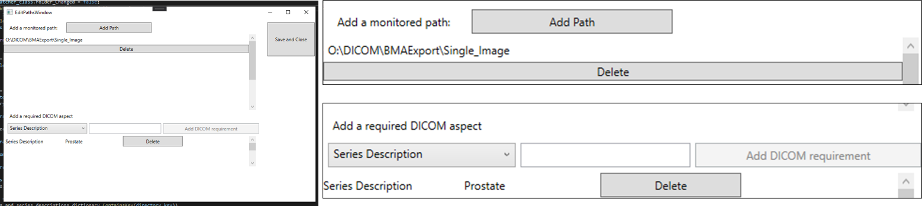

Figure : Example of setting monitored paths for the program. DICOM files placed within the list of paths will have RT Structure files created. Furthermore, users can add a required Series Description and Study Description. Here, the Series Description must contain the word ‘Prostate’.

#### Defining necessary DICOM Tags

Furthermore, if the DICOM images are consistently placed within the same folder, the users can also define values that need to be present within the Series Description or Study Description before an RT Structure file will be created, as shown at the bottom of Figure 5.

#### Clicking ‘Run DICOM server’

After a template has been made, and an associated path set, the template will no longer be highlighted in red. Selecting the ‘Run DICOM server’ will depress button, xxx sup figure.

a period of time

DICOM files are internallyedmultiple scans with the form ‘{Structure_template}_{UID}.dcm’. The generated structure file will correctlye, as well as

### Create loadable DICOM and RT Structures

If the user instead wishes to create a dummy patient, and load RT Structure files to save as templates, they can select the ‘Create folder with loadable RTs’. This will automatically create a folder with a previously anonymized four-slice CT, and generate the available structure templates as described above.

### Create loadable Varian XML Files

If the user wishes to create a series of loadable XML files, they can select the ‘Create folder with loadable Varian Xmls’. Generated .xml files follow the 2001 xmlscheme instance version 1.2. The default .xml file is present within our GitHub page named ‘Structure Template.xml’. The program will default to try and find the current Varian directory of .xml files, allowing for easy uploading.

## Uploading to a new AirTable

Users are encouraged to create their clinic-specific online spreadsheet, the AirTable. Since individual ROIs are linked across treatment sites, changes in nomenclature can easily be transferred to all sites via a single change. If the user wishes to create their Airtable templates to download/upload to, they can use the ‘Add Airtable?’ button after selecting ‘Load Online Templates’. They will be prompted to add the Table Name (a self-serving label for the Airtable), a Personal Access Token10, Base Key, and Table Key. **New users are recommended to create an account, and then copy the BaseTemplate from here** [**https://airtable.com/shr4bUE1KfQxZtu23**](https://airtable.com/shr4bUE1KfQxZtu23) **before going through these steps.**

From the main splash screen, any number of templates can be uploaded to the specified AirTable using the ‘Write to AirTable’ button.

## Behind the scenes

This section is written to help the reader understand how the program writes and maintains the information present. It is not recommended for the user to manually alter the files created without a high level of confidence. However, should issues arise, the program can be re-downloaded from the site.

### Creation of ROIs

Each ROI is saved as an individual text file, consisting of three lines. The first line is the RGB color which will be presented for the ROI in the treatment planning system. The second line is the associated ontology. The third line is the ROI interpreted type, as listed in the DICOM Standard Brower9. The interpreted type can be changed at any time within the template software, as shown in Figure 8.

Figure : Example of a template named ‘TG263_Breast’. The user has the ability to change the interpreted type of a region of interest after creation. Likewise, the color, name, and ontology can be changed.

### Creation of Paths

Each template folder contains a file called ‘Paths.txt’, which contains a list of lines specifying what paths the program should monitor for incoming DICOM files.

### Creation of Ontologies

DICOM RT Structures have an Identification Code Sequence which is a code, typically an unambiguous sequence of numbers, that relates the ROI with a name defined by the coding scheme. The sequence is defined by several items, including a code value, coding scheme designator, and code meaning. The coding scheme designator is a short string that relates the code value to a human interpretable value. A list of available code schemes can be found online11. The code value is an unambiguous code that is typically not natural language, e.g., ‘50801’ which relates to a natural language value via the coding scheme. The code meaning is text that is human interpretable. Detailed descriptions of each of these can be found in the DICOM Standard Brower for identication code12.

Any newly created ROI is required to have an associated ontology. These can be uploaded manually, by including a Common Name, associated Code, and Code Scheme. For example, the ‘Brain’ in the Foundation Model of Anatomy (FMA)13 is defined as having a code value of 5080114. An example of the ontology for ‘Brain’ is shown in Figure 9.

Figure : Demonstration of ontology ‘Brain’. Based on the FMA model, the ‘Brain’ has a code value of 50801.14

When ontologies are not present, a newly created ROI will default to ‘Undefined Normal Tissue’, this is not an FMA ontology, but instead a Varian Medical Systems code.

# Discussion

This is the first reported effort to create an open-source software to create and maintain treatment planning structure templates utilizing TG-263 standardized nomenclature. There have been previous reports of software tools used to correct previously treated structures to support retrospective data analysis15. There have also been tools created within the TPS to verify that structures names are following the standard to ensure TG-263 compliance16. With DICOM Template maker, clinics can ensure that clinical standards are met, enable automated workflows, and facilitate data pooling and outcomes research.

The DICOM Template Maker reduces the burden of manual creation of structure templates by providing TG-263 designed templates or allowing users multiple pathways for the creation of user-defined templates. Time savings are significant as RT Structure files are generated within 5 seconds of the images being uploaded to the monitored paths, making it efficient regarding clinical workflow. Templates can be easily edited in case of future changes, and default TG-263 templates can be easily downloaded using the ‘Load Online Templates’ feature.

To support large-scale, multi-institutional, and international data sharing, DICOM Template Maker enables users to create templates in English, French, or Spanish. French and Spanish language versions also follow TG-263 guidelines to enable easy mapping of structures between languages. The framework of DICOM Template Maker that utilizes AirTable enables the quick integration of TG-263 updates and new languages. The inclusion of other languages will be an ongoing effort within both TG-263 and DICOM Template Maker.

# Conclusion

We have created open-source software to drastically reduce the burden of creating and maintaining treatment planning system structure templates and which facilitates the adoption of TG-263 standardized nomenclature. This program allows clinics to quickly create templates in English, Spanish, and French and allows for customization of laterality location and color schemes. We believe this simple tool can be of significant benefit to clinics that do not have access to templates within their treatment planning systems or do not have sufficient resources to create new templates. If the user would like to create a template within the TPS, it is easily facilitated by the use of the program as well, in the form of XML files, or loadable DICOM RT Structures with the shipped anonymized DICOM.

# References

1. Mayo CS, Moran JM, Bosch W, et al. American Association of Physicists in Medicine Task Group 263: Standardizing Nomenclatures in Radiation Oncology. *Int J Radiat Oncol Biol Phys*. 2018;100(4):1057-1066. doi:10.1016/J.IJROBP.2017.12.013

2. Larouche, R., Mayo, C., Tantot, L., Ying, X., Covington E. Update from AAPM TG263U1: Standardizing Nomenclatures in RO. In: ; 2022.

3. 2013 MC. C# .NET 4.8.1. Accessed January 31, 2023. https://dotnet.microsoft.com/en-us/download/dotnet-framework

4. fo-dicom/fo-dicom: Fellow Oak DICOM for .NET, .NET Core, Universal Windows, Android, iOS, Mono and Unity. Accessed July 22, 2022. https://github.com/fo-dicom/fo-dicom

5. Beare R, Lowekamp B, Yaniv Z. Image segmentation, registration and characterization in R with simpleITK. *J Stat Softw*. 2018;86(1):1-35. doi:10.18637/jss.v086.i08

6. Anderson BM, Wahid KA, Brock KK. Simple Python Module for Conversions between DICOM Images and Radiation Therapy Structures, Masks, and Prediction Arrays. *Pract Radiat Oncol*. Published online February 17, 2021. doi:10.1016/j.prro.2021.02.003

7. Wright JL, Yom SS, Awan MJ, et al. Standardizing Normal Tissue Contouring for Radiation Therapy Treatment Planning: An ASTRO Consensus Paper. *Pract Radiat Oncol*. 2019;9(2):65-72. doi:10.1016/J.PRRO.2018.12.003

8. Chao CKS, Apisarnthanarax S. *Practical Essentials of Intensity Modulated Radiation Therapy*. 2nd ed. (Ozyigit G, Chao KSC, Apisarnthanarax S, eds.). Lippincott Williams & Wilkins; 2005.

9. RT ROI Interpreted Type Attribute – DICOM Standard Browser. Accessed February 9, 2023. https://dicom.innolitics.com/ciods/rt-structure-set/rt-roi-observations/30060080/300600a4

10. Creating and Using API Keys and Access Tokens | Airtable Support. Accessed February 9, 2023. https://support.airtable.com/docs/creating-and-using-api-keys-and-access-tokens

11. 8 Coding Schemes. Accessed February 9, 2023. https://dicom.nema.org/medical/dicom/current/output/chtml/part16/chapter_8.html

12. RT ROI Identification Code Sequence Attribute – DICOM Standard Browser. Accessed February 9, 2023. https://dicom.innolitics.com/ciods/rt-structure-set/rt-roi-observations/30060080/30060086

13. Foundational Model of Anatomy - Summary | NCBO BioPortal. Accessed July 22, 2022. https://bioportal.bioontology.org/ontologies/FMA?p=summary

14. onttk fma. Accessed February 9, 2023. http://fma.si.washington.edu/browser/#/?iri=http%3A%2F%2Fpurl.org%2Fsig%2Font%2Ffma%2Ffma50801

15. Schuler T, Kipritidis J, Eade T, et al. Big Data Readiness in Radiation Oncology: An Efficient Approach for Relabeling Radiation Therapy Structures With Their TG-263 Standard Name in Real-World Data Sets. *Adv Radiat Oncol*. 2018;4(1):191-200. doi:10.1016/J.ADRO.2018.09.013

16. Cardan RA, Covington EL, Popple RA. Technical Note: An open source solution for improving TG-263 compliance. *J Appl Clin Med Phys*. 2019;20(9):163-165. doi:10.1002/ACM2.12701