# DICOM Template Maker: A Simple Solution for Transitioning to TG263

**Brian M. Anderson PhD1, Laura Padilla1, Jeff Ryckman, Elizabeth Covington, Kevin L. Moore1, Casey Bojechko1**

*University of California San Diego Health*

***1****Department of Radiation Medicine & Applied Sciences*

# Abstract

Consistency of nomenclature within radiation oncology is becoming increasingly important as big data efforts and data sharing become more prevalent. Automation of radiation oncology workflows depends on standardized contour nomenclature which enables retrospective data analysis and outcomes research. The American Association of Physicists in Medicine (AAPM) published a report from Task Group 263 titled ‘Standardizing Nomenclatures in Radiation Oncology’ to provide recommendations for standardized nomenclature of structures and dosimetric data. Converting to the new nomenclature requires retraining of staff and the creation of structure templates, which can be a considerable burden on clinical resources. To facilitate its implementation, we developed a program that allows users to create TG-263-compliant structure templates in English, Spanish, or French. This C# program was written as an installable executable on any Windows system, it outputs the template files in either DICOM or XML format, and it extracts standardized structure nomenclature from an online spreadsheet maintained by TG-263 members, which ensures users have the most up-to-date structure names. This tool has been evaluated for ease of use and functionality. The program will be publicly available via our GitHub page, allowing feedback and improvement as needed from community use.

# Introduction

The creation of treatment plans in radiation oncology require the definition of regions of interest (ROIs), which can represent structures such as treatment targets, organs at risk (OARs), contrast agents, etc. While Digital Imaging and Communications in Medicine (DICOM) standards dictate the data format required to properly transfer information about these structures between different radiotherapy equipment, individual users are responsible for creating and naming structures for each treatment plan in their treatment planning system (TPS). When done manually, labeling the structures (‘Liver’, ‘Brain’, ‘Brainstem’, etc.) can be tedious, error-prone (‘Brian’ instead of ‘Brain’), and highly variable (i.e. ‘Lung_R’ vs ‘Right Lung’), with greater than 10 variants reported for the same OAR1.

While many TPS provide the option of creating templates to automatically load a set of desired ROIs for a given treatment, these templates are often manually created, makings the process relatively time-intensive, both for their initial creation and subsequent updates, and still vulnerable to the issues listed above.

The American Association of Physicists in Medicine (AAPM) published ‘Standardizing Nomenclatures in Radiation Oncology’1, a report from Task Group 263 (TG-263) whose charge was to create a standard nomenclature for ROIs and dosimetric data. While adoption of the standard nomenclature is widely supported, clinical implementation can be time-consuming and resource-intensive. In a recent survey conducted by TG-263, the majority of respondents who had not yet adopted the standardized nomenclature indicated that the largest hurdle was difficulty with retraining staff and/or a lack of time/resources to create new templates. The work presented here addresses this issue. We have developed a tool to easily create TG-263-compliant structure templates for commonly treated sites, with the capability of creating patient-specific structure sets based on DICOM header information from the patient’s simulation CT or MRI. The program is designed to work on any Windows system, and the templates are compatible with any TPS that uses the DICOM standard.

# Methods and Results

The program was written using C#3 and its workflow is broken down into three major steps, as illustrated in Figure 1: (1) the creation of a template, (2) manipulation of ROIs, and (3) setting DICOM paths and requirements, and/or creating loadable DICOM/XML files. DICOM files are manipulated via the publicly available FellowOakDicom package4, and a C# wrapper for the ITK coding package, SimpleITK5. The framework for creating RT Structure files in Python has been previously reported6. Videos for the installation and running of the program can be found linked at the bottom of the publicly available GitHub page: <https://github.com/brianmanderson/DicomTemplateMakerCSharp>, these are continually updated to show the performance of the program, and demonstrate all features.

The subsequent sections expand on each step of the program’s workflow.

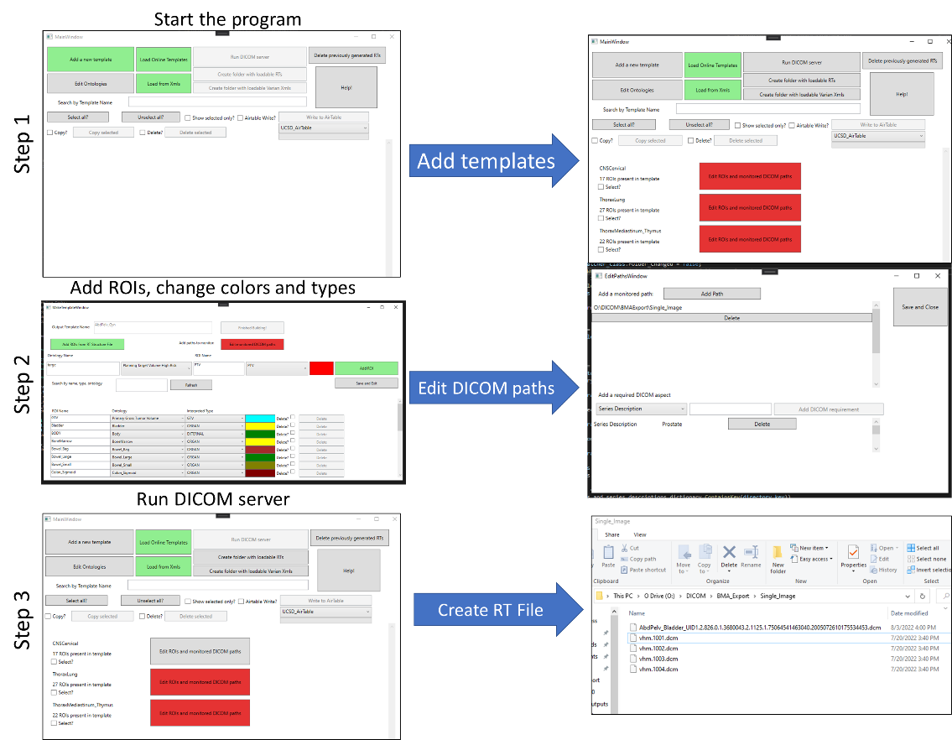

Figure 1: General workflow of the program

## Step 1: Creation of Template

The program comes with over 50 premade structure set templates based on anatomical site and surgical status. The online spreadsheet containing the raw data for all templates may be found at the following link: [bit.ly/StructureNaming](https://airtable.com/shrojSoXyfnHHKzJV). Any changes to the online spreadsheet are viewed and updated by the program in real time, therefore this is an evergreen program. These structure templates are arranged by treated organ and include all sites based on an American Society for Radiation Oncology (ASTRO) consensus paper7. Templates were further customized with common target structures for each site, relevant OARs, miscellaneous structures (e.g. Body, Fiducials, etc), and building out additional sub-site specific templates (e.g. partial breast, whole breast, etc.).

The program has preset OAR and target coloration, though color selections are fully customizable. Template language can be selected as English, Spanish, or French. By default, the program orders the structures using a combination of primary and reverse orders, as reverse order may reflect natural language more clearly for certain structures (e.g., Anal_Canal, Bowel_Bag, etc). The program also defaults to displaying laterality after the name of the structure (e.g. Breast_L), but the user can select to display it first, if desired.

Brachytherapy templates including breast, endobronchial, gynecological, ocular, prostate, and skin templates are also available and were created based on guidance from AAPM brachytherapy working group.

If the user has pre-existing templates in Varian .xml file format, the folder to these files can be selected to create templates for each unique file. Template names will be assigned from the ID attribute, replacing spaces with ‘_’.

Additionally, the user may manually create a new template by selecting the ‘Add a new template’ button, which will prompt the user to create a new template name, prepping the addition of ROIs.

Users are encouraged to create their clinic-specific online spreadsheet, the AirTable. Since individual ROIs are linked across treatment sites, changes in nomenclature can easily be transferred to all sites via a single change when the clinic-specific online spreadsheet is used. For more information, refer to our Github page.

## Step 2: Manipulation of ROIs

After a template has been created, each ROI present will be listed. The ROIs are listed alphabetically within their Interpreter type. This means any ROI with a type of PTV will be listed above CTV, then GTV, and then all other types, as shown in Figure 2. The list of ROI interpreter types can be found in the DICOM Standard Brower.9 ROIs can be added via the program interface or selection of an existing RT Structure file, with the ‘Add ROIs from RT Structure File’ button. Users might find it easier to import a series of ROIs from a previously exported RT Structure than to add them manually, as ontologies (FMA codes) will automatically be created after reading the RT Structure file.

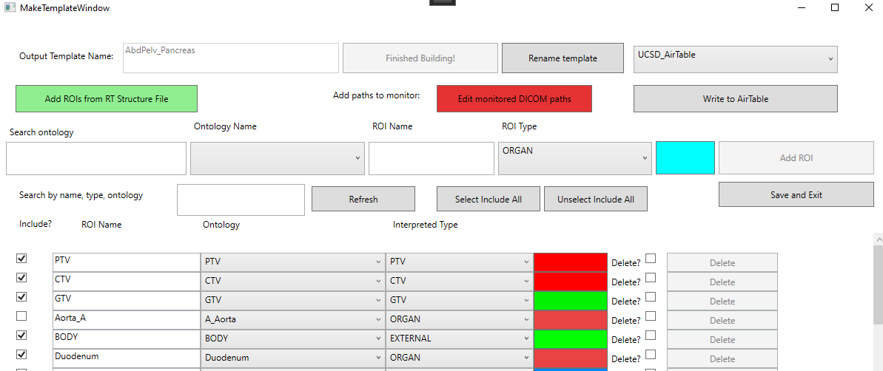

Figure : Edit within the template window for ‘AbdPelv_Gyn’. The user can add targets, and see the presented ROIs listed below. Here, the ‘PTV’ is about to be added.

## Step 3: Setting DICOM paths and requirements, and/or creating loadable DICOM/XML files

The user can utilize this program as a server with which to create a structure set for each patient image that appears in a monitored folder designated by the user, or as a tool to create structure templates to be assigned to patients within the TPS.

If set up as a server, wa period of time If the DICOM images are consistently placed within the same folder, the users can also define values that need to be present within the Series Description or Study Description before an RT Structure file is created. DICOM files are internallyedmultiple scans with the form ‘{Structure_template}_{UID}.dcm’. The generated structure file will correctlye, as well as

If the user instead wishes to create a dummy patient, and load RT Structure files to save as templates, they can select the ‘Create folder with loadable RTs’. This will automatically create a folder with a previously anonymized four-slice CT, and generate the available structure templates as described above. The user may also create a series of loadable XML files, by selecting the ‘Create folder with loadable Varian Xmls’. Generated .xml files follow the 2001 xmlscheme instance version 1.2. The default .xml file is present within our GitHub page named ‘Structure Template.xml’. The program will default to try and find the current Varian directory of .xml files, allowing for easy uploading.

## Uploading to a new AirTable

If the user wishes to create their Airtable templates to download/upload to, they can use the ‘Add Airtable?’ button after selecting ‘Load Online Templates’. They will be prompted to add the Table Name (a self-serving label for the Airtable), a Personal Access Token10, Base Key, and Table Key. **New users are recommended to create an account, and then copy the BaseTemplate from here** [**https://airtable.com/shr4bUE1KfQxZtu23**](https://airtable.com/shr4bUE1KfQxZtu23) **before going through these steps.**

From the main splash screen, any number of templates can be uploaded to the specified AirTable using the ‘Write to AirTable’ button.

## Behind the scenes

This section is written to help the reader understand how the program writes and maintains the information present. It is not recommended for the user to manually alter the files created without a high level of confidence. However, should issues arise, the program can be re-downloaded from the site.

### Creation of ROIs

Each ROI is saved as an individual text file, consisting of three lines. The first line is the RGB color which will be presented for the ROI in the treatment planning system. The second line is the associated ontology. The third line is the ROI interpreted type, as listed in the DICOM Standard Brower9. The interpreted type can be changed at any time within the template software, as shown in Figure 3.

Figure : Example of a template named ‘TG263_Breast’. The user has the ability to change the interpreted type of a region of interest after creation. Likewise, the color, name, and ontology can be changed.

### Creation of Ontologies

DICOM RT Structures have an Identification Code Sequence which is a code, typically an unambiguous sequence of numbers, that relates the ROI with a name defined by the coding scheme. The sequence is defined by several items, including a code value, coding scheme designator, and code meaning. The coding scheme designator is a short string that relates the code value to a human interpretable value. A list of available code schemes can be found online11. The code value is an unambiguous code that is typically not natural language, e.g., ‘50801’ which relates to a natural language value via the coding scheme. The code meaning is text that is human interpretable. Detailed descriptions of each of these can be found in the DICOM Standard Brower for identication code12.

Any newly created ROI is required to have an associated ontology. These can be uploaded manually, by including a Common Name, associated Code, and Code Scheme. For example, the ‘Brain’ in the Foundation Model of Anatomy (FMA)13 is defined as having a code value of 5080114. An example of the ontology for ‘Brain’ is shown in Figure 4.

Figure : Demonstration of ontology ‘Brain’. Based on the FMA model, the ‘Brain’ has a code value of 50801.14

When ontologies are not present, a newly created ROI will default to ‘Undefined Normal Tissue’, this is not an FMA ontology, but instead a Varian Medical Systems code.

# Discussion

This is the first reported effort to create an open-source software to create and maintain treatment planning structure templates utilizing TG-263 standardized nomenclature. There have been previous reports of software tools used to correct previously treated structures to support retrospective data analysis15. There have also been tools created within the TPS to verify that structures names are following the standard to ensure TG-263 compliance16. With DICOM Template maker, clinics can ensure that clinical standards are met, enable automated workflows, and facilitate data pooling and outcomes research.

The DICOM Template Maker reduces the burden of manual creation of structure templates by providing TG-263 designed templates or allowing users multiple pathways for the creation of user-defined templates. Time savings are significant as RT Structure files are generated within 5 seconds of the images being uploaded to the monitored paths, making it efficient regarding clinical workflow. Templates can be easily edited in case of future changes, and default TG-263 templates can be easily downloaded using the ‘Load Online Templates’ feature.

To support large-scale, multi-institutional, and international data sharing, DICOM Template Maker enables users to create templates in English, French, or Spanish. French and Spanish language versions also follow TG-263 guidelines to enable easy mapping of structures between languages. The framework of DICOM Template Maker that utilizes AirTable enables the quick integration of TG-263 updates and new languages. The inclusion of other languages will be an ongoing effort within both TG-263 and DICOM Template Maker.

# Conclusion

We have created open-source software to drastically reduce the burden of creating and maintaining treatment planning system structure templates and which facilitates the adoption of TG-263 standardized nomenclature. This program allows clinics to quickly create templates in English, Spanish, and French and allows for customization of laterality location and color schemes. We believe this simple tool can be of significant benefit to clinics that do not have access to templates within their treatment planning systems or do not have sufficient resources to create new templates. If the user would like to create a template within the TPS, it is easily facilitated by the use of the program as well, in the form of XML files, or loadable DICOM RT Structures with the shipped anonymized DICOM.

# References

1. Mayo CS, Moran JM, Bosch W, et al. American Association of Physicists in Medicine Task Group 263: Standardizing Nomenclatures in Radiation Oncology. *Int J Radiat Oncol Biol Phys*. 2018;100(4):1057-1066. doi:10.1016/J.IJROBP.2017.12.013

2. Larouche, R., Mayo, C., Tantot, L., Ying, X., Covington E. Update from AAPM TG263U1: Standardizing Nomenclatures in RO. In: ; 2022.

3. 2013 MC. C# .NET 4.8.1. Accessed January 31, 2023. https://dotnet.microsoft.com/en-us/download/dotnet-framework

4. fo-dicom/fo-dicom: Fellow Oak DICOM for .NET, .NET Core, Universal Windows, Android, iOS, Mono and Unity. Accessed July 22, 2022. https://github.com/fo-dicom/fo-dicom

5. Beare R, Lowekamp B, Yaniv Z. Image segmentation, registration and characterization in R with simpleITK. *J Stat Softw*. 2018;86(1):1-35. doi:10.18637/jss.v086.i08

6. Anderson BM, Wahid KA, Brock KK. Simple Python Module for Conversions between DICOM Images and Radiation Therapy Structures, Masks, and Prediction Arrays. *Pract Radiat Oncol*. Published online February 17, 2021. doi:10.1016/j.prro.2021.02.003

7. Wright JL, Yom SS, Awan MJ, et al. Standardizing Normal Tissue Contouring for Radiation Therapy Treatment Planning: An ASTRO Consensus Paper. *Pract Radiat Oncol*. 2019;9(2):65-72. doi:10.1016/J.PRRO.2018.12.003

8. Chao CKS, Apisarnthanarax S. *Practical Essentials of Intensity Modulated Radiation Therapy*. 2nd ed. (Ozyigit G, Chao KSC, Apisarnthanarax S, eds.). Lippincott Williams & Wilkins; 2005.

9. RT ROI Interpreted Type Attribute – DICOM Standard Browser. Accessed February 9, 2023. https://dicom.innolitics.com/ciods/rt-structure-set/rt-roi-observations/30060080/300600a4

10. Creating and Using API Keys and Access Tokens | Airtable Support. Accessed February 9, 2023. https://support.airtable.com/docs/creating-and-using-api-keys-and-access-tokens

11. 8 Coding Schemes. Accessed February 9, 2023. https://dicom.nema.org/medical/dicom/current/output/chtml/part16/chapter_8.html

12. RT ROI Identification Code Sequence Attribute – DICOM Standard Browser. Accessed February 9, 2023. https://dicom.innolitics.com/ciods/rt-structure-set/rt-roi-observations/30060080/30060086

13. Foundational Model of Anatomy - Summary | NCBO BioPortal. Accessed July 22, 2022. https://bioportal.bioontology.org/ontologies/FMA?p=summary

14. onttk fma. Accessed February 9, 2023. http://fma.si.washington.edu/browser/#/?iri=http%3A%2F%2Fpurl.org%2Fsig%2Font%2Ffma%2Ffma50801

15. Schuler T, Kipritidis J, Eade T, et al. Big Data Readiness in Radiation Oncology: An Efficient Approach for Relabeling Radiation Therapy Structures With Their TG-263 Standard Name in Real-World Data Sets. *Adv Radiat Oncol*. 2018;4(1):191-200. doi:10.1016/J.ADRO.2018.09.013

16. Cardan RA, Covington EL, Popple RA. Technical Note: An open source solution for improving TG-263 compliance. *J Appl Clin Med Phys*. 2019;20(9):163-165. doi:10.1002/ACM2.12701