# Open RT Structures: A Scalable Solution for TG-263 Accessibility

**Brian M. Anderson PhD1, Laura Padilla PhD1, Jeffrey M. Ryckman MD2, Elizabeth Covington PhD3, David S. Hong MD4, Kaley Woods PhD4, Kevin L. Moore PhD1, Casey Bojechko PhD1**

1Department of Radiation Medicine and Applied Sciences, University of California San Diego

2Department of Radiation Oncology, West Virginia University Medicine Camden Clark Medical Center

3University of Michigan, Ann Arbor, Michigan

4University of Southern California, Los Angeles, California

# Abstract

Consistency of nomenclature within radiation oncology is becoming increasingly important as big data efforts and data sharing become more prevalent. Automation of radiation oncology workflows depends on standardized contour nomenclature which enables retrospective data analysis and outcomes research. Recommendations for standardized nomenclature of structure and dosimetric data have been published in the American Association of Physicists in Medicine (AAPM) report from Task Group 263 titled ‘Standardizing Nomenclatures in Radiation Oncology’. However, transitioning to TG-263 requires creation and management of structure template libraries, and retraining of staff, which can be a considerable burden on clinical resources. To reduce practice expense and facilitate TG-263’s implementation, we developed a program that allows users to create TG-263-compliant structure templates in English, Spanish, or French. This C# program is usable on any Windows system and generates template files in practice-specific DICOM or XML formats, extracting standardized structure nomenclature from an online database maintained by members of the TG-263U1 Task Group; this ensures users have continuous access to up-to-date structures. This tool has been evaluated for ease of use and designed to allow users multiple pathways for the creation of user-defined templates. The program and source code are publicly available via GitHub. Feedback from community users is encouraged to identify opportunities for improvement and guide further development.

# Introduction

The creation of treatment plans in radiation oncology requires the delineation of regions of interest (ROIs), which often represent structures such as targets and organs at risk (OARs). While Digital Imaging and Communications in Medicine (DICOM) standards specify data formats required to electronically communicate information about these structures, users are individually responsible for creating and naming sets of structures for each treatment plan in their treatment planning system (TPS). Done manually, labeling structures (‘Liver’, ‘Brain’, ‘Brainstem’, etc.) is tedious, error-prone (‘Brian’ instead of ‘Brain’), and variable (i.e. ‘Lung_R’ vs ‘Right Lung’), with greater than 10 variants reported for many OARs1.

While many TPS provide the option of maintaining template libraries to let users load a specific set of ROIs for a particular treatment, these libraries are often manually created, making the process relatively time-intensive, both for their initial creation and subsequent updates, and remain vulnerable to the issues listed above.

The American Association of Physicists in Medicine (AAPM) published ‘Standardizing Nomenclatures in Radiation Oncology’1, a report from Task Group 263 (TG-263) whose charge was to create a standard nomenclature for ROIs and dosimetric data. While adoption of the standard nomenclature has popular support, its implementation is time-consuming and resource-intensive. In a recent survey conducted by the TG-263U1 Task Group, the majority of respondents who had not yet adopted the standardized nomenclature, indicating that the largest hurdles were lack of time/resources to create new templates and difficulty with retraining staff. The work presented here directly addresses this issue. We have developed a tool to easily create TG-263-compliant structure template libraries, along with the ability to monitor folders and automatically add patient-specific structure sets to image sets triggered by specific DICOM labeling on CT and MRI scans. This program allows the user to create a template in several ways; 1) 50 pre-made structure templates, 2) from current RT structure sets or Varian xml files or 3) Custom manual creation. The program is designed to work on any Windows system, and the templates are compatible with any TPS that uses the DICOM standard.

# Methods and Results

The program was written using C#2 and its workflow is broken down into three major steps, as illustrated in Figure 1: (1) the creation of a template, (2) manipulation of ROIs, and (3) setting DICOM paths and requirements, and/or creating loadable DICOM/XML files. DICOM files are manipulated via the publicly available FellowOakDicom package3, and a C# wrapper for the ITK coding package, SimpleITK4. The framework for creating RT Structure files in Python has been previously reported5. Videos for the installation and running of the program can be found linked at the bottom of the publicly available GitHub page: <https://github.com/brianmanderson/DicomTemplateMakerCSharp>, these are continually updated to demonstrate current features and performance of the program.

The subsequent sections expand on each step of the program’s workflow.

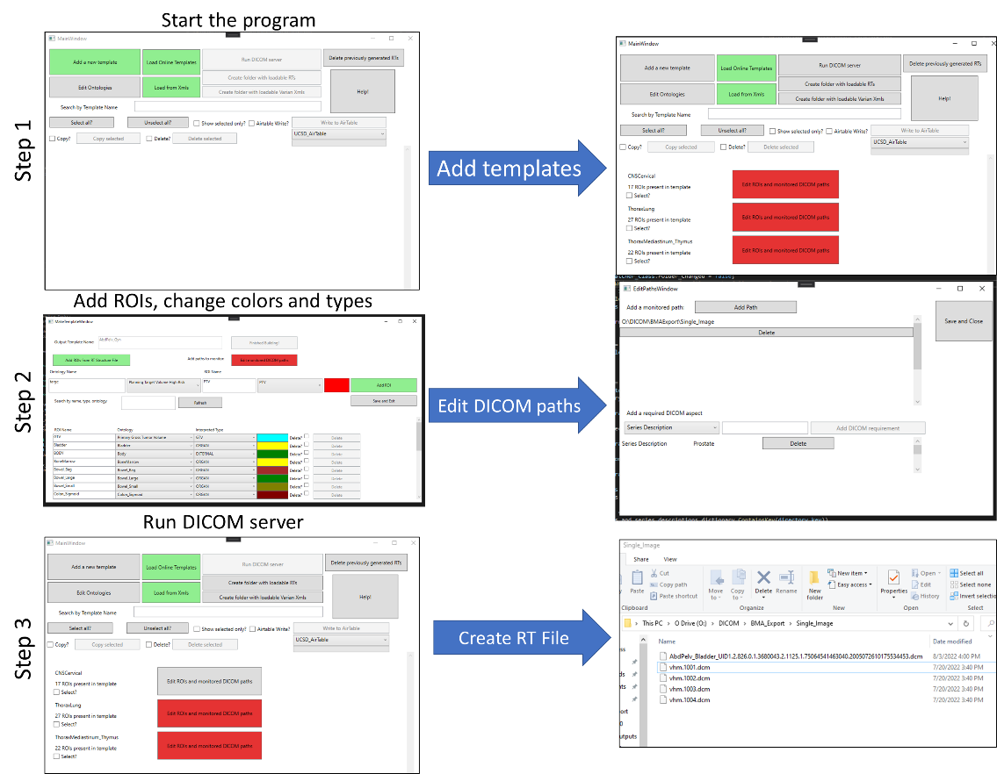

Figure 1: General workflow of the program

## Step 1: Creation of Template

The program comes with a library of over 50 premade structure set templates designed for specific anatomical sites and clinical indications which can be loaded from our online spreadsheet. The online spreadsheet containing the raw data for all templates may be found at the following link: [bit.ly/StructureNaming](https://airtable.com/shrojSoXyfnHHKzJV). Changes to the online spreadsheet are updated and viewable in the program in real time. These structure templates includes all anatomic sites identified in American Society for Radiation Oncology (ASTRO) consensus6, but with enhanced patient-specificity for certain anatomic sites (e.g. head and neck subsites) and clinical indications (e.g. whole breast vs. partial breast), with support for various support structures (e.g. fiducials). Structures sets are customizable and erred on the side of being thorough and inclusive given advances in automated segmentation.

The program has preset OAR and target coloration; color selections are customizable. Template language can be selected as English, Spanish, or French. Structures default to English where Spanish or French translations are not available. By default, the program orders the structures using a combination of primary and reverse orders, as reverse order reflects natural language more clearly for certain structures (e.g., Anal_Canal, Bowel_Bag, etc). The program defaults to displaying laterality after the name of the structure (e.g. Breast_L), but can be adjusted to display laterality first.

Brachytherapy templates including breast, endobronchial, gynecological, ocular, prostate, and skin templates are provide, created with guidance from the brachytherapy subgroup within the TG-263 update committee.

If the user has pre-existing templates in Varian .xml file format, these can be easily added to the program for future maintaince.

Additionally, the user may manually create a new template by selecting the ‘Add a new template’ button, which will prompt the user to create a new template name, prepping the addition of ROIs.

Individual ROIs are linked across treatment sites, so changes in nomenclature can easily be transferred to all structure set templates via a single change when a clinic-specific online spreadsheet is used. For more information, refer to our Github page.

## Step 2: Manipulation of ROIs

After a template has been created, ROIs are listed alphabetically grouped within their Interpreted Type7. This means any ROI with a type of PTV will be listed above CTV, then GTV, and then all other types, as shown in Figure 2. The list of ROI Interpreter Types can be found in the DICOM Standard Brower.7 ROIs can be added via the program interface or selection of an existing RT Structure file with the ‘Add ROIs from RT Structure File’ button. Users might find it easier to import a series of ROIs from a previously exported RT Structure than to add them manually, as ontologies (FMA codes) will automatically be created after reading the RT Structure file. Specifics on the creation of ROIs and Ontologies can be found later in this document.

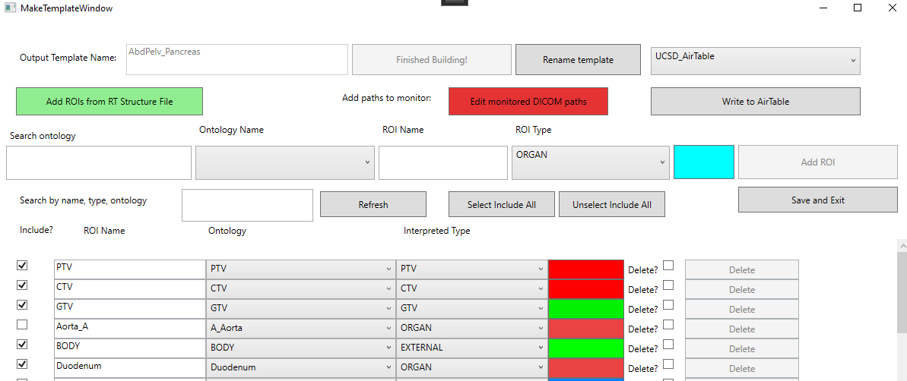

Figure : Edit within the template window for ‘AbdPelv_Gyn’. The user can add targets, and see the presented ROIs listed below. Here, the ‘PTV’ is about to be added.

## Step 3: Setting DICOM paths and requirements, and/or creating loadable DICOM/XML files

The user can utilize this program as a server with which to create a structure set for each patient image that appears in a monitored folder designated by the user, or as a tool to create structure templates to be assigned to patients within the TPS.

If set up as a server, while running, the program will loop through each of the monitored paths defined within each template. A file system watcher monitors for file changes at each path, waiting a period of time between each change to ensure all files are uploaded before the process begins. If the DICOM images are consistently placed within the same folder, the users can also define values that need to be present within the Series Description or Study Description before an RT Structure file is created. DICOM files are internally separated based on the series instance UID. This ensures that a unique RT structure file will be made, even if multiple scans are placed within the same folder. For each unique series instance UID, a new RT-Structure file is created with the form ‘{Structure template name}_{UID}.dcm’. The generated structure file will correctly update the necessary frame of reference UID, and SOP Instance UID for the associated images, as well as study time, study date, accession number, referring physician name, study description, patient name, patient ID, patient birthdate, patient sex, study instance UID, and study description.

If the user instead wishes to create a dummy patient, and load RT Structure files to save as templates, as is possible within certain TPS, they can select the ‘Create folder with loadable RTs’. This will create a folder with a previously anonymized four-slice CT, and generate the available structure templates as described above. The user may also create a series of loadable XML files, by selecting the ‘Create folder with loadable Varian Xmls’. Generated .xml files follow the 2001 xmlscheme instance version 1.2. The default .xml file is present within our GitHub page named ‘Structure Template.xml’. The program will default to attempt to find the current Varian directory of .xml files, allowing for easy uploading.

## Behind the scenes

This section is written to help the reader understand how the program writes and maintains the information present. It is not recommended for the user to manually alter the files created without a high level of confidence. However, should issues arise, the program can be re-downloaded from the site.

### Creation of ROIs

Each ROI is saved as an individual text file, consisting of three lines. The first line is the RGB color which will be presented for the ROI in the treatment planning system/within the generated RT Structure file. The second line is the associated ontology, detailed below. The third line is the ROI Interpreted Type, as listed in the DICOM Standard Brower7. The Interpreted Type can be changed at any time within the template software, as shown in Figure 3.

Figure : Example of a template named ‘TG263_Breast’. The user has the ability to change the interpreted type of a region of interest after creation. Likewise, the color, name, and ontology can be changed.

### Creation of Ontologies

DICOM RT Structures have Identification Code Sequences which are codes, typically unambiguous sequences of numbers, that relate a ROI with a name defined by the coding scheme. The sequence is defined by several items, including a code value, coding scheme designator, and code meaning. The coding scheme designator is a short string that relates the code value to a human interpretable value. A list of available code schemes can be found online9. The code value is an unambiguous code that is typically not natural language, e.g., ‘50801’. The code meaning is text that is human interpretable. Detailed descriptions of each of these can be found in the DICOM Standard Brower for identication code10.

Any newly created ROI is required to have an associated ontology. These can be uploaded manually, by including a Common Name, associated Code, and Code Scheme. For example, the ‘Brain’ in the Foundation Model of Anatomy (FMA)11 is defined as having a code value of 5080112. An example of the ontology for ‘Brain’ is shown in Figure 4.

Figure : Demonstration of ontology ‘Brain’. Based on the FMA model, the ‘Brain’ has a code value of 50801.12

When ontologies are not present, a newly created ROI will default to ‘Undefined Normal Tissue’, this is not an FMA ontology, but instead a Varian Medical Systems code.

# Discussion

This is the first reported effort to create open-source software to create and maintain libraries of patient-specific treatment planning structure templates utilizing TG-263 standardized nomenclature. There have been previous reports of software tools used to homologate sets of previously treated structures to support retrospective data analysis13. There have also been tools created within the TPS to verify that structures names comply with TG-26314. With Open RT Structures, clinics can ensure that clinical standards are met, enable automated workflows, and facilitate data pooling and outcomes research.

Generated RT Structure files have been evaluated within the treatment planning system of Eclipse. Colors are accurately represented, as well as names, interpreter types, and associated ontologies, XXX sup figure.

The DICOM Template Maker reduces the burden of manual creation of structure templates by providing TG-263 designed templates and allowing users multiple pathways to ease the creation of user-defined templates. Time savings are significant as patient-specific RT Structure files can be generated within seconds of the image uploaded to monitored paths, an efficient clinical workflow. Templates can be easily edited in case of future changes, and a reasonable set of default TG-263 templates can be refreshed using the ‘Load Online Templates’ feature.

To support large-scale, multi-institutional, and international data sharing, the DICOM Template Maker enables users to create templates in English, French, or Spanish. French and Spanish language versions also follow TG-263 guidelines to enable easy mapping of structures between languages. The framework of DICOM Template Maker that utilizes AirTable enables the quick integration of TG-263 updates and new languages. The inclusion of other languages will be an ongoing effort within both TG-263 and DICOM Template Maker.

# Conclusion

We have created open-source software that drastically reduces the burden of creating and maintaining TPS structure templates and facilitate the adoption of TG-263 standardized nomenclature. This program allows clinics to quickly create templates in English, Spanish, or French and allows for customization of laterality location and color schemes. Both patient-specific DICOM RT Structure files and Varian XML template files can be easily created. We believe this simple tool can be of significant benefit to clinics that do not have ready access to templates within their treatment planning systems or do not have sufficient resources to invest in new template creation.

# References

1. Mayo CS, Moran JM, Bosch W, et al. American Association of Physicists in Medicine Task Group 263: Standardizing Nomenclatures in Radiation Oncology. *Int J Radiat Oncol Biol Phys*. 2018;100(4):1057-1066. doi:10.1016/J.IJROBP.2017.12.013

2. 2013 MC. C# .NET 4.8.1. Accessed January 31, 2023. https://dotnet.microsoft.com/en-us/download/dotnet-framework

3. fo-dicom/fo-dicom: Fellow Oak DICOM for .NET, .NET Core, Universal Windows, Android, iOS, Mono and Unity. Accessed July 22, 2022. https://github.com/fo-dicom/fo-dicom

4. Beare R, Lowekamp B, Yaniv Z. Image segmentation, registration and characterization in R with simpleITK. *J Stat Softw*. 2018;86(1):1-35. doi:10.18637/jss.v086.i08

5. Anderson BM, Wahid KA, Brock KK. Simple Python Module for Conversions between DICOM Images and Radiation Therapy Structures, Masks, and Prediction Arrays. *Pract Radiat Oncol*. Published online February 17, 2021. doi:10.1016/j.prro.2021.02.003

6. Wright JL, Yom SS, Awan MJ, et al. Standardizing Normal Tissue Contouring for Radiation Therapy Treatment Planning: An ASTRO Consensus Paper. *Pract Radiat Oncol*. 2019;9(2):65-72. doi:10.1016/J.PRRO.2018.12.003

7. RT ROI Interpreted Type Attribute – DICOM Standard Browser. Accessed February 9, 2023. https://dicom.innolitics.com/ciods/rt-structure-set/rt-roi-observations/30060080/300600a4

8. Creating and Using API Keys and Access Tokens | Airtable Support. Accessed February 9, 2023. https://support.airtable.com/docs/creating-and-using-api-keys-and-access-tokens

9. 8 Coding Schemes. Accessed February 9, 2023. https://dicom.nema.org/medical/dicom/current/output/chtml/part16/chapter_8.html

10. RT ROI Identification Code Sequence Attribute – DICOM Standard Browser. Accessed February 9, 2023. https://dicom.innolitics.com/ciods/rt-structure-set/rt-roi-observations/30060080/30060086

11. Foundational Model of Anatomy - Summary | NCBO BioPortal. Accessed July 22, 2022. https://bioportal.bioontology.org/ontologies/FMA?p=summary

12. onttk fma. Accessed February 9, 2023. http://fma.si.washington.edu/browser/#/?iri=http%3A%2F%2Fpurl.org%2Fsig%2Font%2Ffma%2Ffma50801

13. Schuler T, Kipritidis J, Eade T, et al. Big Data Readiness in Radiation Oncology: An Efficient Approach for Relabeling Radiation Therapy Structures With Their TG-263 Standard Name in Real-World Data Sets. *Adv Radiat Oncol*. 2018;4(1):191-200. doi:10.1016/J.ADRO.2018.09.013

14. Cardan RA, Covington EL, Popple RA. Technical Note: An open source solution for improving TG-263 compliance. *J Appl Clin Med Phys*. 2019;20(9):163-165. doi:10.1002/ACM2.12701