# General Goal

Identify an angle range allowable on the IC Profiler which corresponds to the 2% threshold recommended in TG-142.

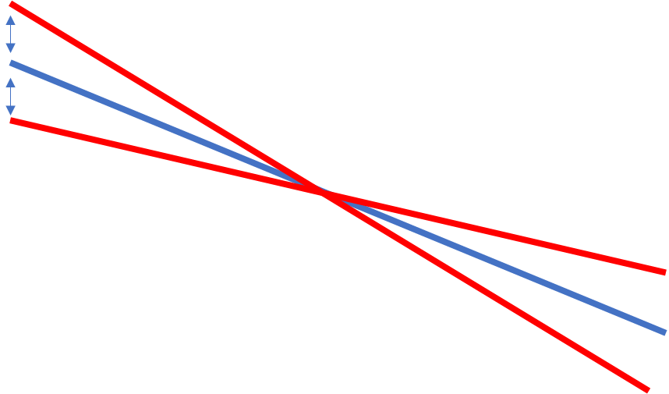

Using the TPS acquire the same profiles we would expect to collect on the IC Profiler. The expected wedge angle is measured from TPS, as well as a range of wedge angles associated with +/- 2%.

# Phantom Information

Patient: Commissioning, LaJolla TrueBeam

Image set: ICProfiler1: Dimensions 42x42x12cm (3cm depth of IC profiler, plus 9cm solid water)

## Plan Information

User origin set to be 9.9cm deep, corresponding with plane of electronics.

Plan Group: Geom 4 (EDW)

Plan: ICProfiler15X/ICProfiler6X

Fields: 20x20 field, 90.1SSD, EDW60IN

Depth of 9.9cm, 100SAD

Profile plane at user origin was exported, coronal field (bottom left)

Move viewing plane to the origin

Right click Dose -> export dose plane

X Plane: 25.5cm 256 pixels, and Y Plane: 25.5cm 256 pixels

## In code

Set cross plane field size as 200mm

# Calculating Wedge Angle

Equation is based on acquisition model expressed in the IC Profiler.

<https://pulse.ucsd.edu/tools/radonc/physicists/Documents/Manuals/IC%20PROFILER%E2%84%A2%20Reference%20Guide.pdf>

Pages 65 on pdf for acquisition

R refers to response at two points, respectively, and wdistL refers to the distance between those to points. The equation for u is below.

$$u=\frac{\ln\left(\frac{PDD_{1}}{PDD_{2}}\right)}{D_{PDD_{2}}-D_{PDD_{1}}}$$

Where PDD refers to percent depth dose at depth D.

For 15X, D1 at 4cm and PDD1 = 96.1%, D2 = 10.02cm and PDD2 = 76.7% results in

u15MV = 0.0375

For 6X, D1 at 4.02cm and PDD1 = 91.00%, D2 = 10.00cm and PDD2 = 69.53% results in

u6MV = 0.0450.

For the 20x20 field, we selected points at the 80% field size (20*.8=16cm), we took the points +8cm and -8cm from the middle.

## Comparing to IC Profiler

15MV: From the equations listed above, and the exported dose profile, we would expect the measured angle to be 62.52 degrees, and between 61.69-63.32 degrees. The IC Profiler measured a response of 62.25 degrees.

6MV: From the equations listed above, and the exported dose profile, we would expect the measured angle to be 62.75 degrees, and between 62.07-63.4 degrees. The IC Profiler measured a response of 62.28 degrees.