Introduction

Colorectal Cancer in the United States
Colorectal cancer (CRC) is one of the predominant forms of cancer within the United States, being the 3rd most common cause of cancer and cancer death in both men and women(Siegel et al., 2019). While 25% of patients present with colorectal liver metastasis (CRL-mets) at the time of diagnosis, up to 60% will develop CRL-mets over the course of their disease(Alper Sag et al., 2016).

Detection of Colorectal Liver Metastasis (CRL-mets)
While several treatment options are available for CRL-mets, they all first rely on proper identification of the disease. The acquisition of a contrast-enhanced CT (CECT) scan is the standard of care for identifying CRL-mets. A CECT often consists of three phases: an arterial phase, where the contrast is most prominent in the descending aorta, the portal-venous phase, where contrast is mostly present within the portal-vein, and a washout phase. CRL-mets often appear as hypo-dense regions in the arterial and portal-venous phase of the image, in stark contrast to the normal liver tissue.
Detecting CRL-mets can be challenging due to the relatively small size of the metastases at early detection and large search area in the liver. Furthermore, interventions such as radiation therapy, radiofrequency ablation, and microwave ablation, require accurate segmentations of the disease site for dose evaluation or image guidance. To date, automated liver disease segmentation tasks have largely focused on primary liver disease (Christ et al., 2016) or not included qualitative evaluation of generated contours (Vorontsov et al., 2019). New institution and society-sponsored competitions, such as the Liver Tumor segmentation (LiTs) challenge, have contained data of both primary and secondary liver cancers, enabling our training on public data.

Ablation Therapies
For ablation interventions, segmentations of the disease in the pre-treatment imaging, and the ablation cavity in the post-treatment imaging, are important for planning the treatment and assessing the outcome, such as evaluating the minimum delivered ablation margin. Both radiofrequency and microwave ablation interventions aim for a minimum margin be delivered around the gross disease to ensure that all microscopic disease is treated. The ablation cavity appears hypodense on CECT images, similar to the CRL-mets. While a clinical trial is underway to map the disease from the pre-treatment to the post-treatment imaging and assess treatment efficacy they still require manual segmentations of both disease and ablation zone(Software-Aided Imaging (Morfeus) for Confirming Tumor Coverage With Ablation in Patients With Liver Tumors, the COVER-ALL Study - Full Text View - ClinicalTrials.Gov, n.d.).
We hypothesize that fully convolutional neural networks, trained using novel methods to account for the challenges of disease size with respect to the overall liver, can provide rapid and accurate identification and segmentation of both CRL-mets and ablation generated cavities. The creation of which would help facilitate automated detection of CRL-mets, treatment planning of CRL-mets in radiation therapy, and facilitate margin evaluations in ablation therapy.

Materials/Methods

Data

LiTs Quantitative Training/Validation/Test
To ensure that the model creation is reproducible at other institutions, our training\validation and quantitative test data was collected from the publicly available Liver Tumor Segmentation (LiTS) challenge (https://competitions.codalab.org/competitions/17094). This data consisted of 130 CECT scans with liver tumors of primary liver cancer and secondary liver metastasis. Ground truth segmentations of the liver and disease were provided by the challenge, although only the disease is predicted by our model. Each image was evaluated by xxx, and removed if the disease was hyper-enhancing or not secondary metastasis, or if the image acquisition parameters (slice thickness, pixel spacing) were not correctly included. A total of 92 patients remained, which were then distributed into 57 patients for training, 10 patients for validation, and 25 patients for a completely withheld test set. The image acquisition parameters for the training, validation, and test set can be seen in Table xxx.
Table 1: Image acquisition parameters from LiTs Training, Validation, and Test set.
Folder | Slice Thickness (mm) | Pixel Size X (mm/voxel) | Pixel Size Y (mm/voxel)
 | Mean (Min, Max)
Training | 1.64 (0.7, 5.0) | 0.75 (0.60, 0.98) | 0.75 (0.60, 0.98)
Validation | 2.02 (0.7, 5.0) | 0.78 (0.68, 0.98) | 0.78 (0.68, 0.98)
Test | 1.41 (0.7, 5.0) | 0.76 (0.64, 0.97) | 0.76 (0.64, 0.97)

Quantitative Evaluation
Architecture success was evaluated on the test set based on Dice Similarity Coefficient (DSC) and Median Surface Distance (MSD) between the manual segmentation and the predicted segmentation. To remove bias of patients with multiple small disease sites, evaluations were performed on both a disease site-by-site basis, and patient-by-patient basis. For the site-by-site comparison, each non-connected manually defined binary structure of the disease site of the test patients was considered as an independent case. Note that these cases are still only in the testing cohort, not training or validation. For these site-by-site comparisons, predictions segmentations were evaluated by removing all but the closest (determined by the centroid of and prediction regions) continuous prediction segmentation. For patient-by-patient comparison, metrics were computed by comparison of the manual contours and the prediction segmentations within the entire liver.
Sensitivity of the algorithm was evaluated on a site-by-site basis, where the disease was defined as ‘identified’ if at least 25% of the manually defined tumor volume was covered by prediction. False positive volume was defined as the volume of predicted disease segmentation outside of the ground truth disease segmentation, Figure xxx. False positive volume is comprised of two errors, one is over segmentations of an actual tumor volume, and the second is erroneous segmentation of normal liver as disease. We measured the erroneous false positive volume as the volume completely unconnected from any ground truth disease segmentations, the total false positive volume as the total predicted volume outside of ground truth segmentations, and the over-segmentation false volume as the total predicted volume minus the erroneous volume, Figure xxx.
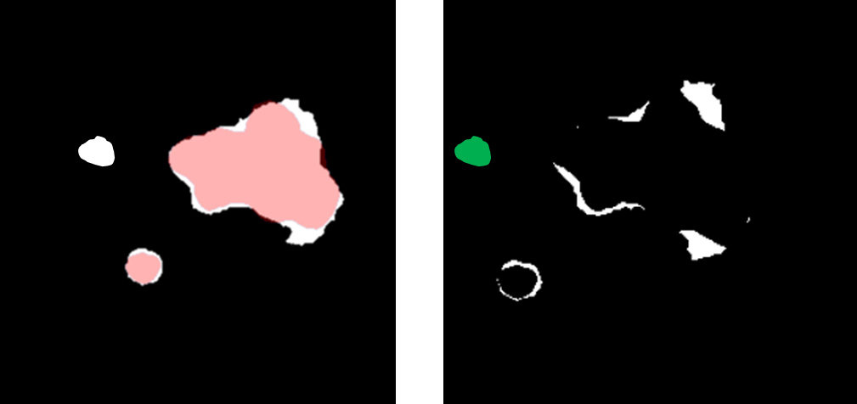
Figure 1: (Left) Prediction in white with ground truth overlaid in red. (Right) Subtraction image of prediction outside of ground truth, white voxels are connected to a disease ground truth segmentation, while green is unconnected. False positive volume is the volume of white + green voxels, erroneous false positive region is the volume in green, and over-segmentation volume is the volume in white.

Institutional Test Data

Quantitative Evaluation
Eighteen patients who had previously undergone thermal ablation therapy at our institution were retrospectively identified under an Institutional Review Board approved study. Each patient had two CECT scans, one pre-ablation to identify the disease, and one post-treatment to identify the ablation zone. Two patients had two disease sites present, therefore an evaluation of the DSC for each disease site was performed.
Scans were removed if the radiologists felt sufficient contrast was not present or the disease was contrast enhancing, Supplementary Figure xxx, this removed six post-treatment CECT (ablation zones) and two pre-treatment CECT. The final count was 18 disease sites and 12 ablation sites.
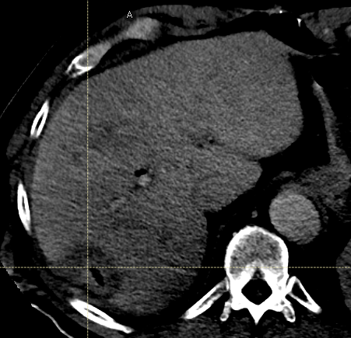
Supplementary Figure 2: Example of image deemed to lack sufficient contrast for segmentation of ablation cavity.

Qualitative Evaluation
Quantitative metrics are not always sufficient to assess a segmentation algorithms efficacy. For large structures, a high Dice Similarity Coefficient (DSC) can hide clinically impactful inaccuracies, while for smaller structures a low DSC could be overly critical(Anderson et al., 2020). Therefore, a qualitative assessment of both CRL-met segmentation and ablation segmentation of the 18 institutional test cases described above was performed by two board certified interventional radiologists, each with over a decade of experience.
Contours were scored independently by both interventional radiologists based on a Likert quality scale of 1-5. The criteria for the scale can be seen in Table xxx.
Table 2: Likert scoring for assessment of colorectal liver metastasis (CRL-met) and ablation contours
Score |  | Criteria
5 | Excellent | Negligible changes, could be used clinically without edits
4 | Good | Minor changes on < 4 slices, or that would take less than 10 seconds to fix
3 | Fair | Edits needed on multiple slices, but less than 50%
2 | Poor | Greater than 50% of slices need editing
1 | Very poor | Contours are completely useless, missed disease

Data Pre-Processing

Intensity Manipulation
Initial attempts to normalize the data based on a global mean and standard deviation resulted in extreme outliers when the contrast within the liver was high or low relative to the global mean. To best separate the normal tissue from the disease, a patient specific mean and standard deviation was calculated based on the FWHM of values within the provided contoured liver. This led to the consistent visual appearance of the disease appearing darker than the normal tissue. Image intensity outside of the liver was set to be equal to 0 after normalization.

Voxel Size Resampling
A known weakness of convolutional neural networks is instability with varying image sizes. All training and validation images were resampled to be 1mm in slice thickness using bi-linear interpolation. Likewise, bi-linear interpolation was applied to the ground-truth segmentations of the disease, providing the model with values ranging from 0-1 for each part of the disease.
For all test assessment, predictions were resampled to the original slice thickness and compared against the unchanged ground truth.

Training Image ‘Cubes’
The relative size of annotation vs background is a well-known concern within image segmentation. Smaller structures are inherently worth less than large structures when categorical cross-entropy is used as a loss and class weighting is not applied. Unfortunately, simple class weighting would invariably weigh the more heavily diseased patients over less diseased patients.
To this end, each independent disease site within a patient was divided into individual ‘cubes’ of 32x120x120 voxels. Note that this means disease not centered on the cube is still properly defined as disease, Figure xxx. After extraction, the training dataset consists of 572 unique image cubes.
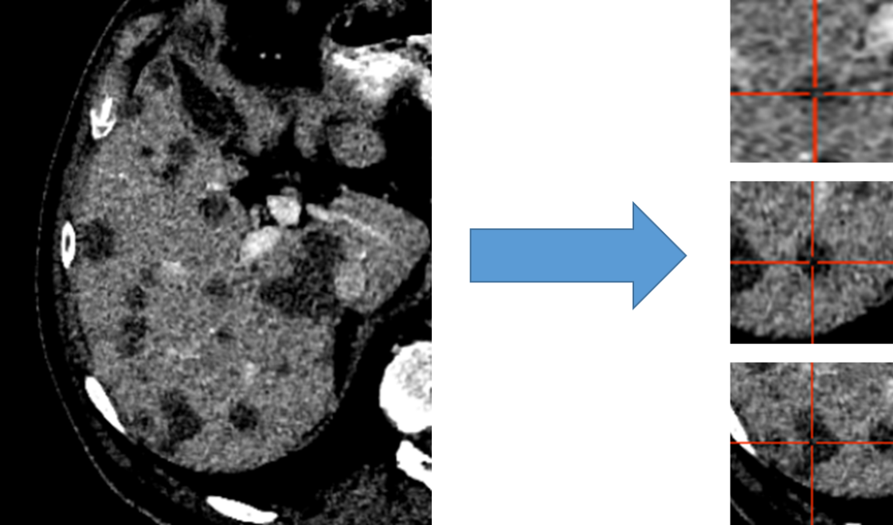
Figure 3: Liver distributed into individual cubes of 32x120x120. Disease is labeled as disease regardless of center of cube.

Architectures
Three 3D-UNet style architectures were investigated with several fine-tuning variations. The basic architectural framework was in the form of a standard UNet, defined as a number of convolution blocks per layer, number of layers, convolution block lambda (which is the increase in number of convolution blocks per layer), maximum number of convolution blocks, and presence of atrous convolutions, Figure xxx.
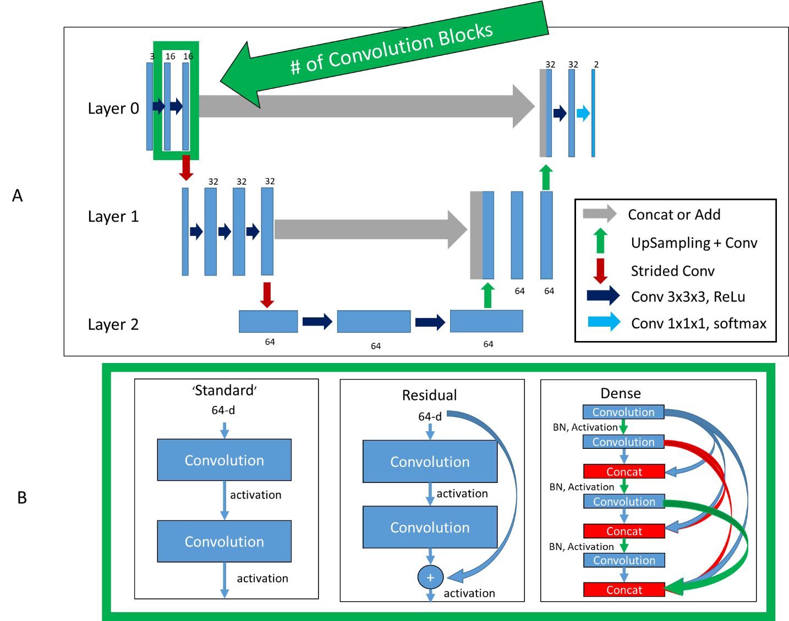
Figure 4: Top (A): Basic framework of architectures. Bottom (B): Difference in convolution blocks, surrounded by green to indicate same region in (A). ‘Standard’, previous feature maps are convolved and activated. ‘Residual’, previous feature maps are directly added to convolutional output in a ‘skip’ connection before activation. ‘Dense’, previous feature maps are continually concatenated together before activation and convolution.
A comparison of all three approaches in how the convolution blocks (green bounded region in Figure xxx) were created is shown in part B, Figure xxx.

Standard UNet
The first style investigated was a standard UNet, where concatenations or additions were used to combine equal size feature maps from the encoder to the decoder side.
Standard Architecture Parameters:
- Number of layers were varied, including1, 2, 3, and 4
- Initial number of convolution blocks were varied from 1, 2, and 3
- The increase in number of convolution blocks (convolution lambda) for each layer was varied from 0, 1, and 2
- Maximum number of convolution blocks was 4
- The number of initial filters was varied from 8, 16, and 32
- The maximum number of filters was varied from 32, 64, and 128

Residual UNet
The Standard UNet was expanded to include residual connections for each convolution block in each layer, with motivation from the ‘ResNet’ architecture(He et al., n.d.). Residual connections have the benefit of allowing a ‘flow’ of loss from previous convolutions. This allows the model to create skip-connections over convolutions that might not be necessary. Unfortunately, convolutions after the skip-connection are a combination of both the skip connection and direct line.
Residual Network Architecture Parameters:
- Number of layers were varied from 1, 2, 3, and 4
- Initial number of convolution blocks were varied from 1, 2, 3, and 4
- The increase in number of convolution blocks (convolution lambda) for each layer was varied from 0, 1, and 2
- Maximum number of convolution blocks was 4
- The number of initial filters was 32
- The maximum number of filters was 128

Dense UNet
A more complete ‘flow’ of loss from previous convolutions can be realized with the DenseNet architecture(Huang et al., n.d.). This architecture style allows previous convolutions to be re-used, removing the potential necessity of the model to re-create feature maps and enabling more diversified feature creation. Another benefit of this method is that the number of filters can be significantly reduced since previous convolutions are re-used; only increasing the number of filters by a small amount each time (referred to here as ‘growth rate’).
Dense Network Architecture Parameters:
- Number of layers were varied from 2, and 3
- Initial number of convolution blocks were 2
- The increase in number of convolution blocks (convolution lambda) for each layer was varied from 0, and 1
- Maximum number of convolution blocks was 4
- The number of initial filters was 8, 12, 16, and 32
- Filter growth rate was 0, and 4
- The maximum number of filters was infinity
A representation of the differences in how convolutions and connections occur from the Standard UNet, ResNet UNet, and Dense UNet can be seen in Figure xxx.

Training
All model training was performed using NVIDIA-Tesla V100 32GB GPUs(NVIDIA Tesla V100 | NVIDIA, n.d.). All model creation, training, optimization, and evaluation was performed using Tensorflow version 2.2.0 (Abadi et al., n.d.). Models were optimized using a sparse categorical cross entropy loss and Adam optimizer. Mixed precision was enabled to speed up the training process.
The model was trained with two inputs, a CT image and a binary mask of the liver. The liver mask automatically assigns background to any voxel not present within the liver, as any disease should be within the provided liver contour. Training involved passing batches of 8 or 16 ‘cubes’ of 32x120x120x1 images and liver masks to the model.

Hyper-Parameters
The learning rate is known to be one of the most important variables in determining a model’s ability to converge, and optimal rates will vary based on the architecture depth (layers), number of convolution blocks, and number of filters in each block. For each model, a variation on the cyclical learning rate(Smith, n.d.) is used (link to GitHub, anonymized for now), where the model starts training at a minimum learning rate before linearly increasing to the maximum and back down to the minimum. Our version allows the user to select the fraction of previous max (shown as ½) and allows the user to define a fraction that the minimum learning rate decreases by each cycle.
The minimum and maximum learning rate are found via small adaptations of code presented here https://www.pyimagesearch.com/2019/08/05/keras-learning-rate-finder/, our own variation of the code can be found at our Github page, link to github anonymized*. This code functions by slowly increasing the learning rate from a very low value (~1e-10) to a large value (~1-e-1), and training solely on the training dataset. The point where the loss begins to decrease refers to the minimum learning rate, and the point where it begins to increase again is the maximum learning rate, Supplementary Figure xxx.
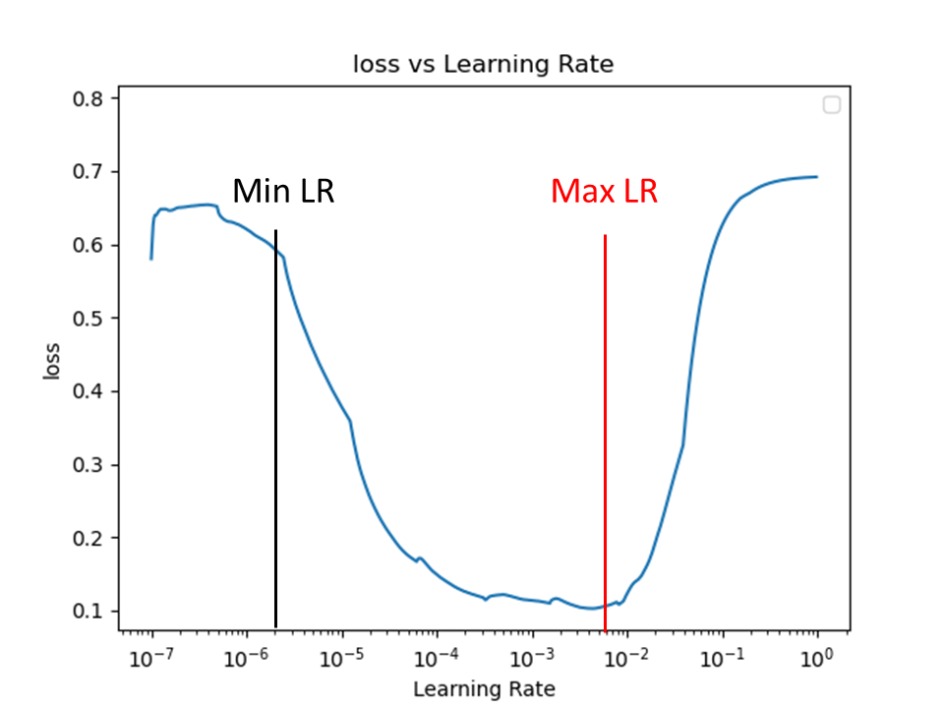
Supplementary Figure 5: Learning Rate Finder figure. Learning rate is gradually increased from 10e-7 to 10e-0, the point where loss begins to decrease is the minimum learning rate (Min LR), the point where it begins to increase is the maximum learning rate (Max LR).
A unique minimum and maximum learning rate were found for each architecture parameter, for reach style of architecture.

Optimization
To overcome the impact of the poor initialization, each unique model was run three independent times with randomly initialized variables for 101 epochs. Plotnine and Tensorflow’s Tensorboard with hyperparameter tuning were used to identify any potential trends and direct model training. The final model was selected based on the Dice Similarity Coefficient (DSC) between the validation set prediction and ground truth during the training process.

Visualization of Training
As disease sites are quite small and therefore quantitative metrics may be misleading to actual segmentation accuracy, a method of creating prediction images on the validation data during training was implemented to visually assess the accuracy of the training, Figure xxx. This method can be easily implemented as a Tensorflow callback, *link to github, left out for anonymization*.
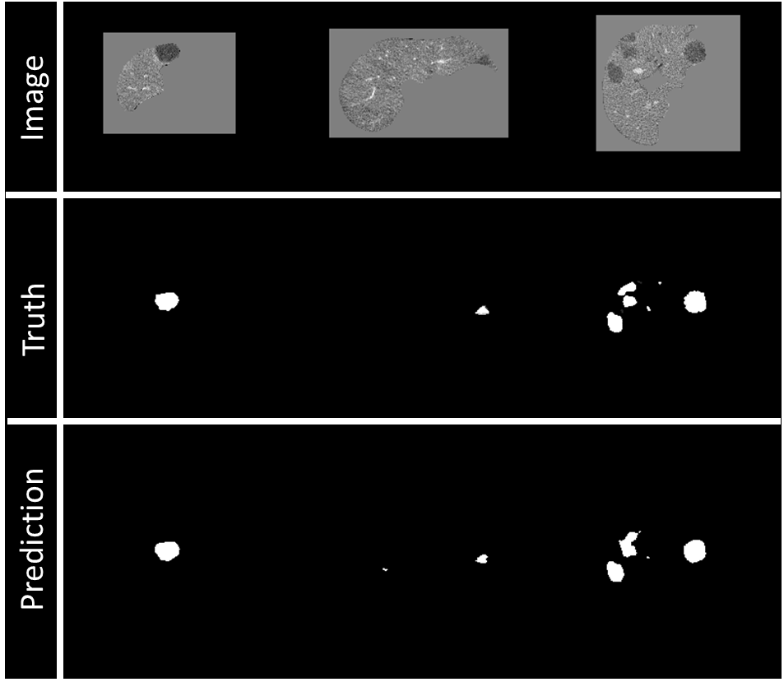
Figure 6: Example of visualization of prediction on validation data during training. Top row: Image being fed into model, masked to 0 outside of the liver. Middle row: Ground truth of disease contours, resampling to 1mm slicing will also interpolate ground truth, right image shows some sampling. Bottom row: Prediction of disease contours, set with threshold of 0.5 to binary mask.

Model Evaluation

Determining Seed and Threshold Values
Predictions of disease from the model come in a range of 0-1. Binary masks are generated via seed-point identification and growth of the output prediction, Figure xxx. The ideal seed value and threshold values were selected based on the highest DSC in the validation dataset. Seed values ranged from 0.25-0.95 in 0.01 increments, and threshold ranges from 0.2 to 0.8 in 0.01 increments.

Results

Quantitative
The best model, determined from the DSC on the validation dataset with a value of 0.79, was found to be the DenseNet model with two layers, two convolution blocks, convolution lambda equal to one, and eight filters, Figure xxx. The model consists of 56,210 parameters (55,490 trainable, 720 non-trainable). From this model, a seed-value of 0.67 and threshold value of 0.30 resulted in the highest overall DSC in the validation dataset. Predictions of LiTs test set (n=25) took a mean of 9.58 seconds, with a standard deviation of 2.32 seconds.
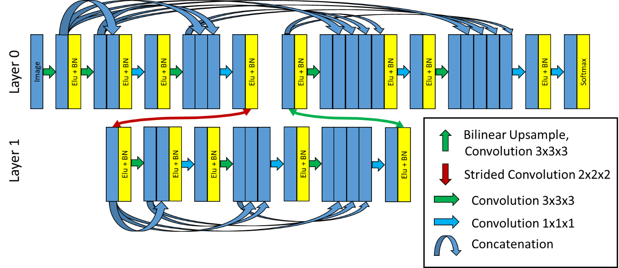
Figure 7: DenseNet final architecture. Two layers, two convolution blocks in Layer 0, three convolution blocks in Layer 1, and eight initial filters.

LiTs Test Disease Site-by-Site evaluation
On a site-by-site basis, the median (min, max) Median Surface Distance (MSD) for sites less than 10mm (n=64) was 16.19mm (0.00, 74.53), for sites 10-20mm (n=17) was 0.75mm (0.00, 41.13), for sites greater than 20mm (n=57) was 0.82mm (0.00, 103.82), and for sites greater than or equal to 10mm (n=74) was 0.79mm (0, 103.82). The mean (min, max) Dice Similarity Coefficient for sites less than 10mm (n=64) was 0.21(0.00, 0.88), for sites 10-20mm (n=17) was 0.57(0.00, 0.84), for sites greater than 20mm (n=57) was 0.68(0.00, 0.97), and for sites greater than or equal to 10mm (n=74) was 0.66(0.00, 0.97), Table xxx.
Table 3: Mean, min and max Dice Similarity Coefficient and Median Surface Distance, and Sensitivity for individual disease sites by differing size criteria.
Criteria | # Sites | Dice Similarity Coefficient |  |  | Median Surface Distance (mm) |  |  | Sensitivity
 |  | Mean | Min | Max | Median | Min | Max
less than 10 mm | n = 64 | 0.21 | 0.00 | 0.88 | 16.19 | 0.00 | 74.54 | 48%
10 – 20 mm | n = 17 | 0.57 | 0.00 | 0.84 | 0.75 | 0.00 | 41.13 | 82%
greater than 20mm | n = 57 | 0.68 | 0.00 | 0.97 | 0.82 | 0.00 | 103.82 | 98%
Greater than or equal to 10 mm | n = 74 | 0.66 | 0.00 | 0.97 | 7.63 | 0.00 | 103.82 | 95%

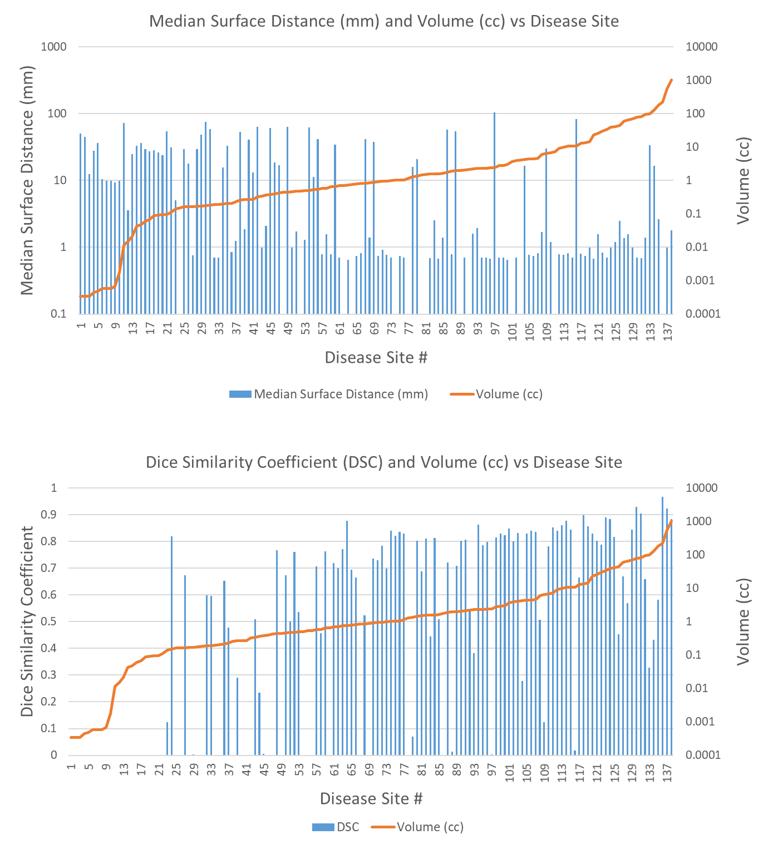
Figure 8: Mean Surface Distance (mm) and volume (cc) for each independent disease site in test set (n=138).

LiTs Patient-by-Patient evaluation
On a patient-by-patient basis, median (min, max) Median Surface Distance was 1.59mm (0.67mm, 109mm), DSC was 0.63 (0.04, 0.93), False Positives per patient was 4 (0, 19), false-positive volume 17.9cc (0.15cc, 236cc), erroneous false-positive volume 4.0cc (0.00cc, 65cc), and over-segmentation false positive volume was 3.7cc (0.03cc, 236cc), Table xxx. Note that a single patient might have multiple disease sites of varying size.
Table 4: Metrics of Dice Similarity Coefficient, Median Surface Distance (mm), False Positive Discoveries (#/patient), and False Positive Volume (cc) for 25 LiTs test patients.
Metric | N = 25 Patients
 | Median | Min | Max | Standard Deviation
Dice Similarity Coefficient | 0.63 | 0.04 | 0.93 | 0.29
Median Surface Distance (mm) | 1.59 | 0.67 | 109 | 29.6
False Positive Discoveries (#/Patient) | 4 | 0 | 19 | 4.5
False Positive Volume (cc) | 17.9 | 0.15 | 236 | 56.3
Erroneous False Positive Volume (cc) | 4.0 | 0.00 | 65 | 16.1
Over-segmentation False Positive Volume (cc) | 3.7 | 0.03 | 236 | 58.21

The false positive volume of 236cc was a patient with a particularly large tumor (1035cc), where even small amounts of over-segmentations resulted in large false-positive volume, Supplementary Figure xxx.
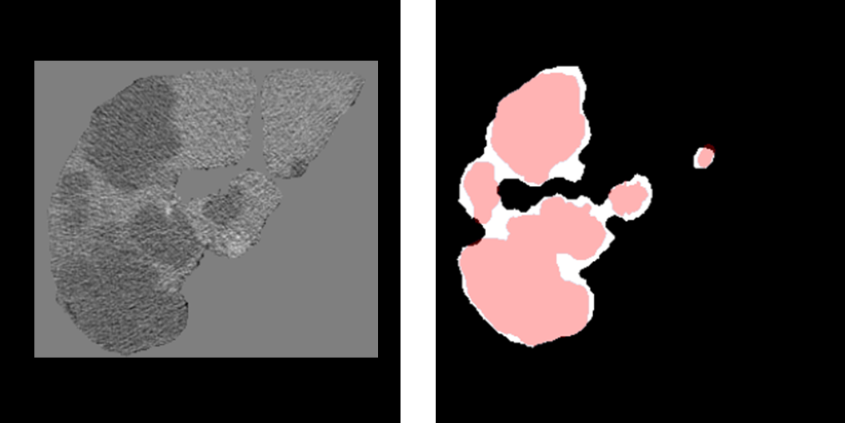
Supplementary Figure 9: (Left) image of patient with particularly large disease, previously masked to the liver. (Right) Predictions of disease in white and ground-truth disease segmentations in red.

Institutional Data
For the pre-treatment CECT identifying disease sites (n=18), the average (min, max) DSC was 0.79 (0.60, 0.90). For the post-treatment CECT identifying ablation zone (n=12), the average (min, max) DSC was 0.75 (0.25, 0.89). 87% (26/30) of the cases had a DSC of greater than 0.74, where the typical inter-observer variability is 0.76 into contouring disease structures (Jensen et al., 2014).

Qualitative

Institutional Data
Using the Likert scoring system shown in Table xxx, the average (min, max) Likert score for all qualitative patients gross tumor volumes (n=18) for each radiologist and their combined score was Radiologist One: 4.63 (3, 5), Radiologist Two: 4.80 (4, 5), Combined: 4.71 (3, 5). The average (min, max) Likert for each qualitative patient ablation volume (n=12) for each radiologist and their combined was Radiologist One: 4.00 (1, 5), Radiologist Two: 3.77 (1, 5), Combined: 3.88 (1, 5). 94% of the GTV contours and 75% of the ablation contours had a Likert score of 4 or greater by both radiologists.
A more detailed graph for each radiologist score on each gross tumor volume and ablation zone are shown in Figure xxx.
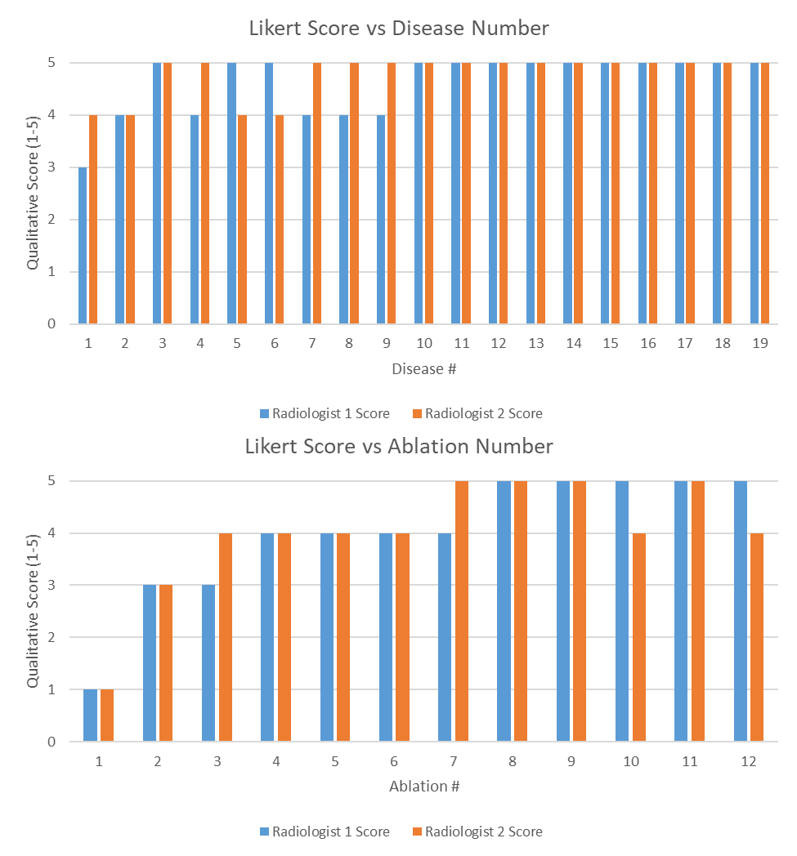
Figure 10: (Top) Likert Score for each radiologist on each disease site. (Bottom) Likert Score for each radiologist on each ablation site. A higher value is associated with a better contour.

Discussion
Our work is highly innovative for two reasons: 1) the densenet model architecture, and 2) the training of the model, the result of which is a model with 100% sensitivity on disease sites greater than 2cc, and a qualitative Likert score of 4 out of 5 (or greater) for 94% of the disease contours and 75% of the ablation contours in < 30 seconds.

Innovations

Densenet Architecture
While algorithms using dense connections for semantic segmentation have been created in the past(Brahimi et al., 2019; Hai et al., 2019; Jégou et al., n.d.), they did not connect all of the convolutional layers within the convolution blocks and from encoding to decoding, the way that our model does, Figure xxx. Previous implementations focused on dense connections within a single block, where our implementation allows the model to receive input from every convolution of the same image size across the entire network, and is available for public use at our Github page (redacted for anonymization).

Model Training
Segmentation of CRL-mets has historically been difficult due to the relatively small size of disease and large search space. The extent of disease can vary from patient to patient, with some containing a single lesion and others having multiple lesions. Simple class weighting of disease would lead to favoring training on patients with more disease sites. While model training by breaking up the liver into cubes is not new, our method of splitting up the liver into cubes centered specifically on disease sites ensures that the model learns on a more balanced representation of data. By allowing batches to be formed from cubes of multiple patients, we also enable the model to more easily generalize.

General Discussion
While FCN have been used to segment CRL-mets previously (Vorontsov et al., 2019), their work did not include a qualitative assessment of the created segmentations. A comparison of their test results and ours is shown in Table xxx. The mean Dice Similarity coefficient and sensitivity of our model was greater than that presented by (Vorontsov et al., 2019), with more test sites for two of the criteria (n=72 vs n=30 for less than 1 cc, and n=50 vs n=40 for greater than 2cc). Similar work has also been done by (Christ et al., 2016), however their work focused on primary liver disease.
Table 5: Comparison of CRL-met segmentation results from our model and the literature. Green box indicates more disease sites (n) or better Dice Similarity Coefficient (DSC), yellow indicates a tie.
Method | Criteria | # Sites | Mean DSC | Sensitivity
Presented Method | less than 10 mm | n = 64 | 0.21 | 48%
 | 10-20 mm | n = 17 | 0.57 | 82%
 | greater than 20 mm | n = 57 | 0.68 | 98%
 | greater than or equal to 10 mm | n = 74 | 0.66 | 95%
(Vorontsov et al., 2019) | less than 10 mm | n = 30 | 0.14 | 10%
 | 10-20 mm | n = 35 | 0.53 | 71%
 | greater than 20 mm | n = 40 | 0.68 | 85%

While detection of very small disease sites remains challenging, (e.g. a sensitivity of 48% for less than 10mm), the detectability of disease greater than 10mm is very promising (e.g. sensitivity of 95% for greater than or equal to 10mm).

Potential Weaknesses
The measurement of false positive volume seems highly biased when there are small amounts of over-segmentation on large tumors, Figure xxx, this was the rationale for the creation of the erroneous false positive volume and over-segmentation false positive. To ensure transparency, we include all three and rely on the qualitative assessment to add weight to the quality of the contours.
The two exams which had scores less than 4 out of 5 on the Likert scale are shown in Figure xxx. The top of Figure xxx shows the segmentation of the ablation zone with a Likert score of 1 and was the lowest DSC score on the institutional ablation data. We suspect the reason for this is that the ablation zone is somewhat similar in appearance to the gallbladder. The bottom of Figure xxx shows the segmentation of the ablation zone with Likert score of 3, where oversegmentation of the ablation zone on the inferior aspect of the cavity resulted in the poorer score.
The success of our model relies largely on the presence of contrast within the scan. The interventional radiologists deemed several of the post-treatment scans as lacking sufficient contrast for evaluation, an example is shown in Figure xxx.

Conclusion
With sufficient contrast, we believe that our model is able to rapidly (< 30 seconds) and accurately segment both CRL-mets and ablation cavities in a potentially clinically useful manner. We believe that this model can provide benefit for detection of CRL-mets, ablation therapy assessment, and automated planning for radiation therapy.
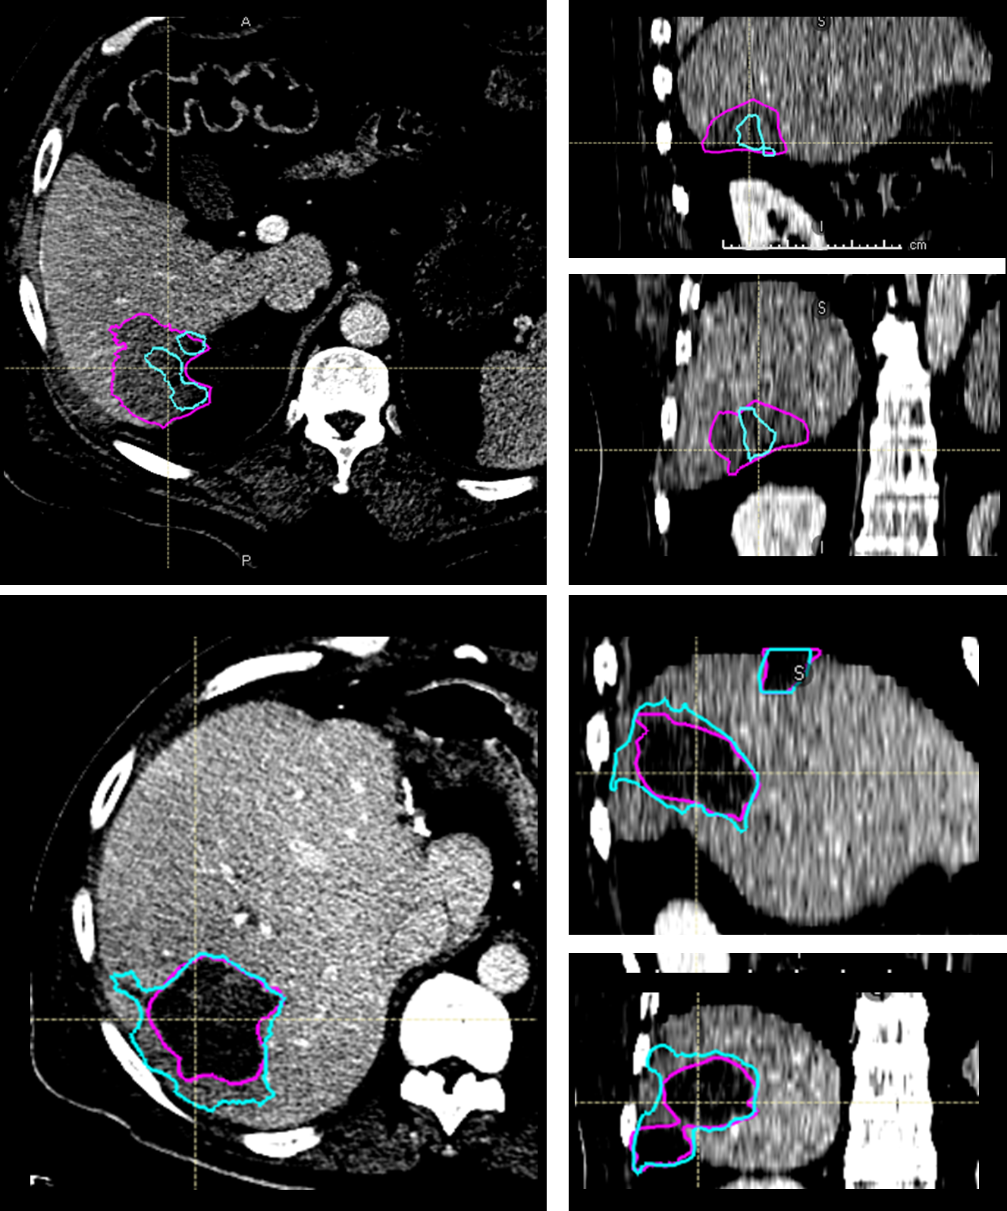
Figure 11: (Top) Ablation segmentation exam with Likert score of 1, pink is ground truth, cyan is prediction. Undersegmentation of ablation zone resulted in poorer score. (Bottom) Ablation segmentation exam with Likert score of 3, pink is ground truth, cyan is prediction. Over segmentation on the inferior aspect of the axial image resulted in poorer score.

