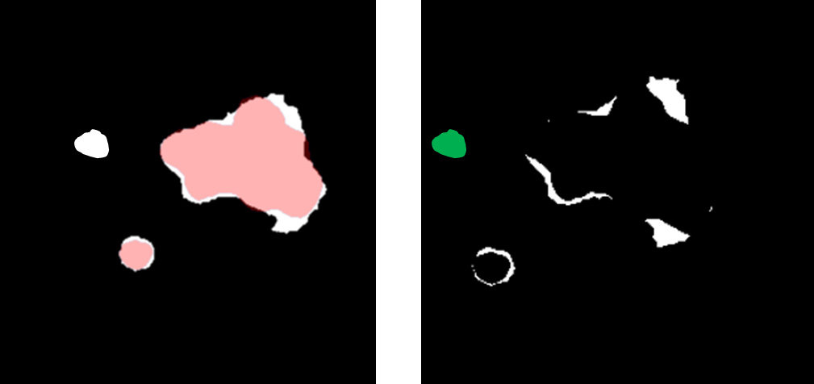
Figure 1: (Left) Prediction in white with ground truth overlaid in red. (Right) Subtraction image of prediction outside of ground truth, white voxels are connected to a disease ground truth segmentation, while green is unconnected. False positive volume is the volume of white + green voxels, erroneous false positive region is the volume in green, and over-segmentation volume is the volume in white.
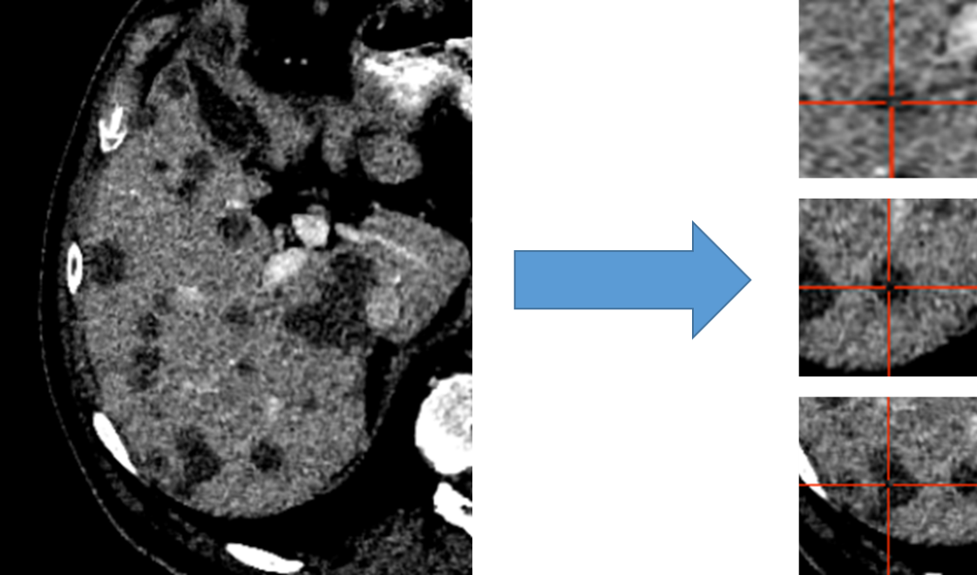
Figure 2: Liver distributed into individual cubes of 32x120x120. Disease is labeled as disease regardless of center of cube.
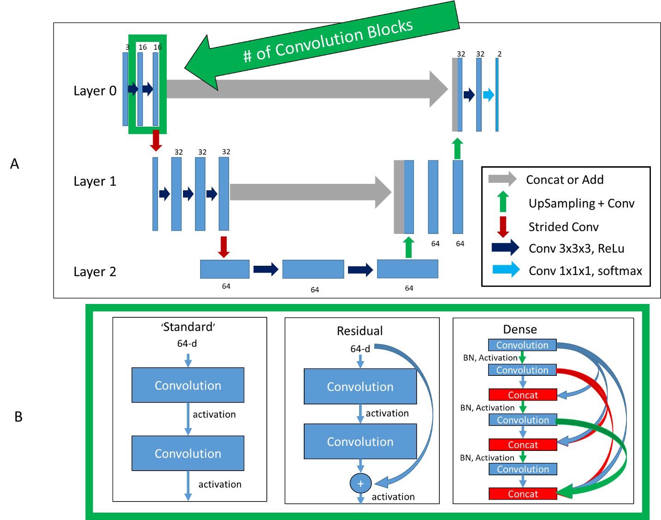
Figure 3: Top (A): Basic framework of architectures. Bottom (B): Difference in convolution blocks, surrounded by green to indicate same region in (A). ‘Standard’, previous feature maps are convolved and activated. ‘Residual’, previous feature maps are directly added to convolutional output in a ‘skip’ connection before activation. ‘Dense’, previous feature maps are continually concatenated together before activation and convolution.
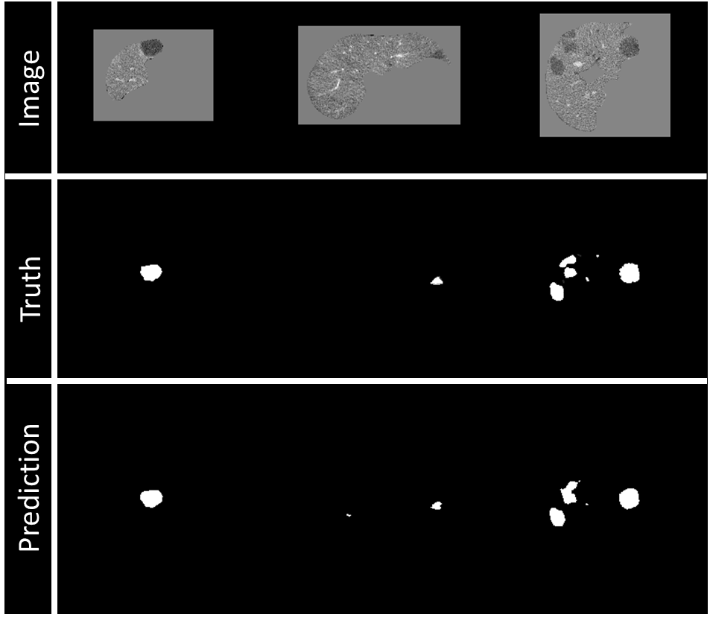
Figure 4: Example of visualization of prediction on validation data during training. Top row: Image being fed into model, masked to 0 outside of the liver. Middle row: Ground truth of disease contours, resampling to 1mm slicing will also interpolate ground truth, right image shows some sampling. Bottom row: Prediction of disease contours, set with threshold of 0.5 to binary mask.
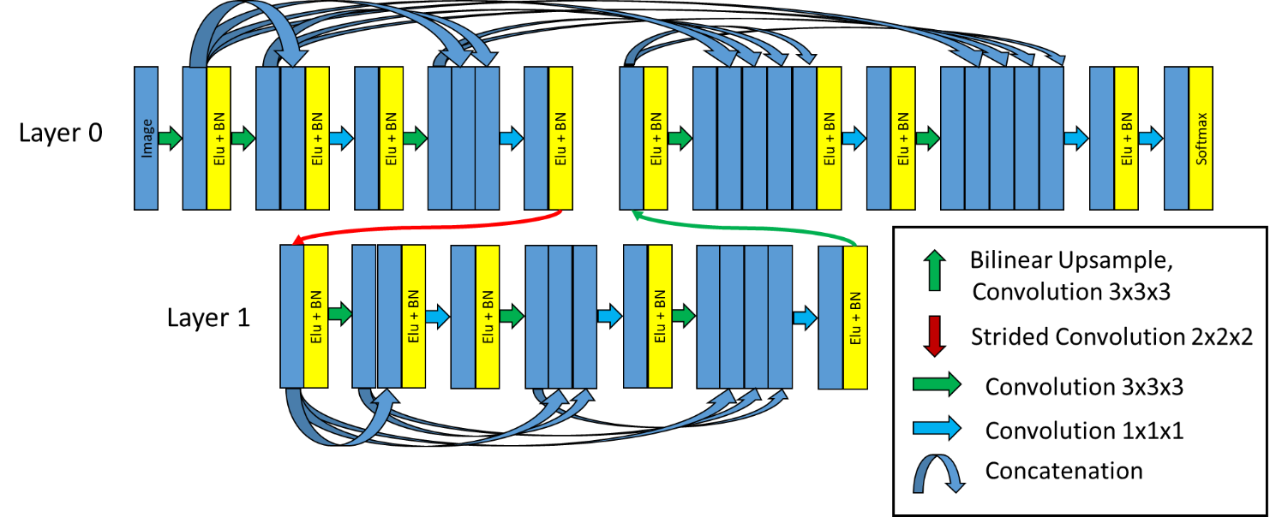
Figure 5: DenseNet final architecture. Two layers, two convolution blocks in Layer 0, three convolution blocks in Layer 1, and eight initial filters.
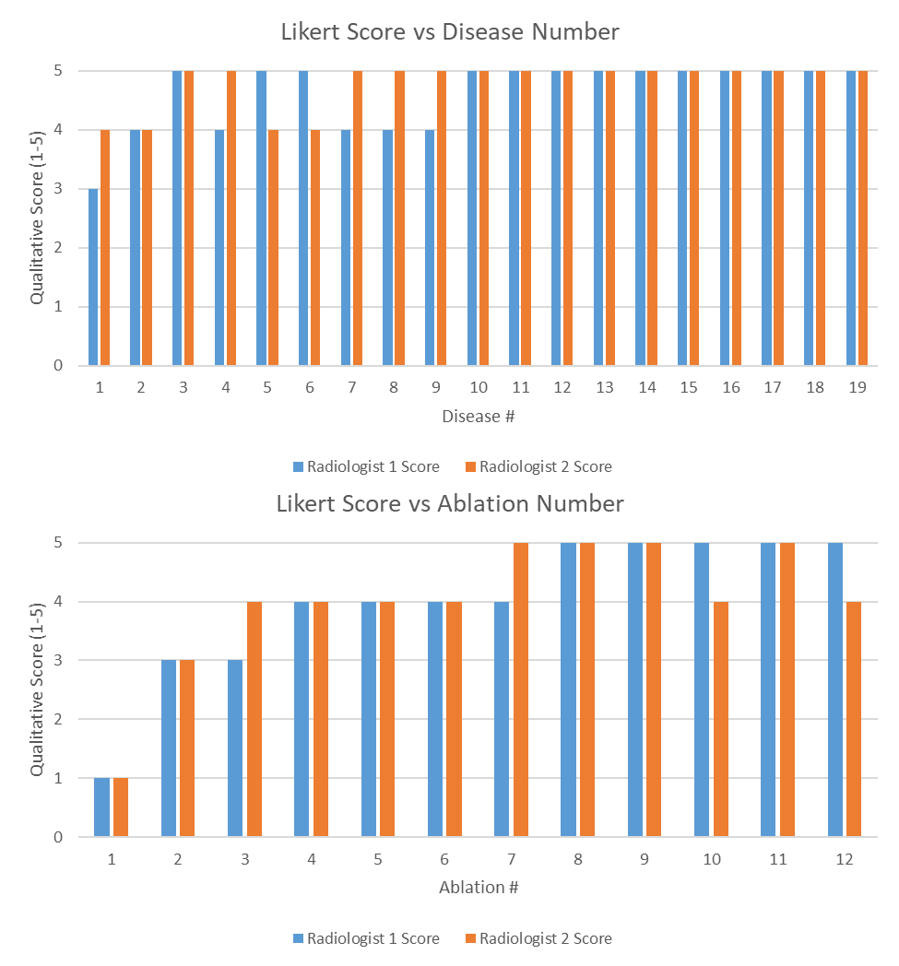
Figure 6: (Top) Likert Score for each radiologist on each disease site. (Bottom) Likert Score for each radiologist on each ablation site. A higher value is associated with a better contour.

