Introduction

Colorectal Cancer in the United States
Colorectal cancer (CRC) is the 3rd most common cancer in the U.S for both men and women¹, and a leading cause of cancer-related death worldwide. While 25% of patients present with colorectal liver metastasis (CRLM) at the time of diagnosis, up to 60% will develop CRLM over the course of their disease².

Detection of Colorectal Liver Metastasis (CRLM)
While several treatment options are available for CRLM, they all first rely on proper identification of the disease. The acquisition of a contrast-enhanced CT (CECT) scan is the standard of care for identifying CRLM. CRLM often appear as hypo-enhancing lesions on routine portal-venous phase images.
Detecting CRLM can be challenging due ill-defined margins, particularly for sub-centimeter lesions. Interventions such as radiation therapy, radiofrequency ablation, and microwave ablation require accurate segmentations of the disease site for dose evaluation or image guidance. To date, automated liver disease segmentation tasks have largely focused either on primary liver disease³, or not included qualitative evaluation of generated contours⁴. New institution and society-sponsored competitions, such as the Liver Tumor segmentation (LiTs) challenge⁵ have contained data of both primary and secondary liver cancers, enabling investigation, development and comparison of automatic segmentation algorithms on public data.

Ablation Therapies
For ablation interventions, segmentation of the disease on pre-treatment imaging, and localization of the ablation cavity on post-treatment imaging, are important for planning the treatment and assessing the outcome, such as evaluating the minimum delivered ablation margin.
Both radiofrequency and microwave ablation interventions aim for a minimum margin to be delivered around the gross disease to ensure that all microscopic disease is treated. The ablation cavity appears hypo-enhancing on CECT images, similar to the CRLM. However, the margin is well-circumscribed, in contrast to the untreated metastasis. While a clinical trial is underway to map the disease from the pre-treatment to the post-treatment imaging and assess treatment efficacy they still require manual segmentations of both disease and ablation zone⁶.
We hypothesize that fully convolutional neural networks, trained using novel methods to account for the challenges of disease size, can provide rapid and accurate identification and segmentation of both CRLM and ablation cavities. This would help facilitate automated detection of CRLM, treatment planning of CRLM in radiation therapy, and margin evaluations in ablation therapy.

Materials/Methods

Data

LiTs Quantitative Training/Validation/Test
To ensure reproducibility by other institutions, the proposed fully convolutional neural network was investigated on the quantitative test data from the publicly available Liver Tumor Segmentation (LiTS) challenge⁵. The data consisted of CECT scans from 130 patients with liver tumors of primary liver cancer and secondary liver metastasis. Ground truth segmentations of the liver and disease were provided by the challenge, although only the disease segmentations were used in this study. Each image and disease segmentations were reviewed by XXX in order to remove the data showing hyper-enhanced disease, no secondary metastasis, or absence of image acquisition parameters (e.g. slice thickness, pixel spacing). A total of 92 patients remained, which were then distributed into groups of 57 for training, 10 for validation and 25 for a completely withheld test set. Table 1 reports the image acquisition parameters for the training, validation, and test sets.
Table 1: Image acquisition parameters of the LiTs challenge for the training, validation, and test set.
Folder | Mean (Min - Max)
 | Slice Thickness (mm) | Pixel Size X (mm/voxel) | Pixel Size Y (mm/voxel)
Training | 1.64 (0.7 - 5.0) | 0.75 (0.60 - 0.98) | 0.75 (0.60 - 0.98)
Validation | 2.02 (0.7 - 5.0) | 0.78 (0.68 - 0.98) | 0.78 (0.68 - 0.98)
Test | 1.41 (0.7 - 5.0) | 0.76 (0.64 - 0.97) | 0.76 (0.64 - 0.97)

Data Pre-Processing

Intensity Manipulation
Initial attempts to normalize the data based on a global mean and standard deviation resulted in extreme outliers when the contrast within the liver was high or low relative to the global mean. To best separate the normal tissue from the disease, a patient specific mean and standard deviation was calculated based on the FWHM of values within the provided contoured liver. This led to the consistent visual appearance of the disease appearing darker than the normal tissue. Image intensity outside of the liver was set to be equal to 0 after normalization.

Voxel Size Resampling
A known weakness of convolutional neural networks is instability with varying image sizes. All training and validation images were resampled to be 1mm in slice thickness using bi-linear interpolation. Likewise, bi-linear interpolation was applied to the ground-truth segmentations of the disease, providing the model with values ranging from 0-1 for each part of the disease.

Training Image ‘Cubes’
The relative size of annotation vs background is a well-known concern within image segmentation. Smaller structures are inherently worth less than large structures when categorical cross-entropy is used as a loss and class weighting is not applied. Unfortunately, simple class weighting would invariably weigh the more heavily diseased patients over less diseased patients.
To this end, each independent disease site within a patient was divided into individual ‘cubes’ of 32x120x120 voxels. Figure xxx illustrates several cubes of disease for one patient. After extraction, the training dataset consists of 572 unique image cubes.
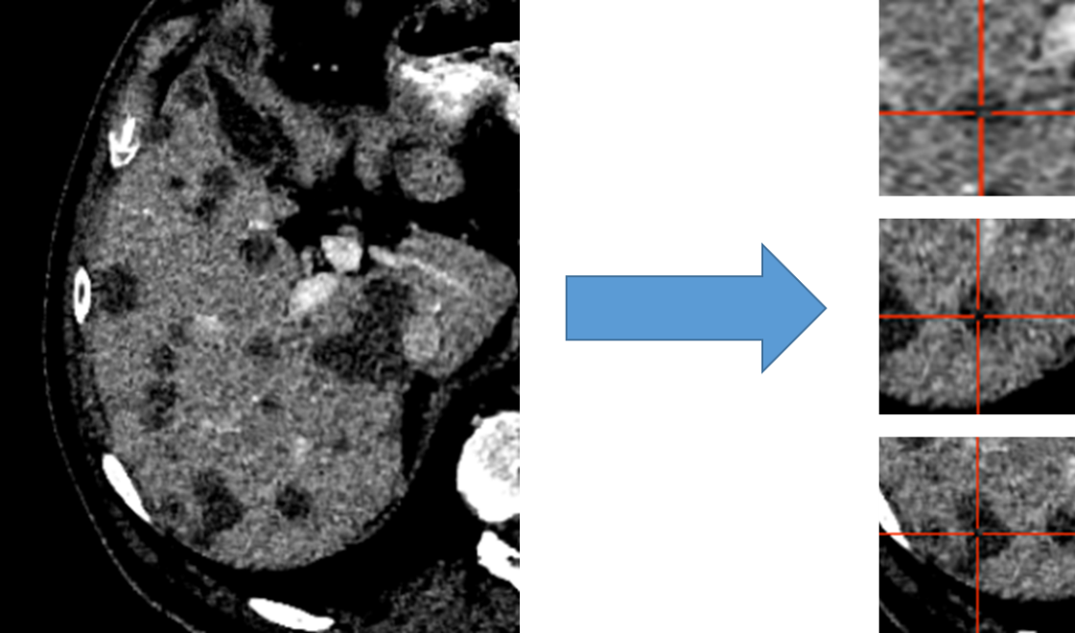
Figure 3: Liver distributed into individual cubes of 32x120x120. Disease is labeled as disease regardless of center of cube.

Architectures
Three 3D-UNet style architectures were investigated, a Standard UNet, Residual UNet, and Dense UNet. The basic architectural framework, A of Figure xxx, remained the same for all three, defined as a number of convolution blocks per layer, number of layers, convolution block lambda (i.e. increase in number of convolution blocks per layer), and maximum number of convolution blocks. A representation of the differences in how convolutions and connections occur from the Standard UNet, Resisudal UNet, and Dense UNet is shown in B of Figure xxx.
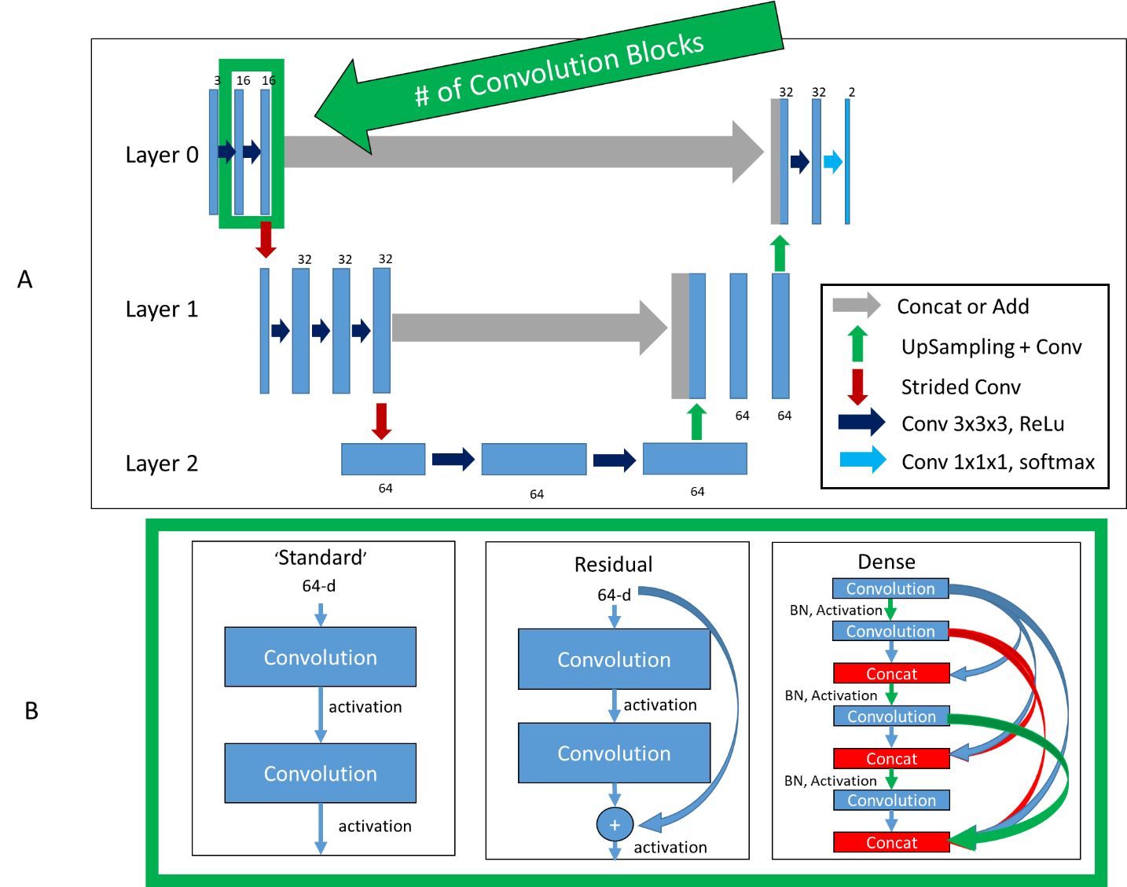
Figure 4: Top (A): Basic framework of architectures. Bottom (B): Difference in convolution blocks, surrounded by green to indicate same region in (A). ‘Standard’, previous feature maps are convolved and activated. ‘Residual’, previous feature maps are directly added to convolutional output in a ‘skip’ connection before activation. ‘Dense’, previous feature maps are continually concatenated together before activation and convolution.

Standard UNet
The first style investigated was a standard UNet, where concatenations or additions were used to combine equal size feature maps from the encoder to the decoder side.
Standard Architecture Parameters:
- Number of layers were varied, including 1, 2, 3, and 4
- Initial number of convolution blocks were varied from 1, 2, and 3
- The increase in number of convolution blocks (convolution lambda) for each layer was varied from 0, 1, and 2
- Maximum number of convolution blocks was 4
- The number of initial filters was varied from 8, 16, and 32
- The maximum number of filters was varied from 32, 64, and 128

Residual UNet
The Standard UNet was expanded to include residual connections for each convolution block in each layer, with motivation from the ‘ResNet’ architecture⁷. Residual connections have the benefit of allowing a ‘flow’ of loss from previous convolutions. This allows the model to create skip-connections over convolutions that might not be necessary.
Residual Network Architecture Parameters:
- Number of layers were varied from 1, 2, 3, and 4
- Initial number of convolution blocks were varied from 1, 2, 3, and 4
- The increase in number of convolution blocks (convolution lambda) for each layer was varied from 0, 1, and 2
- Maximum number of convolution blocks was 4
- The number of initial filters was 32
- The maximum number of filters was 128

Dense UNet
A more complete ‘flow’ of loss from previous convolutions can be realized with the DenseNet architecture⁸. This architecture style allows previous convolutions to be re-used, allowing the model to optimize reuse of feature maps and enabling more diversified feature creation. Another benefit of this method is that the number of filters can be significantly reduced since previous convolutions are re-used; only increasing the number of filters by a small amount each time (referred to here as ‘growth rate’).
Dense Network Architecture Parameters:
- Number of layers were varied from 2, and 3
- Initial number of convolution blocks were 2
- The increase in number of convolution blocks (convolution lambda) for each layer was varied from 0, and 1
- Maximum number of convolution blocks was 4
- The number of initial filters was 8, 12, 16, and 32
- Filter growth rate was 0, and 4
- The maximum number of filters was infinity

Training
All model training was performed using NVIDIA-Tesla V100 32GB GPUs⁹. All model creation, training, optimization, and evaluation was performed using Tensorflow version 2.2.0 ¹⁰. Models were optimized using a sparse categorical cross entropy loss and Adam optimizer. Mixed precision was enabled to speed up the training process.
The model was trained with two inputs, a CT image and a binary mask of the liver. The liver mask automatically assigns background to any voxel not present within the liver, as any disease should be within the provided liver contour. Training involved passing batches of 8 or 16 3D cubes of shape 32x120x120x1 images and liver masks to the model.

Hyper-Parameters
The learning rate is known to be one of the most important variables in determining a model’s ability to converge, and optimal rates will vary based on the architecture depth (layers), number of convolution blocks, and number of filters in each block. For each model, a variation on the cyclical learning rate¹¹ is used (GitHub link: anonymized for review), where the model starts training at a minimum learning rate before linearly increasing to the maximum and back down to the minimum.
The minimum and maximum learning rates were defined using an in-house function (Githb link: anonymized for review). This function slowly increases the learning rate from a very low value (~1e-10) to a large value (~1-e-1) on the training dataset. From the resulting training loss curve, the minimum and maximum learning rates were extracted where the loss begins to decrease and increase, respectively (Figure XXX, supplementary material).
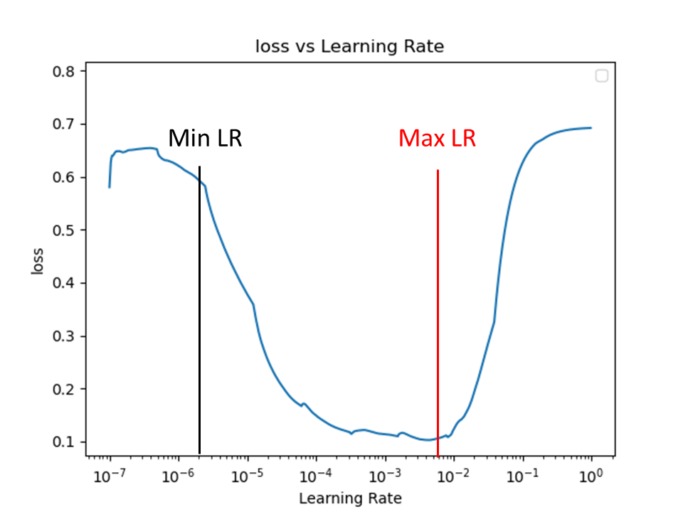
Supplementary Figure 5: Learning Rate Finder figure. Learning rate is gradually increased from 10e-7 to 10e-0, the point where loss begins to decrease is the minimum learning rate (Min LR), the point where it begins to increase is the maximum learning rate (Max LR).
A unique minimum and maximum learning rate were found for each architecture parameter, for reach style of architecture.

Optimization
To overcome the impact of random variable initialization, each unique model was run three independent times with randomly initialized variables for 101 epochs. Plotnine and Tensorflow’s Tensorboard with hyperparameter tuning were used to identify any potential trends and direct model training. The final model was selected based on the DSC between the validation set prediction and ground truth during the training process.

Visualization of Training
As disease sites can be small and therefore quantitative metrics may be misleading to the actual segmentation accuracy, a method of creating prediction images on the validation data during training was implemented to visually assess the accuracy of the training, Figure xxx. This method has been implemented as a Tensorflow callback function (Githb link: anonymized for review).
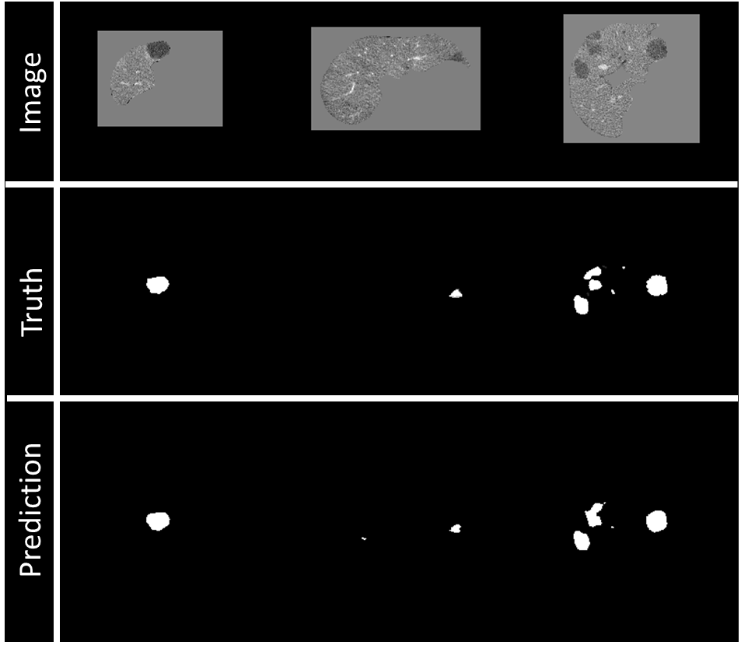
Figure 6: Example of visualization of prediction on validation data during training. Top row: Image being fed into model, masked by the liver segmentation. Middle row: Ground truth of disease contours, resampling to 1mm slice thickness will also interpolate ground truth, right image shows some sampling. Bottom row: Prediction of disease contours, set with a threshold of 0.5 to binary mask.

Model Evaluation

Determining Seed and Threshold Values
Predictions of disease from the model come in a range of 0-1. Binary masks are generated via seed-point identification and growth of the output prediction, Figure xxx. The ideal seed value and threshold values were selected based on the highest DSC in the validation dataset. Seed values ranged from 0.25-0.95 in 0.01 increments, and threshold ranges from 0.2 to 0.8 in 0.01 increments.

Quantitative Evaluation
The geometric performance of the model was evaluated on the test set using the Dice Similarity Coefficient (DSC) and Median Surface Distance (MSD) between the manual and predicted segmentations. To measure the impact of patients with multiple small disease sites, the evaluation was separated in a disease site-by-site and patient-by-patient basis. For the site-by-site comparison, each non-connected disease segmentation of the test patients was considered as an independent case. In that regard, the metrics were computed between each manual and the closest continuous predicted disease segmentations, using the distance between sites centroids. For patient-by-patient comparison, metrics were computed between the manual and predicted segmentations within the entire liver. All metrics were computed using the predicted segmentation resampled to the original image resolution.

Sensitivity of the model was evaluated on a site-by-site basis, where the disease was considered identified if at least 25% of the manual disease volume was covered by the predicted disease volume. False positive volume was defined as the volume of predicted disease segmentation outside of the ground truth disease segmentation. False positive volume is comprised of two errors, one is over segmentations of the actual disease volume, and the second is erroneous segmentation of normal liver area as disease. The erroneous false positive volume was quantified as the volume completely unconnected from any ground truth disease segmentations, and the over-segmentation false volume as the total predicted volume minus the erroneous volume (the sum of the erroneous false volume and the over-segmentation false volume), Figure xxx.
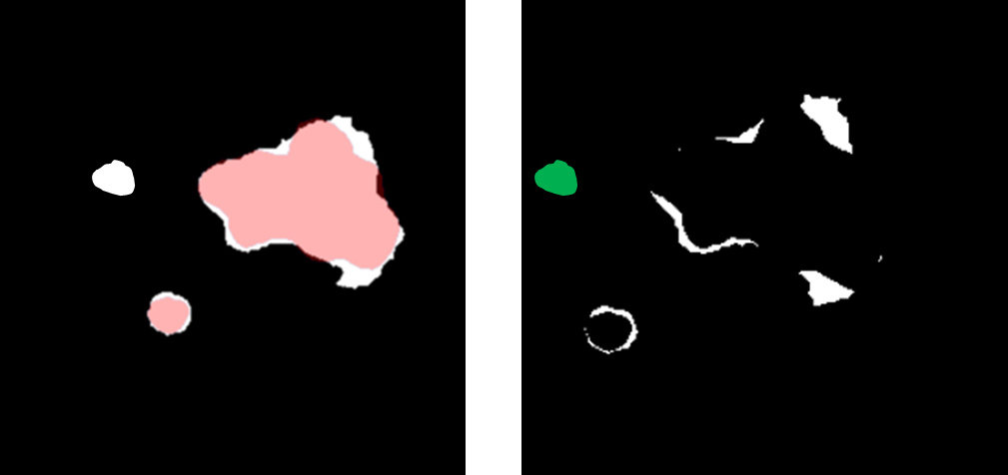
Figure 1: (Left) Overlay between a predicted (white) and ground truth (red) disease segmentations. (Right) Subtraction of the predicted and ground truth disease segmentation representing the over-segmentation of the disease volume (white) and the unconnected erroneous false positive region (green).

Qualitative Evaluation
Quantitative metrics are not always sufficient to assess a segmentation algorithms efficacy. For large structures, a high DSC can hide clinically impactful inaccuracies, while for smaller structures a low DSC could be overly critical¹². Therefore, a qualitative assessment of both CRLM and ablation segmentations was performed by two board certified radiologists (XXX, interventional radiologist and YYY, diagnostic radiologist, both with more than 10 years of experience). Eighteen patients who had previously undergone thermal ablation therapy at our institution were retrospectively identified under an Institutional Review Board approved study. Each patient had two CECT scans, one pre-ablation to identify the disease, and one post-treatment to identify the ablation zone. Two patients had two disease sites present, therefore an evaluation of the DSC for each disease site was performed.
Scans were removed if the radiologists felt sufficient contrast was not present or the disease was hyper-enhancing, Supplementary Figure xxx, this removed six post-treatment CECT (ablation zones) and two pre-treatment CECT. The final count was 18 disease sites and 12 ablation sites.
Contours were scored independently by both radiologists based on a Likert quality scale of 1-5. The criteria for the scale can be seen in Table xxx.
Table 2: Likert scoring for assessment of colorectal liver metastasis (CRLM) and ablation contours
Score |  | Criteria
5 | Excellent | Negligible changes, could be used clinically without edits
4 | Good | Minor changes on < 4 slices, or that would take less than 10 seconds to fix
3 | Fair | Edits needed on multiple slices, but less than 50%
2 | Poor | Greater than 50% of slices need editing
1 | Very poor | Contours are poorly predicted, missed disease

Results

Quantitative
The best model, determined from the DSC on the validation dataset with a value of 0.79, was found to be the DenseNet model with two layers, two convolution blocks, convolution lambda equal to one, and eight filters, Figure xxx. The model consists of 56,210 parameters (55,490 trainable, 720 non-trainable). From this model, a seed-value of 0.67 and threshold value of 0.30 resulted in the highest overall DSC in the validation dataset. Predictions of LiTs test set (n=25) took a mean time of 9.58 seconds, with a standard deviation of 2.32 seconds.
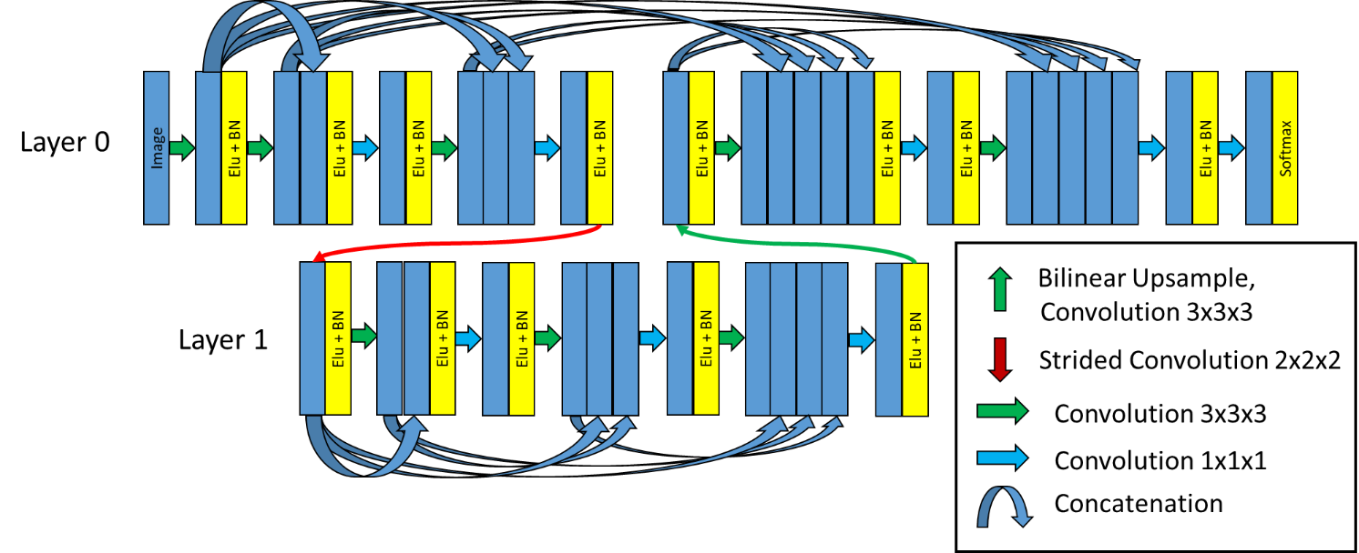
Figure 7: DenseNet final architecture. Two layers, two convolution blocks in Layer 0, three convolution blocks in Layer 1, and eight initial filters.

LiTs Test Disease Site-by-Site evaluation
On a site-by-site basis, the median (min, max) MSD for sites less than 10mm (n=64) was 16.19mm (0.00, 74.53), for sites 10-20mm (n=17) was 0.75mm (0.00, 41.13), for sites greater than or equal to 10mm (n=74) was 0.79mm (0, 103.82), and for sites greater than 20mm (n=57) was 0.82mm (0.00, 103.82).
The mean (min, max) DSC for sites less than 10mm (n=64) was 0.21(0.00, 0.88), for sites 10-20mm (n=17) was 0.57(0.00, 0.84), for sites greater than or equal to 10mm (n=74) was 0.66(0.00, 0.97), and for sites greater than 20mm (n=57) was 0.68(0.00, 0.97), Table xxx.
Table 3: Mean, min and max Dice Similarity Coefficient and Median Surface Distance, and Sensitivity for individual disease sites by differing size criteria.
Disease site diameter | # Sites | Dice Similarity Coefficient |  |  | Median Surface Distance (mm) |  |  | Sensitivity
 |  | Mean | Min | Max | Median | Min | Max
less than 10 mm | n = 64 | 0.21 | 0.00 | 0.88 | 16.19 | 0.00 | 74.54 | 48% (31/64)
10 – 20 mm | n = 17 | 0.57 | 0.00 | 0.84 | 0.75 | 0.00 | 41.13 | 82% (14/17)
greater than 20mm | n = 57 | 0.68 | 0.00 | 0.97 | 0.82 | 0.00 | 103.82 | 98% (56/57)
Greater than or equal to 10 mm | n = 74 | 0.66 | 0.00 | 0.97 | 7.63 | 0.00 | 103.82 | 95% (70/74)

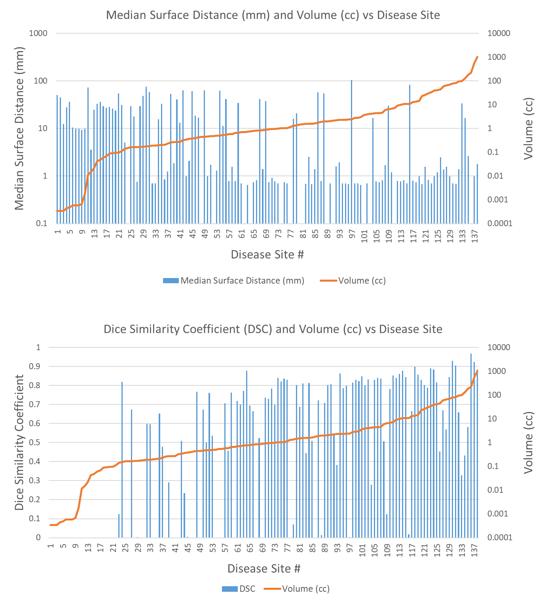
Figure 8: Median Surface Distance (mm) and Volume (cc) for each independent disease site in test set (n=138).
A comparison of our model results to that of similar work done by Vorontsov et al ⁴ shown in Table xxx.
Table 4: Comparison of CRLM segmentation results from our model and the literature. Green box indicates more disease sites (n) or better Dice Similarity Coefficient (DSC), yellow indicates a tie.
Method | Disease diameter | # Sites | Mean DSC | Sensitivity
Presented Method | less than 10 mm | n = 64 | 0.21 | 48%
 | 10-20 mm | n = 17 | 0.57 | 82%
 | greater than 20 mm | n = 57 | 0.68 | 98%
 | greater than or equal to 10 mm | n = 74 | 0.66 | 95%
Vorontsov et al ⁴ | less than 10 mm | n = 30 | 0.14 | 10%
 | 10-20 mm | n = 35 | 0.53 | 71%
 | greater than 20 mm | n = 40 | 0.68 | 85%

LiTs Test Patient-by-Patient evaluation
On a patient-by-patient basis, median (min, max) MSD was 1.59mm (0.67mm, 109mm), DSC was 0.63 (0.04, 0.93), number of FP was 4 (0, 19), FP volume was 17.9cc (0.15cc, 236cc), erroneous FP volume was 4.0cc (0.00cc, 65cc), and over-segmentation FP volume was 3.7cc (0.03cc, 236cc), Table xxx. Note that a single patient might have multiple disease sites of varying size.
Table 5: Metrics of Dice Similarity Coefficient, Median Surface Distance (mm), False Positive Discoveries (#/patient), and False Positive Volume (cc) for 25 LiTs test patients.
Metric | N = 25 Patients
 | Median | Min | Max | Standard Deviation
Dice Similarity Coefficient | 0.63 | 0.04 | 0.93 | 0.29
Median Surface Distance (mm) | 1.59 | 0.67 | 109 | 29.6
False Positive Discoveries (#/Patient) | 4 | 0 | 19 | 4.5
False Positive Volume (cc) | 17.9 | 0.15 | 236 | 56.3
Erroneous False Positive Volume (cc) | 4.0 | 0.00 | 65 | 16.1
Over-segmentation False Positive Volume (cc) | 3.7 | 0.03 | 236 | 58.21

The false positive volume of 236cc was a patient with a large tumor volume (1035cc), where even small amounts of over-segmentations resulted in large false-positive volume, Supplementary Figure xxx. Proposition: Figure X (supplementary) illustrates the patient with the maximum FP volume (236cc) due to having a large disease volume (1035cc). For this case, the proposed model predicted a slightly over-segmented disease delineation that resulted in a large FP volume.
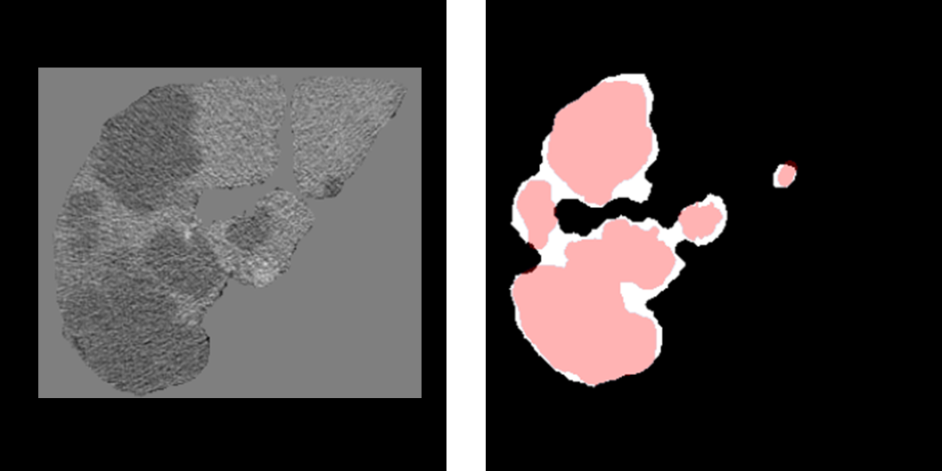
Supplementary Figure 9: (Left) Liver of a patient showing a large tumor volume. (Right) Segmentation of the predicted (white) and ground-truth (red) tumor volume.

Institutional Data
For the pre-treatment CECT identifying disease sites (n=18), the average (min, max) DSC was 0.79 (0.60, 0.90). For the post-treatment CECT identifying ablation zone (n=12), the average (min, max) DSC was 0.75 (0.25, 0.89). A total of 87% (26/30) of the cases had a DSC greater than 0.74, where the typical inter-observer variability is 0.76 into contouring disease structures ¹³.

Qualitative

Institutional Data
Table XXX report the Liker scoring results by the two radiologist. The average (min, max) Likert scores for all qualitative patients gross tumor volumes (n=18) for each radiologist and their combined score was radiologist one: 4.63 (3, 5), radiologist two: 4.80 (4, 5), Combined: 4.71 (3, 5). The average (min, max) Likert scores for each qualitative patient ablation volume (n=12) for each radiologist and their combined was radiologist one: 4.00 (1, 5), radiologist two: 3.77 (1, 5), Combined: 3.88 (1, 5). 94% (17/18) of the GTV contours and 75% (9/12) of the ablation contours had a Likert score superior to 4 by both radiologists.
Figure xxx represents the detailed scoring by the two radiologists on the GTV volume s and ablation zones.
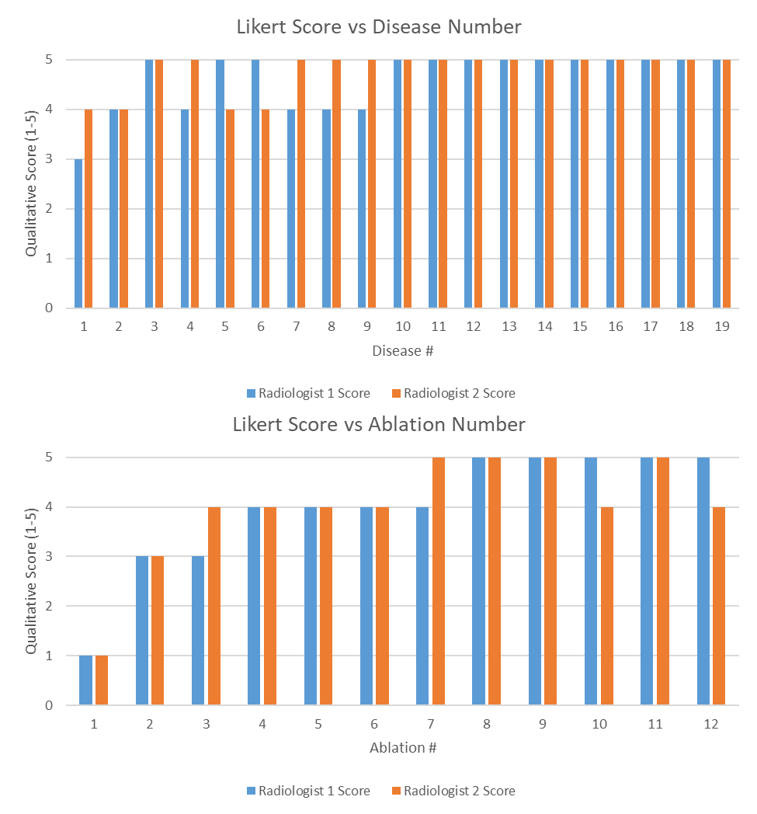
Figure 10: (Top) Likert Score by each radiologist for each disease site. (Bottom) Likert Score by each radiologist for each ablation site. A higher value is associated with a better contour.
Figure xxx (supplementary material) illustrates the two cases with a Likert score of less than 4. The top image shows the segmentation of the ablation zone with a Likert score of 1 and was the lowest DSC score on the institutional ablation data. The bottom image shows the segmentation of the ablation zone with Likert score of 3.

Discussion
Our work is highly innovative for two reasons: 1) the Densenet model architecture, and 2) the training of the model, the result of which is a model with 100% sensitivity on disease sites greater than 2cc, and a qualitative Likert score of 4 out of 5 (or greater) for 94% of the disease contours and 75% of the ablation contours in < 30 seconds.
In this study, we proposed a DenseNet model architecture for the segmentation of the disease sites and ablation areas in the context of colorectal cancer metastasis in the liver treated with ablation therapy. The results showed, both on open-access and institutional data, that the model was able to segment the disease and ablation margin usefully, 87% (26/30) of the cases had a DSC greater than 0.74. The model was further evaluated using the Likert scoring method by two board certified radiologists (XXX, interventional radiologist and YYY, diagnostic radiologist), with scores greater than or equal to 4 out of 5 for 94% (17/18) of the disease and 75% (9/12) of the ablation segmentations. Our work is highly innovative in regard of the proposed DenseNet model architecture (elaborated below) and the training workflow (elaborated below). The whole process was implemented in a treatment planning system (RayStation 9B, RaySearch Laboratories, Sweden) and was able to perform the segmentations in less than 30s, making it highly suitable for clinical use.

Innovations

Densenet Architecture
The proposed DenseNet architecture in this study differs by connecting all convolutional layers within the convolution blocks and between the encoding to the decoding parts. Previous published studies proposed similar architectures focused only on dense connections within a single convolutional block^{14–16}. Our proposed implementation allows the model to receive inputs from every convolution of the same image size across the entire network. This global passing of convolution layers across the network removes bottlenecks in each convolution block, something which is particularly important with dense connections where convolutions can be re-used. The proposed model will be publicly available, Githublink: redacted for anonymization.

Model Training
Segmentation of CRLM has historically been difficult due to the relatively small size of disease and large search space. The extent of disease can vary from patient to patient, with some containing a single lesion and others having multiple lesions. Simple class weighting of disease would lead to favoring training on patients with more disease sites. While model training by breaking up the liver into cubes is not new, our method of splitting up the liver into cubes centered specifically on disease sites ensures that the model learns on a more balanced representation of data. The training workflow was designed to allow the model learn from batches that contains cubic images from multiple patients at once, enabling the creation of a more generalized model.

General Discussion
While fully convolutional networks have been previously investigated for the segmentation of CRLM⁴, only a quantitative assessment of the model performance has been reported. The mean DSC and sensitivity of our model was greater than that presented by Vorontsov et al⁴, with more test sites for two of the criteria (n=64 vs n=30 for less than 10mm, and n=57 vs n=40 for greater than 20mm). Similar work has also been reported by Christ et al,³ however their work focused on primary liver disease.

Limitations
Our study has several limitations. The proposed model showed limitation on segmenting small disease site of less than 10 mm in diameter with a reported mean sensitivity of 48%. However, the detectability of disease greater than 10 mm was more satisfactory with a reported sensitivity of 95%. This could be explained by different reasons such as the image resolution and quality.
The reported FP volumes could be high for a small over-segmentation of large tumor volume (Figure XXX, supplementary material). In regard of the sensitivity of FP volume metric, the evaluation was enriched with the erroneous FP volume and over-segmentation FP metrics. Furthermore, quality of the predicted segmentations by the proposed DenseNet model was qualitatively assessed by two board certified radiologists, both interventional (XXX) and diagnostic (YYY). The reported Likert score showed that even for over-segmentation cases, the model had clinical interest for the radiologist.
Poor Likert scoring was reported (scored 1 out of 5 and 3 out of 5) for two cases. These poor segmentation scores could be explained by similarity in intensity between the gallbladder and the ablation zone, and over segmentation of the ablation zone. Both cases are shown in Supplementary Figure xxx.
The measurement of false positive volume seems highly biased when there are small amounts of over-segmentation on large tumors, this was the rationale for the creation of the erroneous false positive volume and over-segmentation false positive. To ensure transparency, we include all three and rely on the qualitative assessment to add weight to the quality of the contours.

Conclusion
The proposed DenseNet model was able to provide fast (<30 seconds) and accurate colorectal metastasis and ablation cavity segmentations for CECT. The model can provide clinical benefit in detection of colorectal metastasis, ablation therapy assessment and automated planning for radiotherapy.

