Introduction

Colorectal Cancer in the United States
Colorectal cancer (CRC) is the 3rd most common cancer in the U.S for both men and women¹, and a leading cause of cancer-related death worldwide². Up to 60% of patients will develop colorectal liver metastasis (CRLM) over the course of their disease, and 25% present with CRLM at the time of cancer diagnosis³. Moreover, it is believed that liver involvement with CRLM is the main determinant of survival in this patient population. Such facts highlight the importance of liver-directed loco-regional therapies (LRT) for the management of these patients.
While several treatment options are available for CRLM (in particular radiation and ablation therapies), they all rely on accurate estimation of disease extent, usually involving cross-sectional imaging with contrast-enhanced CT (CECT) or MRI. CRLM often appear as hypo-enhancing lesions on routine CECT portal-venous phase images; however, their detection
can be challenging due ill-defined margins, particularly for sub-centimeter lesions.
Both radiofrequency and microwave ablation interventions aim for a minimum margin to be delivered around the gross disease to ensure that all microscopic disease is treated. This requires both segmentation of disease on pre-treatment images, and the ablation zone on post-treatment images to assess the final delivered ablation margin⁴. The ablation zone appears hypo-enhancing on CECT images, similar to the CRLM. A clinical trial is underway (Identifier: NCT04083378) to map the disease from the pre-treatment to the post-treatment imaging and assess treatment efficacy, but still requires manual segmentations of both disease and ablation zone⁵, adding time to the procedure.
To date, automated liver disease segmentation tasks have largely focused either on primary liver disease, or not included qualitative evaluation of generated contours^{6–9}. New institution and society-sponsored competitions, such as the Liver Tumor segmentation (LiTs) challenge¹⁰ and the 3D-IRCADb01⁶ dataset have contained data of both primary and secondary liver cancers, enabling investigation, development and comparison of automatic segmentation algorithms on public data.

We hypothesize that fully convolutional neural networks, trained using novel methods to account for the challenges of disease size, can provide rapid and accurate identification and segmentation of both CRLM and ablation cavities. This would help facilitate automated detection of CRLM, treatment planning of CRLM in radiation therapy, and margin evaluations in ablation therapy.

Materials/Methods

Data

Quantitative Training/Validation/Test
To ensure reproducibility by other institutions, the proposed fully convolutional neural network was generated on data provided by the publicly available Liver Tumor Segmentation (LiTS) challenge¹⁰. The LiTs dataset consists of CECT scans from 131 patients with liver tumors of primary liver cancer and secondary liver metastasis. Ground truth segmentations of the liver and disease were provided by the challenge, although only the disease segmentations were used in this study. Each image and disease segmentations were reviewed by XXX in order to remove the data showing hyper-enhancing metastases, lack of CRLM, or absence of image acquisition parameters (e.g. slice thickness, pixel spacing). A total of 92 patients remained, which were then distributed into groups of 72 for training and 20 for validation.
Our model was evaluated via submission to the LiTs challenge (70 patients), and via predictions created on the 3D-IRCADb01 publically available dataset¹¹. Table 1 reports the image acquisition parameters for the training, validation, and test sets. Five of the patients from the 3D-IRCADb01 dataset were excluded: patients 5, 11, and 20 had no CRLM, patient 12 had a large cystic lesion on the base of the liver, and patient 18 had CRLM with atypical enhancement pattern.
Table 1: Image acquisition parameters of the LiTs challenge for the training, validation, and test set.
Origin | Distribution | Mean (Min - Max)
 |  | Slice Thickness (mm) | Pixel Size X (mm/voxel) | Pixel Size Y (mm/voxel)
LiTs | Training  (n=72) | 1.64 (0.7 - 5.0) | 0.75 (0.60 - 0.98) | 0.75 (0.60 - 0.98)
 | Validation  (n=20) | 2.02 (0.7 - 5.0) | 0.78 (0.68 - 0.98) | 0.78 (0.68 - 0.98)
 | Test  (n=70) | 2.43 (0.45 – 6.0) | 0.75 (0.60 – 0.98) | 0.75 (0.60 – 0.98)
3D-IRCADb | Test  (n=15) | 1.78 (1.0 – 4.0) | 0.72 (0.56 – 0.87) | 0.72 (0.56 – 0.87)

Data Pre-Processing

Intensity Manipulation
Initial attempts to normalize the data based on a global mean and standard deviation resulted in extreme outliers when the contrast within the liver was high or low relative to the global mean. To best separate the normal tissue from the disease, a patient specific mean and standard deviation was calculated based on the Full-Width-Half-Max of values within the provided contoured liver. This led to the consistent visual appearance of the disease appearing darker than the normal tissue. Image intensity outside of the masked-liver was set to be equal to 0 after normalization.

Voxel Size Resampling
To account for the sensitivity of CNNs with varying image size and resolution, all training and validation images were resampled to 1mm slice thickness using bi-linear interpolation. Likewise, bi-linear interpolation was applied to the ground-truth segmentations of the disease, providing the model with values ranging from 0-1 for each part of the disease.

Training Image ‘Cubes’
To account for disparities in class representation, where smaller structures are inherently ‘worth less’ than large structures when categorical cross-entropy is used as a loss and class weighting is not applied, we distributed our training into unique cubes. Simple class weighting would not solve this problem as it would result in the modeling weighing heavily disease cases as more important to learning than the less disease cases. Each independent disease site within a patient was divided into individual ‘cubes’ of 32x120x120 voxels. Figure xxx illustrates several cubes of disease for one patient. Cubes are extracted sequentially, with large disease sites being broken up into multiple cubes. Every cube defined has disease present within it. After extraction, the training dataset consists of 572 unique image cubes which are shuffled randomly.
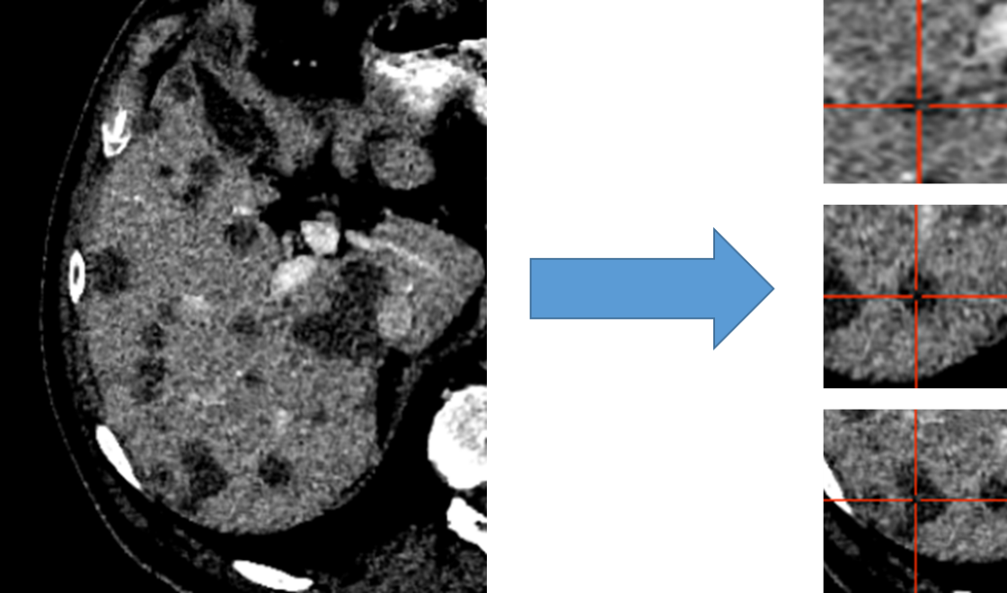
Figure 1: Liver distributed into individual cubes of 32x120x120. Disease is labeled as disease regardless of center of cube.
The validation and test set are not broken into cubes, our architectures accepts variable input size, with the entire liver being passed at once for evaluation and testing.

Architectures
Four architectures were investigated: Standard 3D UNet, Residual 3D UNet, Dense 3D UNet, and Hybrid-WNet (a hybrid pre-trained Standard 2D UNet combined with a 3D DenseUNet). The basic architectural framework (i.e., the number of convolution blocks per layer, number of layers, convolution block lambda [increase in the number of convolution blocks per layer], and maximum number of convolution blocks) remained the same for the Standard, Residual, and Dense 3D UNets (Figure xxxA). The differences in the convolutions and connections in the Standard, Residual, and Dense 3D UNets are represented in Figure xxxB. A representative diagram of the Hybrid-WNet architecture is shown in Figure xxx.

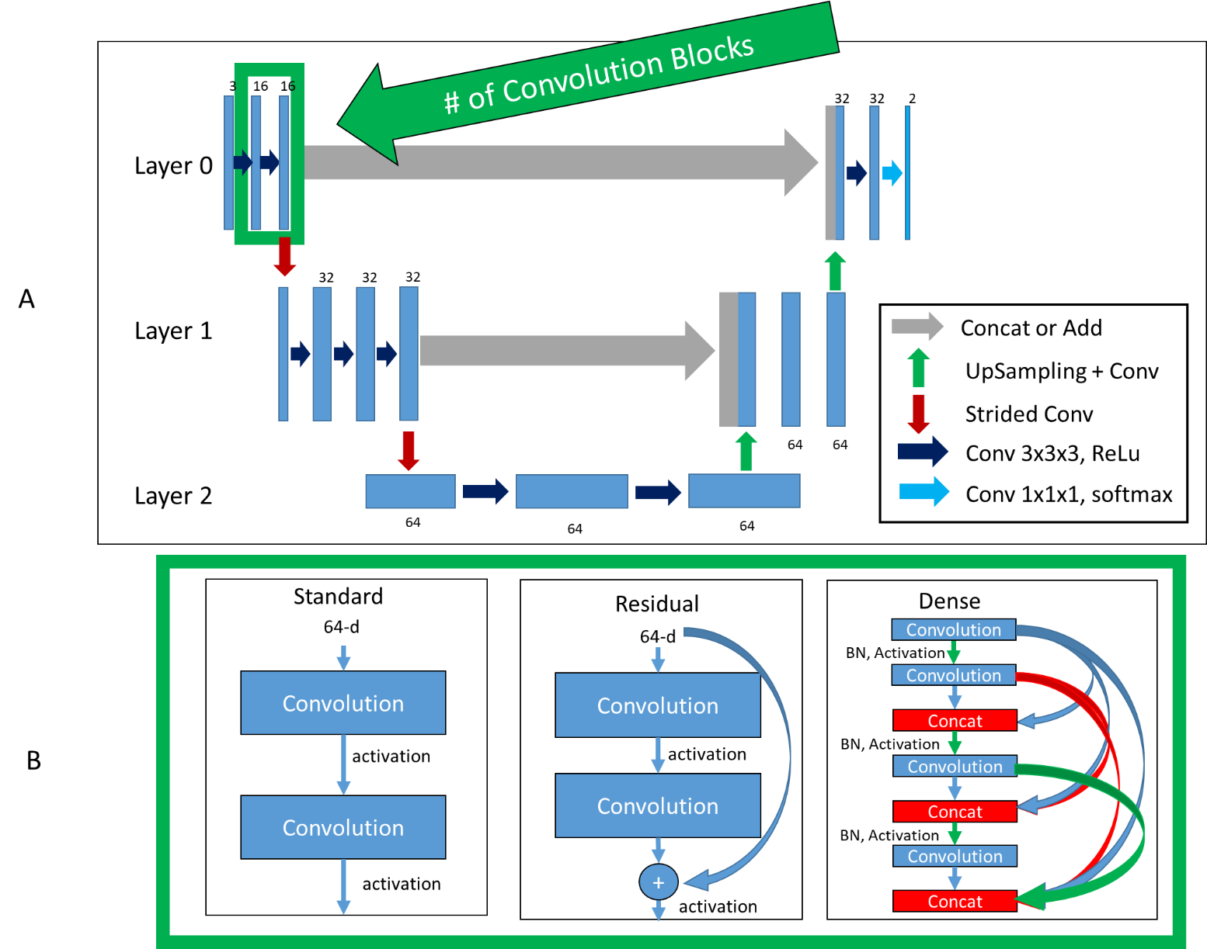
Figure 2: Top (A): Basic framework of architectures. Bottom (B): Difference in convolution blocks, surrounded by green to indicate same region in (A). ‘Standard’, previous feature maps are convolved and activated. ‘Residual’, previous feature maps are directly added to convolutional output in a ‘skip’ connection before activation. ‘Dense’, previous feature maps are continually concatenated together before activation and convolution. BN: Batch Normalization

Standard 3D UNet
We first investigated the Standard 3D UNet, in which concatenations or additions were used to combine equal-sized feature maps from the encoder to the decoder side.
Standard architectural parameters:
- 1, 2, 3, or 4 layers
- 1, 2, or 3 initial convolution blocks
- Increase in number of convolution blocks (convolution lambda) for each layer of 0, 1, or 2
- 4 maximum convolution blocks
- 8, 16, and 32 initial filters
- 32, 64, or 128 maximum filters

Residual 3D UNet
The Standard 3D UNet was expanded to include residual connections for each convolution block in a layer, with motivation from the ‘ResNet’ architecture¹². Residual connections have the benefit of allowing a “flow” of loss from previous convolutions. This allows the model to create skip-connections over convolutions that might not be necessary.
Residual Network Architecture Parameters:
- 1, 2, 3, or 4 layers
- 1, 2, 3, or 4 initial convolution blocks
- Increase in number of convolution blocks (convolution lambda) for each layer of 0, 1, and 2
- 4 maximum convolution blocks
- 32 initial filters
- 128 maximum filters

Dense 3D UNet
A more complete “flow” of loss from previous convolutions can be realized with the DenseNet architecture¹³. This architectural style allows previous convolutions to be re-used; optimizing the model’s reuse of feature maps enables more diversified feature creation. The reuse of previous convolutions allows the number of filters to be significantly reduced since the number of filters is increased by a small amount each time (referred to here as the “growth rate”).
Dense Network Architectural Parameters:
- 2 or 3 layers
- 2 initial convolution blocks
- Increase in convolution blocks (convolution lambda) for each layer of 0 or 1
- 4 maximum convolution blocks
- 8, 12, 16, and 32 initial filters
- Filter growth rate of 0 and 4
- Infinite maximum filters

Hybrid-WNet
Our Hybrid-WNet architectural style was inspired by that presented by Li et al.⁸ with significant alterations. The architecture combined 2D features extracted from the pre-trained 2D DenseNet¹³ with a 3D convolutional neural network. Our model builds on the DenseNet 121 architecture implemented in Tensorflow software¹⁴. To turn this classifier into a semantic segmentation algorithm, we created a UNet of the DenseNet 121 and performed bilinear upsampling, followed by a convolution and the addition of encoding features (Figure xxx, gray arrow). We coined the term Hybrid-WNet on the basis of the hybrid approach of combing 2D and 3D features, along with W-shaped appearance of two UNets beside each other (Figure xxx).
Our architecture and training varied from the original architecture in three fundamental ways. First, we provided connections from the encoding to the de-coding side of the DenseNet 121 network via additions, ensuring that previous features were not lost as a result of pooling and upsampling. Second, in architecture training, we broke the training process into four steps: 1) training only the new decoding side of the DenseNet 121, 2) training the entire DenseNet121, 3) training only the 3D network with the extracted 2D features, and 4) entire end-to-end training. By breaking up the training process in this fashion, we ensured that we could use high learning rates without the risk of “untraining” pretrained layers or feature extractors. Third, our 3D DenseNet contained truly dense layers, with extracted features shared throughout the entirety of each layer; this enabled the use of significantly fewer features.

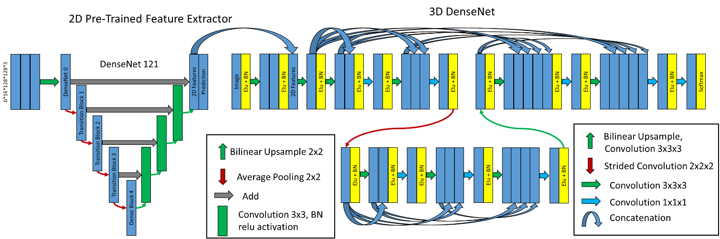
Figure 3: Hybrid W-Net (HWNet). (Left) Pre-trained 2D DenseNet 121 converted into UNet, where final features are concatenated into 3D DenseNet. (Right) 3D DenseNet architecture defined as two layers, two convolution blocks in Layer 0, three convolution blocks in Layer 1, and eight initial filters.

Model Training

All model training was performed using NVIDIA-Tesla V100 32GB GPUs¹⁵. All model creation, training, optimization, and evaluation was performed using Tensorflow software version 2.2.0¹⁶. Models were optimized using a sparse categorical cross entropy loss and an Adam optimizer. Mixed precision was enabled to reduce the training time.
The model was trained with two inputs, a CT image and a binary mask of the liver. The liver mask automatically assigns a background to any voxel that is not present within the liver, as any disease should be within the provided liver contour. Training involved passing B*N*H*W*C tensors to the model, where the (B)atch varied from 8, to 16, the (N)umber of slices was 32, the (H)eight was 120, the (W)idth was 120, and the (C)hannels was 2 (image and binary liver mask). Thus, a single pass might be 8x32x120x120x2 in size.

Training the DenseNet121 UNet
When training the 2D aspect of the Hybrid-WNet, 3D cubes were reshaped into stacked 2D images. For example, a batch of 8x32x120x120x1 would be transformed into 8*32x120x120x1. To ensure that pre-trained weights were taken advantage of, the first iteration froze all weights on the pre-trained encoding aspect of the architecture, only training the decoding aspect. Next, all weights were made trainable, allowing the model to tweak any pre-trained layers.

Training the Combined 2D-3D WNet
After training the 2D part of the W-Net, we concatenated the 2D features before classification to the input of the 3D model. For the first iteration, all weights from the 2D network were frozen, and only the 3D model was trained. Next, all weights were unfrozen, allowing the model to be fine tuned.

Hyper-Parameters
The learning rate is known to be one of the most important variables in determining a model’s ability to converge; optimal rates vary based on architecture depth (layers), number of convolution blocks, and number of filters in each block. For each model, a variation in the cyclical learning rate¹⁷ ws used (GitHub link: anonymized for review), where the model started training at a minimum learning rate before linearly increasing to the maximum and decreasing back to the minimum.
The minimum and maximum learning rates were defined using an in-house function (Githb link: anonymized for review). This function slowly increases the learning rate from a very low value (~1e-10) to a large value (~1-e-1) on the training dataset. The minimum and maximum learning rates were extracted from the resulting training loss curve where the loss began to decrease and increase, respectively (Figure XXX, supplementary material).
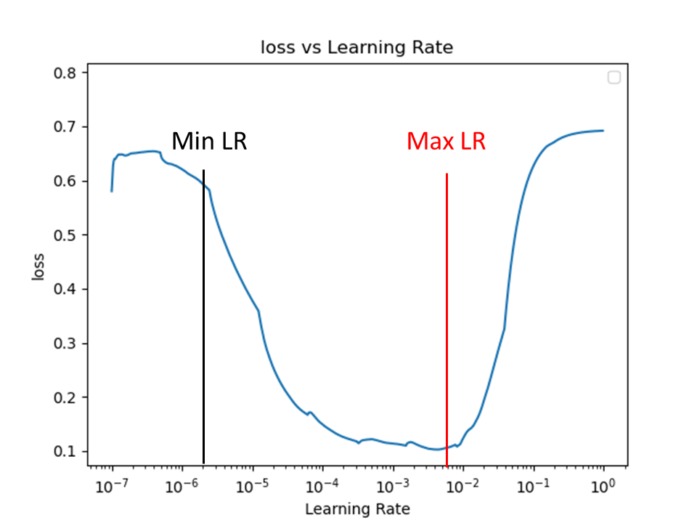
Supplementary Figure 4: Learning Rate Finder figure. Learning rate is gradually increased from 10e-7 to 10e-0, the point where loss begins to decrease is the minimum learning rate (Min LR), the point where it begins to increase is the maximum learning rate (Max LR).
Unique minimum and maximum learning rates were found for each architectural parameter for reach architectural style.

Model Optimization
To overcome the impact of variable initialization, we ran each unique model three times independently using randomly initialized variables for 101 epochs. Plotnine and Tensorflow’s Tensorboard (https://github.com/tensorflow/tensorboard) with hyperparameter tuning was used to identify any potential trends and direct model training. The final model was selected on the basis of the Dice similarity coefficient (DSC) between the validation set prediction and the ground truth during the training process.
Disease sites can be small; therefore, quantitative metrics may led to inaccurate segmentation results. Prediction images were created on the validation data during training to visually assess training accuracy (Figure xxx). This method has been implemented as a Tensorflow callback function (Githb link: anonymized for review).

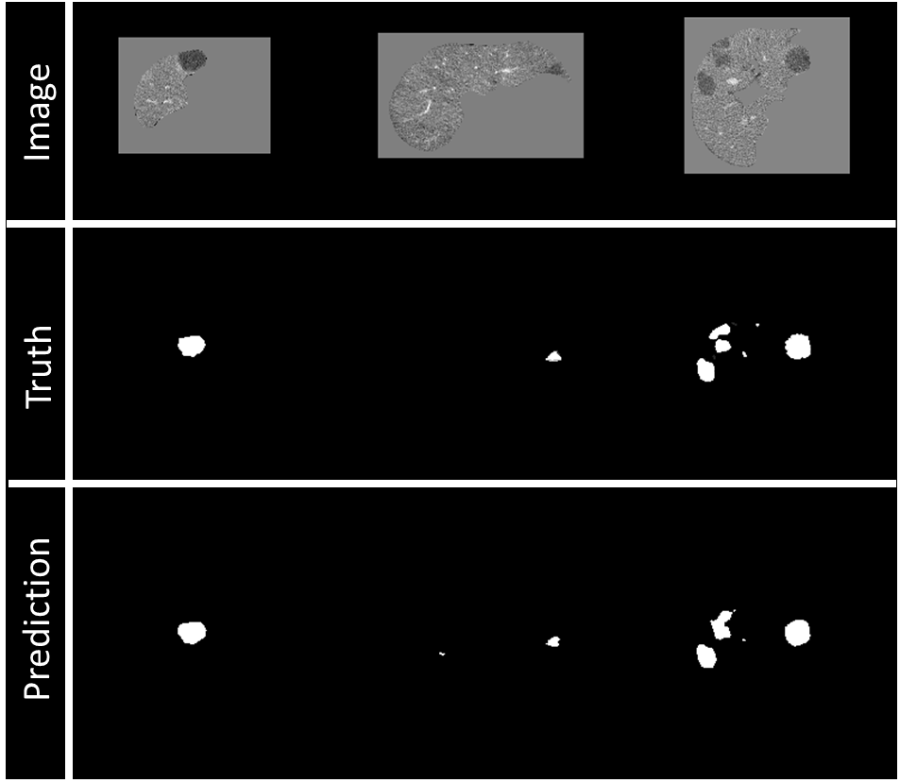
Figure 5: Example of visualization of prediction on validation data during training. Top row: Image being fed into model, masked by the liver segmentation. Middle row: Ground truth of disease contours. Bottom row: Prediction of disease contours, set with a threshold of 0.5 to binary mask.

Model Evaluation

Seed and Threshold Values
The disease predictions from our model ranged from 0-1. Unfortunately, because of slice thickness, the most inferior and superior aspects of a disease site might have a lower probability than the “middle” of the disease. For this reason, we used seed-point growth for the final prediction. Seed points were created to define the likely starting point of a disease site, and then grown outwards to the threshold value. The seed value and threshold values were selected on the basis of the highest DSC in the validation dataset. The seed values ranged from 0.25-0.95 in 0.01 increments, and the thresholds ranged from 0.2 to 0.8 in 0.01 increments.

Quantitative Evaluation
The geometric performance of the model was evaluated on the test set using the (DSC) and Median Surface Distance between the manual and predicted segmentations. To evaluate our model, we report on predictions in a disease site-by-site, patient-by-patient, and “global” basis.
For the site-by-site comparison, each non-connected disease segmentation of the test patients was considered an independent case. In that regard, we computed the metrics between the manual segmentation and the closest continuous predicted disease segmentation, using the distance between site centroids. For the patient-by-patient comparison, we computed the metrics between the manual and predicted segmentations within the entire liver. For global DSC, all images were stacked together, this metric comes from the LiTs challenge¹⁰. All metrics were computed using their original image resolution.
The sensitivity of the model was evaluated on a site-by-site basis, where the disease was considered identified if at least 45% of the manual disease volume was overlapped by the predicted disease volume. The false-positive volume was defined as the volume of the predicted disease segmentation outside of the ground truth disease segmentation and was comprised of two errors: over-segmentation of the actual disease volume and erroneous segmentation of the normal liver area as disease. The erroneous false-positive volume was quantified as the volume that was completely unconnected from any ground truth disease segmentations and the over-segmentation false volume as the total predicted volume minus the erroneous volume (Figure xxx).
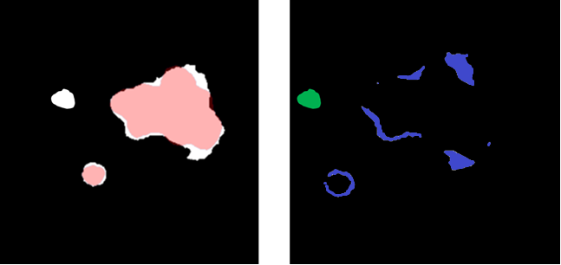
Figure 6: (Left) Overlay between a predicted (white) and ground truth (red) disease segmentations. (Right) Subtraction of the predicted and ground truth disease segmentation, over-segmentation of the disease volume (blue) and the unconnected erroneous false positive region (green). Sum of blue and green is false positive volume.

Qualitative Evaluation
To enrich the quantitative evaluation, we also evaluated quantitative metrics. For large structures, a high DSC can hide clinically important inaccuracies, while for smaller structures, a low DSC can be overly critical¹⁸. Therefore, a qualitative assessment of both CRLM and ablation segmentations was performed by a radiology-trained physician fellow (1, XXX) and two board-certified radiologists (2, XXX), an interventional radiologist, and (3, XXX), a diagnostic radiologist, both of whom have more than 10 years of experience).
We retrospectively identified 18 patients who had previously undergone thermal ablation therapy at our institution under an Institutional Review Board-approved study; these patients had 24 CRLM sites and 19 ablation sites. The predicted CRLM and ablation contours were scored independently by both radiologists and the radiology physician fellow based on a Likert quality scale of 1-5. The criteria for the scale are shown in Table xxx.
Table 2: Likert scoring for assessment of colorectal liver metastasis (CRLM) and ablation contours
Score |  | Criteria
5 | Excellent | Negligible changes, could be used clinically without edits
4 | Good | Minor changes on < 4 slices, or that would take less than 10 seconds to fix
3 | Fair | Edits needed on multiple slices, but less than 50%
2 | Poor | Greater than 50% of slices need editing
1 | Very poor | Contours are poorly predicted, missed disease

Results
The best validation loss scores for each architectural style were, Standard UNet: 0.041, Residual UNet: 0.024, DenseUNet: 0.016, DenseNet2D (Encoder frozen): 0.022, DenseNet2D (All trainable): 0.013, DenseNet3D (2D frozen): 0.011, DenseNet3D (All trainable): 0.0092.

Quantitative
The best model was the Hybrid-WNet model: the 3D UNet contained two layers, two convolution blocks, and 32 filters and had a convolution lambda of two. The model consisted of 14,497,600 parameters (14,408,960 trainable and 88,640 non-trainable).
A seed value of 0.67 and threshold value of 0.30 resulted in the highest overall DSC in the validation dataset. LiTs test set (n = 70) predictions required a mean of 9.58 seconds, with a standard deviation of 2.32 seconds.

3D-IRCADb Site-by-Site evaluation
On a site-by-site basis, the median (min-max) median surface distance for sites < 15mm (n=73) was 28.25 mm (0.67-108) and for sites > 15mm (n=48) was 1.23mm (0.28–19.4). The mean (min-max) DSC for sites < 15mm (n=73) was 0.16 (0.00 - 0.89) and for sites > 15mm (n=48) was 0.74(0.00 - 0.94) (Table xxx).
Table 3: Mean, min and max Dice Similarity Coefficient and Median Surface Distance, and Sensitivity for individual disease sites by differing size criteria of the 3DIRCADb dataset.
Disease site diameter | # Sites | Dice Similarity Coefficient |  |  | Median Surface Distance (mm) |  |  | Sensitivity
 |  | Mean | Min | Max | Median | Min | Max
less than 15 mm | n = 73 | 0.16 | 0.00 | 0.89 | 28.25 | 0.67 | 108 | 23% (15/73)
greater than 15 mm | n = 48 | 0.74 | 0.00 | 0.94 | 1.23 | 0.28 | 19.4 | 98% (47/48)

We compared our model results to those of other authors (Table xxx); our size distributions were varied to match to ensure fair comparison.
Table 4: Comparison of CRLM segmentation results from our model and the literature. Green box indicates more disease sites (n), better Dice Similarity Coefficient (DSC), or higher sensitivity. Patients are specified instead of sites for LiTs test submission.
Method | Model | Disease diameter/Source | # Sites | Mean DSC | Sensitivity
Presented Method | Hybrid WNet | less than 10 mm | n = 42 | 0.00 | 7%
 |  | 10-20 mm | n = 49 | 0.43 | 59%
 |  | 15-20 mm | n = 18 | 0.68 | 94%
 |  | greater than 20 mm | n = 30 | 0.77 | 98%
 |  | LiTs Test | n = 70  patients | 0.810 global | -
 |  | 3DIRCADb | n = 15  patients | 0.69 | -
Vorontsov et al ⁷ | FCN | less than 10 mm | n = 30 | 0.14 | 10%
 |  | 10-20 mm | n = 35 | 0.53 | 71%
 |  | greater than 20 mm | n = 40 | 0.68 | 85%
Li et al⁸ | Hybrid Dense UNet | LiTs Test | n = 70  patients | 0.824 global | -
Seo et al⁹ | mU-Net | 3DIRCADb | n = 5  patients | 0.68 | -

3D-IRCADb Patient-by-Patient evaluation
On a patient-by-patient basis, the median (min-max) median surface distance was 1.75mm (0.57–7.63mm), the DSC was 0.73 (0.41-0.88), the number of false-positives was 1 (0-4), false-positive volume was 4.25cc (0.08-28.34cc), the erroneous false-positive volume was 2.35cc (0.00, 14.56cc), and over-segmentation false-positive volume was 1.24cc (0.00, 17.56cc) (Table xxx). Note that a single patient might have multiple disease sites of varying sizes. The global DSC score was 0.81.
Table 5: Metrics of Dice Similarity Coefficient, Median Surface Distance (mm), False Positive Discoveries (#/patient), and False Positive Volume (cc) for 15 3D-IRCADb test patients.
Metric | N = 15 Patients
 | Median | Min | Max | Standard Deviation
Dice Similarity Coefficient | 0.74 | 0.40 | 0.89 | 0.16
Global Dice Similarity Coefficient | 0.81 | N/A | N/A | N/A
Median Surface Distance (mm) | 1.95 | 0.57 | 8.00 | 1.90
False Positive Discoveries (#/Patient) | 1 | 0 | 7 | 2.0
False Positive Volume (cc) | 4.25 | 0.08 | 28.34 | 7.48
Erroneous False Positive Volume (cc) | 2.35 | 0.00 | 14.56 | 5.01
Over-segmentation False Positive Volume (cc) | 1.24 | 0.00 | 17.56 | 5.50

Institutional Data Site-by-Site Test
For the pre-treatment CECT in which previously defined manual contours were present in the CRLM (n=19 sites), the mean (min-max) DSC was 0.80 (0.59-0.91), with 84% (16/19) having DSC ≥ 0.76. For the post-treatment CECT where previously defined manual contours were present of the ablation zone (n=14 sites), the mean (min-max) DSC was 0.75 (0.09-0.90), with 71% (10/14) having DSC ≥ 0.76.

Institutional Data Patient-by-Patient Test
Manual contours of the CRLM and ablation zones were not always present; for this reason, fewer sites were used than in the qualitative analysis.
For the pre-treatment CECT in which previously defined manual contours were present in the CRLM (n=15 patients), the mean (min-max) DSC was 0.67 (0.28-0.91), with 84% (16/19) having DSC ≥ 0.76. For the post-treatment CECT, in which previously defined manual contours were present of the ablation zone (n=9 patients), the mean (min-max) DSC was 0.72 (0.42-0.89), with 67% (6/9) having DSC ≥ 0.75.
Metric | N = 15 CRLM Patients
 | Median |  | Min | Max | Standard Deviation
Dice Similarity Coefficient | 0.78 |  | 0.28 | 0.91 | 0.17
Median Surface Distance (mm) | 0.78 |  | 0.01 | 83.28 | 27
False Positive Discoveries (#/Patient) | 1 |  | 0 | 4 | 1.2
False Positive Volume (cc) | 2.43 |  | 0.28 | 14.47 | 4.68
Erroneous False Positive Volume (cc) | 1.05 |  | 0.00 | 14.23 | 4.54
Over-segmentation False Positive Volume (cc) | 0.73 |  | 0.23 | 3.68 | 0.97
Metric | N = 9 Ablation Patients
 | Median | Min |  | Max |  | Standard Deviation
Dice Similarity Coefficient | 0.79 | 0.42 |  | 0.89 |  | 0.16
Median Surface Distance (mm) | 0.76 | 0.01 |  | 5.72 |  | 1.76
False Positive Discoveries (#/Patient) | 2 | 0 |  | 6 |  | 1.6
False Positive Volume (cc) | 27.8 | 5.84 |  | 174.07 |  | 61.25
Erroneous False Positive Volume (cc) | 5.62 | 0.00 |  | 107.47 |  | 32.77
Over-segmentation False Positive Volume (cc) | 11.40 | 4.35 |  | 172.54 |  | 50.97

Qualitative Evaluation

Institutional Data
Table XXX shows the Likert scores of the two radiologists and radiology trained physician fellow. The mean (min-max) Likert scores for all qualitative patient gross tumor volumes (n=24) were interventional radiologist: 4.7 (4-5), diagnostic radiologist: 4.6 (4-5), physician fellow 4.9 (4-5), and majority: 4.8 (4-5). The mean (min - max) Likert scores for each qualitative patient ablation volume (n=19) and the majority score were interventional radiologist: 4.1 (2-5), diagnostic radiologist: 3.8 (2-5), physician fellow 4.5 (3-5), and majority: 4.1 (2-5). All (24/24) of the CRLM contours and 84%(16/19) of the ablation contours had a majority Likert score ≥ 4.
Figure xxx and Table xxx show the scores of the two radiologists and physician fellow on the CRLM and ablation zones.
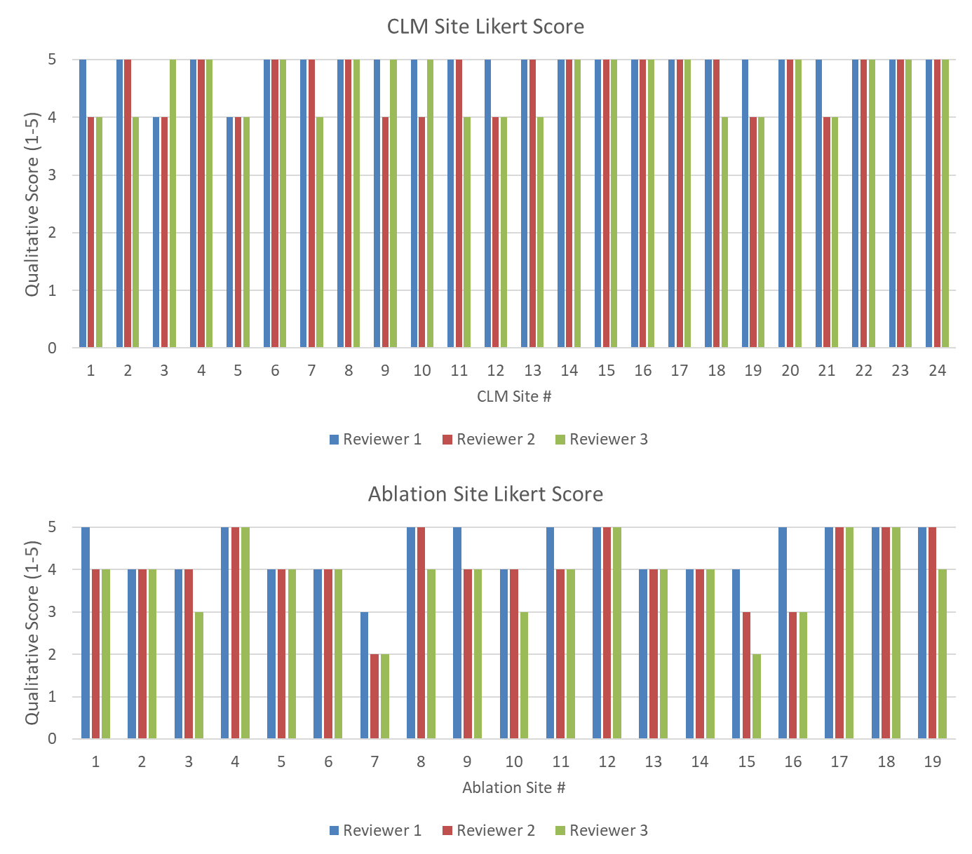
Figure 7: (Top) Likert Score by each reviewer for each disease site. (Bottom) Likert Score by each reviewer for each ablation site. A higher value is associated with a higher quality.

Table 6: Breakdown of Likert score (1-5) for predicted contours of CLM and Ablation sites by each reviewer, %>=4 is the percentage of cases with a Likert score of 4 or greater.
 | CRLM Scoring (n=24)
 | Reviewer 1 | Reviewer 2 | Reviewer 3 | Majority Vote
Mean | 4.9 | 4.7 | 4.6 | 4.8
Min | 4 | 4 | 4 | 4
Max | 5 | 5 | 5 | 5
% >= 4 | 100 | 100 | 100 | 100
 | Ablation Scoring (n=19)
 | Reviewer 1 | Reviewer 2 | Reviewer 3 | Majority Vote
Mean | 4.5 | 4.1 | 3.8 | 4.1
Min | 3 | 2 | 2 | 2
Max | 5 | 5 | 5 | 5
% >= 4 | 95 | 89 | 74 | 84

Discussion
In this study, we proposed a Hybrid-WNet model architecture for the segmentation of the disease sites and ablation areas in the context of CRLM treated with ablation therapy. The model was further evaluated using the Likert scoring method by two board certified radiologists (XXX, interventional radiologist and YYY, diagnostic radiologist) and a radiology trained physician fellow (ZZZ), with majority voting scores ≥ 4 out of 5 for 100% (24/24) of the disease and 84% (16/19) of the ablation segmentations. Our work is highly innovative in regard to the proposed model architecture and training workflow (discussed below). The prediction process has been implemented in a treatment planning system (RayStation 9B, RaySearch Laboratories, Sweden) and can perform segmentations in < 30 seconds, making it highly suitable for clinical use.
Our work is highly innovative because of the Hybrid-WNet model architecture and the training of the model; the model had with 98% (47/48) sensitivity on disease sites > 15mm, with predictions in < 30 seconds. Our model performed similarly to the state-of-the-art architectures shown in Table xxx with respect to DSC and sensitivity.

The proposed Hybrid-WNet architecture in this study differs from the model which inspired it⁸ by adding additions to the 2D feature extractor, and connecting all of the convolutional layers within the convolution blocks between the encoding and decoding of the 3D DenseNet. Previously published studies proposed similar architectures that were focused only on dense connections within a single convolutional block^{19–21}. Our proposed implementation allows the model to receive inputs from every convolution of the same image size across the entire network. This global passing of convolution layers across the network removes bottlenecks in each convolution block, something that is particularly important with dense connections where convolutions can be re-used. The proposed model will be publicly available (Github: redacted for anonymization).

Segmentation of CRLM has historically been difficult because of the relatively small size of lesions and the large search area. The extent of disease can vary from patient to patient, from a single lesion to multiple lesions. Simple class weighting of disease would lead to favoring training in patients with more disease sites. Our proposed method of splitting the liver into cubes that are centered specifically on disease sites ensures that the model learns using a more balanced representation of data. The training workflow was designed to allow the model to learn from batches that contains cubic images from multiple patients at once, enabling the creation of a more generalized model.

While fully convolutional networks have been previously investigated for the segmentation of CRLM⁷, only a quantitative assessment of model performance has been reported. The mean DSC and sensitivity of our model were slightly lower than those presented by Vorontsov et al⁷, with more test sites for two of the criteria (n=42 vs n=30 for < 10mm, and n=49 vs n=35 for 10-20mm). Similar findings have also been reported by Christ et al;⁶ however, their work focused on primary liver disease. Within our institutional data, 84% (16/19) of the disease sites had a DSC > 0.76, which is reported as the inter-observer variability for CRLM segmentation²².

Limitations
Our study has several limitations. The mean sensitivity was only 7% in disease sites < 10 mm in diameter compared with 98% in sites > 15 mm. We believe that the low sensitivity in small sites may be partly due to the test data used, where several 10-15-mm disease sites were present on a single scan slice. Unfortunately, manual contours were not present for all of the institutional CRLM and ablation data, limiting our quantitative comparison to 19 of the 24 CLRM sites and 9 of the 19 ablation sites.

Majority voting showed poor Likert score (< 4) for three ablation sites. The predictions for these sites can be seen in the Supplementary Figure xxx, where disagreement about the boundary of the ablation zone and the time needed for correction resulted in a range of scores from the reviewers. We believe that suboptimal imaging quality during porto-venous CT acquisition phase might have negatively impacted ablation zone boundary identification in such patients. Optimizing imaging acquisition protocol intra-procedurally during ablation interventions might overcome such limitation.
The measurement of false-positive volume seemed to be highly biased when there were small amounts of over-segmentation on large tumors (Supplementary Figure xxx); this was the rationale for the creation of the erroneous and over-segmentation false-positive volumes. To ensure transparency, we included all three and relied on qualitative assessment to add weight to the quality of the contours.

Conclusions
The proposed Hybrid-WNet model provided fast (< 30 seconds) and accurate CRLM and ablation zone segmentations for CECT. Our model’s results were well accepted by the reviewers, with all three scoring the disease segmentation (n=24) as 4 or higher on the Likert scale, and 84% (16/19) as 4 or higher with ablation segmentation. We believe that this model can provide clinical benefits in the detection of CRLM, the assessment of ablation therapy, and automated planning for radiation therapy.

References
1. Siegel RL, Miller KD, Jemal A. Cancer statistics, 2019. CA Cancer J Clin. 2019;69(1):7-34. doi:10.3322/caac.21551
2. WHO Biennial Report 2012-2013. Accessed October 27, 2020. https://governance.iarc.fr/SC/SC50/Biennial Report 2012-2013.pdf
3. Alper Sag A, Selcukbiricik F, Mandel NM. Evidence-based medical oncology and interventional radiology paradigms for liver-dominant colorectal cancer metastases. World J Gastroenterol. 2016;22(11):3127-3149. doi:10.3748/wjg.v22.i11.3127
4. Gillams A, Goldberg N, Ahmed M, et al. Thermal ablation of colorectal liver metastases: a position paper by an international panel of ablation experts, the interventional oncology sans frontières meeting 2013. Eur Radiol. 2015;25(12):3438-3454. doi:10.1007/s00330-015-3779-z
5. Software-Aided Imaging (Morfeus) for Confirming Tumor Coverage With Ablation in Patients With Liver Tumors, the COVER-ALL Study - Full Text View - ClinicalTrials.gov. Accessed August 28, 2020. https://clinicaltrials.gov/ct2/show/NCT04083378
6. Christ PF, Elshaer MEA, Ettlinger F, et al. Automatic liver and lesion segmentation in CT using cascaded fully convolutional neural networks and 3D conditional random fields. In: Lecture Notes in Computer Science (Including Subseries Lecture Notes in Artificial Intelligence and Lecture Notes in Bioinformatics). Vol 9901 LNCS. Springer Verlag; 2016:415-423. doi:10.1007/978-3-319-46723-8_48
7. Vorontsov E, Cerny M, Régnier P, et al. Deep Learning for Automated Segmentation of Liver Lesions at CT in Patients with Colorectal Cancer Liver Metastases. Radiol Artif Intell. 2019;1(2):180014. doi:10.1148/ryai.2019180014
8. Li X, Chen H, Qi X, Dou Q, Fu C-W, Heng P-A. H-DenseUNet: Hybrid Densely Connected UNet for Liver and Tumor Segmentation from CT Volumes. IEEE Trans Med Imaging. Published online June 11, 2018:1-1. doi:10.1109/TMI.2018.2845918
9. Seo H, Huang C, Bassenne M, Xiao R, Xing L. Modified U-Net (mU-Net) with Incorporation of Object-Dependent High Level Features for Improved Liver and Liver-Tumor Segmentation in CT Images. IEEE Trans Med Imaging. 2020;39(5):1316-1325. doi:10.1109/TMI.2019.2948320
10. Bilic P, Christ PF, Vorontsov E, et al. The Liver Tumor Segmentation Benchmark (LiTS).; 2019.
11. 3D-IRCADb 01 | IRCAD France. Accessed September 29, 2020. https://www.ircad.fr/research/3d-ircadb-01/
12. He K, Zhang X, Ren S, Sun J. Deep Residual Learning for Image Recognition. Accessed July 28, 2020. http://image-net.org/challenges/LSVRC/2015/
13. Huang G, Liu Z, Van Der Maaten L, Weinberger KQ. Densely Connected Convolutional Networks. Accessed July 28, 2020. https://github.com/liuzhuang13/DenseNet.
14. Abadi M, Agarwal A, Barham P, et al. TensorFlow: Large-Scale Machine Learning on Heterogeneous Distributed Systems. Accessed December 10, 2017. https://static.googleusercontent.com/media/research.google.com/en//pubs/archive/45166.pdf
15. NVIDIA Tesla V100 | NVIDIA. Accessed July 28, 2020. https://www.nvidia.com/en-gb/data-center/tesla-v100/
16. Abadi M, Agarwal A, Barham P, et al. TensorFlow: Large-Scale Machine Learning on Heterogeneous Distributed Systems. Accessed July 28, 2020. www.tensorflow.org.
17. Smith LN. Cyclical Learning Rates for Training Neural Networks. Accessed July 28, 2020. www.cs.toronto.edu/
18. Anderson BM, Lin EY, Cardenas CE, et al. Automated Contouring of Contrast and Noncontrast Computed Tomography Liver Images With Fully Convolutional Networks. Advancesradonc. Published online 2020. doi:10.1016/j.adro.2020.04.023
19. Jégou S, Drozdzal M, Vazquez D, Romero A, Bengio Y. The One Hundred Layers Tiramisu: Fully Convolutional DenseNets for Semantic Segmentation. Accessed August 26, 2020. https://github.com/SimJeg/FC-DenseNet
20. Hai J, Qiao K, Chen J, et al. Fully convolutional densenet with multiscale context for automated breast tumor segmentation. J Healthc Eng. 2019;2019. doi:10.1155/2019/8415485
21. Brahimi S, Ben Aoun N, Benoit A, Lambert P, Ben Amar C. Semantic segmentation using reinforced fully convolutional densenet with multiscale kernel. Multimed Tools Appl. 2019;78(15):22077-22098. doi:10.1007/s11042-019-7430-x
22. Jensen NKG, Mulder D, Lock M, et al. Dynamic contrast enhanced CT aiding gross tumor volume delineation of liver tumors: An interobserver variability study. Radiother Oncol. 2014;111(1):153-157. doi:10.1016/j.radonc.2014.01.026

