Introduction

Colorectal Cancer in the United States
Colorectal cancer (CRC) is one of the predominant forms of cancer within the United States, being the 3rd most common cause of cancer and cancer death in both men and women(Siegel et al., 2019). While 25% of patients present colorectal liver metastasis (CRL-mets) at the time of diagnosis, up to 60% will develop CRL-mets over the course of their disease(Alper Sag et al., 2016).

Detection of Colorectal Liver Metastasis (CRL-mets)
While several treatment options are available for CRL-mets, they all first rely on the proper identification of the disease. Several imaging techniques exist to identify CRL-mets: ultrasound [ref], Computed Tomography (CT) [ref], Positron Emission Tomography (PET), and/or nuclear Magnetic Resonance Imaging (nMRI) [ref]; however, the gold standard consists of a contrast-enhanced CT (CECT) scan[ref]. A CECT often consists of three phases: an arterial phase where the contrast is most prominent in the artery, the portal-venous phase, where contrast is mostly present within the portal-vein, and a washout phase. CRL-mets often appear as hypo-dense regions in the arterial and portal-venous phase of the image, in stark contrast to the normal liver tissue.
Challenges with detecting CRL-mets are mostly with respect to the diseases relatively small size and large search area in the liver. Furthermore, interventions such as radiation therapy, radiofrequency ablation, and microwave ablation, require accurate segmentations of the disease site. To date, automated liver disease segmentation tasks have largely focused on primary liver disease, although new competitions such as the Liver Tumor segmentation (LiTs) challenge have contained data of both primary and secondary liver cancers.

Ablation Therapies
Specifically for ablation interventions, segmentations of the disease in the pre-treatment imaging, and the generated ablation cavity in the post-treatment imaging, are important for evaluating the minimum delivered ablation margin. Both radiofrequency and microwave ablation interventions require that a minimum margin be delivered around the gross disease to ensure that all microscopic disease is treated. While automated workflows exist to map the disease from the pre-treatment to the post-treatment imaging to assess treatment efficacy, these still require manual segmentations of both disease and ablation zone.
We hypothesize that fully convolutional neural networks, trained in a unique fashion to account for the challenges of disease size with respect to the overall liver, can provide rapid and accurate segmentations of both CRL-mets and ablation generated cavities. The creation of which would enable dose escalation studies of CRL-mets in radiation therapy, and facilitate margin evaluations in ablation therapy.

Materials/Methods

Data

Quantitative Training/Validation/Test
To ensure that our model is reproducible at other institutions, our training\validation and quantitative test data was collected from the publically available Liver Tumor Segmentation, LiTS, challenge (https://competitions.codalab.org/competitions/17094). This data consisted of 130 CECT scans with liver tumors of primary liver cancer and secondary liver metastasis. Ground truth segmentations of the liver and disease were provided by the challenge. Each image was evaluated by xxx, and removed if the disease was hyper-enhancing or not secondary metastasis, or if the image acquisition parameters (slice thickness, pixel spacing) were not correctly included. A total of 93 patients remained, which were then distributed into 57 patients for training, 10 patients for validation, and 26 patients for a completely withheld test set. The image acquisition parameters for the training, validation, and test set can be seen in Table xxx.
Table 1: Image acquisition parameters from LiTs Training, Validation, and Test set.
Folder | Slice Thickness | Pixel Size X | Pixel Size Y
 | Mean (Min, Max)
Training | 1.635 (0.7, 5.0) | 0.75 (0.597, 0.976) | 0.75 (0.597, 0.976)
Validation | 2.017 (0.7, 5.0) | 0.78 (0.675, 0.976) | 0.78 (0.675, 0.976)
Test | 1.41 (0.7, 5.0) | 0.76 (0.644, 0.968) | 0.76 (0.644, 0.968)
Model predictions on the test set were assessed based on the Dice Similarity Coefficient (DSC), and Mean Surface Distance (MSD).

Qualitative Test
Quantitative metrics are not always sufficient to assess a segmentation algorithms efficacy. For large structures, a high Dice Similarity Coefficient (DSC) can hide clinically impactful inaccuracies, while for a smaller structures a low DSC could be misleading. Therefore, we wanted to acquired a qualitative assessment of both CRL-met segmentation and ablation segmentation by trained interventional radiologists.
We acquired 18 patients who had previously undergone thermal ablation therapy at our institution. These patients each had two CECT scans, one pre-ablation to identify the disease, and one post-treatment to identify the ablation zone. Two interventional radiologists independently reviewed the program’s segmentation of the disease and ablation zone on pre-treatment and post-treatment scans, scoring each contour on a scale of 1-5. The criteria for the scale can be seen in Table xxx.
Table 2: Likert scoring for assessment of colorectal liver metastasis (CRL-met) and ablation contours
Score |  | Criteria
5 | Excellent | Negligible changes, could be used clinically without edits
4 | Good | Minor changes on < 4 slices, or that would take less than 10 seconds to fix
3 | Fair | Edits needed on multiple slices, but less than 50%
2 | Poor | Greater than 50% of slices need editing
1 | Very poor | Contours are completely useless, missed disease

Data Pre-Processing

Intensity Manipulation
Initial attempts to normalize the data based on a global mean and standard deviation resulted in extreme outliers when the contrast within the liver was high or low, Figure xxx. To best separate the normal tissue from the disease, we acquired a patient specific mean and standard deviation based on the FWHM of values within the contoured liver. Visually, this appeared to result in a robust method where the disease appeared consistently darker than the normal tissue.
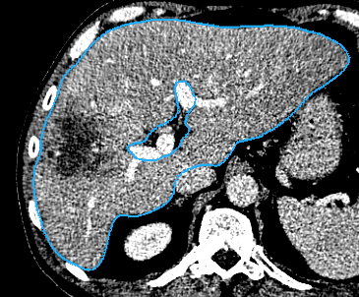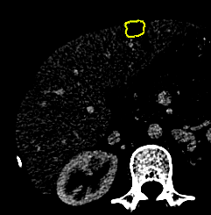
Figure 1: Images normalized based on global mean and standard deviation of liver tissue. Left, patient with mean liver HUs near the global mean. Right, patient with mean liver HU < 3 sigma from global mean.

Voxel Size Resampling
A known weakness of convolutional neural networks is instability with varying image sizes. Our first naïve approach to this task did not involve resampling the images in any form, and the results showed a clear improvement in predictions when the images has slice-thicknesses similar to the mean of the training dataset. In our final iteration, we re-sampled all training and validation images to be 1mm in slice thickness using bi-linear interpolation. Likewise, we bi-linearly interpolate the ground-truth segmentations of the disease, providing the model with values ranging from 0-1 for each part of the disease, Figure xxx. This bi-linear interpolation of ground truth was performed after our first naïve approach of nearest neighbor showed routine under-segmentation of disease.
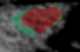
Figure 2: Linearly resampled ground-truth overlaid onto CT. Green region represents 60% certainty, yellow is 80%, and red is 100%.
For all test assessment, predictions were resampled to the original slice thickness and compared against the unchanged ground truth.

Training Image ‘Cubes’
Relative sizes of annotations is a well-known concern within image segmentation. Smaller structures are inherently worth less than large structures without a class weighting and a categorical cross-entropy loss. Unfortunately, simple class weighting would invariably weigh the more heavily diseased patients over less diseased patients, Figure xxx.
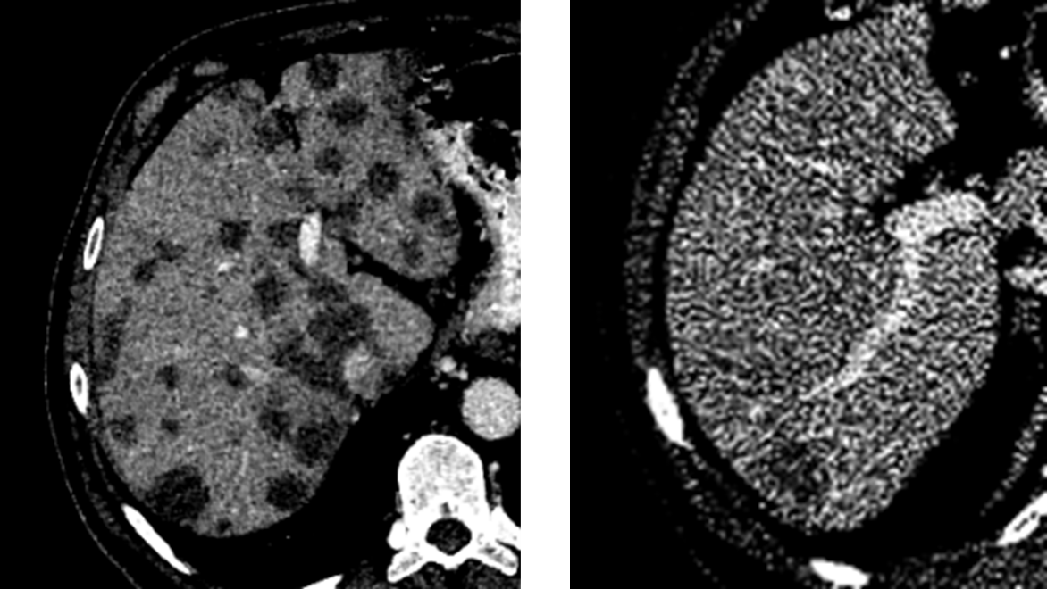
Figure 3: Representation of disease size issue. If class weighting is used to increase the value of ‘disease’, the image on the left will be worth more in the training process than the one on the right.
To this end, we break up each independent disease site within a patient into individual ‘cubes’ of 32x120x120 voxels. Note that this means disease not centered on the cube is still properly defined as disease, Figure xxx.
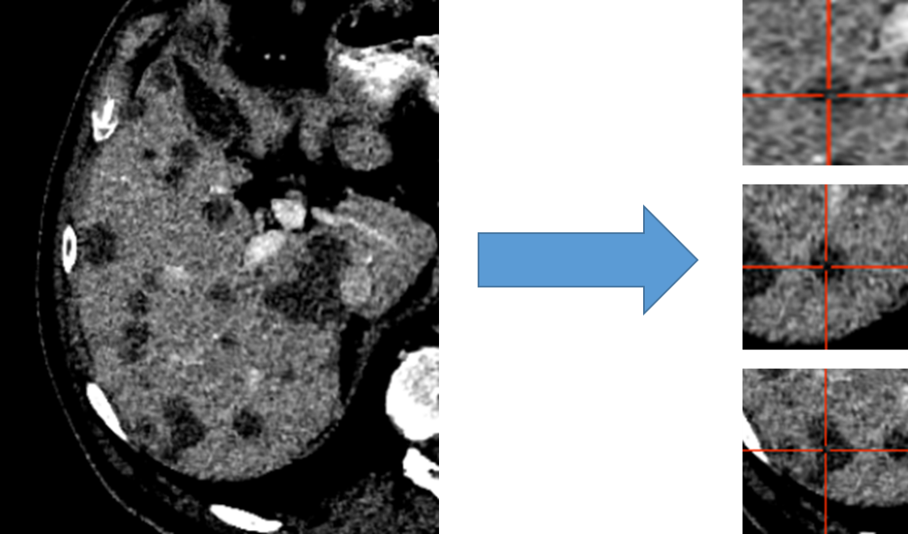
Figure 4: Liver distributed into individual cubes of 32x120x120. Disease is labeled as disease regardless of center of cube.

Architecture
We initially attempted to train a 2D model, the DeepLabV3+ with the Xception backbone; however, our inability to converge and over-abundance of false-positives led us to pursue 3D approaches.
We investigated three broad architectural styles with several fine-tuning variations. The basic framework for our architecture is the form of a UNet, defined as a number of convolution blocks per layer, number of layers, convolution block lambda (which is the increase in number of convolution blocks per layer), maximum number of convolution blocks, and presence of atrous convolutions, Figure xxx.
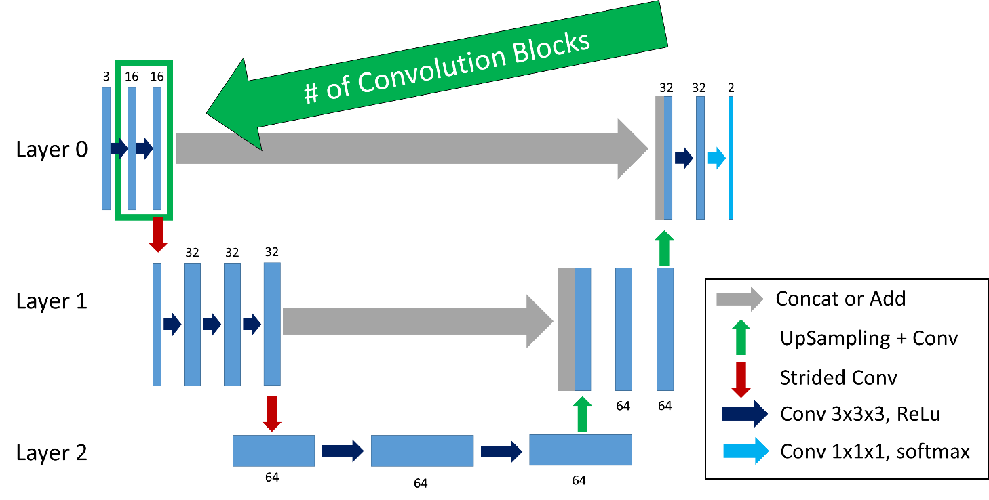
Figure 6: Basic framework of architecture. This would be defined as a three layer, two convolution block (large green arrow), convolution block lambda equal to one (increase in number of convolution blocks each layer), and max convolution blocks equal to three.
A comparison of all three approaches in how the convolution blocks (green bounded region in Figure xxx) were created is shown in Figure xxx.
The first style we investigated is a ‘vanilla’ UNet, where concatenations or additions were used to combine equal size feature maps from the encoder to the decoder side.
Vanilla Architecture Parameters:
- Number of layers were varied from 1, 2, 3, and 4
- Initial number of convolution blocks were varied from 1, 2, and 3
- The increase in number of convolution blocks (convolution lambda) for each layer was varied from 0, 1, and 2
- Maximum number of convolution blocks was 4
- The number of initial filters was varied from 8, 16, and 32
- The maximum number of filters was varied from 32, 64, and 128
Next, we investigated using residual connections for each convolution block in each layer, with motivation from the ‘ResNet’ architecture(He et al., n.d.). Residual connections have the benefit of allowing a ‘flow’ of loss from previous convolutions. This allows the model to create skip-connections over convolutions that might not be necessary. Unfortunately, convolutions after the skip-connection are a combination of both the skip connection and direct line.
Residual Network Architecture Parameters:
- Number of layers were varied from 1, 2, 3, and 4
- Initial number of convolution blocks were varied from 1, 2, 3, and 4
- The increase in number of convolution blocks (convolution lambda) for each layer was varied from 0, 1, and 2
- Maximum number of convolution blocks was 4
- The number of initial filters was 32
- The maximum number of filters was 128
A more complete ‘flow’ of loss from previous convolutions can be realized with the DenseNet architecture(Huang et al., n.d.). This architecture style allows previous convolutions to be re-used, removing the potential necessity of the model to re-create feature maps and enabling more diversified feature creation. Another benefit of this method is that the number of filters can be significantly reduced since previous convolutions are re-used; only increasing the number of filters by a small amount each time (referred to here as ‘growth rate’).
Dense Network Architecture Parameters:
- Number of layers were varied from 2, and 3
- Initial number of convolution blocks were 2
- The increase in number of convolution blocks (convolution lambda) for each layer was varied from 0, and 1
- Maximum number of convolution blocks was 4
- The number of initial filters was 8, and 12
- Filter growth rate was 4
- The maximum number of filters was infinity
A representation of the differences in how convolutions and connections occur from the ‘vanilla UNet’, ResNet UNet, and Dense UNet can be seen in Figure xxx.
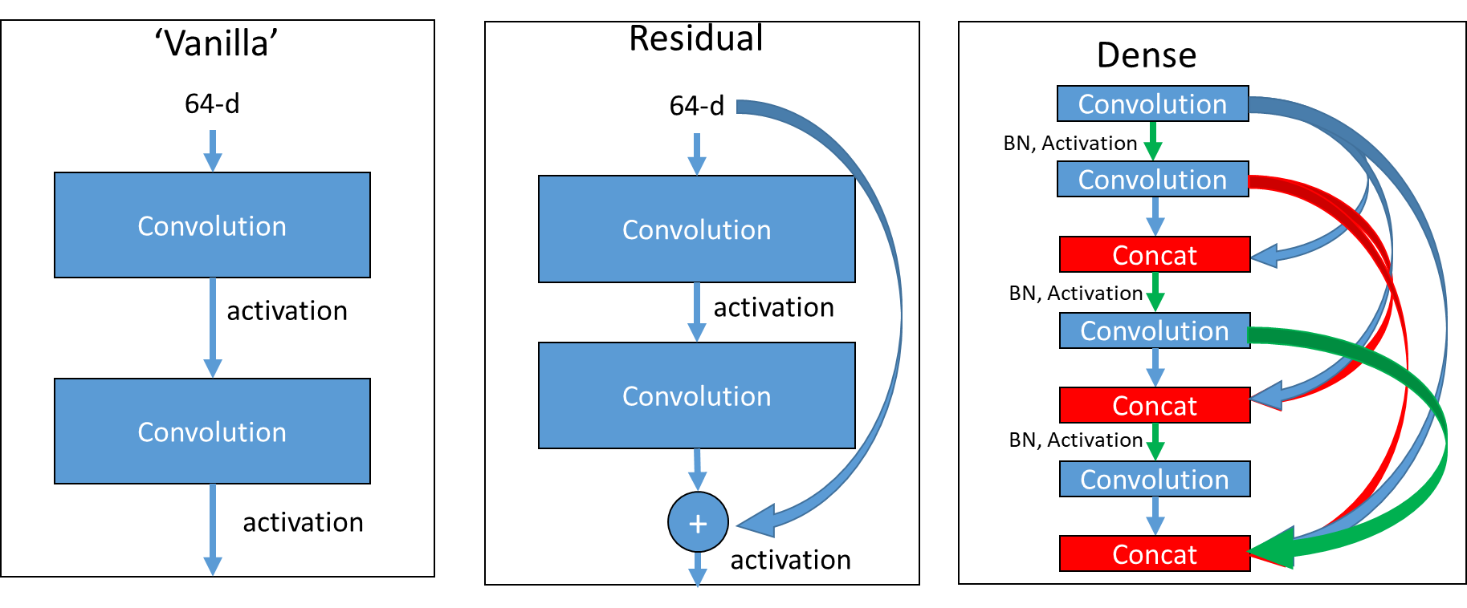
Figure 7: Difference in convolution block. Left, ‘Vanilla’, previous feature maps are convolved and activated. Middle, ‘Residual’, previous feature maps are directly added to convolutional output in a ‘skip’ connection before activation. Right, ‘Dense’, previous feature maps are continually concatenated together before activation and convolution.

Training
All model training was performed using NVIDIA-Tesla V100 32GB GPUs(NVIDIA Tesla V100 | NVIDIA, n.d.). All model creation, training, optimization, and evaluation was performed using Tensorflow version 2.2.0 (Abadi et al., n.d.). Each model is trained using batches of randomly selected eight randomly selected

Training Image Presentation
Initial attempts at
Leveraging our previous success with liver segmentation, we begin the task of disease segmentation by searching within the bounding box of the liver. Our architecture consists of multiple atrous convolutions combined with residual connections. The atrous convolutions maintain image resolution while gradually increasing receptive field size, and residual connections ensure that previous activations are propagated through the network. The model was trained by randomly pulling cubes of disease from patients in the training set. Hyper parameters for the model include training with a cyclical learning rate, varying cube size, and optimizer to be either Stochastic Gradient Descent or Adam.

