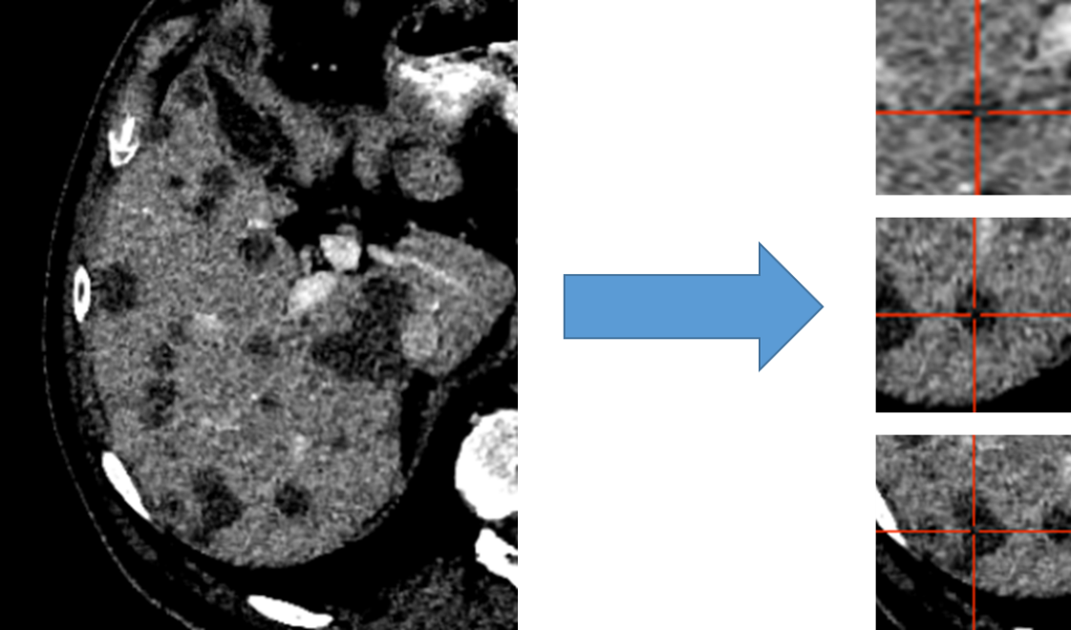
Figure 1: Liver distributed into individual cubes of 32x120x120. Disease was labeled as disease, regardless of the center of the cube. The validation and test set were not broken into cubes; our architectures accepted variable input sizes, with the entire liver being passed at once for evaluation and testing.
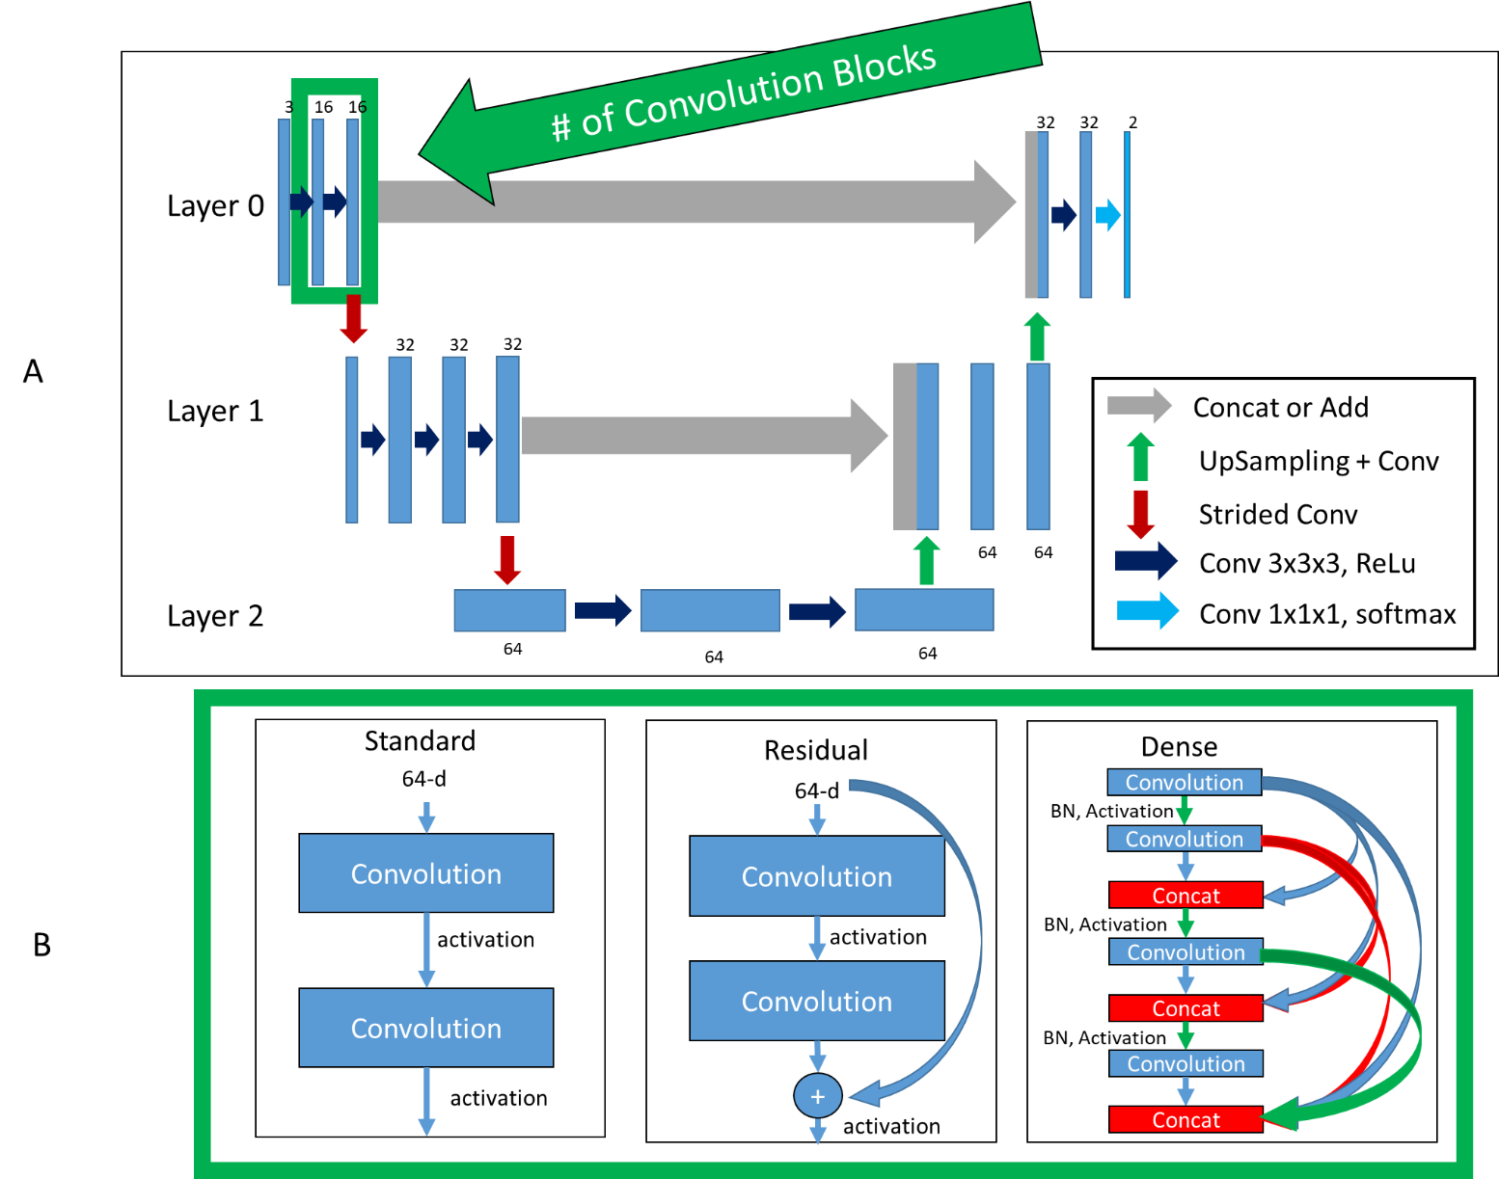
Figure 2: Top (A): Basic architecture framework. Bottom (B): Difference in convolution blocks, surrounded by green to indicate the same region in (A). Standard: previous feature maps are convolved and activated. Residual: previous feature maps are directly added to convolutional output in a skip-connection before activation. Dense: previous feature maps are continually concatenated together before activation and convolution. BN: batch normalization.
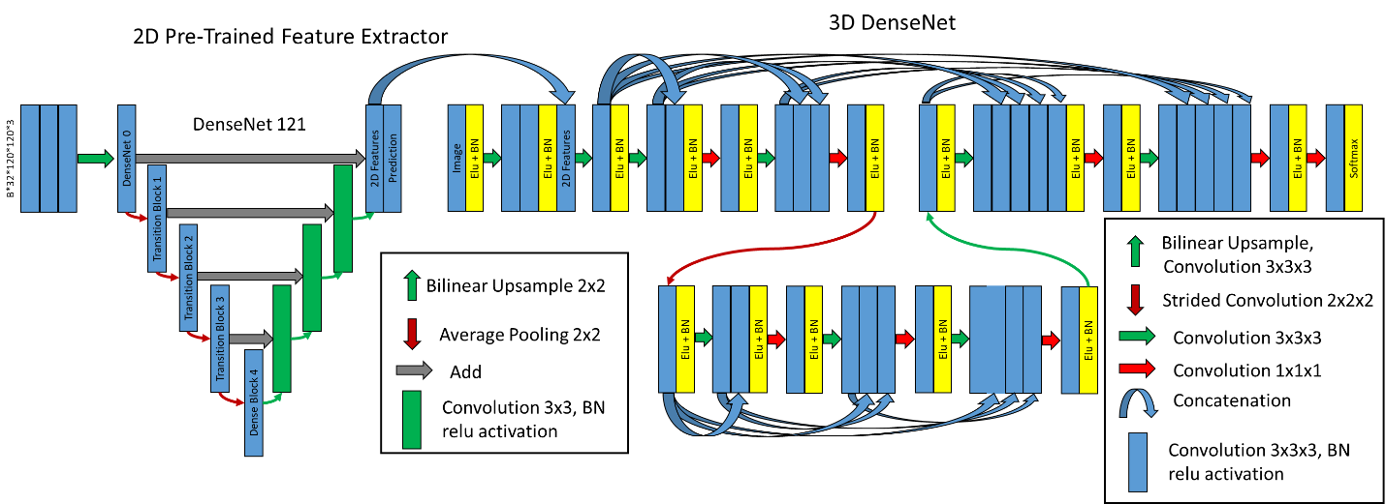
Figure 3: Hybrid-WNet. (Left) Pre-trained 2D DenseNet 121 converted into UNet, where final features, filters from 2D prediction are 32 and concatenated into 3D DenseNet. (Right) 3D DenseNet architecture was defined as two layers, two convolution blocks in layer 0, three convolution blocks in layer 1, and 8 initial filters. BN: Batch Normalization.

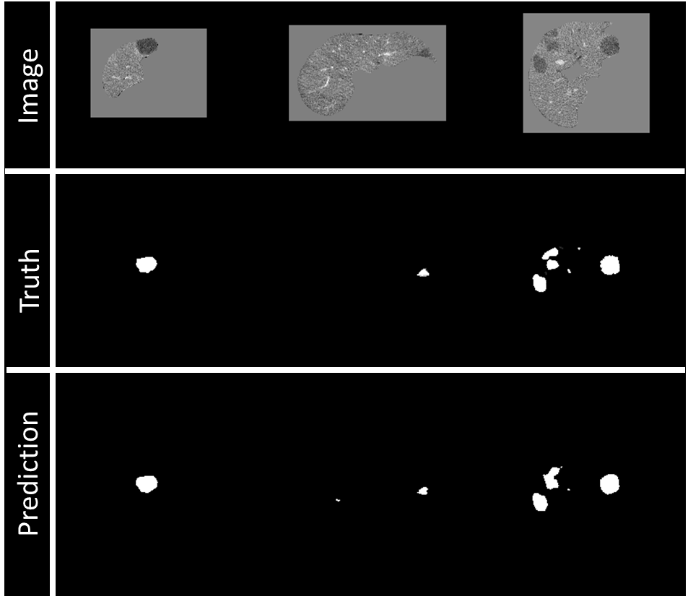
Figure 4: Example of visualization of prediction on validation data during training. Top row: Image being fed into the model, masked by the liver segmentation. Middle row: Ground truth of disease contours. Bottom row: Prediction of disease contours, set with a threshold of 0.5 to the binary mask.
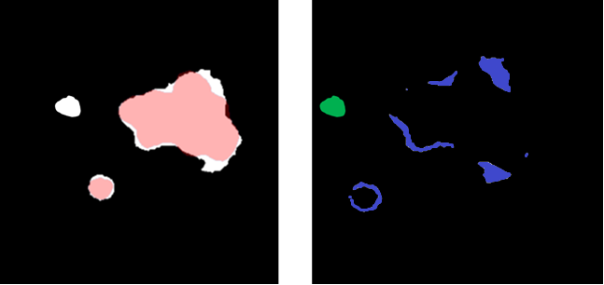
Figure 5: (Left) Overlay between predicted (white) and ground truth (red) disease segmentations. (Right) Subtraction of the predicted and ground truth disease segmentation and over-segmentation of the disease volume (blue) and unconnected erroneous false-positive region (green). The sum of blue and green is a false-positive volume.

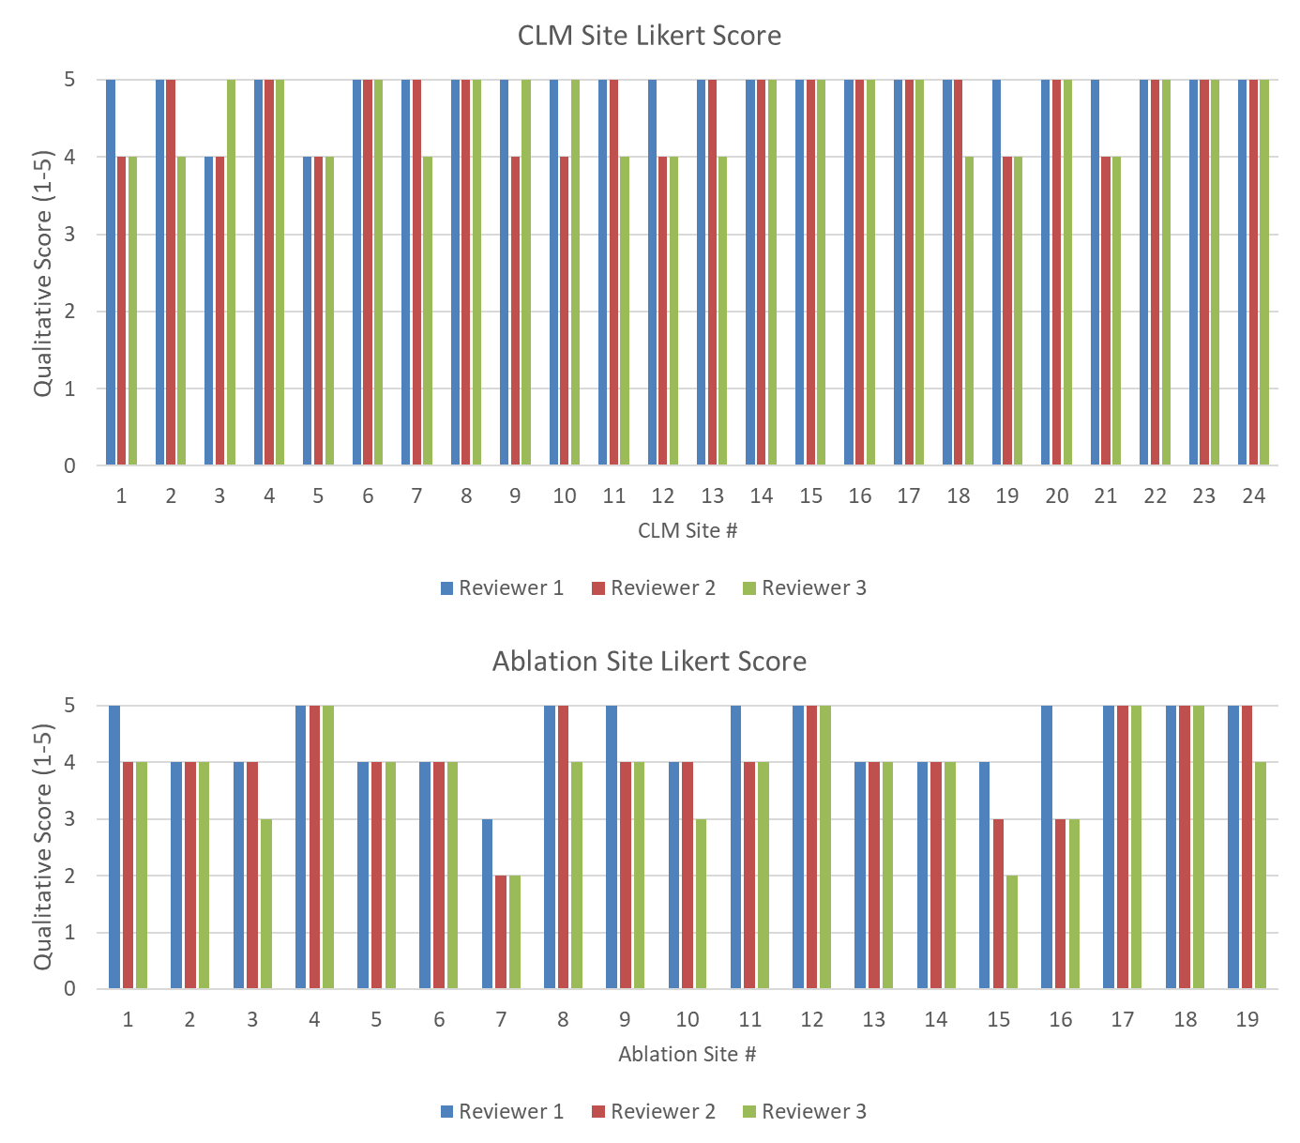
Figure 6: (Top) Likert score by each reviewer for each disease site. (Bottom) Likert score by each reviewer for each ablation site. A higher value is associated with higher quality.

