# Drawing template

Place your acrylic electron template face up on the table.

Place your clear plastic sheet on top and trace it entirely. Note where -x and -y are on the sheet

Place the traced plastic *face down* on the scanner. Cover it with a piece of white paper

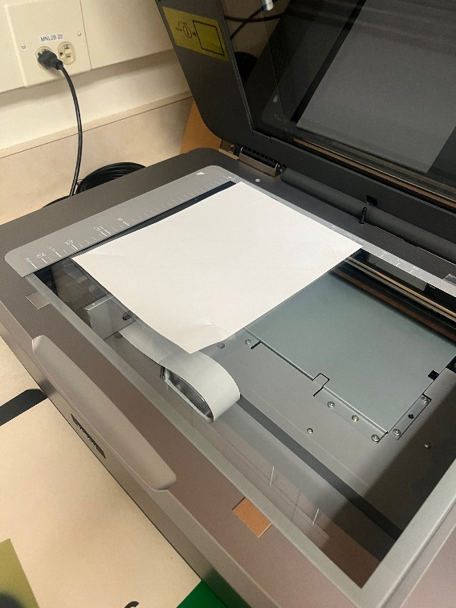

Preview the scan to make sure it looks okay

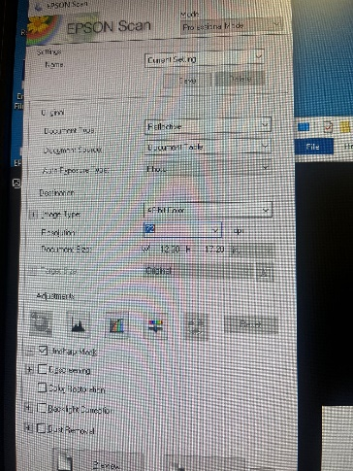

**Make sure to set resolution to 72 DPI**

### Save the image

Save the file as a .jpg image, uploading it to

\\vscifs1\physicsQAdata\UNC_ElectronCutout\*marker color*

Review the mask that is made and automatically

# Raystation Importing

Open Electron phantom

## Open the Template Plan

## Copy Plan

Make a copy of this plan by going to Plan design -> Copy plan

Name plan with First_Last_MM.DD.YYYY format

## Set Beam SSD

Beam SSD To Surface should be set to 95.5. This means that aperture is almost exactly on the surface of the phantom

## Clear previous ROI of ‘New’

Select ‘Patient modeling’ -> ‘New’ Target and Delete Geometry

## Import generated structure from scanner

Once the .jpg file has been made, it will automatically create a structure file.

Click the blue button in the upper left corner -> Import -> Import to current patient

Select ‘File’ and paste

\\vscifs1\PhysicsQAdata\UNC_ElectronCutout

## Measure comparison

Localize ‘New’ and use the measure tool to evaluate the dimensions of the structure.

# Create cutout from structure

Go to Plan Design -> Electron beam design -> Cutout

## Verify beam SSD!

Beam SSD should still be 95.5!

## Set Applicator

Applicator defaults to be 25x25, set it to the desired size

## Conform Cutout

Select conform cutout, cutout should conform to the ‘New’ structure

## Change SSD

Change the SSD to the desired SSD for treatment