# Abstract

In medicine, the integration and registration of multiple imaging modalities is often a crucial aspect of the diagnosis and treatment planning process. Often, these images are inherently registered, a useful feature in most cases, but possibly a hinderance when manual adjustments are required. To break this registration requires expert knowledge of file structure or specialized software, posing challenges and potential errors in changing other attributes in the process accidentally.

To address these issues, we present a novel tool designed to simplify the task of changing three often edited attributes: the frame of reference, the series instance unique identifier, and the study instance unique identifier. The tool features an intuitive user interface that empowers practitioners, regardless of their expertise, to effortlessly modify these three key attributes. By focusing on the most frequently edited parameters, our tool minimizes the risk of unintended alterations to other attributes, contributing to increased accuracy and reliability.

The program is written in C#, easily distributed via GitHub or Google drive and compatible with any Windows computer with .NET 4.8 (the standard as of 2023). This innovation holds promise for improving the overall workflow efficiency and safety within radiation oncology and radiology, where breaking the frame of refence or changing the series/study unique identifiers is a regular occurrence.

# Introduction

The Digital Imaging and Communications (DICOM) standard creates a technical protocol for the storage and transmission of medical images and helps facilitate communication between multiple vendors and technologies in medicine.

In radiotherapy clinics, there are often circumstances which require changing certain properties of the DICOM images. As a commonly seen case in stereotactic radiosurgery, all MRI images (T1, T2, FLAIR) acquired within the same study will have the same frame of reference, or ‘Frame of Reference Unique Identifier (UID)’. This is a feature based on the understanding that the images are acquired in the same location. Unfortunately, this also means that any motion which occurs between scans cannot be corrected, as both images share the same Frame of Reference UID. To ‘break’ this inherent registration, the DICOM value for Frame of Reference UID must be changed on each scan one wishes to register.

Changing any DICOM value often requires expert knowledge of the file structure, and specialized software, and is prone to error. Attributes can be modified unintentionally, or files can be corrupted and hard to recover. Commonly used software can modify a subset of DICOM file attributes. For example, MIM [ref] allows the user to anonymize DICOM and change certain attributes, but this also rewrites many other DICOM attributes such as the date time creation. Raystation [ref] has built-in functionality to assign an exam to a new frame of reference, but this is the only DICOM attribute that can be changed.

To address these gaps, we have created the Unlink program which provides a user friendly interface to change the commonly required DICOM attributes which are not readily or easily available in commercial software. The simple interface offers the option to change three potential values: the Frame of Reference, Series Instance UID, and/or Study Instance UID. Users can specify which modality they would like to change and use the built-in unzip/unzip and run if files need to be extracted before being changed. This program, built in C#, is designed to run on any Windows based computer and is publicly available at [www.GitHub.com/BrianMAnderson/Unzip_Unlink_CSharp](http://www.GitHub.com/BrianMAnderson/Unzip_Unlink_CSharp).

# Materials and Methods

The program was written using C#[ref] and .NET framework 4.8, the current .NET standard at time of creation (2023). All DICOM manipulation was facilitated with the FellowOak DICOM package [ref] and SimpleITK[ref]. The main splash screen is shown in Figure 1.

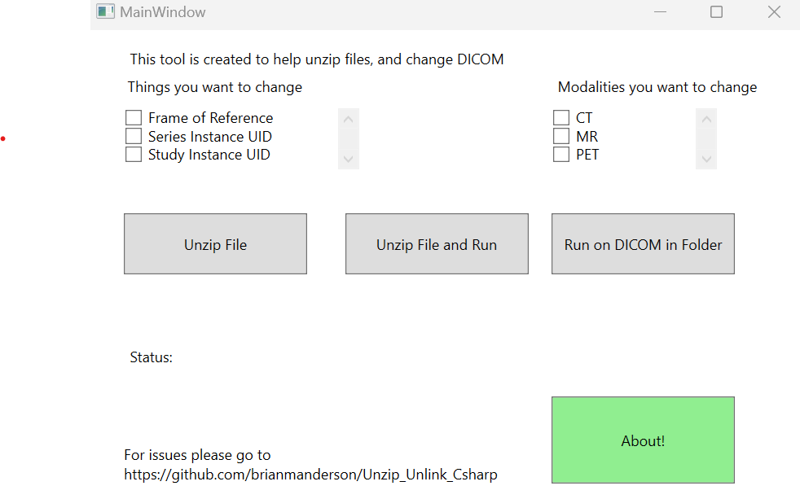

Figure 1: Main splash screen of the program. There are three check boxes of DICOM attributes that can be changed in the top left and three checkboxes for Modalities to change in the top right.

Users can select any or all the options in the upper left: Frame of Reference, Series Instance UID, and Study Instance UID, as well as specify which modalities they would like to change: CT, 4DCT, MR, and/or PET images.

### Why is 4DCT special?

An additional option for 4DCT was added because of the special nature of a 4DCT. Often, a free-breathing scan *and* 4DCT are acquired at the same time. If the user wishes to change the frame of reference UID for the 4DCT, we need to create a unique frame of reference UID that is still consistent across all phases of the 4DCT.

## Changing Attributes

The program runs in two main steps. First, the program groups all files based on their unique Series Instance UIDs and modalities within the selected folder. Second, based on the attributes selected, the files associated with each Series Instance UID are changed and the DICOM files are overwritten. When the 4DCT option is selected, any CT with the same frame of reference UID will be given a new, consistent frame of reference UID. This means that if the user wishes to break the inherent registration between a free-breathing scan and a 4DCT they will need to run the program on *either the 4DCT or the free breathing scan*.

*Note that this requires the DICOM files to be in a folder accessible to the computer, outside of the treatment planning system.*

A visual representation of the entire workflow can be seen in Figure 2. Green bars beneath the ‘Status’ symbol give real-time feedback of the updating process. Depending on network speed, changing the attributes of a 125 slice CT scan took 10 seconds.

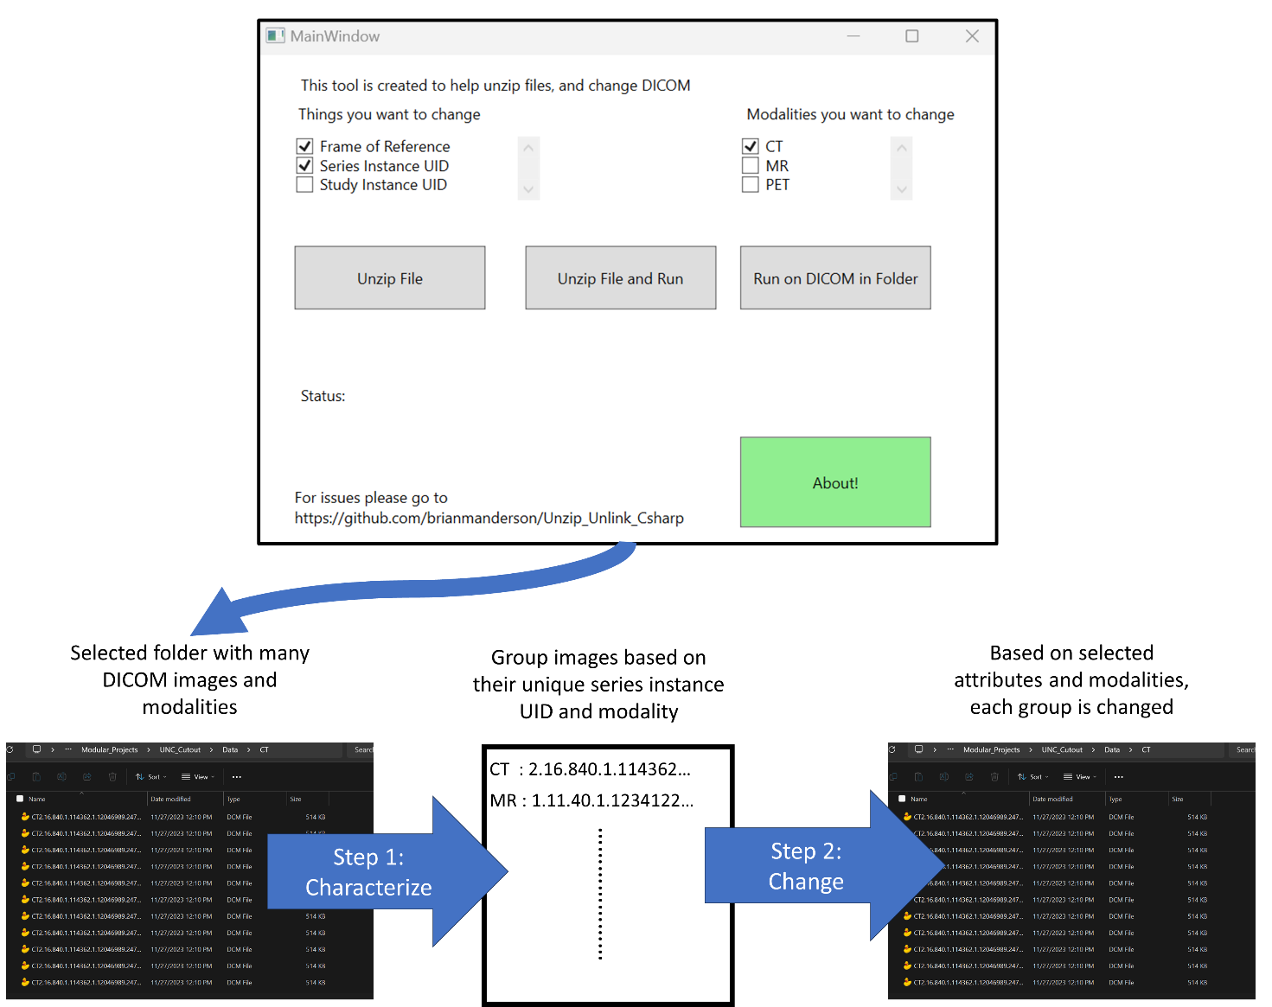

Figure 2: Graphical workflow of program

## Installation

The solution can be downloaded directly GitHub, or the pre-built executable can be downloaded and installed from [link to google drive].

# Discussion

The program does require to be run on a Windows computer. There is concern that institutional internet security division (ISD) may prevent the downloading of this program. Within our institution we were able to circumnavigate this issue by placing the program on a network drive location which was accessible to the team.

# Conclusion

The program presented here represents an easy, user-friendly method of changing three commonly changed DICOM attributes with a vendor agnostic solution. We have implemented this solution within two clinics: [redacted] and [redacted] with positive feedback from the physics and dosimetry teams. The program is freely available and open for input from the community via GitHub, allowing future updates and improvements as requested.

# Acknowledgements

The authors would like to thank ???[xxx]

# References

Refs