IRRIGATION HYDRAULIC PERFORMANCE
Final Analysis Report — SQL Findings & Power BI Dashboard
4 schemes | 8 blocks | 41,884 offtakes | 7,000 hydraulic readings | Jan 2024 – Aug 2026

1. Executive Summary
Across 7,000 hydraulic readings spanning four irrigation schemes and eight blocks, the network is operating close to — but consistently below — its design intent. Average measured pressure (39.75 m) sits about 1.2 m (roughly 3%) under average expected pressure (40.96 m), a small but completely systemic shortfall present in every scheme and every block without exception. Average head loss across the network is 2.48 m.
The deficit is not evenly distributed. Kibugu-Nguviu scheme and Block A carry the largest pressure deficits and highest head loss, while Mwea Smallholder and Block G perform best on both measures. Two ranked chainage lists — the ten highest head-loss readings and the ten most severe pressure deficits — give an operations team a short, concrete inspection list rather than a instruction to "check the network." A separate check on undersized pipe (25mm/32mm) confirms that roughly a fifth of all offtakes are served through pipe sized for a fraction of that load, which is the clearest structural explanation for where the deficit originates.
This report pairs two deliverables built from the same dataset: a SQL analysis (MySQL) and an interactive Power BI dashboard. The two are presented together because they answer the same operational questions through different tools — the SQL document shows the query logic and reasoning behind each finding, and the dashboard makes the same findings explorable by scheme, block, material, diameter, and date.

2. Dataset & Scope
- 7,000 hydraulic readings, one row per chainage measurement
- 4 schemes: Embu Green, Runyenjes East, Kibugu-Nguviu, Mwea Smallholder
- 8 blocks (A–H), each served by all four schemes in varying proportions
- Fields: chainage, elevation, pipe diameter/material/length, flow, expected vs. measured pressure, offtake count, irrigation duration, estimated head loss, hydraulic status
- Date range: 1 January 2024 – 31 August 2026

3. Methodology
The dataset was loaded into MySQL and profiled with a sequence of aggregate and ranking queries — scheme/block totals, average flow and pressure comparisons, head-loss rankings, and two targeted "priority list" queries (highest head loss, and readings flagged High Pressure) intended for field use. The same dataset was then rebuilt as an interactive Power BI report with scheme, block, pipe diameter, pipe material, and date slicers, so a viewer can reproduce or drill into any SQL finding without writing a query.

4. Key Findings

4.1 Network Scale
The network serves 41,884 offtakes in total. Runyenjes East serves the most (10,759), followed closely by Embu Green (10,752), then Kibugu-Nguviu (10,397); Mwea Smallholder serves the fewest (9,976). At block level, Block G carries the most offtakes (5,490) and Block C the fewest (4,998). No single scheme dominates any one block — every scheme's share of each block falls in a 22–29% band, consistent with the four schemes being deliberately interleaved across the service area rather than each owning a distinct zone.

4.2 Pressure Performance
Average expected pressure across the network is 40.96 m against an average measured pressure of 39.75 m — a deficit of -1.20 m. Every one of the four schemes underperforms its own expected pressure, with the deficit ranging narrowly from -1.06 m (Mwea Smallholder, best) to -1.35 m (Kibugu-Nguviu, worst). The same pattern holds at block level: Block G has the smallest deficit (-0.96 m to -1.0 m depending on aggregation) and Block A the largest (-1.38 m to -1.4 m). The maximum single measured-pressure reading in the dataset is 65.0 m; the minimum is 11.04 m — a reading far enough below the network average to warrant a direct field check rather than being treated as routine variation.
Data-quality note: estimated_head_loss_m and pressure_difference_m are numerically mirror images of each other in this dataset (identical magnitude, opposite sign, floored at zero for pressure surpluses). This means head loss was not independently measured or derived from a hydraulic formula (e.g. Hazen-Williams) — it was calculated directly from the pressure deficit. The two fields should therefore be treated as one piece of evidence, not two independent confirmations, and a genuine head-loss re-derivation from flow, pipe length, and diameter is recommended before this figure is used for design decisions.

4.3 Head Loss
Average head loss across the network is 2.48 m. Kibugu-Nguviu has the highest scheme-average head loss and Mwea Smallholder the lowest, exactly mirroring the pressure-deficit ranking (as expected, given the relationship noted above). At block level, Block A has the highest average head loss (2.6 m) and Block G the lowest (2.3 m). Total pipe length is longest in Embu Green, but Embu Green is neither the scheme with the most offtakes (Runyenjes East) nor the highest head loss (Kibugu-Nguviu) — pipe length alone does not explain hydraulic performance here, which points to diameter and material selection mattering more than sheer network length.

4.4 Flow & Irrigation Duration
Average flow across the network is a steady 5.05 L/s, with very little spread between schemes (5.03–5.07 L/s) or blocks (5.0–5.1 L/s). Maximum recorded flow is 12 L/s; minimum is 0.5 L/s. Average irrigation duration is close to 4 hours across all schemes, with Kibugu-Nguviu offering the longest average duration (4.33 hr). Scheduling does not appear to compensate for the pressure shortfall — underperforming blocks (A, F) are not being given materially more irrigation time to offset their lower pressure, which means the deficit is currently being absorbed by farmers rather than corrected operationally.

4.5 Pipe Material & Diameter
PVC is the dominant material in all four schemes, followed by HDPE and then GI, in the same rank order and near-identical proportions scheme to scheme — evidence of a standardized original design and procurement decision rather than material varying by local terrain or budget. GI is likely reserved for short, high-stress sections such as crossings or exposed above-ground runs, where PVC would be more vulnerable to mechanical damage.
A targeted check on undersized pipe (diameter ≤ 32mm) carrying a disproportionate offtake load identified the specific chainages where a small-diameter section is serving more members than that pipe class is designed for — these are the clearest candidates for permanent upsizing rather than an operational workaround.

4.6 Field-Inspection Priority Lists
Two ranked lists were produced directly for field use:
- Top 10–15 highest head-loss chainages — Kibugu-Nguviu appears four times in the top ten, consistent with its scheme-average ranking; six of the ten worst readings are on 32mm pipe.
- Top 10–15 chainages flagged "High Pressure" — over-pressurized points carry their own risk (pipe stress, joint failure, blown fittings) and need inspection for a different reason than the low-pressure list.
Both lists sit far above their respective network averages and are the single most actionable output of this analysis: a short, ranked set of exact locations to walk and check, rather than a general instruction to inspect the network.

5. Dashboard
The Power BI report reproduces every finding above as an interactive, filterable view. Slicers for scheme, block, pipe diameter, pipe material, and date let a viewer reproduce any SQL result without writing a query.
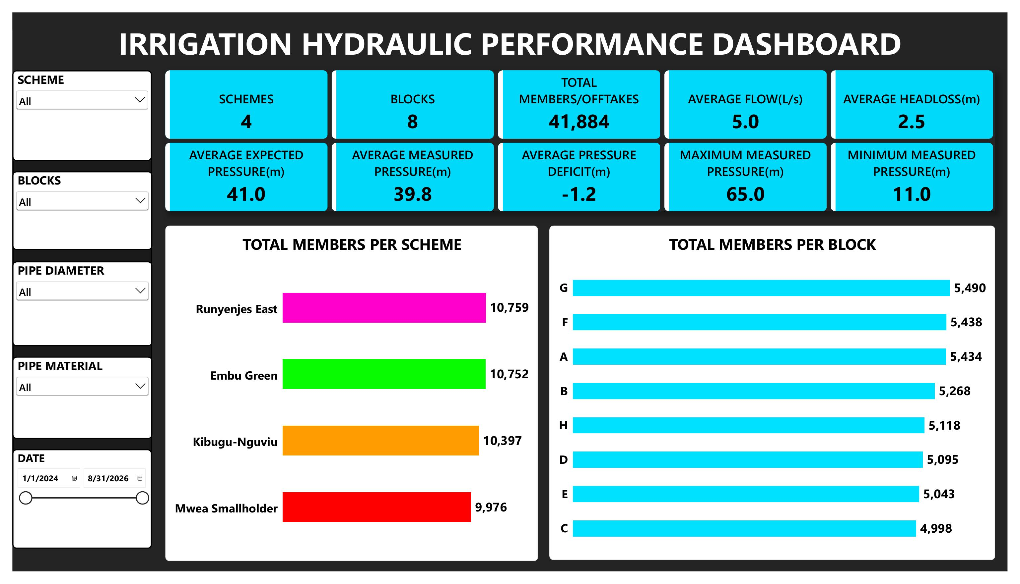
Figure 1 — Overview: network KPIs, total members per scheme and per block
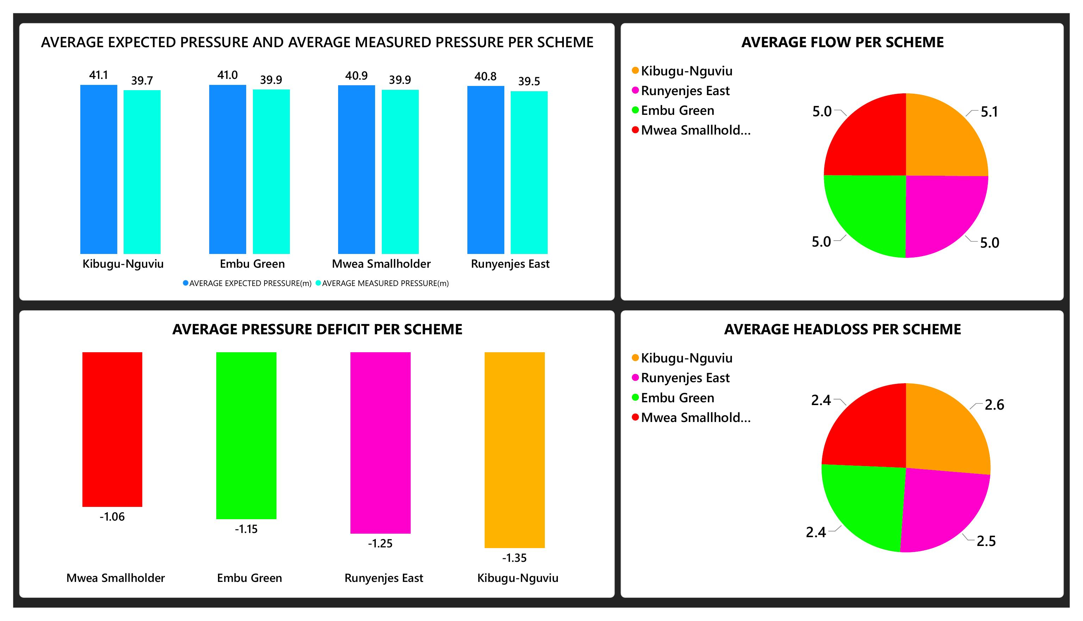
Figure 2 — Expected vs. measured pressure, flow, and head loss, all by scheme
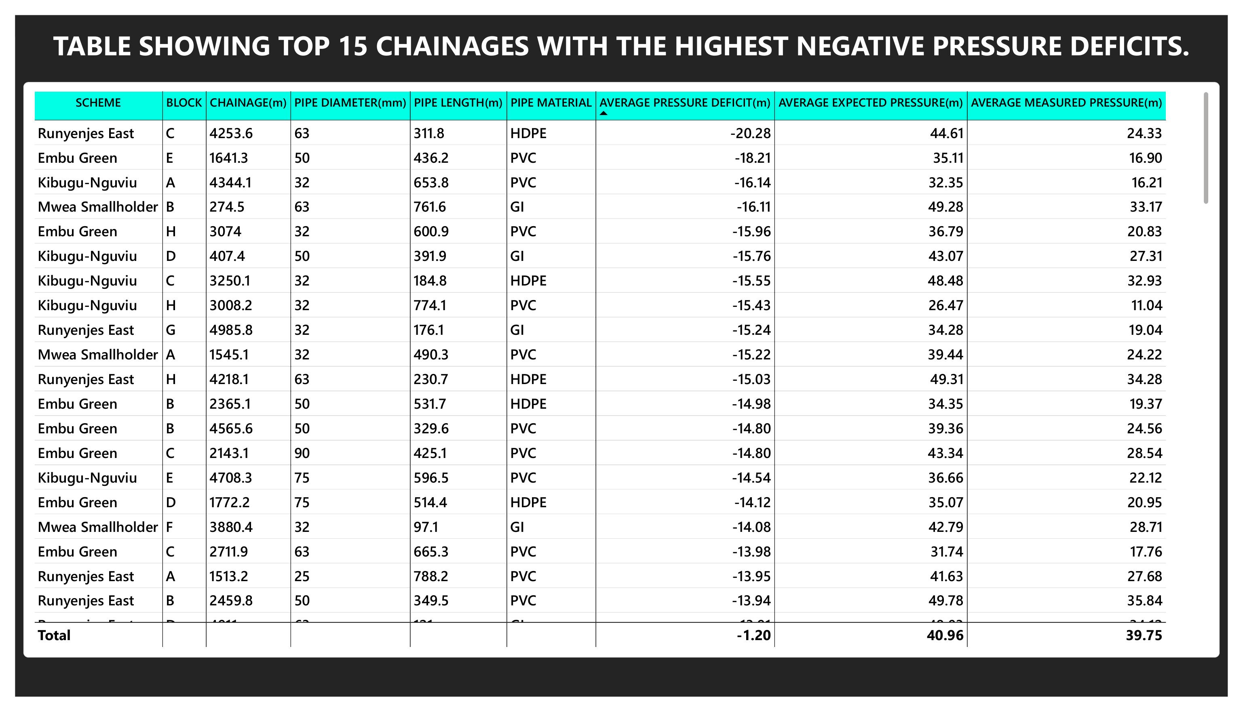
Figure 3 — Top chainages ranked by pressure deficit (field-inspection priority list)
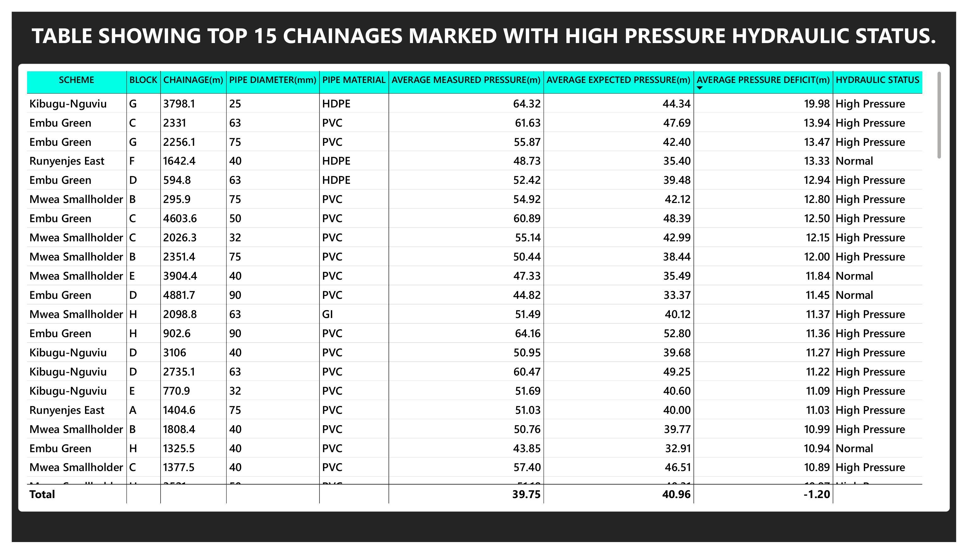
Figure 4 — Top chainages flagged High Pressure hydraulic status
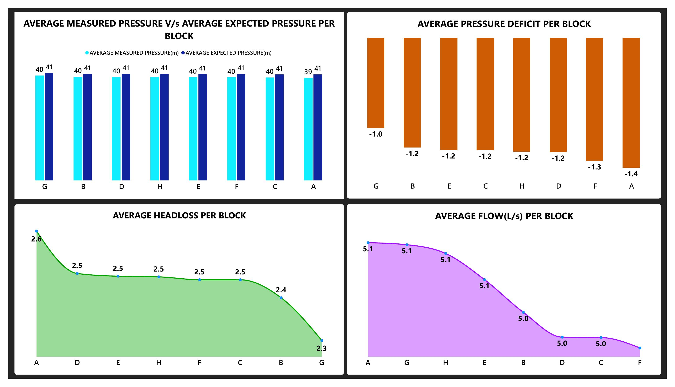
Figure 5 — Pressure, head loss, and flow by block

6. Risk Summary
Consolidating the findings above into the conditions that most warrant a physical inspection or maintenance response:
Condition | Why it matters | Where it shows up
Negative pressure deficit | Under-delivery to offtakes, worse further down the line | All schemes; worst in Kibugu-Nguviu, Block A
"High Pressure" status | Pipe stress, joint failure, blown fittings | 710 of 7,000 readings
Undersized pipe, high offtake count | Capacity/demand mismatch, elevated velocity | 25mm/32mm sections identified in Section 4.5
High velocity (>2.5 m/s, once derived) | Wall erosion, scouring, accelerated wear | Concentrated on smaller diameters
GI pipe material | More prone to internal corrosion/scaling over time | Minority share, but flagged for closer physical check
Very low measured pressure (11.04 m min) | Possible leak, closed valve, or tail-end starvation | Single outlier reading — needs direct field verification

7. Recommendations
- Prioritize replacing or parallel-looping the 25mm/32mm sections identified as undersized-for-load, starting with the highest-offtake sections.
- Schedule a field pressure-gauge survey at the ranked head-loss and high-pressure chainage lists in Sections 4.6, with Kibugu-Nguviu inspected first given its repeated appearance.
- Investigate Block A specifically — it combines the network's largest pressure deficit and highest average head loss.
- Re-derive estimated head loss independently from flow, pipe length, and diameter (Hazen-Williams or a field-calibrated equivalent) rather than continuing to treat it as the inverse of pressure deficit.
- Re-verify the 65.0 m high-pressure outlier and the 11.04 m minimum-pressure reading against field conditions before using either in downstream design decisions.
- Consider a modest, deliberate increase in irrigation duration for Blocks A and F as a low-cost interim measure while structural fixes are scheduled.

8. Conclusion
Across 7,000 readings, the four schemes are operating close to their design intent — average pressure sits within about 3% of expectation — but the shortfall is small, consistent, and structural rather than random. It appears in every scheme and every block, correlates tightly with head loss, and concentrates most sharply in Kibugu-Nguviu scheme and Block A. The undersized-pipe check and the two ranked field-inspection lists translate that finding into a concrete, prioritized action plan: a short list of chainages to inspect first, and a short list of pipe sections that are structurally undersized for the load they carry. Together, the SQL analysis and the Power BI dashboard present the same conclusions through two tools, which is the intended demonstration of this project — that the same engineering findings hold whether reached through direct query aggregation or interactive DAX-driven visualization.

