WATER QUALITY ANALYSIS REPORT
Monitoring results across five stations, 2023–2024

Prepared by: Brian Mbae Mwarania
Tools: MySQL (SQL analysis), Power BI (dashboard), Python (validation and extended analysis)
Data: 300 water samples · 5 stations · 5 regions · 1 January 2023 – 31 December 2024

1. Executive Summary
This report consolidates the SQL analysis, the Power BI dashboard and the underlying dataset for 300 water samples collected from five stations along a supply chain: river intake, reservoir, treatment plant outlet, distribution main and consumer tap. Each sample is tested for 11 parameters and checked against WHO-style pass/fail rules for pH, turbidity, nitrate and coliform.
Headline findings
- Treatment works. Between the river intake (Station A) and the treatment outlet (Station C), mean coliform falls from 230.5 to 2.0 CFU/100 mL (99.1%), turbidity from 45.9 to 0.86 NTU (98.1%) and nitrate from 7.57 to 1.36 mg/L (82%).
- But almost no treated sample is potable. Only 20 of the 187 treated samples (10.7%) pass the coliform rule, and those 20 are the only potable samples in the dataset. Every treated sample passes the pH, turbidity and nitrate checks, so coliform is the single reason for non-potability.
- Water quality deteriorates after the plant. Mean coliform rises from 2.03 (outlet) to 4.00 (distribution main) to 7.29 (consumer tap), while mean chlorine falls from 1.03 to 0.69 to 0.53 mg/L. Differences between the three treated stations are statistically significant (Kruskal–Wallis p < 0.001).
- Raw sources are the risk hotspot. Station A fails the WHO coliform and turbidity checks in all 56 samples, and fails the nitrate check in 17 of 56 (30%). Station B fails coliform in all 57 samples and turbidity in 56 of 57.
- Seasonal and year-to-year patterns are weak. Monthly averages in the dashboard look volatile, but they are not statistically significant once station mix is accounted for (Section 6). Do not present them as seasonality.

2. Data and Method
The dataset has 300 rows and 21 columns, with no missing values and unique Sample IDs. Samples were spread across two years (155 in 2023 and 145 in 2024) and across five stations (56 to 65 samples each). Each station maps to exactly one region, so station and region carry the same information.
Station | Region | Role | Samples
A – River Intake | North | Raw source | 56
B – Reservoir | East | Raw source | 57
C – Treatment Plant Outlet | South | Treated | 61
D – Distribution Main | West | Treated | 61
E – Consumer Tap | Central | Treated | 65

Analysis workflow: (1) SQL queries in MySQL for KPIs, station, year and month comparisons and WHO pass/fail counts; (2) a Power BI dashboard visualizing the same measures with station, region and date slicers; (3) Python (pandas, SciPy) to validate SQL and dashboard figures against the raw CSV and to run the extended tests in Section 7. All headline figures in the SQL file and dashboard reconcile exactly with the CSV.

3. Core KPIs
Parameter | Overall average | Parameter | Overall average
Samples tested | 300 | Nitrate | 3.43 mg/L
Stations | 5 | BOD | 2.07 mg/L
pH | 7.44 | Total coliform | 65.80 CFU/100 mL
Hardness | 207.06 mg/L | Chlorine | 0.49 mg/L
Dissolved oxygen | 8.14 mg/L | Temperature | 19.21 °C
Turbidity | 12.35 NTU | Conductivity | 359.60 µS/cm

Overall averages hide the structure of the data. Raw and treated stations are very different populations, so a blended figure such as 65.8 CFU/100 mL coliform describes no real station. The station-level results below are more meaningful.

4. Station-Level Analysis
Each SQL query groups by station and region and orders by the average, which returns the highest and lowest station for each parameter.
SELECT Station_Name, Region, ROUND(AVG(Total_Coliform_CFU_100mL),2) AS Average_Total_Coliform
FROM water_quality_dataset GROUP BY 1,2 ORDER BY 3 DESC;
Parameter | A Intake | B Reservoir | C Outlet | D Main | E Tap
Coliform (CFU/100 mL) | 230.48 | 105.11 | 2.03 | 4.00 | 7.29
Turbidity (NTU) | 45.93 | 15.87 | 0.86 | 1.01 | 1.76
Nitrate (mg/L) | 7.57 | 4.23 | 1.36 | 1.98 | 2.46
BOD (mg/L) | 2.96 | 2.31 | 1.68 | 1.76 | 1.74
Conductivity (µS/cm) | 513.42 | 376.90 | 281.90 | 313.36 | 328.21
Chlorine (mg/L) | 0.10 | 0.05 | 1.03 | 0.69 | 0.53
Dissolved oxygen (mg/L) | 8.22 | 9.57 | 7.98 | 7.70 | 7.39
Hardness (mg/L) | 195.72 | 213.69 | 192.28 | 205.59 | 226.27
pH | 7.43 | 7.57 | 7.36 | 7.45 | 7.40
Temperature (°C) | 19.88 | 18.47 | 18.57 | 18.74 | 20.32

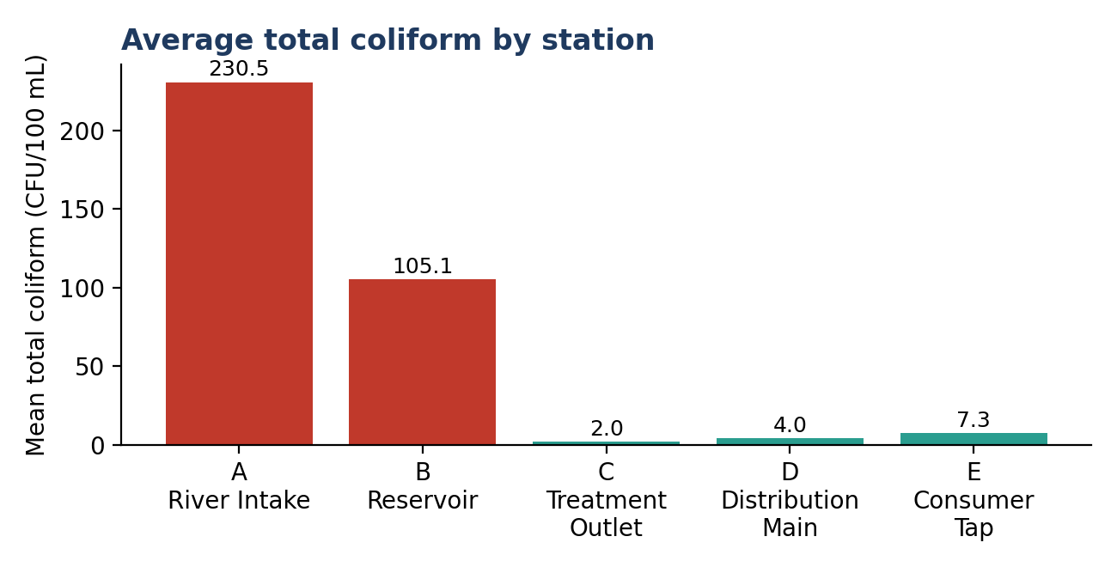
Figure 1. Average total coliform by station (red = raw source, teal = treated).

Interpretation
- Contamination indicators are highest at the river intake: coliform, turbidity, nitrate, BOD and conductivity are all highest at Station A, consistent with surface-water runoff and organic or agricultural loading. Station B is an intermediate raw source (partial settling in the reservoir).
- Treatment effect is large and broad. Station C has the lowest turbidity, coliform, nitrate, BOD and conductivity, and the highest chlorine (1.03 mg/L), which is expected at the point of dosing.
- Station E has the highest hardness and temperature and the lowest dissolved oxygen. Consumer-tap water is warmer and sits longer in the network, and this is also where coliform is highest among treated stations.
- pH is essentially uniform (7.36 to 7.57), with all 300 samples inside the 6.5 to 8.5 range. Hardness does not differ significantly between stations (p = 0.18), so it is not a useful discriminator.
- Caution: because each region contains only one station, statements such as “North recorded the highest turbidity” are the same finding as “Station A recorded the highest turbidity.” Regional conclusions should not be drawn from this dataset.

5. WHO Compliance and Potability
Station | Coliform pass | Coliform fail | Turbidity pass | Nitrate pass | pH pass | Potable (YES)
A – River Intake | 0 | 56 | 0 | 39 | 56 | n/a (raw)
B – Reservoir | 0 | 57 | 1 | 57 | 57 | n/a (raw)
C – Treatment Outlet | 8 | 53 | 61 | 61 | 61 | 8 (13.1%)
D – Distribution Main | 7 | 54 | 61 | 61 | 61 | 7 (11.5%)
E – Consumer Tap | 5 | 60 | 65 | 65 | 65 | 5 (7.7%)
Total | 20 | 280 | 188 | 283 | 300 | 20

SELECT Station_Name,
COUNT(CASE WHEN Overall_Potable='YES' THEN 'Y' END) AS POTABLE,
COUNT(CASE WHEN Overall_Potable='NO' THEN 'N' END) AS NOT_POTABLE,
COUNT(CASE WHEN Overall_Potable='N/A (Raw Source)' THEN 'R' END) AS RAW_WATER
FROM water_quality_dataset GROUP BY 1 ORDER BY 2 DESC;

Interpretation
- Potability is only assessed for the treated stations (C, D, E): 20 samples are potable, 167 are not, and 113 raw-source samples are marked not applicable.
- The potable flag is identical to the coliform pass flag. Every sample that passes coliform is potable, and none that fails is. Potability in this dataset is therefore driven entirely by coliform, which uses a zero-tolerance rule (pass = 0 CFU/100 mL).
- Nitrate is a problem only at the river intake (17 fails, all between 10.3 and 15.0 mg/L). Turbidity fails at both raw stations; one Station B sample (2.87 NTU on 4 September 2023) passed.

6. Yearly and Seasonal Patterns

6.1 Year-on-year
Parameter | 2023 | 2024 | Change
Total coliform (CFU/100 mL) | 81.42 | 49.10 | −39.7%
Turbidity (NTU) | 14.65 | 9.89 | −32.5%
Nitrate (mg/L) | 3.74 | 3.09 | −17.4%
Conductivity (µS/cm) | 381.27 | 336.43 | −11.8%
BOD (mg/L) | 2.15 | 1.98 | −7.9%
Dissolved oxygen (mg/L) | 8.22 | 8.06 | −1.9%
pH | 7.46 | 7.41 | −0.7%
Chlorine (mg/L) | 0.46 | 0.52 | +13.0%
Hardness (mg/L) | 204.02 | 210.31 | +3.1%
Temperature (°C) | 19.09 | 19.33 | +1.3%

2024 looks cleaner on most contamination measures, but the evidence is weak. Mann–Whitney tests give p = 0.060 for coliform, 0.083 for turbidity and 0.072 for nitrate, all above the usual 0.05 threshold. Only conductivity and TDS (p ≈ 0.04) cross it, and that is marginal with ten parameters tested. Within stations the movement is mixed: for example coliform at Station A fell from 246 to 202 while at Station D it rose from 3.5 to 4.5. The fair conclusion is “possible improvement, not confirmed.”

6.2 Monthly pattern: a data-validity warning
The dashboard shows large month-to-month swings, for example average coliform of 94.7 in September against 31.0 in November, and turbidity of 4.7 in November against 16.8 in August. These should not be read as seasonality, for two reasons:
- Sample mix changes by month. With only 300 samples, each month holds only 18 to 32 samples, and the share taken from the dirty raw stations varies a lot (for instance November has just 1 Station A sample, October has 5 from A and 10 from B). A month with more river-intake samples will show high coliform regardless of season.
- The tests agree. Coliform does not vary significantly by month (Kruskal–Wallis p = 0.81 raw, 0.39 after removing station means); turbidity p = 0.64 raw, 0.28 adjusted; nitrate p = 0.95 and BOD p = 0.74. Conductivity is marginal when raw (p = 0.03) and not significant once station is controlled for (p = 0.09).
Recommendation for the dashboard: add a note to the monthly visuals, or show monthly averages per station, to stop viewers inferring a seasonal cycle that the data do not support.

7. Extended Analysis

7.1 Where does potability fail? Coliform in treated water
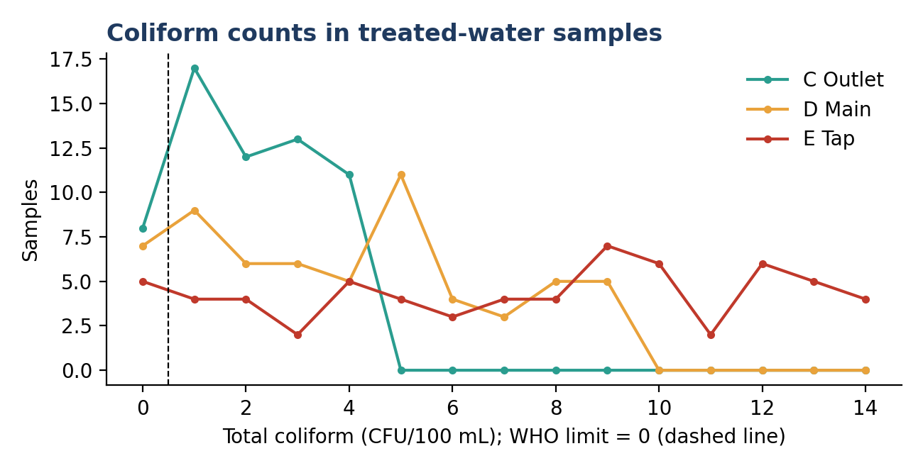
Figure 2. Distribution of coliform counts in treated samples (C, D, E).
Treated-water coliform counts are small in absolute terms (maximum 4 at Station C, 9 at D and 14 at E), but the rule allows none. Only 20 of 187 samples record zero, and counts of 1 to 5 CFU/100 mL account for 109 samples. Station E’s average (7.29) is 3.6 times Station C’s (2.03), and the gap between C and E is significant (Mann–Whitney p < 0.001).

7.2 Disinfectant residual
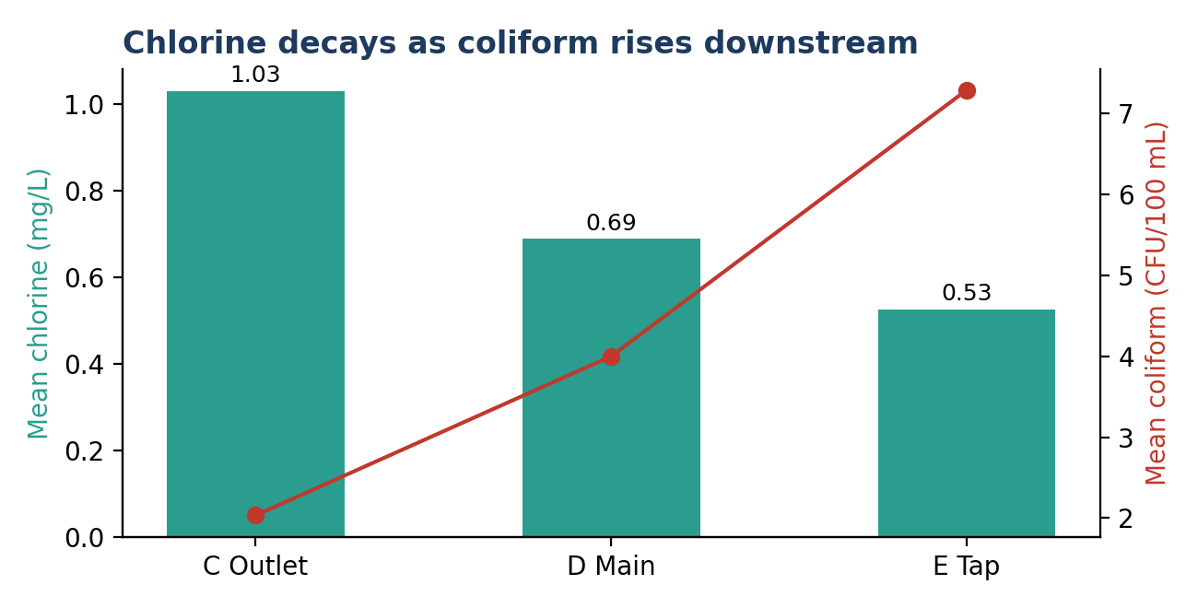
Figure 3. Mean chlorine and coliform along the treated stations.
- Chlorine halves between the outlet (1.03 mg/L) and the tap (0.53 mg/L). At Station E, 12.3% of samples have a residual below 0.2 mg/L, a level commonly treated as the minimum for maintaining protection in the network. Stations C and D have none below it.
- Within each treated station, chlorine is not significantly correlated with coliform (Spearman p = 0.08, 0.89 and 0.65 for C, D, E). The overall relationship (ρ = −0.74) is driven by the raw-versus-treated split and must not be read as proof that more chlorine lowers coliform at a given station. The 8 samples below 0.2 mg/L did show none passing, but that sample is too small to conclude from.

7.3 Treatment-train removal efficiency
Parameter | Intake (A) | Outlet (C) | Reduction
Total coliform | 230.48 | 2.03 | 99.1%
Turbidity | 45.93 | 0.86 | 98.1%
Nitrate | 7.57 | 1.36 | 82.0%
BOD | 2.96 | 1.68 | 43.2%
Conductivity | 513.42 | 281.90 | 45.1%

7.4 Which parameters move together?
Across all samples, coliform correlates strongly with turbidity (ρ = 0.76), nitrate (0.56) and BOD (0.48), and negatively with chlorine (−0.74). Turbidity is therefore a useful low-cost early-warning proxy for microbial risk at the raw stations. Conductivity and TDS are almost perfectly correlated (ρ = 1.00; TDS ≈ 0.67 × conductivity), so one of them is redundant in a dashboard. pH, hardness and temperature are essentially unrelated to contamination.

8. Data Quality and Methodology Notes
- Synthetic-looking thresholds. The data show clean cut-offs: turbidity PASS ≤ 3 NTU (all fails ≥ 4.0), nitrate PASS < 10 mg/L and coliform PASS = 0. The turbidity limit is stricter than the WHO guideline of 5 NTU. If the dataset is illustrative or synthetic, findings demonstrate the method rather than real-world conditions.
- WHO pH check has no variation. All 300 samples pass, so the pass/fail query carries no information and sorting it by the fail column (order by 3) is arbitrary.
- Raw-source samples have no potability verdict, so “potable” percentages should use the 187 treated samples as the denominator, not 300.
- Column naming in SQL: the file mixes Total_Coliform_CFU_100mL and Total_Coliform_CFU_100ml, and Temperature rather than Temperature_C. MySQL ignores case, but a consistent schema is cleaner for portfolio review.
- Year and month columns. Some queries use the Year and Month_name columns and others use YEAR(Date). Both give the same result, but standardizing on one is tidier.
- Small samples. Station-month cells contain 1 to 10 samples. Conclusions at that level would be unreliable.

9. Recommendations
- Prioritise network protection over plant upgrades. Plant performance is strong; the loss of quality occurs after Station C. Investigate distribution-main and service-connection integrity, storage and dead-end flushing, and biofilm or cross-connection risk.
- Raise and hold chlorine residual through the network. Consider booster chlorination before the distribution main or in the consumer zone, with a target residual at the tap that keeps the minimum above 0.2 mg/L.
- Investigate the zero-coliform requirement. With counts of 1 to 14 CFU/100 mL, check for sampling contamination, lab method limits and whether repeat sampling confirms the detections, before concluding that 90% of treated water is unsafe.
- Manage raw-water risk at source. Nitrate above 10 mg/L at the river intake in 30% of samples points to catchment or agricultural inputs; consider catchment controls and intake-level monitoring, and turbidity-triggered treatment adjustments.
- Use turbidity as an operational early-warning indicator for raw water, given its strong link to coliform.
- Improve the sampling design. Collect balanced samples per station per month (for example 4 to 5 per station per month) so that seasonal analysis is valid, and add rainfall and flow data to test the runoff hypothesis.
- Dashboard changes. Split KPIs into raw and treated groups, replace blended averages with station-level views, add a potability rate per station and a chlorine-residual compliance card, and annotate monthly charts with sample counts.

10. Limitations
The dataset has 300 samples over two years and one sampling point per station, so it cannot separate station from region or establish cause. Correlations are associational. Tests are run on the data as given, without adjustment for multiple comparisons, and the thresholds used by the dataset’s pass/fail columns have been taken as supplied.

Appendix A. SQL Query Catalogue
Section | What the queries answer | Output
Core KPIs | Sample count, distinct stations and regions, average of each of the 11 parameters | Single-value queries
Station and region charts | Highest and lowest station and region for each parameter | 10 grouped queries
Yearly analysis | Highest and lowest year per parameter (2023 vs 2024) | 10 queries
Seasonal pattern | Monthly averages for 2023 and 2024 separately | 20 queries
WHO compliance | Pass/fail counts per station for coliform, turbidity, nitrate and pH | 4 queries
Potability | Potable, not potable and raw-source counts per station | 1 query

