Registration & Beneficiary Data Interoperability
  - South Sudan Workshop
Location: Juba, South Sudan (in-person)
Date: 19th November 2025
Time: 09:00 – 15:00 CAT (6 hours)
Location: Imperial Plaza Hotel, Juba
Organizer: IOM
Supported by: European Commission’s Humanitarian Office (ECHO)
 Note
Thank you to everyone who joined the workshop. The analysis presented is available here. The workshop report will be circulated shortly.

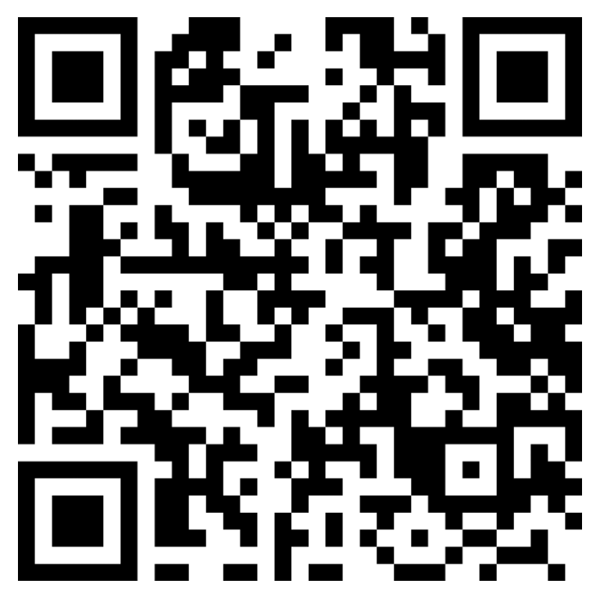

1 Background
The humanitarian community in South Sudan faces significant challenges related to beneficiary registration and data management. Current systems operate largely in silos, leading to inefficient referrals, duplicated beneficiary lists, inconsistent vulnerability criteria, and limited data sharing capabilities. These issues prevent effective coordination and increase the burden on crisis-affected populations who often must register multiple times with different organizations.
The Interoperable Data Ecosystem for Humanitarian Assistance (IDEHA) initiative seeks to address these challenges by promoting standardization, interoperability, and shared resources across humanitarian actors. Building on the mapping exercises and consultations conducted in the third quarter of 2025, this workshop aims to move from analysis to action initiating development of practical tools and frameworks for improved registration data interoperability.

2 Objectives
The workshop aims to:
- Present findings from recent assessments of registration practices, data sharing patterns, and system capabilities among humanitarian actors in South Sudan
- Build consensus around common registration standards and data sharing protocols
- Begin co-design of practical tools including a Single Registration Form and a Data Protection Impact Assessment template.
- Explore the possible establishment of a Task Force on registration data interoperability
- Foster collaboration and commitment among humanitarian actors toward a federated approach to beneficiary data management

3 Expected Outcomes
By the end of the workshop, participants will have:
- Shared understanding of the current state of registration practices and data sharing in South Sudan
- Initiated drafting of a Single Registration Form incorporating common data points across organizations
- Identify main component of a Data Protection Impact Assessment (DPIA) template tailored to the South Sudan context
- Decision or roadmap regarding the establishment of a Task Force on registration data interoperability
- Increased awareness of available beneficiary management tools and their interoperability capabilities
- Commitment to next steps in the improvement of interoperability

4 Target Audience
Primary Participants (Approx 30 people):
Technical registration and information management staff from UN agencies, INGOs, and NGOs implementing cash and voucher assistance or other humanitarian programs in South Sudan
Program Managers for Cash programs.
Cluster coordinators
Data protection and legal officers from humanitarian organizations

5 Agenda

5.1 Arrival
08:30 – 09:00 | Arrival, Registration and Networking (30 minutes)
- Participant registration and coffee

5.2 Opening
09:00 – 09:30 | Opening (30 minutes)
- Welcome remarks
- Introduction to the data interoperability challenge and overview of workshop objectives
- CCD and DIGID recap

5.3 Session 1
09:30 – 11:00 | Survey Findings (90 minutes)

5.3.1 Presentation 1: Current Practices (40 minutes)
- Registration Actors Survey Findings
- Current registration practices, standards, and gaps
- Q&A (10 min)

5.3.2 Breakout 1: (40 minutes)
Groups working on the following questions:
- What does an ideal humanitarian registration and beneficiary data ecosystem look like.
- What are the biggest challenges organizations face when doing registration and managing data.
- How impacts would a ideal registration ecosystem have on your own organizations work and the response as a whole?

5.3.3 Plenary summary (10 minutes)

5.4 Coffee break
11:00 – 11:30 | Coffee break (30 minutes)
Tea, coffee and light snacks.

5.5 Session 2
11:30 – 13:00 | Interoperability (90 minutes)

5.5.1 Presentation 2: (30 minutes)
- Data Sharing Agreement network graph
- Analysis of Registration Form Data Point Overlaps
- Q&A (5 min)

5.5.2 Breakout 2: Working sessions (45 minutes)
- Group A: Data Protection Impact Assessment group
- Group B: Standardization group
- Group C: Data governance group

5.5.3 Report to plenary (15 min)
5 minutes per group to present their ideas and plans

5.6 Lunch break
13:00 – 14:00 | Lunch (60 minutes)

5.7 Plenary discussion
14:00 – 14:45 | Recap, discussion & next steps (45 minutes)
- Recap of group findings
- Discussion of proposed next steps
- Summary of agreements and commitments
- Timeline for key actions

5.8 Closing
14:45 – 15:00 | Closing (15 minutes)
- Closing remarks

6 Methodology
The workshop will employ participatory and collaborative methodologies including:
- Presentation of evidence-based findings
- Small group working sessions with structured facilitation
- Plenary discussions and consensus-building
- Hands-on tool demonstrations
- Action-oriented planning
- All sessions will be facilitated to ensure inclusive participation and practical outputs.

7 Contact
For any questions related to the workshop, please contact:
- Daniel HILLAIRE - dhilaire@iom.int
- Benson MBOGANI - BMbogani@iom.int
- Brian MC DONALD - bmcdonald@iom.int
Send Email

This workshop is co-funded by the European Commission’s Humanitarian Office (ECHO).
