**Application Running on Docker**

* This has only been tested on Linux, but should work on Windows & Mac OS.

1. Install Docker & Docker Compose
   * <https://docs.docker.com/engine/install/>
2. Clone the git repository with the voting-app project

git clone https://github.com/brianmorel99/voting-app-bjm.git

1. Change into the project directory

cd voting-app-bjm

1. Run the below command to start all containers.

docker compose up

[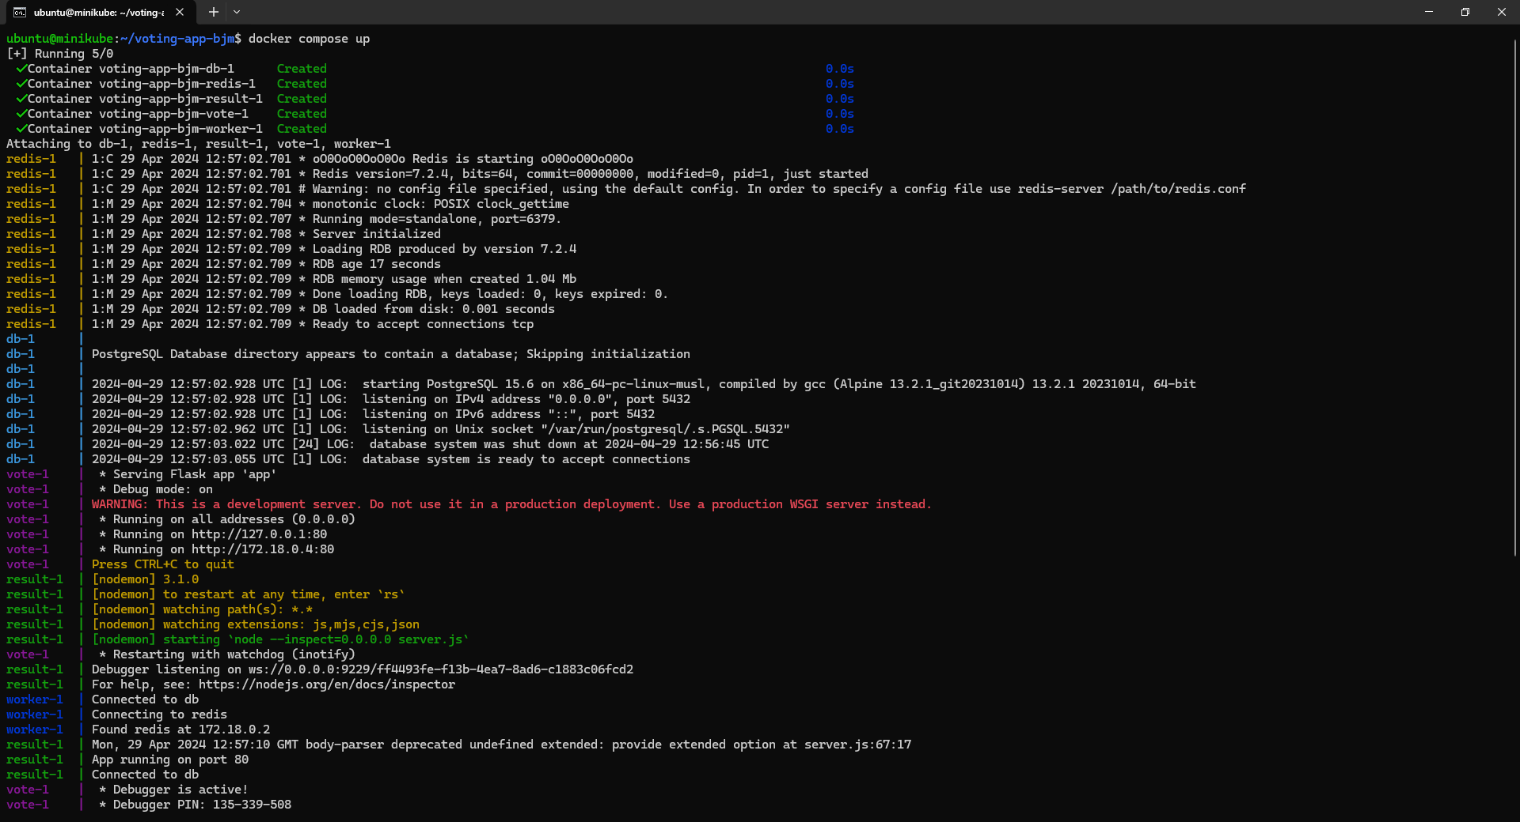](https://github.com/brianmorel99/voting-app-bjm/blob/19cf4501ee31d5e2365cae9f99b05104de05bdac/docs/images/docker-1.PNG)

1. Open a web browser and navigate to the below address to see the vote page
   * ([http://localhost:5000](http://localhost:5000/))

[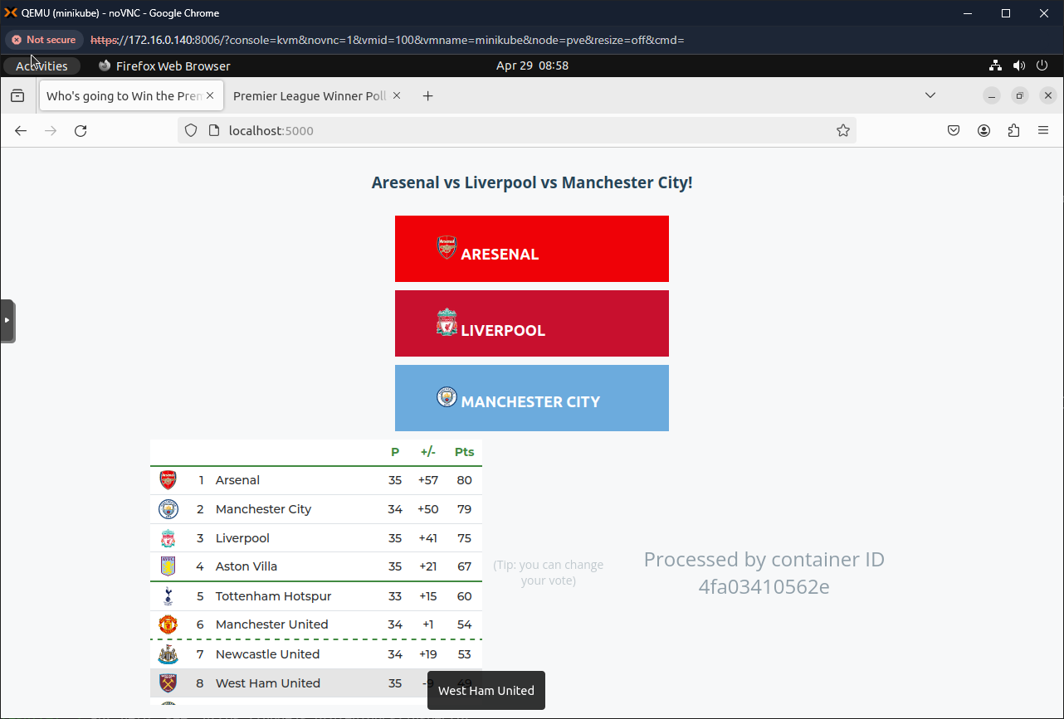](https://github.com/brianmorel99/voting-app-bjm/blob/19cf4501ee31d5e2365cae9f99b05104de05bdac/docs/images/docker-2.PNG)

1. Navigate to the below address to see the results page
   * ([http://localhost:5000](http://localhost:5000/))

[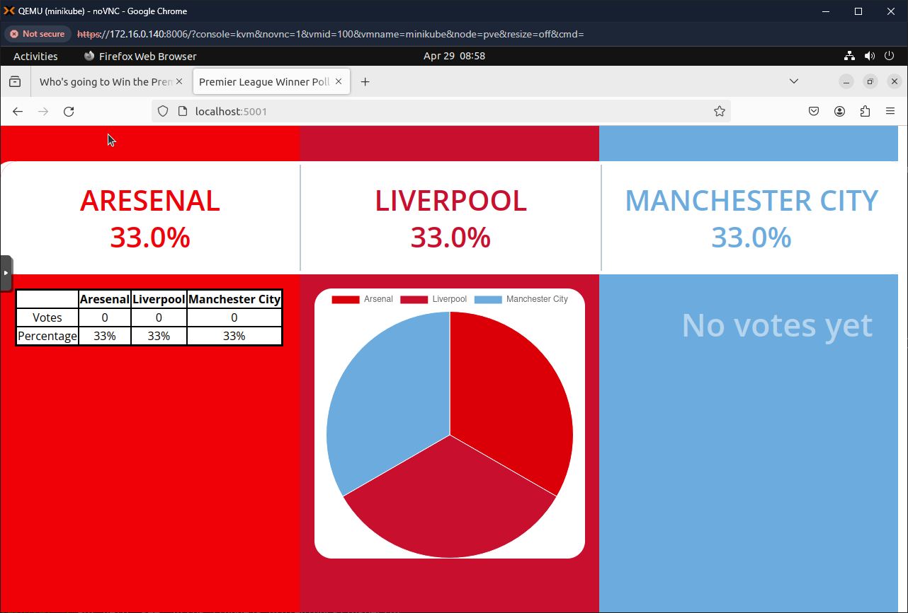](https://github.com/brianmorel99/voting-app-bjm/blob/19cf4501ee31d5e2365cae9f99b05104de05bdac/docs/images/docker-3.PNG)

**Cleanup**

1. Run the below command to shut down the docker containers.

docker compose down