Introduction

My site is going to be based on a local pizzeria that has an outdated and lousy looking website. I plan on adding a pleasant and modern look that allows the user to place online orders directly from the site. It will have a sleek design where you can access an interactive cart that updates and displays items.

UI Design/Prototype

I included a basic outline of the website, and I will probably make changes as I start to create it. I want this site to have a more simplistic look, but it should be appealing and have features such as an order (from the site) option, a cart display, and a navbar.

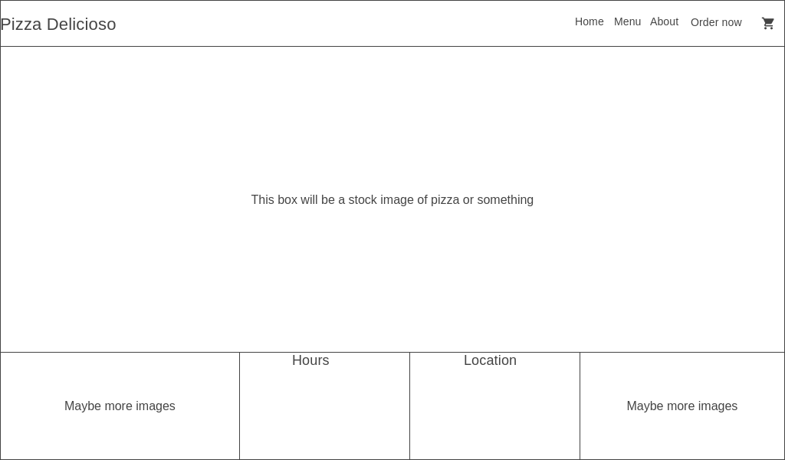

Navigation Structure

The site will be designed in a way to draw attention, and it will be easily navigable whether on mobile or desktop. The most important feature will be the order placing and cart display. Ideally when a user accesses this site, they are either checking out the menu, scrolling down to see the location, or placing an order.

References

<https://wireframe.cc/>