**Student Name:**

**Student ID:**

**Unit Code:** COM710

**Unit Title:** Web Technologies

# Introduction

A dynamic website mainly consists of a front and back end. The two sides are essential in ensuring that the website handles user requests appropriately, and facilitates transmission of data from database. The primary languages used in developing such websites are HTML, CSS, and JavaScript for the front-end, and NodeJS for server-side depending on the database type and the nature of the back-end. The following is a documentation highlighting the procedures, techniques and guidelines used to develop a website for Solent technology Conference. The website’s function is to display information about the conference and to help users view and manipulate speakers that are to present their research in the event. The website front-side uses EJS for templating, with basic html used to display the various elements. Additionally, the website can be accessed locally as it is served at 127.0.0.1:5000.

# Evidence that website meets the website’s requirements

The website views use hyper text markup language (HTML) tags and a cascading styling sheet to display the layouts. The HTML tags in the website are for creating the structure of the website while the custom styling sheet is used to enhance the appearance of the website, by adding styles such as colour, typography, images, and transitions to the website. EJS is used for templating of the views. Additionally, NodeJS is used for the server-side scripting of the website. Express is used as the object relational mapper for the website, and for routing purposes. The website makes use of SQLite as its database as specified. The database contains a table that contains details about the speakers to present in the event. The database schema contains a speakers table which contains five columns, namely, ID, name, title, about, and workplace.

The ID column is the primary key that uniquely identifies the speakers, name column specifies the speakers name, while title, about, and workplace columns identify the speaker’s research title, a description of the speaker, and where the speaker works respectively. There are various routes linked to certain views that help users to manipulate the speakers table. The database functions are all serialized to ensure that they take place in the correct order as specified. The user can create, retrieve, update, and delete speakers information using certain views, following which the database is updated and user redirected appropriately. The various CRUD operations are made possible by the application programming interface (API) that is written in the index.js file in the root of the project. As mentioned, express is used extensively in the back-end to facilitate routing as specified in the API endpoints. The following are screenshots of the various pages in the website as specified, and a code snippet confirming 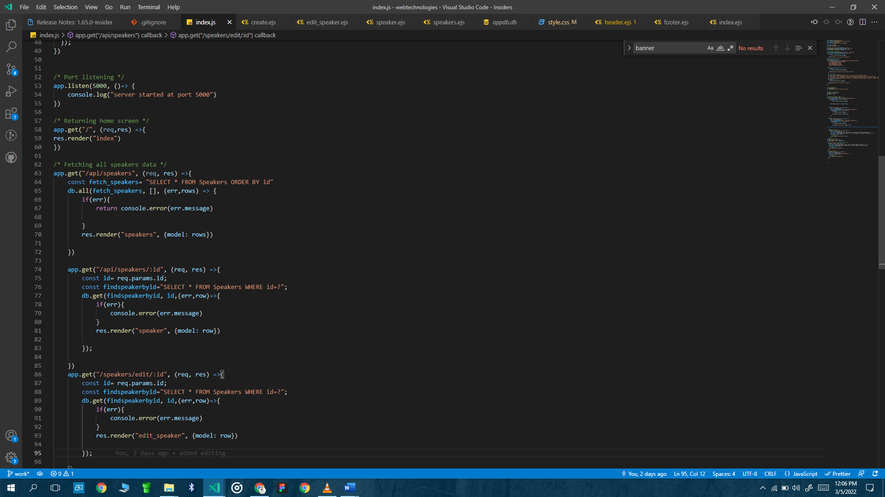requirements adherence.

Figure Code snippet

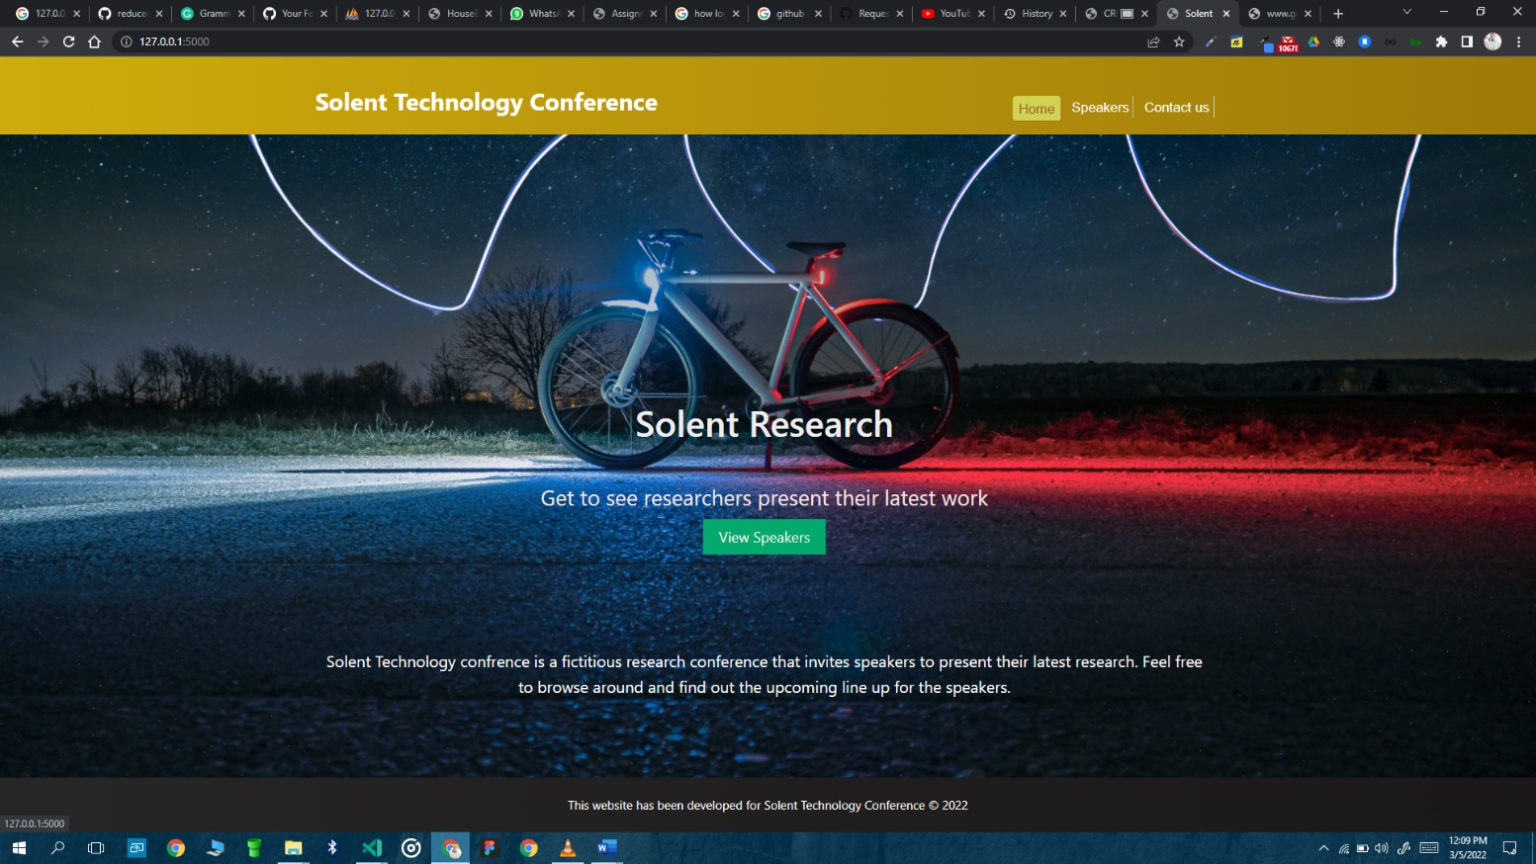

Figure Website's home page

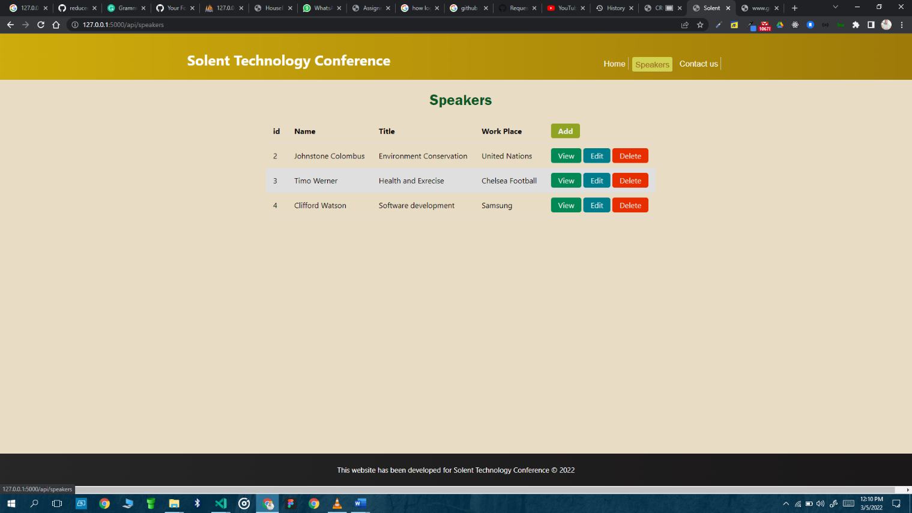

Figure Speakers screen ( /speakers)

This screen represents the GET speakers/ route where a list of all available speakers is displayed on a table.

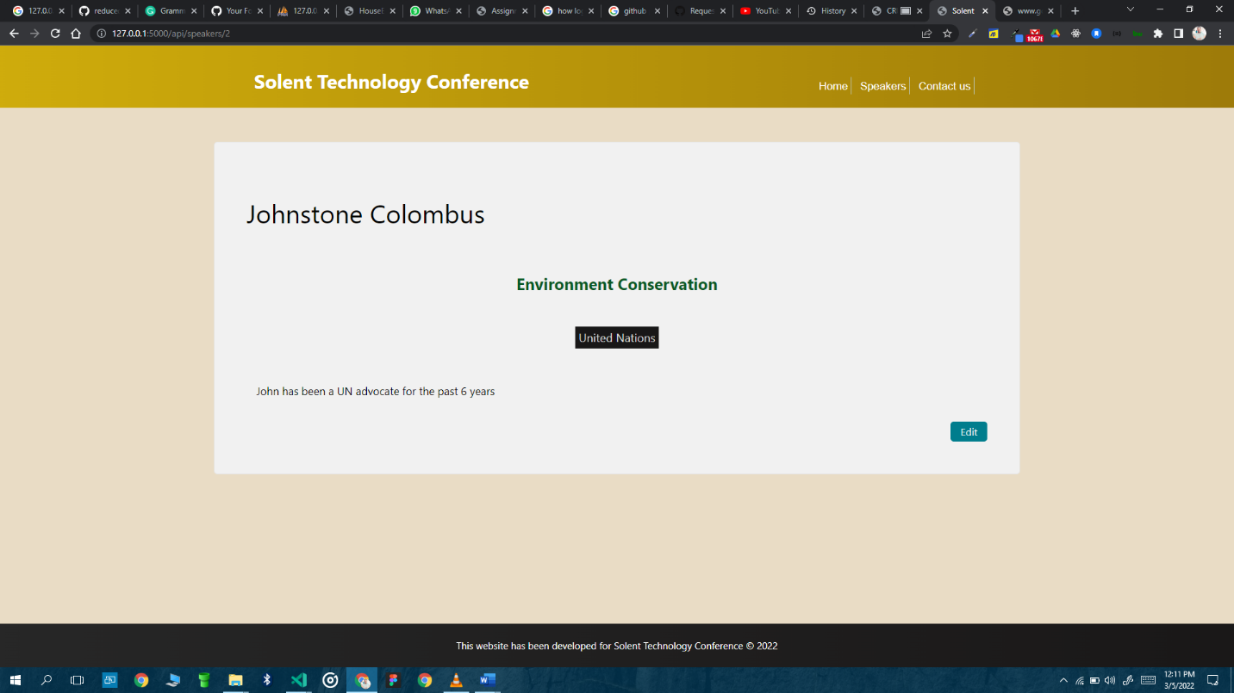

Figure view speakers screen

This page represents the Get speakers/:id route where one can view the details about the speaker.

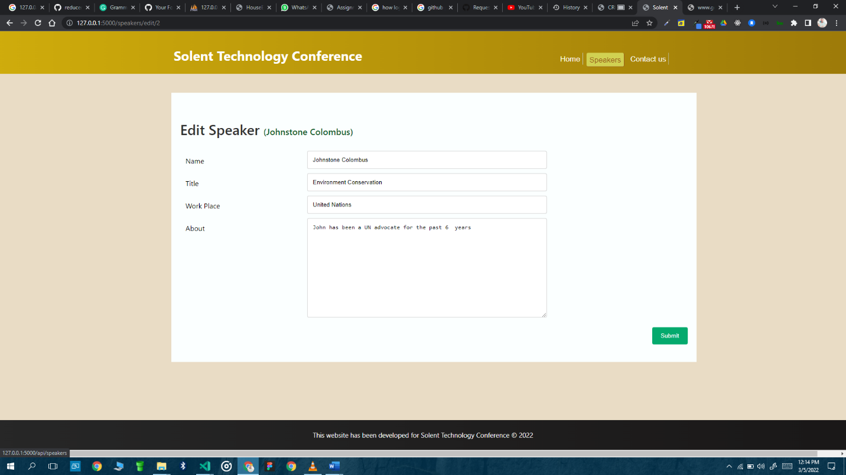

Figure Edit speaker

The above screen represents the edit screen of the /speakers/edit/:id route where a user can update the records of a speaker.

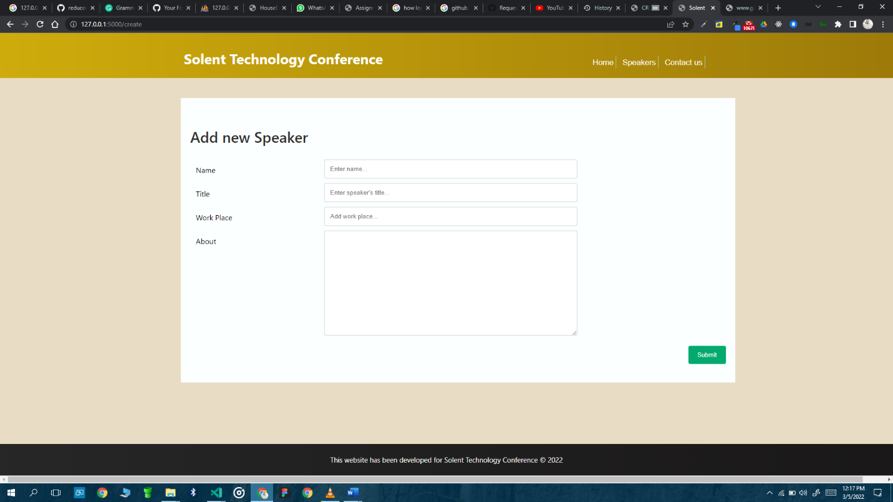

Figure Add new speaker

The above screen shows the add new screen with a form to aid in adding a new speaker.

# Proof that the website conforms to W3C standards

The world wide web consortium dubbed W3C is a community consisting of members and organizations globally aimed at standardizing web design practices to promote consistency and accessibility despite the location, and physical capabilities. The standards and guidelines proposed by W3C are good and it is advised that web developer follow them as they detail web development best practices. The Solent Technology Conference website has employed the proposed guidelines of web application development to ensure the website is accessible to all devises and people globally.

The website used cascading style sheets that describe how different elements are to appear on different devices by using media queries. The website is therefore responsive, and can provide the same functionality in desktop screens, tablets, and mobile devices. Additionally, the website makes use of html 5 which is highly recommended by the world wide web consortium, thus promoting uniformity in web development. Additionally, the websites uses a combination of fonts to ensure that there are fallback fonts depending on the users device, internet connectivity, and available fonts in the users’ browsers. This guideline ensures that the website is displayed in each users’ devices as specified by the developer. The following font-families have been used for all text elements in the website.

font-family: 'Segoe UI', Tahoma, Geneva, Verdana, sans-serif;

Moreover, the website has ensured that there is separation of concerns by having the styling sheets linked from an external file as opposed to inline styling as mentioned in the W3C standards. This separation of concern ensures that is easy to maintain the website, share styling sheet code among multiple views, and ensure that different pages are tailored to different environments. Additionally, the website uses asynchronous programming for server-side scripting which allows for non-blocking during execution of requests as proposed in the W3C standards. The web site also considers mobile users in its design with pages such as home and speakers screen designed mobile first. Due to above mentioned factors, it can be established that the Solent Technology Conference website conforms to the W3C standards. Failure to follow these standards brings about a website that is not accessible well by all users using different devices, and browsers, creating a challenge for users, therefore chasing away possible users or customers.

# Legal and Ethical Considerations

## Accessibility

The Solent Technology website is designed to allow accessibility to anybody despite their location, device, and internet connectivity. Accessibility ensures inclusiveness in access to a website to all persons despite their challenges physically or technologically, for instance bandwidth. The website ensures this through a number of ways, for instance, each page contains proper heading tags to help ensure there is context in every page, and that users can know exactly where they are in the website and what is expected of them. Additionally, the color used on the website are user friendly. The website makes use of warm colors to bring about a welcoming and joyful feeling to its users.

In addition, the forms used in the website are user friendly and are designed for accessibility. The forms make use of labels and placeholders to help users fill them with ease. Moreover, the forms are designed with consistency in mind with the submit buttons placed on the bottom right of each form to enable users learn and gain familiarity with the website easily. Besides the forms, the website also makes use of distinct links that are within the context of the conference and are descriptive.

Moreover, the website uses large enough fonts which are easily readable for any users. The typography of texts and headings contrast nicely with the color scheme of the website to allow users to read without struggle or glare. In addition, the fonts used are available in most browsers eliminating the need to download the fonts in case of poor internet connection. The website also makes use of contrasting buttons to help every user easily understand the meaning of each button. For instance, the delete buttons have a red background to indicate danger and the add button have a green background for success. This color coding helps every users including the not so computer literate understand the meaning behind them.

## Legal Considerations

The Solent Technology Conference website has ensured that it adheres to legal requirements in the internet. For instance, the website does not use any images that are subject to copyright or licensed images from the internet. Additionally, the website does not use any unique name, or symbol that has been trademarked by another entity. Additionally, the website does not make use of any names belonging to real people as stated in the requirements to avoid defamation. There is no page linked to another trade marked website illegally. Moreover, the website does not use any cookies that illegally check users’ activity in the site since the site is currently hosted locally. However, if it were to go live, cookies would be carefully set, and permission to allow them asked before use.

## Security Consideration

The website does no require any authentication since the information available presently is available publicly to all users. Therefore, the website has no authorization and authentication checks. The various requests used in the website are http, however when the website is live, they will be switched to https to ensure a more secure encryption during data transmission. Additionally, the form fields contain validation to ensure there is no injection of malicious code. The forms are also equipped with means to prevent cross-site request forgery.

# Version Control