First part of the project process was following the “L293D: pinout” figure of the instruction module.

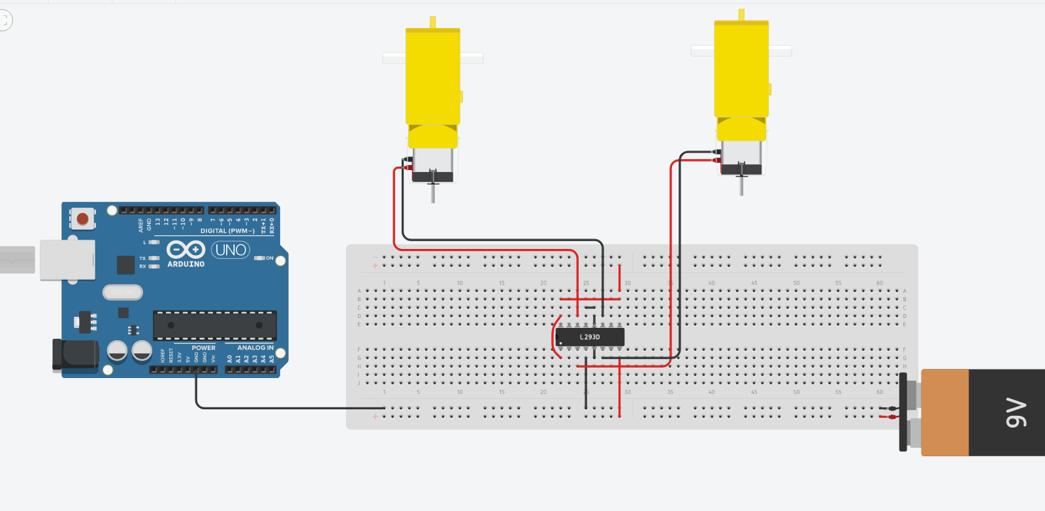

Using functions, I created functions for each type of mode that was required. However, I came to a stump for a while thinking about how to go about the DIP switches changing the mode of the motors. After thinking about it for a while, I thought about the process of having the switches high and only through toggling the switch “ON” the Arduino would read the input as high.

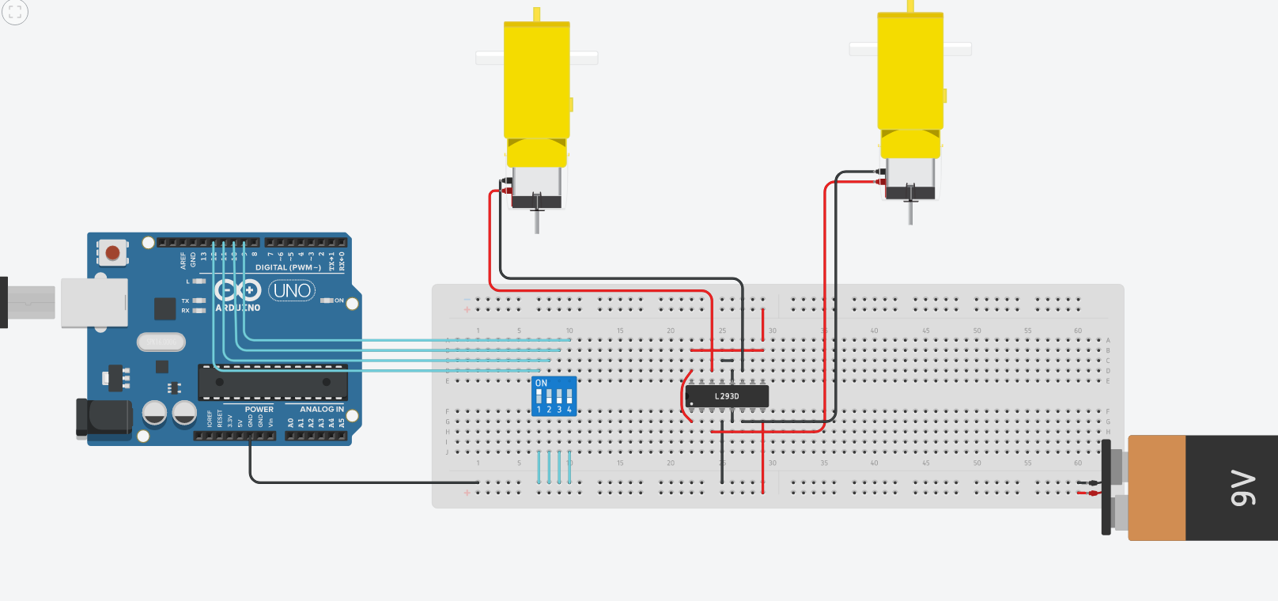

Afterwards I hooked up the motors to the corresponding outputs and turned one to high to determine which was which.

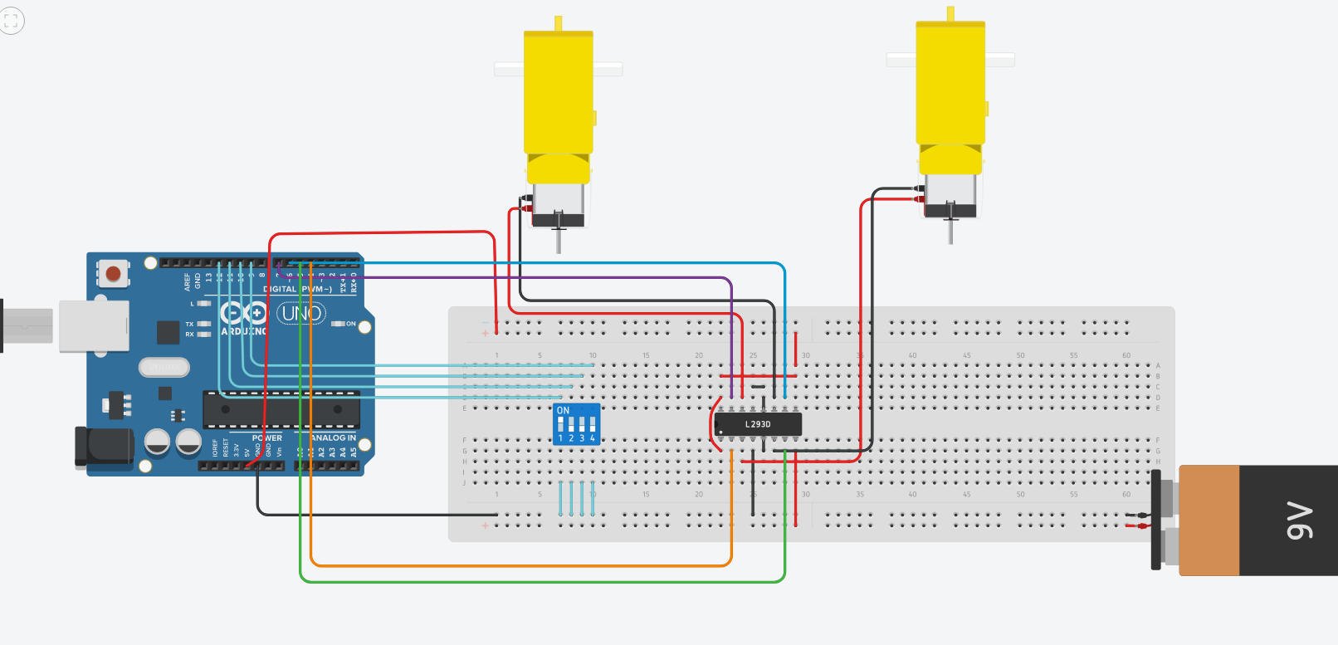

Then I used “if” and “else if” statements to decide which motor would be on and off based on which switch was active. The last but difficult process was the potentiometer. After reading up on the potentiometer, I decided that the analogRead() command would be used to read the value of the potentiometer.

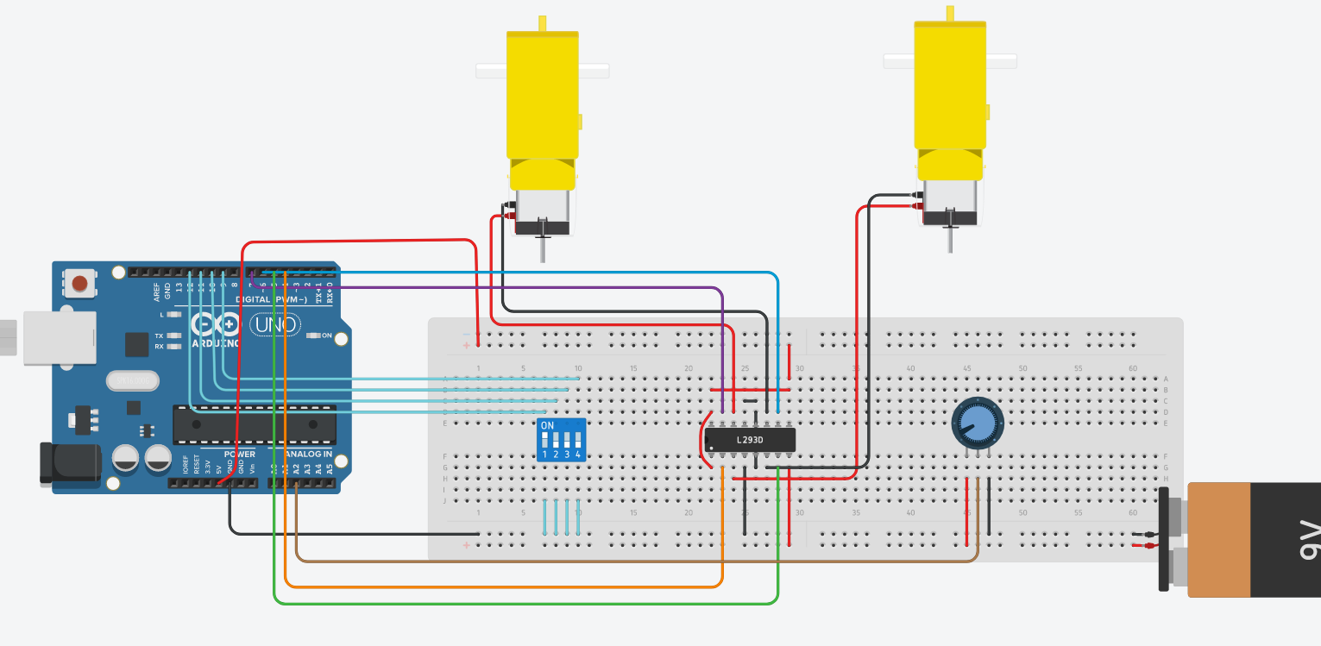

Soon after I programmed it into the Arduino and the value read would become the speed of the motor. Overall, using Arduino and Tinkercad I created a circuit and programmed the circuit to read inputs and create certain outputs.

