User Documentation and Use Guide

This is a documentation manual for general users. The following are simple explanations and walkthroughs for running and maintaining the attached client runnable jar file. A more in-depth explanations can be found in the admin documentation manual.

In this package is a simple client/server chat model that allows the user to select which protocol they would like to use to communicate. The client is dependent on the servers they have access to.

Contents

Setting up an Active Chat Client………………………………….……………….…………………………4

Running a Chat Client………...……………………………………….…………………………………………5

Closing a Chat Client………...……………………………………….……..……………………………………8

Connection Types………...……………………………………….……………….………………………………9

UDP Information and Restrictions……………………………………………………………………………..……10

TCP/IP Information and Restrictions……………………………………………….………………………………11

Issues and Error Handling………...……………..………………….……………………………………….12

Failed Connection………...……………………………………….….……………………………………………………13

Crashed/Unresponsive Server………...………….…………………………………………………………..………15

Message Lengths and Loss………...…………………………….………….………………………………..………16

Setting up an Active Chat Client
Before attempting to start a chat client make sure the following tools are available on the machine that the client will be executed on.
- Java 8 – The most recent download can be found here : Download Java 8
A quick description is provided to indicate which package of the Java Runtime Environment is needed to run a java program (ie. Chat Client).
- Client executable file – this is provided in the zip file
- Network Access – While the chat client will still run, communication between two chats will not be possible without a network connection.
- Admin Server Information – Contact your admin if you have not received the following credentials from the server host
  - Server IP address
  - Server Port Number
Running a Chat Client
The following is a complete walkthrough of how to run and create a connection to the server given the necessary conditions from ‘Setting up an Active Chat Client’. Screenshots are shown as necessary.

- Open client executable file.
The interface should open and allow for entering the credentials given by an administrator. The following application will appear:
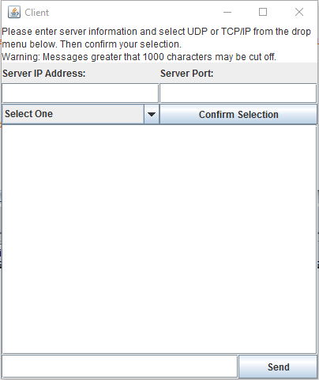

- Enter in the server IP address given by an administrator.
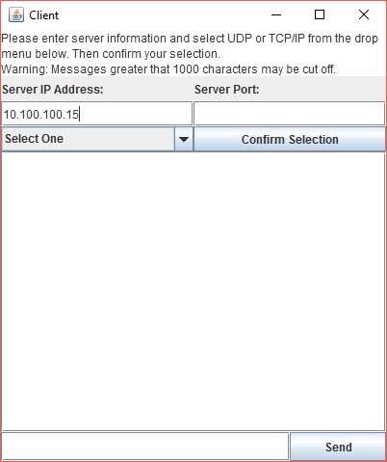

- Enter in the server port given by an administrator.
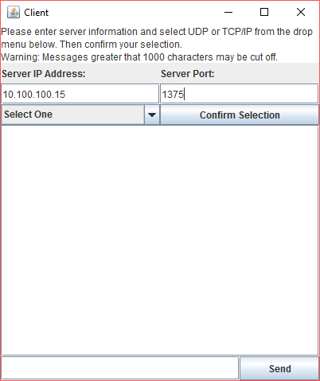

- Select a form of connection. A brief explanation of each type of connection is given in ‘Connection Types’.
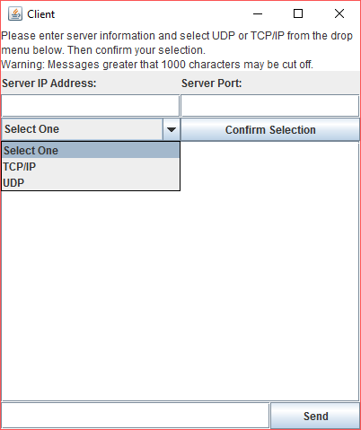
- Select ‘Confirm Selection’ to connect to the chat server.
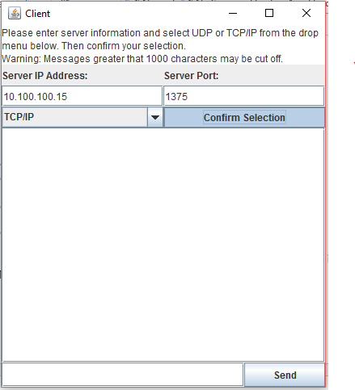
- Upon connecting a success message should be displayed.
*Once a connection is made, restarting the current or creating another client is the only way to switch to another connection
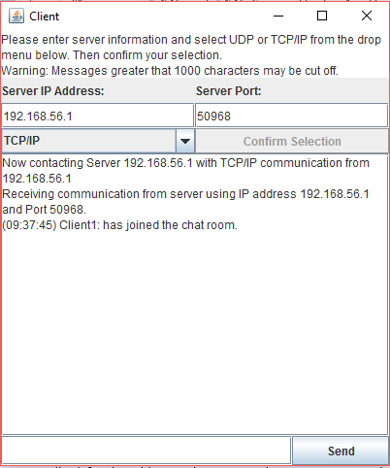
ProTip: If trying to connect and the program seems to have frozen, check the entered IP address. If the address is correct wait for the application to finish processing. If a connection cannot be made the application will ask for the address to be reentered. Processing may take longer than expected depending on the specifications of the machines hardware.
Closing a Chat Client

Closing an active chat client is clean and straightforward. Simply selection the ‘X’ button in the top right corner to exit the chat and disconnect from the server.
*previous communication of a closed chat, regardless of if the same server is used, will not be kept and cannot be back tracked or retained. It is the user’s responsibility to track any conversations that need to be saved.
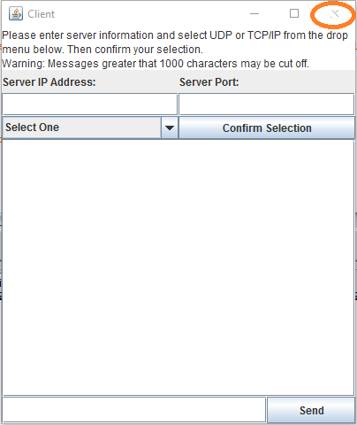
Connection Types
The client chat server is able to use UDP and TCP/IP connections. The following is a very brief description and documentation of the differences between each type.

UDP
UDP stands for User Datagram Protocol and is a basic communication language or protocol of the Internet. UDP uses connectionless transmission to maintain a minimum protocol. This means that in the client chat, once a message is sent, there is no way of tracking if the entire message is received on the other end. UDP is faster, but less reliable.

TCP/IP
TCP/IP stands for Transmission Control Protocol/Internet Protocol and is the major protocol through which communication is conducted over the Internet. TCP/IP communication is primarily point-to-point, meaning each communication is from one point (or host computer) in the network to another point or host computer. This protocol is more reliable.

UDP Information and Restrictions
If using a UDP connection there are certain features that must be kept track of. The following are a list of the major differences in a UDP connection that may not occur in a TCP/IP connection.

- Message Sending
Due to UDP being connectionless, there is no way to track if one chat client is actually relaying information to another client.

- UDP Timeouts
Due to the possibility of server error, if a message is not received within an hour, the client will disconnect and instruct the user to restart the service and try to reconnect. This is the only way to ensure that a connection is still active on a UDP based chat client.

- Server Disconnections
When a server is disconnected or crashes, UDP clients cannot receive an error message to inform the user. For this reason timeouts are incorporated to monitor activity and reduce the chance of an unnoticed disconnect.

ProTip: If a message is sent and it does not appear on the console it may indicate that the server is down or there is a problem in the application. Restart the chat client with a new connection or contact your administrator with questions.
TCP/IP Information and Restrictions
TCP/IP will most likely be the protocol of choice for users that wish to keep live connections to a server. Below is a list of the difference in features that TCP/IP has in comparison to UDP.

- Message Sending
Messages are more secure over TCP/IP in that they are always connection based. This means that confirmations are sent if a message is well received and vice versa. Users will be alerted if there is an error in any of the processes of sending a message.

- Server Disconnections
When a server disconnects from a client, a message will appear to the client (image shown below). Restart the client and try to reconnect. If connection fails, connect an administrator for information.

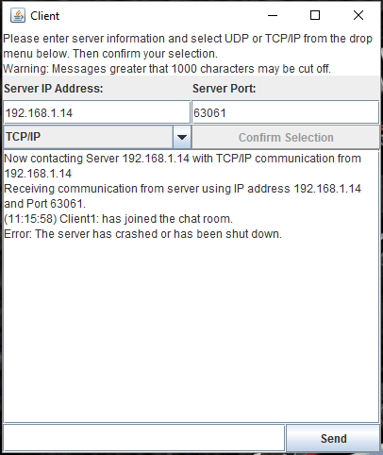
Error Handling
All though the client chat application has been strenuously tested, errors do occur. The following are some of the most common errors and how to handle them if the chat malfunctions.
Failed Connections
A connection may fail for many reasons. If there is ever a failure the application will warn the user and suggest the best course of action to a solution. The following are examples of some of the possible failures.

- Invalid IP address or port number
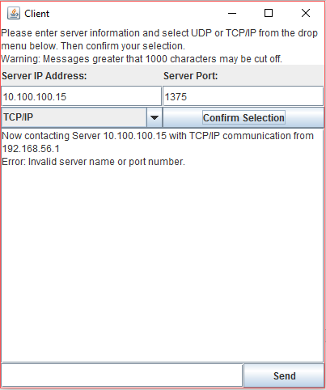

- Unselected protocol
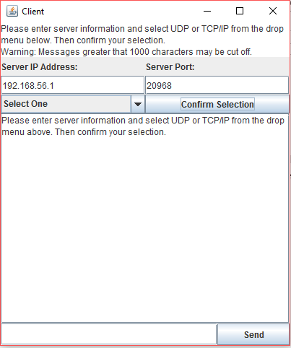

- Disconnected Server (TCP/IP Only)
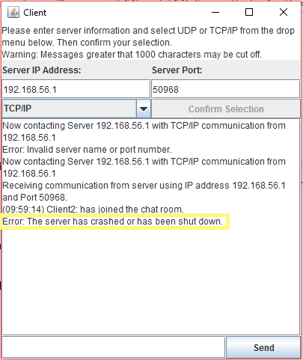
Crashed/Unresponsive Server
In the instance of an unresponsive or crashed server, restart the client chat and try to reconnect. If a connection is not possible contact an administrator for information.
TCP/IP will notify the user of server issues but UDP will not. If the server seems to be failing or messages seem to not be sending during UDP communication, follow the same directions.
Message Length and Loss
The maximum amount of character that can be sent in one message is limited to around 1000. If more than 1000 are sent, there is no guarantee that it will be fully received. Although the message will be completely shown to the user sending it (right), it may not be complete for the receiver (left) as shown below.

