Design Sketch

10/19/17

Team A

Class Diagram

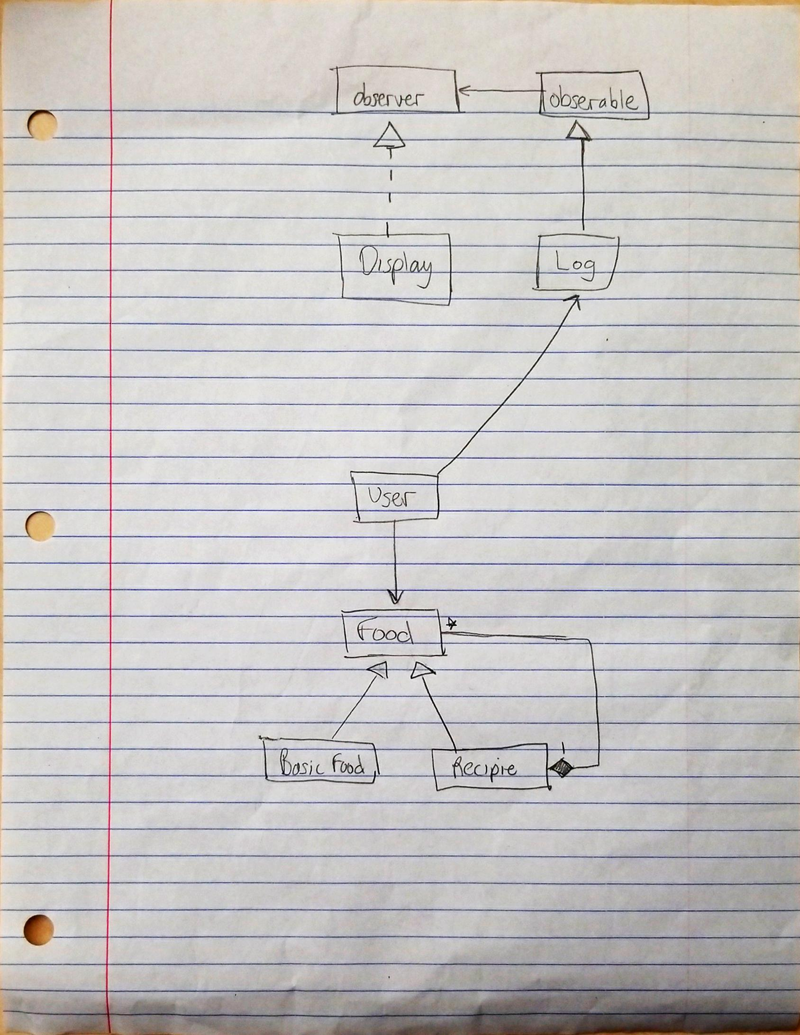

Sequence Diagram

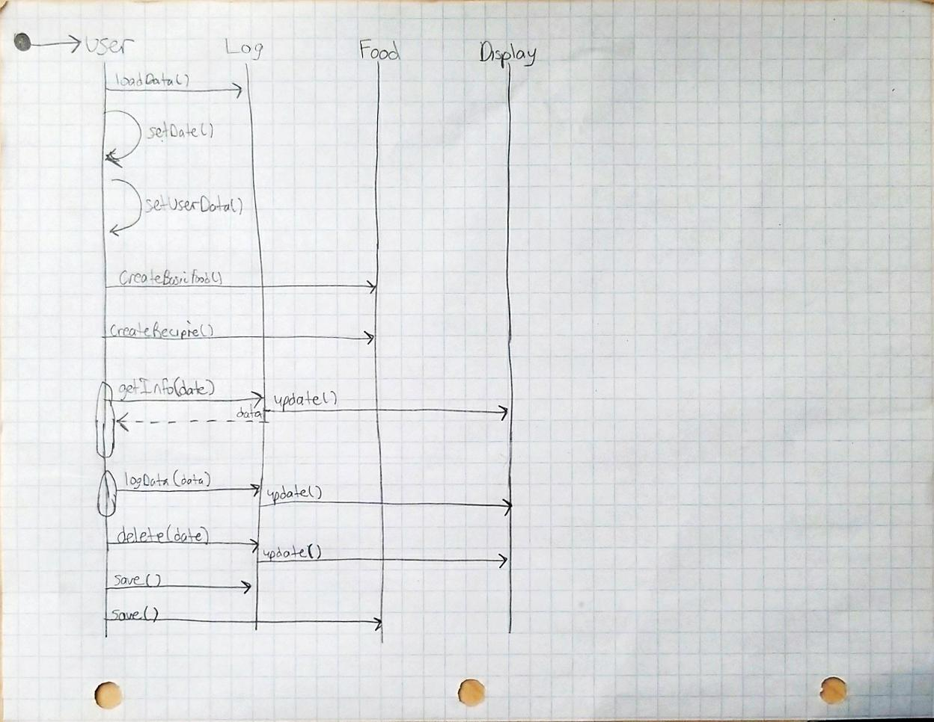

Class Description

1. A narrative in which the team:
   1. Provides a brief description of each of the application classes other than those in the UI; the description must include each class's responsibilities (what the objects in the class ***know*** and what they can ***do***).
   2. Provides a ***brief*** (2 paragraph max.) rationale for organizing the system in the way that they have. In particular, what are the advantages and disadvantages for both initial implementation and on-going maintenance and upgrades to a system conforming to the design.