**Final Documentation**

**Group 14 - ISTE 330**

Jon Aurit, Brianna Buttaccio, Joshua Lora, and Joseph Oh

**Requirements Document**

# Introduction

*Purpose:* Develop web based portal to allow below defined users read/write access to the faculty research database depending on permissions. Faculty, students, and the public need the ability to search and update the faculty research database in order to find research papers based off of stored keywords.

*Timeline:* Academic exercise to be completed no later than May 16, 2017

*Team:*

Lead designer: Brianna Buttaccio

Lead backend engineer: Joseph Oh

Lead frontend engineer: Joshua Lora

Lead database engineer: Jon Aurit

# Language/Environment

*Language(s):* PHP, HTML, CSS, Javascript

*Libraries:* PHP Extensions, jQuery, BootStrap

*Database:* MySQL

*Environment:* Web Interface

# Minimum System Requirements

* Login page/modal
* Simple browser based user interface to access database contents on current faculty research
* Maintain database housing information on current research papers, their authors, faculty information, and paper key words
* Develop database support for new user types such as “student”
* Develop database support for storing user passwords
* Faculty will be able to add papers and paper keys words to the database
* Faculty, students, and the public will be able to browse the database

# User Definitions

## *Faculty*

* View all papers
* Add papers and paper key words
* Edit papers and key-words they have created
* Remove papers and key-words they have created

## *Student*

* View all papers
* Shared authorship of papers with faculty and students
* Cannot edit or delete any data

## *Public*

* View all papers
* Cannot edit or delete any data

## *Admin*

* View all papers
* Full access to the database and will be granted all permissions
* Add, edit, and remove all papers and key-words
* Create new users and modify or remove existing users

# Post Completion Requirements

* Improving the database by adding features and normalizing all data
* Notification to faculty from public users for speaking requests
* Admin functionality separate from the main three (3) users
  + Adding/Modifying Users
  + Keyword management for papers

Design Document

**Architecture Diagram**

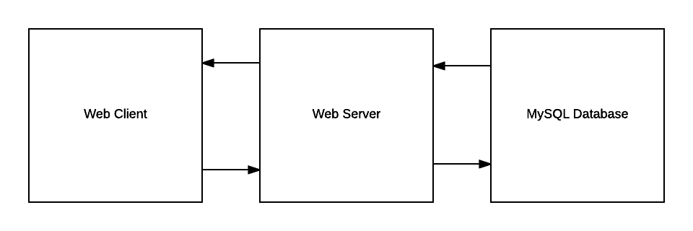

**Languages**

* *Database*: MySql
  + Hassle free implementation for the purposes of this course.
* *Data layer*: PHP
  + Because the system was to be web based, PHP was the obvious choice. No need for the extra overhead of deploying an application server and having to rebuild for every fix during development. PHP would also afford us the opportunity to set it up as a web service to be used by any front end of our choosing to include Java.
* *Presentation layer/Front-end*: HTML, CSS, JavaScript, jQuery, PHP
  + Having decided to create the data layer using PHP, it was determined that a web based front end would far better serve the purposes of this project. Using web technologies allows us to make the project more accessible and easy to distribute, and also provides the latest in easy to use front end UI/UX. There will be some inline PHP to control authorization.

**Choice of Passing Information**

* Sessions/Cookies
  + Used to store user credentials in order to track state between pages to control authorization
* Ajax/JSON
  + All data coming to the frontend will be formatted in JSON and fetched through AJAX

**User Interface Mock up**

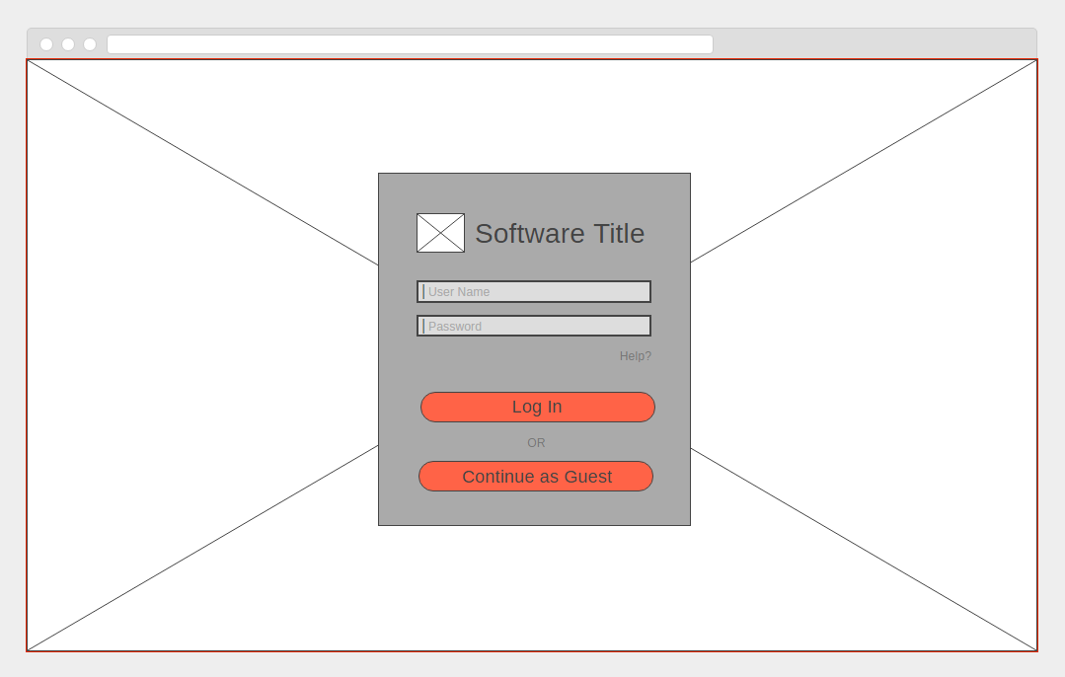

*Homepage*: Login screen for the user. All users will login or select “continue as guest”. They will be directed to a page to perform searches against the data after valid login or refused entry.

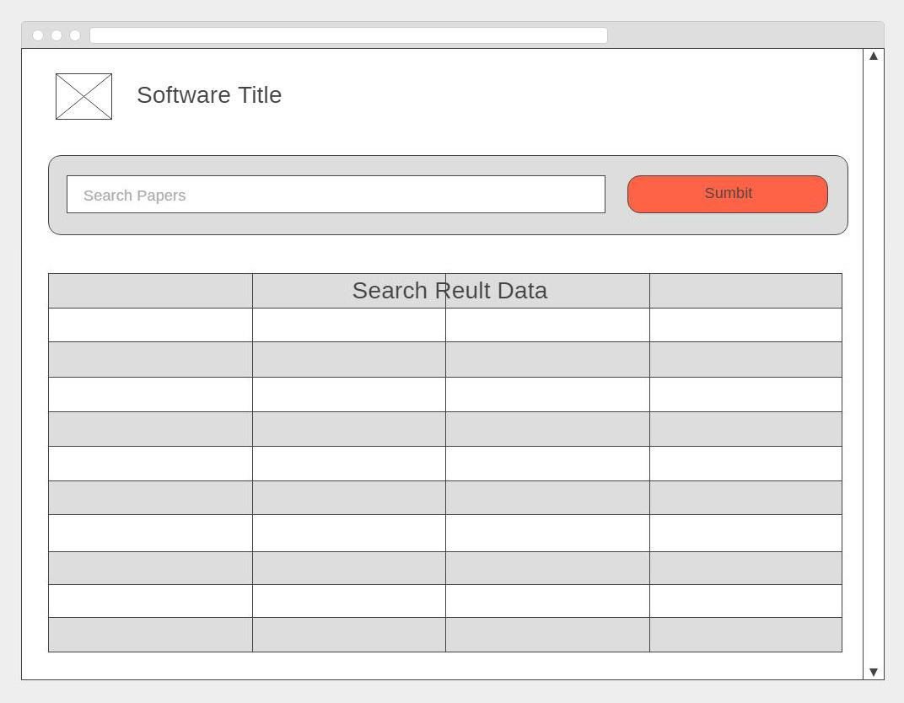

*Search page*: All users can enter keywords to search for academic papers. Upon successful search return, paper metadata will be displayed such as title, authors, etc for each paper. Each result row will have a “view” button which will take the user to a “paper detail” page (not shown).

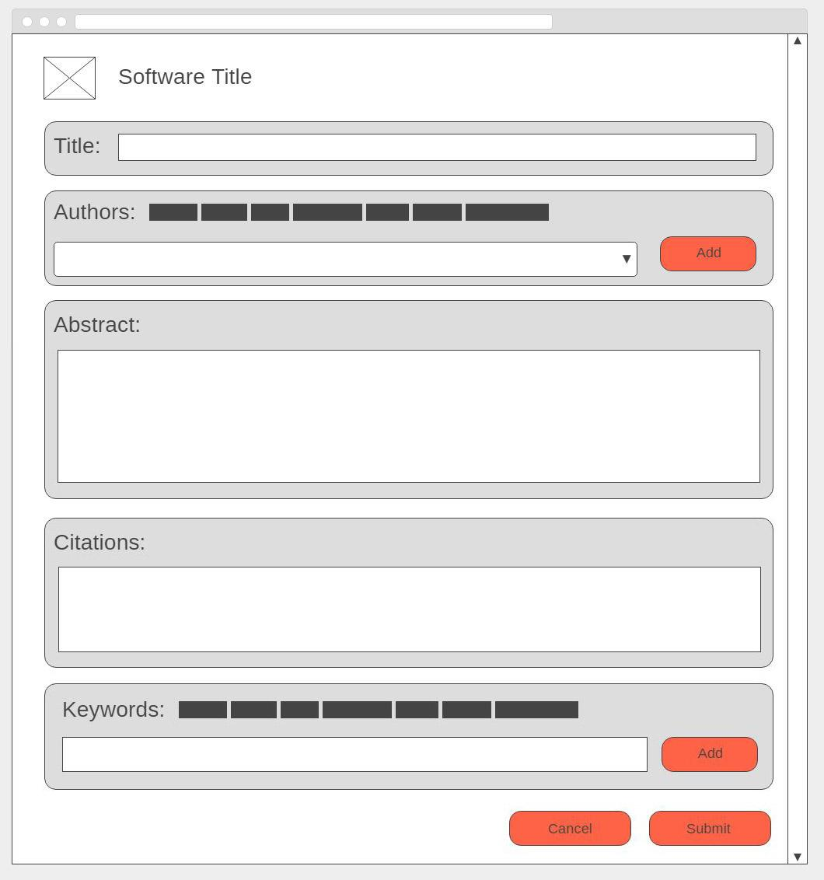*Fig 1 - Admin/Fac*

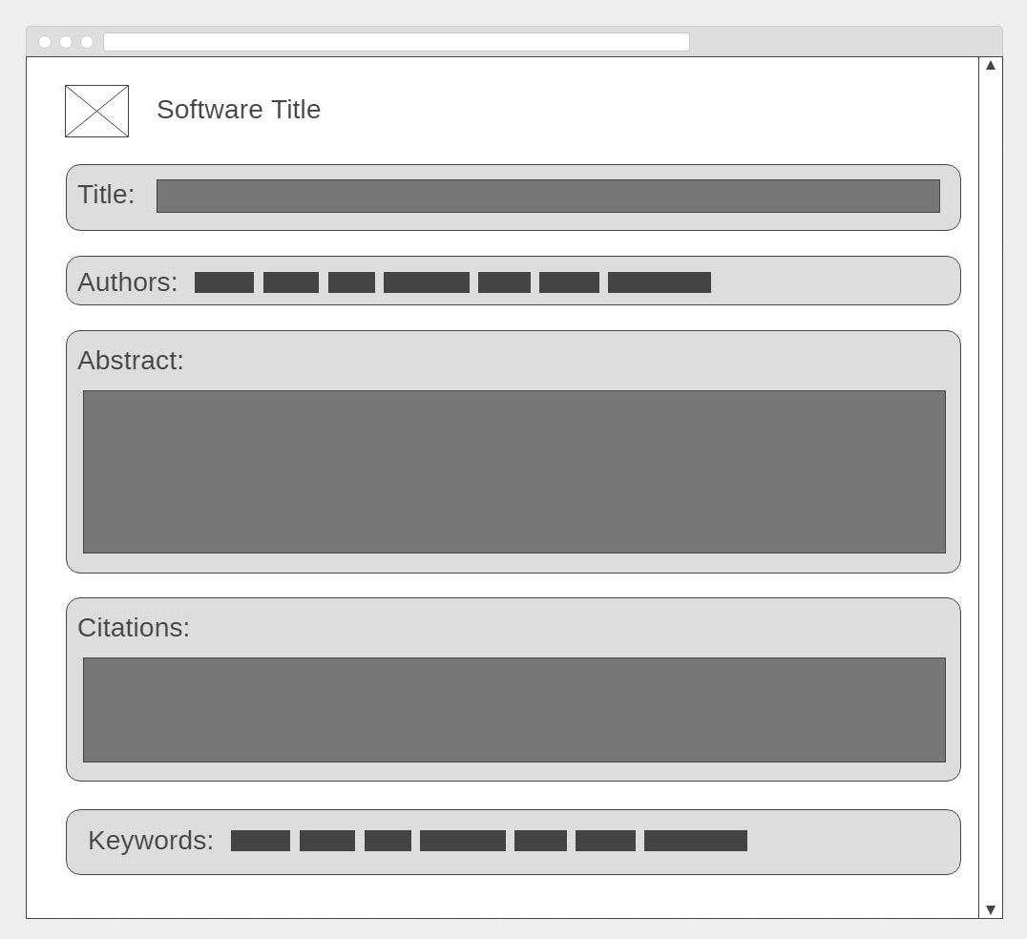

*Fig 2 - Public/Student*

*Paper detail (Fig 1 - Admin/Fac, Fig 2 - Public/Student)*: All users will be taken here after selecting to “view” a specific paper from the search page. Depending on user authorization level, the ability to edit/add entries through the GUI may be present.

**Key Functionality**

* Login/Authorization
  + Users will be able to login using their usernames and passwords
  + Users will either be taken to the appropriate page or given an error message
* Data presentation
  + Having logged in, users will be presented with the appropriate user interface/form to perform authorized actions
  + Upon submitting data requests, users will be presented with a modern tabular presentation of the requested data
* CRUD operations for authorized users only
  + Depending on user authorization, user may have the ability to perform various Create, Read, Update, and Delete functions

**UML Diagram**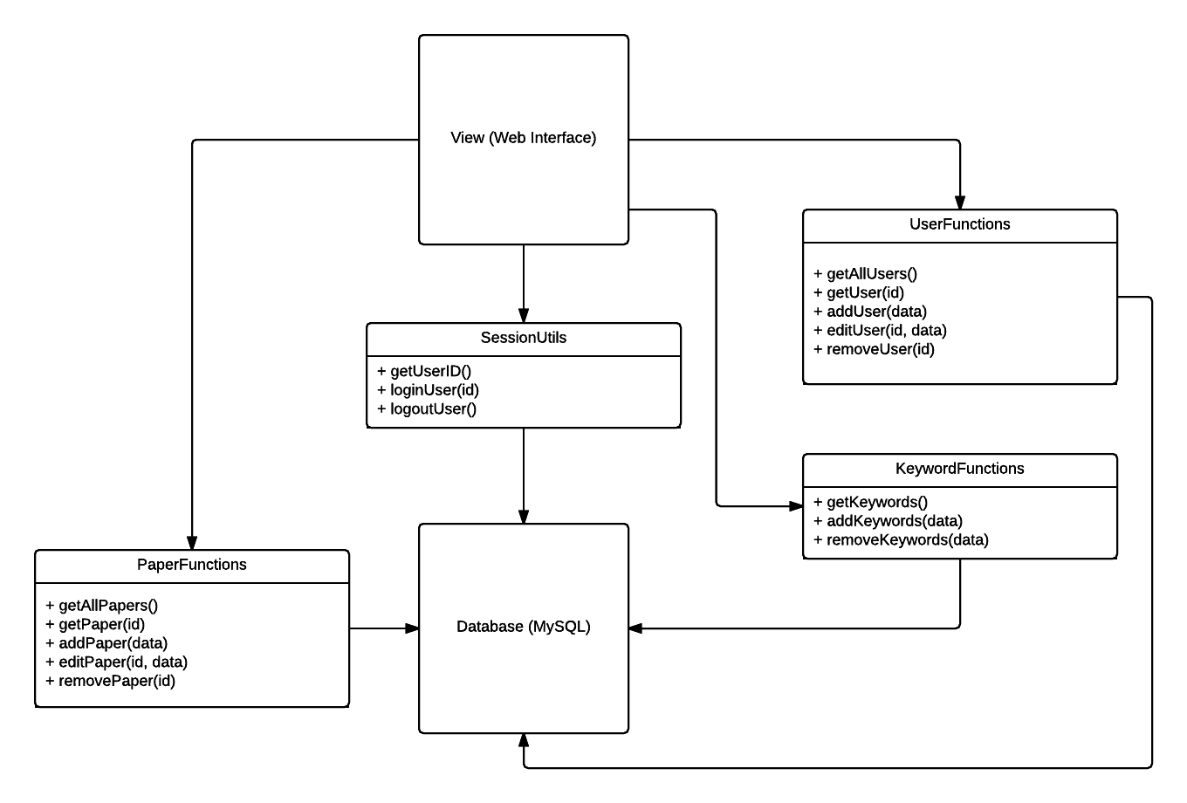

**Areas of Concern**

* Short timeline doesn’t allow for much refactoring/redesigning so developing the concrete implementation of the plan may require more time.
* Implementing a clean and modern responsive design and user experience may prove the most difficult and time consuming.

**User Documentation**

# Introduction

Welcome to the Faculty Research Database Portal(FRDP). This document was written and provided for the user in order to serve as a general manual and guide to the FRDP. The FRDP is open to all users but only certain functionality is available to registered users; to that end, all prospective users are welcomed to read this, but understand that not all content will be relevant to you.

# Functions

* Login: Upon reaching the FRDP landing page you will be greeted by a simple login form consisting of two fields, Username and Password. If you are a registered user, please enter your login credentials to be allowed access to the rest of the site. If you are a public user, simply click on “Continue as guest” in order to continue on to the search page.
* Research paper search/list view: For all users, this page will appear the same. Upon landing on the search page you will be presented with a search text field and search button. Simply enter a paper keyword into the search bar and click on the search button. If a match is found based on the keyword, you will be presented with all matching papers in a tabular format. Each paper(row) in the table will contain a button to view that paper in further detail.
* View/update paper: Depending on your credentials, this page may appear differently.
  + General User: You will be able to view the paper and its contents. That is all. You may return to the search page to search/view other papers.
  + Faculty: You will be able to view the paper and its contents. You will be able to update and edit any papers tied to your username. If you are logged into a faculty account, you will notice a edit button above the paper’s detail section. Pressing this button will allow you to edit all paper fields. When done editing click on the submit button below to save your new edits to the paper. If successful, you will presented with a success message. If not successful, you will be presented with a fail message. You may return to the search page to search/view other papers.
  + Admin: You will be able to view the paper and its contents. You will be able to update and edit any papers as described above. You may return to the search page to search/view other papers.

# Sketches and Menus

Page Definition:

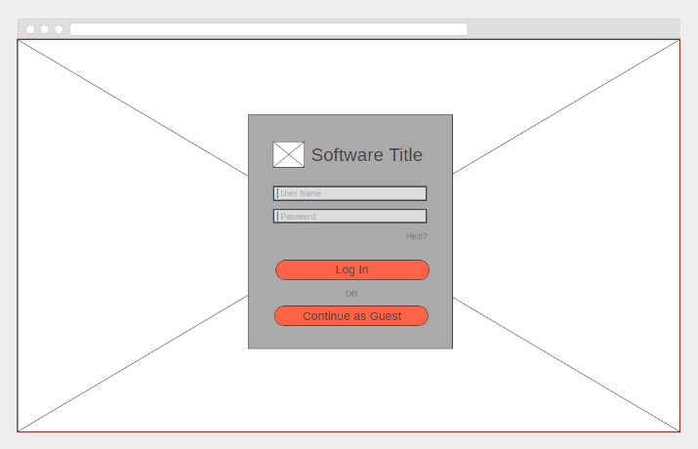 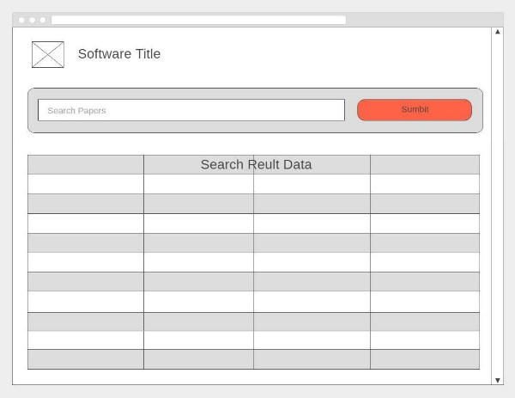

Login Screen Paper Search

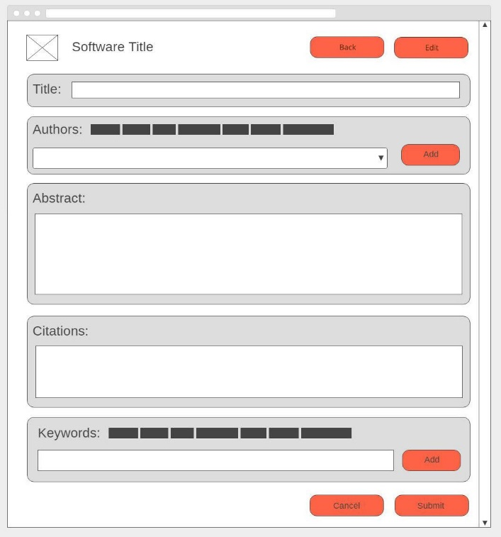 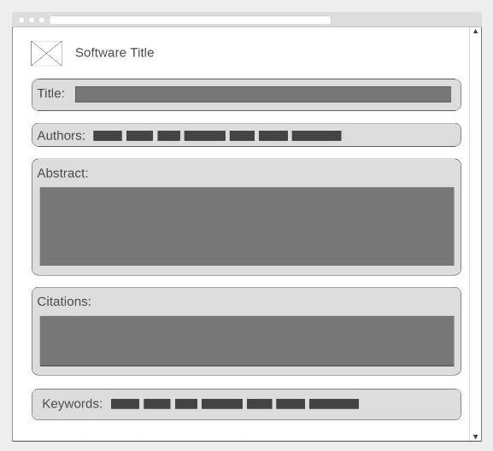

Faculty/Admin Paper Details Public Paper Details

Page Flow:

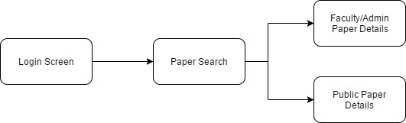

The website has a linear flow with three pages. The first time you go to the site, you will land on the Login Screen. After you login, you will proceed to the Paper Search page. Once you are logged in, if you return to the login page, you will be forwarded to the Paper Search page. From the Paper Search page, you can navigate to any of the papers’ detail pages. From the Faculty/Admin Paper Details page or the Public Paper Details page, you can go back to the Paper Search page to make a new search or to view a new paper’s detail.

FRDP Makes use of frontend and backend web technologies. The site has two main pages, Paper Search and Paper Details, that the user can navigate between. The user interface provides the user with all functionality they have access to, because of this, there is no need for menus with the page flow.