**1.     Title Page**

**AntiFix: Computational Creativity for Industrial Engineering**

Dr. dr. Johan F. Hoorn 洪 约翰 (D. Litt., D. Sc.)

Professor of Social Robotics

School of Design and Dept. of Computing

Tel (852) 2766 4509 Fax (852) 2774 5067

Email johan.f.hoorn@polyu.edu.hk

Website www.sd.polyu.edu.hk; www.comp.polyu.edu.hk

**2.     Abstract / Summary**

To innovate an industry, one must overcome fixity. Optimizing a product or service only goes so far and is not up to disruptions in the market. However, most people do not look beyond the boundaries of their industry. AntiFix is a system of computational creativity that will help them do so.

Common approaches to innovation are convergent: They reason towards a consequence and sometimes with great success (e.g., the discovery of graphene). However, such approaches are bounded by the premises and constraints of the discipline. They are incapable to diverge. Innovation through biomimetic design is one way to diverge and overcome fixity. For instance, a cutter suction dredge may be modeled after a snail’s abrasive tongue (Van der Wal, Giesen, & Videler, 2000). And although divergent in connecting engineering with biology, these approaches are limited by the stock of known biological mechanisms for which an application is sought. AntiFix takes it up a notch and offers Artificial Creativity (AC) that can diverge while using all available data in the Cloud; not a mere sub set of it.

To deliver the AntiFix system and demonstrate the kind of novel engineering solutions it produces, the following methods will be employed: First, requirements engineering with professional designers will tell how they diverge and innovate an industrial design. This information is used to, second, update three computational systems that claim to produce creative output and compare them in simulation tests. The technologies underlying these systems vary in their dependence on convergence (i.e. reasoning) and divergence (i.e. association) to produce a solution. The data sets these systems use are more limited (i.e. AskNature Database for biomimetics) or less limited (the Cloud). Third, the various designs that are delivered by the three systems with two data sets are evaluated by professional designers in an advanced version of the Turing Test (human-made or not?) on dimensions such as novelty, usefulness, aptness, applicability, etc.

As a demonstrator, the best performing system according to the Turing-Test results will be updated and implemented in a Hanson robot that sketches, draws, and annotates the (biomimetic) designs that AntiFix generated beyond what humans can possibly think of. From here on, the system can be applied to any domain that produces Big Data to help industries disruptively innovate their trade.

**3.     Aims and Objectives**

Fixation in problem solving keeps people from formulating breakthrough solutions (Laird, Bailey, & Hester, 2018; Koppel & Storm, 2014). Computational creativity may serve as an antidote to fixation (AntiFix) by suggesting solutions that humans hardly can think up themselves. Therefore, the project wants to:

1. Deliver a computational system (AntiFix) that can generate creative solutions for engineering problems by combining data bases from (seemingly) unrelated domains
2. Make this system incorporate the integrated result of tests with existing creativity systems, some of which are more reasoning-oriented and other more directed at association
3. Do the tests for data bases of biomimetics versus general Cloud repositories and have the solutions that the systems output evaluated by professional designers
4. Demonstrate the capabilities of AntiFix with a social robot that sketches out and annotates the novel conceptual designs

A further aim is the impact that this work will have, which has a number of scientific, academic, and societal aspects:

1. Scientific
2. Advancement of our understanding of creativity as a problem-solving strategy
3. Furthering the computational modeling of creativity
4. Introduction of the idea of theory-driven data analytics
5. Academic
6. Establishing a sample crossover-project between SD and COMP
7. To let students and staff of design and computing work together to achieve innovation excellence (and in so doing, overcome disciplinary fixation)
8. Societal
9. To provide a tool that helps decision makers go beyond ‘scientific manage­ment’ and ‘strategic planning’ as their routinely given answer to under-determined problems such as global warming, immigration, and ageing (note that the tool is general and not restricted to a field or discipline)
10. To improve people’s resilience by increasing their coping capabilities through AntiFix

**4.     Background Research**

Fixation is one of the major hurdles in solving the problems of today. Due to various reasons, people hold on to conventional means because ‘this is how it’s done’ and if that does not work, they will try harder doing the same thing time and again. Whether in science, design, or in everyday life, many people are unable to abandon overlearned behaviors so to approach a challenge from a fresh perspective (Laird, Bailey, & Hester, 2018). That is because they lack the information that might give them new ideas or because they do not have the ‘mental flexibility’ to recognize solutions in fields other than those already known (cf. Koppel & Storm, 2014).

What if we could support fixated problem solvers with a nearly endless solution space, a pattern recognizer that detects more abstractions than a human possibly could, and that based on those abstractions connects areas of knowledge so remote that humans never would have thought of them.

From a viewpoint of basic science, this brings us to the tenets of creative problem solving in design. What is the fundamental process of creativity and can it be ‘computed?’ Can creative design happen without any intelligence required (cf. serendipity) or is reasoning a prerequisite? With respect to computing, the basic question would be how to discern in a surplus of data randomly occurring patterns from ‘meaningful’ ones?

The next sections discuss three approaches to creative problem solving in relation to predictive data analysis to test the performance of each. I discuss a feature-matching algorithm, artificial neural networks, and case-based reasoning for the patterns they predict in data repositories and in how far that can be considered ‘a creative solution.’

*4.1 ACASIA, an algorithm for fuzzy comparison*

In Hoorn (2014, p. 124), creativity is the combination of two or more entities from unrelated domains or ‘categories’ in a fuzzy manner. Entities do not have to be identical, they can partly resemble one another (cf. Santini & Jain, 1999).

Fuzzy set theory provides the theoretical background to model inexact expressions. It is possible to express the concept of “almost equal” through a fuzzy equality. This captures an important aspect of similarity. (Richter & Weber, 2013, p. 115)

The fuzzy resemblance may be optimized by selection and adaptation techniques (Hoorn, 2014, p. 137, p. 140). This approach to creativity showed to be successful, for example, in forwarding innovative design ideas for electric wheelchairs (Hoorn, 2013, p. 18) or tweeking the design space of motor homes (Hoorn, 2014, p. 204). The software to produce those design ideas was ACASIA, which is the acronym of Association, Combination, Abstraction, Selection, Integration, and Adaptation, a six-factor model of creativity (Hoorn, 2002).

*Association* is the capacity to generate images, words, meanings, and other semantically related features in response to a stimulus (an entity). *Combination* is the process in which connections between associations of disparate entities are established, rooted in a matching mechanism of (fuzzy) feature sets and reflected in a measure of perceived similarity (and hence, dissimilarity). *Abstraction* is a means to bring certain phenomena on such a conceptual level that the connection actually can take place (i.e. similarity increases at higher abstraction levels). *Selection* is the dismissal of those features that cannot be used to make the combination acceptable in the eyes of the creator or her audience, hence affecting the measure of dissimilarity between disparate entities. Selection could consist of domain-specific knowledge or theory that forbids that something can occur (e.g., perpetual motion). *Integration* is an activity to literally attach the features of one entity to the other. *Adaptation* is to change individual features such that the transition from the one entity to the other would become acceptable (i.e. optimizing the blend). The only database structure ACASIA requires is that categories (e.g., animals) contain exemplars (e.g., shark), which have features (e.g., triangular dorsal fin). The procedure then is to:

1. Draw two exemplars from different categories
2. (Fuzzy) compare the sets of features of each exemplar
3. Generate a similarity score as well as a dissimilarity score
4. If a specific ratio is met (criterion *q*), the idea is accepted
5. Go to 2

The above would count as the AC part of the ACASIA model. Note that between 3 and 4, selection, adaptation, abstraction, and integration (the ASIA part) may take place to optimize the ratio between similarity and dissimilarity to satisfy *q*. Below is a version of the process that uses distance for similarity but more importantly, has added the selection criterion that the combination should be ‘novel’ (cf. innovative).

step():

a = get random entity from I

b = get random entity from I

diss = distance(a,b)

if diss <= MINIMUM, return 0

if diss > MAXIMUM and serendipity check fails, return 0

c = combine(a,b)

if c too close to any other entity in the entity list, return 0

insert c into I

return diss – MINIMUM

main:

total = 0

loop:

total = total + step()

Unlike other systems (Section 4.2 and 4.3), ACASIA does not rely on reasoning but on merely association alone (plus some check lists). Moreover, it deliberately makes room for stochastics as an integral part of the design process (mimicing so called ‘serendipitous findings’), which other systems do not. It is only through selection and adaptation that a combination may be optimized to satisfy certain constraints or goals (e.g., ‘novelty’ or ‘usefulness’). Basically, what ACASIA claims, is that creativity can happen without intelligence required. Intelligence is not forbidden but actually not necessary to explain why plants show (brainless) creative combinations (cf. lichen, Euglena) or chemical elements show (brainless) synergistic interactions.[1]

*4.2 CLARION, an artificial neural network*

Unlike logit models, which merely produce binary outcomes (in or out-of-category), neural nets can carry out non-linear statistics that more closely represent creative combination-making. Formal training time of neural networks is relatively modest (notorious exception being Deep Learning systems). Neural nets offer a range of algorithms to discover compound non-linear patterns in large sets of divergent variables. However, sometimes the way a network detects the interactions between variables is untraceable (whereas ACASIA’s path can be completely logged). Scientifically, that is hard to swallow because there is no theory from which a pattern is predicted. It might be that the network merely finds spurious correlations (coincidental significance) in a set of random noise. That actually gives way to ‘modeling in hindsight,’ which is fine if no theory exists and data exploration is to formulate first principles and hypotheses. Such a pattern may be useful, applicable, but scientifically, we do not know what it ‘means.’ It is switching on the light without understanding electricity. For testing a theory, it should be visible how the network explores the data without any ‘magic moments’ happening.

A related problem is the trade-off between model complexity and overfitting. Sometimes neural nets fail to discern a general pattern because they keep on adding more parameters to the model to explain a mass of detail. This is the *issue of overlearning,* which is not typical to neural networks alone but may be found in humans and animals as well. Overlearning happens if too little variance is allowed to the solution. It may happen with too little data input or by increasing the number of parameters that describe the case, complicating the explanatory model. The fit may be increased but at the cost of losing generalizability over other cases (hence, overfitting). Through overlearning, the learner acquires maximal precision (on the learned case, that is) but does not acquire the optimal resolution to predict other cases, a resolution that probably is courser and less precise (cf. fuzziness in ACASIA or in case-based reasoning, Section 4.3). In other words, overprecision merely recognizes what it knows already and is prone to detect the differences with every next case, rejecting the overall pattern. If the world does not fit the learned concepts, the world is rejected. Overlearning reaches a stable overall score but at a lower level of success (i.e. lower average scores with smaller standard deviations). With an optimal resolution, the success rate is more instable but overall more accurate (i.e. higher average scores with larger standard deviations). The specialist drowns in detail and does not see the forest for the trees. The generalist sees the big picture but may hold the tree for a giraffe. It is the specialist’s pitfall of precision against the generalist being error-prone. It is problem-solving fixation against risky innovation. The generalist has a bigger chance to find a creative solution than the specialist but at the cost of being mistaken. This is why people must be brave to innovate.

Finding spurious correlations, untraceable interaction detection, and overfitting are problematic for predictive data analysis. Various techniques in neural net analysis have been proposed to deal with those issues such as early stopping, max-norm constraints, regularization, and drop-out layers. These regulatory methods indeed are quite clever and effective but they are still interpretations in hindsight, fully data-driven, untill the fit is general enough according to… eye-ball analysis. It is a bit arbitrary when a fit is general enough to be considered ‘good.’ As long as there is no theory behind the analysis that does predictions on the data it is hard to decide whether we should believe a straight line through a scatter plot or the non-linear polynomial that covers every data point? Despite their high level of sophistication, neural nets remain a general-purpose technique if they are not the implementation of a theory, in our case, of creative problem-solving.

*4.3 FAMING, a case-based reasoning system*

Case-based reasoning is a second worthy competitor of ACASIA because its main approach to problem solving is to find analogies in other, even unrelated, domains. It uses similarity metrics and does adaptations, the main difference being its reliance on reasoning, which ACASIA does not do. Like ACASIA, case-based reasoning does not assume full formal knowledge engineering, which differs from methods working from ‘first-principles.’ Because creativity operates in “weak theory domains” (Cunningham, 1998) (cf. ‘soft constraints’ in Helie & Sun (2010)), the presence of ‘shallow knowledge’ (Cunningham, 1998) should suffice and may provide better solutions overall (cf. the specialist’s pitfall, Section 4.2).

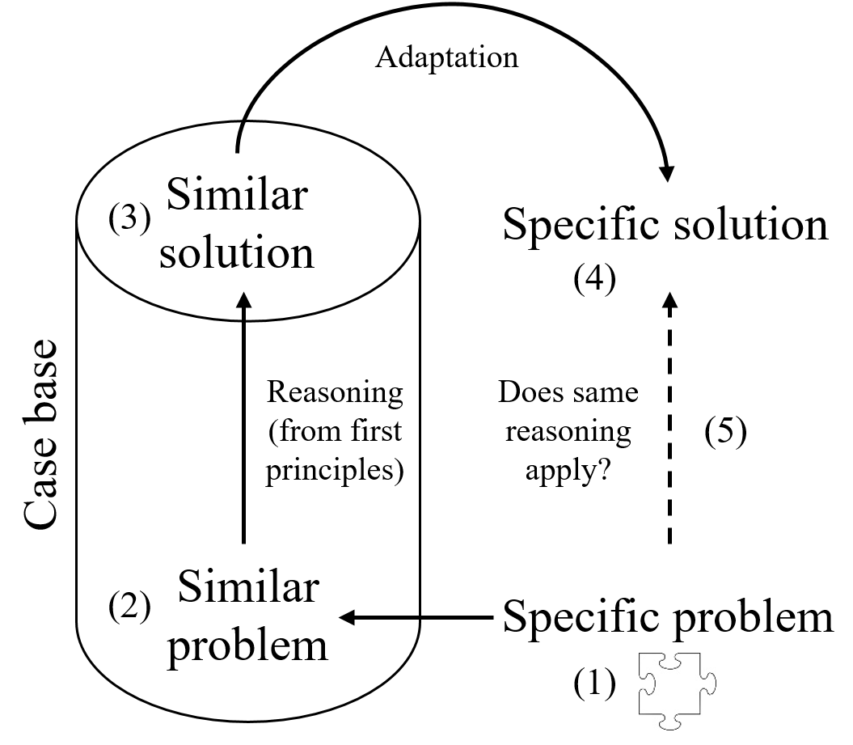

*Figure 1.* Case-based reasoning solves problems by analogy (after Cunningham, 1998).

Figure 1 shows the way case-based reasoning works, which resembles the way humans solve analogies (A:B::C:D). From a specific problem (1), a general case base is searched for similar problems (2), which may lie in completely different domains. For example, an operating room may visit the control tower of an airfield to see how they handle safety issues. The similarity metric commonly involves *k*-nearest neighbor or alternatively, decision trees. In ACASIA, the ‘nearest neighbor’ would roughly equal the entity with the highest fuzzy similarity to another entity.

The specifications of the problem are usually represented by feature vectors. In object-oriented approaches, a number of relations in the knowledge domain is explicated (e.g., taxonomic: a shark *is a* fish; a jet fighter *is an* aircraft) from which features are transposed from one object to another.

The solution of the similar problem in the case base (Figure 1: (3)) is supposed to come from reasoning from first principles. That solution is adapted to the specific case at hand and proposed as a specific solution (4) to the specific problem in the original domain. For instance, the operating room will use similar check lists as the control tower does. The quality of that solution supposedly is warranted when the first principles also apply (5) to the transferred and adapted solution (heuristic: if the solution is the same, the problem must have been as well, Richter & Weber, 2013, p. 114).

**5.     Research Plan and Methodology**

ACASIA stands for Association, Combination, Abstraction, Selection, Integration, and Adaptation. ACASIA supposedly covers the 6 factors that make up organic (i.e. human) creativity. State-of-the-art of version 1 of ACASIA is that we have the AC part in place, but that ASIA is incomplete. The plan, therefore, is to investigate these factors empirically with design practitioners (qualitative methods), represent our findings formally by means of computer modeling, and testing the output (i.e. computer-generated creative designs) against the empirical world (quantitative methods). Next, I outline the phases, research questions (RQs), and methods employed in the AntiFix project.

*Phase 1 Improvement of the ACASIA v1 software*

­­­

* RQ1: How do designers make abstractions, selections, how do they make adaptations, how do they integrate?

Method 1 Literature review, derive theory for research

Method 2 Exploratory requirements research: observational coding schemes, focus sessions, interviews. Qualitative data are quantified by raters in Atlas.ti or RQDA (to be decided)[2]

* RQ2: Can we translate the design practice registered in Method 1-2 into ASIA algorithms?

Method 3 Access the AskNature Database (Deldin & Schuknecht, 2014) and run ACASIA simulation tests with and without the new ASIA modules

Implementation of results in ACASIA v2

Method 1 – Literature review. Guided by RQ1, I will do a critical summary of work on the creative process and on guidelines of industrial design engineering that is pertinent to computational creativity. I will search the APA database for high-quality and reliable sources (e.g., *Creativity Research Journal*) and synthesize the sources in a concept-map format.[3] That knowledge is used to inform the requirements research.

Method 2 – Requirements engineering. The literature review will shape the observational coding scheme, which we will use while professional designers do a free design exercise. Focus sessions and interviews are conducted to discuss the observation results. Qualitative data obtained by all three methods are quantified by raters and interrater reliabilities are calculated. With respect to the computer simulations, the results help define what is in the design case, how the design case is represented, indexed, and how the data repositories should be organized.

Method 3 – ACASIA simulation tests. Regarding RQ2, to run ACASIA on existing data bases, we should define each exemplar from a category as an *n*-dimensional vector. We should then define the complete space of all possible exemplars by an *n*-dimensional (hyper)cube. Each coordinate will represent a feature, ranging from -1 to 1, which simulates bipolar features (i.e. long = not short, high = not low). Although a bipolar approach is not conducive to creativity (Hoorn, 2012, pp. 147-151), this way the similarity operation can be sharply defined as the Euclidian distance between two vectors. For comparison, we also will create a version of ACASIA that works with fuzzy membership functions instead of distance. Based on the requirements-engineering results, we should define a minimum distance below which two exemplars are regarded the same. A maximum distance also is required above which two exemplars are regarded as too dissimilar.

Serendipity (coincidental combinations at times of high tolerance) allow crossing distances beyond the maximum regardless. In addition, we will construct a novelty check, formalized as a frequency of occurrence in a preset database (someone’s brain, the Internet) checked against a criterion value: The more *freq./N* approaches zero, the more original the combination is, where *freq.* ≥ 1 and *N* is sample size. Adaptation and selection modules should be designed from the requirements-engineering results so to optimize each vector combination.

To model the optimization, an ideal distance setting should be defined to represent the ‘perfect’ ratio between similarity and dissimilarity that a designer may wish for (cf. requirements engineering). Both the selection and adaptation stages will modify the vectors towards this optimal distance. Figure 2 shows ACASIA’s combinatory creativity with optimization stages (i.e. selection and adaptation) and a novelty check.

Selection is assumed to ‘remove features,’ for example, because domain-specific theory or constraints demand ‘mathematical elegance’ or ‘cogwheels must be round’ (hence, no square cogwheels). What the domain specific rules are in design, we will gather from the requirements-engineering results. In the simulations, then, the selection stage simply will remove (make 0) the most suitable coordinate of the exemplar vector. The most suitable coordinate will be the one that yields a distance closer to the ideal distance. The adaptation module will make ‘small adjustments’ (e.g., rounding off the teeth on a cogwheel). For our simulations, the adaptation module will modify the weighing factor *f*, as shown in Figure 2. When *f* is 0, the combination consists of only the exemplar B. When *f* is 1, the combination consists of exemplar A alone.

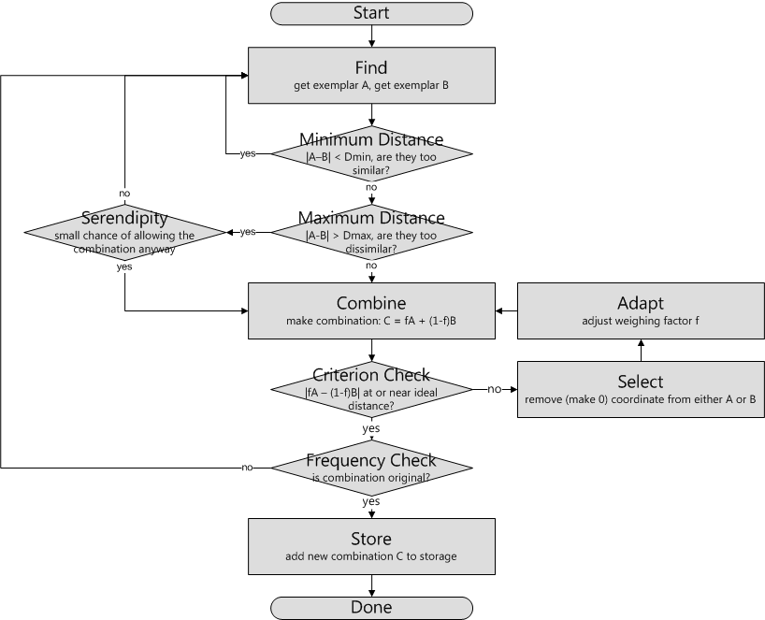

*Figure 2.* ACASIA with selection, adaptation, and novelty check.

Thus far, the integration and abstraction steps are missing out from ACASIA (as is fuzzy similarity). Integration means that entities are physically positioned and connected, for instance, by putting them together in a sketch (cf. Figure 3 for an artist’s impression). In previous simulations (e.g., Hoorn, 2014, pp. 206-221), this would have been meaningless because the entities were vectors in an abstract *n*-dimensional space. Including the abstraction step would be meaningless as well because a hierarchical specification of entities is absent if every vector is equally abstract. However, if a conceptual blend is supposed to be materialized (cf. Figure 3), implementation of the abstraction and integration modules is required.

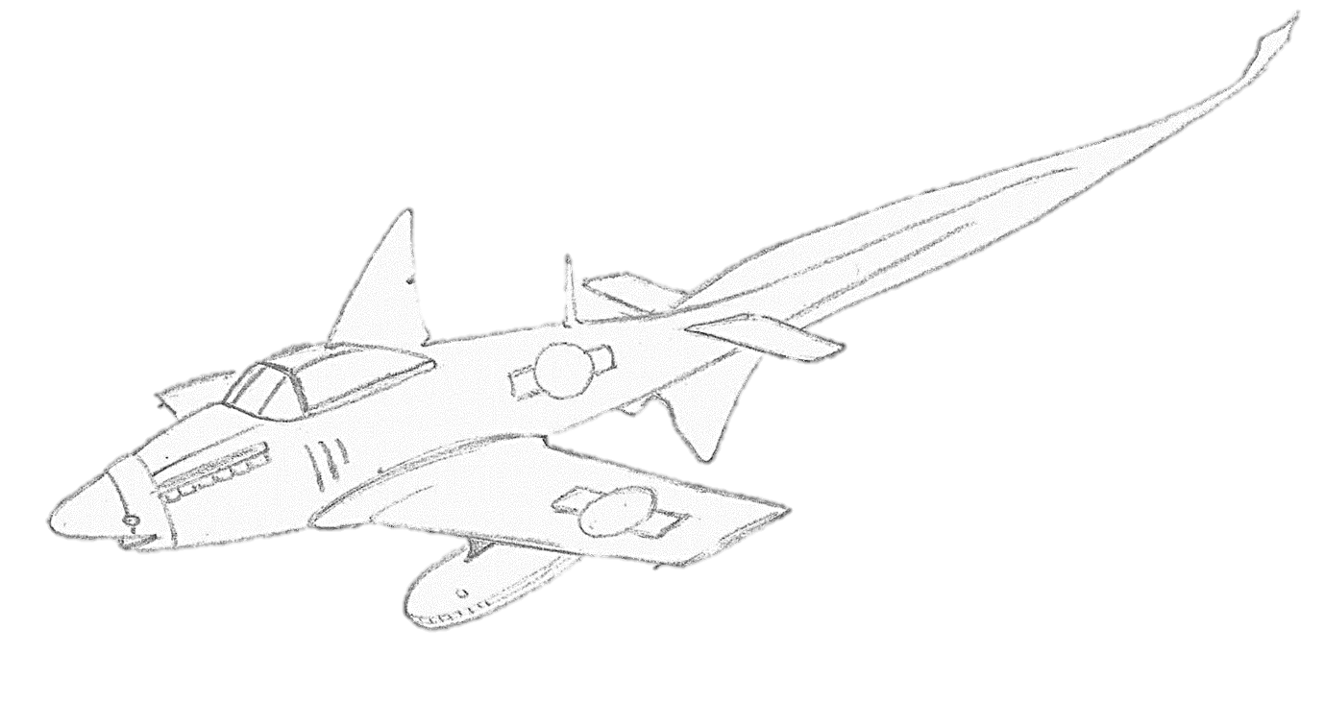

*Figure 3.* Bio-inspired jet fighter modeled after Smalltooth thresher shark (artist’s impression).

If, while data-mining, ACASIA’s selection modules contain domain-specific theory and constraints (e.g., motion laws), ACASIA should be better equipped to detect combinatorial patterns than, for instance, unsupervised multivariate hidden Markov models. Because ACASIA with selection ‘on’ does theory-driven pattern recognition, it will suffer less from dataset-specific noise. If, however, selection modules are turned off, ACASIA will find more innovative combinations than other machine-learning techniques because it deliberately explores dataset-specific noise to do serendipitous findings (more creative solutions – perhaps more artistic than useful).

*Phase 2 Theory-driven (ASIA) prediction of patterns in Big Data*

* RQ3: Can we use ASIA modules to guide data analysis?

Method 4 Literature review, philosophy of science (induction vs. deduction)

Method 5 Combinatorial pattern recognition in Big Data with and without ASIA modules

Implementation of test results in ACASIA v2

If we can predict combinatorial pattern recognition in Big Data, it will be possible to find engineering solutions that depend less on coincidence and can be directed at finding more reliable (because theory-based) creative solutions for specific problems. Therefore, we should be capable to clearly discern induction from deduction and tabulate which existing data-mining techniques do the latter according to science-philosophical standards. We then test the ASIA modules in ACASIA for predicting combinatorial patterns.

Method 4 – Literature review. RQ3 focuses the literature review on the philosophy of science on the one hand and data-mining practice on the other. IEEE and ACM databases are searched for recent approaches to data analytics and a table is produced of studies that work inductively (data exploration) or deductively (pattern prediction). Known practices in analytics will be framed in different approaches to science and conclusions are drawn for making data analytics more deductive.

Method 5 – Combinatorial pattern recognition. Along the lines of the literature review, Big Data repositories are analyzed with and without the ASIA modules created in *Phase 1.* The table crafted under Method 4 is then used to evaluate the performance: How many patterns could be predicted from theory and how many were detected in hindsight? Lessons learned will be added to the ACASIA v2 code.

*Phase 3 Testing existing technologies against ACASIA v2*

* RQ4: Does ACASIA v2 generate more innovative solutions than existing technology?

Method 6 Generate designs with three types of systems: ACASIA v2, neural net CLARION, and case-based reasoning FAMING in biomimetics data base versus general Cloud repositories

Method 7 Turing Test with expert designers and naïve users (lab experiment). Participants rate the degree to which they believe a design was human or machine-made, the degree of creativity, novelty, usefulness, etc. Data are analyzed according to Bayes and classical frequentist techniques (MANOVA)

Implementation of test results of all three systems in *AntiFix*

Method 6 – Generating creative design solutions. In *Phase 3,* ACASIA v2 is tested against a neural network (i.e. CLARION) and a case-based reasoning system (i.e. FAMING) as alternatives for generating creative output. Although Section 4.2 ended on the conclusion that most neural net approaches are mere general-purpose systems that are not guided by theory, a notable exception in the field is the connectionist implementation of creativity theory in the CLARION system (Helie & Sun, 2010). Therefore, CLARION will serve as the first competitor in the performance test against ACASIA.

CLARION assumes that a creative solution is the product of reasoning forward and backward (convergence) on the one hand and almost unconstrained association (divergence) on the other. Both processes produce separate, sometimes conflicting, solutions, which are then integrated. The outcome may loop back into the two processes again until the solution meets some threshold.

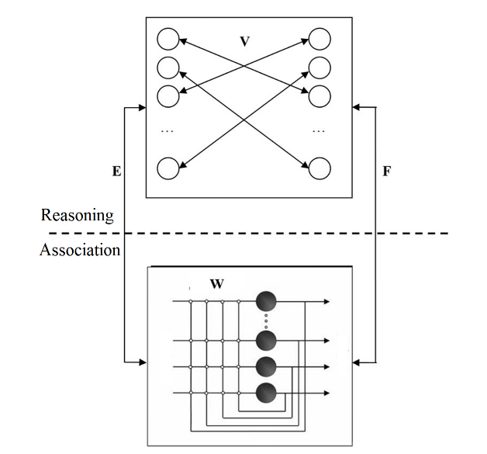

*Figure 4.* CLARION process of creativity (after Helie & Sun, 2010).

The top panel of Figure 4 (V) is a two-layered linear connectionist network in which localist representations in two sets of nodes refer to explicit knowledge, concepts, or hypotheses, which are connected by Reasoning rules. At the bottom panel (W), a non-linear attractor neural network in the style of Chartier and Proulx (2005) represents the Association cycle with soft constraints. When both cycles are active, more intricate solutions are likely to occur.

Hypotheses that are generated by Association are send to Reasoning and vice versa (E and F). The output from Association is integrated with the activations in the right layer of the Reasoning cycle top level, using a Max function, and then transformed into a Boltzmann distribution of hypotheses, while its mode is compared with predefined thresholds. Through the Boltzmann distribution, solutions are stochastically chosen. The distribution includes a noise parameter that is claimed to influence the probability of solving problems creatively (Helie & Sun, 2010).

Another competitor in generating creative solutions is FAMING, which is a mechanism-design system that uses engineering solutions from one domain to solve problems in another. Because we plan on design and sketching support, FAMING is our case-based reasoning system of choice (Maher & Pu, 2014; Faltings & Sun, 1996). FAMING supposedly is capable of the “creative design of elementary mechanisms” and shows “potential for creativity” (Maher & Pu, 2014, p. 43; p. 49) by combining kinematic pairs. FAMING represents (existing) machine parts as metric diagrams combined with a set of device functions (its ‘features,’ ‘annotations,’ ‘meta data’).

After finding a ‘similar problem’ in the case base (Figure 1), FAMING starts to adapt the imported solution through reasoning, such that functional constraints are satisfied and a working mechanism materializes (Maher & Pu, 2014, p. 48, p. 54). Through automation of the low-level details of a device, FAMING is said to create novel devices with precise shapes and interactions (Maher & Pu, 2014, p. 58). That approach can probably be translated to biomechanical solutions as well.

Method 7 – Advanced Turing Test for evaluating output. We will conduct a 2 (Designers: experts vs novices) (between Ss) by 3 (Output: ACASIA vs CLARION vs FAMING) by 2 (Data base: biomimetic vs Cloud) by 2 (Creator: human vs machine) (within Ss) Turing Test to measure the degree of creativity, novelty, usefulness, etc. of the generated designs by means of a structured questionnaire (pseudo-randomized items within pseudo-randomized blocks). Filler items created by human hand are used to evaluate whether decisions of ‘human-made’ or ‘machine-generated’ reach above chance level (pass-or-fail).[4] Data are analyzed according to Bayes and classical frequentist techniques (MANOVA, Fraction (in)Correct). Test results guide the upgrade and integration of all three systems in *AntiFix.*

*Phase 4 AntiFix Demonstrator*

* AntiFix generates novel biomimetic concepts from a database (e.g., AskNature)
* Represented in words and as integrated combinations of abstracted pictures (Hoorn & Siebes, 2015). For an artist’s impression, see Figure 3.

The objective of *Phase 4* is to promote computer-generated solutions to industrial design challenges. We plan to develop an Internet-connected social robot (preferably Hanson) with AntiFix software. The robots will be equipped with a sketching arm, drawing, and annotation capabilities (Figure 5), which cannot be found in any of the social robots in the market. The robot will mine databases to find matching features between remote areas on an abstract level (e.g., squares, triangles, cubes, tubes, spirals, cylinders). For example, it may find a match between rope and the tubular tongue of butterflies. Both are round and elongated, yet, there is a mismatch as well: When rolled up (spiral), ropes get tangled and tubular tongues remain in place. Hence, AntiFix transfers the scale-like interlocking structures on the tongue to the rope surface such that a rolled up rope or cable will never get tangled again!

After making the conceptual blend through AntiFix, an SVG file is produced (perhaps CAD), the coordinates of which drive the robot arm. Words (meta data) from the concept map (‘rope,’ ‘coil,’ ‘scale,’ ‘interlocking’) are jotted down by means of annotation. We will optimize existing image-transform­ation algorithms for the chosen robot platform and upgrade standard robot design with a sensing camera for automatic control of sketch patterns (optical zoom) and individual adjustments of the drawing angle and direction.

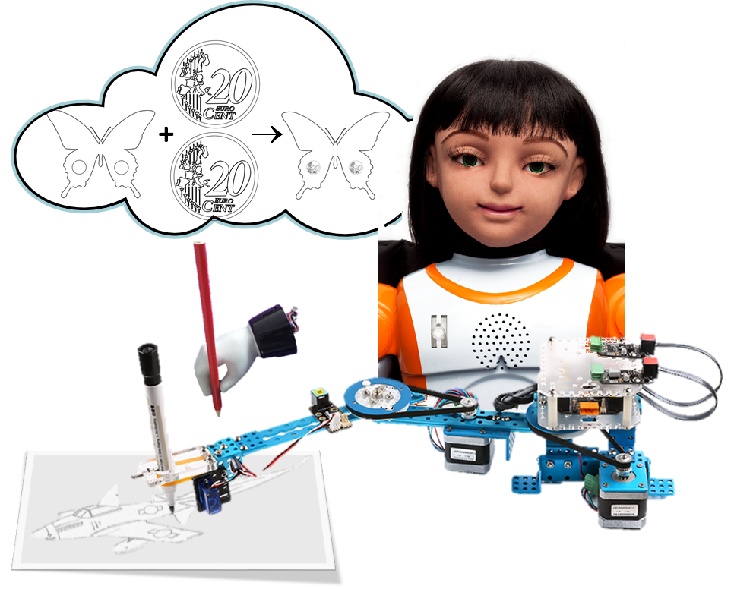

*Figure 5.* Social robot thinking up novel combinations and drawing them.

**5.1     Uniqueness of the Proposal**

There is no technological system deliberately designed to counter psychological fixation. Most problem-solving technologies rely on structured decisions and tackle equations with one variable unknown although they can do so for a complex of such equations. Current problem-solving systems are not capable of tackling under-determined problems. They cannot make unstructured decisions and come up with convergent solutions alone. AntiFix will be capable of dealing with ill-defined problem spaces.

Attempts to do theory-driven or knowledge-driven analysis of Big Data are rare. The current proposal wants to venture into predictive data analysis by formalizing the strategies creative designers use (e.g., selection and adaptation) to address an under-determined problem space. To my knowledge it is the first time that Big Data analysis is connected with artificial creativity.

Whereas most scientific research stays within one domain (e.g., computing), using one specific method (e.g., machine learning), this proposal is multidisciplinary (design, psychology, computing) and multimethod (participant observation, simulation, data analytics, psychological experiment) from the start. For PolyU, this opens opportunities for a tight collaboration between SD and COMP with one strand of work informing the other from student to professor level.

**5.2     Justification**

The time is ripe. Because on the one hand society faces globalized problems so big (e.g., global warming, immigration, ageing, pollution) that they go way beyond ‘scientific management’ or ‘strategic planning.’ There are simply too many variables unknown to calculate a valid result. On the other hand, we do have access to Big Data and have the tools to mine them but it is hard to ‘predict’ a pattern beforehand; most of the time we merely recognize patterns in hindsight. Additionally, we do have systems that are able to produce solutions and designs that humans acknowledge as ‘creative.’ However, these systems are not completed yet and to my knowledge, have not been connected to Big Data repositories before.

**6.     Significant and Possible Outcomes**

*6.1 Scientific significance*

Scrutiny of the tenets of creativity. Creativity is an elusive concept just like intelligence is. Yet, current academic and societal debate is filled with notions of ‘creative industries’ and ‘artificial intelligence.’ Questions arise as to what creativity is and how it is related to intelligence? Is intelligence a prerequisite of solving problems creatively or just an option? Similar to intelligence, can creativity be artificially generated? And will professional designers recognize the difference?

The current proposal attempts a down-to-earth approach, envisioning creativity as the retrieval of features to find an intersetion between exemplars from different categories. Intelligence would be the reasoning part; towards a goal or within constraints, to optimize the combination or to calculate its novelty (*freq./N*).

The test of this conceptualization is done against systems that hold other conceptualizations of creativity: The core of ACASIA is a feature matching system, neural nets such as CLARION basically are correlational (multiple linear regressions feed (non)linear activation functions), and case-based reasoning such as FAMING work from analogy (A:B::C:D). ACASIA claims that reasoning is subordinate whereas the other systems attach equal value (if not more).

The performance tests are not merely computerized. Creative output is tested against real design professionals in a manner that both design and computing are unaccustomed to: Using structured questionnaires to measure multiple creative dimensions in a Turing Test, including Bayesian and frequentist evaluation.

Theory-driven data mining. AntiFix also attempts the improvement of data analytics. ACASIA cannot only be used to detect novel combinatorial patterns when selection modules are off and data is explored without theory; when selection according to theory is ‘on,’ it should be possible to predict combinatorial patterns, according to the constraints of the field. Those predictions would not depend on coincidental correlations (neural nets) or on available solutions in other domains (case base), relatively unstructured feature sets from various domains would suffice to find intersections that are not correlational but based on ‘equality’ and that are independent of previous solutions, showing ‘irrational’ combinations that are yet (or can be) tested against the principles of a given theory.

*6.2 Academic and educational relevance*

Because AntiFix deliberately looks for the touchpoints between design and computing, both staff and students of SD and COMP are welcome to find plenty of opportunities to start working together. Students and staff of SD and COMP will find in AntiFix a common ground to lauch various projects together, which may be within the lines of AntiFix or that are completely new. SD and COMP will learn the different tongues they speak but more importantly, that computation is a logic, deterministic, and rationalist discipline, whereas design is associative, probabilistic, and empirical. Like AntiFix, the test is whether their combination leads to more and more novel synergistic interactions than either of the component parts alone.

*6.3 Practical application value*

The proposal is drafted as a competition between three techniques with fundamental differences. And although scientifically, this helps us understand what is and what is not substantive to creativity, on the application side there is no limit to combining the best parts of each approach and hybridize all three.

The three fundamentally different systems all claim to generate creative solutions to design problems: ACASIA is a fuzzy feature-matching system, CLARION a connectionist neural network, and FAMING is a case-based reasoning system. Simulation tests will be performed with a database for biomimetic design (combining animal and plant solutions with engineering) and evaluated by professional designers in an advanced version of the Turing Test. It may well be that the features a creative system should use are best described by FAMING’s metric diagrams combined with a set of functions and that the combination making in ACASIA gains from non-linear attractor neural networks a la CLARION, or that adaptation is fully covered by FAMING’s mechanisms to satisfy the functional constraints of a working mechanism.

The complementary systems then may operate as one (the AntiFix system). This hybridized version may not only result into usable (bio-inspired) innovations but also may advance a more theory-driven, predictive data analytics.

*6.4 Societal impact*

In facing societal problems (e.g., plastic pollution), many people are stuck in fixity and tend to repeat the same solutions (e.g., introduce another deposit scheme). Creative problem solving counters fixity because by its very nature, creativity transcends boundaries and refrains from known practice. Because the mechanisms of creativity are general, implemented in a social robot that has access to Cloud repositories, AntiFix may help, for example, older adults to stay independent for a longer period of time by improving their coping abilities. In science education and entertainment, children will be amazed that a robot thinks up funny combinations and can draw them (Figure 5) like an updated version of a Maillardet Automaton (from around 1800).[5] It may help businesses to find unexpected niches in the market. It may help find solutions to break down plastics when certain bacteria are fused with algae.

In all, to pay tribute to the great Book of Change (Yijing) and help advance society with of as yet unanticipated (bio-inspired) design concepts that can be sketched, annotated, and applied to the real world.

**7.     Schedule of Implementation**

**10.   Conclusions**

We will produce the AntiFix computational system, which conceptualizes creative solutions for engineering problems by combining data bases that appear to be unrelated at first. This system is the integrated result of simulation tests of three creativity systems, combining both reasoning and association strategies. AntiFix will be evaluated in data bases of biomimetics and in general Cloud repositories. The output is judged by professional designers for creativeness, innovativeness, usability, etc. AntiFix will be demonstrated by a social robot that sketches out and annotates innovative designs in engineering.

Additionally, AntFix offers a set of unique opportunities. It may shed light on the foundations of the creative process in a down-to-earth manner and help us understand what the role of intelligence is therein. The project shows how design, psychology, and computing are facets of the same diamond and can be integrated, leading to testable hypotheses. It will improve our thinking about predictive data analytics as a complement to the more common exploratory data-mining techniques.

AntiFix will lead to a set of biomimetic designs, sketched and annotated, that are artistic science fiction (without physical constraints) or applicable science faction (with physical constraints). Due to its general principles, AntiFix when applied to different problem domains may produce innovative solutions or suggestions to solutions in areas as diverse as ageing, global warming, and immigration.

For certain, AntiFix opens the door to researchers in industrial design engineering and computing, welcoming students and professors alike to let their creative veins run free in joint collaborations.

**11.   References**

Chartier, S., & Proulx, R. (2005). NDRAM: A nonlinear dynamic recurrent associative memory for learning bipolar and nonbipolar correlated patterns. *IEEE Transactions on Neural Networks, 16,* 1393-1400.

Cunningham, P. (1998). CBR: strengths and weaknesses. In A. Pasqual del Pobil, J. Mira, & M. Ali (Eds.), *Tasks and methods in applied artificial intelligence (IEA/AIE 1998). Lecture notes in computer science (lecture notes in artificial intelligence), 1416,* (pp. 517-524). Berlin, Heidelberg: Springer. doi: 10.1007/3-540-64574-8_437

Deldin, J.-M., & Schuknecht, M. (2014). The AskNature database: Enabling solutions in biomimetic design. In A. K. Goel et al. (Eds.), *Biologically Inspired Design* (pp. 17-27). London: Springer.

Faltings, B., & Sun, K. (1996). FAMING: Supporting innovative mechanism shape design. *Computer-Aided Design*, *28*(3), 207-216.

Helie, S., & Sun, R. (2010). Incubation, insight, and creative problem solving: A unified theory and a connectionist model. *Psychological Review, 117*(3), 994-1024. doi: 10.1037/a0019532.

Hoorn, J. F. (2002). A model for information technologies that can be creative. In T. T. Hewett, & T. Kavanagh (Eds.), *Proceedings of the fourth creativity and cognition conference, Loughborough, UK* (pp. 186-191). New York: ACM.

Hoorn, J. F. (2013). *How to build a Caredroid*. Delft, NL: TU Delft Library.

Hoorn, J. F. (2014). *Creative confluence.* Philadelphia, PA: John Benjamins.

Hoorn, J. F., & Siebes, R. (2015). Deep Learning for creative imagery [Software]. VU University Amsterdam.

Koppel, R. H., & Storm, B. C. (2014). Escaping mental fixation: Incubation and inhibition in creative problem solving. *Memory, 22*(4), 340-348. doi: 10.1080/09658211.2013.789914

Laird, B. K., Bailey, C. D., & Hester, K. (2018). The effects of monitoring environment on problem-solving performance. *The Journal of Social Psychology, 158*(2), 215-219. doi: 10.1080/00224545.2017.1324396

Maher, M. L., & Pu, P. (Eds.). (2014). *Issues and applications of case-based reasoning to design*. New York: Psychology Press.

Richter, M. M., & Weber, R. O. (2013). *Case-based reasoning*. Berlin, Heidelberg: Springer.

Santini, S., & Jain, R. (1999). Similarity measures. *IEEE Transactions on Pattern Analysis and Machine Intelligence, 21*(9), 871-883. doi: 10.1109/34.790428

Van der Wal, P., Giesen, H. J., & Videler, J. J. (2000). Radular teeth as models for the improvement of industrial cutting devices. *Materials Science and Engineering: C, 7*(2), 129-142.

1. For example, one methane plus 4 oxygen become two water plus one carbon-dioxide with chemical characteristics totally different from its constituent parts.
2. [http](http://alternativeto.net/software/atlasti/?license=free)://alternativeto.net/software/atlasti/?[license=free](http://alternativeto.net/software/atlasti/?license=free)
3. https://www.lucidchart.com/pages/examples/concept-map?search=&page=2
4. Alternatively, participants could estimate their level of confidence about ‘human-made’ (indicative) vs ‘machine-made’ (counter-indicative).
5. https://www.youtube.com/watch?v=C7oSFNKIlaM