Figure 1. FTIR litter chemistry data. (a) an NMDS plot of the litter chemistry data. The dependent variable for each scatterplot subplot is the area under the curve assigned to a specific spectral range for each sample’s FTIR spectra, with spectral area for (b) 1450 - 1475 cm-1, representative of C-H deformations in methyl and methylene groups, (c) 1700 - 1750 cm-1, representative of lipids (d) 1015 - 1080 cm-1, representative of C-O deformation of glycosidic bonds, (e) 1160 - 1230 cm-1, representative of carbohydrate C-O stretches, amide spectral bands (f) 1620 - 1645 cm-1 (amide 1) and (g) 1545 - 1600 cm-1 (amide 2), and carbohydrate ester bands (h) 970 - 1015 cm-1 and (i) 1100 - 1160 cm-1, which are representative of C-O stretches in carbohydrate esters

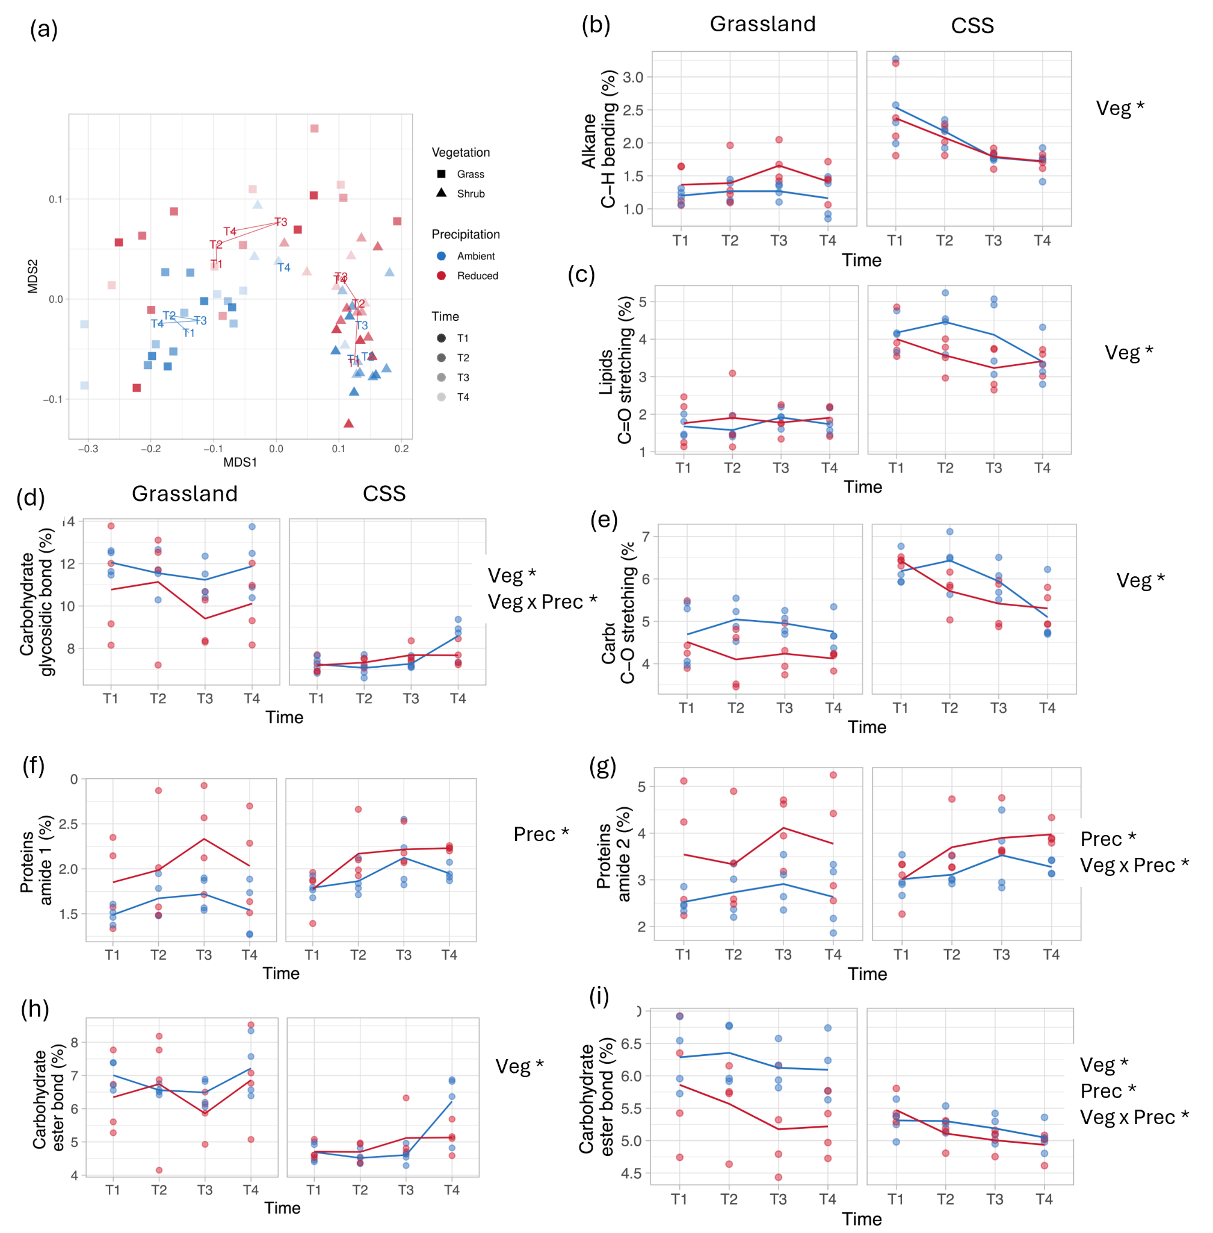

Figure 2. CAZyme gene abundance, where each panel is the abundance of CAZyme genes for a putative substrate. Significant effects by precipitation treatment, ecosystem, or their interaction or noted for each subplot with asterisks. Further information on p-values and effect sizes are in Table 3. The putative substrates are (a) peptidoglycan, (b) chitin, (c) cellulose, (d) hemicellulose, (e) starch, (f) polysaccharides, (g) lignin, (h) oligosaccharides

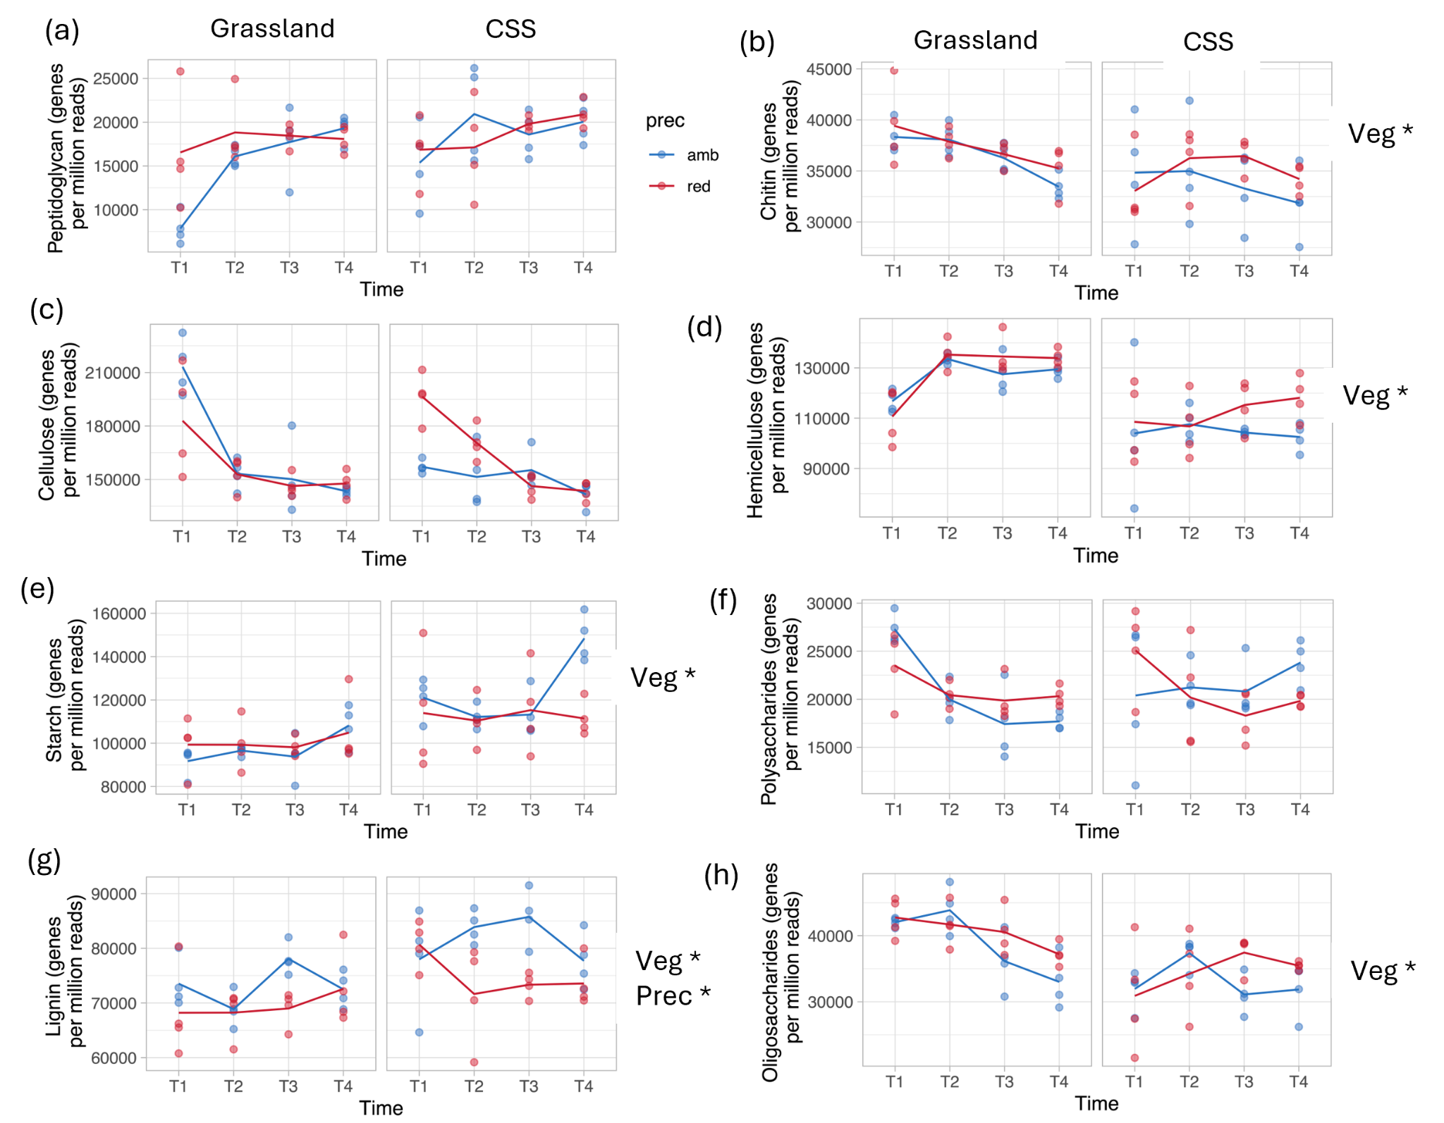

Figure 3. Changes in community composition over time and between different ecosystems estimated from reads. (a) Taxonomic diversity presented as the alpha diversity based on genus-level annotations derived from metagenomics. (b) Fungal:bacterial ratios estimated as abundance ratios of the two groups from the same dataset.

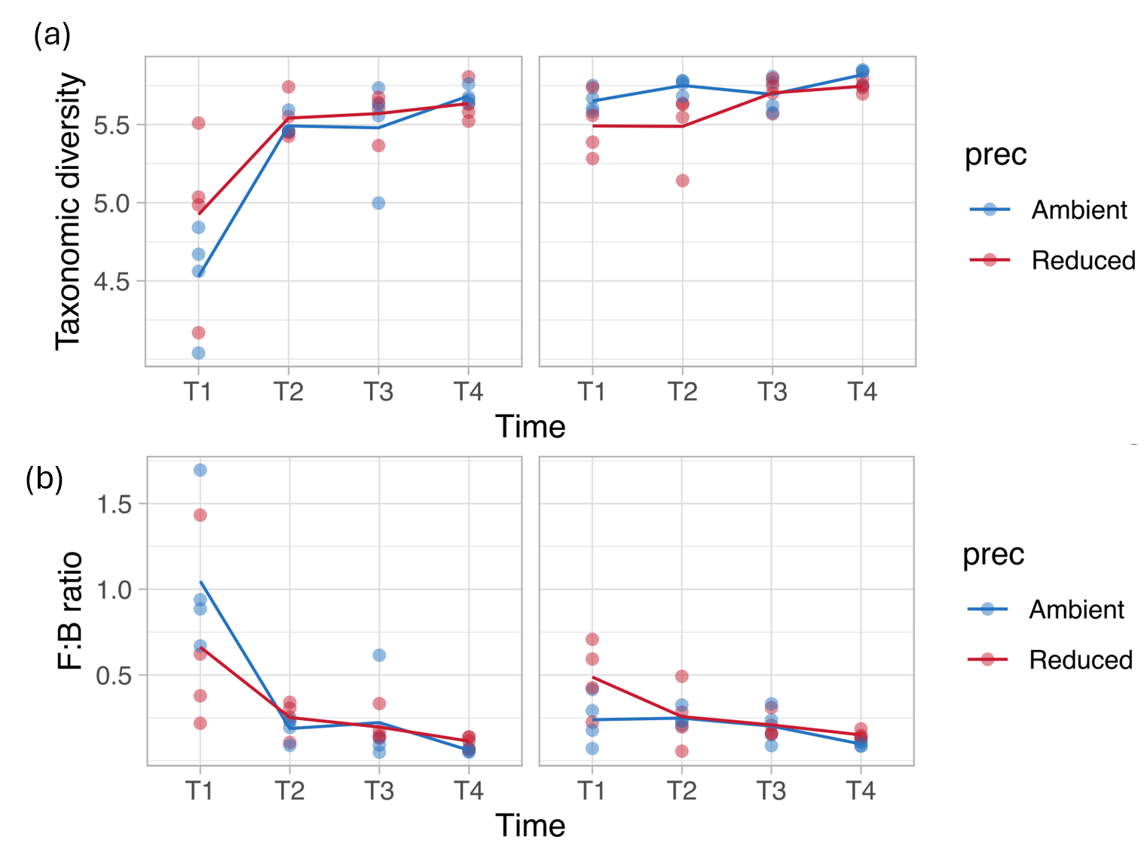

Figure 4. Vmax. Enzymes are (a) ɑ-glucosidase (AG), (b) β-glucosidase (BG), (c) β-xylosidase (BX), (d) cellobiohydrolase (CBH), (e) leucine aminopeptidase (LAP), and (f) N-acetyl-β-glucosaminidase. Vmax of the carbon-degrading hydrolases – AG, BG, BX, and CBH – are summed up in (g)

