Challenge Track
Computer Science: Program Your Own RPG

Instructions: Congratulations! You have been given this since you already know how to program. Read and think about this challenge question while in class today. You may discuss this with others in the challenge track by writing them notes, but you may not talk aloud. The challenge track questions are made to be between hard and impossible. Make as much progress as you can.

Bonus #1: You have a 2-dimensional game where an NPC (N) has a simple AI where it moves in a circle around a player P. Here is a sketch of the NPC moving counterclockwise around the player:
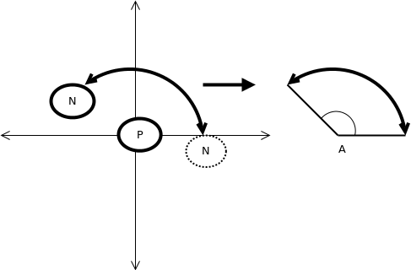
Develop an algorithm for the NPC. Things to help you get started:
- Both the Player and the NPC have variables coor_x and coor_y that hold their position.
- You will need to use functions Math.sin(double a) and Math.cos(double a).
- Remember that Sin = Opposite/Hypotenuse, and Cosign = Adjacent/Hypotenuse.
- It may be easier to start by assuming:
P.coor_x = 0, P.coor_y = 0
N.coor_x = x, N.coor_y = 0
- Next, assume that N.coor_y ≠ 0. Then assume P.coor_x ≠ 0 and P.coor_y ≠ 0.

You can write your algorithm in pseudocode (fake or made-up code); however, the fake code should resemble a language that if compiled would carry out the algorithm.

SUPER-Bonus: Implement the above algorithm in Java. The beginning of your methods will look like this:

public static double getnextNx(double Px, double Py, double Nx, double Ny, double A ){
….}
public static double getnextNy(double Px, double Py, double Nx, double Ny, double A ){
….}
Challenge Track
Computer Science: Program Your Own RPG

Instructions: Congratulations! You have been given this since you already know how to program. Read and think about this challenge question while in class today. You may discuss this with others in the challenge track by writing them notes, but you may not talk aloud. The challenge track questions are made to be between hard and impossible. Make as much progress as you can.

Bonus #2: You have a 2-dimensional grid where an NPC (N) has a simple AI where if a path exists the NPC finds the shortest path to a player P while avoiding obstacles (O). Here is a sketch of the NPC moving towards the player:
 |  |  | O |  | O | O | O
O | O |  | O | P
 |  |  | O | O | O | O
 |  |  |  | O | O
 | O |  |  | O
 |  | O | N | O | O
 |  |  |  |  |  |  | O

Develop an algorithm for the NPC. Things to help you get started:
- The positions of the player, the obstacles and the NPC are kept in a 2-dimensional array, map[MAX][MAX].
- The NPC always “knows” the player’s position, but must calculate the shortest path.
- The algorithm will look similar to the fill algorithm for the paint bucket in the drawing program Paint.

You can write your algorithm in Java using recursion.

SUPER-Bonus: Implement the above algorithm in Java without recursion. You may use for loops and while loops, but methods may not call themselves.

SUPER-SUPER-Bonus: In our game we have an Ice Queen on an MMORPG server. The Queen can freeze all players, and can kill any players she can touch. We want to create an algorithm that maximizes the number of players the Ice Queen kills. Recreate the above algorithm so that the NPC can find the shortest path to any number of players P1, P2, ... Pn.

Hints:
- First recreate the algorithm for two players P1 and P2.
- You should not need to find more than 3 shortest paths for 2 players.
- Figure out how many paths you would need for 4, 5 players, etc.

