PitchVision: How Much Temporal Context Does a Lightweight Soccer Action Spotter Need?
A controlled study of the temporal context window on SoccerNet Ball Action Spotting
PARC 2026 AI League — Final Report · Team [TEAM NAME] · [Member names]

1. Task Definition, Evaluation Protocol, and Data
Task. We study action spotting, introduced by Giancola et al. [1]: instead of predicting start/end boundaries, a model must find the single timestamp (anchor) at which a soccer event occurs. A video is represented as a sequence of per-second feature vectors X = {x₁,…,x_T}, x_t ∈ ℝ⁵¹². Ground truth is G = {(t*ᵢ, c*ᵢ)} with class c*ᵢ ∈ {1,…,C}; the model outputs scored candidates (t̂ⱼ, ĉⱼ, sⱼ). Our application motivation (PitchVision) is a low-cost system that turns match video into a searchable timeline of ball events for coaches and analysts in resource-constrained settings. This report contains a research study on broadcast footage; a single-camera deployment is a future scenario that we have not tested.
Data. We use the SoccerNet Ball Action Spotting (BAS) 2024 data [2, 3]: EFL Championship (2019–20) broadcast videos annotated with 12 ball-centric classes (PASS, DRIVE, HEADER, HIGH PASS, OUT, CROSS, THROW IN, SHOT, BALL PLAYER BLOCK, PLAYER SUCCESSFUL TACKLE, FREE KICK, GOAL) at millisecond precision. Our copy contains 4 training, 1 validation and 2 test games, and we use all seven. From each we take the first 2,500 s, sampled at 1 frame/s from the 224p, 25 fps videos, giving 10,000 s of training material and three disjoint evaluation matches. Annotations are binned to the containing second. The footage is multi-camera broadcast and the seven games involve fourteen different clubs. Table 1 gives the class distribution of the slices used.
Split (first 2,500 s each) | All | PASS | DRIVE | HP | HDR | OUT | TI | CRS | BPB | PST | SHOT | FK | GOAL
Train ×4 (pooled) | 2,952 | 1,257 | 1,099 | 199 | 153 | 136 | 88 | 74 | 54 | 19 | 33 | 5 | 1
Blackburn–Forest | 864 | 355 | 320 | 47 | 47 | 30 | 20 | 17 | 10 | 11 | 6 | 1 | 0
Brentford–Bristol City | 871 | 369 | 303 | 58 | 36 | 36 | 22 | 17 | 14 | 7 | 9 | 0 | 0
Hull City–Sheff. Wed. | 711 | 271 | 249 | 60 | 45 | 32 | 21 | 15 | 9 | 0 | 7 | 2 | 0
Leeds–West Brom | 672 | 262 | 227 | 34 | 25 | 38 | 25 | 25 | 21 | 1 | 11 | 2 | 1
Valid: Middlesbrough–PNE | 725 | 263 | 259 | 53 | 50 | 34 | 25 | 10 | 12 | 9 | 9 | 0 | 1
Test A: Stoke–Huddersfield | 842 | 364 | 314 | 27 | 41 | 31 | 23 | 14 | 14 | 10 | 4 | 0 | 0
Test B: Reading–Fulham | 996 | 465 | 385 | 41 | 26 | 20 | 13 | 13 | 13 | 8 | 9 | 0 | 3
Table 1. Positive seconds per class after 1-s binning (same-second duplicates merged; the pooled training row counts distinct seconds and is therefore lower than the sum of the per-game rows). HP = High Pass, HDR = Header, TI = Throw In, CRS = Cross, BPB = Ball Player Block, PST = Player Successful Tackle, FK = Free Kick. GOAL has a single training instance and FREE KICK five, so neither is learnable here; classes absent from a split are excluded from that split’s mAP, so validation and Test B average 11 classes and Test A averages 10.
The events are dense: one every ≈3.4 s (validation), 3.0 s (Test A) and 2.5 s (Test B), against one every 6.9 minutes in the original SoccerNet [1]. As Section 4 shows, this density changes how tolerance-based metrics behave, which is why we report a random-score floor beside every result.
Evaluation protocol. Following [1], a candidate of class c counts as a true positive (TP) if |t̂ − t*| ≤ δ for an unmatched ground-truth event of class c. Candidates are processed in descending score order and each event can be matched once, to the nearest unmatched event. Further candidates near an already-matched event are false positives (FP), and unmatched events are false negatives (FN) (Fig. 1b). Per class and tolerance we compute 11-point interpolated average precision (AP) [4]. mAP_δ averages AP over the classes that have at least one validation event, and Average-mAP averages over tolerances:
AP_c,δ = (1/11) Σ_{r∈{0,0.1,…,1}} max_{r′≥r} P(r′), Average-mAP = (1/|Δ|) Σ_{δ∈Δ} mAP_δ, Δ = {1, 3, 5, 10, 20, 30} s
We use two candidate-generation rules. Protocol A is the protocol declared in our proposal: every second is a candidate and the 200 highest-scoring seconds per class are ranked. Protocol B was added after the results in Section 4.3 (i.e. post hoc): candidates are local score maxima within ±1 s, with no cap. For both protocols we report a random-score floor, the same metric computed on uniformly random scores (20 draws). Our Average-mAP definition differs from [1] (area under the curve for δ = 5–60 s) and from the official BAS challenge metric, so our numbers are not comparable with the 49.7% reported in [1].
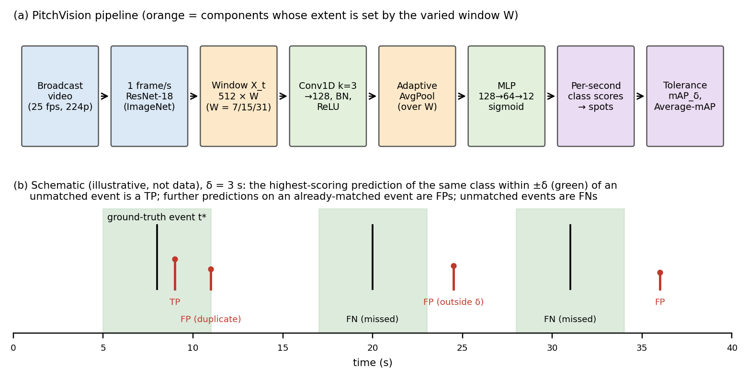
Figure 1. (a) The PitchVision pipeline; the context window W (orange) is the experimental variable. (b) Illustrative schematic of tolerance-based matching (not experimental data).

2. Neural Network / Machine Learning Model

2.1 Reference model: the SoccerNet baseline
Giancola et al. [1] extract ResNet-152, C3D or I3D features every 0.5 s, reduce them to 512 dimensions with PCA, and classify one-minute chunks (120 feature vectors) using a pooling layer (mean, max, a temporal CNN, SoftDBOW, NetFV, NetVLAD or NetRVLAD) followed by a fully connected layer with sigmoid outputs and a weighted binary cross-entropy loss. Spotting is done by sliding the chunk classifier with a 1-s stride and extracting candidates from the score curve (watershed segments or non-maximum suppression). Their best chunk classifier reaches 67.8% classification mAP, and their best spotting baseline 49.7% Average-mAP, on three sparse classes (Goal, Card, Substitution). Their "training on smaller windows" experiment (60 s vs 20 s vs 5 s chunks) already shows that the amount of temporal context changes spotting behaviour. Our study examines that question with a much smaller model on a dense 12-class task.

2.2 PitchVision temporal spotter
Features. Each sampled frame is resized to 224×224 (the 16:9 aspect ratio is not preserved) and passed through an ImageNet-pretrained ResNet-18 [5] with its classification layer removed, giving x_t ∈ ℝ⁵¹². Unlike [1], we use one frame per second and no PCA. Extraction takes 38–51 s per 2,500 s of video on a Tesla T4, and the arrays are cached so every condition sees byte-identical inputs.
Spotter. For each target second t the model receives a centred window X_t = [x_{t−⌊W/2⌋}, …, x_{t+⌊W/2⌋}] ∈ ℝ^{512×W}. The window passes through a 1-D temporal convolution (512→128 channels, kernel 3, padding 1), batch normalisation and ReLU, which give local features h_τ ∈ ℝ¹²⁸. Adaptive average pooling over the window, z_t = (1/W) Σ_τ h_τ, is followed by an MLP (128→64, ReLU, dropout 0.3, 64→12) and element-wise sigmoids that output 12 independent class probabilities. The design follows the temporal-convolution family [6] and replaces the learnable pooling of [1] with convolution plus average pooling. It has 206,028 trainable parameters (Table 2). Because of the adaptive pooling, the same architecture accepts any W without changing any weight shape, which is what lets W be the only varied factor.
Layer | Input → Output | Parameters
Conv1d (k=3, p=1) | [B,512,W] → [B,128,W] | 196,736
BatchNorm1d + ReLU | [B,128,W] → [B,128,W] | 256
AdaptiveAvgPool1d(1) + Flatten | [B,128,W] → [B,128] | 0
Linear + ReLU + Dropout(0.3) | [B,128] → [B,64] | 8,256
Linear (+ sigmoid) | [B,64] → [B,12] | 780
Total |  | 206,028
Table 2. Architecture; parameter counts recomputed from the layer definitions.
Loss. Training targets are the 12-dimensional label vector of the centre second only (y_t,c = 1 if an event of class c is anchored at second t). In the pooled 10,000-second training set only 29.5% of seconds carry any event, and individual classes are far rarer (GOAL: 1 instance, SHOT: 33), so we use positively weighted binary cross-entropy (PyTorch BCEWithLogitsLoss, pos_weight α = 15), analogous to the weighting strategy of [1]:
L = −(1/C) Σ_c [ α·y_c·log σ(ℓ_c) + (1 − y_c)·log(1 − σ(ℓ_c)) ], α = 15

2.3 Why the window W should matter: the part of the model we modify
The convolution only sees 3 seconds at a time, and W controls how many of these local features are averaged. Ignoring zero-padding at the window edges, moving from second t−1 to t replaces one averaged term:
z_t − z_{t−1} ≈ ( h_{t+⌊W/2⌋} − h_{t−⌊W/2⌋−1} ) / W
Consecutive windows share a fraction (W−1)/W of their inputs (0.857, 0.933 and 0.968 for W = 7, 15, 31), and the pooled representation, and therefore the score, can change by at most O(1/W) per second. A larger W thus gives smoother score curves with broader peaks. With events only ≈3.4 s apart, broad peaks should merge neighbouring events and blur their timing. This is the formal basis for our hypothesis (Section 3). A larger W also adds context (e.g. build-up play), which could help recognition at coarse tolerances; the experiment tests which effect dominates.

2.4 Implementation
The model is implemented in PyTorch [7] with Adam [8] (learning rate 10⁻³, weight decay 10⁻⁴), batch size 64 and 12 epochs. Training on the full 10,000-second corpus takes 7.5–10.4 s per run on a Colab Tesla T4, which is what makes a 15-run design (3 conditions × 5 seeds) practical. We first attempted T-DEED [9], a model designed for precise event spotting on this dataset, but the two recorded runs ended during setup without training (empty logs), so we moved to the lightweight model above.

3. Experiment
Research question. How does the temporal context window W affect the temporal precision and overall spotting performance of a lightweight Conv1D spotter? In particular, does its effect differ between fine (δ ≤ 5 s) and coarse (δ ≥ 10 s) tolerances?
Hypotheses (stated in the proposal before the multi-seed experiment). H1: increasing W reduces spotting mAP at every tolerance, because averaging dilutes short, localised event evidence (Section 2.3). H2: the benefit of a shorter window is relatively largest at fine tolerances, because W mainly limits temporal resolution. H1 is falsified if W = 31 matches or beats W = 15 (or W = 7 fails to beat W = 15) consistently across seeds. H2 is falsified if the relative gain of W = 7 over W = 15 is not larger at δ ≤ 5 s than at δ ≥ 10 s.
Element | Specification
Independent variable | Context window W: Condition 1 = 7 s, Baseline = 15 s, Condition 2 = 31 s
Control variables | ResNet-18 features (512-d, 1 fps); architecture (Table 2); weighted BCE, α = 15; Adam, lr 10⁻³, weight decay 10⁻⁴; batch 64; 12 epochs; identical 10,000-s training corpus; common evaluation range (t = 15…2484, 2,470 s) on every match; seeds 0–4 re-applied before every run; deterministic cuDNN
Dependent variables | mAP@1, 3, 5, 10, 20, 30 s; Average-mAP; per-class AP; training loss per epoch; training time; inference throughput; lag-1 autocorrelation of score curves (smoothness); TP/FP/FN and timing offsets
Evaluation splits | Validation (Middlesbrough–PNE) used during development; two fully held-out matches (Stoke–Huddersfield, Reading–Fulham) used for no training and no design decision
Reference points | Random-score floor per split (20 draws); reproduction of the earlier single-match configuration
Table 3. Experimental design. W = 15 sits in the middle of the range, so one condition shortens and the other lengthens the context. Each of the 15 runs (3 conditions × 5 seeds) is evaluated on all three matches.
Methodology and code. An earlier version of this experiment trained on a single match (2,500 s) and evaluated only on the validation match; its results are retained for the data-scale comparison in Section 4.8. The study reported here scales training to four matches and adds two held-out test matches, keeping the architecture, windowing, loss and hyper-parameters unchanged. The pipeline is: extract features once per match → pool the four training matches into a single array with a match-id vector → train → evaluate on three matches → compute random-score floors. Specific methodological points:
(i) Boundary masking. The pooled training array concatenates four matches, so a naive sliding window could span the end of one match and the start of another. Every training window is required to have the same match id at its first and last frame, which removes 18, 42 and 90 windows at W = 7, 15 and 31 respectively (three seams × (W − 1)), leaving 9,976 / 9,944 / 9,880 valid windows.
(ii) Held-out protocol. The two test matches were feature-extracted and scored only after all design choices were fixed. No hyper-parameter, threshold, protocol or figure was chosen with reference to them.
(iii) Seeding and reproducibility. Seeds 0–4 are re-applied immediately before each run with deterministic cuDNN. Re-running the seed-0 single-match configuration reproduced the saved predictions bit-exactly (maximum absolute difference 0.000000 across all three conditions), and re-training all 15 scaled runs reproduced their stored validation Average-mAP to within 10⁻⁹, so the released checkpoints are the models behind the reported numbers.
(iv) Identical inputs across conditions. Features are extracted once and cached, so the three conditions differ only in W. All conditions are evaluated on the same 2,470 seconds of each match.
(v) Evidence. All metrics, per-class APs, loss curves and timings are written to results_v3.json; error diagnostics to analysis_v3.json. Relative changes are computed as (new − baseline)/baseline.
Deviations from the concept note and proposal, disclosed. The concept note proposed windows of 5/20/60 s plus additional event types (fouls, cards, substitutions), player context and game-phase detection; the proposal and this study use 7/15/31 s (odd lengths give symmetric windows centred on the target second) and the 12 BAS classes. Player context and game-phase detection were not implemented. The proposal trained on one match and reported no test-set result; this final study trains on four matches and reports two held-out matches. Protocol B (Section 1) was added after observing that the pre-declared Protocol A saturates on dense events, and is reported throughout as a post-hoc sensitivity check rather than as the primary metric.

4. Experimental Results and Discussion

4.1 Reproduction and scale
Re-running the seed-0 single-match configuration reproduced the saved predictions bit-exactly (maximum absolute difference 0.000000 for all three conditions), and re-training all 15 scaled runs reproduced their stored validation Average-mAP to within 10⁻⁹, confirming that the released checkpoints are the models behind the reported results. Scaling training from one match to four (2,500 → 10,000 s) improved every condition on validation: Average-mAP under Protocol A rose from 0.1476 to 0.1928 (+30.6%) at W = 7, from 0.1177 to 0.1706 (+44.9%) at W = 15, and from 0.0803 to 0.1384 (+72.4%) at W = 31. The largest relative gain went to the worst condition, indicating that longer context is more data-hungry, but the ordering of conditions was unchanged, so the effect of W is not an artefact of limited data. Four times the data also lifted W = 7 from below the validation random floor (0.1476) to 13.8% above it.

4.2 Main results
W | Valid A | Valid B | Stoke A | Stoke B | Reading A | Reading B
7 | 0.1928±0.0162 | 0.3458±0.0162 | 0.1668±0.0148 | 0.3090±0.0149 | 0.1419±0.0110 | 0.2806±0.0081
15 | 0.1706±0.0069 | 0.3154±0.0096 | 0.1067±0.0112 | 0.2261±0.0240 | 0.1102±0.0165 | 0.2474±0.0288
31 | 0.1384±0.0255 | 0.2695±0.0279 | 0.0858±0.0078 | 0.2127±0.0127 | 0.0993±0.0108 | 0.2476±0.0167
Random | 0.1694±0.0096 | 0.2249±0.0092 | 0.1661±0.0114 | 0.2368±0.0110 | 0.1516±0.0106 | 0.2224±0.0102
Table 4. Average-mAP (δ ∈ {1,3,5,10,20,30} s) by condition and evaluation match, mean ± std over 5 seeds. A = pre-declared protocol; B = post-hoc peak-picking protocol. Random-score floors highlighted.
Comparison | Valid A | Valid B | Stoke A | Stoke B | Reading A | Reading B
W = 7 vs baseline | +13.0% (5/5) | +9.6% (5/5) | +56.4% (5/5) | +36.6% (5/5) | +28.7% (5/5) | +13.4% (4/5)
W = 31 vs baseline | −18.8% (1/5) | −14.6% (0/5) | −19.6% (0/5) | −6.0% (2/5) | −9.9% (1/5) | +0.1% (3/5)
W = 7 vs random | +13.8% | +53.8% | +0.4% | +30.5% | −6.4% | +26.2%
W = 15 vs random | +0.7% | +40.3% | −35.8% | −4.5% | −27.3% | +11.3%
W = 31 vs random | −18.3% | +19.8% | −48.4% | −10.2% | −34.5% | +11.3%
Table 5. Relative change against the W = 15 baseline and against the random-score floor. Bracketed counts give the seeds (of 5) in which that condition exceeded the baseline.
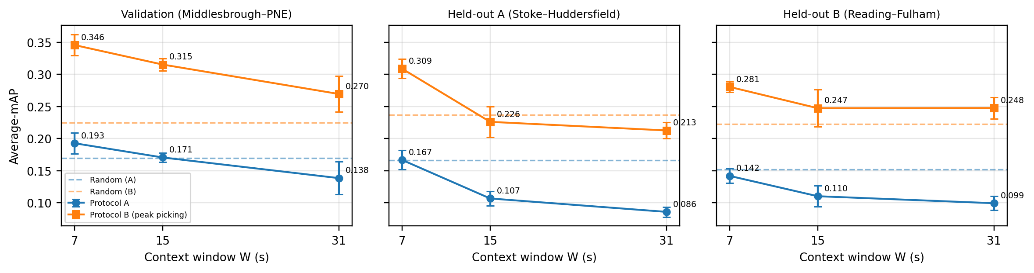
Figure 3. Average-mAP versus context window W on all three matches; dashed lines are the random-score floors for that match and protocol. W = 7 is the only condition above both floors on every match.

4.3 Hypothesis tests
H1a — a shorter window beats the baseline: supported and replicated. W = 7 exceeds W = 15 on all three matches under both protocols, in 5/5 seeds in five of the six split–protocol combinations and 4/5 in the sixth. Reproduction across three fixtures, two protocols and five seeds each makes this the most robust finding of the study.
H1b — a longer window underperforms the baseline: supported under Protocol A only. W = 31 falls below baseline under Protocol A on every match (−18.8%, −19.6%, −9.9%). Under Protocol B the deficit shrinks from −14.6% (validation) to −6.0% (Stoke) and disappears on Reading (+0.1%, 3/5 seeds higher). We therefore do not claim a strict monotonic ordering W = 7 > W = 15 > W = 31 on unseen data; what holds consistently is that the shortest window always wins and the longest never wins.
H2 — the short-window advantage concentrates at fine tolerances: partly supported. The gain of W = 7 over baseline from δ = 1 s to δ = 30 s declines as predicted on validation (+29% → +15%) and Stoke (+90% → +43%), but is flat on Reading (+23%, +31%, +32%, +24%, +33%, +27%). H2 replicates on two of three matches and fails on the third, so we report it as suggestive rather than established. What does hold everywhere is the comparison against chance: W = 7 beats the random floor by +169% / +125% / +88% at δ = 1 s and +48% / +36% / +30% at δ = 5 s, and falls to or below it by δ = 10–20 s on every match.
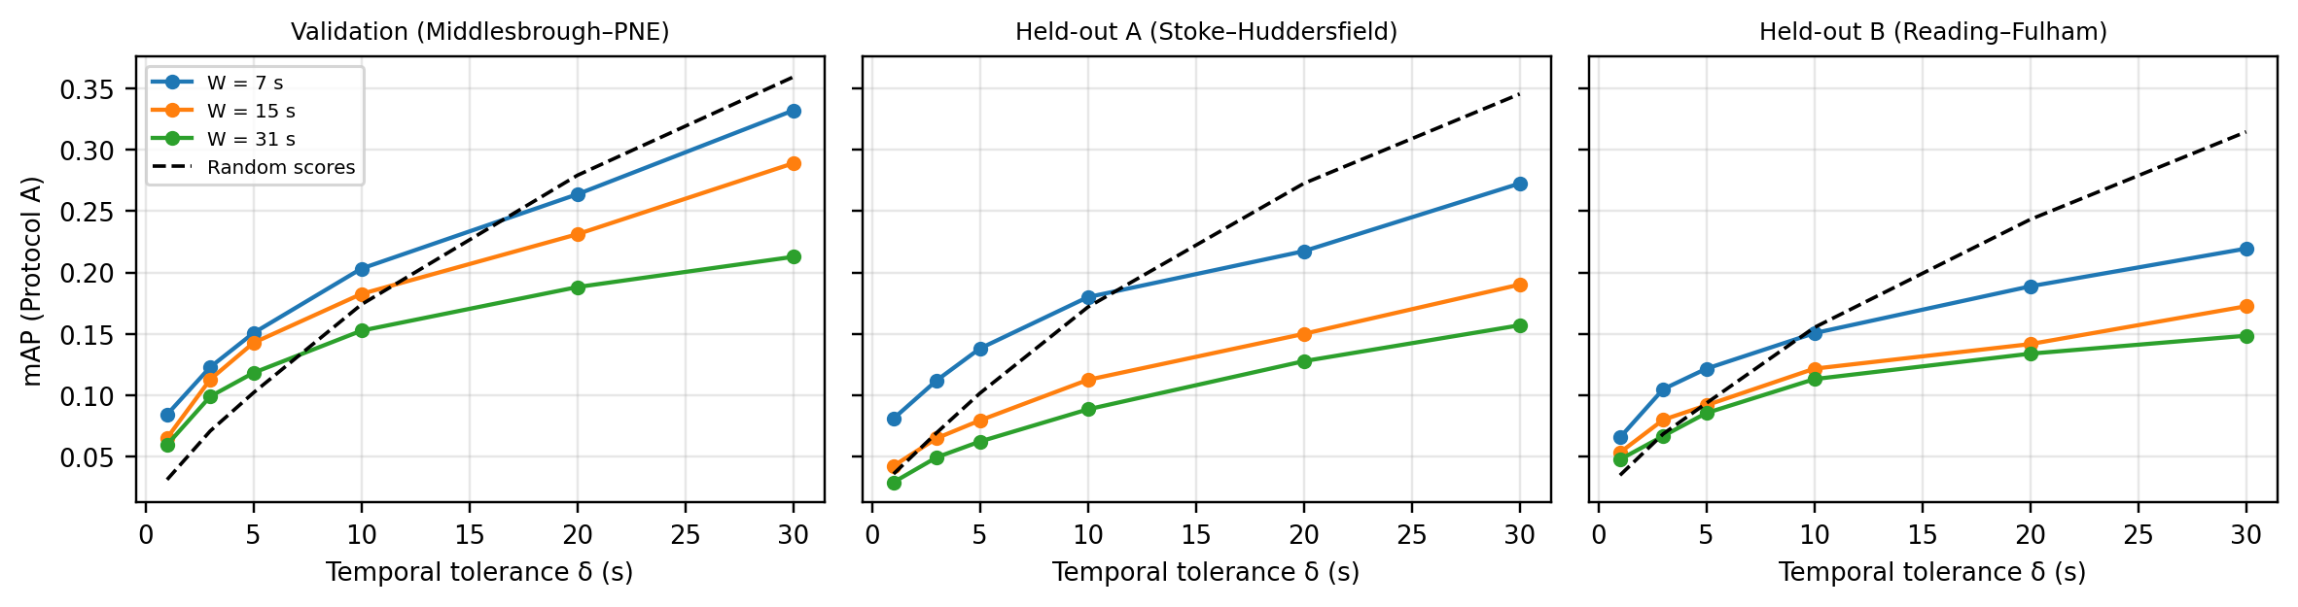
Figure 4. mAP versus temporal tolerance δ under Protocol A. All conditions converge toward or below the random floor (dashed) as δ grows, because at loose tolerances the metric is dominated by event density rather than model skill.

4.4 Comparison with chance
With one event every 2.5–3.4 s, a randomly placed candidate lands near some event almost always at loose tolerances, so absolute values are meaningless without the floor. Under Protocol B, W = 7 is the only condition above chance on every match (+53.8%, +30.5%, +26.2%). Averaged over the two held-out matches it is +28.4% above chance, against +3.1% for W = 15 and +0.2% for W = 31 — the baseline and long-window conditions are indistinguishable from random guessing on unseen footage. Under Protocol A no condition reliably beats the floor on held-out data (W = 7: +0.4% on Stoke, −6.4% on Reading), yet the same predictions beat it decisively at δ ≤ 5 s on all three matches. Averaging across tolerances therefore conceals genuine fine-grained skill behind coarse-tolerance noise, and coarse-tolerance mAP on dense event vocabularies should always be reported with a random-score floor.

4.5 Generalisation to unseen matches
Measured by Protocol B Average-mAP, W = 7 retains 85% of its validation performance on the two held-out matches (0.3458 → 0.3090, 0.2806) and stays clearly above chance on both; W = 15 retains 75% and drops to chance level on average. The advantage of W = 7 over the baseline is in fact larger on the held-out matches (+36.6%, +13.4%) than on validation (+9.6%), consistent with longer windows partially fitting match-specific context that does not transfer. Two qualifications apply: the held-out matches disagree about W = 31 (clearly worst on Stoke, tied with baseline on Reading), and all seven matches come from one competition and a single matchday, so this establishes cross-fixture transfer rather than general robustness.

4.6 Mechanism and error analysis
Score smoothness rises with W as Section 2.3 predicts: lag-1 autocorrelation is 0.915 (W = 7), 0.958 (W = 15) and 0.990 (W = 31), tracking the window-overlap fractions 0.857, 0.933 and 0.968.
Match | W | Peaks/class | TP | FP | Dup. | FN | Median |offset| | TPs within 1 s
Validation | 7 | 314.9 | 381 | 238 | 92 | 330 | 1 s | 57.2%
Validation | 15 | 235.5 | 312 | 292 | 39 | 399 | 1 s | 53.8%
Validation | 31 | 197.8 | 221 | 285 | 32 | 490 | 1 s | 50.2%
Test A (Stoke) | 7 | 319.9 | 384 | 328 | 87 | 443 | 1 s | 66.9%
Test A (Stoke) | 15 | 241.1 | 330 | 288 | 39 | 497 | 1 s | 64.2%
Test A (Stoke) | 31 | 191.3 | 226 | 254 | 27 | 601 | 1 s | 52.2%
Test B (Reading) | 7 | 342.9 | 469 | 332 | 65 | 509 | 1 s | 65.7%
Test B (Reading) | 15 | 249.8 | 355 | 270 | 33 | 623 | 1 s | 62.3%
Test B (Reading) | 31 | 191.3 | 258 | 207 | 15 | 720 | 1 s | 67.4%
Table 6. Error diagnostics, seed 0, δ = 5 s, using the top-N local peaks per class where N is the number of ground-truth events of that class.
The recall effect is consistent on all three matches: moving from W = 7 to W = 31 cuts distinct score peaks per class by 37–44%, reduces true positives by 41–45% and raises false negatives by 36–48%, while false positives fall only slightly. The dominant failure mode of long context is therefore merging neighbouring events into one broad peak and missing them entirely. The timing of detections that are found is largely unaffected: the median absolute offset is 1 s in every condition on every match. The share of true positives within 1 s falls with W on validation (57.2% → 50.2%) and Stoke (66.9% → 52.2%) but rises on Reading (65.7% → 67.4%), so we do not claim that shorter windows improve timing precision. The robust mechanism is loss of recall through peak merging, not temporal displacement.
Training loss is consistent with the same mechanism: after 12 epochs it settles near 0.32 (W = 7), 0.36 (W = 15) and 0.43 (W = 31), with very small spread across seeds (Figure 5). Larger windows fit the per-second targets worse even on the training corpus, as expected when heavily overlapping inputs are averaged. Training loss is not an evaluation metric and is reported only as a convergence check.
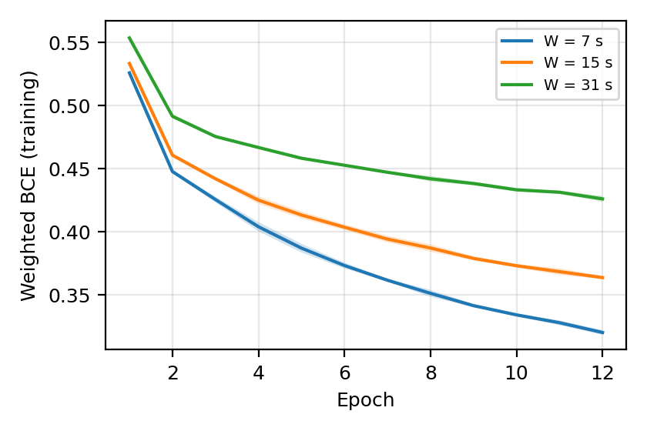 | Figure 5. Weighted BCE training loss per epoch on the pooled 10,000-second corpus, mean ± std over 5 seeds. All conditions converge smoothly within 12 epochs; the ordering of final training loss matches the ordering of spotting performance, indicating underfitting rather than overfitting at large W.
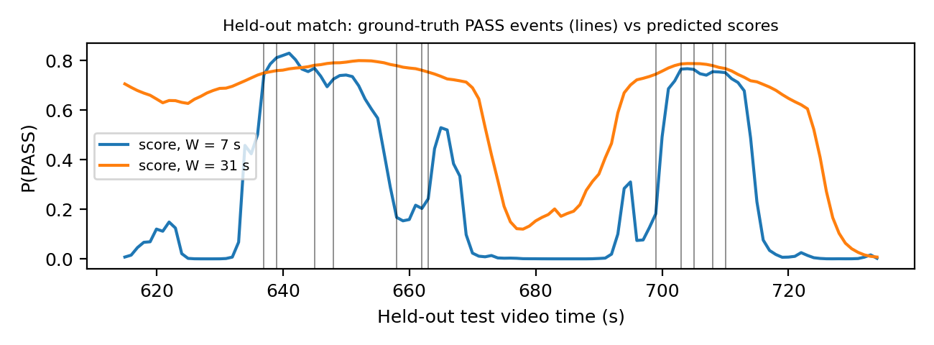
Figure 2. A 2-minute excerpt from held-out Test A (seed 0): predicted PASS probability against ground-truth PASS anchors (vertical lines). The W = 31 curve (orange) is a broad plateau near 0.8 that cannot resolve individual events; the W = 7 curve (blue) rises and falls sharply, separating bursts of play from stoppages. Neither separates events 1–3 s apart, which bounds achievable fine-tolerance performance for this architecture.

4.7 Per-class behaviour
Under Protocol B at δ = 5 s, W = 7 achieves the best AP in 8 of 10 classes on Stoke, 6 of 11 on validation and 4 of 11 on Reading, so the per-class picture is match-dependent. The exception is the two highest-frequency classes, where the ordering is identical everywhere: DRIVE scores 0.524 / 0.514 / 0.496 at W = 7 against 0.413 / 0.426 / 0.374 at W = 15 and 0.377 / 0.341 / 0.312 at W = 31 (validation / Stoke / Reading), and PASS scores 0.505 / 0.458 / 0.425 against 0.405 / 0.390 / 0.342 and 0.317 / 0.319 / 0.255. DRIVE and PASS account for roughly 70% of all events, so the aggregate advantage of W = 7 is driven mainly by the classes where the evidence is strongest (6 of 6 match–class combinations). Classes with few events are unreliable: SHOT has 9, 4 and 9 events across the three matches, PLAYER SUCCESSFUL TACKLE 9, 10 and 8, and GOAL 1, 0 and 3 against a single training instance, so we draw no conclusions from them.

4.8 Efficiency
The model has 206,028 parameters. On a Colab Tesla T4, 12 epochs over 10,000 s of training take 7.5 s at W = 7 and W = 15 and 10.4 s at W = 31; inference runs at roughly 2–3 × 10⁴ one-second windows per second. Feature extraction dominates end-to-end cost at 38–51 s per 2,500 s of video. The shortest window is simultaneously the most accurate, the most transferable and among the cheapest, so this study found no accuracy–efficiency trade-off: W = 7 dominates on both axes.

4.9 Limitations, generalisation and applicability
(i) Scale. Four training and three evaluation matches, 2,500 s each, all from one competition and a single matchday (1 October 2019).
(ii) Metric. Protocol A saturates on dense events; Protocol B was defined after observing that saturation and uses a single untuned peak radius (±1 s). Neither is the official SoccerNet BAS metric, so our numbers are not comparable with published leaderboard results.
(iii) Sub-claims that did not replicate. The held-out matches disagree on whether W = 31 underperforms the baseline under Protocol B; H2’s fine-tolerance concentration appears on two matches but not the third; and the timing-precision trend reverses on Reading. Three matches cannot separate these from fixture-level variation.
(iv) Class coverage. Five classes have 14 or fewer events in an evaluation split; GOAL and FREE KICK are effectively unlearnable with one and five training instances.
(v) Camera setting. All footage is multi-camera broadcast, so nothing here demonstrates single-camera performance — the untested central assumption of the product concept.
Implications and next steps. For a PitchVision-style match index the measurements give direct guidance: use short temporal context (≤ 7 s), include peak picking in the spotting stage, and report confidence against a chance baseline rather than raw mAP. Current accuracy supports assisted review — surfacing candidate moments for a human to confirm — rather than unattended automatic indexing. The immediate steps are to test windows below 7 s, to evaluate above 1 fps for finer timing, and to collect single-camera footage before any deployment claim.

5. References
[1] S. Giancola, M. Amine, T. Dghaily, and B. Ghanem. SoccerNet: A scalable dataset for action spotting in soccer videos. In Proc. IEEE/CVF CVPR Workshops, pp. 1711–1721, 2018.
[2] A. Cioppa, S. Giancola, V. Somers, et al. SoccerNet 2024 challenges results. arXiv:2409.10587, 2024.
[3] S. Giancola, A. Cioppa, B. Ghanem, and M. Van Droogenbroeck. Deep learning for action spotting in association football videos. arXiv:2410.01304, 2024.
[4] M. Everingham, L. Van Gool, C. K. I. Williams, J. Winn, and A. Zisserman. The PASCAL Visual Object Classes (VOC) challenge. International Journal of Computer Vision, 88(2):303–338, 2010.
[5] K. He, X. Zhang, S. Ren, and J. Sun. Deep residual learning for image recognition. In Proc. IEEE CVPR, pp. 770–778, 2016.
[6] C. Lea, M. D. Flynn, R. Vidal, A. Reiter, and G. D. Hager. Temporal convolutional networks for action segmentation and detection. In Proc. IEEE CVPR, pp. 156–165, 2017.
[7] A. Paszke, S. Gross, F. Massa, et al. PyTorch: An imperative style, high-performance deep learning library. In Advances in Neural Information Processing Systems 32, 2019.
[8] D. P. Kingma and J. Ba. Adam: A method for stochastic optimization. In Proc. ICLR, 2015 (arXiv:1412.6980).
[9] A. Xarles, S. Escalera, T. B. Moeslund, and A. Clapés. T-DEED: Temporal-discriminability enhancer encoder-decoder for precise event spotting in sports videos. In Proc. IEEE/CVF CVPR Workshops, 2024.
[10] A. Deliège, A. Cioppa, S. Giancola, et al. SoccerNet-v2: A dataset and benchmarks for holistic understanding of broadcast soccer videos. In Proc. IEEE/CVF CVPR Workshops, pp. 4508–4519, 2021.
Reproducibility. Code: the pitchvision package (README with install and run instructions for Linux, macOS and Windows; GPU optional but recommended). Evidence bundled with the submission: features_v2/data_report.json and data_report_extra.json (per-match class distributions), features_v2/trainall_report.json (pooled corpus and boundary-masked window counts), results_v2/results_v3.json (all 15 runs × 3 matches, per-class APs, loss curves, timings, random-score floors), results_v2/analysis_v3.json (error diagnostics), results_v2/reproduction_check_0924.txt (bit-exact reproduction log), results_v2/decisions_log.json (GOAL/FREE KICK retention decision), and results_v2/figures_v3/ (Figures 2–5). Every number in this report is traceable to one of these files.

