Homework 3: Building Your Neural Network
EN.705.641.81 Natural Language Processing: Self-Supervised Models
Brian Onieal
Module 4, Fall 2026
Name: Brian Onieal
Collaborators, if any: None
Sources used for your homework, if any: Claude (Anthropic), as described in the disclosure below. The PyTorch documentation linked in the assignment. The upstream JHU CS 601.471/671 hw3 skeleton, for the fixed hyper-parameters of the two experiment functions missing from the class template (Section 6.1.4). The papers cited inline.
GenAI Disclosure
Claude (Anthropic, model claude-opus-5-5) was used to produce the written answers, derivations, and figures in this document, to complete the code in the accompanying repository, and to run the programming experiments and generate the plots in Section 6. The results that can be computed (the Jacobians in Section 2, the softmax Jacobian, the XOR networks in Section 4, and the computation graph in Section 5) were also checked numerically with PyTorch autograd, using the scripts in the repository’s verification/ folder. The three Copy from your HW1 blocks in mlp.py (featurize, the create_tensor_dataset loop, and accuracy) are adapted from my Homework 1 submission. I directed the work and reviewed it before submitting. Code generated with Claude’s assistance is identified in the header comment of each .py file.

Concepts, intuitions and big picture

1.1 Zero initialization
Answer: Only the first statement is true. Each neuron in the first hidden layer performs the same computation, and it keeps computing the same thing as the other neurons in its layer after any number of gradient descent iterations.
Derivation. Write hidden unit $j$ as $z_{j}=w_{j}^{⊤}x+b_{j}$, $a_{j}=g\left(z_{j}\right)$, and let $W^{\left[2\right]}$ be the outgoing weights. With every weight and bias at zero:
$$\begin{matrix}z_{j} & =0^{⊤}x+0=0 \text{for every }j, a_{j}=g\left(0\right) \text{for every }j.\end{matrix}$$
Backpropagation gives, for unit $j$,
δj=∂L∂zj=k​Wkj2 δk2 g′zj, ∂L∂wj=δj x⊤, ∂L∂Wkj2=δk2 aj.
Column $j$ of $W^{\left[2\right]}$ is the same for every $j$ (all zeros) and $z_{j}$ is the same for every $j$, so $δ_{j}$ is the same for every $j$. Every row $w_{j}$ therefore receives the same update. Every column of $W^{\left[2\right]}$ also receives the same update, because $a_{j}$ is the same for every $j$. By induction on the step number, if the rows of $W^{\left[1\right]}$ and the columns of $W^{\left[2\right]}$ are identical before a step, they are identical after it. (For zero initialization in particular, $W^{\left[2\right]}=0$ makes $δ_{j}=0$ on the first step, so the first layer does not move at all.)
Why the other three are false. Statement 2: the updates are identical, so one step of gradient descent cannot break the tie. Statement 3: different layers computing different things does not help, because within each layer every unit is still a copy of one unit. Statement 4: in the first iteration $z_{j}=0$ for all $j$, so they do not compute different things.

1.2 Vectorization across layers
Answer: False. Layer $l$ computes $A^{\left[l\right]}=g\left(W^{\left[l\right]}A^{\left[l−1\right]}+b^{\left[l\right]}\right)$, which needs $A^{\left[l−1\right]}$ as input. That dependence forces the layers to be computed in order $l=1,2,…,L$, so an explicit loop over layers remains. Vectorization removes the loop over the examples in a batch (they are the columns of $A^{\left[l−1\right]}$) and the loop over units inside a layer (one matrix product), not the loop over layers.

1.3 Tanh versus sigmoid
Answer: True. The two functions are related by
$$tanh\left(x\right)=\frac{e^{x}−e^{−x}}{e^{x}+e^{−x}}=\frac{1−e^{−2x}}{1+e^{−2x}}=\frac{2}{1+e^{−2x}}−1=2σ\left(2x\right)−1.$$
So tanh is a sigmoid rescaled to the range $\left(−1,1\right)$ and centered so that $tanh\left(0\right)=0$, while $σ\left(0\right)=0.5$ and $σ\left(x\right)∈\left(0,1\right)$. Hidden activations that average near zero give the next layer centered inputs, which is better for its gradient updates (derivation in 3.4). Tanh also has a larger slope at the origin, $tanh′\left(0\right)=1$ versus $σ′\left(0\right)=1/4$.

1.4 Which technique does NOT prevent overfitting?
Answer: None of the above. All three reduce overfitting. Data augmentation adds label-preserving variations of the training examples, which gives the model more data and lowers variance. Dropout randomly zeroes units during training, which acts as a regularizer (1.5). Early stopping halts training when dev loss stops improving, which limits how far the weights can move toward fitting noise in the training set.

1.5 Dropout at training time and not at evaluation time
With drop probability $p$, inverted dropout (what nn.Dropout does) replaces each activation $h_{i}$ during training with
$${\tilde{h}}_{i}=\frac{m_{i} h_{i}}{1−p}, m_{i}∼\text{Bernoulli}\left(1−p\right).$$
Why apply it during training. A unit cannot rely on any particular other unit being present, so units cannot co-adapt into fragile combinations that only fit the training set. Each mini-batch trains a different thinned sub-network, so the full network behaves like an ensemble of up to $2^{N}$ weight-sharing sub-networks for $N$ droppable units, and averaging an ensemble reduces variance. The $1/\left(1−p\right)$ scaling keeps the expected activation unchanged:
$$E\left[{\tilde{h}}_{i}\right]=\left(1−p\right)⋅\frac{h_{i}}{1−p}+p⋅0=h_{i}, Var\left[{\tilde{h}}_{i}\right]=h_{i}^{2} \frac{p}{1−p}>0.$$
Why not apply it during evaluation. At evaluation we want the ensemble’s averaged prediction, and we want it to be deterministic. Averaging over all $2^{N}$ masks exactly is intractable, but using every unit with its expected activation approximates that average, and the expectation above shows the training-time scaling already makes the plain activation $h_{i}$ the right value to use. Keeping dropout on at evaluation would inject the variance $h_{i}^{2} p/\left(1−p\right)$ into every prediction, so the same input could get different outputs and accuracy would drop. In PyTorch, model.eval() turns nn.Dropout into the identity and model.train() turns it back on. The skeleton’s language model training loop in mlp_lm.py calls evaluate(), which switches to eval mode, and never switches back, so I added model.train() at the start of each epoch. Without it, dropout would be off from the second epoch on.

1.6 Initializing with a constant
Suppose every weight in a layer equals the same constant $c$ (and the biases share a value $β$). Then every unit in that layer sees the same pre-activation and outputs the same value:
zj=ck​xk+β for all j ⇒ aj=gzj is the same for all j.
The backward pass gives $∂L/∂W_{jk}=δ_{j}x_{k}$ with δj=m​Wmjnextδmnext g′zj. The outgoing weights $W_{:,j}^{\text{next}}$ are also constant, so $δ_{j}$ is the same for every $j$ and every unit gets the same update. The units start identical and, by the same induction as 1.1, stay identical for the whole run. A layer of $n$ units then has the capacity of a single unit, and the network wastes almost all of its parameters. This is the symmetry problem, and random initialization is what breaks it. The numerical check for the XOR network in 4.4 shows it: after 20,000 gradient descent steps from a constant initialization, the two hidden units still had identical weights. A constant of $c=0$ is the worst case, because it also zeroes the gradient reaching earlier layers (4.3). A large constant has a second problem, saturation, covered next.

1.7 All-sigmoid network initialized with large positive weights
Answer: No, it is a bad idea. With large positive weights, pre-activations $z=Wa+b$ are large. Every sigmoid output is positive, so after the first layer all inputs to a unit are positive and all its weights are positive, and every term in zj=k​Wjkak adds in the same direction. The units saturate at $σ\left(z\right)≈1$, where the slope vanishes:
$$σ′\left(z\right)=σ\left(z\right)\left(1−σ\left(z\right)\right), σ′\left(5\right)≈6.6×{10}^{−3}, σ′\left(10\right)≈4.5×{10}^{−5}.$$
Backpropagation multiplies by this slope at every layer, $δ^{\left[l\right]}=\left(W^{\left[l+1\right]⊤}δ^{\left[l+1\right]}\right)⊙σ′\left(z^{\left[l\right]}\right)$, so the gradient shrinks toward zero and learning stalls (the vanishing gradient problem of 3.3). Larger weights do not rescue it. For $u>0$, $σ′\left(u\right)=\frac{e^{−u}}{{\left(1+e^{−u}\right)}^{2}}≤e^{−u}$ because the denominator is at least $1$. So for one unit with input $s>0$ and weight $w>0$, the factor passed back satisfies $0<w σ′\left(ws\right)≤w e^{−ws}$, which goes to $0$ as $w→∞$ because the exponential wins over the linear term. The forward pass is damaged too: a saturated unit outputs about $1$ for nearly every input, so it carries almost no information about $x$ to the next layer. Small random weights (for example Xavier initialization, $Var\left(W_{jk}\right)=2/\left(n_{\text{in}}+n_{\text{out}}\right)$) keep $z$ in the region where $σ′$ is close to its maximum of $1/4$.

1.8 Why residual connections matter
A residual block adds its input back to its output, $x_{l+1}=x_{l}+F_{l}\left(x_{l}\right)$. Its Jacobian is
$$\frac{∂x_{l+1}}{∂x_{l}}=I+\frac{∂F_{l}}{∂x_{l}},$$
so the gradient reaching layer $l$ from the output of an $L$-layer stack is
∂L∂xl=∂L∂xLi=L−1lI+∂Fi∂xi=∂L∂xLI+i​∂Fi∂xi+⋯.
The leading $I$ term delivers the loss gradient to every layer unchanged, even when the individual $∂F_{i}/∂x_{i}$ are small. Without the skip path the gradient is the bare product i​∂Fi/∂xi, which shrinks or grows exponentially with depth. Residual connections matter for three reasons. They keep gradients flowing through very deep networks. They make the identity map easy to learn (drive $F_{l}$ to zero), so adding a layer should not make the best achievable training loss worse, and each layer only has to learn a correction to its input. And they are what made networks with 100+ layers trainable (He et al., 2016, Deep Residual Learning for Image Recognition, CVPR). Every Transformer block uses them. In this homework, NPLMBlock in mlp_lm.py is a residual block, hidden = inputs + tanh(linear(inputs)).

1.9 What is cached
Answer: The first option. Variables computed during forward propagation are cached and passed to the corresponding backward step to compute derivatives. For layer $l$ the backward step needs values from the forward step:
$$dZ^{\left[l\right]}=dA^{\left[l\right]}⊙g′\left(Z^{\left[l\right]}\right), dW^{\left[l\right]}=1/m dZ^{\left[l\right]}A^{\left[l−1\right]⊤}, dA^{\left[l−1\right]}=W^{\left[l\right]⊤}dZ^{\left[l\right]},$$
so $Z^{\left[l\right]}$, $A^{\left[l−1\right]}$, and $W^{\left[l\right]}$ are cached. The second option describes hyper-parameter search, which has nothing to do with caching, and the third reverses the direction of the data flow.

1.10 Deeper versus earlier layers
Answer: The first statement. Deeper layers typically compute more complex features, because each layer builds its features out of the features computed by the layer below, so depth composes simple functions into more complex ones. In vision, early layers respond to edges and later ones to parts and objects. In NLP, probing studies of BERT find lower layers encode more surface and syntactic information and higher layers more semantic information (Jawahar et al., 2019, What Does BERT Learn about the Structure of Language?, ACL, and Tenney et al., 2019, BERT Rediscovers the Classical NLP Pipeline, ACL).

Revisiting Jacobians
Conventions. $w∈R^{d×1}$. The Jacobian has shape (shape of output) $×$ (shape of input), with entry $∂f_{a}/∂w_{b}$ in row $a$, column $b$. A scalar output therefore gives a $1×d$ row vector. Every result below was checked against torch.autograd.functional.jacobian on random inputs (verification/verify_theory.py).

2.1 $f\left(w\right)=c$
Shape $1×d$. For every $j$, $∂c/∂w_{j}=0$. So $J=0^{⊤}=\left[0 ⋯ 0\right]∈R^{1×d}$.

2.2 $f\left(w\right)=∥w∥^{2}$
Shape $1×d$. Write $f=w^{⊤}w=\sum_{i=1}^{d}{w_{i}^{2}}$. Then
$$\frac{∂f}{∂w_{j}}=\sum_{i=1}^{d}{2}w_{i} \frac{∂w_{i}}{∂w_{j}}=\sum_{i=1}^{d}{2}w_{i} δ_{ij}=2w_{j}, J=\left[2w_{1} ⋯ 2w_{d}\right]=2w^{⊤}∈R^{1×d}.$$

2.3 $f\left(w\right)=w^{⊤}x_{i}$
Shape $1×d$. Write $f=\sum_{j=1}^{d}{w_{j}}x_{ij}$, where $x_{ij}$ is entry $j$ of $x_{i}$. Then
$$\frac{∂f}{∂w_{j}}=x_{ij}, J=\left[x_{i1} ⋯ x_{id}\right]=x_{i}^{⊤}∈R^{1×d}.$$

2.4 $f\left(w\right)=Xw$
The output is $n×1$, so the shape is $n×d$. Entry $a$ of the output is $f_{a}=\sum_{j=1}^{d}{X_{aj}}w_{j}$, so
$$\frac{∂f_{a}}{∂w_{b}}=\sum_{j=1}^{d}{X_{aj}} δ_{jb}=X_{ab}, J=X∈R^{n×d}.$$
Row $a$ of $J$ is $x_{a}^{⊤}$, which matches 2.3 applied to each row of $X$.

2.5 $f\left(w\right)=w$
Shape $d×d$. $f_{a}=w_{a}$, so $∂f_{a}/∂w_{b}=δ_{ab}$ and $J=I_{d}∈R^{d×d}$.

2.6 $f\left(w\right)=w^{2}$ (element-wise)
Shape $d×d$. $f_{a}=w_{a}^{2}$ depends only on $w_{a}$, so
$$\frac{∂f_{a}}{∂w_{b}}=2w_{a} δ_{ab}, J=diag\left(2w\right)=\left[\begin{matrix}2w_{1} & & 0 \\ & ⋱ & \\ 0 & & 2w_{d}\end{matrix}\right]∈R^{d×d}.$$
Any element-wise function gives a diagonal Jacobian, because output $a$ depends on input $a$ alone.

2.7 Extra credit: $F\left(W\right)=XW^{⊤}$
Shapes: $X∈R^{n×d}$, $W∈R^{k×d}$, so $W^{⊤}∈R^{d×k}$ and $F∈R^{n×k}$. The Jacobian has shape (output) $×$ (input) $=\left(n×k\right)×\left(k×d\right)$, a 4th-order tensor with $nk⋅kd$ entries.
Entry $\left(a,b\right)$ of the output is the dot product of row $a$ of $X$ with row $b$ of $W$:
$$F_{ab}=\sum_{c=1}^{d}{X_{ac}} {\left(W^{⊤}\right)}_{cb}=\sum_{c=1}^{d}{X_{ac}}W_{bc}=x_{a}^{⊤}w_{b}.$$
Differentiate with respect to the input entry $W_{pq}$, using $∂W_{bc}/∂W_{pq}=δ_{bp}δ_{cq}$:
$$J_{ab,pq}=\frac{∂F_{ab}}{∂W_{pq}}=\sum_{c=1}^{d}{X_{ac}} δ_{bp} δ_{cq}=δ_{bp} X_{aq}.$$
So output $\left(a,b\right)$ depends only on row $b$ of $W$, and its gradient with respect to that row is $x_{a}^{⊤}$: $∂F_{ab}/∂W=e_{b}x_{a}^{⊤}∈R^{k×d}$, a matrix that is zero except for row $b$. The same Jacobian can be written as a matrix. Flatten $F$ row by row, so $F_{ab}$ sits at position $\left(a−1\right)k+b$, and flatten $W$ column by column, so $W_{pq}$ sits at position $\left(q−1\right)k+p$ (this pairing is the one that gives a clean Kronecker form). The Kronecker product $X⊗I_{k}$ has entry ${\left(X⊗I_{k}\right)}_{\left(a−1\right)k+b, \left(q−1\right)k+p}=X_{aq} {\left(I_{k}\right)}_{bp}=X_{aq} δ_{bp}$, which is $J_{ab,pq}$. So the flattened Jacobian is the $nk×kd$ matrix $X⊗I_{k}$. Both forms match autograd.

Activations Per Layer, Keeps Linearity Away!

3.1 Why activation functions are used
Without a non-linearity, stacking layers gains nothing, because a composition of affine maps is affine:
$$h^{\left[2\right]}=W_{2}\left(W_{1}x+b_{1}\right)+b_{2}=\underset{W′}{\underset{⏟}{\left(W_{2}W_{1}\right)}}x+\underset{b′}{\underset{⏟}{\left(W_{2}b_{1}+b_{2}\right)}}.$$
By induction, any number of linear layers equals one linear layer $W′x+b′$, whose decision boundaries are hyperplanes. Such a model cannot represent XOR (4.1). Putting a non-linear function between the layers stops the collapse. With a non-polynomial activation such as sigmoid, tanh, or ReLU, a network with even one hidden layer of enough units can approximate any continuous function on a compact set to any accuracy (Cybenko, 1989, Approximation by Superpositions of a Sigmoidal Function. Hornik, 1991, Approximation Capabilities of Multilayer Feedforward Networks. Leshno et al., 1993, Multilayer Feedforward Networks with a Nonpolynomial Activation Function Can Approximate Any Function). Activation functions are what let depth add expressive power.

3.2 Sigmoid, ReLU, and tanh with their derivatives
Sigmoid. $σ\left(x\right)=\frac{1}{1+e^{−x}}$, range $\left(0,1\right)$, with $σ\left(x\right)→0$ as $x→−∞$ and $σ\left(x\right)→1$ as $x→+∞$.
$$σ′\left(x\right)=\frac{d}{dx}(1+e^{−x})^{−1}=−(1+e^{−x})^{−2}⋅\left(−e^{−x}\right)=\frac{1}{1+e^{−x}}⋅\frac{e^{−x}}{1+e^{−x}}=σ\left(x\right)\left(1−σ\left(x\right)\right),$$
using $1−σ\left(x\right)=e^{−x}/\left(1+e^{−x}\right)$. Its maximum is $σ′\left(0\right)=1/2⋅1/2=1/4$, and $σ′\left(x\right)→0$ as $\left|x\right|→∞$.
ReLU. $ReLU\left(x\right)=max\left(0,x\right)$, range $[0,∞)$.
$$ReLU′\left(x\right)=\left\{\begin{matrix}1, & x>0 \\ 0, & x<0\end{matrix}\right.$$
At $x=0$ the left derivative is $0$ and the right derivative is $1$, so the derivative is undefined there. PyTorch uses the subgradient value $0$ at $x=0$.
Tanh. $tanh\left(x\right)=\frac{e^{x}−e^{−x}}{e^{x}+e^{−x}}$, range $\left(−1,1\right)$. By the quotient rule, with $u=e^{x}−e^{−x}$ and $v=e^{x}+e^{−x}$ (so $u′=v$ and $v′=u$):
$$tanh′\left(x\right)=\frac{u′v−uv′}{v^{2}}=\frac{v^{2}−u^{2}}{v^{2}}=1−\frac{u^{2}}{v^{2}}=1−\tanh^{2}\left(x\right).$$
Its maximum is $tanh′\left(0\right)=1$, and $tanh′\left(x\right)→0$ as $\left|x\right|→∞$.
Figure 1 plots each function (solid) and its derivative (dashed). The plot window is $\left[−6,6\right]$. Past that range on both sides, sigmoid and tanh sit on their asymptotes with derivatives indistinguishable from $0$, and ReLU continues as $0$ on the left and the line $y=x$ on the right.
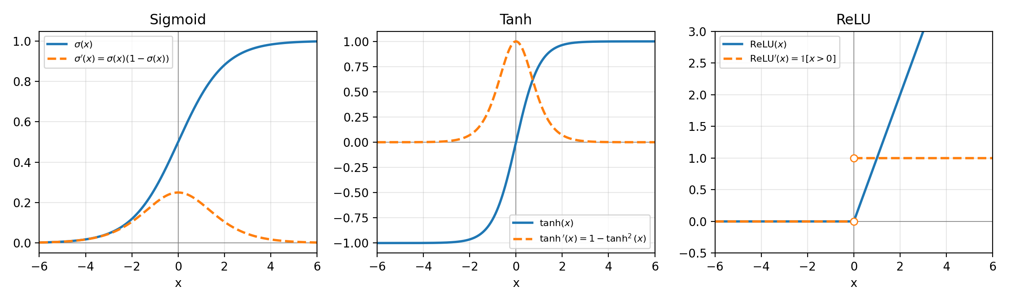
Sigmoid, tanh, and ReLU (solid) and their derivatives (dashed). The open circles on the ReLU derivative mark the jump at $x=0$, where the derivative is undefined.

3.3 The vanishing gradient problem
What it is. Backpropagation computes the gradient at layer $l$ as a product of one Jacobian per layer above it, $\frac{∂L}{∂h^{\left[l\right]}}=\frac{∂L}{∂h^{\left[L\right]}} J^{\left[L\right]}J^{\left[L−1\right]}⋯J^{\left[l+1\right]}$, where the chain rule applied to $h^{\left[i\right]}=g\left(z^{\left[i\right]}\right)$ with $z^{\left[i\right]}=W^{\left[i\right]}h^{\left[i−1\right]}+b^{\left[i\right]}$ gives $J^{\left[i\right]}=\frac{∂h^{\left[i\right]}}{∂z^{\left[i\right]}}\frac{∂z^{\left[i\right]}}{∂h^{\left[i−1\right]}}=diag\left(g′\left(z^{\left[i\right]}\right)\right)W^{\left[i\right]}$. When those factors have norm below 1, the product shrinks exponentially with depth, so the early layers get almost no gradient and barely learn. It hits deep feedforward networks and RNNs unrolled over long sequences, where the same recurrent weight matrix enters the product once per time step.
Which activations and why. Sigmoid and tanh are subject to it because they saturate: $σ′\left(x\right)≤1/4$ and $tanh′\left(x\right)≤1$, and both derivatives go to $0$ as $\left|x\right|$ grows (3.2). With sigmoid each layer multiplies the gradient by at most $1/4$, so ten layers scale it by at most ${\left(1/4\right)}^{10}≈9.5×{10}^{−7}$ before the weights are even counted. ReLU’s derivative is $1$ for every positive input, so it does not shrink the gradient through active units (inactive units pass back a zero gradient, which is the separate “dying ReLU” problem).

3.4 Why zero-centered activations matter for backprop
Take one unit in the next layer, z=i​wiai+b, with upstream gradient $δ=∂L/∂z$. Its weight gradient is
$$\frac{∂L}{∂w_{i}}=δ a_{i} \text{for every }i.$$
If the incoming activations are all positive, as sigmoid outputs in $\left(0,1\right)$ always are, then every component of $∇_{w}L$ has the sign of the single scalar $δ$. For one example, all of the unit’s weights go up together or all go down together. If the better weight vector needs some weights to rise and others to fall, gradient descent can only get there by zig-zagging between the all-positive and all-negative directions, which slows convergence. Over a mini-batch the $δ$’s of different examples can differ in sign, so the constraint is softer, but the same bias remains. Zero-centered activations such as tanh give $a_{i}$ of both signs, so the gradient components can have different signs and point more directly at the optimum. A non-zero mean in the activations also shifts the next layer’s pre-activations by i​wi Eai, pushing units toward saturation. LeCun et al. (1998, Efficient BackProp) recommend zero-mean inputs to every layer for these reasons, and batch and layer normalization re-center activations for the same reason.

3.5 Derivative of softmax
Let $σ{\left(z\right)}_{i}=e^{z_{i}}/S$ with $S=\sum_{k=1}^{K}{e^{z_{k}}}$, and note $∂S/∂z_{j}=e^{z_{j}}$ and $∂e^{z_{i}}/∂z_{j}=δ_{ij}e^{z_{i}}$. By the quotient rule,
$$\begin{matrix}\frac{∂σ{\left(z\right)}_{i}}{∂z_{j}} & =\frac{\frac{∂e^{z_{i}}}{∂z_{j}} S−e^{z_{i}} \frac{∂S}{∂z_{j}}}{S^{2}}=\frac{δ_{ij}e^{z_{i}}S−e^{z_{i}}e^{z_{j}}}{S^{2}}=δ_{ij}\frac{e^{z_{i}}}{S}−\frac{e^{z_{i}}}{S}⋅\frac{e^{z_{j}}}{S} \\ & =δ_{ij} σ{\left(z\right)}_{i}−σ{\left(z\right)}_{i} σ{\left(z\right)}_{j}=σ{\left(z\right)}_{i}\left(δ_{ij}−σ{\left(z\right)}_{j}\right). ◼\end{matrix}$$
The two cases are $∂σ_{i}/∂z_{i}=σ_{i}\left(1−σ_{i}\right)$, which matches the sigmoid derivative of 3.2 as it should, and $∂σ_{i}/∂z_{j}=−σ_{i}σ_{j}$ for $i≠j$.

3.6 Jacobian of softmax
By 3.5, entry $\left(i,j\right)$ of $J_{σ}\left(z\right)∈R^{K×K}$ is
$${\left[J_{σ}\left(z\right)\right]}_{ij}=\frac{∂σ{\left(z\right)}_{i}}{∂z_{j}}=σ{\left(z\right)}_{i} δ_{ij}−σ{\left(z\right)}_{i} σ{\left(z\right)}_{j}.$$
The first term is $σ{\left(z\right)}_{i}$ when $i=j$ and $0$ otherwise, which is entry $\left(i,j\right)$ of $diag\left(σ\left(z\right)\right)$. The second term is entry $\left(i,j\right)$ of the outer product of the column vector $σ\left(z\right)∈R^{K×1}$ with itself, ${\left[σ\left(z\right)σ{\left(z\right)}^{⊤}\right]}_{ij}=σ{\left(z\right)}_{i} σ{\left(z\right)}_{j}$. Since the two matrices agree entry by entry,
$$J_{σ}\left(z\right)=diag\left(σ\left(z\right)\right)−σ\left(z\right) σ{\left(z\right)}^{⊤}∈R^{K×K}. ◼$$
Two checks. The matrix is symmetric. Each row sums to zero, j​Jij=σi−σij​σj=0, which it must, because adding the same constant to every $z_{j}$ leaves softmax unchanged. A consequence used in every classifier in this course: for cross-entropy L=−i​yilogσi with one-hot $y$, ∂L/∂zj=−i​yiσiσiδij−σj=−yj+σji​yi=σj−yj.

Simulating XOR

4.1 A single-layer network cannot represent XOR
Answer: No. Write $\hat{y}=ReLU\left(t\left(x\right)\right)$ with $t\left(x\right)=w_{1}x_{1}+w_{2}x_{2}+b$. At the four inputs,
$$t_{00}=b, t_{01}=w_{2}+b, t_{10}=w_{1}+b, t_{11}=w_{1}+w_{2}+b,$$
and these always satisfy the identity
$$t_{01}+t_{10}=w_{1}+w_{2}+2b=t_{00}+t_{11}. \left(*\right)$$
XOR needs $\hat{y}=1$ at $\left(0,1\right)$ and $\left(1,0\right)$, and $ReLU\left(t\right)=1$ forces $t=1$, so $t_{01}=t_{10}=1$ and the left side of $\left(*\right)$ is $2$. XOR needs $\hat{y}=0$ at $\left(0,0\right)$ and $\left(1,1\right)$, and $ReLU\left(t\right)=0$ forces $t≤0$, so the right side of $\left(*\right)$ is at most $0$. Since $2≰0$, no $W$ and $b$ exist.
The same holds if we only ask the network to score the positive inputs higher than the negative ones (for example, predict 1 when $\hat{y}>0.5$). ReLU is non-decreasing, so ${\hat{y}}_{01}>{\hat{y}}_{00}$ requires $t_{01}>t_{00}$, and likewise $t_{01}>t_{11}$, $t_{10}>t_{00}$, $t_{10}>t_{11}$. Adding the first and last gives $t_{01}+t_{10}>t_{00}+t_{11}$, which contradicts $\left(*\right)$. Geometrically, the inputs with $\hat{y}>0$ form the half-plane $w^{⊤}x+b>0$, and no line separates $\{\left(0,1\right),\left(1,0\right)\}$ from $\{\left(0,0\right),\left(1,1\right)\}$. This is the limitation of single-layer perceptrons that Minsky and Papert pointed out in Perceptrons (1969).

4.2 A two-layer network that computes XOR
$$W_{1}=\left[\begin{matrix}1 & 1 \\ 1 & 1\end{matrix}\right], b_{1}=\left[\begin{matrix}0 \\ −1\end{matrix}\right], W_{2}=\left[\begin{matrix}1 & −2\end{matrix}\right], b_{2}=0.$$
Check on all four inputs, with $z=W_{1}x+b_{1}={\left(x_{1}+x_{2}, x_{1}+x_{2}−1\right)}^{⊤}$:
$x$ | $z=W_{1}x+b_{1}$ | $h=ReLU\left(z\right)$ | $\hat{y}=h_{1}−2h_{2}+0$ | XOR
$\left(0,0\right)$ | $\left(0, −1\right)$ | $\left(0, 0\right)$ | $0−0=0$ | 0
$\left(0,1\right)$ | $\left(1, 0\right)$ | $\left(1, 0\right)$ | $1−0=1$ | 1
$\left(1,0\right)$ | $\left(1, 0\right)$ | $\left(1, 0\right)$ | $1−0=1$ | 1
$\left(1,1\right)$ | $\left(2, 1\right)$ | $\left(2, 1\right)$ | $2−2=0$ | 0
The first hidden unit counts how many inputs are 1. The second fires only when both are 1. The output subtracts twice the second from the first, which cancels the double count at $\left(1,1\right)$. This is the solution given in Goodfellow, Bengio, and Courville (2016, Deep Learning, Section 6.1), and the hidden layer is what maps the four points into a space where a linear output layer can separate them.

4.3 Zero initialization never learns XOR
Let the hidden layer have $H$ units, and start from $W_{1}=0∈R^{H×2}$, $b_{1}=0$, $W_{2}=0∈R^{1×H}$, $b_{2}=0$. Write $g_{n}=∂ℓ\left({\hat{y}}_{n},y_{n}\right)/∂{\hat{y}}_{n}$ for training example $n$, which exists because $ℓ$ is differentiable.
Forward pass, for every input $x$:
$$z=W_{1}x+b_{1}=0, h=ReLU\left(0\right)=0, \hat{y}=W_{2}h+b_{2}=b_{2}.$$
Backward pass, for one example (chain rule from the output down):
$$\begin{matrix}\frac{∂ℓ}{∂b_{2}} & =g_{n}, & \frac{∂ℓ}{∂W_{2}} & =g_{n} h^{⊤}=0^{⊤} \left(\text{since }h=0\right), \\ \frac{∂ℓ}{∂h} & =W_{2}^{⊤}g_{n}=0 \left(\text{since }W_{2}=0\right), & \frac{∂ℓ}{∂z} & =\frac{∂ℓ}{∂h}⊙ReLU′\left(z\right)=0, \\ \frac{∂ℓ}{∂W_{1}} & =\frac{∂ℓ}{∂z} x^{⊤}=0, & \frac{∂ℓ}{∂b_{1}} & =\frac{∂ℓ}{∂z}=0.\end{matrix}$$
The value assigned to $ReLU′\left(0\right)$ does not matter, because it is multiplied by $∂ℓ/∂h=0$. Summing over the four training examples keeps every gradient except ∂L/∂b2=n​gn at zero. The gradient descent update with step size $η$ is therefore
W1←W1, b1←b1, W2←W2, b2←b2−ηn​gn.
Induction. Suppose $W_{1}=0$, $b_{1}=0$, $W_{2}=0$ before some step, with $b_{2}$ arbitrary. The forward and backward computations above used only those three facts, never $b_{2}=0$, so they give the same zero gradients and the three stay zero after the step. They are zero at step 0, so they are zero at every step. The network output is then $\hat{y}\left(x\right)=b_{2}$, the same number for all four inputs, while XOR needs $\hat{y}\left(0,1\right)≠\hat{y}\left(0,0\right)$. Gradient descent never learns XOR from this initialization. The only thing it learns is the best constant, for squared error the mean label $0.5$.
Numerical check (verification/verify_xor.py). Full-batch gradient descent on mean squared error, 5,000 steps: $W_{1}$, $b_{1}$, and $W_{2}$ were still exactly zero, $b_{2}=0.5$, every prediction was $0.5$, and the loss was stuck at $0.25$.

4.4 Extra credit: any uniform constant initialization
Initialize every parameter to the same constant $c$: every entry of $W_{1}∈R^{H×2}$, of $b_{1}$, and of $W_{2}$, and $b_{2}$. (The biases $b_{1}$ need a shared value for this argument. Different hidden biases would break the tie.) Let $f$ be any differentiable activation.
Step 1: the hidden units stay identical. Claim: at every step, all rows of $W_{1}$ are equal (call the common row $u^{⊤}$), all entries of $b_{1}$ are equal ($β$), and all entries of $W_{2}$ are equal ($a$). This holds at step 0. Assume it holds before a step. Then for every input, every hidden unit has the same pre-activation and output,
$$z_{j}=u^{⊤}x+β=:z, h_{j}=f\left(z\right)=:h, \hat{y}=\sum_{j=1}^{H}{a} h+b_{2}=Ha f\left(u^{⊤}x+β\right)+b_{2},$$
and with $g=∂ℓ/∂\hat{y}$ the per-example gradients are
$$\begin{matrix}\frac{∂ℓ}{∂{\left(W_{2}\right)}_{j}} & =g h_{j}=g h, & \frac{∂ℓ}{∂h_{j}} & ={\left(W_{2}\right)}_{j} g=a g, & \frac{∂ℓ}{∂z_{j}} & =a g f′\left(z\right), \\ \frac{∂ℓ}{∂{\left(W_{1}\right)}_{j,:}} & =a g f′\left(z\right) x^{⊤}, & \frac{∂ℓ}{∂{\left(b_{1}\right)}_{j}} & =a g f′\left(z\right).\end{matrix}$$
None of these depends on $j$. Summing over training examples keeps that true, so every row of $W_{1}$, every entry of $b_{1}$, and every entry of $W_{2}$ gets the same update, and the claim holds after the step. By induction it holds for the whole run.
Consequence. Throughout training the model is
$$\hat{y}\left(x\right)=A f\left(u^{⊤}x+β\right)+b_{2}, A=Ha,$$
a network with a single hidden unit, no matter how large $H$ is.
Step 2: one monotone unit cannot represent XOR. Let $t\left(x\right)=u^{⊤}x+β$. The identity $\left(*\right)$ from 4.1, $t_{01}+t_{10}=t_{00}+t_{11}$, holds for any $u$ and $β$. XOR needs $\hat{y}$ larger at $\left(0,1\right)$ and $\left(1,0\right)$ than at $\left(0,0\right)$ and $\left(1,1\right)$. If $A=0$, $\hat{y}$ is constant. If $A>0$ and $f$ is non-decreasing, ${\hat{y}}_{01}>{\hat{y}}_{00}$ requires $t_{01}>t_{00}$, and in the same way $t_{01}>t_{11}$, $t_{10}>t_{00}$, $t_{10}>t_{11}$. Adding two of these gives $t_{01}+t_{10}>t_{00}+t_{11}$, contradicting $\left(*\right)$. If $A<0$ every inequality flips and the contradiction is the same. A non-increasing $f$ is handled the same way. So for every monotone activation (sigmoid, tanh, ReLU, leaky ReLU, softplus, ELU, the step function) gradient descent from a uniform constant initialization cannot learn XOR.
Where the claim stops. Step 1 holds for any $f$, but Step 2 needs $f$ to be monotone. For a non-monotone activation one hidden unit can be enough. With $f\left(z\right)=z^{2}$, the choice $u=\left(1,1\right)$, $β=−1$, $A=−1$, $b_{2}=1$ gives $\hat{y}=1−{\left(x_{1}+x_{2}−1\right)}^{2}$, which equals $0,1,1,0$ on the four inputs. GELU, which is used in Section 6, is also non-monotone (it dips below zero for negative inputs, with a minimum near $z≈−0.75$), so a single GELU unit can also score the middle value $x_{1}+x_{2}=1$ differently from both ends. The numerical test (verification/verify_xor.py, $H=2$, mean squared error, full-batch gradient descent, step size $0.05$, 20,000 steps) gives:
Activation | Constant $c$ | Hidden units still identical? | Final loss
sigmoid | $0.5, −0.3, 1.0$ | yes | $0.171$ to $0.174$ (does not learn XOR)
tanh | $0.5, −0.3, 1.0$ | yes | $0.168$ (does not learn XOR)
ReLU | $0.5, −0.3, 1.0$ | yes | $0.250$ (does not learn XOR)
GELU | $0.5, −0.3, 1.0$ | yes | $3×{10}^{−8}$ to $3×{10}^{−6}$ (learns XOR)
$z^{2}$ | $0.5, −0.3$ | yes | $6×{10}^{−30}$ (learns XOR)
The symmetry collapse happened in every run, as Step 1 predicts. So the statement is true for every monotone activation (sigmoid, tanh, ReLU and its variants), and false for non-monotone ones such as GELU. For a general $f$ the correct statement is that constant initialization reduces the hidden layer to one effective unit, and for XOR that is fatal whenever one unit of that activation cannot separate the data.

Neural Nets and Backpropagation

5.1 Computation graph for $f\left(x,y,z\right)=lnx+exp\left(y\right)⋅z$
Each node does one operation: $h_{1}=lnx$, $h_{2}=exp\left(y\right)$, $h_{3}=h_{2}⋅z$, and $f=h_{1}+h_{3}$.
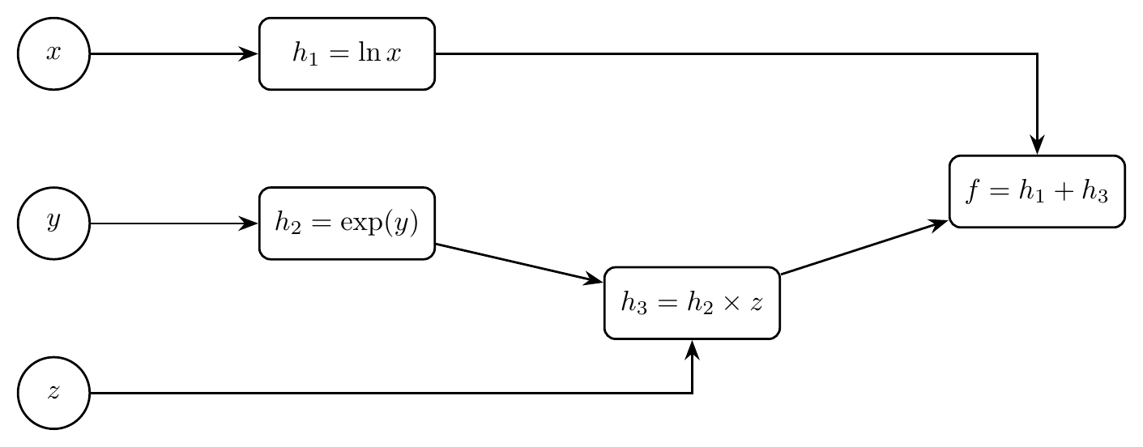
Computation graph. Inputs on the left, output $f$ on the right. Edges carry values forward and gradients backward.

5.2 Forward propagation at $\left[x,y,z\right]=\left[1,3,2\right]$
$$\begin{matrix}h_{1} & =lnx=ln1=0 \\ h_{2} & =exp\left(y\right)=e^{3}≈20.0855 \\ h_{3} & =h_{2}⋅z=e^{3}⋅2=2e^{3}≈40.1711 \\ f & =h_{1}+h_{3}=0+2e^{3}=2e^{3}≈40.1711\end{matrix}$$

5.3 Backward propagation
Local partial derivatives (one per edge of the graph), evaluated at $\left[1,3,2\right]$ using the forward values from 5.2:
$$\begin{matrix}\frac{∂h_{1}}{∂x} & =\frac{1}{x}=\frac{1}{1}=1, & \frac{∂h_{2}}{∂y} & =e^{y}=e^{3}≈20.0855, \\ \frac{∂h_{3}}{∂h_{2}} & =z=2, & \frac{∂h_{3}}{∂z} & =h_{2}=e^{3}≈20.0855, \\ \frac{∂f}{∂h_{1}} & =1, & \frac{∂f}{∂h_{3}} & =1.\end{matrix}$$
Every pair not joined by an edge has partial derivative $0$ (for example $∂h_{1}/∂y=0$ and $∂h_{2}/∂x=0$).
Upstream gradients, computed from the output back toward the inputs, each one being the gradient arriving at the node times the local derivative of the edge:
$$\begin{matrix}\frac{∂f}{∂f} & =1 \\ \frac{∂f}{∂h_{3}} & =\frac{∂f}{∂f}⋅1=1 \\ \frac{∂f}{∂h_{1}} & =\frac{∂f}{∂f}⋅1=1 \\ \frac{∂f}{∂h_{2}} & =\frac{∂f}{∂h_{3}}⋅\frac{∂h_{3}}{∂h_{2}}=1⋅2=2\end{matrix}$$

5.4 Aggregating with the chain rule
Each input has a single path to $f$, so each gradient is the product along that path:
$$\begin{matrix}\frac{∂f}{∂x} & =\frac{∂f}{∂h_{1}}⋅\frac{∂h_{1}}{∂x}=1⋅1=1 \\ \frac{∂f}{∂y} & =\frac{∂f}{∂h_{3}}⋅\frac{∂h_{3}}{∂h_{2}}⋅\frac{∂h_{2}}{∂y}=1⋅2⋅e^{3}=2e^{3}≈40.1711 \\ \frac{∂f}{∂z} & =\frac{∂f}{∂h_{3}}⋅\frac{∂h_{3}}{∂z}=1⋅e^{3}=e^{3}≈20.0855\end{matrix}$$
Check against the closed forms $∂f/∂x=1/x$, $∂f/∂y=z e^{y}$, $∂f/∂z=e^{y}$, which give $1$, $2e^{3}$, and $e^{3}$ at $\left[1,3,2\right]$. PyTorch autograd returns the same three values ($1.0$, $40.1711$, $20.0855$).

Programming

6.1.1 and 6.1.2: Reusing Homework 1 and building the MLP
The three Copy from your HW1 blocks in mlp.py are adapted from my Homework 1 code to this skeleton’s contract: featurize averages the GloVe vectors of the in-vocabulary tokens and returns None when there are none, create_tensor_dataset drops those reviews and stacks the rest into a float feature tensor and an int64 label tensor, and accuracy takes the arg-max over the class dimension. The MLP builds one nn.Linear per consecutive pair in [embed_dim] + hidden_dims + [num_classes], so an empty hidden_dims gives the single linear layer of Homework 1, and forward applies the activation after every layer except the last, because CrossEntropyLoss expects raw logits:
layer_dims = [embed_dim] + list(hidden_dims) + [num_classes]
for in_dim, out_dim in zip(layer_dims[:-1], layer_dims[1:]):
self.linears.append(nn.Linear(in_dim, out_dim))
...
hidden = inp # (batch_size, embed_dim)
for linear in self.linears[:-1]:
hidden = self.activation(linear(hidden)) # (batch_size, hidden_dims[i])
logits = self.linears[-1](hidden) # (batch_size, num_classes)
Before training, the layer shapes were checked for all four configurations, forward was checked against a hand-written composition of the same layers, and featurize and accuracy were checked on small inputs.
Setup shared by every run in Section 6. IMDB, shuffled once with seed 42 (the skeleton’s shuffle() was unseeded, and seeding it makes the split reproducible). Dev is the first 1,000 training reviews, train the next 20,000, and test the first 1,000 test reviews. Features are the average glove-twitter-50 vector of the NLTK tokens of the lower-cased review. Training uses Adam and cross-entropy for 20 epochs, and the checkpoint with the best dev accuracy is scored on the test set. With 1,000 dev reviews, the standard error of an accuracy near 77% is $\sqrt{0.77⋅0.23/1000}≈1.3$ points, which is the scale of the epoch-to-epoch wiggles in every plot below.

6.1.3 Train and evaluate MLPs
Configurations from explore_mlp_structures (sigmoid activation, batch size 64). The template assigns each depth its own learning rate, so depth and step size change together in this experiment.
Hidden layers | Learning rate | Best dev accuracy | Min dev loss | Test accuracy
None (linear) | 0.025 | 0.771 | 0.481 | 0.770
512 | 0.02 | 0.779 | 0.472 | 0.767
512 $→$ 512 | 0.01 | 0.777 | 0.471 | 0.774
512 $→$ 512 $→$ 512 | 0.001 | 0.767 | 0.480 | 0.778
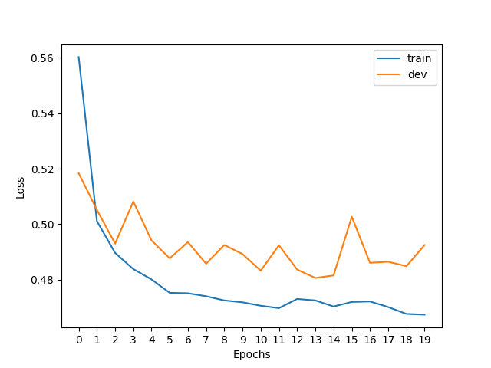
(No hidden layer)
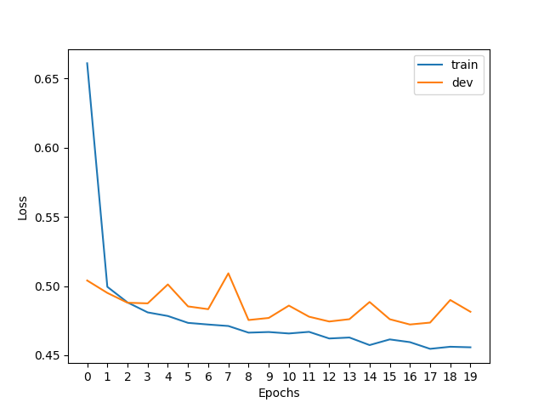
(512)
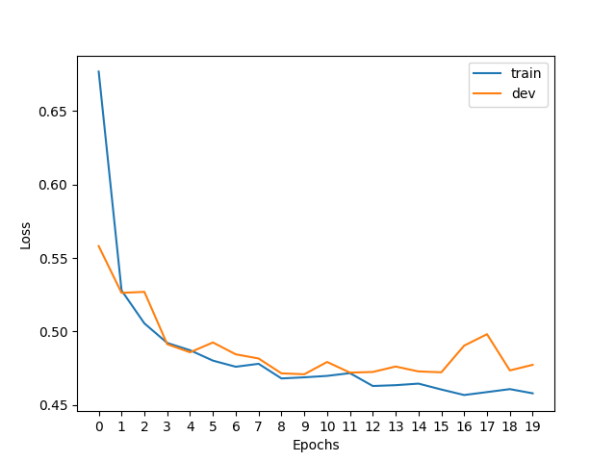
(512 $→$ 512)
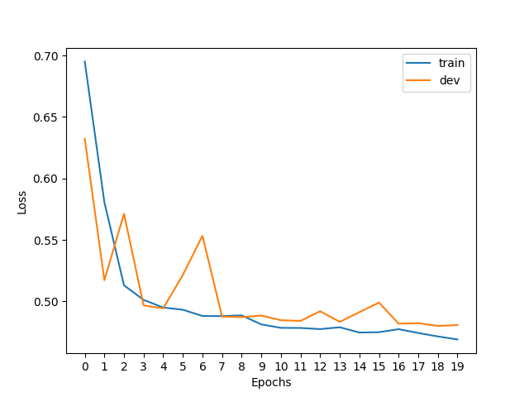
(512 $→$ 512 $→$ 512)
Train and dev loss per epoch for each MLP configuration.
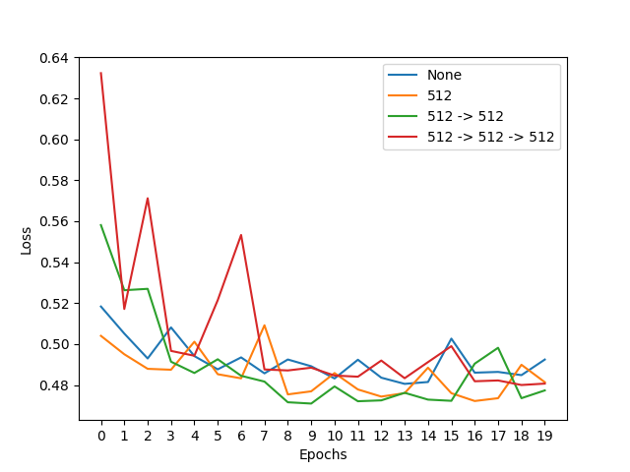
(Dev loss)
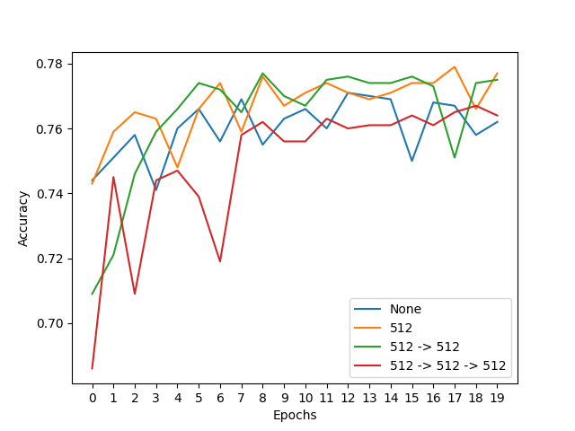
(Dev accuracy)
Dev loss and dev accuracy across MLP configurations.
Findings. In all four configurations the train loss keeps falling while the dev loss drops for a few epochs and then flattens between about 0.47 and 0.49, and the final train and dev losses differ by only 0.01 to 0.03, so the models are limited by their input features more than by overfitting. Deeper is not better here: best dev accuracy is 77.1%, 77.9%, 77.7%, and 76.7% for zero to three hidden layers, all within about one standard error of each other, and the three-layer network (which the template also trains at the smallest learning rate, 0.001) starts at chance (epoch-0 train loss 0.695, about $ln2$) and has the noisiest dev curve. An average of 50-dimensional word vectors discards word order and negation, so a linear classifier already gets most of what the feature holds, and extra layers add parameters to optimize without adding information the classifier can use.

6.1.4 Embrace non-linearity: the activation functions
SentimentClassifier takes an activation argument that selects nn.Sigmoid, nn.Tanh, nn.ReLU, nn.GELU, or nn.LeakyReLU, and explore_mlp_activations trains one model per activation with everything else fixed (one 512-unit hidden layer, learning rate 0.02, batch size 128, 20 epochs). The Canvas version of the class template does not contain this function, so its fixed hyper-parameters are taken from the upstream JHU CS 601.471/671 hw3 skeleton that this assignment comes from.
Activation | Epoch-0 train loss | Best dev accuracy | Min dev loss | Final dev loss | Test accuracy
Sigmoid | 0.695 | 0.784 | 0.471 | 0.498 | 0.771
Tanh | 0.615 | 0.774 | 0.473 | 0.473 | 0.781
ReLU | 0.599 | 0.774 | 0.477 | 0.505 | 0.767
GELU | 0.602 | 0.787 | 0.472 | 0.519 | 0.760
LeakyReLU | 0.570 | 0.778 | 0.464 | 0.464 | 0.774
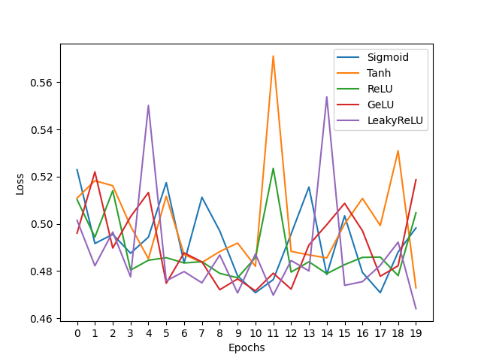
(Dev loss)
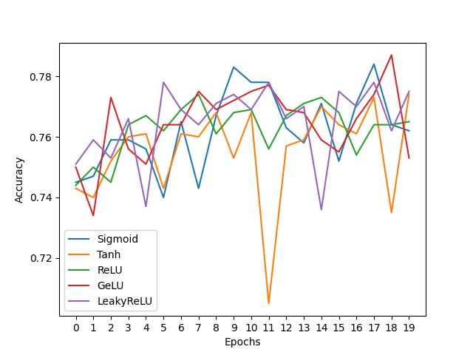
(Dev accuracy)
Dev loss and dev accuracy across activation functions (one 512-unit hidden layer).
Findings. All five activations end in the same place, with best dev accuracy between 77.4% and 78.7% and minimum dev loss between 0.464 and 0.477, differences that sit inside the noise of a 1,000-review dev set. The visible difference is at the start: sigmoid begins at chance (epoch-0 train loss 0.695) while ReLU, GELU, and LeakyReLU begin at 0.57 to 0.60, which fits Sections 3.3 and 3.4 (sigmoid’s slope is at most 1/4 and its output is not zero-centered), but with a single hidden layer the handicap does not compound and it is gone within a few epochs. From epoch 5 to epoch 19, each activation’s dev loss wanders over a band 0.05 to 0.10 wide (tanh from 0.473 to 0.571) while its train loss moves within a band 0.015 to 0.034 wide, so for this feature set which checkpoint is kept matters more than which activation is used.

6.1.5 Hyper-parameter tuning: learning rate
explore_mlp_learning_rates trains the same single 512-unit sigmoid MLP (batch size 64, 20 epochs) at five learning rates: the provided 0.02 plus 0.1, 0.002, 0.0002, and 0.00002, spaced on a log scale from 0.1 down to 0.00002.
Learning rate | Best dev accuracy | Min dev loss | Final dev loss | Test accuracy
0.1 | 0.772 | 0.482 | 0.528 | 0.776
0.02 | 0.780 | 0.470 | 0.480 | 0.772
0.002 | 0.769 | 0.479 | 0.482 | 0.779
0.0002 | 0.750 | 0.499 | 0.499 | 0.739
0.00002 | 0.694 | 0.646 | 0.646 | 0.639
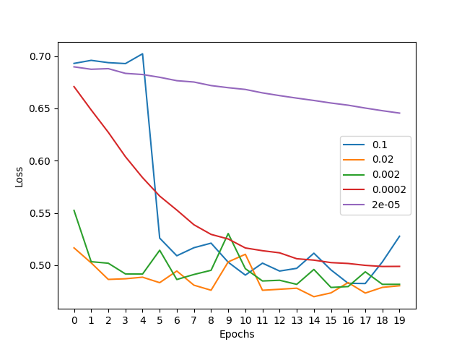
(Dev loss)
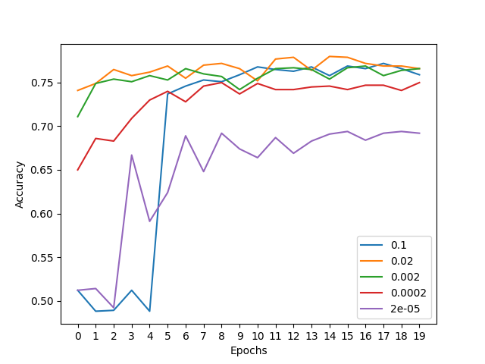
(Dev accuracy)
Dev loss and dev accuracy across learning rates (one 512-unit sigmoid hidden layer).
Findings. Learning rates from 0.002 to 0.02 work about equally well (best dev accuracy 76.9% and 78.0%), and the provided 0.02 gets to a good model fastest. At 0.1 the network sits at chance for the first five epochs (dev loss 0.693, accuracy near 50%) and stays noisy after it escapes, while at 0.0002 the loss falls smoothly and slowly to a worse end point (dev loss 0.499, 75.0%) and at 0.00002 it has barely moved (dev loss 0.690 to 0.646, 69.4%), so the two ends fail in opposite ways, one by overshooting and one by running out of epochs. The chance-level start at 0.1 coincides with sigmoid saturation: in a separate two-epoch check (verification/check_lr_saturation.py), 100% of the hidden sigmoid outputs on the dev set were below 0.01 or above 0.99 after the first epoch at 0.1 (dev accuracy 48.8%) against 0% at 0.02 (75.0%), and at 0.1 accuracy recovered to 73.8% in the next epoch with 99.8% still saturated, so the saturated units act like near-binary switches whose small gradients (Section 1.7) slow the start rather than block learning.

